DESIGN AND IMPLEMENTATION OF PELTIER BASED MOBILE SOLAR VACCINE REFRIGERATOR

ABSTRACT
The design and implementation of a Peltier-based mobile solar vaccine refrigerator is presented in this report. The refrigerator is specifically developed to provide reliable and portable storage of vaccines in areas with limited access to electricity. The system utilizes Peltier sensors, powered by a combination of a lithium-ion battery and a solar panel, to achieve the required cooling effect. The Peltier sensors provide cooling by utilizing the thermoelectric effect, while the liquid cooling system and air cooling system helps to dissipate heat efficiently. The solar panel and lithium-ion battery enable autonomous operation and recharge the battery during daylight hours. An LM35 temperature sensor is employed to monitor the internal temperature of the refrigerator, and the temperature readings are displayed on a 16x2 LCD display connected to an Arduino.
This mobile solar vaccine refrigerator represents an innovative and sustainable solution for vaccine storage, overcoming the challenges posed by unreliable electricity supply in remote areas. The combination of Peltier technology and solar power offers a cost-effective and environmentally friendly approach to maintaining vaccine integrity and efficacy. The successful implementation of this design holds great potential for enhancing healthcare services and facilitating vaccination campaigns in underserved regions worldwide.

- Introduction
Vaccines play a crucial role in safeguarding public health by preventing the spread of infectious diseases. However, ensuring the effectiveness and potency of vaccines requires strict temperature control during storage and transportation. This becomes particularly challenging in remote areas with limited or unreliable access to electricity, where maintaining the required temperature range for vaccine storage becomes a significant concern.
To address this issue, the design and implementation of a Peltier-based mobile solar vaccine refrigerator are proposed. This innovative solution aims to provide a reliable and portable means of storing vaccines in off-grid locations, where conventional refrigeration systems are impractical or unavailable. By harnessing the power of Peltier technology and solar energy, this refrigerator offers a sustainable and self-sufficient approach to vaccine storage.
The Peltier effect, also known as thermoelectric cooling, is utilized in this design to achieve the desired cooling effect [1]. Peltier sensors, powered by a combination of a lithium-ion battery and a solar panel, are employed to create a temperature-controlled environment within the refrigerator. The integration of a water-cooling system and an air-cooling system further enhances the cooling efficiency and ensures optimal heat dissipation [2-3].
The use of a solar panel allows the refrigerator to operate autonomously, utilizing renewable energy to power the cooling system and recharge the battery during daylight hours [4-5]. This eliminates the dependence on external electricity sources and enhances the mobility of the refrigerator, making it well-suited for remote healthcare facilities, mobile vaccination campaigns, and disaster-stricken areas.
The main objective of this work is to design and implement a Peltier-based mobile solar vaccine refrigerator that addresses the challenges of storing vaccines in areas with limited access to electricity. The specific objectives include:
- Reliable Vaccine Storage: Developed a refrigerator that maintains the required temperature range of 2 to 8 degree Celsius for vaccine storage, ensuring the potency and effectiveness of vaccines in remote or off-grid locations.
- Portability and Mobility: Designed a compact and portable vaccine refrigerator that can be easily transported to different locations, such as remote healthcare facilities, mobile vaccination campaigns, and disaster-affected areas.
- Sustainable Power Source: Integrated a solar panel and a high-capacity lithium-ion battery to provide a renewable and self-sufficient power supply for the refrigerator, reducing dependence on external electricity sources and enhancing the system's autonomy.
- Efficient Cooling Mechanism: Utilizing Peltier technology to achieve precise temperature control within the refrigerator, optimizing cooling performance while minimizing energy consumption.
- Temperature Monitoring and Display: Implemented a temperature sensing system using an LM35 sensor and an Arduino to monitor the internal temperature of the refrigerator in real-time. Display the temperature readings on an LCD display for easy observation and control.
- Cost-effectiveness: Design a solution that is cost-effective and affordable, considering the economic constraints often present in resource-limited settings. This ensures accessibility and scalability of the mobile solar vaccine refrigerator.
- Methodology
The methodology for the design and implementation of a Peltier-based solar vaccine refrigerator involves several steps to ensure efficient cooling, reliable operation, and sustainable energy utilization. The following are the steps shown in Fig.1.
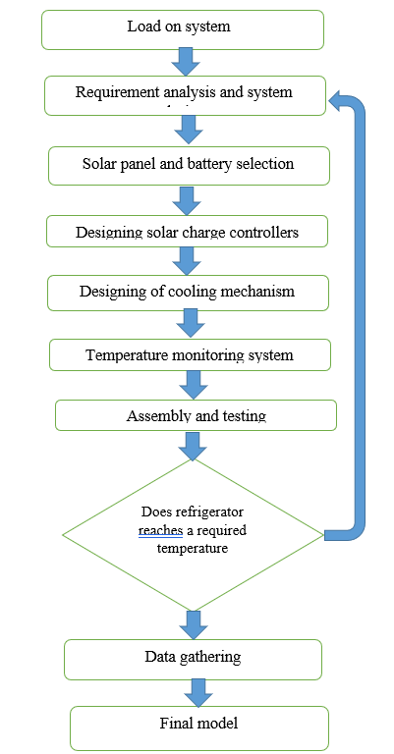
Fig. 1 Flow chart
- System Description
  - Peltier Sensor
Peltier sensor is a thermoelectric device. Thermoelectric device uses See beck, Peltier and Thomson Effect. The Peltier effect is recognized as the dominant force that permits thermoelectric devices to function. A Peltier cooler, heater, or thermoelectric heat pump is a solid-state active heat pump which transfers heat from one side of the device to the other, with consumption of electrical energy, depending on the direction of the current. Such an instrument is also called a Peltier device, Peltier heat pump, solid state refrigerator, or thermoelectric cooler (TEC) and occasionally a thermoelectric battery. It can be used either for heating or for cooling, although in practice the main application is cooling. It can also be used as a temperature controller that either heats or cools. The photograph of a Peltier Sensor is shown in Fig. 2 and the cross-sectional view is shown in Fig. 3. The following are the advantages of Peltier elements:
- Highly reliable, durable, and requires less maintenance as they do not contain moving components that are prone to wear.
- Vibration and noise-free operation.
- Lightweight and smaller footprint.
- Low manufacturing cost.
- Absence of refrigerants that are ozone depleting, thanks to the advanced control technology.
- System function can be reversed by reversing the polarity.
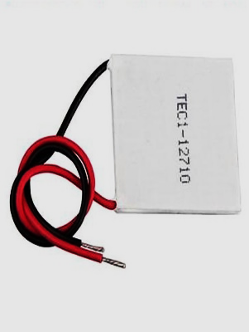
Fig. 2 Peltier sensor
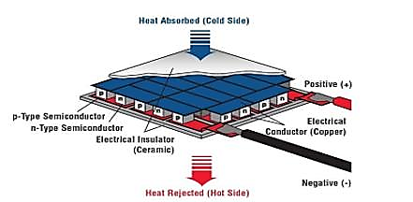
Fig. 3 Peltier sensor cross sectional view

  - Solar Panel, Battery and Charge Controller
Solar panel is a device that converts light from the sun, which is composed of particles of energy called "photons", into electricity that can be used to power electrical loads. Solar panels collect clean renewable energy in the form of sunlight and convert that light into electricity which can then be used to provide power for electrical loads. A solar charge controller is fundamentally a voltage or current controller to charge the battery and keep electric cells from overcharging. A solar charge controller is an essential component in a solar power system that regulates the charging process of a battery from the solar panels. It directs the voltage and current hailing from the solar panels setting off to the electric cell. Generally, 12V boards/panels put out in the ballpark of 16 to 20V, so if there is no regulation the electric cells will damage from overcharging. Generally, electric storage devices require around 14 to 14.5V to get completely charged. The solar charge controllers are available in all features, costs, and sizes. The range of charge controllers is from 4.5A and up to 60 to 80A.
  - Cooling Blocks
Cooling blocks shown in Fig. 4, also known as heat sinks, are devices used to dissipate heat generated by electronic components or systems. They are commonly made of materials with high thermal conductivity, such as aluminum or copper, to efficiently transfer heat away from the heat source and into the surrounding environment.
Cooling blocks work based on the principle of conduction. They provide a large surface area in contact with the heat-generating component, allowing heat to flow from the component to the cooling block. The heat is then dissipated into the surrounding air through convection or further transferred to other cooling mechanisms, such as fans or liquid cooling systems. When installing a cooling block, it is important to ensure proper thermal contact between the heat-generating component and the cooling block. This is often achieved using thermal interface materials, such as thermal paste or thermal pads, to fill any gaps and enhance heat transfer efficiency.
Therefore, cooling blocks are essential heat management components that efficiently dissipate heat generated by electronic devices. By providing a larger surface area for heat transfer, they help maintain safe operating temperatures and prevent thermal damage to the components.
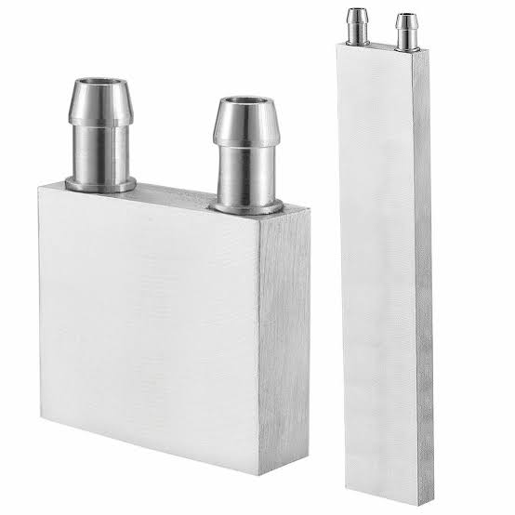
Fig. 4 Cooling Blocks

  - Thermal Paste
Thermal grease (also called CPU grease, heat paste, heat sink compound, heat sink paste, thermal compound, thermal gel, thermal interface material, or thermal paste) is a kind of thermally conductive (but usually electrically insulating) compound, which is commonly used as an interface between heat sinks and heat sources (e.g., high- power semiconductor devices). The main role of thermal grease is to eliminate air gaps or spaces (which act as thermal insulator) from the interface area so as to maximize heat transfer.
  - Heat Sink
A heat sink shown in Fig. 5 is a passive heat exchanger that transfers the heat generated by an electronic or a mechanical device to a fluid medium, often air or a liquid coolant, where it is dissipated away from the device, thereby allowing regulation of the device's temperature.
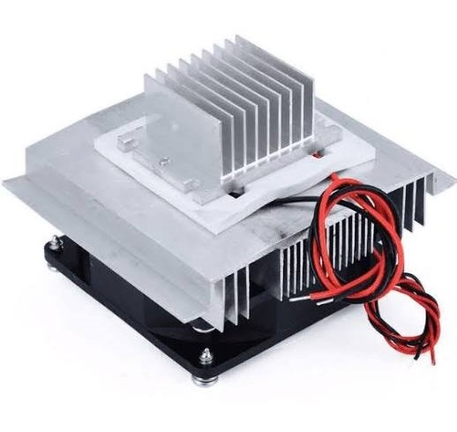
Fig. 5 Heat Sink
  - LM35 Temperature Sensor
The LM35 is a widely used analog temperature sensor that accurately measures temperature in Celsius and provides a linear voltage output proportional to the temperature being measured. With its wide temperature range of -55°C to +150°C and high measurement accuracy of typically ±0.5°C, the LM35 is suitable for precise temperature monitoring in various applications. Its low self-heating characteristics ensure minimal interference from sensor-generated heat, while its low power consumption makes it ideal for energy-efficient or battery-powered applications. The LM35's small size and wide voltage supply range further enhance its versatility, allowing for easy integration into electronic circuits and compatibility with various power sources.
  - Controller
The Arduino Uno is a popular microcontroller board based on the ATmega328P chip. It is widely used in various electronics and prototyping projects due to its simplicity, versatility, and user-friendly nature. The board features multiple input and output pins, digital and analog, which allow for the connection and control of various sensors, actuators, and other electronic components.
The Arduino Uno is known for its ease of use, even for beginners in the field of electronics and programming. It has a straightforward programming environment that uses the Arduino programming language, based on C/C++. The Arduino IDE (Integrated Development Environment) provides a user-friendly interface for writing, compiling, and uploading code to the board. With a vast library of pre-built functions, it simplifies the process of interacting with external devices and handling different types of signals.
The Arduino Uno also offers a wide range of shields, which are additional boards that can be stacked on top of the Uno to expand its capabilities. These shields provide additional functionality, such as wireless communication (Wi-Fi, Bluetooth), motor control, LCD displays, and more. This modularity makes the Arduino Uno highly adaptable to various project requirements.
  - LCD Display
A 16x2 LCD display, also known as a 16 character by 2-line LCD display, is a common alphanumeric display module widely used in various electronic projects and devices. It consists of 16 character spaces arranged in 2 lines, with each space capable of displaying a single character.
The 16x2 LCD display operates on a parallel interface, which means it requires several data pins and control pins to communicate with a microcontroller or other controlling devices. The most common interface used is the Hitachi HD44780 controller, which simplifies the process of interfacing with the display.
These displays typically have backlighting, which can be controlled separately to provide better visibility in different lighting conditions. The backlighting is usually powered by an additional set of pins and can be adjusted for brightness or turned on/off as per the requirements. The 16x2 LCD display is capable of displaying not only alphanumeric characters but also basic symbols and custom characters. It offers flexible programming options to control the cursor position, display scrolling, and other display-related functions.
  - Motor
A 12V, 1A water pump motor is a type of motor specifically designed to pump water or other fluids. It operates at a voltage of 12 volts and requires a current of 1 ampere to function properly. This motor is commonly used in applications where a small to medium amount of water needs to be pumped, such as in aquariums, small-scale irrigation systems, or hydroponic setups. The 12V, 1A water pump motor typically features a compact design, allowing it to fit into tight spaces or be integrated into portable systems. It may incorporate various mechanisms such as impellers, centrifugal pumps, or diaphragms to efficiently move water.
These motors are often powered by direct current (DC) sources, such as batteries or power supplies, which provide the required 12V voltage. It is important to ensure that the power supply can deliver at least 1 ampere of current to meet the motor's operating requirements. The water pump motor is commonly controlled using a switch or a motor controller that allows for adjusting the speed or turning the motor on and off. Additionally, some models may include built-in safety features such as thermal overload protection or low voltage cut-off to prevent damage to the motor in case of overheating or power fluctuations.
- Simulation Of Solar Charge Controller
The purpose of the system described is to simulate the charging of a battery using a photovoltaic panel. The system aims to track the maximum power point of the panel by applying a changing signal, such as variable radiation, throughout the day. This is achieved by utilizing the Perturb and Observe (P&O) algorithm.
The P&O algorithm is employed to calculate power using the voltage values obtained from the panel's input. The algorithm compares the current power value with the previous power value and checks for any difference. If the difference is zero, indicating no change in power, the algorithm recalculates. However, if the difference is non-zero, either negative or positive, it adjusts the reference voltage of the panel's input to achieve maximum power point tracking. The power value taken from the input is compared with the previous power value and the difference is checked. If the difference is 0, the algorithm goes back and does the computation again. If the difference is not 0, that is if it is negative or positive, the input value of the panel is checked. Provide maximum power point tracking by increasing or decreasing the reference voltage depending on the change in input voltage.
To implement the algorithm, program coding with MATLAB functions in Simulink is utilized. The efficiency of the system is calculated at the beginning of the simulation and shows an approximate 90% efficiency level, which indicates the system's ability to effectively convert solar radiation into usable power for charging the battery.
Initially, the battery's charge is set to 20%, based on statistical analysis of battery parameters. Over time, the battery charges in response to the intensity of radiation received by the photovoltaic panel. The simulation visualizes the charging process, with the current signal represented by a negative value, indicating the battery is being charged. The voltage of the battery reaches a stable level of 12V.When zooming in on the simulation, it becomes apparent that the battery is indeed charging, demonstrating the effectiveness of the system in utilizing solar radiation to charge the battery.
The simulation diagram shown in Fig. 6 demonstrates the practical implementation of a photovoltaic panel system for charging a battery. By tracking the maximum power point using the P&O algorithm and optimizing the input voltage, the system achieves a high level of efficiency. This simulation serves as a valuable tool for understanding and optimizing the charging process in photovoltaic systems and can aid in the development of more efficient and sustainable energy solutions. A changing signal is applied to the input of the panel in the system, such as radiation, which is constantly changing throughout the day. The main reason for this is to follow the maximum power by applying this variable signal.
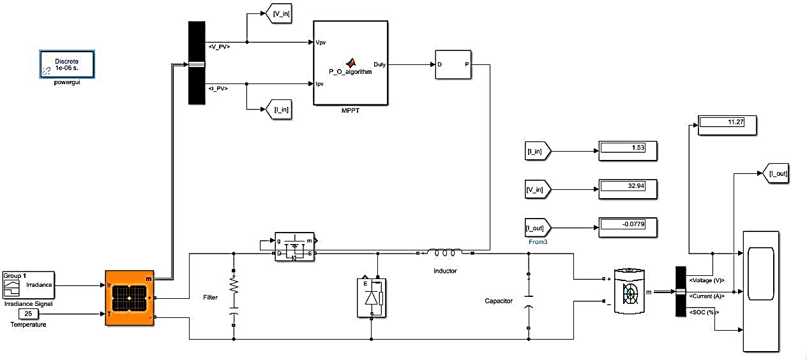
Fig. 6 Simulation of Solar Charge Controller
  - Results Obtained from Simulation
    - Output Voltage
In a simulation of a solar charge controller, the output voltage waveform shown in Fig. 7 represents the voltage generated by the charge controller as it regulates and controls the charging process of the battery using the solar panel as the power source. During the charging phase, when the solar panel is actively charging the battery, the output voltage waveform typically exhibits a stable and constant voltage level. This voltage level is determined by the charge controller to ensure proper charging of the battery without exceeding its voltage limits. The waveform remains relatively steady as long as the solar panel is generating sufficient power and the battery is accepting the charge.
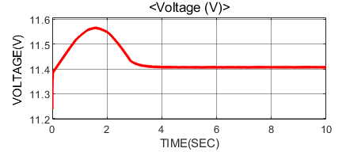
Fig. 7 Output Voltage Waveform

    - State Of Charge
In a simulation of a charge controller, the state of charge (SOC) waveform shown in Fig. 8 represents the level of charge in the battery over time. It provides a graphical representation of how the battery's capacity changes during the charging and discharging process. The SOC waveform typically starts at a certain initial level, such as 20%. As the simulation progresses, the SOC waveform shows the battery's charge level increasing during the charging phase and decreasing during the discharging phase.
During the charging phase, the SOC waveform exhibits a gradual increase as the battery receives charge from the solar panels. The rate at which the SOC increases depends on factors such as the charging current, battery capacity, and efficiency of the charge controller.
Once the battery reaches its fully charged state, the SOC waveform levels off and remains relatively stable in the maintenance mode. In this mode, the charge controller typically provides a trickle charge to compensate for self-discharge and maintain the battery's charge at an optimal level.
During the discharging phase, the SOC waveform shows a decline as the battery supplies power to connected loads. The rate of discharge depends on factors such as the load current, battery capacity, and efficiency of the charge controller. The SOC waveform helps visualize the dynamic behavior of the battery's charge level and allows for analysis of its performance and capacity utilization.
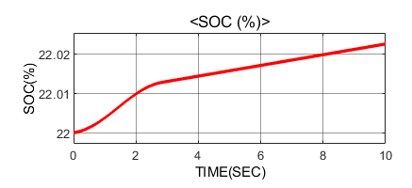
Fig. 8 State of Charge

- 3D Design of Vaccine Refrigerator
This vaccine refrigerator is specifically designed to store vaccines at the appropriate temperature to maintain their effectiveness. The vaccine refrigerator is specially designed with two compartments to cater to its specific purpose. The first compartment serves as the storage area for vaccines and utilizes a copper container to maintain the desired temperature. This copper container provides excellent thermal conductivity, helping to regulate and stabilize the temperature inside.
The second compartment is dedicated to housing all the necessary components required for the refrigerator's operation. This compartment is designed to keep the components organized and easily accessible for maintenance and servicing purposes. It ensures that the components, such as the cooling fan, reservoir, battery, charge controller, Arduino, and motor, are securely placed within the refrigerator.
The overall 3D design model of the vaccine refrigerator incorporates an insulated cabinet as the main structure. This cabinet is constructed using aluminum material and is lined with Styrofoam insulation. The combination of aluminium and insulation helps in maintaining a stable internal temperature by minimizing temperature fluctuations.
To ensure efficient operation, the refrigerator is equipped with a door made of aluminum material. The door is designed to provide a tight seal with the help of an insulating material, such as Styrofoam, preventing any air leakage that may affect the temperature stability inside the refrigerator.
Therefore, the vaccine refrigerator's 3D design shown in Fig. 9 and Fig. 10 includes an insulated cabinet, a dedicated compartment for vaccine storage using a copper container, and a separate compartment for housing the essential components. The design emphasizes temperature stability, easy access to components, and proper sealing to create an optimal environment for storing vaccines effectively.
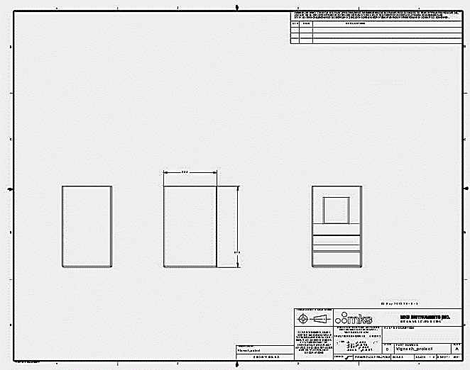
Fig. 9 System design and fabrication of refrigerator

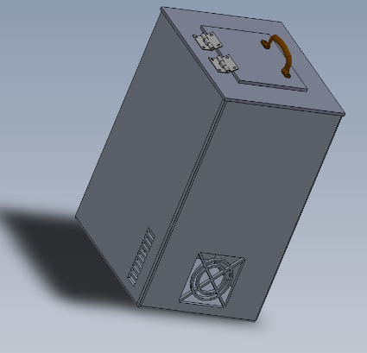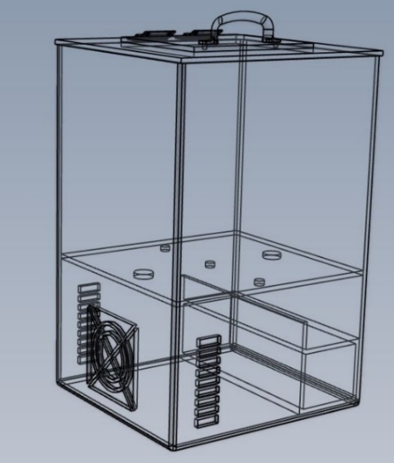
Fig. 10 Outer and internal structure of vaccine refrigerator
  - Cooling System
The cooling system used in the model is a combination of a liquid cooling system and an air cooling system. These systems work together to regulate and maintain the temperature inside the mobile solar vaccine refrigerator.
    - Liquid cooling system:
The water cooling system used in this model is a method of cooling that utilizes a water pump, cooling block, and tubing to circulate water and remove heat from the components. It is specifically designed for the mobile solar vaccine refrigerator.
In this system, the water pump, powered by a 12V, 1A motor, is responsible for circulating the water throughout the system. The pump creates a flow of water, allowing it to absorb heat from the items inside the refrigerator and carry it away.
The cooling block is a key component of the system. It is typically made of a material with good thermal conductivity, such as copper or aluminum, and is in direct contact with the items that require cooling, such as vaccines or temperature-sensitive medications. As the water flows through the cooling block, it absorbs heat from the items, thereby cooling them down.
To connect the various components, tubing is used. The tubing is typically made of flexible material, such as PVC or silicone, and is designed to withstand the flow of water and maintain a tight seal. The tubing connects the water pump to the cooling block, allowing the water to circulate through the system. It ensures that other side of the Peltier sensor maintains the proper temperature so that it does not affect the stored vaccines. Cooling blocks are pasted on the Peltier sensor with the help of thermal paste so that it exchange the heat properly and holds the cooling blocks with the sensors.
Overall, the water cooling system in this model shown in Fig. 11 provides efficient cooling for the mobile solar vaccine refrigerator. It enables the removal of heat from the interior of the refrigerator and helps maintain the required temperature for storing vaccines and medications effectively. The circulation of water ensures that the cooling process is continuous, contributing to the reliability and performance of the cooling system.
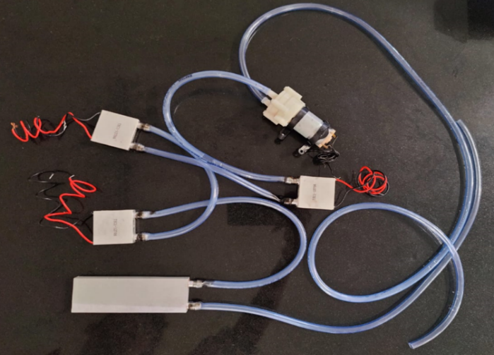
Fig. 11 Liquid Cooling System
    - Air cooling system:
In addition to the water-cooling system, the model also incorporates an air-cooling system shown in Fig. 12 to further enhance the cooling capabilities. This system utilizes a cooling fan that is positioned to blow air over the heat sink and cooling blocks.
The cooling fan used in the model is a 12V fan with a power rating of 2.5W and a current of 0.5A. The fan is strategically placed to draw in ambient air from the surrounding environment and direct it towards the heat sink and cooling blocks.
The heat sink is a component designed to efficiently dissipate heat. It is typically made of metal, such as aluminum, with a large surface area and fins that increase the contact area with the air. The heat sink is attached to the components that generate heat, such as the cooling blocks or other heat-generating elements. As air is blown across the heat sink by the cooling fan, it absorbs the heat from the heat sink and carries it away, helping to maintain lower temperatures. The cooling blocks, which are in direct contact with the items requiring cooling, also benefit from the air cooling system. As the fan blows air over the cooling blocks, it facilitates the transfer of heat from the blocks to the surrounding air, further aiding in the cooling process. Cooling blocks pasted on other side of the heat sink is used to exchange the heat with the sink so that it exchanges with the surrounding environment. Continuously water is circulated in the cooling blocks so that it exchange the internal temperature with the surrounding.
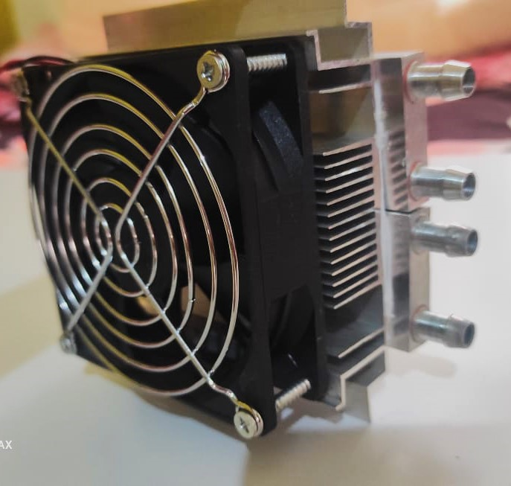
Fig. 12 Air Cooling System
The combination of water cooling and air cooling ensures effective temperature control within the mobile solar vaccine refrigerator. By directly cooling the items with the water cooling system and dissipating heat with the air cooling system, the system maintains a suitable and stable temperature for the safe storage of vaccines and medications.
It's important to consider various factors when designing and implementing the cooling system. Insulation is crucial to minimize heat transfer from the external environment, ensuring that the cooling system operates efficiently. The heat load, which depends on the number of items being cooled and their thermal characteristics, should be taken into account to determine the cooling capacity required. Additionally, the system should be designed to withstand the environmental conditions in which it operates, such as ambient temperature and humidity levels.
  - Power Management
The power supply system consists of an 18V, 0.59A solar panel used to charge an 11.1V, 24Ah lithium-ion battery. The energy generated by the solar panel is converted and stored in the battery for later use.
The solar panel, rated at 18V and 0.59A, produces a maximum power output of approximately 10.62W (18V * 0.59A). It harnesses sunlight and converts it into electrical energy. The panel's voltage and current ratings indicate the optimal operating conditions for generating power.
The 11.1V, 24Ah lithium-ion battery serves as an energy storage device. It has a nominal voltage of 11.1V and a capacity of 24Ah, which means it can deliver a current of 24A for one hour or proportionally lower currents for a longer duration. The battery stores the energy generated by the solar panel and supplies power to various components when needed.
The power supply from the battery is distributed to several devices as shown in Fig. 13.
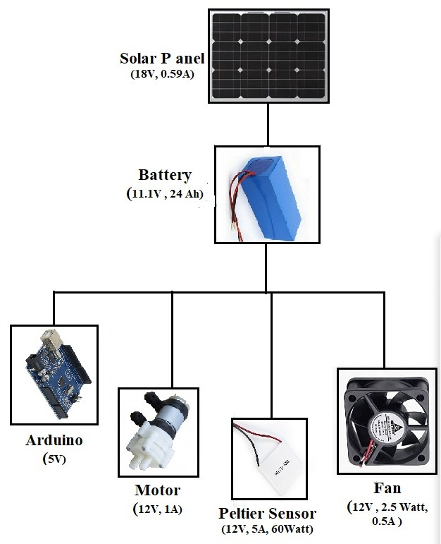
Fig. 13 Block Diagram of Power Flow
  - Hardware Implementation
The hardware implementation of the proposed system involves several key steps to ensure its proper functioning:
- Solar Panel Installation: The solar panel is mounted on the exterior side of the box or in an area that receives direct sunlight. This positioning allows the solar panel to capture solar energy effectively. The solar panel is then connected to the charge controller, which regulates and manages the charging of the battery using the solar energy harvested.
- Peltier Sensor Integration: Peltier sensors are affixed to the walls of the copper container using thermal paste. These sensors play a crucial role in maintaining the required temperature inside the refrigerator for storing vaccines. By applying an electric current to the Peltier sensors, they can transfer heat from one side to the other, enabling precise temperature control.
- Cooling System Integration: The cooling system is integrated into the refrigerator by connecting various components. This includes installing a cooling fan to facilitate heat dissipation, a heatsink to absorb and dissipate heat efficiently, and a circulation system consisting of cooling blocks and a motor. The cooling blocks are responsible for absorbing heat from the copper container, while the circulation system ensures the movement of coolant (water) through the cooling blocks to facilitate effective cooling.
- Temperature Monitoring: An LM35 temperature sensor is installed inside the refrigerator to monitor the internal temperature. The sensor is interfaced with the Arduino Uno, which acts as the controller for the entire system. The Arduino collects temperature data from the LM35 sensor and displays it on an LCD display, providing real-time monitoring of the internal temperature of the copper container.
By following these steps, the hardware implementation of the proposed system shown in Fig. 14 to Fig. 17 allows for the efficient utilization of solar energy, precise temperature control through Peltier sensors, effective cooling through the integrated cooling system, and accurate temperature monitoring using the LM35 sensor and Arduino interface. This ensures the reliable and optimal storage of vaccines in the copper container of the refrigerator.
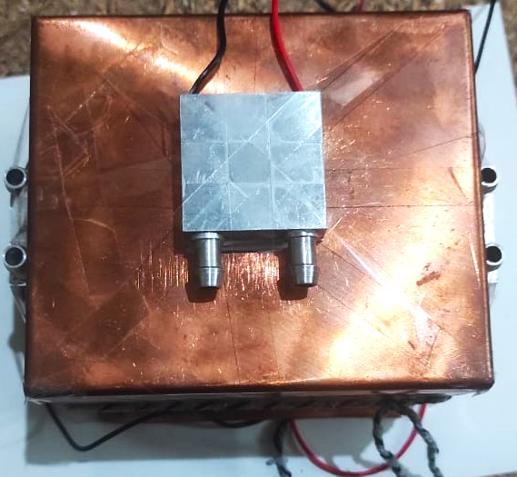
Fig. 14 Copper Container with Peltier Sensors
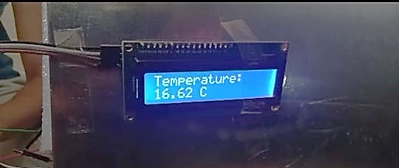
Fig. 15 Temperature displayed on LCD display
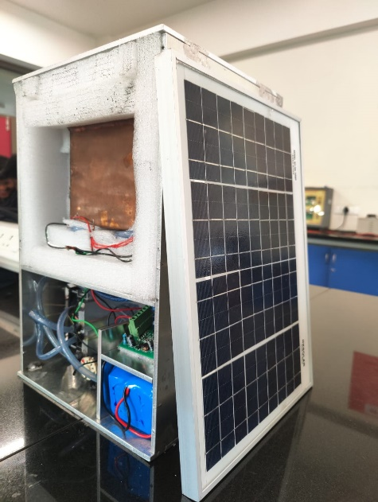
Fig. 16 Side view of vaccine refrigerator
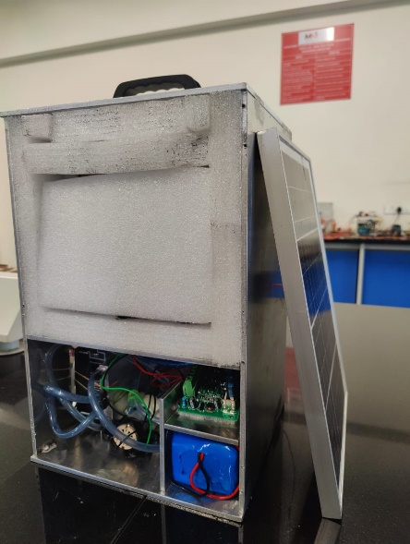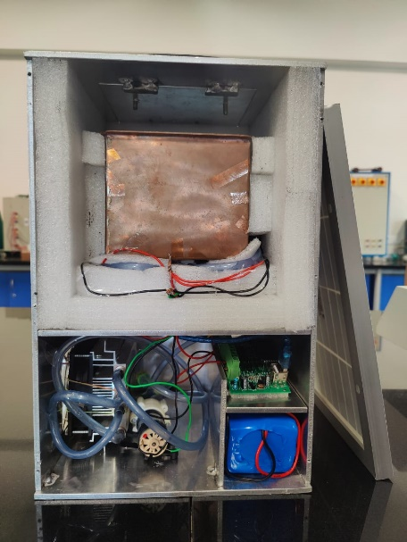
(b)
(a)

Fig. 17 (a) & (b) Front view of vaccine refrigerator
- Advantages and Disadvantages
The proposed model for a vaccine refrigerator offers several advantages:
- Energy Efficiency: The integration of a solar panel and a charge controller allows the system to harness renewable solar energy for charging the batteries. This reduces reliance on grid electricity and promotes energy efficiency, making it a sustainable solution.
- Effective Cooling System: The integration of a cooling fan, heatsink, and circulation system provides an effective cooling mechanism. The cooling fan facilitates heat dissipation, while the heatsink absorbs and dissipates heat efficiently. The circulation system, with cooling blocks and a motor, ensures the movement of coolant, facilitating effective cooling of the vaccines.
- Real-time Temperature Monitoring: The inclusion of an LM35 temperature sensor and an Arduino controller allows for real-time monitoring of the internal temperature. This ensures that the vaccines are stored within the recommended temperature range and provides users with immediate feedback on the temperature status.
- Sustainable and Reliable Power Supply: The utilization of solar energy and the integration of batteries for energy storage make the system self-sustainable and reliable. It can operate even in areas with limited or no access to electricity, ensuring uninterrupted storage conditions for the vaccines.
- Versatility and Adaptability: The modular design of the refrigerator allows for easy integration of components and customization according to specific requirements. The separate compartments for vaccine storage and hardware components provide flexibility in arrangement and maintenance.
Disadvantages of the proposed model are:
- Initial Cost: The upfront cost of implementing the system, including the solar panel, charge controller, Peltier sensors, cooling components, Arduino controller, and other necessary hardware, is relatively high. This initial investment can pose a financial barrier, especially in low-resource settings or areas with limited funding.
- Maintenance and Repairs: As with any complex system, there may be a need for regular maintenance and occasional repairs. The cooling components, Peltier sensors, and other hardware elements may require cleaning, calibration, or replacement over time. Ensuring the availability of skilled technicians and spare parts for repairs can be a challenge in certain regions.
- Applications
The main applications of this model are:
- Hospitals: The model can be implemented in hospitals to ensure proper storage of vaccines within the healthcare facility. It provides a reliable and controlled environment for storing vaccines, maintaining their efficacy and integrity. Hospitals can benefit from the precise temperature control and monitoring capabilities of the model to ensure vaccines are kept at optimal conditions.
- Army and Military Installations: The model can be utilized in army and military installations where vaccines are required for personnel serving in various locations and conditions. The portable nature of the model makes it suitable for deployment in field hospitals or mobile medical units. It ensures that vaccines remain effective and readily available for vaccination campaigns within military operations.
- Field Vaccinations: The model is well-suited for field vaccination campaigns, such as those conducted in remote or underserved areas, during outbreak responses, or in disaster-stricken regions. Its portability and self-sufficient power supply enable healthcare workers to transport and set up the vaccine refrigerator in these settings. The model ensures that vaccines are stored at the appropriate temperature during the vaccination process, safeguarding their potency and effectiveness.
- Conclusion
The design and implementation of a Peltier-based portable solar vaccine refrigerator present a significant advancement in healthcare and immunization effort, particularly in remote and resource-constrained areas. This innovative solution addresses the critical challenge of vaccine storage and transportation, ensuring the integrity and efficacy of life-saving vaccines. The utilization of Peltier technology, which uses thermoelectric effect, offers numerous benefits for portable vaccine refrigeration. By harnessing solar energy, the refrigerator becomes independent of traditional power sources, making it ideal for areas with limited or unreliable electricity supply. This not only reduces operational costs but also minimizes the environment impact.
The compact and lightweight design of portable solar vaccine refrigerator allows for easy transportation and deployment in remote areas. Health workers can easily access communities that were previously inaccessible due to logistical challenges, ensuring equitable access to vaccines and strengthening immunization coverage. It presents remarkable advancement in public health infrastructure.
REFERENCES
- Riffat SB Xiaolima ,"Thermoelectrics: A Review of Present and Potential Applications"June 2003 Applied Thermal Engineering 23(8):913-935DOI:10.1016/S1359-4311(03)00012-7.
- R. Sharma et al., "Peltier Effect Based Solar Powered Air Conditioning System," 2009 International Conference on Computational Intelligence, Modelling and Simulation, Brno, Czech Republic, 2009, pp. 288-292, doi: 10.1109/CSSim.2009.40.
- P. Attavane, G. B. Arjun, R. Radhakrishna and S. R. Jadav, "Solar powered portable food warmer and cooler based on peltier effect," 2017 2nd IEEE International Conference on Recent Trends in Electronics, Information & Communication Technology (RTEICT), Bangalore, India, 2017, pp. 1975-1978, doi: 10.1109/RTEICT.2017.8256944.
- I. Hajar and E. Martianis, "Refrigerator Design Using Solar Energy," 2018 International Conference on Applied Science and Technology (iCAST), Manado, Indonesia, 2018, pp. 322-325, doi: 10.1109/iCAST1.2018.8751629.
- P. R. V. Meris et al., "Design, Fabrication and Testing of Portable Thermoelectric Refrigerator with Arduino-Based Temperature Controller for Prevnar 13 Vaccine," 2020 11th IEEE Control and System Graduate Research Colloquium (ICSGRC), Shah Alam, Malaysia, 2020, pp. 306-311, doi: 10.1109/ICSGRC49013.2020.9232625.

