Chandrayaan: Survey on the Journey to Moon
By
Dr.NELLUTLA SASIKALA, Professor, Department of Electronics & Communication Engineering, KAMALA INSTITUE OF TECHNOLOGY & SCIENCE
, Dr.K.PRAVEEN KUMAR RAO, Professor, Department of Computer Science Engineering, KAMALA INSTITUE OF TECHNOLOGY & SCIENCE

- CHANDRAYAAN-1
ISRO has launched its first lunar probe under Chandrayaan programme in October 2005 and it worked upto august 2009. The spacecraft used PSLV-XL rocket for launching on 22 October 2008 from Satish Dhawan space center(SHAR), Sriharikota Andhra Pradesh which include a lunar orbiter and an impactor. For this mission, to explore moon, India has done a wide research and tried to develop and indigenous technology in which the country was successful. On 8 November 2008, the vehicle was placed in the lunar orbit.. many countries tried to study the south pole of the moon , but none succeeded. So it was an aim for the mission is to study the south pole of the moon.The impact probe separated from the orbiter on 14 November 2008 and hit near the crater Shackleton of South Pole in a controlled manner. The mission was planned for 2 years to work on lunar surface; however it operated only for 312 days, as it was experiencing several technical issues and stopped communication on 28 august 2009. Thw mission was successful in one of the scientific objectives aimed, to detect the presence of water on the lunar surface.
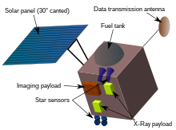
Fig 1: Chandrayaan -1 courtesy: https://en.wikipedia.org/wiki/Chandrayaan-1
The mission objectives is to yield a data which can be used that can be used for the design of atlas which is three dimensional for near and far sides of moon , mineral and chemical mapping of the entire lunar surface with a high spatial resolution, to find the existence of chemical elements like magnesium, aluminum, silicon, calcium, iron, titanium, radon, uranium and thorium.
The mass of the craft was about 1380kg at the launch, 675 kg at the lunar orbit and 523 kg after the impactor was released. Space craft was in Cuboid shape of 4.9ft. for payload data transmission X-Band was used with dual gimbaled parabolic antenna. The Telemetry, Tracking & Command (TTC) communication operated in S band frequency. 36 A.h lithium ion batteries were used to store a power of 750W which was intended to use during eclipses. The space craft was powered by solar array, one solar panel covering an area of 7.1 x 1.8 ft. Bi propellant integrated propulsion system was used by the space craft. The power plant consisted of one 440 N engine and eight 22 N thrusters. Fuel and oxidizer were stored in two tanks of 390 liters (100 US gal) each. The craft was 3-axis stabilized with two star sensors, gyros and four reaction wheels. The craft carried dual redundant bus management units for attitude control, sensor processing, antenna orientation, etc. It has taken almost 21 days for chandrayaan 1 to reach the orbit of the moon as it performed manoeuvres in a series of increasing orbits.The spacecraft was inserted into geostationary transfer orbit (GTO) at the launch with an apogee of 22,860 km (14,200 mi) and a perigee of 255 km (158 mi). The apogee was increased with a series of five orbit burns conducted over a period of 13 days after launch.
Other countries also contributed for the payload had 6 instruments and 5 indian instruments. The scientific payload had a weight of 90kgs
Indian instruments included TMC or the Terrain Mapping Camera is a CMOS camera with 5 m (16 ft) resolution and a 40 km (25 mi) in the panchromatic band and was used to produce a high-resolution map of the Moon. This instrument was aimed to map the topography of the Moon. The camera was operated in the visible region of spectrum (ElectroMagnectic) which are used to capture Black and white stereo images . Lunar Laser Ranging Instrument (LLRI), helped knowing the lunar gravitational field . ISRO's Space Applications Centre (SAC) at Ahmedabad has designed TMC
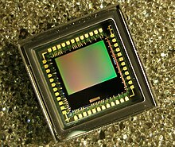
Fig 2: terrain mapping camera courtesy: https://en.wikipedia.org/wiki/Chandrayaan-1
Mineral mapping was performed by HySI or Hyper Spectral Imager is a CMOS camera in the 400–900 nm band with a spectral resolution of 15 nm and a spatial resolution of 80 m (260 ft).
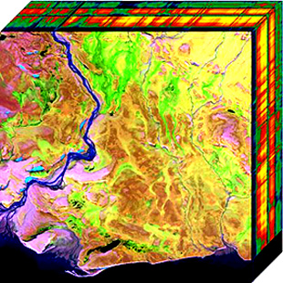
Fig 3: Hyper Spectram Imager courtesy: https://en.wikipedia.org/wiki/Chandrayaan-1
LLRI or Lunar Laser Ranging Instrument analyzes the reflected light from the lunar surface, and finds the height of the surface topography from the pulses of infrared laser. It operated continuously and collected 10 measurements per second on both the day and night sides of the Moon. LLRI was developed by Laboratory for Electro Optics Systems of ISRO, Bangalore.
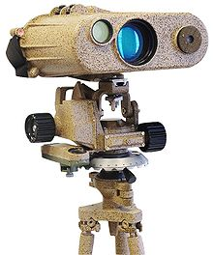
Fig 4: lunar laser ranging instrument courtesy: https://en.wikipedia.org/wiki/Chandrayaan-1
HEX is a High Energy aj/gamma x-ray spectrometer for 30–200 keV measurements with ground resolution of 40 km (25 mi), the HEX measured U, Th, ²¹⁰Pb, ²²²Rn degassing, and other radioactive elements.
MIP or the Moon Impact Probe developed by the ISRO, is designed with a impact probe which works in C-band and is used as a Radar altimeter for measurement of height, acquisition of images is by video imaging system of the lunar surface and study of lunar atmosphere is done by a mass spectrometer.
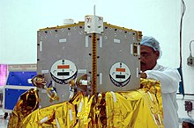
Fig 5: Moon impact probe courtesy: https://en.wikipedia.org/wiki/Chandrayaan-1
Instruments from other court space agencies like ESA, NASA, Bulgarian academy of sciences were also used. These included C1XS or X-ray fluorescence spectrometer covering 1–10 keV, is used for monitoring solar flux and checked for the availability of abundance of Mg, Al, Si, Ca, Ti and Fe at the surface with a ground resolution of 25 km (16 mi), and monitored solar flux. This payload is designed and manufactured by a collaboration of Rutherford Appleton laboratory, U.K, ESA and ISRO.
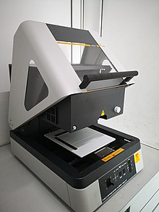
Fig6: X-ray fluorescence spectrometer courtesy: https://en.wikipedia.org/wiki/Chandrayaan-1
SARA, the Sub-keV Atom Reflecting Analyser from the ESA used the low energy neutral atoms emitted from the surface and mapped mineral composition .
M³, the Moon Mineralogy Mapper from Brown University and JPL (funded by NASA) is an imaging spectrometer designed to map the surface mineral composition.
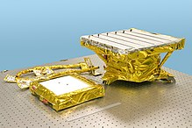
Fig7: moon mineralogy mapper courtesy: https://en.wikipedia.org/wiki/Chandrayaan-1
SIR-2, Max Planck Institute for Solar System Research, Polish Academy of Science and University of Bergen, designed SIR2, a near infra red spectrometer which mapped the mineral composition using an infrared grating spectrometer which is similar to that of the Smart-1 SIR.
Mini-SAR, designed, built and tested for NASA by a large team that includes the Naval Air Warfare Center, Johns Hopkins University Applied Physics Laboratory, Sandia National Laboratories, Raytheo and Northrop Grumman with outer support from ISRO.to search water and ice on the lunar surface Mini SAR is used which is a active synthetic aperture radar system. The scattered left and right polarized radiations are monitored and analyzed with the instrument which transmitted right polarized radiation of 2.5GHz frequency.the parameters found from this measurements are Fresnel reflectivity and the circular polarization ratio (CPR).
RADOM-7 Radiation Dose Monitor Experiment from the Bulgarian Academy of Sciences mapped the radiation environment around the Moon.
Near the Shackleton at the south pole, Moon Impact Probe (MIP) crash landed on the surface of moon on fourteen November 2008. MIP was one of 11 scientific payloads on board Chandrayaan-1.
Findings of mission:
- Moon mineralogy mapper found the presence of iron traces and also found the changes in rock and mineral composition.
- Mapping of landing site of Apollo fifteen and Apollo seventeen
- 70000 images of luna surface was acquired as the craft completed 3000 orbits.X-ray camera found the traces of aluminium, magnesium and silicon.
- Earth complete image was captured by chandrayaan and was sent.
- Water Vapor was detected by NASA's Lunar Crater Observation and Sensing Satellite and the watr molecules in the polar regions were found by Moon Mineralogy Mapper (MP3)

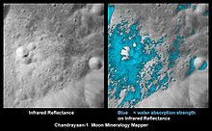
Fig 8: Images of water traces courtesy: https://en.wikipedia.org/wiki/Chandrayaan-1

- ESA payload – Chandrayaan-1 imaging X-ray Spectrometer (C1XS) – found solar flares during the mission duration , which were weak and were a dozen in number . Radiation Dose Monitor (RADOM) was a payload from Bulgaria and completely worked till the end of the mission.
- Lunar lava tube was found which was like a empty volcanic tube near the lunar equator.
- Tectonic activity was observed which was based on the data from mini SAR, processed by software ENVI.

- CHANDRAYAAN-2
ISRO had reported on 25th November 2008 that Chandrayaan-1's experienced an abnormal temperature that has risen above normal to 50 °C (122 °F), and was higher than expected temperatures in lunar orbit. . By switching off some of the instruments and changing the orientation of the spacecraft by 20 degrees, the temperature was brought down to 10 °C (18 °F) .Loss of communication with the craft was the ultimate failure which occurred because of very high radiation. This was unexpected as the power supply units controlling both the computer systems on board failed.
The second lunar exploration mission a modified version of chandrayaan 1 is chandrayaan 2 which consists a rover pragyan which was in the Vikram Lander and these two were embed into the orbiter. A robust design was made in order to study the lunar surface compositions, lunar atmosphere and the presence of water in the southern polar region.
On July 22, 2019, at 09:13:12 UTC, an LVM3-M1 rocket from the Satish Dhawan Space Centre in Andhra Pradesh launched the spacecraft from the second launch pad. On August 20, 2019, the spacecraft entered the Moon's orbit and started orbital positioning maneuvers in preparation for the landing of the Vikram lander. On September 6, 2019, the lander and rover were supposed to touch down on the near side of the Moon in the south polar area at a latitude of roughly 70° south. There was a software glitch, and the lander crashed as it deviated from the intended trajectory on 6 September 2019.
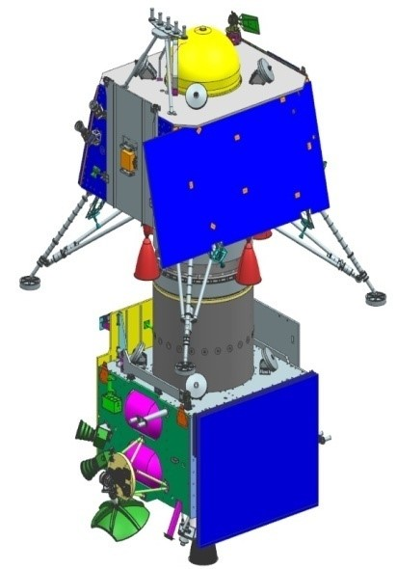
Fig 9: Chandrayaan 2 composite courtesy: https://en.wikipedia.org/wiki/Chandrayaan-2

The primary objectives of the Chandrayaan-2 lander is to do a sof landing on the lunar surface and make the rover to operate on the suface to study the minerals , atmosphere and water in Luna. The scientific aim of the orbiter is:
- to analyze the lunar topography, elemental abundance, mineralogy, the lunar exosphere, and presence of hydroxyl and water ice.
- to detect the presence water ice in the southern polar region and lunar regolith thickness on the luna surface.
- For the mapping of lunar surface which helps in preparing 3D maps
The mission was launched from the Satish Dhawan Space Centre(SHAR) on Sriharikota Island in Andhra Pradesh by a Geosynchronous Satellite Launch Vehicle Mark III (GSLV Mk III) M1 with a lift-off mass of 3,850 kg (8,490 lb).The mission budget on June 2019 was estimated allocated budget of 9.78 billion (about US$141 million), which includes 3.75 billion for the GSLV Mk III M1 launch and 6.01 billion for the space segment. The launch vehicle first placed the Chandrayaan-2 stack in an Earth parking orbit with a 170 km perigee and a 40,400 km (25,100 km) apogee.
  - Orbiter:
At a height of 100 km, the Chandrayaan-2 orbiter is moving in a polar orbit around the Moon. Eight scientific instruments are aboard, including two upgraded versions of those used on Chandrayaan-1. The launch mass was approximately 2,379 kg, Prior to the lander's separation from the orbiter, the landing site observations were made by Orbiter High Resolution Camera (OHRC) which is of high resolution. Hindustan Aeronautics Limited created the orbiter's structure.
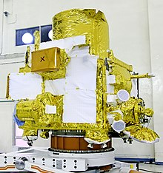
Fig 10: orbiter courtesy: https://en.wikipedia.org/wiki/Chandrayaan-2
  - Vikram Lander:
With the aid of its 800 N liquid main engines, the Vikram lander separated from the orbiter and dropped to a low lunar orbit of 30 km 100 km (19 mi 62 km). It attempted a soft landing after validating all of its onboard systems, which would have deployed the rover and allowed it to conduct research for roughly 14 days on Earth. Vikram failed miserably in this endeavor. The lander and rover weighed a total of about 1,471 kg.The design of the Vikram lander was in such a way that it can to safely land on slopes up to 12°.
Some associated technologies include:
- A high resolution camera, Laser Altimeter (LASA)
- Lander Hazard Detection Avoidance Camera (LHDAC)
- Lander Position Detection Camera (LPDC)
- Lander Horizontal Velocity Camera (LHVC), an 800 N throttleable liquid main engine
- Attitude thrusters
- Ka-band radio altimeters
- Laser Inertial Reference and Accelerometer Package (LIRAP) and the software needed to run these components.
  - Pragyan Rover:
The rover for the mission was known as Pragyan, weighed 60 pounds (27 kg) which worked on solar power. The six-wheeled rover was designed to drive 500 meters (1,600 feet) per second across the lunar surface as it conducted on-site assessments . Mission Control on Earth has its communication to lander where it gathered the information on site from rover. The Pragyan rover's electronics were not designed to withstand the cool atmosphere of luna night, its projected functioning time was one lunar day, or 14 Earth days. The power system's implementation of a solar-powered sleep/wake cycle, however, may led to a longer service life than anticipated. The State Emblem of India and the ISRO emblem were engraved on the rover's two rear wheels, which were designed to make imprints on the lunar surface as it makes the tracks.
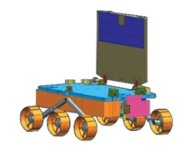
Fig 11: Pragyan rover courtesy: https://en.wikipedia.org/wiki/Chandrayaan-2
- Dimensions: 0.9 × 0.75 × 0.85 m
- Power: 50 watts
- Travel speed: 1 cm/sec
- Mission duration: ~14 Earth days (one lunar day)
The orbiter's payloads are as follows:
X-ray fluorescence spectra are used by the Chandrayaan-2 Large Area Soft X-ray Spectrometer (CLASS) from the ISRO Satellite Center (ISAC) to ascertain the elemental composition of the lunar surface.
In order to support the CLASS equipment, the Solar X-ray Monitor (XSM) from the Physical Research Laboratory (PRL), Ahmedabad, supplies solar X-ray spectra and intensity measurements as input. These data will also aid in the research of other high-energy solar coronal processes.
The Space Applications Centre's (SAC) Dual Frequency L-band and S-band Synthetic Aperture Radar (DFSAR) is used to scan the first few meters of the lunar surface for the presence of various materials. Further proof of the existence of water ice and its dispersion beneath the Moon's shadow was anticipated from DFSAR. It has a 5 m (16 ft) (L-band) lunar surface penetration depth.
Imaging IR Spectrometer (IIRS) from the SAC which is used for mapping of luna surface used a wide wavelength range for studying minerals, water molecules and hydroxyl present. Payloads worked up to 3 μm and had a extended spectral range (0.8 μm to 5 μm), which is an improvement shown over the previous luna missions.
Chandrayaan-2 Atmospheric Compositional Explorer 2 (ChACE-2) Quadrupole Mass Analyzer from Space Physics Laboratory (SPL) to carry out a detailed study of the lunar exosphere.
Terrain Mapping Camera-2 (TMC-2) from SAC for preparing a three-dimensional map essential for studying the lunar mineralogy and geology.
Radio Anatomy of Moon Bound Hypersensitive Ionosphere and Atmosphere – Dual Frequency Radio Science experiment (RAMBHA-DFRS) by SPL for the studying electron density in the lunar ionosphere.
Orbiter High Resolution Camera (OHRC) by SAC for scouting a hazard-free spot prior to landing. This aids in preparing digital elevation models and high-resolution topographic maps of luna surface. OHRC had a spatial resolution of 0.32 m (1 ft 1 in) from 100 km (62 mi) polar orbit, which was the best resolution among any lunar orbiter mission to date.
The Vikram lander's and its payloads were as follows:
LEOS's MEMS-based Instrument for Lunar Seismic Activity (ILSA) seismometer for observing Moonquakes close to the landing site.
SPL, the Vikram Sarabhai Space Center (VSSC), and the Physical Research Laboratory (PRL), Ahmedabad together developed the thermal probe known as Chandra's Surface Thermo-physical Experiment (ChaSTE) to measure the thermal characteristics of the lunar surface.
In order to measure the density and variation of lunar surface plasma, SPL and VSSC developed the RAMBHA-LP Langmuir probe.
Goddard Space Flight Center's laser retroreflector array (LRA) is used to measure distances precisely between lunar spacecraft in orbit and a reflector on the moon's surface.The microreflector was roughly 22 g (0.78 oz) in weight and was ineffective for collecting data from lunar laser stations located on Earth.
  - Rover Pragyan:
To ascertain the amount of components close to the landing location, the Pragyan rover carried two instruments: Laser induced Breakdown Spectroscope (LIBS) from the laboratory for Electro Optic Systems (LEOS), Bangalore. Alpha Particle Induced X-ray Spectroscope (APXS) from PRL, Ahmedabad
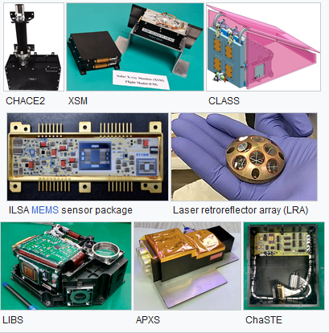
Fig 12: Pragyan rover instruments courtesy: https://en.wikipedia.org/wiki/Chandrayaan-2
On September 6, 2019, at 20:08:03 UTC, Vikram started making its way toward the Moon. It was planned to touch down there about 20:23 UTC. Mission control was unable to make adjustments, thus Vikram's on-board computers were to carry out the descent and soft landing.The lander's trajectory started to veer off course at around 2.1 km (1.3 mi) above the surface, but the initial descent was thought to stay within mission limitations and pass essential braking procedures as predicted. Vikram's final vertical velocity was 58 m/s (210 km/h) at 330 m (1,080 ft) above the surface, according to the final telemetry readings during ISRO's live feed. A number of experts observed that this was too fast for the lunar lander to accomplish a successful landing. K. Sivan, the ISRO chairman, verified the initial claims of a crash, saying that "it must have been a hard landing".
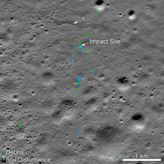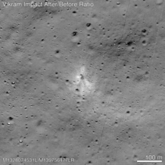
Fig13: Vikram lander impact site before and after courtesy: https://en.wikipedia.org/wiki/Chandrayaan-2

The Vikram impact site was discovered by the LROC team at 70.8810°S 22.7840°E with the assistance of Shanmuga Subramanian, a volunteer from Chennai, Tamil Nadu, who identified spacecraft debris in images made public by NASA. While the first estimate placed the initial impact within 500 m of the planned landing site, best-guess calculations based on satellite images place the initial hit at a distance of around 600 m. The spacecraft broke apart upon impact, leaving debris spread across nearly two dozen spots in a kilometer-wide area.
- CHANDRAYAAN-3
Chandrayaan-3 is the recent luna mission for exploration on the moon surface interested in exploring the south pole. It is similar to Chandrayaan-2 in that it comprises of a, lander and rover. Lander was named Vikram and a rover named Pragyan, but it lacks an orbiter. Its propulsion system functions like a satellite relaying communications. Up until the spacecraft is in a 100 km lunar orbit, the lander and rover configuration is carried by the propulsion module.
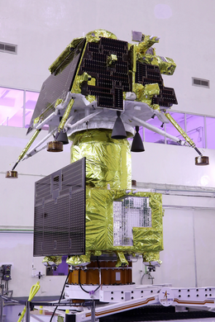
Fig 14: Chandrayaan 3 integrated module courtesy: https://en.wikipedia.org/wiki/Chandrayaan-3
Chandrayaan-3 was launched on July 14, 2023, at 2:35 IST and phase one of the lunar injection of a 100 km circular polar orbit was successfully accomplished. On August 23, 2023, the lander and rover are anticipated to touch down close to the lunar south pole.
For the Chandrayaan-3 mission, ISRO has established three key goals, which include:
- Achieving a soft, safe landing of a lander on the Moon's surface.
- Observing and showcasing the rover's moon-based loitering capability.
- To better understand the makeup of the Moon, on-site observation and experimentation using elements found on the lunar surface are recommended.
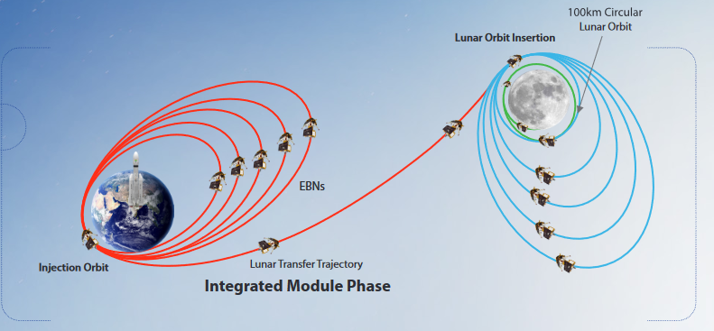
Fig 15: Integrated module phase Courtesy: https://www.isro.gov.in/Chandrayaan3_New.html
  - Propulsion Module:
The indigenous propulsion module is designed in such a way that it carries lander and rover configuration upto 100 km luna orbit. One large soloar panel is mounted on one side , top is a cylindrical structure Intermodular Adapter Cone or called as mounting structure and both are fitted into a box like structure. Spectro-polarimetry of Habitable Planet Earth (SHAPE) is the payload carried additionally with lander. SHAPE is used to do the polarmatric measurements of earth from luna surface in the near-infrared (NIR) wavelength range (1-1.7 μm) and to study the spectrum related to the measurements.
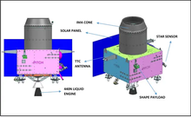
Fig 16: Propulsion module courtesy: https://en.wikipedia.org/wiki/Chandrayaan-3
  - Lander:
Lander is a box shaped structure with four legs for soft landing and four landing thrusters of 800 newtons each. The site analysis is performed by all the various scientific instruments and it will also carry rover.
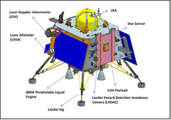
Fig 17: Lander courtesy: https://en.wikipedia.org/wiki/Chandrayaan-3
The lander has three payloads. RAMBHA_LP, Langmuir probe which is used to measure the near surface plasma (ions and electrons) density and how it changes with respect to time. ChaSTE( Chandra’s Surface Thermo Physical Instrument) is designed to carry out the measurement and thermal properties of lunar surface near polar region. ILSA (Instrument for Lunar Seismic Activity) which is designed to measure seismicity around the landing site and delineating the structure of the lunar crust and mantle.
  - Rover:
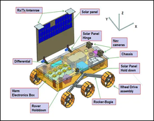
Fig 18: rover courtesy: https://en.wikipedia.org/wiki/Chandrayaan-3
- Six-wheeled design
- Weight of 26 kilograms (57 pounds)
- Range of 500 meters (1,600 ft)
- Scientific instruments including cameras, spectrometers, and a drill
- Expected lifespan of one lunar day (14 Earth days)
- Communication with the lander and ground control team in India
The rover has two payloads. They are APXS (Alpha Particle X-Ray Spectrometer) which is used to derive the chemical composition and infer mineralogical composition to further enhance the understanding of lunar surface. Another payload LIBS (Laser Induced Breakdown Spectroscope) which is designed to determine the elemental composition Mg, Al, Si, K,Ca,Ti,Fe of lunar soil and rocks around the lunar landing site.
- PAY LOAD ACCOMMODATION
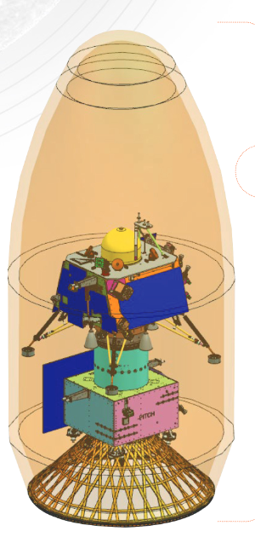
Fig 19: Courtesy: https://www.isro.gov.in/Chandrayaan3_New.html
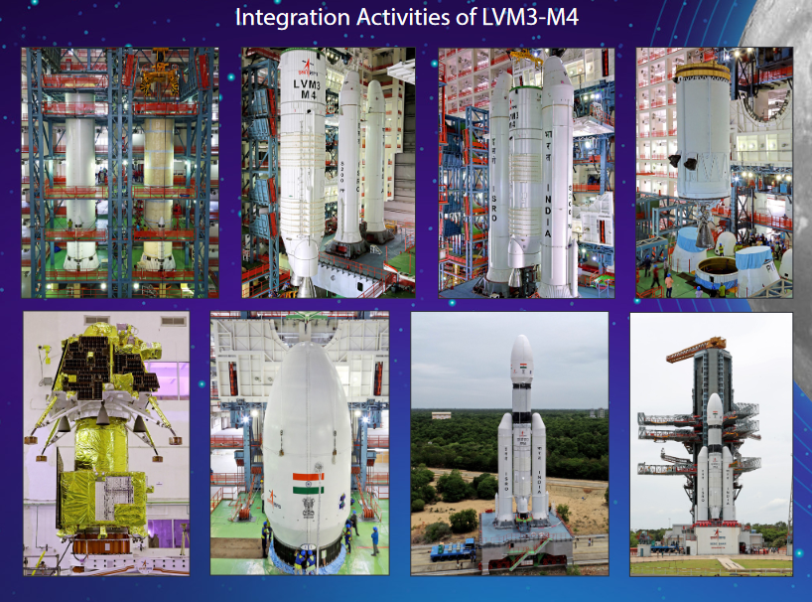
Fig 20: Courtesy: https://www.isro.gov.in/Chandrayaan3_New.html

REFERENCES:
- "Chandrayaan-1 Successfully Enters Lunar Orbit". ISRO. Archived from the original on 30 June 2014. Retrieved 8 November 2008.
- Laxman, Srinivas (15 November 2008). "Chandrayaan-I Impact Probe lands on moon". Times Of India. Retrieved 14 November 2008.
- "Luna 2". US National Space Science Data Center. Retrieved 3 December 2013.
- "Ranger 3". US National Space Science Data Center. Retrieved 3 December 2013.
- "Hiten". NASA Space Science Data Coordinated Archive (NSSDCA). Retrieved 12 April 2019.
- "Probe crashes into Moon's surface". BBC News. 3 September 2006. Retrieved 23 May 2010.
- "China's lunar probe Chang'e-1 impacts moon_English_Xinhua". news.xinhuanet.com. Archived from the original on 2 March 2009.
- "Chandrayaan-1 starts observations of the Moon". www.esa.int. Retrieved 29 July 2022.
- "An afterthought". frontline.thehindu.com. 18 December 2008. Retrieved 29 July 2022.
- "Chandrayaan team over the Moon". The Hindu. 15 November 2008. Archived from the original on 16 December 2008.
- "081125 Chandrayaan1 Moon probe a big hit". www.astronomynow.com. Archived from the original on 29 July 2022. Retrieved 29 July 2022.
- "8.4 Chandrayaan-1 Mission The New Face of the Moon by J.N. GOSWAMI". From Fishing Hamlet To Red Planet. Harper Collins. 2015. p. 506. ISBN 978-9351776895. Archived from the original on 9 September 2017. Retrieved 28 March 2019. The landing site of the MIP was named 'Jawahar Sthal' to commemorate the birthday of India's first Prime Minister, Jawaharlal Nehru, which also falls on 14 November coinciding with the date of the MIP impact.
- Acharya, Prasanna; Singh, Jitendra (3 August 2017). "Question No. 2222: Status of Chandrayaan Programme" (PDF). Rajya Sabha.
- Bhandari N. (2005). "Title: Chandrayaan-1: Science goals" (PDF). Journal of Earth System Science. 114 (6): 699. Bibcode:2005JESS..114..701B. doi:10.1007/BF02715953. S2CID 55469375.
- VOA News – Chandrayaan Lunar Probe detects water on Moon
- "Chandrayaan-2 Latest Update". Indian Space Research Organisation. 7 September 2019. Archived from the original on 8 September 2019. Retrieved 7 September 2019.
- Nair, Avinash (31 May 2015). "ISRO to deliver "eyes and ears" of Chandrayaan-2 by 2015-end". The Indian Express. Archived from the original on 15 February 2018. Retrieved 7 August 2016.
- "Launch Kit of GSLV Mk III M1 Chandrayaan-2" (PDF). Indian Space Research Organisation. 19 July 2019. Archived (PDF) from the original on 19 July 2019. Retrieved 21 July 2019.
- "Chandrayaan-2 to Be Launched in January 2019, Says ISRO Chief". NDTV. 29 August 2018. Archived from the original on 29 August 2018. Retrieved 29 August 2018.
- "ISRO to send first Indian into Space by 2022 as announced by PM, says Dr Jitendra Singh" (Press release). Department of Space. 28 August 2018. Archived from the original on 28 August 2018. Retrieved 29 August 2018.
- "Chandrayaan-2: All you need to know about India's 2nd Moon mission". The Times of India. 21 July 2019. Archived from the original on 14 July 2019. Retrieved 22 July 2019.
- "Chandrayaan-2". Indian Space Research Organisation. Archived from the original on 29 July 2019. Retrieved 20 June 2019.
- "Launch kit at a glance". Indian Space Research Organisation. Archived from the original on 23 July 2019. Retrieved 23 July 2019.
- "Chandrayan-2 Launch Rescheduled on 22 July 2019, AT 14:43 HRS". Indian Space Research Organisation. 18 July 2019. Archived from the original on 30 August 2019. Retrieved 18 July 2019.
- Singh, Surendra (5 August 2018). "Chandrayaan-2 launch put off: India, Israel in lunar race for 4th position". The Times of India. Archived from the original on 19 August 2018. Retrieved 15 August 2018.
- Shenoy, Jaideep (28 February 2016). "ISRO chief signals India's readiness for Chandrayaan II mission". The Times of India. Archived from the original on 20 July 2019. Retrieved 7 August 2016.
- Ratcliffe, Rebecca (22 July 2019). "India's Chandrayaan-2 moon mission lifts off a week after aborted launch". The Guardian. Archived from the original on 22 July 2019. Retrieved 23 July 2019.
- "GSLV-Mk III – M1 / Chandrayaan-2 Mission". Indian Space Research Organisation. Archived from the original on 12 September 2019. Retrieved 21 July 2019.
- Kiran Kumar, Aluru Seelin (August 2015). Chandrayaan-2 – India's Second Moon Mission. youtube.com. Inter-University Centre for Astronomy and Astrophysics. Retrieved 7 August 2016.
- "ISRO aims for Chandrayaan-2 landing at 1.55 AM on September 7, says Dr K. Sivan" (Press release). Delhi. Press Information Bureau. Archived from the original on 20 August 2019. Retrieved 24 August 2019.
- Madhumathi, D. S. (9 June 2019). "ISRO gears up for Chandrayaan-2 mission". The Hindu. Archived from the original on 19 June 2019. Retrieved 10 June 2019.
- Chand, Manish (12 November 2007). "India, Russia to expand n-cooperation, defer Kudankulam deal". Nerve. Archived from the original on 13 January 2014. Retrieved 12 January 2015.
- Sunderarajan, P. (19 September 2008). "Cabinet clears Chandrayaan-2". The Hindu. Archived from the original on 20 July 2021. Retrieved 23 October 2008.
- "ISRO completes Chandrayaan-2 design". Domain-b.com. 17 August 2009. Archived from the original on 8 June 2019. Retrieved 20 August 2009.
- "Payloads for Chandrayaan-2 Mission Finalised" (Press release). Indian Space Research Organisation. 30 August 2010. Archived from the original on 13 May 2019. Retrieved 4 January 2010.
- Ramachandran, R. (22 January 2013). "Chandrayaan-2: India to go it alone". The Hindu. Archived from the original on 1 August 2017. Retrieved 21 January 2013.
- Laxman, Srinivas (6 February 2012). "India's Chandrayaan-2 Moon Mission Likely Delayed After Russian Probe Failure". Asian Scientist. Archived from the original on 8 June 2019. Retrieved 5 April 2012.
- "India's next moon mission depends on Russia: ISRO chief". NDTV. 9 September 2012. Archived from the original on 8 June 2019. Retrieved 2 April 2016.
- "Chandrayaan-2" (Press release). Department of Space. 14 August 2013. Archived from the original on 5 August 2019. Retrieved 26 August 2017. Chandrayaan-2 would be a lone mission by India without Russian tie-up.
- "How ISRO modified a lunar orbiter into Mars orbiter Mangalyaan, India's "Moon Man" recalls". Zee News. 25 October 2020. Archived from the original on 26 October 2020. Retrieved 25 October 2020.
- Clark, Stephen (15 August 2018). "Launch Schedule". Spaceflight Now. Archived from the original on 16 August 2018.
- "Chandrayaan-2 launch postponed to October: ISRO chief". India Times. 23 March 2018. Archived from the original on 11 July 2019. Retrieved 16 August 2018.
- "Soft-landing challenges keep Chandrayaan-2 grounded". The Times of India. 5 August 2018. ISSN 0971-8257. Archived from the original on 29 December 2021. Retrieved 9 July 2023
- "ISRO to launch moon mission Chandrayaan-3 on July 14. Check details". Hindustan Times. 6 July 2023. Archived from the original on 8 July 2023. Retrieved 6 July 2023.
- "Chandrayaan-3 Launch LIVE Updates: Chandrayaan 3 successfully separated from LVM, injected to internal orbit". mint. 14 July 2023. Archived from the original on 17 July 2023. Retrieved 14 July 2023.
- "Chandrayaan-3 launch on July 14; August 23-24 preferred landing dates". THE TIMES OF INDIA. 6 July 2023. Archived from the original on 8 July 2023. Retrieved 7 July 2023.
- "ANI on Twitter". 14 July 2023. Archived from the original on 17 July 2023. Retrieved 14 July 2023.
- "Mission homepage". Archived from the original on 23 June 2023. Retrieved 29 June 2023.
- "India launches Chandrayaan-3 mission to the lunar surface". Physicsworld. 14 July 2023. Archived from the original on 17 July 2023. Retrieved 15 July 2023.
- "Chandrayaan-3 to cost Rs 615 crore, launch could stretch to 2021". The Times of India. 2 January 2020. Archived from the original on 19 November 2021. Retrieved 3 January 2020.
- "NASA - NSSDCA - Spacecraft - Details". Archived from the original on 8 June 2022. Retrieved 10 June 2022.
- Guptan, Mahesh (16 November 2019). "How did Chandrayaan 2 fail? ISRO finally has the answer". The Week. Archived from the original on 19 February 2021. Retrieved 3 January 2020.
- "Chandrayaan-3". www.isro.gov.in. Archived from the original on 10 July 2023. Retrieved 14 July 2023.
- "Chandrayaan 3 Launch Live: India's Chandrayaan-3 moon mission lifts off from Sriharikota". The Times of India. 14 July 2023. Archived from the original on 17 July 2023. Retrieved 14 July 2023.
- "Chandrayaan-3 launch on 14 July, lunar landing on 23 or 24 August". The Hindu. 6 July 2023. ISSN 0971-751X. Archived from the original on 11 July 2023. Retrieved 14 July 2023.
- ‘ISRO Launches Chandrayaan-3 Moon Mission’. Scientific European. Retrieved 2023-07-14
- "Chandrayaan-3 a shot in the arm for Gaganyaan-1". The Times of India. 15 July 2023. Archived from the original on 17 July 2023. Retrieved 15 July 2023.
- Singh, Surendra (5 August 2018). "Chandrayaan-2 launch put off: India, Israel in lunar race for 4th position". The Times of India. Archived from the original on 19 August 2018. Retrieved 15 August 2018.
- Shenoy, Jaideep (28 February 2016). "ISRO chief signals India's readiness for Chandrayaan II mission". The Times of India. Archived from the original on 20 July 2019. Retrieved 3 January 2020.
- "ESA and Indian space agency ISRO agree on future cooperation". www.esa.int. Archived from the original on 21 March 2022. Retrieved 16 April 2022.
- "Indian Space Research Organisation". www.isro.gov.in. Archived from the original on 2 October 2019. Retrieved 14 July 2023.
- Kumar, Chethan (19 November 2019). "Chandrayaan-3 plans indicate failures in Chandrayaan-2". The Times of India. Archived from the original on 21 November 2019. Retrieved 15 September 2020.
- After 4 Years, ISRO Reveals Why Chandrayaan 2 FAILED, retrieved 10 August 2023
- Sharma, Shaurya (21 October 2022). "Chandrayaan-3 To Be More Robust, Have Contingency Systems Onboard, Says ISRO Chief". News18. Archived from the original on 22 October 2022. Retrieved 22 October 2022.
- "ISRO Chandrayaan 3 brochure" (PDF).Archived 10 July 2023 at the Wayback Machine
- "ISRO Chandrayaan 3 brochure" (PDF).Archived 10 July 2023 at the Wayback Machine
- "Chandrayaan-3: Historic India Moon mission sends new photos of lunar surface". 7 August 2023. Retrieved 7 August 2023.
- "Chandrayan-3 lifts off on mission to the moon". 14 July 2023. Archived from the original on 17 July 2023. Retrieved 14 July 2023.
- "Chandrayaan 3: Know why July is important for ISRO". News9live. 14 July 2023. Archived from the original on 17 July 2023. Retrieved 14 July 2023

