ECONOMIC EXPLOITATION OF NON-EDIBLE SEED OIL FROM JATROPHA CURCAS- A PROMISING APPROACH TOWARDS THE PRODUCTION OF II GENERATION BIOFUEL

Author information:
SUBIKSHA G R
Mail Id: subiksharamkumar650@gmail.com
School Of Life Sciences
Bharathidasan University
Tiruchirapalli-620 024.

Abstract:
Towards the alarming rate of environmentally hazardous greenhouse gas emissions, this chapter features the potential exploitation of seeds of Jatropha curcas L. as a raw material for biodiesel production. Biodiesels are single-alkyl esters generated from plant and animal oils that serve as a sustainable source of liquid biofuel. The examination of oil derived from Jatropha curcas seeds indicates its economic viability, environmental safety, and technological achievability in response to increasing energy needs and dwindling fossil fuel resources. The seeds of J. curcas possess good fuel properties with an enormous quantity of oil extracted per hectare, accounting for 40% per seed by weight; it contributes to developmental strategies involved in marketing low-cost biodiesel on a large scale. Further, biodiesels have no traces of sulfur, aromatic hydrocarbons, or crude oil leftovers, leading to a firm possibility to overcome the release of harmful pollutants (CO₂, SO₂, methane, etc.) The extraction of seed oil from Jatropha spp. has also led to outweigh the growing critical concerns and impact of ‘food’ over ‘fuel’ in highly populated countries such as India and China; the production of second-generation biofuels from non-edible sources (J. curcas L.) deduces the chance of usage of edible oil sources (Soybean oil, for instance) as biodiesel feedstock. With the physicochemical properties evaluated to be in an acceptable range for use in diesel engines, the delimiting exploitation of biofuels from Jatropha sp. finds promising economic value in semi-arid regions and encourages the betterment of rural life. This chapter aims to disclose the replacement of fossil fuels by an alternative renewable energy source and describe the methods of oil extraction, biodiesel production, and improvement strategies in crop yield and crude oil properties of J. curcas L. seeds.
- INTRODUCTION
Over the last two decades, one can witness the growing popularity of Jatropha cultivation across the globe, especially in developing countries, owing to the production of liquid biodiesels which serve as a renewable source of energy in the future. The critical concerns associated with growing energy demands and the socioeconomic status of under-developed countries have been addressed via two prospects. The emerging exploration of low-cost harvesting of non-edible seeds especially, Jatropha curcas L. has provided a promising approach towards mitigation of negative influences of combustion of fossil fuels in the environment and the emergence of sustainable second-generation biofuels across the globe. Despite a greatly increased rate of biodiesel production and simple oil extraction procedures, the usage of first-generation biodiesel feedstock produced from easily accessible edible seeds has significantly exacerbated global food security concerns. This is because edible seeds such as soybean, linseed, and sunflower contribute a significant 75% of the overall costs associated with biodiesel production.
To overcome the ‘food vs fuel’ economic crisis, novel research directions look forward to the cultivation of non-edible seeds for biodiesel feedstock on an industrial scale. The genus Jatropha particularly, J. curcas L. has provided a promising yield to drive the production of second-generation biodiesels. (Kumar and Sharma, 2008). Jatropha curcas L. is a tropical deciduous shrub that thrives in untamed or partially cultivated environments (Kumar and Sharma, 2008) It is classified as a member of the Jatropheae tribe within the Euphorbiaceae family, and over 170 species have been identified to date (Carels, 2009). The term "Jatropha" is derived from the Greek terms "Jatros," which means "doctor," and "trophy," which means "food." This appellation reflects the plant's historical use for medical and therapeutic purposes (Kumar and Sharma, 2008). It has been traditionally used as a medicinal plant possessing anti-microbial, anti-inflammatory, healing, homeostatic, anti-cholinesterase, anti-diarrheal, anti-hypertensive and anti-cancer properties, which finds applications in pharmaceutical industries (M. Moniruzzaman and M. Shahinuzzaman et al.)
Jatropha curcas L. is a resistant wild plant native to South and Central America that grows well in tropical environments with annual rainfall ranging from 250 to 3,000 mm (Foidl et al., 1996). Its habitat spans over one million hectares globally, with the majority of its origins (85%) in Asian countries such as India, China, and Myanmar. The remaining 12% is split evenly between Africa and Latin America (Brazil and Mexico) (M. Moniruzzaman and M. Shahinuzzaman et al.). Temperatures ranging from 20 to 26°C, well-ventilated soil, good drainage, and soil pH values ranging from 5.0 to 6.5 are optimum conditions for cultivating Jatropha (Katwal and Soni, 2003). Given its ability to flourish in nutrient-poor, marginal soils, the plant has expanded its presence throughout tropical regions, exhibiting distinct variations (Kumar and Sharma, 2011; Moser, 2011). Reports indicate that planting schemes such as 2m×2m, 2.5m×2.5m, and 3m×3m are suitable for ensuring proper growth of the plant (Heller, 1996). The current scenario focuses on the seed properties, challenges of the total seed output, oil extraction methods, setbacks of seed oil, biodiesel production, improvement in crop yield, and agronomic practices.
- JATROPHA- A POTENTIAL ENRGY SOURCE
The potential of biomass as a source of renewable energy to meet the demand for fossil fuels is attracted by a number of factors, including its ease of production, long-term viability, and environmental friendliness (Valipour, 2014).
Jatropha possesses an oil content ranging from 40% to 60%, rendering it well-suited for biofuel production. An intriguing attribute of this plant is its capacity to thrive on marginal lands without the need for extensive agricultural inputs, such as irrigation and fertilizers, as highlighted in the studies by Koh and Ghazi (2011) and Mofijur et al. (2012). The potential of Jatropha as a biofuel source is underscored by its straightforward propagation, swift growth rate, ability to endure drought conditions, natural resistance to pests, and a higher oil content compared to other oil crops. Its adaptability to diverse environmental conditions, along with its relatively short time to maturity, further contributes to its appeal for biofuel production. Additionally, Jatropha's suitable plant size and structure facilitate efficient seed collection, as noted in the works of Singh et al. (2013), Atabani et al. (2013), and Abhilash et al. (2011). It is worth noting that field studies have documented varying Jatropha yields across different geographic regions. For instance, in India, the yield has been observed to range from 0.5 to 1.4 mg/ha/yr. In Belgium, the yield stands at approximately 0.5 mg/ha/yr. Comparatively, South Africa reports a yield of around 0.35 mg/ha/yr, while Tanzania boasts a higher yield of about 2 mg/ha/yr, as reported by Kant and Wu (2011).
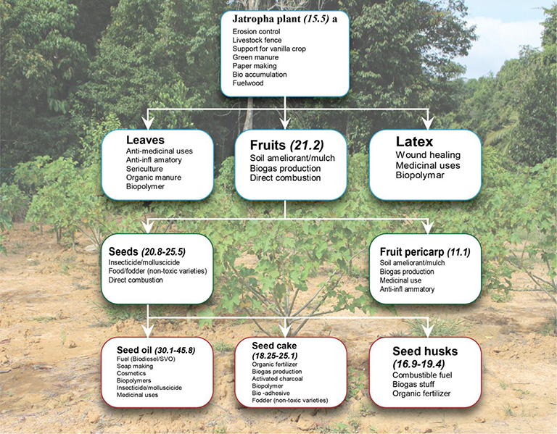

Figure 1: Potential uses of Jatropha plant (Jatropha Biofuel Industry: The Challenges, http://dx.doi.org/10.5772/64979
Wood, fruit shells, seed husks, and kernels from the Jatropha plant are used to generate energy. In rural places, its wood, leaves, and fruits have been used as firewood. Jatropha was used in prehistoric times to manage soil erosion and as a hedge (M. Moniruzzaman & M. Shahinuzzaman et.al.,).
The primary resource derived from Jatropha is raw oil. Decorticated seeds contain 40-60% oil, depending on the variety/cultivar. Because the properties of Jatropha seed oil mirror those of diesel, it is referred to as a biodiesel plant (Liberalino, A.A.A., et al., 1988, Gandhi, V., K. Cherian, and M. Mulky, 1995, Sharma, G., S. Gupta, and M. Khabiruddin, 1997, Wink, M., et al., 1997, Makkar, H. and K. Becker, 1997, Openshaw, K., 2000).

- Physical and Chemical properties of Jatropha seed oil:
The seeds of Jatropha Curcas are 212 cm long and readily split to obtain the oil (Raju and Ezradanam, 2002; Kumar and Sharma, 2011). Jatropha seed contains 37.5% fruit shell and 62.5% seed (42% skin seeds or husk and 58% kernel), as well as 64.4% oil or fat (triglycerol 88.2% and linoleic acid 47.3%). The oil content of Jatropha varies depending on where it is planted and the treatments used, such as water and fertilizer (Gudeta TB, 2016. Different chemical compositions, varietals, genetics, age, and environment may account for the variance in dry weight in a similar number of seeds (Achten WMJ, et.al., 2008).
Toxic substances including phorbol esters, curcin, trypsin inhibitors, lectins, and phytates are found in elevated levels within the dark seeds of many origins. These concentrations are significant enough that the consumption of the seeds, oil, and seed cake is not advisable without undergoing a detoxification process (Raju and Ezradanam, 2002; Kumar and Sharma, 2011).
Properties | Units | Diesel | Jatropha biodiesel (JME) | Palm biodiesel (PME) | Calophyllum inophyllum (COME) | Rapeseed oil
Viscosity | cSt | 3.6 @35°C | 3.57 @ 35°C | 4.5 @ 40°C | 4.72 @ 40°C | 42.1 @ 40°C
Specific density | Kg/L | 0.841 @35°C | 0.8809 @ 35°C | 0.855 @40°C | 0.8768 @ 40°C | 0.917 @ 15°C
Cetane value | - | 47.8 | 58.4 | 65 | 51.9 | 36-55
Flash point | °C | 52 | 174 | 174 | 151 | 100
Carbon residue | Wt% | 5 | 2.4 | 2 | - | 78.0
Sulfur | %m/m | <1.0 | - | 0.04 | 1.6 | 0.005
Calorific value | J/Kg | 45,457 | 39,340 | 41,300 | 39,880 | 36,992
Jatropha oil contains around 24.60% crude protein, 47.25% crude fat, and 5.54% moisture, respectively (Akintayo, E., 2004).
Table 1: Comparative study of the physicochemical properties of biodiesels feedstocks and fossil-derived diesel Abbreviations: JME- Jatropha oil methyl ester, PME- Palm oil methyl ester, COME- Calophyllum oil methyl ester
References: https://www.researchgate.net/profile/Robinson-Ejilah/publication/290825132/figure/tbl2/AS:669400281673745@1536608872951/Physical-and-chemical-properties-of-Jatropha-curcas-oil-and-diesel.png
https://www.researchgate.net/profile/Robinson-Ejilah/publication/290825132/figure/tbl2/AS:669400281673745@1536608872951/Physical-and-chemical-properties-of-Jatropha-curcas-oil-and-diesel.png

Jatropha seed oil has a higher energy value (39MJ kg-1) than anthracite coal and is comparable to crude oil (Sotolongo, J.A., et al., 2007).
Density, viscosity, cetane number, and flash point are the most important fuel parameters to consider while using biodiesel in diesel engines (Patel, C., Chandra, K., et al., 2019).
Within diesel engines, the Cetane number holds primary significance as a gauge of fuel quality, specifically in terms of ignition and combustion characteristics. A higher Cetane number commonly signifies a briefer interval of ignition delay—this being the duration between the injection of fuel and the initiation of ignition within the combustion chamber. This parameter substantially contributes to effective fuel combustion, smoother cold starts, improved engine performance, alongside the minimized generation of white smoke and emissions (Ramos, M.J.; Fernández, C.M.; 2009). Jatropha's cetane number is reported to be on par with that of conventional diesel. Consequently, for any biodiesel to proficiently replace diesel, it must possess a higher cetane number.
In practical application, any biodiesel derived from vegetable sources and blended with petroleum diesel must adhere to the two most commonly referenced biodiesel standards. These are the American Standard Specifications for Biodiesel Fuel (B100) Blend Stock for Distillate Fuels (ASTM 6751) and the European Standard for Biodiesel (EN 14214). Both of these standards necessitate that biodiesel possesses a minimum flash point exceeding 120°C. The flashpoint of a fuel signifies the temperature at which it initiates combustion when exposed to a flame. Typically, fuels with high flash points can lead to carbon accumulation within the combustion chamber.
As indicated in Table 1, Jatropha oil demonstrates intermediate viscosity values, positioning it between conventional diesel and other fatty acid methyl esters (FAME). This characteristic renders it suitable for employment as biodiesel. Most vegetable oils exhibit greater viscosity compared to petroleum fuels due to their elevated fatty acid content. Elevated viscosity augments the lubrication of internal mechanical components within the engine, mitigating wear and tear. Consequently, this reduction in wear curtails leakage concerns and mitigates issues associated with power loss and engine longevity. Viscosity plays a pivotal role in influencing the efficacy of fuel injection atomization within the combustion chamber, determining the size distribution of fuel droplets, and the uniformity of the mixture. Higher viscosity levels can lead to complications such as pump malfunction, filter obstruction, suboptimal combustion, and heightened emissions. Moreover, heightened viscosity accentuates surface tension, influencing the fragmentation of a liquid jet into smaller droplets during fuel injection. This, in turn, unfavorably impacts the spray characteristics of a diesel engine's fuel injector. Consequently, instead of a fine mist of small droplets, larger fuel droplets are expelled from the injector nozzle, leading to inadequate mixing with air (Ejim, C.E.; Fleck, B.A.; 2007; Abedin, M.J.; Masjuki, H.H.; 2014).
- Second-generation biofuels:
The main biofuel components of various agricultural biomasses produced by various biochemical processes are bioethanol, biodiesel, and biogas.
The shell of a Jatropha seed includes 34% cellulose, 10% hemicelluloses, and 12% lignin (Singh, R., et al., 2008). One (1) kilogram of Jatropha seed shell delivers approximately 11.1 MJ of energy (Sotolongo, J.A., et al., 2007). The seed husk contains ash (4%), volatile matter (71%), and fixed carbon (25%). One (1) kilogram seed husk yields approximately 16 MJ of energy, which is comparable to wood (Vyas, D. and R. Singh, 2007).
Figure 2: Processing of Jatropha curcas seeds (Evangelista and Cermak, 2007; Rao and Rao, 2013; Rao and Rao, 2013)
Jatropha curcas plant with fruits | Jatropha curcas seed | Jatropha curcas seeds with shells
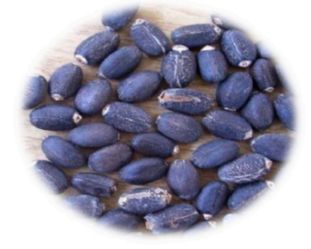  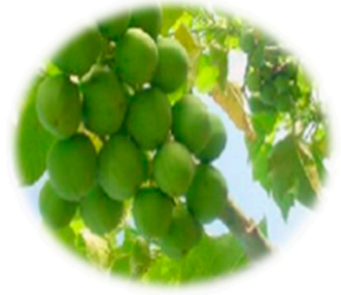 |  | 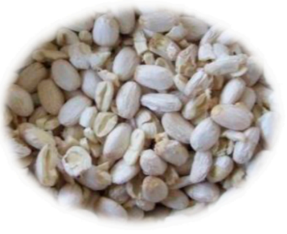
Biohydrogen derived from lignocellulosic sources like de-oiled Jatropha solid waste (DJSW) and Jatropha seed cake containing lignocellulose has garnered attention for its potential. Researchers Kumar et al. (2015) and Lopes et al. (2015) have explored the fermentation of these materials as a means to produce lignocellulose biohydrogen. In a study by Kumar and his team, they identified optimal conditions leading to the highest cumulative hydrogen production (CHP) of 296 mL H2 through the fermentation of de-oiled Jatropha waste. The conditions associated with this achievement were a substrate concentration of 211 g/L, a pH of 6.5, and a temperature of 55.4°C. These findings carry notable implications for energy conservation (Kumar et al., 2015).

In addition to biohydrogen, other potentially valuable biofuel products can be obtained from the growth of Jatropha Curcas. For instance, methane synthesis can be explored using the de-oiled cake. The husk can be transformed into fuel briquettes, providing an alternative fuel source. Furthermore, Jatropha Curcas biomass can undergo pyrolysis, leading to the production of bio-oil with physicochemical properties akin to those of crude petroleum. This multi-faceted approach is highlighted in the work of Meher et al. (2013).
- Industrial uses:
The thick oil extracted from Jatropha seed is commonly used to make soap (Openshaw, K., 2000). Because of the high palmitic acid concentration and hydrophobic character of Jatropha oil, it is simple to make soft and lasting soap (Pratt, J., et al., 2002).
Jatropha soap is commonly used in West Africa, Zambia, Tanzania, and Zimbabwe. Given the presence of glycerine in Jatropha oil soap, the white soap is gentle on the skin. It also has excellent foaming characteristics (Henning, R., 2000). Because of its therapeutic characteristics, jatropha soap can be used to treat a variety of skin problems (Messemaker, L., 2008). Jatropha seed oil comprises 32.8% linoleic acid (C18:2), which is beneficial to skin care (Pratt, J., et al., 2002; Benge, M., 2006). The oil is also used in hair conditioners (Brittaine, R. and N. Lutaladio, 2010).

Fatty acid (%) | Jatropha curcas oil | Palm oil
Oleic | 44.7 | 39.2
Linoleic | 32.8 | 10.1
Palmitic | 14.2 | 44.0
Stearic | 7.0 | 4.5
Table3: Fatty acid profile of Jatropha curcas oil and palm oil (Sinha P., Islam M.A., Negi M.S., Tripathi S.B., 2015; Aransiola E.F., Daramola M.O., et al., 2012)
Jatropha contains a variety of phytochemical components. This plant contains alkaloids, coumarins, flavonoids, lignoids, phenols, saponins, steroids, tannins, and terpenoids in various portions (Zhang, X.P., et al., 2009). These components have anti-cancer (Shahwar, D., et al., 2010; Kharat, A., A. Dolui, and S. Das, 2011), anti-microbial (Ravindranath, N., et al., 2003), anti-inflammatory (Bhagat, R., et al. 2011; Apu, A.S., et al., 2012; Reena, P., 2011), healing, homeostatic (Oduola, T., et al., 2005), anti-cholinesterase (Singh, D. and A. Singh, 2005; Feitosa, C., et al., 2011), anti-diarrheal (Apu, A.S., et al., 2012; Silva, S.d.N., et al., 2011 Félix-Silva, J., et al., 2014), and anti-hypersensitive properties (Abreu, I.C., et al., 2003). It is vital to investigate the toxicity of these phytochemicals. The toxic effects may reduce its medical usefulness.
- Ecological uses:
Jatropha has a historical application as hedging plants, stretching back to prehistoric times. A notable advantage lies in its natural resistance to consumption by animals. Notably, Jatropha belongs to the category of seed-germinating plants, characterized by both taproots and surface roots. This seed-germinating trait contributes significantly to soil erosion prevention. Moreover, its role extends to that of a nutrition pump, as its roots proficiently absorb leached minerals, subsequently replenishing the soil through processes like leaf fall, fruit decay, and the deposition of other organic remnants.

After undergoing detoxification processes, Jatropha seed cake emerges with a higher protein content (weighing at 58.1%) compared to soy meal (at 48%). This characteristic positions it as an exceptional protein supplement for animal feed. Beyond its protein content, Jatropha seed cake emerges as a rich source of minerals, encompassing a wide array including nitrogen, potassium, calcium, magnesium, sulfur, iron, phosphorus, zinc, copper, and manganese. This diverse mineral composition renders it a valuable organic fertilizer, as supported by the research of Achten et al. (2008) and Ghosh et al. (2007).

- OIL EXTRACTION METHODS
The oil present within Jatropha Curcas is stored as triacylglycerol (TAG) within the fruit. To liberate these lipids, it's necessary to disrupt or break the cell wall structure. Diverse techniques for lipid extraction exist to recover lipids from a range of organic sources. The quantity of oil and the specific lipid constituents can differ significantly. Numerous approaches are currently under exploration to enhance the efficiency of extracting the maximum oil content from Jatropha Curcas seeds, all while striving to minimize costs (Mariana et al.).
Techniques commonly used for Jatropha oil extraction are as follows:
- Mechanical extraction
- Soxhlet extraction
Owing to technological improvements in recent years, some new methods have been established. These oil extraction procedures are designed to produce high extraction yields and high-value meals by getting high-quality oil with minimal undesirable components. They include supercritical fluid extraction, ultrasound-assisted extraction, and microwave-assisted extraction.
- Mechanical extraction:
Mechanical pressing stands out as a widely used technique for oil recovery. In this method, a helical body, often referred to as a spring, is set into rotational motion within a confined space to exert the pressing force. This process can be facilitated using hydraulic presses or screw presses, with the latter, known as press chambers, gaining preference due to their reduced labor requirements. To execute this, a vertical feeder and a horizontal screw with gradually increasing diameter move along the length of the press, exerting pressure on the oilseeds. The screw barrel is designed with lengthwise slots that first expel air and subsequently allow the oil to flow through the barrel due to increasing internal pressure. The extracted oil is collected in a receptacle, while the de-oiled cake is discharged at the end of the screw mechanism (Romanić, 2020).
Before pressing, oilseed materials typically undergo various preparatory steps, including washing, conditioning, heating, flaking, and dehulling. These pre-treatments are aimed at optimizing the quantity and quality of oil obtained from the raw material (Riayatsyah et al., 2022).
Historical efforts have been invested in enhancing the efficiency of oil extraction through screw presses. Consequently, a majority of studies have concentrated on refining pressing process variables, such as applied pressure, pressing temperature, and moisture conditioning of the sample under examination (Ofori-Boateng et al., 2012; Subroto et al., 2015).
Merits of mechanical extraction:
• Screw presses are typically preferred by small enterprises because they are less expensive, safer, and require less maintenance than solvent extraction.
• The fundamental feature of screw presses is that they can handle vast amounts of Jatropha curcas seed with little effort, and continuous oil extraction is possible.
Demerits of mechanical extraction:
• Because 8-14% of the oil remains in the cake and residual material, mechanical screw presses are suited for higher oil yield feedstocks. This method is not suitable for low oil yield feedstock; instead, solvent extraction would be preferable.

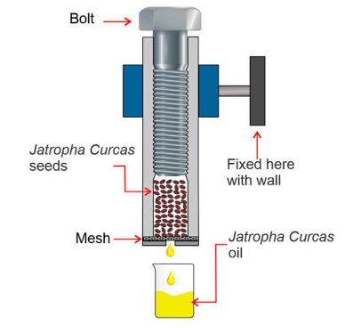

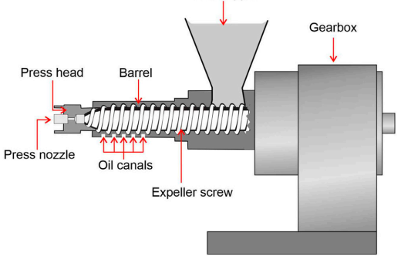
- B. Soxhlet extraction method:
Figure 3: The screw press design obtains oil by pressing seeds and nuts through a high friction and pressure chamber. The procedure does not include any additional heat, but the seeds are crushed using friction, which generates heat between 60 and 100° C. After the seeds have been crushed, the oil will be extracted. The seeds will remain in the press and harden into a "brick" that can be used as animal feed. (Riayatsyah et al., January 2022)
Figure 4: The cold-pressed method involves pressing the seed with an oilseed press to produce cold-pressed oil with less heat used or generated throughout the process. This technique is performed at a much lower temperature (50°C). (Riayatsyah et al., January 2022)

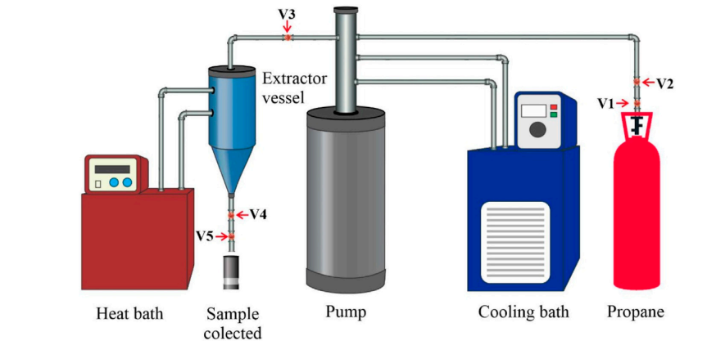

Figure 5: Soxhlet extraction using propane as the leaching solvent. V1 and V2 denote the ball valves; V3 and V5 the needle valves; V4 the blockage valve. (Riayatsyah et al., January 2022)
The soluble portion, also known as solute or leachate, present in Jatropha Curcas seeds, is separated from the seeds using a liquid solvent through the process of leaching or solvent-based extraction, as highlighted in the research by Bhuiya et al. (2020). Within the realm of oil extraction, chemical extraction has gained considerable traction due to its potential for achieving a high oil yield and producing oil of superior quality. The choice of solvent in the solvent extraction method can significantly influence the oil yield, given the varying polarities of different solvents. Commonly utilized solvents for oil extraction encompass hexane, propane, ethane, tetrahydrofuran (THF), ethanol, dichloromethane, methanol, and the methanol-water binary system (Haile et al., 2019; Zhang et al., 2019; Alrashidi et al., 2020).
Table 4: Comparative study of optimization analysis of crude oil yield in different plant species
Despite the advantages of achieving substantial oil production and purity through solvent-based methods, it's important to acknowledge that the lengthy extraction process does result in energy wastage.
Plant species | Calophyllum inophyllum | Nigella sativa L. | Prosopis julifera | Moringa stenopeta
Solvent | n-hexane | Ethanol | Polar and non-polar | Hexane
Seed-to-solvent ratio | 3:1, 5:1, 7:1 |  | 1:9
Reaction temperature | 60°C - 70°C |  | 60°C
Duration | (4,5,6) h |  | 9h
Yield | 86.4% | 40.2% | 37% | 34.8% - 42.3%
Reference | (Jose et al., 2011; Bhuiya et al., 2020). | (Alrashidi et al., 2020) | (Rajeshwaran et al., 2020) | (Haile et al., 2019)
The Response surface methodology used a set of parameters under consideration for the optimization analysis of crude oil. The solvent-to-seed ratio, reaction temperature, and extraction duration were the analytical parameters (Riayatsyah et al., 2022).
Because it involves dissolving oil by contacting oilseeds with a liquid solvent, solvent extraction is a substantially more successful method of obtaining oil from oilseeds than mechanical extraction.
Demerits of the Soxhlet extraction method:
- The separation of the oil and solvent mixture is difficult with this method, making it more suitable for a small-scale manufacturing plant.

- Supercritical fluid extraction:
Principle:
- As an alternative to standard oil and oilseed processing, the supercritical fluid extraction (SCFE) technology was proposed. This process is most commonly used in the essential oil industry (Xiong and Chen, 2020).
- Ethanol, isopropyl alcohol, acetone, iso-hexane, n-hexane, propane, and other supercritical fluids similar to those used in the Soxhlet extraction technique are among the solvents used.
- Supercritical carbon dioxide extraction (SC-CO2) is a process that employs carbon dioxide as a solvent above its critical pressure and temperature.
- The pressure in the system will be released after the oil has been extracted, the CO2 will return to the gas phase, and the oil will be precipitated from the CO2-Jatropha curcas oil combination.
Advantages:
- Unlike other solvents (n-hexane, ethanol, propane), CO₂ can be readily removed from the Jatropha curcas oil
- Minimal processing time of (25-30) min is achieved (De Lara Lopes et al., 2020; Fetzer et al., 2021).

- Other methods of Jatropha oil extraction:
Ultrasound-assisted extraction (UAE) and Microwave assisted extraction (MAE) are newly employed techniques to extract Jatropha curcas seed oil in recent times. These techniques might possibly ease the extraction process with minimal timeframe, high reproducibility, and low consumption of solvents and other materials required for the extraction process. The principle behind the UAE and MAE is the generation of turbulence between the matrix solutes and solvents namely, ethanol, n-hexane and propanol, etc. This process is facilitated by the poking or cavitation of plant cell walls by creating ultrasound-assisted microbubbles thereby, facilitating rapid diffusion of solvents into the internal area of the plant cells (Suganya et al., 2014). Recent studies highlight the optimizing role of UAE and MAE in the extraction of oils from microalgae and other plant species including Jatropha curcas.
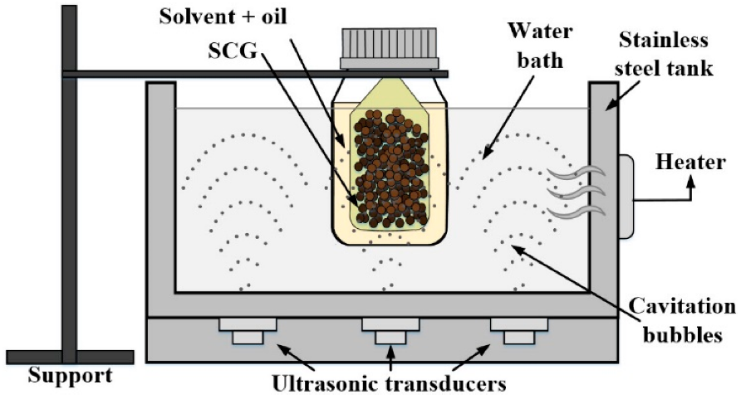

Figure 6: Studies showing the mechanism of ultrasound-assisted oil extraction using spent coffee grounds (SCP) (Malek Miladi et al., Nov 2021)
- BIODIESEL PREPARATION- TRANSESTERIFICATION:
Transesterification can be defined as a chemical process involving the conversion of triglycerides – compounds found in fats and oils – with alcohol, facilitated by a catalyst. This transformation leads to the formation of alkyl esters. Among the alcohols used, methanol and ethanol are particularly favored due to their affordability and ready availability. A noteworthy characteristic of transesterification is its capacity to occur under mild conditions, rendering it environmentally friendly. This method stands as a versatile means to produce biodiesel from a diverse array of raw materials.
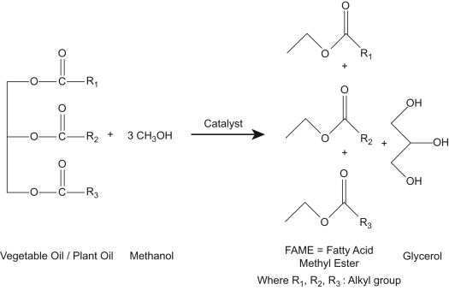
Triglycerides, which constitute a fundamental component of vegetable or animal oils, consist of three fatty acid molecules connected to a glycerol molecule. Through a series of three consecutive reactions, triglycerides engage with an alcohol to generate esters and glycerol. This process holds considerable promise for sustainable fuel production and aligns with environmentally conscious practices.

Figure 7: Transesterification reaction (Nikul K. Patel, Shailesh N. Shah, in Food, Energy, and Water, 2015)

Transesterification of biodiesel is usually carried out using a homogenous alkaline catalyst such as NaOH or KOH.
Although ethanol can be used to produce biodiesel, the use of methanol in biodiesel production is more prevalent and preferred due to its lower cost and huge available feedstock (L S Keong, D S Patle, S R Shukor, Z Ahmad)
- Challenges of biodiesel processing and purification:
Following the extraction of the oil, it is purified and trans esterified in order to produce crude biodiesel. However, due to limitations such as industry standard biodiesel standards, the crude biodiesel cannot be used directly as a transportation fuel. As a result, before being used in diesel engines, crude biodiesel is normally blended in particular quantities with pure diesel. The crude biodiesel is filtered before mixing to remove undesirable moisture and chemical waste created during the transesterification process. Water washing is the most popular method of purification since it is inexpensive and simple, albeit this time-consuming procedure must be repeated numerous times until no more glycerol is created (Ali, R.M.; Farag, H.A.; Amin, N.A.; Farag, I.H., 2015).
The fatty acid composition has a considerable impact on the fuel qualities of biodiesel (Saraf, S.; Thomas, B., 2007). Inedible oils, such as Jatropha, typically contain significant levels of harmful free fatty acids (FFA) (>1% w/w), lowering biodiesel production. Similarly, the large amount of fatty acid inhibits direct conversion of the oil into biodiesel because the high FFAs increase soap production, which might impede product separation during or after transesterification. Jatropha oil has over 14% FFA, greatly exceeding the regulatory limit of 1% FFA. As a result, the pretreatment stage is required to reduce the feedstock FFAs for increased biodiesel yield (Atadashi, I.M.; Aroua, M.K.; Aziz, A.A., 2010). When NaOH catalyst is used, the typical undesirable saponification reaction produces soap and water.

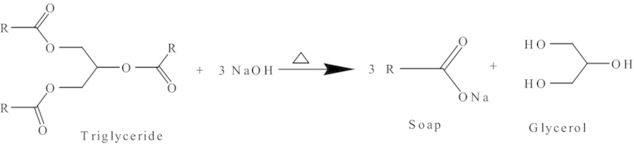
Figure 8: Saponification (Jatropha Biofuel Industry: The Challenges, http://dx.doi.org/10.5772/64979)

- Jatropha plant cultivation
2. Fruit harvesting
7. Transesterification
3. Pretreatment
4. Seeds/kernel storage
5. Oil extraction
6. Crude oil purification
8. Biodiesel purification

Figure 9: Biodiesel processing and challenges (https://doi.org/10.3390/pr8070786)
- Measures undertaken during trans esterification:
The two-step process of transesterification has proven to be a highly effective technique for treating unrefined oil that contains significant levels of free fatty acids (FFAs) derived from Jatropha curcas. Additionally, in the initial stages of this process, an acid-base catalyst is employed as part of a pretreatment or esterification step. This catalyst serves the purpose of reducing the FFA content within Jatropha curcas oil. Consequently, the transesterification process results in an impressive yield of approximately 90% methyl ester within a span of two hours, as indicated by Berchmans and Hirata in their 2008 study.
Furthermore, the utilization of an acid catalyst contributes to the reduction of FFA concentration to a mere 1% through the process of esterification. This transformative process involves converting the FFAs into esters. The second phase of the process takes place using an alkaline catalyst, where the triglycerides present in Jatropha curcas oil are trans-esterified into biodiesel. It's noteworthy that the degree of unsaturation exhibited by the fatty acids within the oil significantly influences the overall quality of the biodiesel product. This aspect plays a pivotal role in determining the biodiesel's desirable properties.
- Pyrolysis/thermal cracking:
Pyrolysis is described as the thermal conversion of vegetable oils into alkanes, alkenes, aromatics, carboxylic acids, and trace amounts of gaseous products in the absence of air (Madras, G., C. Kolluru, and R. Kumar, 2004). Catalytic pyrolysis increases product yield by breaking big molecules and improves product quality (biofuel).
Vegetable oil catalytic cracking is a three-step process. The first is the elimination of oxygen via C=O bond hydrogenation, followed by C-O bond rupture, and finally C-C bond breaking via a catalyst. The cracking reaction can take several forms, including hydrodeoxygenation, decarboxylation, and decarbonylation. With the elimination of water, CO, CO2, and other contaminants, each pathway yields shorter and straighter chain hydrocarbons (M. Moniruzzaman, M. Shahinuzzaman et al.).
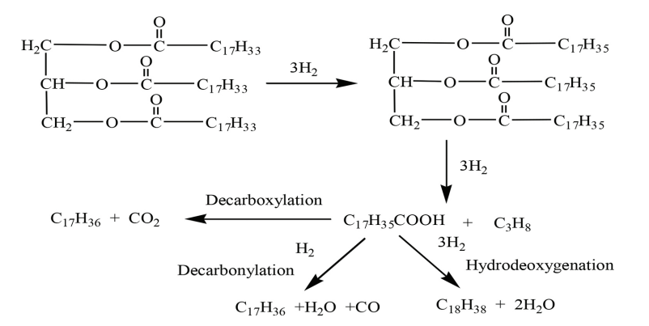
Figure 9: Thermal cracking of triglyceride ((Jatropha Biofuel Industry: The Challenges, http://dx.doi.org/10.5772/64979).

The hydrocracking process requires more energy and temperature (280-300°C) than transesterification of Jatropha vegetable oil for biofuel production, but the pyrolyzed products have a higher cetane number and oxidation stability (Liu, J., et al., 2012).
Because of its reusability, low cost, and good selectivity (Ramachandran, K., et al., 2013), the homogeneous solid base catalyst outperforms the other catalytic systems for hydro processing Jatropha oil. However, the base catalyst generates soap with FFA and requires high quality Jatropha oil, which is the main impediment (Borges, M. and L. Díaz, 2012). The freezing point and low production of Jatropha bio-jet fuel are the main issues. The freezing point of catalytically cracked Jatropha hydrocarbon is greater than zero degrees Celsius, whereas the freezing point of traditional jet fuel is less than 40 degrees Celsius (Liu, Q., et al., 2013; Morgan, P. and P. Roets. 2011; Bishop, G.J.). To address this issue, a novel catalyst system for hydroprocessing Jatropha oil must be developed.
Because of the flexible properties of zeolite, there are numerous advantages to employing metal supported on microporous zeolite catalysts for hydrocracking Jatropha oil (Hancsók, J., et al., 2007). Zeolite catalysts have great porosity, a large surface area, and a concurrent-base nature for ion exchange (Saifuddin, N., A. Samiuddin, and P. Kumaran, 2015). Because of its unique structure, it can overcome the diffusion limitation and boost manufacturing yield. High temperatures (280-300°C) and pressure are required for cracking reactions, which raises the production cost. As a result, it is critical to select and optimize the nonsulphided metal supported zeolite catalyst, as well as the optimal conditions (temperature, pressure, and reaction time) for hydrocracking Jatropha oil to create diesel and jet-fuel range hydrocarbons.
V. LIMITATIONS OF JATROPHA AS A BIOFUEL CROP
- There is still a need for a viable commercial cultivar with increased yield and disease resistance.
- Significant variation in yield among trees.
– Fruiting requires correct irrigation and nutrients, yet it can live with insufficient irrigation and nutrition.
– Long gestation period: it takes 3-5 years to become commercially productive. Its usage as a feed and therapeutic agent is limited due to the presence of hazardous components.
– According to a recent study, Jatropha is prone to pests and illnesses.
– Frost and water logging are problems for Jatropha.
– Some diseases (cassava diseases) may be found in Jatropha.
– Jatropha seed oil's high viscosity limits its application in cool climates.
– Jatropha can become a weed in some conditions.
(M. Moniruzzaman, Zahira Yaakob, M. Shahinuzzaman, Rahima Khatun and A.K.M. Aminul Islam)
VI. MAJOR SETBACKS OF JATROPHA CULTIVATION:
- Poor crop yield:
According to experts, achieving a Jatropha seed yield ranging from 4 to 5 metric tons per hectare per year is essential for the commercial viability of the industry. In this context, Jatropha would be in competition with soybeans in the USA (with an oil yield of 0.38 metric tons per hectare) and rapeseed in Europe (yielding 1.0 metric tons of oil per hectare), assuming a standard seed yield of 3.75 metric tons per hectare with an oil content of 30-35%, or an oil yield of 1.2 metric tons per hectare, as outlined by Gopinathan and Sudhakaran in 2011.
However, the specific unit seed yield and seed oil content of Jatropha exhibit significant variation. Several authors have emphasized that a major challenge to the economic sustainability of the Jatropha biodiesel industry lies in the poor seed yield and seed oil content (Singh et al., 2014; Weyerhaeuser et al., 2007; Zhang et al., 2009; Yu et al., 2007; Fei et al., 2006).
After a 5-year plantation period in India, diverse site trials across varying agro-climatic regions resulted in an average recorded seed yield of 0.5 to 1.4 metric tons per hectare per year (Sabandar et al., 2013). Similar findings were derived from a sodic soil plantation of 24 elite accessions with favorable plant architecture (height and branching pattern) (Singh et al., 2013).
Recent evaluations indicate that the global average seed productivity of Jatropha stands at 1.6 metric tons per hectare, translating to a biodiesel production equivalent of 0.475 metric tons per hectare per year, which falls short of the level required for commercial viability.
To address this challenge, the development of cultivars with higher yields and greater oil content remains a promising solution. However, as of now, a suitable commercial variation meeting these criteria is lacking (Moniruzzaman et al., 2016). The current Jatropha breeding efforts primarily rely on conventional breeding methods and an examination of wild Jatropha plant germplasm resources. The application of biotechnology to Jatropha improvement is limited (Moniruzzaman et al., 2016), and research on gene cloning, expression, and functional annotation, especially concerning economic traits, is notably deficient.
Furthermore, extensive studies on field observations of seed yield under diverse growth strategies are notably lacking. Information regarding tree density for Jatropha cultivation, optimal canopy pruning practices, pesticide usage, and the effectiveness of fertilization and irrigation are often missing in the available literature.
- Low input crop:
Due to its ability to thrive in arid conditions, Jatropha curcas (J. curcas) is often perceived as a low-input crop. However, for it to flourish as a commercially viable crop, it necessitates proper nutrients in the form of fertilizers and an adequate supply of rainfall or irrigation. It's important to note that excessive fertilizer application and irrigation can lead to an overemphasis on vegetative growth (biomass production) at the expense of fruit yield. The interplay between moisture and minerals notably impacts seed production and oil productivity in marginal land plantations. Notably, when J. curcas is cultivated under irrigated conditions, both plant growth and seed yield exhibit significant improvement compared to non-irrigated conditions, as documented in studies by Tikkoo et al. (2013) and Singh et al. (2013).
Applying nitrogen and phosphorus to the soil has been shown to enhance J. curcas growth, seed production, and oil yield, as indicated by Patolia et al. (2007). Another investigation conducted by the BAIF Development Research Foundation found that under rainfed conditions, seed production reached around 500 kg per hectare in the fifth year after planting. However, with consistent irrigation of the same planting, seed output surged to approximately 1200 kg per hectare in the subsequent year, as observed by Daniel in 2008.
Despite the widespread support for large-scale cultivation of J. curcas, there remains a notable gap in systematic studies addressing yield improvement, agronomy (especially regarding irrigation and nutritional requirements), and their adaptations to varying agroclimatic conditions, as highlighted by Mohapatra and Panda (2011).
- Disease susceptibility:
According to recent research, the plants were vulnerable to viral infection (Cucumber mosaic virus), insect attack, rodents, powdery mildew, leaf spots, insect defoliation, and fungal soil infections (Singh, B., et al., 2013; Everson, C.S., M.G. Mengistu, and M.B. Gush, 2013).
VII. CONCLUSION:
Research studies have ensured the economic exploitation of Jatropha seed oil as a potential renewable energy source. The physicochemical properties of Jatropha curcas oil were evaluated and scientifically proven to be in an acceptable range for use as a biofuel crop. Comparative analysis of different fatty acid methyl esters (FAME) was performed and Jatropha biodiesel outweighed as an excellent source of biofuel, owing to its non-sulfur content. The presence of sulfur in biodiesels could lead to the emission of H₂S, which merely contributes to global warming and greenhouse gas emissions (GHG). Furthermore, Jatropha seeds cannot be used for human consumption due to the presence of toxins such as ‘curcin’ which makes it non-edible. These plants can be easily propagated on marginal farms or wastelands, providing a promising approach towards the socioeconomic growth of underdeveloped nations. The biofuel industries have lately employed numerous outbreaking oil extraction techniques for the extraction of Jatropha oil on a large scale, ensuring a proper quality oil yield and higher percentage of lipids present in the oil. However, it has got its own drawbacks in the biodiesel processing of Jatropha oil. The solvents used for oil extraction are hazardous and not cost-effective, and the use of solvents is limited to small throughput industries. In addition to this, the conventional use of mechanical pressing using screw presses finds to be poor-yielding in terms of both quality and quantity. The exploration of novel efficient oil extraction techniques is carried out across the scientific grounds. And, the newly evolved methodologies include Ultrasound assisted extraction (UAE) and Microwave assisted extraction (MAE). Thus far, research studies based on optimization analysis of seed-to-solvent ratio, extraction duration and other processing parameters (Temperature, pressure, etc.) were performed. The results have exquisitely shown to reduce the oil extraction duration (30 mins vs 16 h).
Conversion of crude oil to biodiesel (JME) is another challenge. Transesterification/alcoholysis and thermal cracking/pyrolysis are two commonly used biodiesel preparation techniques. The presence of excessive (14%) free fatty acids (FFA) in crude oil hampers the conversion process and leads to saponification in the presence of base-catalyst therefore, a two-step transesterification is established to reduce the FFA content with the initial step involving an acid catalyst. This establishment has contributed to increased yield and quality, and eases the separation process eventually. Further, appropriate techniques should be developed for efficient recovery of glycerine from the end-products of biodiesel preparation for its extended use in soap and cosmetic industries. On the other hand, thermal cracking involves provision of high temperatures which is quite expensive. However, the introduction of zeolite catalyst has ascertained its own advantages.
Above all, researchers have brought into light the existing knowledge gap in terms of poor crop yield, low input crop, pest and disease susceptibility. Focus on agronomic studies and crop improvement must be enlightened to seal the gap. Diverse breeding programmes must be established for the development of a variety of germplasm to enhance the crop improvement strategies. Applied biotechnological techniques such as marker-assisted selection shall render benefits in the determination of genes associated with high oil yield. Various aspects of Jatropha cultivation and germplasm improvement shall be focused to meet out the demands of fossil fuel-driven vehicles in future, culminating to a sustainable replacement of fuels.
References:
Valipour, A. (2014). A Review on Combustion, Performance and Emission Characteristics of Liquid Alternative Fuels for Diesel Engine. Oxford: Oxford University Press.
Kumar, A., and Sharma, S. (2008). An Evaluation of Multipurpose Oil Seed Crop for Industrial Uses (Jatropha Curcas L.): A Review. Ind. Crops Prod. 28, 1–10. doi: 10.1016/j.indcrop.2008.01.001
Wang, X.-R., and Ding, G.-J. (20122012). Reproductive Biology Characteristic of Jatropha Curcas (Euphorbiaceae). Rev. Biol. Trop. 60 (4), 1525–1533. doi:10.15517/rbt.v60i4.2070
Silitonga, A. S., Mahlia, T. M. I., Kusumo, F., Dharma, S., Sebayang, A. H., Sembiring, R. W., et al. (2019). Intensification of Reutealis Trisperma Biodiesel Production Using Infrared Radiation: Simulation, Optimisation and Validationfication of Reutealis Trisperma Biodiesel Production Using Infrared Radiation: Simulation, Optimisation and Validation. Renew. Energ. 133, 520–527. doi: 10.1016/j.renene.2018.10.023
Ambat, I., Srivastava, V., Iftekhar, S., Haapaniemi, E., and Sillanpää, M. (2020). Effect of Different Co-solvents on Biodiesel Production from Various Low-Cost Feedstocks Using Sr-Al Double Oxides. Renew. Energ. 146, 2158–2169. doi: 10.1016/j.renene.2019.08.061
Ong, H. C., Tiong, Y. W., Goh, B. H. H., Gan, Y. Y., Mofijur, M., Fattah, I. M. R., et al. (2021). Recent Advances in Biodiesel Production from Agricultural Products and Microalgae Using Ionic Liquids: Opportunities and Challenges. Energ. Convers. Management 228, 113647. doi:10.1016/ j. enconman.2020.113647
Meher, L. C., Churamani, C. P., Arif, M., Ahmed, Z., and Naik, S. N. (2013). Jatropha Curcas as a Renewable Source for Bio-Fuels-A Review. Renew. Sustainable Energ. Rev. 26, 397–407. doi: 10.1016/j.rser.2013.05.065
Foidl, N., Foidl, G., Sanchez, M., Mittelbach, M., and Hackel, S. (1996). Jatropha Curcas L. As a Source for the Production of Biofuel in Nicaragua. Bioresour. Technology 58, 77–82. doi:10.1016/s0960-8524(96)00111-3
Carels, N. (2009). Chapter 2 Jatropha Curcas. Adv. Bot. Res. 50, 39–86. doi:10.1016/ s0065-2296(08)00802-1
Garnayak, D. K., Pradhan, R. C., Naik, S. N., and Bhatnagar, N. (2008). Moisturedependent Physical Properties of Jatropha Seed (Jatropha Curcas L). Ind. Crops Prod. 27, 123–129. doi:10.1016/j.indcrop.2007.09.001
Kumar, A., and Sharma, S. (2011). Potential Non-edible Oil Resources as Biodiesel Feedstock: An Indian Perspective. Renew. Sustainable Energ. Rev. 15, 1791–1800. doi:10.1016/j.rser.2010.11.020
Moser, B. R. (2011).“Biodiesel Production, Properties, and Feedstocks,”in Biofuels. Editors D. Tomes, P. Lakshmanan, and D. Songstad (New York: Springer), 285–347. doi:10.1007/978-1-4419-7145-6_15
Divakara, B. N., Upadhyaya, H. D., Wani, S. P., and Gowda, C. L. L. (2010). Biology and Genetic Improvement of Jatropha Curcas L.: A Review. Appl. Energ. 87, 732–742. doi:10.1016/j.apenergy.2009.07.013
Raju, A. S., and Ezradanam, V. (2002). Pollination Ecology and Fruiting Behaviour in a Monoecious Species Jatropha Curcas L.(Euphorbiaceae). CURRENT SCIENCE-BANGALORE- 83, 1395–1397.
Mariana, I., Nicoleta, U., Sorin-Ştefan, B., Gheorghe, V., and Mirela, D. (2013). ACTUAL METHODS FOR OBTAINING VEGETABLE OIL FROM OILSEEDS.
Romanić, R. (2020). “Chapter 17 - Cold Pressed sunflower (Helianthus Annuus L) Oil,” in Cold Pressed Oils: Green Technology, Bioactive Compounds, Functionality, and Applications. Editor M. F. Ramadan (Academic Press), 197–218
Ofori-Boateng, C., Keat Teong, L., and Jitkang, L. (2012). Comparative Exergy Analyses of Jatropha Curcas Oil Extraction Methods: Solvent and Mechanical Extraction Processes. Energ. Convers. Management 55, 164–171. doi:10.1016/ j.enconman.2011.11.005
Subroto, E., Manurung, R., Heeres, H. J., and Broekhuis, A. A. (2015). Optimization of Mechanical Oil Extraction from Jatropha Curcas L. Kernel Using Response Surface Method. Ind. Crops Prod. 63, 294–302. doi:10.1016/ j.indcrop.2014.08.050
Chapuis, A., Blin, J., Carré, P., and Lecomte, D. (2014). Separation Efficiency and Energy Consumption of Oil Expression Using a Screw-Press: The Case of Jatropha Curcas L. Seeds. Ind. Crops Prod. 52, 752–761. doi:10.1016/ j.indcrop.2013.11.046
Yate, A. V., Narváez, P. C., Orjuela, A., Hernández, A., and Acevedo, H. (2020). A Systematic Evaluation of the Mechanical Extraction of Jatropha Curcas L. Oil for Biofuels Production. Food Bioproducts Process. 122, 72–81. doi:10.1016/ j.fbp.2020.04.001
Bhuiya, M. M. K., Rasul, M., Khan, M., Ashwath, N., and Mofijur, M. (2020). Comparison of Oil Extraction between Screw Press and Solvent (N-hexane) Extraction Technique from beauty Leaf (Calophyllum inophyllum L.) Feedstock. Ind. Crops Prod. 144, 112024. doi:10.1016/ j.indcrop.2019.112024
Haile, M., Duguma, H. T., Chameno, G., and Kuyu, C. G. (2019). Effects of Location and Extraction Solvent on Physico Chemical Properties of Moringa Stenopetala Seed Oil. Heliyon 5, e02781. doi:10.1016/j.heliyon.2019.e02781
Zhang, Y., Chang, C., Tan, B., Xu, D., Wang, Y., and Qi, T. (2019). Application of a Sustainable Bioderived Solvent (Biodiesel) for Phenol Extraction. Acs Omega 4, 10431–10437. doi:10.1021/acsomega.9b00977
Alrashidi, M., Derawi, D., Salimon, J., and Yusoff, M. F. (2020). An Investigation of Physicochemical Properties of Nigella Sativa L. Seed Oil from Al-Qassim by Different Extraction Methods. J. King Saud University-Science 32, 3337–3342. doi:10.1016/j.jksus.2020.09.019
Xiong, K., and Chen, Y. (2020). Supercritical Carbon Dioxide Extraction of Essential Oil from Tangerine Peel: Experimental Optimization and Kinetics Modelling. Chem. Eng. Res. Des. 164, 412–423. doi:10.1016/ j.cherd.2020.09.032
De Lara Lopes, N., De Almeida-Couto, J. M. F., Da Silva, C., Pereira, M. B., Pimentel, T. C., Barão, C. E., et al. (2020). Evaluation of the Effects of Pressurized Solvents and Extraction Process Parameters on Seed Oil Extraction in Pachira Aquatica. J. Supercrit. Fluids 161, 104823. doi:10.1016/ j.supflu.2020.104823
Fetzer, D. L., Hamerski, F., Errico, M., and Corazza, M. L. (2021). Extraction of Cumaru Seed Oil Using Compressed Propane as Solvent. J. Supercrit. Fluids 169, 105123. doi:10.1016/j.supflu.2020.105123
Suganya, T., Kasirajan, R., and Renganathan, S. (2014). Ultrasound-enhanced Rapid In Situ Transesterification of marine Macroalgae Enteromorpha Compressa for Biodiesel Production. Bioresour. Technol. 156, 283–290. doi:10.1016/j.biortech.2014.01.050
Koh, M.Y. and T.I.M. Ghazi, A review of biodiesel production from Jatropha curcas L. oil. Renewable and Sustainable Energy Reviews, 2011. 15(5): pp. 2240–2251.
Mofijur, M., et al., Prospects of biodiesel from Jatropha in Malaysia. Renewable and Sustainable Energy Reviews, 2012. 16(7): pp. 5007–5020.
Singh, B., et al., Agro-technology of Jatropha curcas for diverse environmental conditions in India. Biomass and bioenergy, 2013. 48: pp. 191
Atabani, A., et al., Investigation of physical and chemical properties of potential edible and non-edible feedstocks for biodiesel production, a comparative analysis. Renewable and Sustainable Energy Reviews, 2013. 21: pp. 749–755.
Abhilash, P., et al., Revisited Jatropha curcas as an oil plant of multiple benefits: critical research needs and prospects for the future. Environmental Science and Pollution Research, 2011. 18(1): pp. 127–131
Kant, P. and S. Wu, The extraordinary collapse of Jatropha as a global biofuel. Environmental Science & Technology, 2011. 45(17): pp. 7114–7115.
Liberalino, A.A.A., et al., Jatropha curcas L. seeds: chemical analysis and toxicity. Arquivos de Biologia e Tecnologia, 1988. 31(4): pp. 539–550.
Gandhi, V., K. Cherian, and M. Mulky, Toxicological studies on ratanjyot oil. Food and Chemical Toxicology, 1995. 33(1): pp. 39–42.
Sharma, G., S. Gupta, and M. Khabiruddin. Cultivation of Jatropha curcas as a future source of hydrocarbon and other industrial products. In Biofuels and industrial products from Jatropha curcas-Proceedings from the Symposium Jatropha. 1997
Wink, M., et al., 4.1 Phorbol Esters of J. curcas-Biological Activities and Potential Applications. 1997.
Makkar, H. and K. Becker, Potential of Jatropha curcas seed meal as a protein supplement to livestock feed, constraints to its utilization and possible strategies to overcome constraints. Proceeding Jatropha, 1997. 97: p. 37-40.
Openshaw, K., A review ofJatropha curcas: an oil plant of unfulfilled promise. Biomass and Bioenergy, 2000. 19(1): pp. 1–15.
Akintayo, E., Characteristics and composition of Parkia biglobbossa and Jatropha curcas oils and cakes. Bioresource Technology, 2004. 92(3): pp. 307–310.
Sotolongo, J.A., et al., Jatropha curcas L. as a source for the production of biodiesel: A Cuban experience. in 15th European biomass conference and exhibition, Berlin, Germany. 2007.
Singh, R., et al., SPRERI experience on holistic approach to utilize all parts ofJatropha curcasfruit for energy. Renewable Energy, 2008. 33(8): p. 1868-1873.
Kumar, G., et al., Lignocellulose biohydrogen: practical challenges and recent progress. Renewable and Sustainable Energy Reviews, 2015. 44: pp. 728–737.
Kumar, G., et al., Modeling and optimization of biohydrogen production from de-oiled Jatropha using the response surface method. Arabian Journal for Science and Engineering, 2015. 40(1): pp. 15–22.
Kumar, G., et al., Comparative evaluation of hydrogen fermentation of de-oiled Jatropha waste hydrolyzates. International Journal of Hydrogen Energy, 2015. 40(34): pp. 10766–10774
Lopes, S.L., et al., Bioconversion of Jatropha curcas seed cake to hydrogen by a strain of Enterobacter aerogenes. Fuel, 2015. 139(0): pp. 715–719.
Pratt, J., et al., Malawi Agroforestry Extension Project Marketing & Enterprise Program, Main Report. Malawi Agroforestry, 2002: p. 139.
Henning, R., The Jatropha Manual. A guide to the integrated exploitation of the Jatropha plant in Zambia. Germany: Deutsche Gesellschaft für Technische Zusammenarbeit GTZ, 2000.
Messemaker, L., Assessment of the Jatropha value chain and its potential for pro poor biofuel development in Northern Tanzania. 2008, MSc thesis International development studies at the Faculty of Geosciences, Utrecht University, 2008.
Benge, M., Assessment of the potential of Jatropha curcas,(biodiesel tree,) for energy production and other uses in developing countries. USAID Report, 2006.
Brittaine, R. and N. Lutaladio, Jatropha: a smallholder bioenergy crop: the potential for pro-poor development. Vol. 8. 2010: Food and Agriculture Organization of the United Nations (FAO).
Zhang, X.P., et al., Chemical constituents of the plants from genus Jatropha. Chemistry & Biodiversity, 2009. 6(12): pp. 2166–2183.
Ravindranath, N., et al., Jatrophenone, a novel macrocyclic bioactive diterpene from Jatropha gossypifolia. Chemical and Pharmaceutical Bulletin, 2003. 51(7): pp. 870–871.
Bhagat, R., et al., Anti-inflammatory activity of Jatropha gossypifolia L. leaves in albino mice and Wistar rat. Journal of Scientific and Industrial Research, 2011. 70(4): pp. 289–292
Apu, A.S., et al., Study of pharmacological activities of methanol extract of Jatropha gossypifolia fruits. Journal of Basic and Clinical Pharmacy, 2012. 4(1): p. 20.
Reena, P., Evaluation of antimicrobial and anti-inflammatory activities of bark of Jatropha gossypifolia. World Journal of Science and Technology, 2011. 1(10).
Oduola, T., et al., Mechanism of action of Jatropha gossypifolia stem latex as a haemostatic agent. European Journal of General Medicine, 2005. 2(4): pp. 140–14
Singh, D. and A. Singh, The toxicity of four native Indian plants: effect on AChE and acid/alkaline phosphatase level in fishChanna marulius . Chemosphere, 2005. 60(1): pp. 135–140.
Feitosa, C., et al., Acetylcholinesterase inhibition by somes promising Brazilian medicinal plants. Brazilian Journal of Biology, 2011. 71(3): pp. 783–789.
Apu, A.S., et al., Anti-diarrheal Potential of Jatropha gossypifolia (Linn.). Journal of Medical Sciences, 2012. 12(8): pp. 274–279.
Silva, S.d.N., et al., Antispasmodic effect of Jatropha gossypiifolia is mediated through dual blockade of muscarinic receptors and Ca2+ channels. Revista Brasileira de Farmacognosia, 2011. 21(4): pp. 715–720.
Félix-Silva, J., et al., Jatropha gossypiifolia L.(Euphorbiaceae): a review of traditional uses, phytochemistry, pharmacology, and toxicology of this medicinal plant. EvidenceBased Complementary and Alternative Medicine, 2014. 2014 1–32
Abreu, I.C., et al., Hypotensive and vasorelaxant effects of ethanolic extract from Jatropha gossypiifolia L. in rats. Fitoterapia, 2003. 74(7): pp. 650–657.
Shahwar, D., et al., Antioxidant activities of the selected plants from the family Euphorbiaceae, Lauraceae, Malvaceae and Balsaminaceae. African Journal of Biotechnology, 2010. 9(7): pp. 1086–
Kharat, A., A. Dolui, and S. Das, Free radical scavenging potential of Jatropha gossypifolia. Asian Journal of Chemistry, 2011. 23(2): pp. 799–801.
Achten, W., et al.,Jatropha bio-diesel production and use. Biomass and Bioenergy, 2008. 32(12): pp. 1063–1084
Ghosh, Arup, J. S. Patolia, D. R. Chaudhary, Jitendra Chikara, S. N. Rao, Dheerendra Kumar, G. N. Boricha, and A. Zala. “Response of Jatropha curcas under different spacing to Jatropha de-oiled cake.” In Expert seminar on Jatropha curcas L. Agronomy and genetics, pp. 26–28. 2007.
Gopinathan, M.C. and R. Sudhakaran, Biofuels: opportunities and challenges in India, in Biofuels. 2011, Springer, New York, pp. 173–209.
Weyerhaeuser, H., et al., Biofuels in China: an analysis of the opportunities and challenges of Jatropha curcas in Southwest China. World Agroforestry Centre, ICRAF Working Paper, 2007. 53.
Zhang, G.-w., Y. Peng, and M. Huang, Existing Problems and Countermeasures for Jatropha curcas Industrialization in China [J]. Journal of Anhui Agricultural Sciences, 2009. 8.
YU, B., et al., The Current Situation and Countermeasures of Jatropha curcas L. in Sichuan Province. Sichuan Forestry Exploration and Design, 2007. 3: p. 005.
Fei, S., X. Chen, and Y. He, Prospects of studies on Jatropha curcas biodiesel in Sichuan. Biomass Chemical Engineering, 2006. 40(12): pp. 193–139.
Singh, B., et al., The field performance of some accessions of Jatropha curcas L.(Biodiesel Plant) on degraded sodic land in North India. International journal of green energy, 2013. 10(10): pp. 1026–040.
Moniruzzaman, M., Z. Yaakob, and R. Khatun, Biotechnology for Jatropha improvement: a worthy exploration. Renewable and Sustainable Energy Reviews, 2016. 54: pp. 1262–1277.
Patolia, J. S., Arup Ghosh, Jitendra Chikara, D. R. Chaudhary, D. R. Parmar, and H. M. Bhuva. “Response of Jatropha curcas grown on wasteland to N and P fertilization.” In Expert seminar on Jatropha curcas L. Agronomy and genetics, pp. 26–28. 2007.
Daniel, J., Jatropha Oilseed Production: a realistic approach. BAIF Development Research Foundation.(Available Online: http://www. baif. org. in/aspx_pages/pdf/ Agroforesty/MEDA. pdf), 2008.
Mohapatra, S. and P.K. Panda, Effects of fertilizer application on growth and yield of Jatropha curcas L. in an aeric tropaquept of eastern India. Notulae Scientia Biologicae, 2011. 3(1): p. 95.
Madras, G., C. Kolluru, and R. Kumar, Synthesis of biodiesel in supercritical fluids. Fuel, 2004. 83(14): pp. 2029–2033.
Liu, J., et al., Hydroprocessing of Jatropha oil over NiMoCe/Al2O3 catalyst. International Journal of Hydrogen Energy, 2012. 37(23): pp. 17731–17737.
Ramachandran, K., et al., Recent developments for biodiesel production by ultrasonic assist transesterification using different heterogeneous catalyst: a review. Renewable and Sustainable Energy Reviews, 2013. 22: pp. 410–418.
Borges, M. and L. Díaz, Recent developments on heterogeneous catalysts for biodiesel production by oil esterification and transesterification reactions: a review. Renewable and Sustainable Energy Reviews, 2012. 16(5): pp. 2839–2849.
Liu, Q., et al., One-step hydrodeoxygenation of palm oil to isomerized hydrocarbon fuels over Ni supported on nano-sized SAPO-11 catalysts. Applied Catalysis A: General, 2013. 468: pp. 68–74.
Morgan, P. and P. Roets. The Synthetic Jet Fuel Journey. in 20th World Petroleum Congress. 2011. World Petroleum Congress, 4–8 December, Doha, Qatar.
Bishop, G.J., Aviation Turbine Fuels. Ullmann's Encyclopedia of Industrial Chemistry.
Hancsók, J., et al., Investigation of the production of high cetane number bio gas oil from pre-hydrogenated vegetable oils over Pt/HZSM-22/Al2O3 . Microporous and Mesoporous Materials, 2007. 101(1): pp. 148–152.
Saifuddin, N., A. Samiuddin, and P. Kumaran, A review on processing technology for biodiesel production. Trends in Applied Sciences Research, 2015. 10(1): p. 1.
Tikkoo, A., S. Yadav, and N. Kaushik, Effect of irrigation, nitrogen and potassium on seed yield and oil content of Jatropha curcas in coarse textured soils of northwest India. Soil and Tillage Research, 2013. 134: pp. 142–146.
Everson, C.S., M.G. Mengistu, and M.B. Gush, A field assessment of the agronomic performance and water use of Jatropha curcas in South Africa. Biomass and Bioenergy, 2013. 59(0): pp. 59–69.
Gudeta TB. Chemical composition, bio-diesel potential and uses of Jatropha curcas L. (Euphorbiaceae). Am J Agric Forest 2016;4(2):35–48. http://dx.doi.org/10.11648/j.ajaf.20160402.15.
Achten WMJ, Verchot L, Franken YJ, Mathijs E, Singh VP, Aerts R, et al. Jatropha biodiesel production and use. Biomass Bioenergy 2008;32:1063–84. http://dx.doi.org/10.1016/j.biombioe.2008.03.003
Ramos, M.J.; Fernández, C.M.; Casas, A.; Rodríguez, L.; Pérez, Á. Influence of fatty acid composition of raw materials on biodiesel properties. Bioresour. Technol. 2009, 100, 261–268. [Google Scholar] [CrossRef] [PubMed]

Saraf, S.; Thomas, B. Influence of feedstock and process chemistry on biodiesel quality. Process. Saf. Environ. Prot. 2007, 85, 360–364. [Google Scholar] [CrossRef]

Ejim, C.E.; Fleck, B.A.; Amirfazli, A. Analytical study for atomization of biodiesels and their blends in a typical injector: Surface tension and viscosity effects. Fuel 2007, 86, 1534–1544. [Google Scholar] [CrossRef]

Abedin, M.J.; Masjuki, H.H.; Kalam, M.A.; Sanjid, A.; Rahman, S.M.A.; Fattah, I.M.R. Performance, emissions, and heat losses of palm and jatropha biodiesel blends in a diesel engine. Ind. Crops Prod. 2014, 59, 96–104. [Google Scholar] [CrossRef]

Lim, S.; Teong, L.K. Recent trends, opportunities and challenges of biodiesel in Malaysia: An overview. Renew. Sustain. Energy Rev. 2010, 14, 938–954. [Google Scholar] [CrossRef]

Koh, M.Y.; Idaty, T.; Ghazi, M. A review of biodiesel production from Jatropha curcas L. oil. Renew. Sustain. Energy Rev. 2011, 15, 2240–2251. [Google Scholar] [CrossRef]

Jongh, J.A.; van der Putten, E. Contributors. In The Jatropha Handbook. From Cultivation to Application; FACT Foundation: Omaha, NE, USA, 2010; ISBN1 9081521918. ISBN2 9789081521918. [Google Scholar]

Kalam, M.A.; Ahamed, J.U.; Masjuki, H.H. Land availability of Jatropha production in Malaysia. Renew. Sustain. Energy Rev. 2012, 16, 3999–4007. [Google Scholar] [CrossRef]

Mehla, S.K. Biodiesel Production Technologies; Joshi, D.C., Sutar, R.F., Parmar, M.R., Singh, S.N., Eds.; Pointer Publishers: Jaipur, India, 2007; Chapter 11; ISBN1 10: 8171325173. ISBN2 13: 9788171325177. [Google Scholar]

Vairavan, K.; Thukkaiyannan, P.; Paramathma, M.; Venkatachalam, P.; Sampathrajan, A. Biofuel Crops Cultivation and Management: Jatropha, Sweet Sorghum and Sugarbeet; Agrobios: Jodhpur, India, 2007; ISBN1 8177543164. ISBN2 9788177543162. [Google Scholar]

Ali, R.M.; Farag, H.A.; Amin, N.A.; Farag, I.H. Abu-Tartour phosphate rock catalyst for biodiesel production from waste frying oil. JOKULL 2015, 65, 233–244. [Google Scholar]

Berchmans, H.J.; Hirata, S. Biodiesel production from crude Jatropha curcas L. seed oil with a high content of free fatty acids. Bioresour. Technol. 2008, 99, 1716–1721. [Google Scholar] [CrossRef]

Augustus, G.D.P.S.; Jayabalan, M.; Seiler, G.J. Evaluation and bioinduction of energy components of Jatropha curcas. Biomass Bioenergy 2002, 23, 161–164. [Google Scholar] [CrossRef]

Emil, A.; Yaakob, Z.; Kumar, M.N.S.; Jahim, J.M.; Salimon, J. Comparative evaluation of physicochemical properties of jatropha seed oil from Malaysia, Indonesia and Thailand. JAOCS J. Am. Oil Chem. Soc. 2010, 87, 689–695. [Google Scholar] [CrossRef]

Sinha P., Islam M.A., Negi M.S., Tripathi S.B. Changes in oil content and fatty acid composition in Jatropha curcas during seed development. Ind. Crop. Prod. 2015;77:508–510. doi: 10.1016/j.indcrop.2015.09.025. [CrossRef] [Google Scholar]
Aransiola E.F., Daramola M.O., Ojumu T.V., Aremu M.O., Layokun S.K., Solomon B.O. Nigerian Jatropha curcas oil seeds: Prospect for biodiesel production in Nigeria. Int. J. Renew. Energy Res. IJRER. 2012;2:317–325. [Google Scholar]

