REAL-TIME PARKINSON’S DISEASE DETECTION

Dinesh Kumar S | Meera S | Sharmikha Sree R | Deepika R | Kalpana R A
Associate Professor  Master of Business and Administration,  Sri Sairam Engineering College,  West Tambaram, Chennai, India.  dinesh.mba@sairam.edu.in  dhineselvaraj@gmail.com | Associate Professor  Computer Science and Engineering,  Sri Sairam Engineering College,  West Tambaram, Chennai, India.  meera.cse@sairam.edu.in  meeradinesh85@gmail.com | Assistant Professor  Computer Science and Engineering,  Sri Sairam Engineering College,  West Tambaram, Chennai, India.  sharmikhasree.cse@sairam.edu.in  sharmikhasree@gmail.com | Assistant Professor  Computer Science and Engineering,  Sri Sairam Engineering College,  West Tambaram, Chennai, India.  deepika.cse@sairam.edu.in | Assistant Professor  Computer Science and Engineering,  Sri Sairam Engineering College,  West Tambaram, Chennai, India.  kalpana.cse@sairam.edu.in

Abstract— Parkinson's disease is also an ailment of the important device that impacts movement, commonly at the side of tremors. No precise test exists to diagnose Parkinson's disease. Normally, this infection is known in each patient by engaging in experiments supported through their handwriting or examining their gait the use of sensors. Automating the bodily exam paper can decrease the time and strength for the affected person at the same time as no longer compromising the effects. The survey on existing structures reveals a few critical experiences into contemporary ML/DL strategies at intervals the clinical field utilized in today’s disease analysis. The planned system focuses typically on sensing the frame tremors that could dispose of the usage of expensive gait sensors. The technique is to use OpenPose deep learning framework to sight and sense the tremors of the affected person within the duration. Deep learning algorithms are also used to sight hand tremors on the element of different critical factors that have an impact on while detecting the infection which might be studied and analyzed.

Keywords: Parkinson disease, Deep Learning, Machine Learning, 2D, 3D, Tremor Detection
INTRODUCTION
Parkinson's ailment is the second one greatest favored age-related neurodegenerative illness after Alzheimer's disorder. Around seven to ten million oldsters internationally have Parkinson's illness. The rate of the illness goes from 41 individuals with regards to one hundred,000 in the fourth 10 years of presence to north of 1,900 people in accordance with a hundred,000 among those which may be eighty and more seasoned[5]. The frequency of the ailment, or the pace of recently analyzed occasions, as a rule will develop with age, despite the fact that it'll settle in people who are more seasoned than 80. A measurable four % of individuals with Parkinson's are perceived ahead of time by age 50[6]. Men are 1.Five cases more conceivable to claim Parkinson's than young ladies. The tainting influences patients' nature of presence, creating social collaboration more troublesome and tenses their monetary situation, in view of the clinical costs related with the issue[7]. Populace research at the event of Parkinson's area unit are fundamental for's how researchers might interpret the records of the contamination, its improvement, and moreover the danger factors related with it. Data concerning the prevalence in various age associations and sexual orientations will work with leisure activity experts' style strategies to satisfy patients' desires.

RELATED WORK
There are many exciting works associated with Parkinson’s Disease detection. Most of them try to use the prevailing available dataset of MRI scans and use appropriate machine learning or deep learning algorithms to find and come across the ailment[1]. The trouble with the above is that the database used for the look at isn't always big for the deep gaining knowledge of the version used within the work[2]. The normal issues with the gadget learning not entirely set in stone to be, regardless of the coolest by and large execution of custom made ML calculations, there's by the by an issue associated with the capabilities' extraction and determination which significantly influences the general presentation[3]. Some of the existing works encompass the usage of extra pricey gait-sensor gears for recording body moves. Also, maximum of the nicely-installed datasets to be had use highly-priced gait-sensor gears to engineer the information[8].
Kumar, S. D, et.al. (2022) in their audit endeavors to enquire the power of thing strategies in Tamil movies. The past outlines are more connected with towards Hollywood motion pictures, and the greater part of the Indian appraisals are concentrated towards Hindi movies. Hence, there exists a fundamental opening for this stream examination to find the sensibility of thing position and thing movement in the films. The review bargains on Tamil films, superstar support, buyer mentality, corporate reliability, and brand picture and buy suppositions that are considered to develop the speculations. The review was driven utilizing an organized overview which was streamed among 3500 film sidesteps Tamil Nadu[9].
Meera S, et.al. (2022), in this survey two or three methods have been introduced related with the dire test in cloud figuring which is load changing. The issues related with load changing were broken down through near appraisal of the proposed calculations by analysts. It is useful for experts to acknowledge the pile changing methods and stay away from disappointment in the server as it merges an outline of existing and open weight evolving procedures[4].
Kumar, S. D., et.al., (2022) In their assessment the central goal of the study is to isolate electronic entertainment's impact for associating with youth in their business potential and improvement in the Indian Area of Tamil Nadu. The ceaseless overview used a non-whimsical examining technique and with 560 respondents as test size. Youth who are contemplating or have reached their limits are the respondents. The overview has perceived the presence of a relationship among youth and virtual redirection for occupation possible entryways in the regions like data for enrolments and endeavors.[10]
Kumar, S. D., et.al, (2018), in their critical audit examined the interrelationship between promotions, attitude toward advertisements and purchase point. Further some, their survey zeroed in on the mediating position of demeanor towards in between the purchase point and advertisements. The survey was coordinated among 320 ordinary people from various foundations in Chennai city and was used for the audit. The hypotheses were examined by straight backslide and Sobel test. Revelations pleased that the two advertisements and attitude towards plugs influence purchase objective and besides the interceding part demeanor towards advancements have a fragmented association among promotions and purchase assumptions.[11]
Kumar, S. D., et al. (2022), the departmental store needs to address the issue by recommending combo offers in order to increase the sales and profit volume. It is apposite to provide recommendations based on the clear outcome of the model [15].
Kumar, S. D., et.al. (2016) in their audit expected to consider the positions of individual wisdom on mindset towards advertisements and brands and besides its relationship with corporate acceptability which yields in Purchase Point. The audit has been driven among people of various foundations to get to the importance of Acquirement objective with that of corporate legitimacy, disposition towards brand and advertisements.[12]
The structure gives keen shopping to apparently tried people without other assistance using the L293D driver, Raspberry pi and Optical individual affirmation development. It works with the apparently tired people shopping. It saves a client time and advances business bargains. L293D driver helps in the improvement of trolleys considering information sources. The text from the hand-held object is isolated using a text examining methodology close by the camera. Text Restriction computation is used to restrict the text in the locale of interest. Text in limited locales are seen and changed over totally to twofold by text affirmation computation. Using text-to-talk capacity, the sound is gotten accordingly for the apparent text[13].
The information is conveyed continuously to a web server, where the dirt dampness and temperature levels are graphically shown and put away in a data set server. Because of deficient harvest checking, the ongoing methodology produces more unfortunate yields. Since all cultivating is finished manually, there is a gamble that the field won't be directed while the rancher is away from the farmland. This will bring about unfortunate field support and yield quality, bringing about less fortunate results[14].
PROPOSED SYSTEM METHODOLOGY
The proposed device approach attempts to stagger on quakes in arms, the utilization of profound acquiring information on structure for picture fame in real time. The strategy is to apply OpenPose profound acquiring information on structure to hit upon and experience the quakes of the impacted individual in genuine time. This gets rid of the usage of most of the nicely- installed datasets available, the usage of costly gait-sensor gears to engineer the statistics. Thereby proving to be value- effective. Sensing the hand tremors in actual-time ought to get rid of the usage of high priced gait sensors which makes up the main innovation of these paintings. Real-time detection of Parkinson’s Disease also makes it avant-garde. Detection of signs made simple and smooth while compared to current systems and for that reason removing the want for fancy and expensive systems.

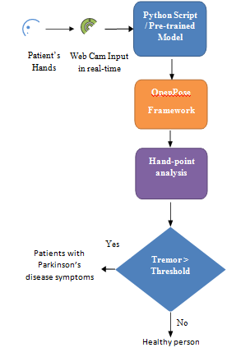
Fig 1.1 System Architecture for the model

KEY- POINT DETECTION OF HANDS
In this module, the landmarks of the fingers are detected by using the HandPose framework. The landmarks are shown to the consumer in actual-time beside the frame rate recorded. MediaPipe Hands might be an correct hand and finger monitoring solution. It employs Machine Learning to infer 21 3-D landmarks of a hand from really a single body the usage of simple net digicam and a PC with an internet connection. The 21 landmarks detected in every body are then used to discover the cartesian distance to calculate the tremor values by using comparing body to frame. The calculated tremor values are then stored in a 1D vector. The paintings tries to carry the accuracy of diagnosing patients with PD tons closer to while they are identified in expert labs. Thus, it makes the detection of symptoms a good deal less difficult and simpler while compared to present systems.

d = √(x1− x2)2+ (y1− y2)2 +(z1− z2)2
where,
x1, y1, z1 – coordinates of previous frame landmark x2, y2, z2 – coordinates of current frame landmark

Formula 1: Cartesian Distance Formula

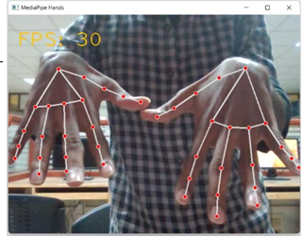

Fig 1.2 Key-Point Detection using OpenPo

2-D POSE BODY ESTIMATION
2D human posture assessment is utilized to appraise the 2D position or spatial area of human body central issues from visuals comprehensive of pictures and recordings. Customary 2D human posture assessment strategies utilize unique home made capability extraction methods for the individual edge parts. Much like for hand tremor detection, the tremors for frame pose can be detected. A threshold cost for the patients with PD is researched and in comparison for evaluation. It offers 33 3-d landmarks of the body the usage of system studying strategies out of which most effective positive vital factors are taken as inputs for calculating the tremors. Using cartesian distance formulation for each body for the respective 10 detected landmarks, the relative alternate in the key-point detected is calculated and the suggested trade in all the frames of those key-points from the enter feed is saved in a 1D vector.

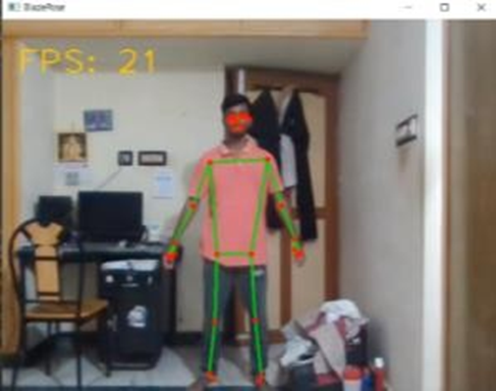

Fig 1.3 2-D POSE BODY ESTIMATION
HAND AND BODY TREMOR DETECTION
A source video for both hand tremors and body tremors where the PDD patients are experimented with is used for comparison of the tremor pattern observed from the live camera feed input. The source video 1D vector is pre- populated for both hand tremors and body tremors using the pre-trained model that is used for calculating the tremors from the PDD patients through the live feed. Hence, the comparison of the vectors is safe as their respective values are calculated using the same technology in both the cases and thereby eliminating conflicts due to the usage of different mediums to calculate tremor values. Cosine similitude estimates the closeness between two vectors of an internal item space. It is estimated by the cosine of the point between two vectors and decides if two vectors are pointing in generally a similar heading.
A . B

‖𝐴‖‖𝐵‖
where,
A – 1D Tremor Pattern Vector of live feed B – 1D Tremor Pattern Vector of source

Formula 2: Cosine similarity Formula

The value similarity index is found out for the hand tremors by comparing it with its source by using cosine similarity. Similarly, the similarity index value for the body tremors is found out by comparing to its source 1D vector. The patient is classified as normal and might have symptoms of PD.

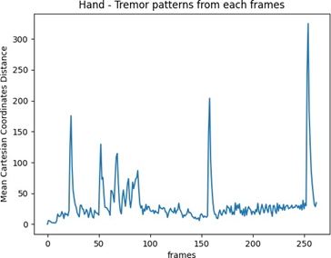
Fig 1.4 TREMOR PATTERN OF HANDS

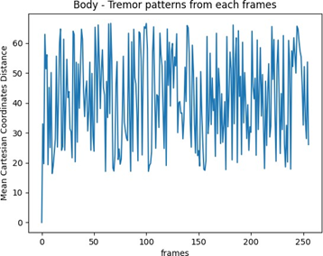
Fig 1.5 TREMOR PATTERN OF BODY

CONCLUSION
The paper deals with how the patients that might show symptoms as that of a patient with PD can be diagnosed. By doing so, the usage of expensive gait sensors is eliminated. This elimination of the need for fancy and costly equipment is considered a huge advantage of this work. Also, the patients are diagnosed in real-time just in their homes as they don’t have the necessity to go to labs to use those expensive traditional gait sensors. All that is needed is just a simple web camera and a PC with an internet connection. The work tries to bring the accuracy of diagnosing patients with PD much closer to when they are diagnosed in professional labs. Thus, it makes the detection of symptoms much simpler and easier when compared to existing systems.

CONFLICT OF INTEREST
The creators have no irreconcilable situations to announce. All co-creators have seen and concur with the items in the composition.
REFERENCE
[1] P. Khan et al. (2021), "Machine Learning and Deep Learning Approaches for Brain Disease Diagnosis: Principles and Recent Advances," in IEEE Access, vol. 9.
[2] A. Moshkova, A. Samorodov, N. Voinova, A. Volkov, E. Ivanova and E. Fedotova (2020), "Parkinson’s Disease Detection by Using Machine Learning Algorithms and HandMovement Signal from LeapMotion Sensor," 2020 26th Conference of Open Innovations Association (FRUCT).
[3] W. Wang, J. Lee, F. Harrou and Y. Sun (2020), "Early Detection of Parkinson’s Disease Using Deep Learning and Machine Learning," in IEEE Access, vol. 8.
[4] S.Meera, K. Valarmathi (2022) “Load Balancing Techniques in Cloud Environment - A Big Picture Analysis” by 2022 1st International Conference on Computational Science and Technology (ICCST) , ISBN: 978-1-6654-7655-3, DOI: 10.1109/ICCST55948.2022.10040387.
[5] E. Kovalenko et al.(2021), "Distinguishing Between Parkinson’s Disease and Essential Tremor Through Video Analytics Using Machine Learning: A Pilot Study," in IEEE Sensors Journal, vol. 21, no. 10.
[6] Khachnaoui, Hajer, Rostom Mabrouk, and Nawres Khlifa (2020). "Machine learning and deep learning for clinical data and PET/SPECT imaging in Parkinson's disease: a review." IET Image Processing.
[7] Moon, Sanghee, et al. (2020) "Classification of Parkinson's disease and essential tremor based on gait and balance characteristics from wearable motion sensors: A data-driven approach." medRxiv.
[8] Banita (2020), "Detection of Parkinson’s Disease Using Rating Scale," 2020 International Conference on Computational Performance Evaluation (ComPE).
[9] Kumar, S. D., & Soundarapandiyan, K. (2022). The Effectiveness of Product Placement in Tamil movies: A Study with Reference to the State of Tamil Nadu, India. South Asian Journal of Social Sciences and Humanities, 3(5), 28-41.
[10] Kumar, S. D., Soundarapandiyan, K., & Meera, S. (2022). Sentience of Career Opportunities and Career Development using Social Media–A Study with Reference to Tamil Nadu. Journal of Big Data Technology and Business Analytics, 1(1), 7-14.
[11] Kumar, S. D., & Kumar, V. H. (2018). Mediation of Attitude toward Advertisements in The Relationship between Advertisements and Purchase Intention. SCOPUS IJPHRD CITATION SCORE, 9(2), 411.
[12] Kumar, S. D., & Kumar, V. H. (2016). Advertisements’ Influence and Antecedents of Purchase Intention towards FMCG Products in Chennai City-A Study. SAMVAD, 11, 65-70.
[13] S. Meera, R. Sharmikha Sree, K. Valarmathi (2019), “Effective shopping method for visually Impaired people using Optical Character Recognition”, International Journal of Engineering and Advanced Technology (IJEAT),ISSN 2249-8958. DOI: 10.35940/ijeat.A2961.109119, Volume 9 Issue -1.
[14] S. Meera, & R. Sharmikha Sree. (2022). Improving Data and Identity Privacy in Online Social Networks. Journal of Network Security and Data Mining, 5(3), 1–8. https://doi.org/10.5281/zenodo.7421748
[15] S. Dinesh Kumar, K. Soundarapandian, S. Meera (2022), “Commiserating Customers’ Purchasing Pattern using Market Basket Analysis” by 2022 1st International Conference on Computational Science and Technology (ICCST) , ISBN: 978-1-6654-7655-3, DOI: 10.1109/ICCST55948.2022.10040387, Nov 2022.

