Obesity, Pathophysiology, Complication Associated With Obesity and Drugs Used For the Management of Obesity: A Brief Introduction
Sakshi Sharma* ¹, Avijit Mazumder 1
¹ Noida Institute of Engineering and Technology (Pharmacy Institute), Greater Noida 210306
Corresponding author: sakshi.sharma1964@gmail.com
Mob: 81910 46602
Abstract
In Today era, obesity is a serious health problem which is growing very rapidly in both developed and the developing countries. It is a complex disease that leads to the excess of fat accumulation in the body which produces negative effect in the health after few years. It is increasing very rapidly that it does not show any sign of slowing down. In the current scenario, obesity is a stimulating health problem and is growing very rapidly in the world. It is a complex disease caused by the imbalance between the energy intake and the energy expenditure. There is various disease associated with the obesity i.e diabetes, hypertension, cancer, atherosclerosis and other cardiovascular problems which produces a serious impact on social and financial system of the population. Moreover, by changing the lifestyle and other behavioural changes might help in decreasing the weight loss, but it is quiet challenging to achieve. Nearly 10-20% male and 20-30% females come under the obese condition. The most convenient therapy for treating the obesity is to use of synthetic drugs available in the markets like orlistat, sibutramine but these drugs are having serious side-effects, along with this surgical procedure are also used by these are also not safe.
Introduction
Obesity is a complex and multifaceted health condition that has become a significant global health concern. Characterized by an excessive accumulation of body fat, it is typically measured using the body mass index (BMI), where a BMI of 30 or above indicates obesity [1]. Obesity poses a significant risk for various chronic diseases, including heart disease, diabetes, hypertension, and certain types of cancer. This condition results from multiple factors such as genetic predisposition, behavioral aspects, environmental influences, and social determinants [2].
World Health Organization (WHO) classified obesity in two ways: -chronic and the severe disease which occurred in both developed and the developing countries affecting both adults and the children. The prevalence of obesity has been on a steady rise across the globe, affecting both adults and children and spanning all segments of society[3]. This alarming increase underscores the importance of understanding the underlying causes of obesity and implementing comprehensive strategies to prevent and manage it. The epidemic of obesity poses not only significant health risks but also a substantial economic burden due to increased healthcare costs and loss of productivity. It is crucial to recognize obesity as a severe health issue and not merely a cosmetic concern, as it significantly impacts an individual's quality of life and longevity[4]. Effective interventions to combat obesity involve dietary modifications, increased physical activity, behavioural changes, and in some instances, pharmacological treatments or surgery. The growing understanding of obesity's complexity necessitates multidisciplinary and multi-sectoral approaches for successful management and prevention [5].
S.No. | Classification | BMI (kg/m²⁾
1. | Underweight | <18.5
2. | Normal range | 18.5-24.9
3. | Overweight (Pre obese) | 25.0-29.5
4. | Obese person | >30.0
5. | Class I obesity | 30.0-34.9
6. | Class II obesity | 35.0-39.9
7. | Severe obese | >40.0

Table 1: Classification of obesity given by WHO
Types of obesity
Central (android) and peripheral (gynoid) obesity
The obesity is mainly of two types one is central also called as android obesity which is very common among men with higher risk of mortality and the other one is called as peripheral obesity also known as gynoid, which is common in women. The visceral adipose tissue is metabolically more active than subcutaneous fat which increases the rate of glucose, type II diabetes, mellitus and hyperinsulinism and due to increase in insulin secretion there is increase in sodium reabsorption which result in hypertension [6]. Central obesity also increases the amount of cholesterol in the form of low- density lipoprotein which further causes atherosclerotic cardiovascular disease and gall stones. Increase in visceral fat which relate to increase in waist: hip ratio and more commonly called as apple versus pear distribution of fat. Computer topography is a well noted method for determining the correlation between the anterior-posterior abdominal diameter and visceral fat distribution than the waist: hip ratio, which is commonly seen in the women having both central and peripheral obesity [7].
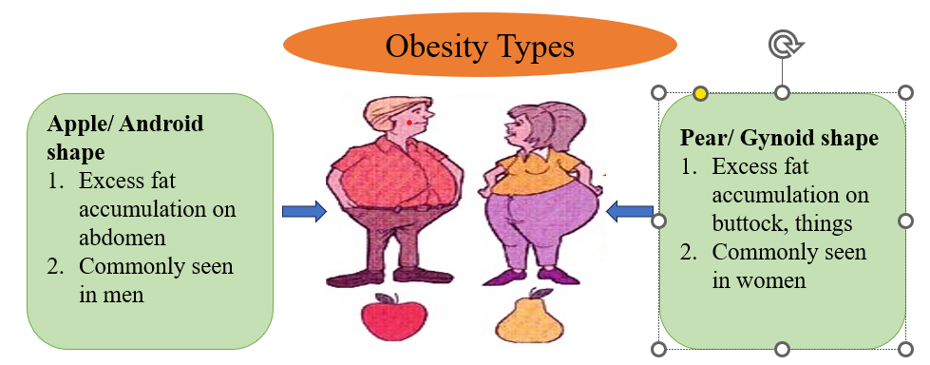

Figure 1: Complication associated with obesity
Complications associated with obesity
Obesity is a significant risk factor for several serious health complications that can affect nearly every system in the body. It is associated with an increased risk of a wide range of diseases, including cardiovascular disease, type 2 diabetes, certain types of cancer, and sleep disorders[8].
Cardiovascular diseases, including hypertension, coronary heart disease, and stroke, are among the most prevalent and severe complications associated with obesity. Obesity leads to changes in the structure and function of the heart, causing increased workload, enlargement of the heart (hypertrophy), and eventually heart failure [9]. Furthermore, obesity is strongly linked to dyslipidemia and hypertension, key risk factors for atherosclerosis and coronary heart disease [9].
Obesity is also a significant risk factor for type 2 diabetes. The excess adipose tissue in obese individuals results in increased levels of free fatty acids and inflammation, leading to insulin resistance. Over time, the pancreas fails to compensate for the resistance, leading to elevated blood sugar levels and the onset of type 2 diabetes [10].
Additionally, obesity has been linked to several types of cancer, including breast, colon, endometrial, kidney, esophageal, and pancreatic cancers. The mechanisms linking obesity to cancer are complex and may involve hormonal changes, chronic inflammation, and alterations in adipose tissue metabolism [11].
Sleep disorders, including obstructive sleep apnea, are also more common in obese individuals. Obesity, particularly abdominal obesity, increases the risk of sleep apnea by compromising respiratory function during sleep [12].
Finally, obesity can also lead to psychological complications, such as depression and anxiety. The stigma associated with obesity and its impact on body image can lead to low self-esteem and social isolation [13].
In conclusion, obesity is a complex health condition with a broad range of serious complications. Addressing obesity requires a comprehensive approach that includes lifestyle modifications, medical interventions, and possibly surgery.
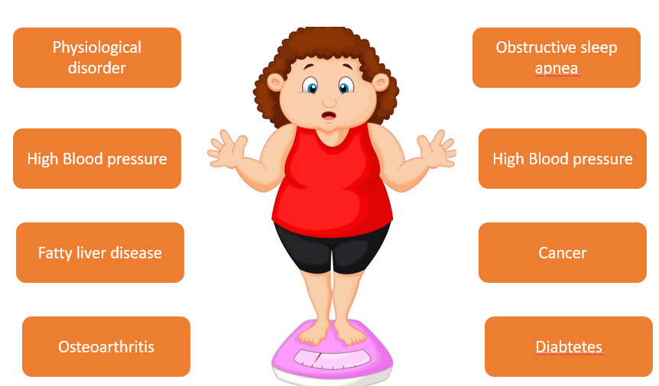
Figure 2: Complication associated with obesity
Epidermalogy of Obesity
The prevalence of obesity has been on the rise globally, reflecting a severe public health concern. The exact prevalence can vary significantly between countries and populations, depending on factors like lifestyle, diet, socioeconomic status, and genetics.
Below is a general description of the prevalence of obesity in different regions and age groups. Please note that these numbers can change over time, and the exact prevalence should be checked from recent, authoritative sources like the World Health Organization (WHO) or the Centers for Disease Control and Prevention (CDC)[14].
Adults:
Worldwide: Approximately 13% of the global adult population was classified as obese in 2016.
USA: About 42.4% of U.S. adults were obese in 2017-2018.
Europe: The prevalence in European countries varies, with some countries like the U.K. having around 27% of adults classified as obese.
Asia: Lower prevalence, but rapidly increasing, especially in urban areas. In China, for example, the adult obesity rate was around 6.2% in 2012[15].
Children and Adolescents:
Worldwide: Around 7% of children and adolescents are estimated to be obese globally.
USA: In the U.S., about 18.5% of children and adolescents were classified as obese in 2015-2016.
Europe: Varied prevalence, with some countries like Greece and Italy reporting higher rates of childhood obesity.
The increasing prevalence of obesity globally requires concerted efforts to promote healthier lifestyles and provide education on nutrition and exercise. Tackling obesity is crucial to preventing many associated health problems, including heart disease, diabetes, and certain cancers. The variance in prevalence between regions highlights the need for tailored approaches to address obesity in different cultural and socioeconomic contexts [16].
Symptoms of Obesity [17]
- Excessive growth of muscle & fat tissue
- Pendulous buttocks-abdomen-breast
- Disproportionate strength with his physical growth
- Deficient in longevity
- Less energy levels
- Weakness
- More sweating
- Excessive hunger
- Excessive thirst
Pathophysiology of Obesity
Regulation of energy balance
Energy balance should be strictly regulated, in the societies where obesity is common, which reflects the excess energy of 20 kcal per day, with 1% of daily energy expenditure the average increase of weight in a normal individual is 1kg per year. The central nervous system control both food intake and energy expenditure. The afferent neuronal and hormonal signals which are originated from the liver, adipose tissue, gastrointestinal tract and another efferent neuronal and hormonal signal help in the digestion and metabolism of the food. The phenomena called thermogenesis caused due to the weight loss in some of the pathological condition, but its protective effect against obesity is uncertain [18].
Appetite regulation
The food taken by the person is under the short term and in long term control:
- In short term control, due to decrease in the glucose concentration, fatty acids and some amino acids in the body hunger develops so, gherin is secreted by stomach to stimulate the food intake. There are some satiety hormone eg. (cholecystokinin, glucagon-like peptide1, oxyntomodulin, pancreatic polypeptide, peptide YY which increases, and reduced hunger signal and act on the brain to stimulate the felling of fullness.
- In the long term, the signal mainly depends on the hormone-like leptin which is derived from the adipocyte and stored as fat. In the body when concentration of leptin, and the adipose mass is low several signals get activated in the hypothalamic region [19].
Central nervous system
- Within the Central nervous system (CNS) complex circuitry involving the brain stem, hypothalamus, limbic system, and cortex responds to the circulating nutritional, humoral, and neuronal signals which determine the feeling of hunger and satiety and thereby food intake and influencing metabolic rate through sympathetic nervous system. Leptin concentration in the body is decreases due to decrease in the body mass which further activate the hunger signals in the brain. Once body fat mass is regaining this process is reversed [20].
Regulation of metabolism
The three principals are involved in the energy expenditure: the basal metabolic rate, the thermic effect, and the energy consumed during the physical work.
- To maintain the normal metabolism basal metabolic rate is required. During some conditions, it is possible to uncouple the oxidative phosphorylation in mitochondria which dissipating the excess energy into the fat. Brown adipose tissue (BAT) is fat-rich within the mitochondria when the uncoupling occurs the BAT gets activated via sympathetic nervous system (β3 adrenoreceptor). It has two main functions it determines the response to the cold but also help in determining to resist weight gain in overfeeding.
- The dietary thermogenesis is the energy which is used in the digestion and storing meal, and this energy is greatest for the protein-rich meals, intermediate for carbohydrate and lowest for the fat [20].
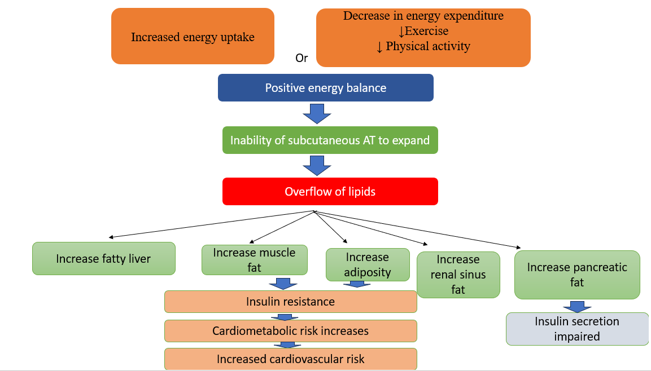
Figure 3: Pathophysiology of obesity
Drugs used for the treatment of obesity
Obesity is a chronic disease that requires long-term treatment and management. Lifestyle interventions such as diet and physical activity are the first line of treatment for obesity. However, when these interventions are insufficient, pharmacological treatment may be recommended. Various medications used to treat obesity work through different mechanisms, primarily by reducing appetite, increasing feelings of fullness, or decreasing fat absorption[20].
Orlistat (Xenical, Alli): Orlistat is a lipase inhibitor that reduces the absorption of dietary fat by the intestines. This results in approximately 30% of the fat consumed in the diet to be excreted undigested in the stool [21].
Phentermine and Topiramate (Qsymia): Phentermine is a sympathomimetic amine that increases the release of norepinephrine in the brain, reducing hunger and increasing feelings of fullness. Topiramate is an anticonvulsant drug that enhances the activity of the neurotransmitter GABA and blocks the activity of the neurotransmitter glutamate, reducing appetite [22].
Bupropion and Naltrexone (Contrave): Bupropion is an antidepressant that increases the levels of norepinephrine and dopamine in the brain, leading to reduced appetite. Naltrexone is an opioid antagonist that reduces food cravings[23].
Liraglutide (Saxenda, Victoza): Liraglutide is a glucagon-like peptide-1 (GLP-1) receptor agonist that slows gastric emptying and increases feelings of fullness, thereby reducing food intake[24].
Lorcaserin (Belviq): Lorcaserin is a serotonin 2C receptor agonist that activates these receptors in the brain, helping people eat less and feel full after eating smaller amounts of food. However, as of February 2020, the manufacturer voluntarily withdrew lorcaserin from the U.S. market because a safety clinical trial showed increased cancer occurrence [25].
Sibutramine (Meridia): Sibutramine is an appetite suppressant that increases the levels of serotonin and norepinephrine in the brain, enhancing feelings of fullness. This drug was withdrawn from the U.S. market in 2010 due to an increased risk of heart attacks and strokes.
Each of these medications has potential side effects and contraindications, and a healthcare professional should closely monitor their use. Additionally, these medications should be used in conjunction with lifestyle modifications, including a healthy diet and regular exercise [26].
Drugs | Approval Bodies | Mechanism | Year of approval | Side-effects
Orlistat | FDA | It inhibits the pancreatic lipase enzymes | 1999 | Stomach pain, Steatorrhea
Phenterine | FDA | It supress of appetite | 2012 | Insomnia, dizziness
Loscaserin | FDA | It activate the 5-HT_{2C receptor} | 2012 | Dizziness, Headache, Insomnia
Bupropion | FDA | It inhibit the dopamine and nor-adrenaline reuptake | 2014 | Headache, Nausea, Vomiting, Dizziness
Liraglutide | FDA | It is a GLP-1 Receptor agonist | 2014 | Pancreatitis, Nausea, Vomiting
Table 2: Marketed drugs used in the treatment of obesity
Conclusion
Obesity is a condition in which there is excess of fat accumulation takes place in the body, and it is becoming a substantial health problem in the world, especially in the industrialized countries. Obesity is increasing very rapidly worldwide. With thus growing rate it represents a pandemic that if it is not well managed or the serious attention is not giving to it, it will produce a potential impact on the patient health. Various diseases can be associated with the obesity with increasing prevalence like cardiovascular disease, hyperlipidaemia, systemic arterial hypertension and type 2 diabetes. Orlistat, Phentermine and Sibutramine are commercially available synthetic drugs for obesity. However, these drugs are reported to cause various side effects such as gastrointestinal symptoms such as: diarrhoea, flatulence, abdominal pain, oily stools etc. Therefore, search for safe and effective medication from the natural sources are of emerging interest.

Reference
1. Al Kibria GM. Prevalence and factors affecting underweight, overweight and obesity using Asian and World Health Organization cutoffs among adults in Nepal: Analysis of the Demographic and Health Survey 2016. Obesity research & clinical practice. 2019 Mar 1;13(2):129-36.
2. Swinburn BA, Sacks G, Hall KD, McPherson K, Finegood DT, Moodie ML, Gortmaker SL. The global obesity pandemic: shaped by global drivers and local environments. The lancet. 2011 Aug 27;378(9793):804-14.
3. Consultation WH. Obesity: preventing and managing the global epidemic. World Health Organization technical report series. 2000;894:1-253.
4. Sacks FM, Bray GA, Carey VJ, Smith SR, Ryan DH, Anton SD, McManus K, Champagne CM, Bishop LM, Laranjo N, Leboff MS. Comparison of weight-loss diets with different compositions of fat, protein, and carbohydrates. New England Journal of Medicine. 2009 Feb 26;360(9):859-73.
5. Heymsfield SB, Wadden TA. Mechanisms, pathophysiology, and management of obesity. New England Journal of Medicine. 2017 Jan 19;376(3):254-66.
6. González-Muniesa P, Mártinez-González MA, Hu FB, Després JP, Matsuzawa Y, Loos RJ, Moreno LA, Bray GA, Martinez JA. Obesity Nat Rev Dis Primers 3: 17034.
7. Flock MR, Green MH, Kris-Etherton PM. Effects of adiposity on plasma lipid response to reductions in dietary saturated fatty acids and cholesterol. Advances in Nutrition. 2011 May;2(3):261-74.
8. Flegal KM, Kit BK, Orpana H, Graubard BI. Association of all-cause mortality with overweight and obesity using standard body mass index categories: a systematic review and meta-analysis. Jama. 2013 Jan 2;309(1):71-82.
9. Poirier, P., Giles, T.D., Bray, G.A., Hong, Y., Stern, J.S., Pi-Sunyer, F.X. and Eckel, R.H., 2006. Obesity and cardiovascular disease: pathophysiology, evaluation, and effect of weight loss: an update of the 1997 American Heart Association Scientific Statement on Obesity and Heart Disease from the Obesity Committee of the Council on Nutrition, Physical Activity, and Metabolism. Circulation, 113(6), pp.898-918.
10. Kahn SE, Hull RL, Utzschneider KM. Mechanisms linking obesity to insulin resistance and type 2 diabetes. Nature. 2006 Dec 14;444(7121):840-6.
11. Calle EE, Kaaks R. Overweight, obesity and cancer: epidemiological evidence and proposed mechanisms. Nature Reviews Cancer. 2004 Aug 1;4(8):579-91.
12. Peppard PE, Young T, Palta M, Skatrud J. Prospective study of the association between sleep-disordered breathing and hypertension. New England Journal of Medicine. 2000 May 11;342(19):1378-84.
13. Puhl RM, Heuer CA. The stigma of obesity: a review and update. Obesity. 2009 May 1;17(5):941.
14. Agha M, Agha R. The rising prevalence of obesity: part A: impact on public health. International journal of surgery. Oncology. 2017 Aug;2(7):e17.
15. Boutari C, Mantzoros CS. A 2022 update on the epidemiology of obesity and a call to action: as its twin COVID-19 pandemic appears to be receding, the obesity and dysmetabolism pandemic continues to rage on. Metabolism. 2022 Aug 1;133:155217.
16. Di Cesare M, Sorić M, Bovet P, Miranda JJ, Bhutta Z, Stevens GA, Laxmaiah A, Kengne AP, Bentham J. The epidemiological burden of obesity in childhood: a worldwide epidemic requiring urgent action. BMC medicine. 2019 Dec;17:1-20.
17. Gjermeni E, Kirstein AS, Kolbig F, Kirchhof M, Bundalian L, Katzmann JL, Laufs U, Blüher M, Garten A, Le Duc D. Obesity–an update on the basic pathophysiology and review of recent therapeutic advances. Biomolecules. 2021 Sep 29;11(10):1426.
18. Romieu I, Dossus L, Barquera S, Blottière HM, Franks PW, Gunter M, Hwalla N, Hursting SD, Leitzmann M, Margetts B, Nishida C. Energy balance and obesity: what are the main drivers?. Cancer causes & control. 2017 Mar;28:247-58.
19. Miller GD. Appetite regulation: hormones, peptides, and neurotransmitters and their role in obesity. American journal of lifestyle medicine. 2019 Nov;13(6):586-601.
20. Rippe JM, Crossley S, Ringer R. Obesity as a chronic disease: modern medical and lifestyle management. Journal of the American Dietetic Association. 1998 Oct 1;98(10):S9-15.
21. Katimbwa DA, Oh J, Jang CH, Lim J. Orlistat, a competitive lipase inhibitor used as an antiobesity remedy, enhances inflammatory reactions in the intestine. Applied Biological Chemistry. 2022 Dec;65(1):1-0.
22. Subbiah V, Solit DB, Chan TA, Kurzrock R. The FDA approval of pembrolizumab for adult and pediatric patients with tumor mutational burden (TMB)≥ 10: a decision centered on empowering patients and their physicians. Annals of Oncology. 2020 Sep 1;31(9):1115-8.
23. Dahlberg S, Chang ET, Weiss SR, Dopart P, Gould E, Ritchey ME. Use of Contrave, Naltrexone with Bupropion, Bupropion, or Naltrexone and Major Adverse Cardiovascular Events: A Systematic Literature Review. Diabetes, Metabolic Syndrome and Obesity: Targets and Therapy. 2022 Jan 1:3049-67.
24. Bode B. Liraglutide: a review of the first once-daily GLP-1 receptor agonist. The American journal of managed care. 2011 Mar 1;17(2 Suppl):S59-70.
25. Woloshin S, Schwartz LM. The new weight-loss drugs, lorcaserin and phentermine-topiramate: slim pickings?. JAMA internal medicine. 2014 Apr 1;174(4):615-9.
26. James WP, Caterson ID, Coutinho W, Finer N, Van Gaal LF, Maggioni AP, Torp-Pedersen C, Sharma AM, Shepherd GM, Rode RA, Renz CL. Effect of sibutramine on cardiovascular outcomes in overweight and obese subjects. New England Journal of Medicine. 2010 Sep 2;363(10):905-17.

