Difference In Palmprint Ridge Density Of Males And Females

Sibin Benzen , Assistant Professor

Department of Forensic Science,

School Of Allied Health Sciences,

Vinayaka Mission Research Foundation (Deemed to be University)

AVMC&H Campus, Puducherry

ABSTRACT
The aim of the present work was to study the difference in Palmprint ridge density of males and females as a method of sex identification. The four prominent areas were analyzed on the palm prints that included central prominent part of the thenar eminence (P1), hypothenar region; inner to the proximal axial triradius (P2), medial mount; proximal to the triradius of the second digit (P3) and lateral mount; proximal to the triradius of the fifth digit (P4). The mean palm print ridge density was significantly higher among women than men in all the designated areas in both hands except for the P3 area in the right hand. Statistically significant differences were observed in the palm print ridge density between the different palm areas in men and women in right and left hands.
No significant right-left differences were observed in the palm print ridge density in any of the four areas of palm prints among men. In women, right-left differences were observed only in the P3 and P4 areas of palm prints. The palm print ridge density is a sexually dimorphic variable; its utility for estimation of sex in forensic identification may be limited owing to significant overlapping of values. In addition, ridge density can be considered as a morphological feature for individual variation.
Keywords: Palmprint, Ridge Density, Thenar, Hypothenar, Medial Mount, Lateral Mount

- INTRODUCTION
The region between wrist and finger is referred as palm and the impression left by the friction ridges of a palm is termed as palm print. The recovery of palm print is an important method of Forensic science. Moisture and grease on a palm result in palm print on the surface such as glass or metal. Human palm prints are rich in features that are unique and stable ^{[1]}.
Major palm print features include principal lines, wrinkles, ridges, singular points, and minutiae points. Palmprints are rich in physical characteristics of skin patterns such as lines, points and textures, which provide stable and distinctive information sufficient for separating an individual from a large population. In addition, human palm prints are also abundant with texture features that contain ridge ending and ridge bifurcation. Also, it has many features namely Geometry feature, Delta point feature, principal lines feature and finally the wrinkles feature. All these features are extracted with different methods. Also, this feature can be captured by different resolution devices (low or high) resolution this one of advantages of palm print which is there is side effect by devices used to capture the palm image. Another advantage is it has a small area with a lot of information to extract compare with another, also it has high acceptance. Each person's palm print is distinctive. A palm print is different from a fingerprint in that it also contains details that can be used to compare one palm to another, such as texture, indents, and marks.
A friction ridge is a raised area of the epidermis on the digits (fingers and toes), palm of hand, or sole of foot that is made up of one or more connected ridge units of friction ridge skin. The skin occurs in a corrugated fashion with elevated ridges broken up by lower furrows. In other words, this skin is not flat and smooth like other skin. Friction ridge skin is slightly elastic in nature and assists in gripping objects and surfaces. Friction ridges form in the uterus by the fourth month of fetal development and remain unchanged and absolute for a person's lifetime, only decomposing after death. These unique factors make friction ridge skin ideal for use in personal identification
a. History of Palmprint

Once friction ridge skin was recognized as valuable and reliable for personal identification, different people began to work on systems for taking these prints and then organizing them. Faults had previously used printer’s ink to take the fingerprints of his subjects. In the early twentieth century, American chemical engineer John A Dondero (1900–1957) developed new inks for the purpose of recording prints, including special ink for foot printing newborns. Edward Henry, with the assistance of two Indian civil servants, developed a system for classifying and filing mass quantities of fingerprint cards. This system is the one shared by Ferrier and is still known today as the Henry System. With the advent of automated identification systems, use of Henry’s system has declined
- COLLECTION PROCEDURE
Healthy individuals aged between 20 to 60 years were included in the study after taking informed consent. A clean plain glass plate was uniformly smeared with black duplicating ink with the help of a roller. The subjects were asked to apply their hand on the smeared plate and then transfer them on to a white paper. Regular pressure was applied to obtain the palm prints.[1] Palm prints were obtained from both right and left hands. The samples are collected by using various collection tools such as

      - Black duplicating ink (Kores India make)
      - Ink roller
      - Inking glass plate
      - Ink cleaning supplies
      - Palm print cards for recording the prints
      - Rulers, Markers and Magnifying lens
      - Transparent OHP sheet

- ANALYSIS OF PALM PRINT
The palmprints were taken in a paper then analyze the sample by using the hand lens and 5mm ×5mm (0.5cm) marked transparent OHP sheet. The transparent OHP sheet was placed on the palm print sample in the defined area to be analyzed. The count was carried out diagonally on a square for measure ridge density or the number of given ridges. The ridges were counted with the help of a hand lens.[2] This value represents the number of ridges in 25 mm square area and reflects the ridge density value. Then the ridge density of the four prominent areas were analyzed on the palm prints that included central prominent part of the thenar eminence (P1), hypothenar region; inner to the proximal axial triradius (P2), medial mount; proximal to the triradius of the second digit (P3) and lateral mount; proximal to the triradius of the fifth digit (P4) were recorded, organized systematically and statistically analyze.[3][4]

CONCLUSION
Palmprints have important role in determining the gender of an individual. The sex differences in palm print ridge density can even be valuable in identification of a dismembered hand during medico legal investigations to establish the identity of an individual in cases of mass disasters/mass homicides.[5] In this context, the sex difference in the ridge density in the fingerprints and palm prints becomes relevant. Despite its reputation as an infallible means of identification. It has significant limitation when it comes to forensic individualization. The ridge pattern of palm print develops during pregnancy and remains unchanged until death, when it is altered by decomposition. The identification of sex is crucial in forensics. Analysis of Palmprints can be used to identify the offender. The prints obtained from the crime scene are matched with the suspects to confirm their involvement in crime.[6][7][8]
The present study was conducted to study the difference in Palmprint ridge density in males and females and it has been successful to determine that, females tend to have grater ridge density than males. Females have higher ridge density in both right and left hand except Medial mount (P3) region. It is evident that statistically significant difference exists in the Palmprint ridge density among the different areas of male and female in right and left hand. Thus, it is concluded that ridge density in Palmprint pattern is a best parameter for identification of gender. This study would be helpful in gender determination in most of the cases where Palmprints are found and other evidences are destroyed or not enough for identification.

APPENDIX

Male Palmprint Sample

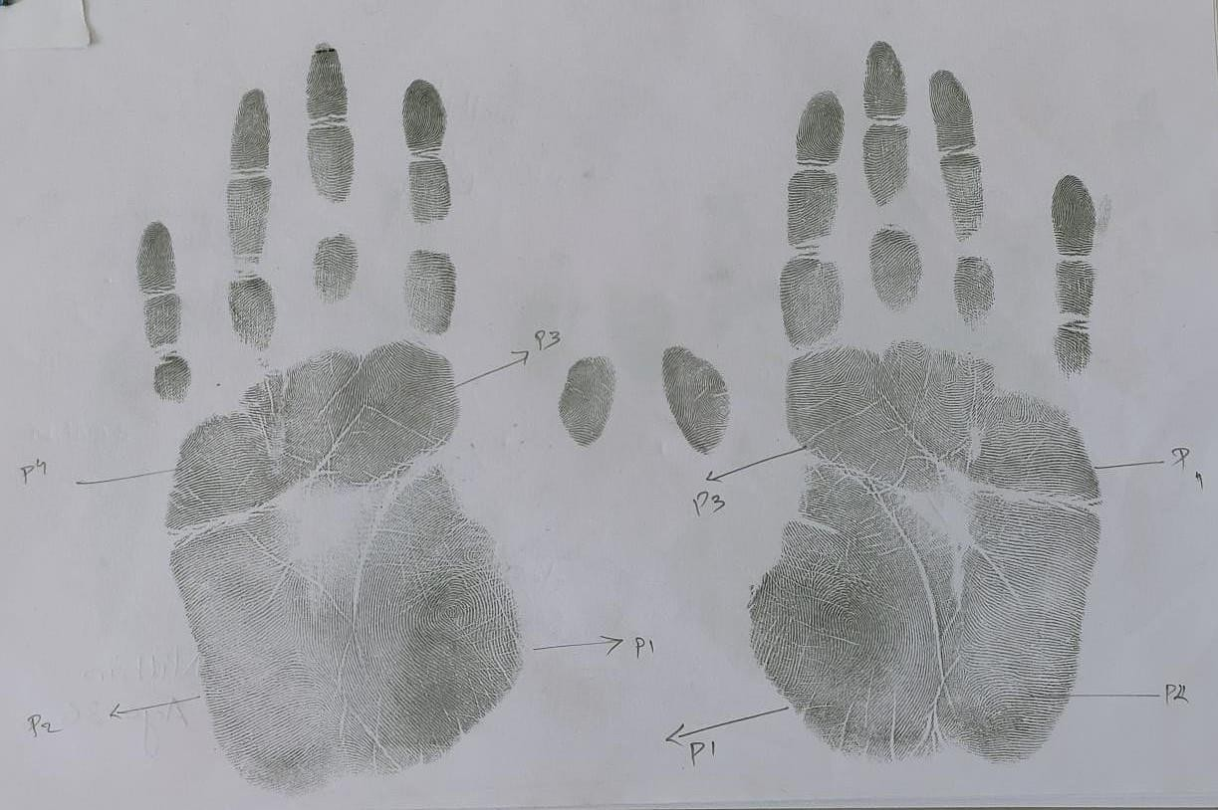
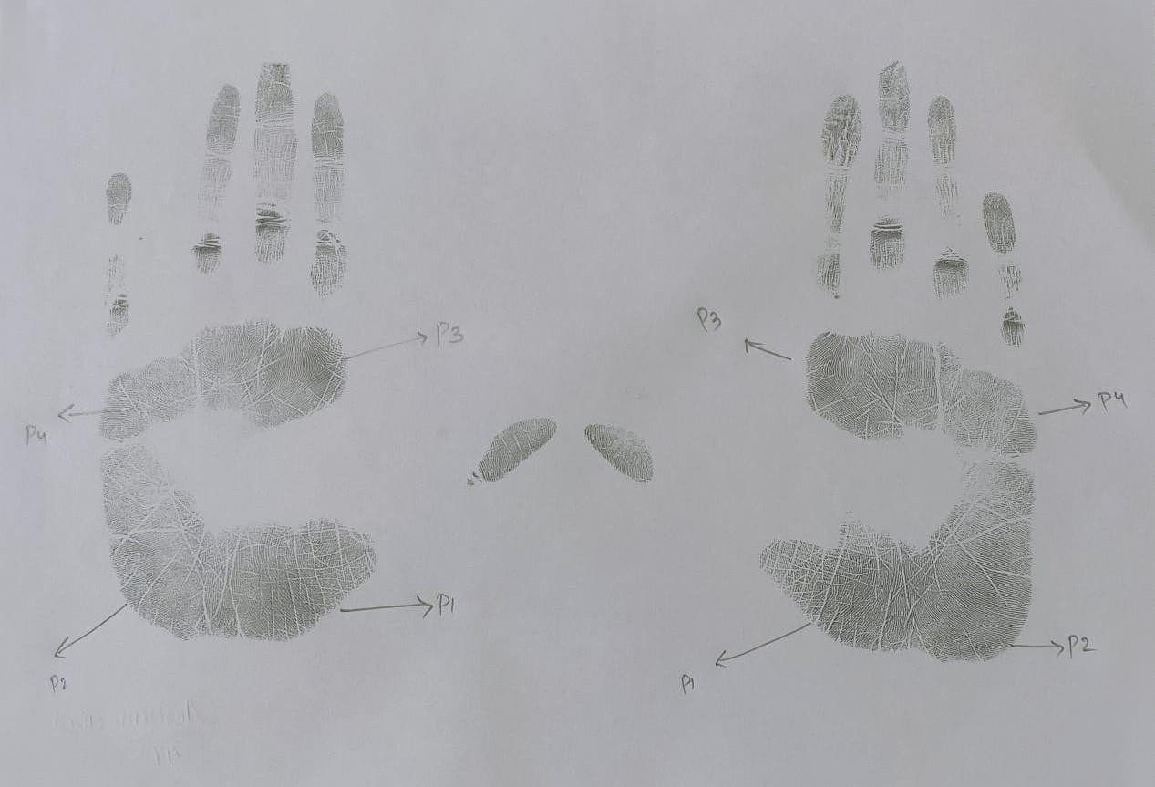

Female Palmprint Sample

REFERENCES

Fathelrahman Idris Ali, Altayeb Abdalla Ahmed, Sexual and topological variability in palmprint ridge density in a sample of Sudanese population, Forensic Science International: Reports, Volume 2, 2020, 100151, ISSN 2665-9107, https://doi.org/10.1016/j.fsir.2020.100151
- Yaacob, R., Hadi, H., Ibrahim, H. et al. Evaluating the potential application of palmprint creases density for sex determination: an exploratory study. Egypt J Forensic Sci 12, 26 (2022). https://doi.org/10.1186/s41935-022-00282-6
- Badiye, Ashish & Kapoor, Neeti & Mishra, Swati. (2019). A novel approach for Sex determination using palmar tri-radii: A pilot study.. Journal of Forensic and Legal Medicine. 65. 10.1016/j.jflm.2019.04.005
- Gornale, S.S., Patil, A., Hangarge, M., Pardesi, R. (2019). Automatic Human Gender Identification Using Palmprint. In: Luhach, A.K., Hawari, K.B.G., Mihai, I.C., Hsiung, PA., Mishra, R.B. (eds) Smart Computational Strategies: Theoretical and Practical Aspects. Springer, Singapore. https://doi.org/10.1007/978-981-13-6295-85

Sánchez-Andrés A, Barea JA, Rivaldería N, Alonso-Rodríguez C, Gutiérrez-Redomero E. Impact of aging on fingerprint ridge density: Anthropometry and forensic implications in sex inference. Sci Justice. 2018 Sep;58(5):323-334. doi: 10.1016/j.scijus.2018.05.001. Epub 2018 May 3. PMID: 30193658

Taduran RJ, Tadeo AK, Escalona NA, Townsend GC. Sex determination from fingerprint ridge density and white line counts in Filipinos. Homo. 2016 Apr;67(2):163-71. doi: 10.1016/j.jchb.2015.11.001. Epub 2015 Nov 12. PMID: 26619792.

Pattanawit Soanboon, Somsong Nanakorn, Wibhu Kutanan, Determination of sex difference from fingerprint ridge density in northeastern Thai teenagers, Egyptian Journal of Forensic Sciences, Volume 6, Issue 2, 2016, Pages 185-193, ISSN 2090-536X, https://doi.org/10.1016/j.ejfs.2015.08.001.
- Ahmed AA, Osman S. Topological variability and sex differences in fingerprint ridge density in a sample of the Sudanese population. J Forensic Leg Med. 2016 Aug;42:25-32. doi: 10.1016/j.jflm.2016.05.005. Epub 2016 May 12. PMID: 27227288.

