MICROSIMULATION MODELLING IN VISSIM ON EFFECTS OF TRAFFIC CONGESTION DUE TO CONSTRUCTION OF FLYOVER ON SINHAGAD ROAD IN PUNE, INDIA

Aishwarya Desai, Rajshekhar Rathod, and Sagar Sonawane
1Department of Civil Engineering, MIT SOE, Loni, Pune, 412201, Maharashtra, India. 2Department of Civil Engineering, MIT SOE, Loni, Pune, 412201, Maharashtra, India.
3Department of Civil Engineering, MIT SOE, Loni, Pune, 412201, Maharashtra, India.

Aishwarya Desai(s). E-mail(s): aishwaryad9009@gmail.com; Rajshekhar Rathod: rajshekhar.rathod@mituniversity.edu.in; Sagar Sonawane: sagar.sonawane@mituniversity.edu.in;

Acknowledgements: The authors would like to express their gratitude my guide, Prof. Rajshekhar Rathod, Assistant Professor of Civil Engineering Department, MIT School of Engineering, Pune and my co-guide Prof. Sagar K. Sonawane, Assistant Professor of Civil Engineering Department, MIT School of Engineering, Pune for their encouragement during my dissertation work. I am also thankful to Prof. Dr. Satish B. Patil, Head, Civil Engineering Department, MIT School of Engineering, Pune for his support and for giving an immense knowledge about the site and various construction safeties.

Abstract
One of the most important aspects of a developing country is transportation, which is essential to ensure the development of metropolitan areas. In India, the number of vehicles has drastically increased due to the country's rapid population growth, urbanization, and improving living conditions. In India, There is a lot of congestion surrounding large urban areas. At intersections, traffic congestion has become a severe issue. In order to look into possible mitigation strategies for these intersections and work zone areas, a traffic simulation model is created that computes traffic flow characteristics and illustrates how congestions behave when certain traffic demands are placed on the system. A 2.75 km stretch of Pune's Funtime cinema to Rajaram Bridge was chosen for the investigation. By providing alternate routes, work zones can lessen the adverse effects of traffic congestion, which frequently result in increased congestion and delays for road users. The condition for traffic volume before and after the construction of the flyover is analysed using VISSIM, a traffic simulation programme. The expected outcomes would demonstrate that the suggested plan can significantly reduce delay time, Queue length, and traffic congestion, greatly enhancing the entire transportation capacity of Sinhagad road.

Keywords: Traffic congestion, flyover, PTV VISSIM.

1 INTRODUCTION
Pune ranks ninth among the most populated cities in India and is the second-largest city in Maharashtra. With the uncontrollable population surge in India, transportation remains one of the important aspects of concern with respect to population increase. One of the most populated areas of Pune is Sinhagad. As with the rapid increase in population, the dependency on vehicles has also increased, which has a major impact on traffic congestion. And as Sinhagad Road is the major connecting link between the city and the national highway, it is an important transportation component as it provides connectivity within the city and intercity via the highway. Sinhgad road stretch from Rajaram Bridge to Funtime junction is a very busy stretch with over five signalized junctions and traffic getting fed from several internal roads. A dense settlement and mixed-use land use on both sides of the road make its edge cause constant friction with the moving traffic. The growth further towards the Nanded city, kirkitwadi is very high. In absence of the PMRDA ring road and poor connectivity from the Katraj-Hinjewadi bypass highway, Sinhgad road faces major traffic congestion and delays. The dense area of Suncity is only accessible from one single road. The high amount of student traffic a Sinhgad College uses this road daily. There is the absence of riverside road. Comprehensive Mobility Plan proposes METRO over Sinhgad road along with connecting link between Karve Nagar and Suncity via River Bridge and connecting link between Dhankawdi Sahakarnagar and Hingne via tunnel in the form of Intermediate ring road. Therefore it was selected for the concerned study of investigating countermeasures for these intersections and work zone areas a traffic simulation model is created that computes the characteristics of traffic flow and analyzes the behaviour of congestions under specific traffic demands. For the study, VISSIM software was used for modeling. For the modeling data required was obtained with the surveys conducted on the above-mentioned stretch of 2.75 km from Rajaram Bridge to the Funtime cinema.

2 METHODOLOGY

STUDY AREA
The stretch of Sinhagad Road from Rajaram Bridge to Fun-time Junction is known for being highly congested, primarily due to the presence of multiple signalized junctions. Along this busy stretch, there are a total of five signalized junctions, consisting of four three-arm junctions and one four-arm junction. The total stretch length is 2.74 Km. the presence of these signalized junctions indicates that traffic flow along Sinhagad Road needs to be regulated to ensure the smooth movement of vehicles and ensure safety for both motorists and pedestrians. However, the frequent stops and signal cycles at these junctions can result in traffic congestion, especially during peak hours when the volume of vehicles is high. The location plan of the research is shown in the figure below
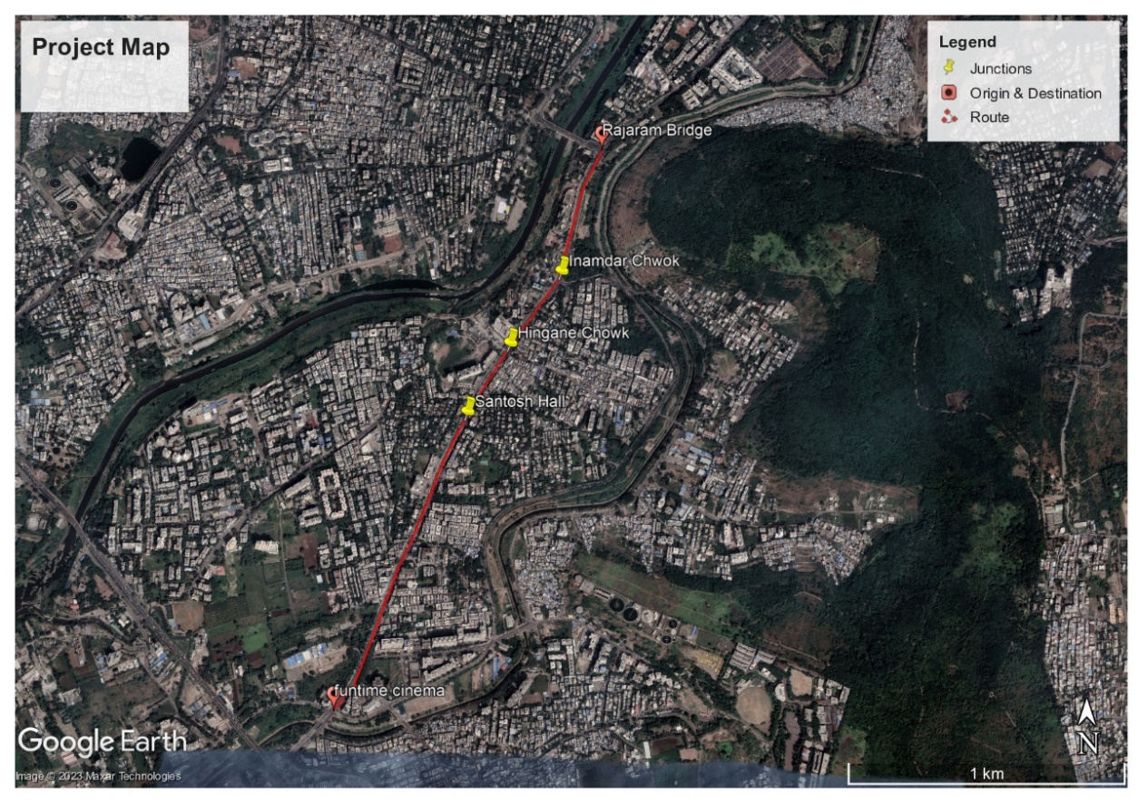
Figure 1 STUDY AREA
At the research site, construction of the flyover is started from Rajaram Bridge to Funtime cinema can be seen in the below figure.
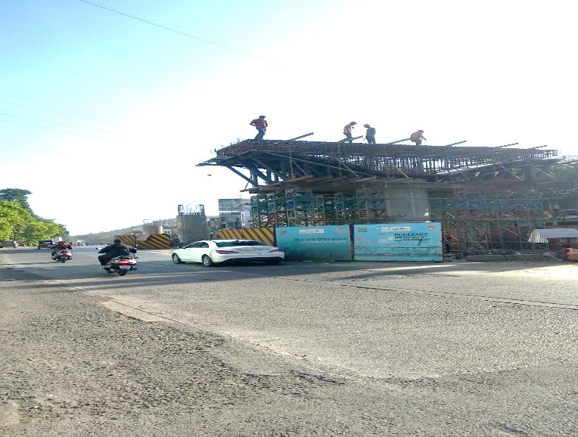
Figure 2 Flyover Construction at research site

2.2 DATA COLLECTION
The before-construction data was collected from PMC, and during construction, data was collected by conducting a manual survey from 15th March 2022 to 21ST March 2022. During the construction phase of the Rajaram Bridge to Fun-time Cinema project, several surveys were conducted to collect data related to traffic conditions. These surveys included vehicle turning movement, vehicle volume, and vehicle speed. The data collected through these surveys was crucial for understanding the existing traffic patterns and informing the design and planning of the construction project. The traffic survey was conducted manually using the tally and mark method. This method involves trained surveyors stationed at specific locations, typically at the five junctions along the project route. The surveyors visually observed and tallied the number of vehicles making different types of turns at each junction. This included counting the vehicles turning left, right, or going straight at each junction. The surveyors also recorded the volume of vehicles passing through each junction during the survey period. This information was used to inform the design and planning of the construction project, including considerations for traffic management, lane configurations, signal timings, and other necessary measures to minimize disruption and ensure smooth traffic flow during the construction period.

2.2 TRAFFIC TURNING MOVEMENT SURVEY
A traffic turning movement survey is a method used to collect data on the volume and patterns of vehicles making various types of turns at a specific intersection or road segment. It provides valuable information about the flow of traffic and helps transportation planners and engineers make informed decisions regarding traffic signal timings, lane configurations, and overall intersection design. During a traffic turning movement survey, data is collected on the number of vehicles turning left, right, or going straight at each approach of an intersection or specific locations along a road. The survey team identifies the specific location on each where data needs to be collected. Factors such as traffic volume, complexity of movements, and specific project requirements are taken into consideration. A manual counting method is used for the survey. The survey team collects data over a specific time period, typically several hours or even days, to capture variations in traffic patterns. They recorded the number of vehicles and the specific turning movements made at each approach or location. Once the data collection is complete, the collected data is analyzed to determine the volume of turning movements, the percentage of traffic making different types of turns, and the peak periods of turning activity. This analysis helps identify traffic patterns, congestion hotspots, and potential areas for improvement.
Table 1 Template for TMC survey
CLASSIFIED TRAFFIC VOLUME COUNT SURVEY
Road Name: |  |  |  | Date and Day |  |  | ADDL INFORMATION
Section From
Location Km |  |  |  | Hour |  |  | WEATHER
Direction Towards
FAST MOVING VEHICLES |  |  |  |  |  |  |  |  | SLOW MOVING VEHICLES
Time | 2W | 3W | 4W | Bus | LCV | HCV | Agri Tractor
 |  |  |  |  |  |  | With Trailer | Without Trailer | Cycle
09:00-09:15
09:15-09:30
09:30-09:45
09:45-10:00

PTV VISSIM SOFTWARE
Microsimulation modeling in VISSIM (Visual Simulation System) can be a valuable tool for analysing the effects of traffic congestion resulting from the construction of a flyover on Sinhagad Road. VISSIM is a microscopic traffic simulation software that allows to simulate and analyse complex traffic scenarios. Start by creating a virtual representation of Sinhagad Road in VISSIM. This involves creating a network model that includes the road geometry, intersections, traffic signals, and any other relevant features. Collect data on the existing traffic conditions, including traffic volume, vehicle types, turning movements, and travel patterns along Sinhagad Road. Input this data into VISSIM to represent the baseline traffic scenario. Identify the location and extent of the flyover construction zones on Sinhagad Road. Adjust the network model in VISSIM to reflect these construction zones, including any detours, lane closures, or changes in road geometry. Determine how traffic will be diverted or rerouted during the construction period. Modify the network model accordingly to reflect the planned traffic diversions, lane closures, and alternative routes available to drivers. Run multiple simulations in VISSIM to analyse the effects of traffic congestion due to the construction of the flyover. Vary the parameters such as traffic volume, signal timings, and traffic diversion strategies to assess different scenarios. Analyse the simulation results to understand the impacts of the flyover construction on traffic congestion. Evaluate key performance measures such as travel time, delay, and queue lengths. Compare the results of different scenarios to identify the most effective traffic management strategies.

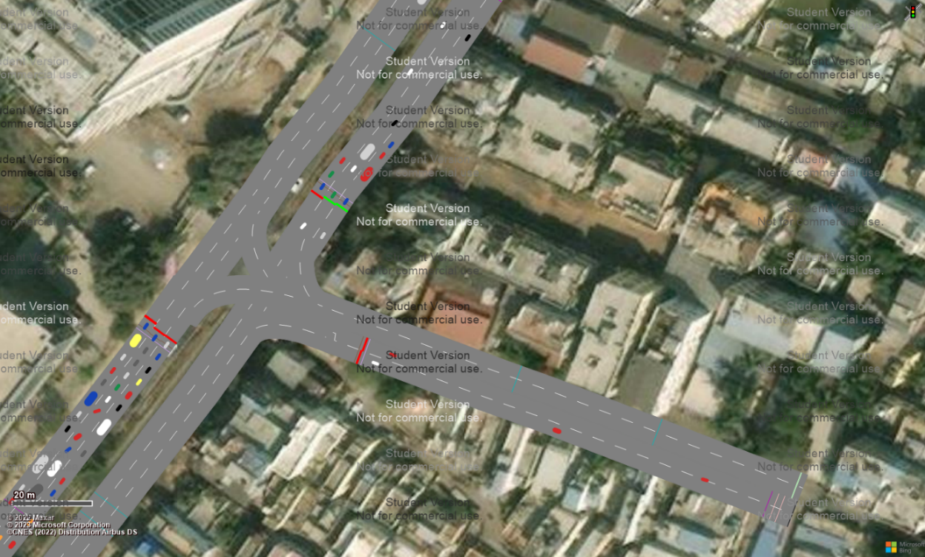
Figure 3 Before construction simulation model form Hingne chowk junction
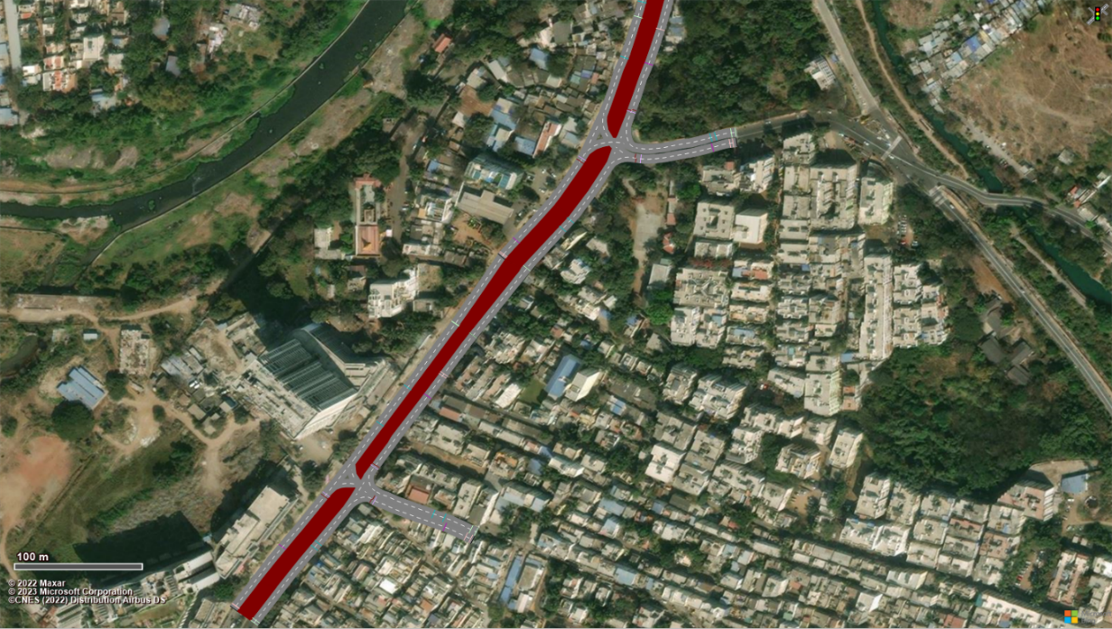
Figure 4 During construction simulation model for Inamdar and hingne chowk junction
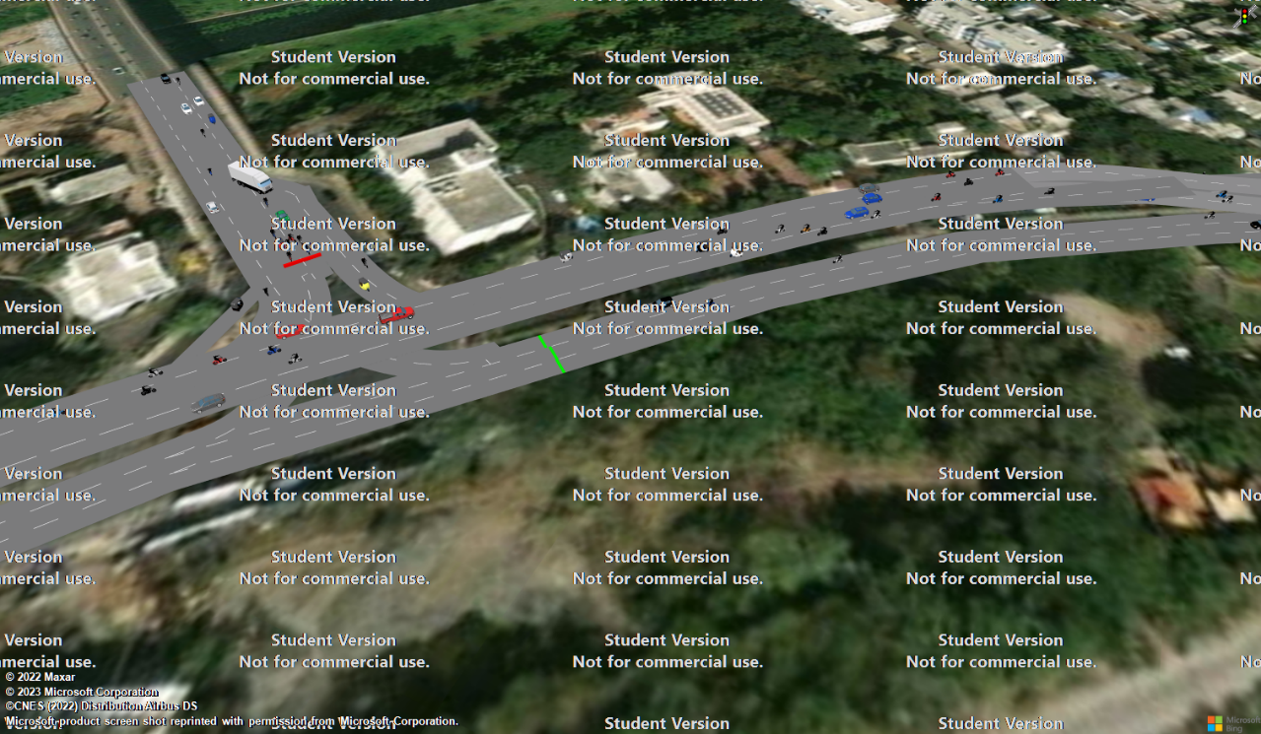
Figure 5 Flyover simulation model for Rajaram Bridge junction

3 RESULTS & DISCUSSION

3.1 TRAFFIC TURNING MOVEMENT SURVEY

Table 2 Before construction traffic behavior for morning and evening peak hours
 | Direction percentages
 | Morning peak hour |  | Evening peak hour
 | Straight traffic | Turning traffic | Straight traffic | Turning traffic
Rajaram chowk | 66 | 34 | 58 | 42
Inamdar chowk | 83 | 17 | 61 | 39
Hingne chowk | 89 | 11 | 59 | 41
Santosh hall chowk | 73 | 27 | 54 | 46
Fun time chowk | 88 | 12 | 84 | 16

The above table shows that before construction, the traffic behavior of intersections in morning and evening peak hours.

Table 3 During construction traffic behavior for morning and evening peak hours
 | Direction percentages
 | Morning peak hour |  | Evening peak hour
 | Straight traffic | Turning traffic | Straight traffic | Turning traffic
Rajaram chowk | 55 | 45 | 54 | 46
Inamdar chowk | 79 | 21 | 58 | 42
Hingne chowk | 84 | 16 | 57 | 43
Santosh hall chowk | 73 | 27 | 56 | 44
Fun time chowk | 82 | 18 | 85 | 15

The above table shows that during construction, traffic behaviour of intersections in morning and evening peak hours.

Figure 6 Average queue length for morning peak hours
Above figure shows the impact of traffic on queue length before, during, channelization during construction and after the implementation of flyover at different junctions. During morning peak hours, construction work at Rajaram Bridge caused a 1.26 times increase in average queue length, but after the flyover's completion, there was a significant reduction of 1.9 times in queue length. At Inamdar Chowk, construction work increased the average queue length by 1.94 times, but diversion measures reduced it by 1.16 times. After the flyover's completion, there was a substantial reduction of 3 times in queue length. Hingne Chowk experienced a 1.45 times increase in average queue length due to construction work, but diversion measures lessened it by 1.12 times. After the flyover's completion, there was a slight reduction of 2.5 times in queue length. Santosh Hall faces 2.04 times increase in average queue length (with no diversion measures possible) due to construction, but after the flyover's completion, there was a significant reduction of 2.7 times in queue length. At Funtime Cinema, construction work led to a 2.18 times increase in average queue length, but diversion measures reduced it by 1.06 times. After the flyover's completion, there was a reduction of 2.46 times in queue length. Overall, the completion of flyovers was effective in significantly reducing traffic congestion during morning peak hours in these locations.

Figure 7 Average vehicle delay time for morning peak hours
During construction, average delay times increased at several locations. At Fun-Time Cinema, the delay time increased from 1.1 minutes to 2 minutes. However, after implementing channelization measures, it reduced by 1.4 minutes, resulting in a 26 second improvement compared to pre-construction. Santosh Hall experienced a slight increase in delay time from 45 seconds to 1.13 minutes during construction, but after the flyover completion, there was a reduction of about 19 seconds. Hingne Chowk faced an increase in average delay time from 58 seconds to 1.4 minutes during construction, but channelization measures led to a decrease of 1.3 minutes, with a significant 31 second reduction after flyover completion. Inamdar Chowk witnessed an increase in delay time from 49 seconds to 1.48 minutes during construction, but channelization measures resulted in a decrease of 1.23 minutes, with an approximate 26 second reduction after flyover completion. At Rajaram Bridge, the delay time increased from 45 seconds to 1.05 minutes during construction, but there was a notable reduction of about 19 seconds after flyover completion. Overall, the completion of flyovers and implementation of channelization measures proved effective in reducing delay times for commuters.

Figure 8 Average travel time for morning peak hours
During construction, average vehicle travel times increased significantly at several locations. At Fun-Time Cinema, travel time increased from 1.55 minutes to 2.7 minutes, but after the flyover completion, there was a notable improvement, with a decrease of approximately 37 seconds compared to pre-construction. Santosh Hall experienced an increase from 1.18 minutes to 1.6 minutes during construction, but after the flyover's completion, there was a significant reduction of around 24 seconds compared to pre-construction. Hingne Chowk saw an increase from 1.57 minutes to 2.13 minutes during construction, but implementing channelization measures led to a noticeable improvement, resulting in a decrease of 1.73 minutes compared to the peak travel time experienced during construction. After implementation of flyover significant reduction is about 43 seconds Inamdar Chowk witnessed an increase from 1.21 minutes to 1.85 minutes during construction, but after the flyover's completion, there was a significant decrease of approximately 39 seconds in travel time compared to pre-construction. At Rajaram Bridge, travel time increased from 1.15 minutes to 1.38 minutes during construction, but there was a noteworthy reduction of approximately 31 seconds after the flyover's completion. Overall, the completion of flyovers and the implementation of channelization measures effectively improved travel times for commuters at these locations.

Figure 9 Average queue length for evening peak hours
During construction, average queue lengths increased at various locations. At Rajaram Bridge, the queue length increased by 1.22 times, but after the flyover's completion, there was a reduction of 2.66 times. Inamdar Chowk experienced a 1.5 times increase in queue length, but diversion measures reduced it by 1.17 times. After the flyover's completion, there was a reduction of 2.2 times in queue length. Hingne Chowk saw a significant increase of 3.32 times in queue length during construction, but diversion measures reduced it by 1.09 times. After the flyover's completion, there was a reduction of 2.02 times in queue length. Santosh Hall faced a 2.35 times increase in queue length (no diversion measures possible) during construction, but after the flyover's completion, there was a reduction of 2.4 times. Fun-Time experienced a 1.84 times increase in queue length during construction, but diversion measures reduced it by 1.04 times. After the flyover's completion, there was a reduction of 2.6 times in queue length. The completion of flyovers and the implementation of diversion measures proved effective in reducing congestion and queue lengths at these locations, benefiting commuters during peak hours.

Figure 10 Average vehicle delay time for evening peak hours

During construction, average delay times increased at Fun-Time Cinema, Santosh Hall, Hingne Chowk, Inamdar Chowk, and Rajaram Bridge. At Fun-Time Cinema, delay time increased from 1.2 minutes to 2.16 minutes, but after channelization, it reduced by 1.7 minutes, and following flyover completion, the delay time improved by approximately 32 seconds compared to pre-construction. Santosh Hall experienced an increase from 58 seconds to 1.1 minutes during construction, with no channelization provided, but after the flyover's completion, there was a reduction of about 19 seconds compared to pre-construction. Hingne Chowk average delay time increased from 1.3 minutes to 1.72 minutes during construction, but channelization measures resulted in a decrease of 1.4 minutes, and after flyover completion, there was a significant reduction of about 41 seconds. Inamdar Chowk delay time increased from 1.24 minutes to 1.59 minutes during construction, but channelization measures led to a decrease of 1.43 minutes, and after the flyover's completion, the delay time reduced by approximately 36 seconds. At Rajaram Bridge, the delay time increased from 53 seconds to 1.05 minutes during construction, but there was a notable reduction after flyover completion is about 21 seconds. These findings highlight the effectiveness of flyovers and channelization measures in reducing delay times and improving traffic flow at these locations.

Figure 11 Average travel time for evening peak hours
During the construction phases, average vehicle travel times increased at Fun-Time Cinema, Santosh Hall, Hingne Chowk, Inamdar Chowk, and Rajaram Bridge. At Fun-Time Cinema, the travel time increased from 1.69 minutes to 2.93 minutes during construction. However, after the flyover's completion, there was a significant improvement, with a decrease of approximately 1.5 minutes compared to pre-construction. At Santosh Hall, travel time increased from 1.38 minutes to 1.7 minutes during construction. After the flyover's completion, there was a notable reduction of around 27 seconds compared to pre-construction. Hingne Chowk experienced an increase in average travel time from 1.3 minutes to 1.7 minutes during construction. However, implementing channelization measures led to a noticeable improvement, resulting in a decrease of 1.56 minutes compared to the peak travel time experienced during construction. At Inamdar Chowk, travel time increased from 1.08 minutes to 1.51 minutes during construction, but after the flyover's completion, there was a significant reduction of approximately 33 seconds compared to pre-construction. Rajaram Bridge faced an increase in travel time from 1.13 minutes to 1.38 minutes during construction. However, after implementing channelization measures and completing the flyover, there was a notable reduction of approximately 29 seconds compared to pre-construction. These findings highlight the effectiveness of flyovers and channelization measures in reducing travel times and improving traffic flow at these locations.

4 CONCLUSIONS
- During construction, the average queue length increased by 1.22 to 3.32 times at the five junctions. Channelizing 30% of traffic reduced the queue length by 1.04 to 1.17 times. After flyover completion, there was a significant reduction of 1.9 to 3 times in the average queue length, indicating improved traffic flow. The flyover had a positive impact in alleviating congestion at these junctions.
- During the construction phase, the average vehicle delay time increased significantly, from 56 seconds to 2.16 minutes, leading to longer queues and increased congestion. However, traffic channelization measures reduced the delay time to a range of 1.23 to 1.7 minutes. After the flyover's completion, there was a noticeable improvement, with the delay time decreasing to a range of 19 to 41 seconds compared to pre-construction, indicating a positive impact on traffic flow and significant reduction in delays at the five junctions.
- During construction, average travel time increased from 1.08 minutes to 2.93 minutes. After channelization, it reduced to 1.35 to 2.6 minutes, improving traffic flow. Post-flyover completion, travel time decreased to 27 to 43 seconds, indicating a significant positive impact on efficiency and reduced delays.

References
- A PRANATHI and G RAVALI (2016) “An overview of flyover construction for lessening congestion of traffic” International Journal of Innovative Technology andResearch Volume No.4, Issue No.3,
- Auttakorn SALA (2018) “Assessment of traffic flow benefits of flyover a case study.” Journal of Society for Transportation and Traffic Studies (JSTS) Vol.4 No.3
- Jianyou Zhao, Yongmei Xueand , Qichen Wu (2018) “Optimization Analysis of Urban Road Intersection Based on VISSIM Simulation” ASCE CICTP
- Keman Wu, Nale Zhao and Tao Du (2019) “Research on the Influence of Front Virtual Work Zone on Traffic Operation of Expressway Construction Sections” ASCE CICTP
- Lenjisa Bedada and Mukti Advani (2020) “Estimating the impact of flyover on the vehicle-on-vehicle delay, Fuel consumption, and emission” ResearchGate
- Ning Yang and Gang-Len Chang (2009) “Simulation-Based Study on a Lane-Based Signal System for Merge Control at Freeway Work Zones.” Journal of Transportation Engineering Vol. 135
- Rose Mary Xavier, Evelyn Antony and Jubin Mathew (2021) “Traffic Analysis and design of flyover” IRJET Volume: 08 Issue: 06
- Shailesh Singh, Kishore Ravande and Rajshekhar Rathod (2021) “Traffic Study and Road Safety Assessment At Bus Terminal” IRJETS Volume: 03 Issue: 10
- Tarun Patel and Mrs. Krupa Dave (2015) “Feasibility Study and Rapid Construction of Flyover at Sahakari Zin Intersection on NH-8, Himmatnagar” ISSN: 2278-0181Vol. 4 Issue 04
- Xiang GAO, Li-xia BAO, and Guiyan JIANG (2016) “CongestionRelated Analysis and Identification of Urban Road Based on VISSIM” ASCE Integrated transportation system.
- Yali Chen, Xiao Qin and David A. Noyce (2010) “Interactive Process of Microsimulation and Logistic Regression for Short-Term Work Zone Traffic Diversion” journal of transportation engineering

