Dielectric Behaviour of CuO Nanoparticles at Elevated Temperatures

Vinayakprasanna N. Hegde
Vidyavardhaka College of Engineering
Mysuru, India
vinayak.phy@vvce.ac.in

ABSTRACT
Copper Oxide (CuO) nanoparticles were created through the solution combustion technique. X-ray diffraction (XRD) analysis was employed to ascertain the crystal structure and crystallite size of these particles. Furthermore, the dielectric properties of CuO nanoparticles were examined at both room temperature and elevated temperatures. The investigation encompassed the evaluation of ac conductivity ($σ_{dc})$, dielectric constant (k), tan d and electric modulus (M) with respect to changes in frequency and temperature. The findings revealed that the dielectric characteristics of the synthesized nanoparticles exhibited significant dependence on both frequency and temperature.

Keywords—CuO; nanoparticles; XRD; dielectric; coductivity

INTRODUCTION

In the realm of nanomaterials research, the investigation of structural, dielectric, and AC conductivity properties holds paramount significance, shaping technological advancements across various domains [1-4]. This research paper delves into a comprehensive exploration of CuO nanoparticles, probing their multifaceted characteristics and potential applications. At the forefront of the nanotechnology landscape, CuO nanoparticles have garnered substantial attention due to their unique properties arising from size effects and increased surface-to-volume ratio. The article embarks on a meticulous analysis of the structural attributes of CuO nanoparticles, unravelling the intricate crystallographic arrangements that underscore their behavior. Dielectric properties constitute a pivotal aspect, governing the material's response to electric fields and paving the way for electronic, photonic, and energy storage applications. By delving into the dielectric characteristics of CuO nanoparticles, this study sheds light on their polarization mechanisms and electronic interactions, thereby contributing to the burgeoning field of dielectric nanomaterials. Furthermore, the research delves into the AC conductivity properties of CuO nanoparticles, elucidating their behavior in alternating electric fields. This facet bears substantial relevance for applications such as sensors, capacitors, and electronic devices [5]. The investigation presented in this chapter encompasses both experimental findings and theoretical insights, fostering a holistic understanding of CuO nanoparticles' behavior. This research amalgamates structural elucidation with dielectric and AC conductivity analyses, offering a profound comprehension of CuO nanoparticles' intrinsic attributes.

EXPERIMENT

Synthesis
The copper (II) nitrate trihydrate Cu(NO₃)₂·3H₂O and glycine C₂H₅NO₂ were used for the CuO nanoparticles synthesis. The Cu(NO₃)₂·3H₂O is an oxidizer and C₂H₅NO₂ is a fuel. A redox mixture is dissolved in double distilled water and stirred for 1 h to form a homogenous mixture. Subsequently, the blend was subjected to heat using a furnace, and upon reaching the ignition temperature, it spontaneously ignited, propelling gases vigorously in a substantial volume to yield a finely powdered product. The resulting powder was calcinated at 750ºC, thoroughly milled and subjected to characterization to investigate its properties.

Characterization
The X-ray diffraction (XRD) patterns of the synthesized samples were acquired using CuKα radiation (λ=1.54Å), the 2θ range selected for analysis ranged from 20 to 80°. To investigate the dielectric properties, pellets of CuO nanoparticles were shaped into disks with a diameter of 10mm and a thickness of 2mm. These properties were examined at various temperatures (30, 50, 100, 150, 200 ºC) within a frequency range spanning from 50 Hz to 1 MHz. An NF LCR meter with computer interface (Model: ZM-2376, Make: Japan) was employed to assess the ac conductivity (σ_{dc}), dielectric constant (k), dielectric loss (tanδ) and impedance (Z) of the prepared samples.

RESULT AND DISCUSSION

Structural Properties
The structural characteristics of the prepared nanoparticles were examined via X-ray diffraction analysis. As depicted in Figure 1, the XRD pattern of the CuO nanoparticles reveals a sharp peak, indicative of their nanocrystalline nature. To determine the crystallite size, the Scherrer formula [6] was employed. The results indicate that the synthesized nanoparticles possess excellent crystallinity, with an average particle size of 26 nm deduced from the diffraction pattern. Furthermore, a prominent, high-intensity peak was identified and compared with the JCPDS card number (89–5895).
Figure 1: XRD Pattern for CuO nanoparticles. unavoidable.

Dielectric Properties
Dielectric investigations provide valuable insights into how temperature and frequency impact the conduction behavior within nanostructured materials. They serve as a valuable tool for scrutinizing the electrical properties of grain boundaries. Dielectric characteristics in materials predominantly arise from several types of polarization: electronic, ionic, dipolar, and space charge. Among these, the most significant impact on bulk polycrystalline materials is electronic polarization, which is prominent within the optical frequency spectrum. Following this is the influence of ionic polarization, which results from the relative displacement of positive and negative ions within the material. Dipolar polarization, also known as orientation polarization, occurs in molecules with a lasting electric dipole moment that can change their orientation in response to an electric field. Additionally, space charge polarization occurs in molecules with a sustained electric dipole moment that can reorient when an electric field is applied. The fundamental electrical properties of CuO nanoparticles are encapsulated by dielectric parameters, including the dielectric constant (ε_{r}) and dielectric loss (tanδ). Studying how these parameters vary with frequency and at different temperatures reveals the underlying electrical mechanisms occurring within CuO nanoparticles. These parameters have been carefully measured to unravel the fundamental phenomena governing the electrical behavior of CuO nanoparticles.
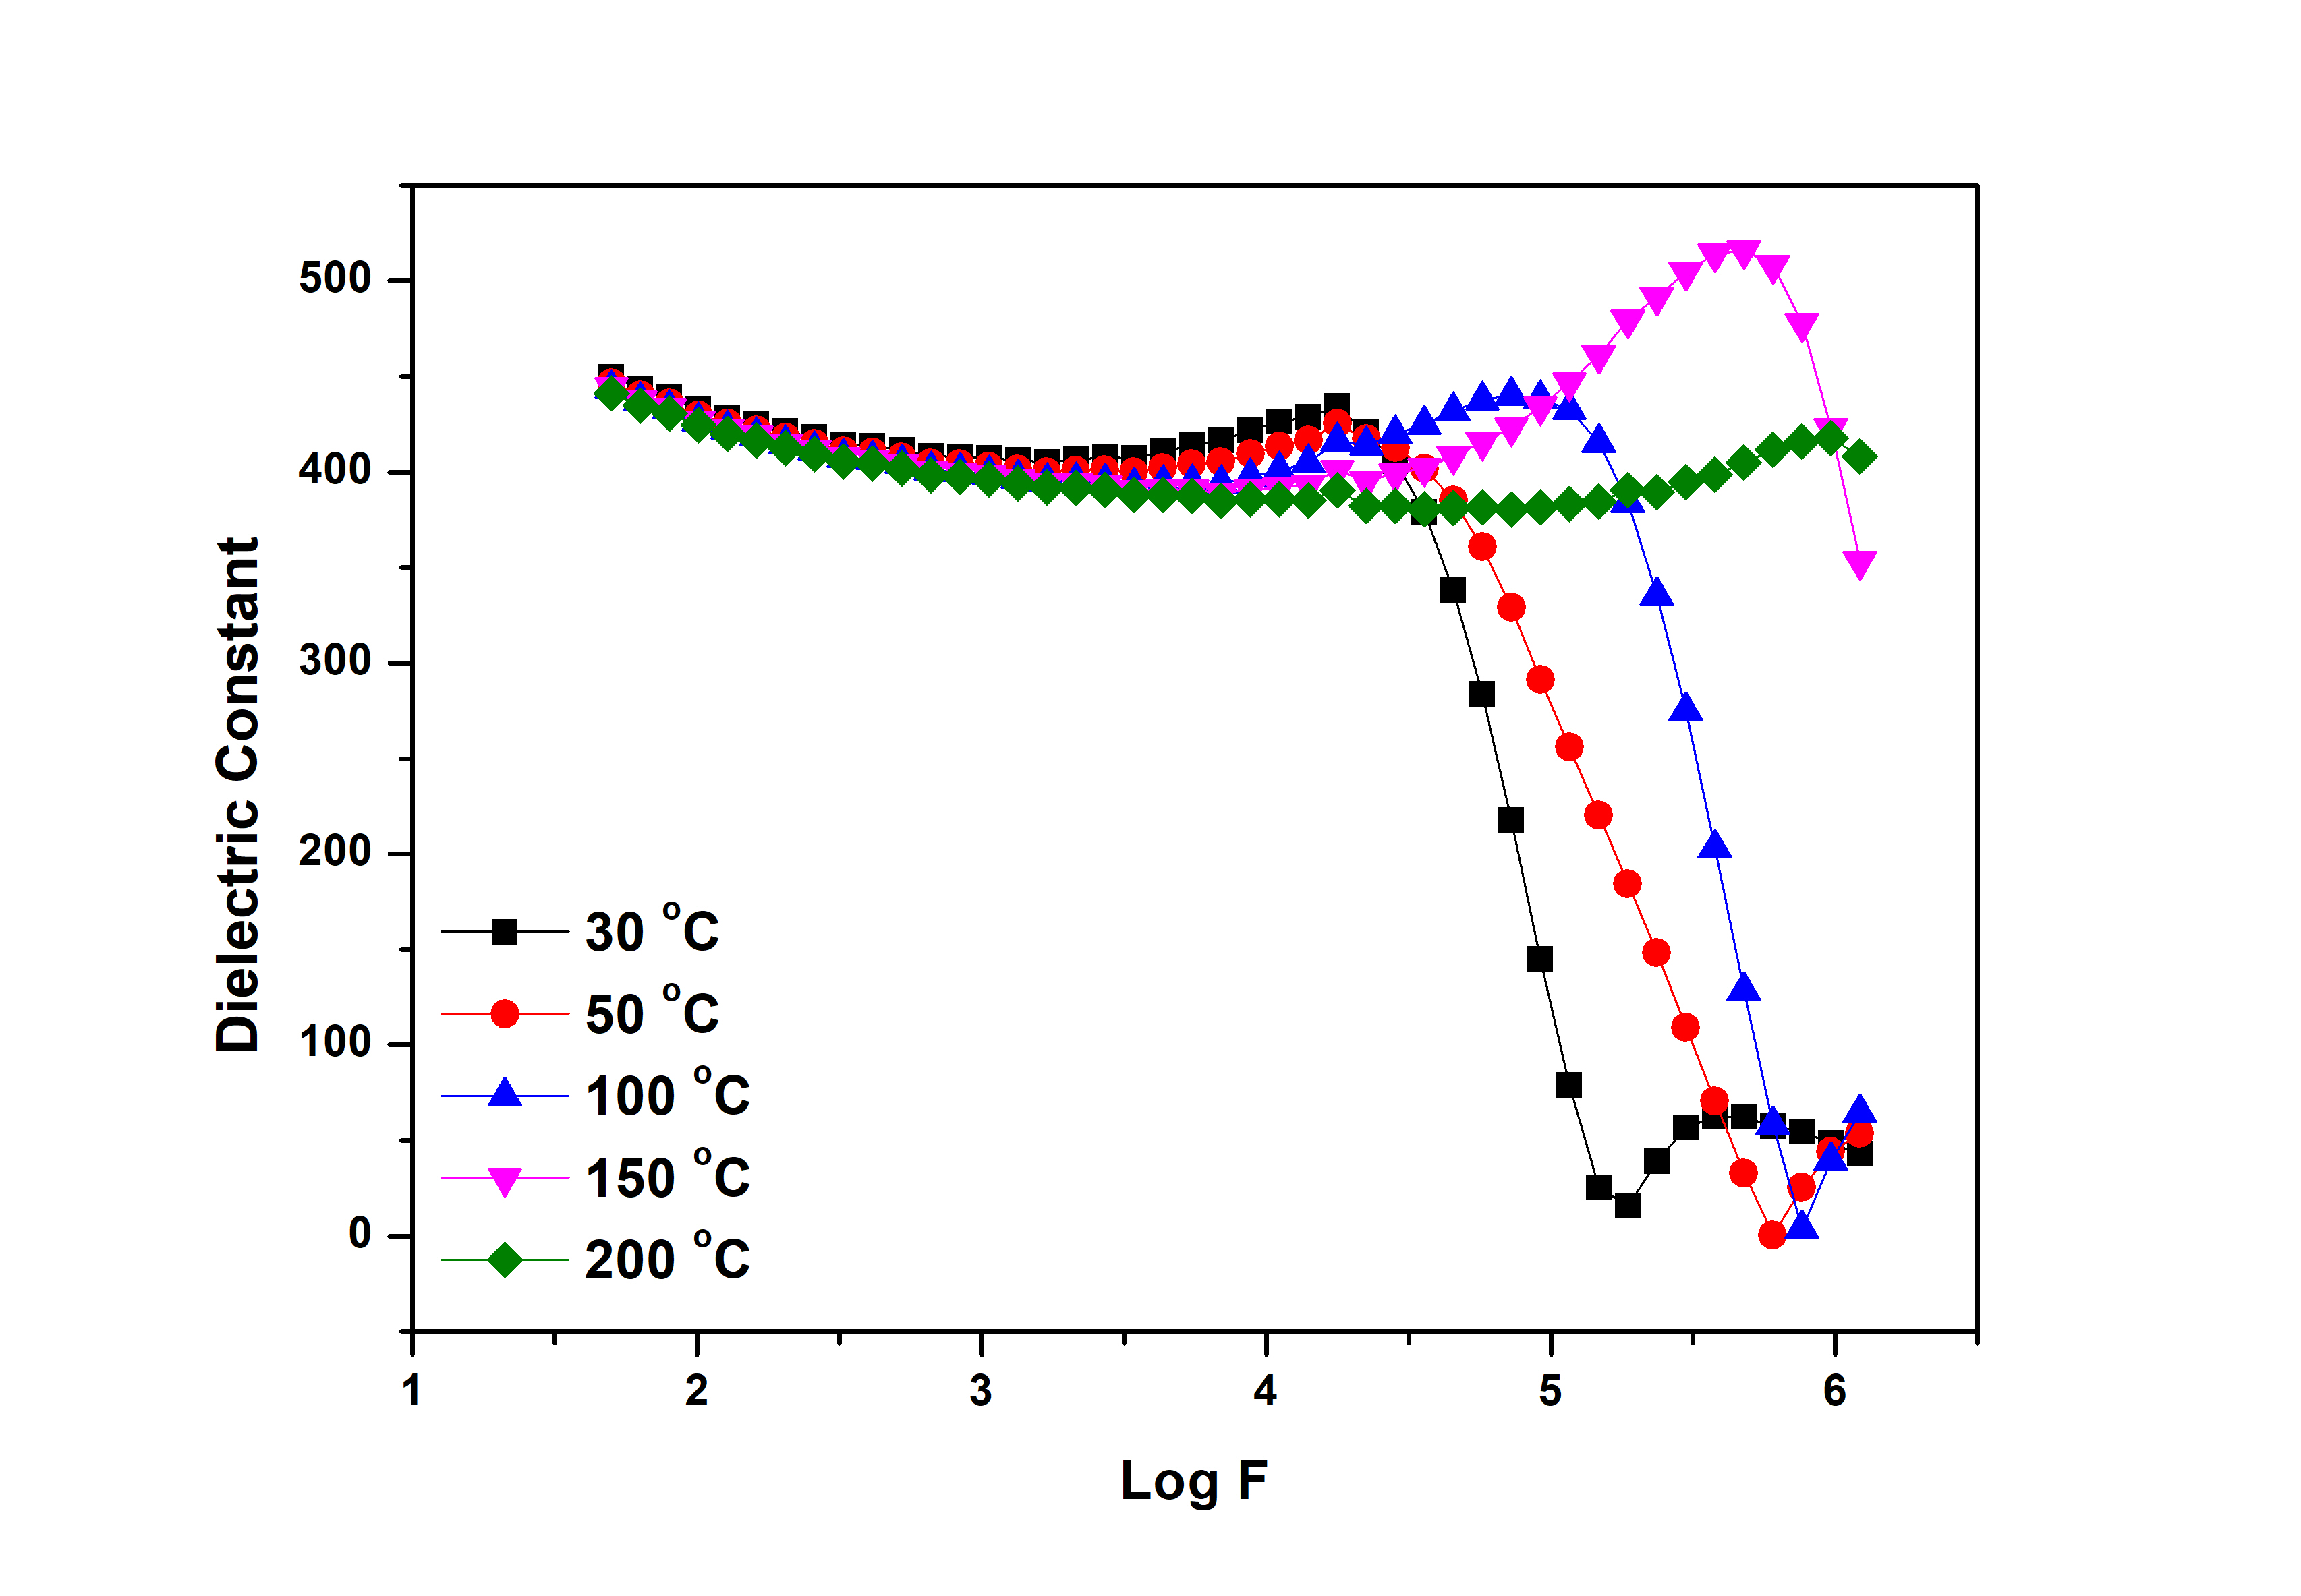
Figure 1: Dielectric constant as a function of frequency.
Figure 1 illustrates the variation of the dielectric constant with frequency at different temperatures. The data in the figures clearly indicate that as the frequency increases, the dielectric constant exhibits a decreasing trend. This behavior can be attributed to the behavior of charge carriers within the material. In the absence of an alternating current (AC) field, these charge carriers are confined to distinct localized states, each having its own unique dipole orientation. However, when subjected to an AC field, a charge carrier could move between these localized states, inducing a reorientation of the associated electric dipoles. Consequently, this gives rise to a frequency-dependent complex dielectric constant, which represents the amount of energy stored in the dielectric material as polarization and energy loss [7]. Hence, as the frequency increases, the dielectric constant decreases due to the energy spent on reorienting dipoles. Furthermore, it is noteworthy that the dielectric constant increases with rising temperature. This phenomenon can be explained by the fact that increasing temperature provides the bound charge carriers with higher thermal excitation energy. This enhanced energy enables them to undergo greater polarization, resulting in an increase in the dielectric constant [8]. As temperature rises, the dipoles within the material become more mobile, responding more effectively to the applied electric field. Consequently, polarization increases, leading to a corresponding increase in the dielectric constant with increasing temperature.
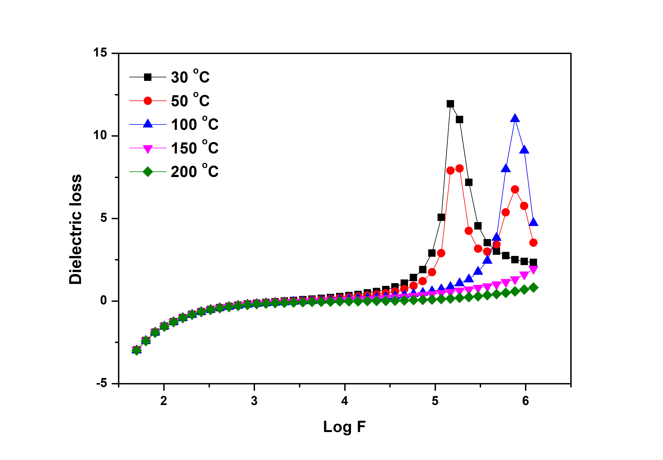
Figure 2: Dielectric Loss as a function of frequency.
From the tanδ, the relaxation of the charge carrier can be attained. The loss tangent can be defined as the ratio of energy loss to energy stored in a periodical field and is given by,
$tanδ= \frac{ϵ^{''}}{ϵ^{' }}$ (1)
where ϵ' and ϵ'' are real and imaginary part of ε_{r}. Figure 2 represent the variation of frequency dependent tanδ at different temperatures. The dielectric loss decreases with increasing with increasing frequency at lower frequencies and reverse trend observed at higher frequency regime. The rise in the loss tangent can be attributed to the increased prevalence of the Ohmic (active) component relative to the capacitive component (reactive). Conversely, the decline in tan δ is a result of the independent behavior of the Ohmic part and the augmentation of the reactive component with frequency [9].
The Cole-Cole plot (Zꞌ vs. Zꞌꞌ) for temperatures of 30 ºC and 200 ºC is illustrated in figure 3. At all temperatures, an intriguing trend toward semicircular behavior becomes evident, signaling the coexistence of both localized and non-localized conduction processes. This observation sheds light on the complex interplay of charge carriers within the material, where some are confined to specific sites (localized), while others exhibit more widespread mobility (non-localized). This duality in conduction mechanisms contributes to the observed semicircular patterns, providing further insight into the multifaceted nature of electrical behavior in the studied system [10].
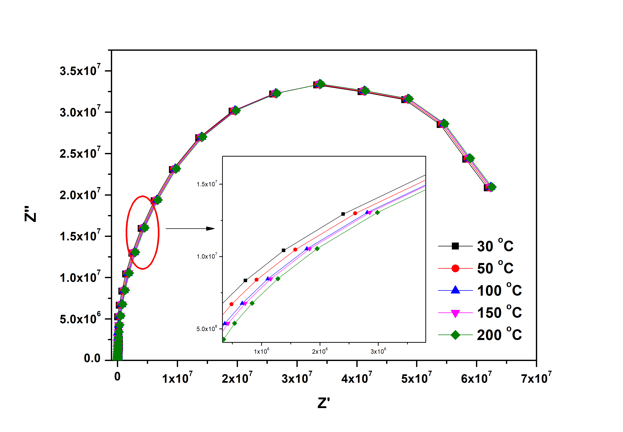
Figure 3: Cole-Cole plot of Z.
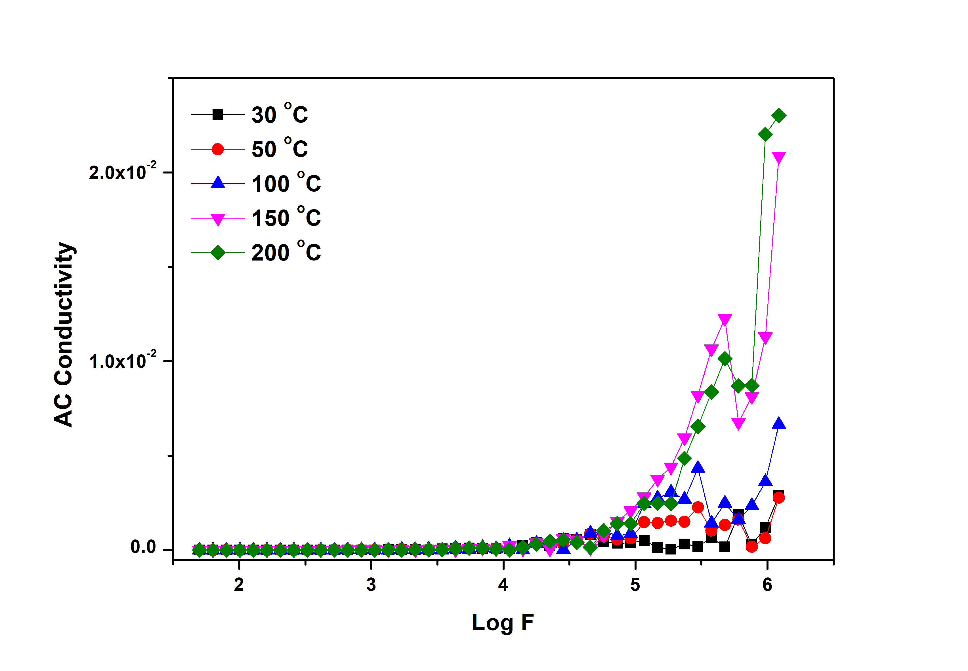
Figure 5: AC conductivity as a function of frequency.
The frequency dependence of the σ_{dc} for different temperatures is depicted in Figure 5. The conductivity follows the equation given by,
$σ\left(ω\right)= σ_{dc}+Aω^{n}$ (2)
where, A is the temperature dependent factor, ω=2πf is angular frequency and n is the frequency exponent of the mobile ions which measures the interaction of the charge carriers with the lattice. From the figure it can be observed that the conductivity is found to be constant in the lower frequency region which defines the dc part of conductivity at the lower region which is independent of frequency and increase with the increase in frequency which represents the ac part. It is also observed that the ac conductivity increases with increase in temperature at higher frequencies and is due to the occurrence of hopping type of conduction mechanism.

REFERENCES

- Oruç, Çiğdem, and Ahmet Altındal. "Structural and dielectric properties of CuO nanoparticles." Ceramics international, Vol. 43, no. 14 (2017): 10708-10714.
- Bouazizi, N., R. Bargougui, A. Oueslati, and R. Benslama. "Effect of synthesis time on structural, optical and electrical properties of CuO nanoparticles synthesized by reflux condensation method." advanced materials letters, Vol. 6, no. 2 (2015): 158-164.
- Yathisha, R. O., Y. Arthoba Nayaka, P. Manjunatha, H. T. Purushothama, M. M. Vinay, and K. V. Basavarajappa. "Study on the effect of Zn2+ doping on optical and electrical properties of CuO nanoparticles." Physica E: Low-dimensional Systems and Nanostructures, Vol. 108 (2019), pp. 257-268.
- Bhalerao-Panajkar, Rohini S., Mandar M. Shirolkar, Raja Das, Tuhin Maity, Pankaj Poddar, and S. K. Kulkarni. "Investigations of magnetic and dielectric properties of cupric oxide nanoparticles." Solid state communications, Vol. 151, no. 1 (2011) ), pp. 55-60.
- Hameed, S. T., Talal F. Qahtan, A. M. Abdelghany, and A. H. Oraby. "Structural, optical, and dielectric characteristics of copper oxide nanoparticles loaded CMC/PEO matrix." Journal of Materials Science, Vol. 57, no. 15 (2022) ), pp. 7556-7569.
- Mustapha, S., M. M. Ndamitso, A. S. Abdulkareem, J. O. Tijani, D. T. Shuaib, A. K. Mohammed, and A. Sumaila. "Comparative study of crystallite size using Williamson-Hall and Debye-Scherrer plots for ZnO nanoparticles." Advances in Natural Sciences: Nanoscience and Nanotechnology, Vol. 10, no. 4 (2019) ), pp. 045013.
- Schrödle, Simon, Gary Annat, Douglas R. MacFarlane, Maria Forsyth, Richard Buchner, and Glenn Hefter. "High frequency dielectric response of the ionic liquid N-methyl-N-ethylpyrrolidinium dicyanamide." Australian journal of chemistry, Vol. 60, no. 1 (2007) ), pp. 6-8.
- Izgorodina, Ekaterina I., Maria Forsyth, and Douglas R. MacFarlane. "On the components of the dielectric constants of ionic liquids: ionic polarization?." Physical chemistry chemical physics, Vol. 11, no. 14 (2009) ), pp. 2452-2458.
- Chopra, Sonalee, Seema Sharma, T. C. Goel, and R. G. Mendiratta. "Structural, dielectric and pyroelectric studies of Pb1− XCaXTiO3 thin films." Solid state communications, Vol. 127, no. 4 (2003) ), pp. 299-304.
- Li, Ming, Derek C. Sinclair, and Anthony R. West. "Extrinsic origins of the apparent relaxorlike behavior in CaCu3Ti4O12 ceramics at high temperatures: a cautionary tale." Journal of Applied Physics, Vol. 109, no. 8 (2011).

