Safe Riding Using IoT

Ila Chandrakar   
*Computer Science Engineering   
Presidency University*Bangalore, India  
https://orcid.org/0000-0002-0520-5772

Gopal K. Shyam  
*Computer Science Engineering   
Presidency University*Bangalore, India  
https://orcid.org/0000-0001-5562-5794

*Abstract*— Bike riding is a lot of fun, but it involves a lot of risk. People prefer motorcycles to cars because they are less expensive to operate, easier to park, and more flexible in traffic. More than 37 million people in India ride two-wheelers. Because of their widespread use, two-wheelers have a higher accident rate than four-wheelers. Motorcycles are more likely than four-wheelers to be involved in deadly accidents. The consequences are more dangerous when a driver is involved in a high-speed accident while not wearing a helmet. It is extremely dangerous and can result in fatalities. As a result, wearing a helmet can lower the incidence of accidents and potentially save lives.

This research aims to prevent accidents and design a helmet detection system. An intelligent or a safety helmet is the proposed system. A module affixed to the helmet syncs with the module affixed to the bike and ensures that the biker is wearing a helmet. An additional function of an accident avoidance detecting module will be added to the bike.

Keywords—IoT, Accident Prevention, Safe Driving

# Introduction

The goal of this research is to ensure complete safety for bike riders. Despite the fact that helmets have recently been mandatory, many people continue to drive without them. Pune City has over 35 lakh two-wheeler riders, resulting in 500-600 incidents every year, with 300-400 fatalities. When it comes to two-wheeler riders, Pune ranks one in the city. The incidence of vehicle accidents has increased dramatically in recent years. The surge in traffic accidents has necessitated the creation of a mechanism to limit accidental deaths. In comparison to those who do not wear helmets, fatalities wearing helmets have a higher chance of surviving.

The accident issues in bikes or two-wheelers can be solved using the Internet of Things (IoT). The Internet, a network of networks, allows us to access the entire globe with a single click. This paper provides a survey on the IoT, which is thought to be the next step in the Internet's evolution. The IoT connects the virtual and real worlds.

The most important IoT key elements that provide key incentives for organizations to use are:

**Sensing:** IoT sensing is the process of collecting data from connected things and delivering it to a data warehouse, database, or cloud. The information gathered is examined in order to take specific actions based on the services requested. Smart sensors, actuators, and wearable sensing devices are all examples of IoT sensors. Smart hubs and mobile applications from firms like Wemo, and Smart Things, for example, allow consumers to monitor and control thousands of smart gadgets and appliances within buildings using their smartphones.

Communication: IoT communication technologies allow heterogeneous items to communicate with one another in order to provide specialized smart services. In the context of lossy and noisy communication networks, IoT nodes should typically run at low power. Wi-Fi, Bluetooth, IEEE 802.15.4, Z-wave, and LTE-Advanced are examples of IoT communication protocols.

Semantics: In the IoT, semantics refers to the ability of various machines to extract knowledge intelligently in order to give essential services. Discovering and utilizing resources, as well as modeling data, are all part of knowledge extraction. It also entails recognizing and evaluating data in order to make the best decision for providing the best service. As a result, semantics acts as the IoT brain, routing requests to the appropriate resource.

# LITERATURE REVIEW

Many researchers have worked towards safety technology on the road while riding two-wheelers.

In [1], researchers have proposed a smart helmet prototype that is designed to identify and report two-wheeler incidents. To fulfill the end objectives of alerting and reporting, a microcontroller interfaced with an accelerometer and a GSM module, as well as cloud service infrastructures, are used. The helmet was created in such a way that it can detect a two-wheeler accident and relay the accident's geographical coordinates to the emergency authorities as well as the victim's emergency contacts. The helmet is equipped with a 6-axis accelerometer that continuously analyses the helmet's acceleration levels. When an accident is identified owing to inconsistent acceleration levels that are above the threshold, the GPS module gathers the GPS coordinates and sends a message to the emergency authorities' web server, which subsequently sends an emergency message to the victim's designated emergency contact.

The solution by researchers in [2] intends to provide a safe bike ride by utilizing a sensor that alerts the user to incoming automobiles and generates vibrations in the handlebar of the bike. When a person first starts riding a bike, he or she must first insert the bike key, which activates the bike's coordinate system. A wireless control system is used to operate it. The majority of the time, people are unconcerned about wearing a helmet. As a result, sensors are installed in the helmet to detect whether or not the individual is wearing it. The helmet will automatically lock and the bike's engine will start once the person has put it on. Underground Mines Safety with a Smart Helmet Using RF and WSN Technology is developed, through Communication Systems

The mine workers' safety is also ensured by the use of RF technology, which allows them to be located in a risky working environment. As a result, the suggested technology assures underground mining safety and dependable wireless communication.

The major goal of the work in [3] was to create a prototype model that would help motorcyclists improve their vision and safety while on the road. The smart control of headlamps using servo motors used here becomes active when certain circumstances are satisfied, such as appropriate helmet strap fastening, which then triggers the next event on the receiver circuit, causing the motorcycle to start. Riders are banned from riding without a proper helmet in this manner. Additional features included with this system enhance the user's safety, such as built-in sleep sensors that monitor the rider and alarms that limit the chance of falling asleep.

The introduction of a safety helmet [4] for coal mine workers is discussed. A methane and carbon monoxide gas sensor is included in this helmet. This sensor detects gas, and the information is wirelessly relayed to the control room via an X-Bee module attached to the helmet. When the quantity of methane or carbon monoxide gas exceeds the critical level, a controller in the control room activates an alarm, keeping the plant and its employees safe by preventing an impending accident.

Existing Systems:

The objective of the existing model of smart helmets is to prevent accidents. Wireless communications such as Bluetooth, and Zig-bee do exist for the purpose of communication between helmets and two-wheelers. For the detection of various activities of bike riders, many types of sensors are attached to the helmet. If the bike rider is in emergency condition then by using GSM and GPS sharing of the exact location is automatically existed. The other set of sensors is fixed to the helmet whether the user is drunk or not for their security purpose [5]. Along with other types of photoelectric cells speed limit sensors are fixed to the helmet module for decreasing the speed of motor vehicles. For measuring distance ultrasonic sensors and for converting text-to-speech, speech synthesizers are used [6]. There are many Research papers on ‘Smart Helmet’ for preventing road accidents and protecting the head from injuries [7]. Many authors are working to build smart helmets with different applications for the convenience of users. One example is that if the bike is stolen then by using a smart helmet, the identification is simple to know who had stolen it [8]. For different types of applications using this smart helmet is very beneficial.

In essence, the Smart Helmet project is a wireless communication network connected to a smartphone. This prototype uses communication technologies to automatically phone a predefined emergency contact number and sensors to detect wrecks or incidents. The cyclist's ability to control speed is the other system currently in use [9]. The helmet has all the parts and sensors necessary to read the bike's speed and instruct the rider to change their speed in reaction to obstacles in front of the bike. This has the following drawbacks: Riders do not wear helmets in areas where traffic enforcement is not enforced. In large countries like India, it is impractical to test the alcohol content of each individual rider's blood [10]. Traffic police have a difficult time enforcing traffic restrictions.

# PROPOSED WORK

## The proposed Safe Ride system using IoT assures the rider's safety while riding on the road. Alcohol detection, accident identification, location monitoring, and fall detection are all included in the proposed model. A Safe Ride is a sort of protective headgear worn by riders that makes them safer than they were previously. The primary goal of this helmet is to keep the rider safe. If the rider is inebriated or does not wear a helmet, the bike's engine will be turned off automatically. It also assists riders in the event of an accident by using our cloud service to notify the rider's location to an emergency contact number. If the rider has fallen from the bike and picks the bike within 10 seconds then SMS will not be sent.

## The different hardware and software components used in this proposed safe ride system are:

## Arduino Uno

Based on the Microchip ATmega328P microprocessor, Arduino.cc created the open-source Arduino Uno microcontroller board. A variety of expansion boards (shields) and other circuits can be connected to the board's digital and analog input/output (I/O) pins. The board has 14 digital I/O pins (six of which may produce PWM), and 6 analogue I/O pins, and is programmable using the Arduino IDE (Integrated Development Environment) using a type B USB cable. Voltages between 7 and 20 volts can be supplied via a USB cable or an external 9-volt battery. It resembles the Leonardo and Nano Arduino microcontrollers.

## Force Sensing Resistor (FSR)

Resistance to Force (FSR) Real human contact is recognized by the Force Sensing Resistor (FSR), which is housed inside the helmet. The helmet unit checks to see if it is on or off before starting the bike. The bike unit's signal to start is sent if this condition is satisfied. With a resistance that is inversely proportional to the force applied to the sensor's face, FSRs (Force Sensing Resistors) are polymer thick film (PTF) devices.

## MQ-2 Alcohol Sensor

Electronic sensors like the MQ2 gas sensor can identify gases in the air such as LPG, propane, methane, hydrogen, alcohol, smoke, and carbon monoxide. MQ2 gas sensor is also known as a chemi-resistor. The sensing material's resistance alters as it comes into touch with the gas. Based on a change in resistance value, gas can be detected.

## Micro-Electro-Mechanical System (MEMS)

MEMS, or Micro-Electro-Mechanical System, is a chip-based technology that uses a suspended mass between two capacitive plates to create sensors. This suspended mass creates an electrical potential difference when the sensor is tilted. The resulting difference is then measured as a capacitance change.

## 2*16 LCD (Liquid Crystal Display)

On each of the two lines of a 16x2 LCD, there can be 16 characters displayed per line. On this LCD, each character is displayed as a 5x7 pixel matrix. The 16 x 2 intelligent alphanumeric dot matrix display can show all 224 different characters and symbols.

## ESP-01-R5

## We can just add the ESP8266 module to the Arduino device and get almost the same amount of WiFi capability as a WiFi Shield because it is cheap and pre-programmed with an AT command set firmware. This module provides advanced onboard processing and storage through its GPIOs, making it possible to integrate it with sensors and other applications.

## In this section, we shall see how to get started with the ESP-01 Wi-Fi module, set ups, and device communication without the use of an FTDI chip.

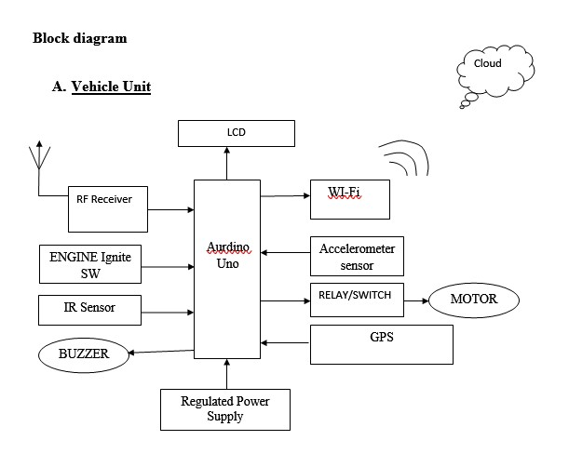

Figure 1

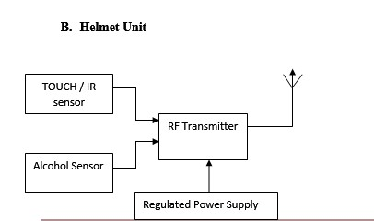

Figure 2

## 

The Methodology /Working of the Proposed system is as discussed below.

**Vehicle Unit:** The PIC microcontroller is connected to the RF receiver, LCD, Wi-Fi module, switches, IR sensor, accelerometer, relay, DC motor, and buzzer as shown in Figure 1. The LCD and WIFI modules will be initialized as soon as the power source is connected to the vehicle unit microcontroller.

When the power is turned on, the LCD will display "Please wear a helmet." When the driver puts on the helmet, the helmet unit will transmit an RF signal to the ignition switch, allowing the car to be started. If the vehicle does not receive a signal from the helmet unit, the controller will not allow the driver to use the ignition switch to start the vehicle.

If the vehicle unit detects alcohol, the controller will raise the alarm sound for 5 seconds and turn off the vehicle for the following 5 hours (for demo 1 minute). An IR sensor is used to detect an accident, and an accelerometer sensor is used to detect a vehicle's fall.

When an accident is detected, the status is transferred to the cloud, and we can receive alert SMS about the accident information from the cloud. GPS is used to track the vehicle and get the exact vehicle location.

**Helmet Unit:** The RF transmitter is connected to the Alcohol Sensor and the Touch Sensor as illustrated in Figure 2.

Alcohol detector, If the driver's blood alcohol level is detected, the sensor transmits an active high signal to the RF transmitter. If the rider is wearing a helmet, the output of the touch sensor or IR sensor becomes active high, and it transmits an active high signal to the RF transmitter, which activates the engine.

# EXPERIMENTS AND RESULTS

The experiments were carried out considering 100 riders who followed the traditional system and did not prioritize the prevention and detection of accidents. We also considered another set of 100 riders who followed the proposed system and prioritized the prevention and detection of accidents.

Following are the test cases for the detection and prevention of accidents.

Test Case 1: Detecting Helmet using FPS sensor

Test Case 2: Detecting Alcohol using MQ2

Test Case 3: Accident Detection Using IR

Test Case 4: Accident Detection Using MEMS

The results corresponding to the same are shown in Figure 3 and Figure 4 respectively.

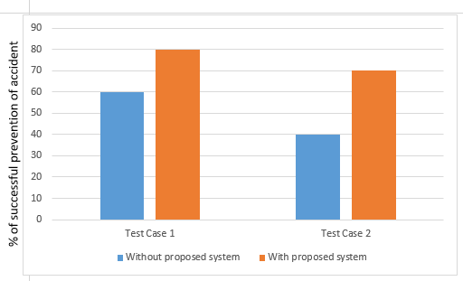

Figure 3: Percentage of successful prevention of accidents vs Test Cases

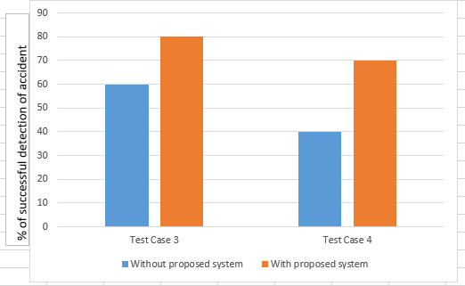

Figure 4: Percentage of successful detection of accidents vs Test Cases

##### CONCLUSION

The proposed research can produce the desired results because it is based on structured modeling. It can be successfully used as a Real-Time system with a few adjustments. Technology advances as a result of the ongoing discovery and creation of significant advancements in science across many fields. The majority of the modules, together with the microcontroller, can also be produced on a single chip, which makes the system more efficient and small. The system has to be upgraded to include components with a broader range in order to be usable in real time.

##### References

1. S. A. Shabbeer and M. Meleet, "Smart Helmet for Accident Detection and Notification," 2017 2nd International Conference on Computational Systems and Information Technology for Sustainable Solution (CSITSS), Bengaluru, India, 2017, pp. 1-5, doi: 10.1109/CSITSS.2017.8447702.
2. Archana D., ; Boomija G., ; Manisha J., ; Kalaiselvi V.K.G., “Mission on! Innovations in bike systems to provide a safe ride based on IOT”, 2nd International Conference on Computing and Communications Technologies (ICCCT), pp. 314–317. doi:10.1109/ICCCT2.2017.7972296
3. M. M., A. N. V. and S. R.K., "Smart helmets for automatic control of headlamps," 2015 International Conference on Smart Sensors and Systems (IC-SSS), Bangalore, India, 2015, pp. 1-4, doi: 10.1109/SMARTSENS.2015.7873589.
4. Muthiah M, ; Aswin Natesh V, ; Sathiendran R K, “Smart helmets for automatic control of headlamps”, IEEE 2015 International Conference on Smart Sensors and Systems (IC-SSS) - Bangalore, India (2015). pp 1-4
5. Vaishali, M. Ashwin Shenoy, P. R. Betrabet and N. S. Krishnaraj Rao, "Helmet Detection using Machine Learning Approach," 2022 3rd International Conference on Smart Electronics and Communication (ICOSEC), Trichy, India, 2022, pp. 1383-1388, doi: 10.1109/ICOSEC54921.2022.9952083.
6. Khamis, Y., Alawi, M., Athumani, R., & Sanya, W. (2022). An IoT Based Worker Safety Helmet Using Cloud Computing Technology. Tanzania Journal of Engineering and Technology, 41(1), 19-26
7. Xinlei Fan, Fan Wang, Shuai Pang, Jiaxing Wang, and Wenjing Wang "Safety helmet wearing detection based on EfficientDet algorithm", Proc. SPIE 12348, 2nd International Conference on Artificial Intelligence, Automation, and High-Performance Computing (AIAHPC 2022), 1234817 (10 November 2022)
8. Vibhutesh Kumar Singh, Himanshu Chandna1, Nidhi Upadhyay, “SmartPPM: An Internet of Things Based Smart Helmet Design for Potholes and Air Pollution Monitoring”, EAI Endorsed Transactions on Internet of Things, April 2019.
9. Y. Yorozu, M. Hirano, K. Oka, and Y. Tagawa, “Electron spectroscopy studies on magneto-optical media and plastic substrate interface,” IEEE Transl. J. Magn. Japan, vol. 2, pp. 740–741, August 1987 [Digests 9th Annual Conf. Magnetics Japan, p. 301, 1982].
10. M. Young, The Technical Writer’s Handbook. Mill Valley, CA: University Science, 1989.