**Hopf Bifurcation and Harvesting Analysis in Prey and Two Predators Model**

1Paparao.A.V, 2G.J.Naga Raju 3N V S R C Murty Gamini

1*Department of Mathematics ,2Department of Physics 3Department of S&H

JNTU-GV JNTU-GV BVCITS -Batlapalam

College of Engineering, Vizianagaram College of Engineering, Vizianagaram Amalapuram-533201

Vizianagaram A.P, India ,Vizianagaram A.P, India, E.G.dt-AP,India

[paparao.alla@gmail.com](mailto:paparao.alla@gmail.com) [gjnraju.phy@jntukucev.ac.in](mailto:gjnraju.phy@jntukucev.ac.in) [murthygamini@gmal.com](mailto:murthygamini@gmal.com)

**ABSTRACT**

In this chapter we studied the dynamics of three species model consisting of a single prey and two predators. The model in volved two predators preying on single prey. Two predators are neutral to each other and of generalist type. A delay is induced in the interaction of prey and second predator species and prey species is harvested. The model equations are described by system of delay differential equations. The co-existing state is identified, and local stability analysis is carried out at this point. The hopf bifurcation analysis is carried outat this point. The critical point is identified using numerical simulation. The harvesting effort of prey species is included in the study and identified the efforts which makes the system stable.

**Key wards**: prey, predator Time lags, Hopf Bifurcation, harvesting.

**AMS classification**: 34DXX

**I INTRODUCTION**

Ecological science gained a lot of importance in this era. The population dynamics of species is widely addressed by many authors. The stability analysis was the main aspect in ecological phenomenon. The modelling approach of ecological study was initiated byLokta [1] and Volterra [2]. The modelling of ecological communities isdispensed by using differential equations. the stability aspects using differential equations are dealt by Braun [9] and Simon’s [10]. The Wide range of model in ecological and epidemical is studied by Kapur [3, 4]. The qualitative analysis is the focus in ecological stability and dealt by authors [5-8]. The time delaysare quite common in biological and ecological phenomenon. The delays are of discrete, continuous are distributed type. The time lags approach in population dynamics was dealt by Cushing, J.M [11], Norman [12]. The time delays are stabilizes or destabilizes the system. The tendency of time delays is influential in ecological science. The approaches in delay differential equations are widely elaborated by the authors [13-15]. The approaches are not only in ecology but also in epidemiology. The time delays in epidemiology are also plays a significant role. Karuna [16] and Ranjith [17] studied the instability tendencies (Hopf bifurcation) in HIV and SIR epidemic models.The distributed time lags are also very important in ecological communities. These delays are significantly explaining the role of history of species dynamics. The role of kernel dynamics with different delay kernels in prey-predator and competitor populations are Widley studied by paparao e.tal [19-25].

The prey-predator models are always intersecting, three species models with one prey and two predators were discussed by shiva Reddy [18]. In his study he chooses the model with a prey, predator and super-predator. The dynamics was well established.The delaysare intersectingin prey-predator models. In this chapter we choose a model consisting of a single prey and two predators preying on a same prey. The two predators are having alternative food source. We infuse a discrete time lag (τ) in prey-predator model (logistic) in the interaction ofprey and second predator and also take harvesting of prey species. The stability analysis was carried out at normal study state and hopf bifurcation analysis is also addressed.Finally, the harvesting efforts are also identified in which the system stabilizes for certain harvesting efforts.

**II. FORMATION OF MATHEMATICAL MODE**L.

The mathematical for three species ecological species consists of a single prey and two predators preying on this prey species. Two predators are neutral to each other and have alternative food sources (Generalist predators). A logistic growth model is proposed for all three species. A discrete time lag is induced in the interaction of prey and second species. The harvesting effort on prey species is also taken investigation. The mathematical model is formulated with a system of delay differential equations given below.

$\frac{dx_{1}}{dt}=a_{1}x_{1}\left[1-\frac{x_{1}}{L_{1}}\right]-αx_{1}x_{2}-βx_{1}\left(t-τ\right)x_{3}\left(t-τ\right)-qEx_{1}$ $\frac{dx_{2}}{dt}=a{{}_{2}^{}x}_{2}\left[1-\frac{x_{2}}{L_{1}}\right]+δx_{1}x_{2}$ $\frac{dx_{3}}{dt}=a{{}_{3}^{}x}_{3}\left[1-\frac{x_{3}}{L_{1}}\right]+εx_{1}(t-τ)x_{3}(t-τ)$ (2.1)

With the following notations

x1(t) Prey density ,x2(t) First predator density ,x3(t) second predator density

 : Intrinsic growth rates three species

 : Inter species competition rate of three species

: Mutual interference strengths of three species

Li : Carrying capacities of three species q: Harsing effort, E: effort of harvesting

all the constants are assumed to be positive

**III. EXISTENCE OF EQUILIBRIUM:**

The system (2.1) admits a positive equilibrium point for the co-existence state if the following conditions hold good.

1. $a_{1}qE>αL_{2}+βL_{3}$ (ii)  (iii) 

The co-existing state given by

$$\overline{x_{1}}=\frac{L_{1}a_{1}a_{3}\left(a_{1}qE-αL_{2}-βL_{3}\right)}{a_{1}a_{2}a_{3}qE+a_{3}δαL_{1}L_{2}+a_{2}βεL_{1}L_{3}}$$ $\overline{ x_{2}}=\frac{L_{2}[a_{1}a_{3}a_{2}qE+a_{1}a_{3}αL_{1}qE+βL_{1}L_{3}(εa_{2}-δa_{3})}{a_{1}a_{2}a_{3}qE+a_{3}δαL_{1}L_{2}+a_{2}βεL_{1}L_{3}}$ (3.1)

$\overline{{ x}_{3}}=\frac{L_{3}[a_{1}a_{3}a_{2}qE+a_{1}a_{2}εL_{1}qE+αL_{1}L_{2}(δa_{3}-εa_{2})}{a_{1}a_{2}a_{3}qE+a_{3}δαL_{1}L_{2}+a_{2}βεL_{1}L_{3}}$

**IV. LOCAL STABILITY ANALYSIS:**

**Theorem 4.1:** The co-existing statecislocally asymptotically stable

**Proof:** The Jacobean matrix for the system of equations (2.1) is given by

$J=\left[\begin{matrix}βx_{3}(1-e^{-λτ})-\frac{a_{1}x_{1}}{L_{1}} & -αx_{1-qE} & -βx_{1}e^{-λτ} \\ δx_{2} & \frac{a_{2}x_{2}}{L_{2}} & 0 \\ εx_{3}e^{-λτ} & 0 & -εx_{1}(1-e^{-λτ})-\frac{a_{3}x_{3}}{L_{3}}\end{matrix}\right]$ (4.1)

With the characterstic equation is given by

 $$\left|J-λI\right|=\left|\begin{matrix}βx_{3}\left(1-e^{-λτ}\right)-\frac{a_{1}x_{1}}{L_{1}}-qE-λ & -αx_{1} & -βx_{1}e^{-λτ} \\ δx_{2} & -\frac{a_{2}x_{2}}{L_{2}}-λ & 0 \\ εx_{3}e^{-λτ} & 0 & -εx_{1}(1-e^{-λτ})-\frac{a_{3}x_{3}}{L_{3}}-λ\end{matrix}\right|=0$$

(4.2)

Where

$$p_{1}=(\frac{a_{2}x_{2}}{L_{2}}+εx_{1}+\frac{a_{1}x_{1}}{L_{1}}-qE-βx_{3}+\frac{a_{3}x_{3}}{L_{3}}) \\ p_{2}=(δαx_{1}x_{2}+\frac{a_{3}a_{2}x_{3}x_{2}}{L_{3}L_{2}}+\frac{εa_{2}x_{1}x_{3}}{L_{3}}+\frac{{(a}_{1}-qE)a_{2}x_{1}x_{2}}{L_{1}L_{2}}+\frac{{(a}_{1}-qE)ε{x_{1}}^{2}}{L_{1}}+\frac{(a_{1}-qE)a_{2}x_{1}x_{2}}{L_{1}L_{2}}-\frac{βa_{3}{x_{3}}^{2}}{L_{3}}-\frac{βa_{2}x_{2}x_{3}}{L_{2}}-βεx_{1}x_{3}) \\ p_{3}=(\frac{(a_{1}-qE)a_{2}a_{3}x_{1}x_{2}x_{3}}{L_{1}L_{2}L_{3}}+\frac{(a_{1}-qE)a_{2}ε{x_{1}}^{2}x_{2}}{L_{1}L_{2}}-\frac{a_{3}a_{2}x_{2}{x_{3}}^{2}β}{L_{3}L_{2}}+\frac{(a_{1}-qE)a_{3}x_{1}x_{3}}{L_{1}L_{3}}+\frac{αδx_{1}x_{2}x_{3}a_{3}}{L_{3}}-\frac{βεx_{1}x_{2}x_{3}a_{2}}{L_{2}}+βαδ{x_{1}}^{2}x_{2}) \\ q_{1}=(βx_{3}-εx_{1}) \\ q_{2}=(\frac{a_{3}β{x_{3}}^{2}}{L_{3}}-\frac{(a_{1}-qE){x_{1}}^{2}ε}{L_{1}}-2βεx_{1}x_{3}-\frac{εa_{2}x_{1}x_{2}}{L_{2}}) \\ q_{3}=(\frac{2βεa_{2}x_{1}x_{2}x_{3}}{L_{2}}+\frac{βa_{3}a_{2}{x_{3}}^{2}x_{2}α}{L_{3}L_{2}}-\frac{(a_{1}-qE)a_{2}ε{x_{1}}^{2}x_{2}}{L_{1}L_{2}}-βεδ{x_{1}}^{2}x_{3})$$

We need to find the condition for existence of negative real roots

**Case (i) :**For equation (4.2) becomes

$$ψ(λ,0)=λ^{3}+λ^{2}(\frac{(a_{1}-qE)x_{1}}{L_{1}}+\frac{a_{2}x_{2}}{L_{2}}+\frac{a_{3}x_{3}}{L_{3}})+λ(\frac{(a_{1}-qE)a_{2}x_{1}x_{2}}{L_{1}L_{2}}+αδx_{1}x_{2} \\ +\frac{a_{3}a_{2}x_{3}x_{2}}{L_{3}L_{2}}+\frac{(a_{1}-qE)a_{3}x_{1}x_{3}}{L_{1}L_{3}}+βεx_{1}x_{3})+(\frac{(a_{1}-qE)a_{2}a_{3}x_{1}x_{2}x_{3}}{L_{1}L_{2}L_{3}}+\frac{αδa_{3}x_{1}x_{2}x_{3}}{L_{3}}+\frac{βεx_{1}x_{2}x_{3}a_{2}}{L_{2}})=0$$

In simplest form the above equation can be represented as $b_{0}λ^{3}+b_{1}λ^{2}+b_{2}λ+b_{3}=0$

Where

$$b_{0}=1$$

$$b_{1}=\frac{\left(a_{1}-qE\right)x_{1}}{L_{1}}+\frac{a_{2}x_{2}}{L_{2}}+\frac{a_{3}x_{2}}{L_{3}}$$

$$b_{2}=\frac{\left(a_{1}-qE\right)a_{2}x_{1}x_{2}}{L_{1}L_{2}}+\frac{a_{3}\left(a_{1}-qE\right)x_{1}x_{3}}{L_{1}L_{3}}+\frac{{a_{2}a}_{3}{x_{3}x}_{2}}{{L_{2}L}_{3}}+αδx_{1}x_{2}+βεx_{1}x_{1}$$

$$b_{3}=x_{1}x_{2}x_{3}\left(\frac{\left(a_{1}-qE\right)a_{2}{a_{3}}_{1}}{L_{1}L_{2}L_{3}}+\frac{a_{3}δα}{L_{3}}+\frac{a_{2}βε}{L_{2}}\right)$$

By using Routh-Hurwitz criteria, we calculate the following determinants



$$D_{1}=b_{1},D_{2}=\left|\begin{matrix}b_{1} & b_{3} \\ b_{0} & b_{2}\end{matrix}\right|,D_{3}=\left|\begin{matrix}b_{1} & b_{3} & b_{5} \\ b_{0} & b_{2} & b_{4} \\ 0 & b_{1} & b_{3}\end{matrix}\right|$$

$$D_{1}=b_{1}=\left(\frac{(a_{1}-qE)x_{1}}{L_{1}}+\frac{a_{2}x_{2}}{L_{2}}+\frac{a_{3}x_{3}}{L_{3}}\right)>0 \\ D_{1}>0at E({\bar{x}}_{1},{\bar{x}}_{2},{\bar{x}}_{3}).$$

$D_{2}=b_{1}b_{2}-b_{3}b_{0}$

Clearly 



Hence the co-existing stateis locally asymptotically stable.

**Case (ii) for τ > 0:**

Suppose there is positive  such that the equation (3.1) has pair of purely imaginary root, can be taken as  then satisfies the equation (4.1)

Putting $λ=iω,ω>0$ we have

$$ψ(iω,τ)=(iω)^{3}+p_{1}(iω)^{2}+p_{2}(iω)+p_{3}+e^{-iωτ}(q_{1}(iω)^{2}+q_{2}(iω)+q_{3})=0$$

$$ψ(iω,τ)=(iω)^{3}+p_{1}(iω)^{2}+p_{2}(iω)+p_{3}+[\cos{(}ωτ)-i\sin{(}ωτ)][q_{1}(iω)^{2}+q_{2}(iω)+q_{3}]=0$$

$$-ω^{2}p_{1}+p_{3}-q_{1}ω^{2}\cos{ω}τ+q_{3}\cos{ω}τ+q_{2}ω\sin{ω}τ+i[-w^{3}+wp_{2}+q_{2}ω\cos{ω}τ+q_{1}ω^{2}\sin{ω}τ-q_{3}\sin{ω}τ]=0$$

$$\left(q_{3}-q_{1}ω^{2}\right)\cos{ω}τ+q_{2}ω\sin{ω}τ=ω^{2}p_{1}-p_{3} (4.3)$$

$$q_{2}ω\cos{ω}τ-\left(q_{3}-q_{1}ω^{2}\right)\sin{ω}τ=ω^{3}-ωp_{2} (4.4)$$

On simplication we get

$$(3.3)^{2}+(3.4)^{2}⇒$$

$$(q_{3}-q_{1}ω)^{2}+(q_{2}ω)^{2}=(ω^{2}p_{1}-p_{3})^{2}+(ω^{3}-ωp_{2})^{2}$$

$$ω^{6}+ω^{4}({p_{1}}^{2}-2p_{2}-{q_{1}}^{2})+ω^{2}(p_{2}^{2}-2p_{1}p_{3}-q_{2}^{2}+2q_{1}q_{3})+{q_{3}}^{2}+{p_{3}}^{2}=0$$

$$letψ(p)=p^{3}+p^{2}N_{1}+pN_{2}+N_{3}=0$$

Where

$$N_{1}=p_{1}^{2}-2p_{1}-{q_{1}}^{2} \\ N_{2}=p_{2}^{2}-2p_{1}p_{2}-q_{2}^{2}+2q_{1}q_{3} \\ N_{3}=q_{3}^{3}+p_{3}^{3} \\ p=ω^{2}$$

$$∴ψ(p)=0$$

If we assume that $N_{1}>0,N_{2}>0,N_{3}>0$ then have no positive real roots

$$N_{1}=p_{1}^{2}-2p_{1}-{q_{1}}^{2}N_{2}=p_{2}^{2}-2p_{1}p_{2}-q_{2}^{2}+2q_{1}q_{3}N_{3}=q_{3}^{3}+p_{3}^{3}$$

Thus if $N_{1}>0,N_{2}>0,N_{3}>0$ then there is no  such that  is an Eigen value of the characteristic equation of $ψ(λ,τ)=0$

If  will never be a purely imaginary root of equation $ψ(λ,τ)=0$, thus the real parts of all Eigen values of

$ψ(λ,τ)=0$ are negative for all summarizing, the above analysis, we have the following theorem

**Theorem 4.2**: Co-existing state $E(\overline{x_{1}},\overline{x_{2}},\overline{x_{3}})$ is locally asymptotically stable for all ,if following condition hold.

$$1.(p_{1}+q_{1})>0,(p_{2}+q_{2})>0,(p_{3}+q_{3})>0 \\ 2.N_{1}>0,N_{2}>0,N_{3}>0$$

Now if any one of $N_{1},N_{2},N_{3}$ is negative then (2.1) has positive root 

Eliminating  from equation (4.3)&(4.4) we get

$$\cos{ω}τ=\frac{\left|\begin{matrix}ω^{2}p_{1}-p_{3} & q_{2}ω \\ ω^{3}-ωp_{2} & -(q_{3}-q_{1}ω^{2})\end{matrix}\right|}{\left|\begin{matrix}q_{3}-q_{1}ω^{2} & q_{2}ω \\ q_{2}ω & -(q_{3}-q_{1}ω^{2})\end{matrix}\right|}$$

$$\cos{ω}τ=\frac{ω^{2}p_{1}q_{3}-p_{3}q_{3}-ω^{4}p_{1}q_{1}+ω^{2}q_{1}p_{3}+q_{3}w^{3}-p_{2}q_{3}ω^{2}}{q_{3}^{2}+q_{1}^{2}ω^{4}-2q_{1}q_{3}w^{2}+q_{2}^{2}ω^{2}}$$

$τ_{k}=\frac{1}{ω_{0}}\cos^{-1}\left[\frac{ω_{0}^{4}(q_{3}-p_{1}q_{1})+ω_{0}^{2}(p_{1}q_{3}+q_{1}p_{3}-p_{2}q_{3})-p_{3}q_{3}}{q_{1}^{2}ω_{0}^{4}+ω_{0}^{2}(q_{2}^{2}-2q_{1}q_{3})+q_{3}^{2}}\right]+\frac{2kπ}{ω_{0}}$ (4.5)

$$where k=0,1,2,3...............$$

**V. HOPFBIFURCATIONS**

**Theorem 5.1:** The sufficient condition for the system (2.1) admits bifurcation along the normal steady state E if

$τ>τ_{0}$ and locally asymptotically stable if $0<τ<τ_{0}$

**Proof:** Hopf bifurcation occurs when the real part of $λ(t)$ become positive when $τ>τ_{0}$ and the steady state become unstable moreover, when passes through the critical value.

To check this result, differentiating (4.2) W .r t. $τ$, we get

$$ψ(λ,τ)=λ^{3}+p_{1}λ^{2}+p_{2}λ+p_{3}+e^{-λτ}(q_{1}λ^{2}+q_{2}λ+q_{3})=0$$

= $3λ^{2}\frac{dλ}{dτ}+2p_{1}λ\frac{dλ}{dτ}+p_{2}\frac{dλ}{dτ}+e^{-λτ}(2q_{1}λ\frac{dλ}{dτ}+q_{2}\frac{dλ}{dτ})+(q_{1}λ^{2}+q_{2}λ+q_{3})(-λ-λ\frac{dλ}{dτ})e^{-λτ}=0$

$$\frac{dλ}{dτ}\left[3λ^{2}+2p_{1}λ+p_{2}+e^{-λτ}(2q_{1}λ+q_{2})-(q_{1}λ^{2}+q_{2}λ+q_{3})λe^{-λτ}\right]=(q_{1}λ^{2}+q_{2}λ+q_{3})λe^{-λτ}$$

$${\left[\frac{dλ}{dτ}\right]}^{-1}=\frac{\left[3λ^{2}+2p_{1}λ+p_{2}+e^{-λτ}(2q_{1}λ+q_{2})-(q_{1}λ^{2}+q_{2}λ+q_{3})πe^{-λτ}\right]}{(q_{1}λ^{2}+q_{2}λ+q_{3})λe^{-λτ}}$$

$${\left[\frac{dλ}{dτ}\right]}^{-1}=\frac{3λ^{2}+2p_{1}λ+p_{2}}{(q_{1}λ^{2}+q_{2}λ+q_{3})λe^{-λτ}}+\frac{(2q_{1}λ+q_{2})}{(q_{1}λ^{2}+q_{2}λ+q_{3})λ}-\frac{τ}{λ}$$

$${\left[\frac{dλ}{dτ}\right]}^{-1}=\frac{3λ^{2}+2p_{1}λ+p_{2}}{-λ(λ^{3}+p_{1}λ^{2}+p_{2}λ+p_{3})}+\frac{(2q_{1}λ+q_{2})}{(q_{1}λ^{2}+q_{2}λ+q_{3})λ}-\frac{τ}{λ}$$

Put $λ=iω$ in the above equation

$${\left[\frac{dλ}{dτ}\right]}^{-1}=\frac{1}{ω_{0}}\left[\frac{-3{ω_{0}}^{2}+2ip_{1}ω_{0}+p_{2}}{(-{ω_{0}}^{3}+p_{2}ω_{0}+i(p_{1}ω_{0}^{2}-p_{3})^{2}}+\frac{(2iq_{1}ω_{0}+q_{2})}{-q_{2}ω_{0}+i(q_{3}-q_{1}ω_{0}^{2})}+τi\right]$$

$${\left[\frac{dλ}{dτ}\right]}^{-1}=\frac{1}{ω_{0}}\left[\frac{(-3{ω_{0}}^{2}+2ip_{1}ω_{0}+p_{2})((-{ω_{0}}^{3}+p_{2}ω_{0}-i(p_{1}ω_{0}^{2}-p_{3})}{(-{ω_{0}}^{3}+p_{2}ω_{0})^{2}+(p_{1}ω_{0}^{2}-p_{3})^{2}}+\frac{(2iq_{1}ω_{0}+q_{2})(-q_{2}ω_{0}-i(q_{3}-q_{1}ω_{0}^{2})}{(q_{2}ω_{0})^{2}+(q_{3}-q_{1}ω_{0}^{2})^{2}}+τi\right]$$

Real part of ${\left[\frac{dλ}{dτ}\right]}^{-1}$

= $\frac{1}{ω_{0}}\left[\frac{(-3{ω_{0}}^{2}+p_{2})(-{ω_{0}}^{3}+p_{2}ω_{0})+2p_{1}ω_{0}(p_{1}ω_{0}^{2}-p_{3})}{(-{ω_{0}}^{3}+p_{2}ω_{0})^{2}+(p_{1}ω_{0}^{2}-p_{3})^{2}}+\frac{-{q_{2}}^{2}ω_{0}+2q_{1}ω_{0}(q_{3}-q_{1}ω_{0}^{2})}{(q_{2}ω_{0})^{2}+(q_{3}-q_{1}ω_{0}^{2})^{2}}\right]$

On substituting $(-{ω_{0}}^{3}+p_{2}ω_{0})^{2}+(p_{1}ω_{0}^{2}-p_{3})^{2}=(q_{2}ω_{0})^{2}+(q_{3}-q_{1}ω_{0}^{2})^{2}$

= $\frac{1}{ω_{0}}\left[\frac{3ω_{0}^{5}+ω_{0}^{3}\left(2p_{1}^{2}-p_{2}-3p_{2}-2q_{1}^{2}\right)+\left(p_{2}^{2}-2p_{1}p_{3}+2q_{1}q_{2}-q_{2}^{2}\right)ω_{0}}{(q_{2}ω_{0})^{2}+(q_{3}-q_{1}ω_{0}^{2})^{2}}\right]$

$${\operatorname{Re}\left[\frac{dλ}{dτ}\right]}^{-1}=\left[\frac{3ω_{0}^{4}+ω_{0}^{2}\left(2p_{1}^{2}-4p_{2}-2q_{1}^{2}\right)+p_{2}^{2}-2p_{1}p_{3}+2q_{1}q_{2}-q_{2}^{2}}{(q_{2}ω_{0})^{2}+(q_{3}-q_{1}ω_{0}^{2})^{2}}\right]$$

$$\left[\frac{d}{dτ}\operatorname{Re}{(}λ)\right]={\left[{\operatorname{Re}\left(\frac{dλ}{dτ}\right)}^{-1}\right]}_{λ=iω_{0}}=\left[\frac{3ω_{0}^{4}+ω_{0}^{2}(2p_{1}^{2}-4p_{2}-2q_{1}^{2})+p_{2}^{2}-2p_{1}p_{3}+2q_{1}q_{3}-q_{2}^{2}}{(q_{2}ω_{0})^{2}+(q_{3}-q_{1}ω_{0}^{2})^{2}}\right]$$

= $\left[\frac{3ω_{0}^{4}+2ω_{0}^{2}N_{1}+N_{2}}{(q_{2}ω_{0})^{2}+(q_{3}-q_{1}ω_{0}^{2})^{2}}\right]$

By using this conditionN1>0, N2>0, N3>0 we have ${\left[\frac{d}{dτ}(\operatorname{Re}{(}λ))\right]}_{λ=iω_{0}}>0$

Therefore, the Hopf bifurcation occurs at $τ>τ_{0}$

**VI. NUMERICAL EXAMPLE:**

Numerical simulation is carried out in support of bifurcation analysis along co-existing state for the system of equations (2.1). Four set of parametric values are chosen for investigation and identified the bifurcation parameter (τ0) shownbelow.

In each graph, figure (a) represents Time series responsesand (b) represents Phase portraits

**Example 6.1:** Let us parametric values

$$a_{1}=1,a_{2}=2,a_{3}=3,α=0.1,β=0.1,δ=0.2,ε=0.1,L_{1}=100,L_{2}=100,L_{3}=100 \\ x_{1}=20,x_{2}=20,x_{3}=20.$$

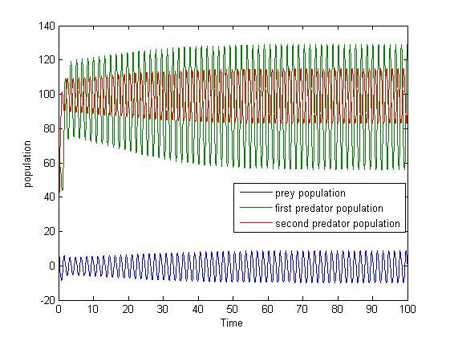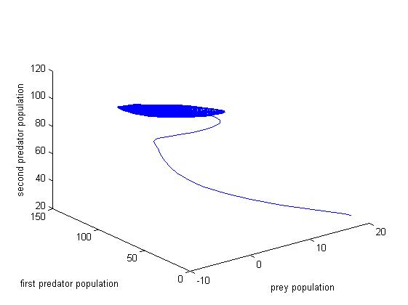

**Fig 6.1.1(A) Fig 6.1.1(B)**

The system possesses unbounded periodic solutions hence the system (2.1) becomes unstable for the critical parameter τ = 0.7.

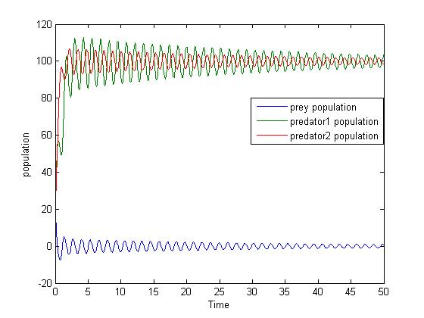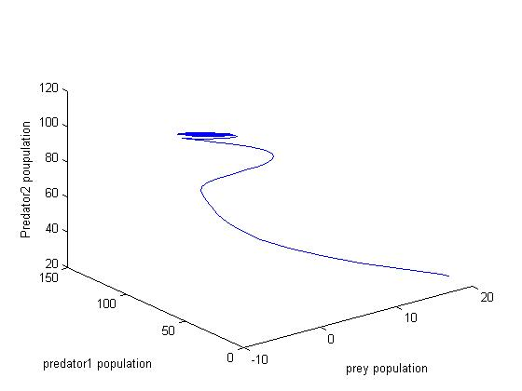

**Fig 6.1.2(A) Fig 6.1.2(B)**

The system becomes stable for τ = 0.65 for the system of equations (2.1).

The critical parameter ‘τ ‘is identified using numerical simulation where the stable system becomes unstable when the critical parameter ‘τ ‘value greater than 0.65.

Now the harvesting parameter dynamics is also discussed with various catch ability coefficient (q) values and effort (E) is shown below.

**Case (i)** :When harvesting effort was induced on prey species the dynamics of q = 1 and E= 5

|  |  |
| --- | --- |
|  |  |

**Fig 6.1.3(A) Fig 6.1.3(B)**

The system admits unbounded periodic solutions with τ = 0.7 and q =1, E=5 makes the system (2.1) unstable.

**Case (ii)** : When harvesting effort was induced on prey species the dynamics of q = 0.1 and E= 5

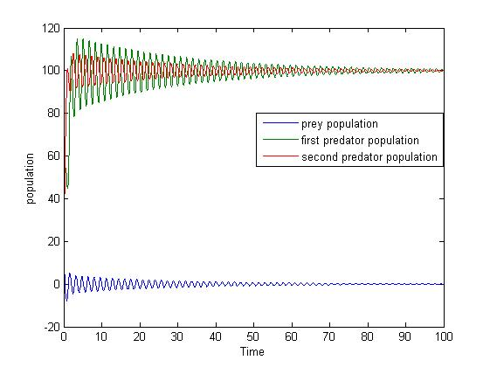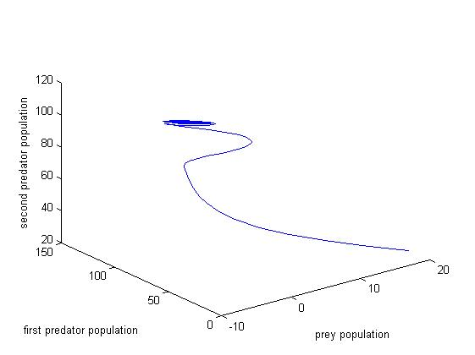

**Fig 6.1.4(A) Fig6.1.4(B)**

The system of equations (2.1) possesses bounded variations and makes the system asymptotically stable for τ = 0.7 and q =0.1, E=5.

**Case(iii) :**When harvesting effort was induced on prey species the dynamics of q = 1 and E= 10

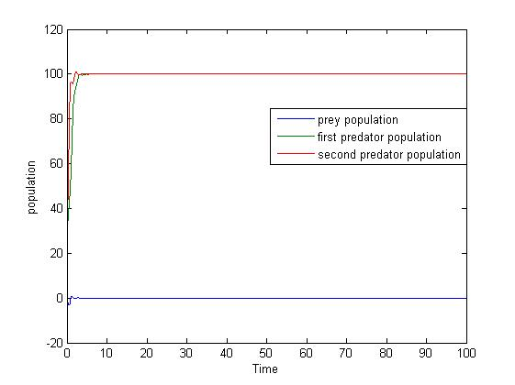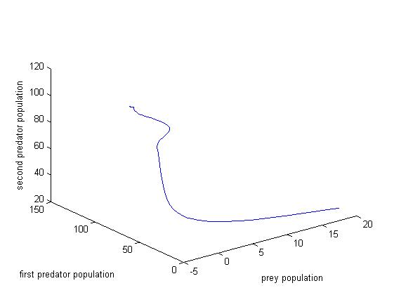

**Fig 6.1.5(A) Fig 6.1.5(B)**

The system is stable for τ = 0.7 and q=1, E= 10.

**VII. DISCUSSION AND CONCLUSION**

The proposed model is asymptotically stable and exhibit Hopf bifurcation nature for certain critical valueτ = 0.65.The sufficient condition for Hopf bifurcation is derived and the critical value (τ0) is identified forone different set of parameters. The critical values for system (2.1) with four set examples are shown in the above graphs [6.1.1 -6.1.2]. The harvesting efforts are also identified in which the system becomes stable is identified using numerical simulation.

The system still admits unstable nature for τ = 0.7 and q=1,E= 5 and becomes asymptotically stable for τ = 0.7 and becomes stable for τ = 0.7 and q=1,E= 10.

The system undergoes hopf bifurcation along the co-existing state and harvesting efforts are significant in stability analysis. The harvesting efforts are identified in which the unstable system becomes stable. Hence harvesting efforts are also significant in stability analysis.

**REFERENCES**

[1] Lotka. A.J.: Elements of physical biology, Williams and Wilkins, Baltimore, 1925.

[2] Volterra, V: Leconssen la theoriemathematique de la leitte pou lavie, Gauthier-Villars, Paris,1931.

[3] Kapur, J.N.: Mathematical Modeling, Wiley-Eatern, 1988.

[4]Kapur,J.N. :Mathematical Models in Biology and Medicine , Affiliated East-west, 1985.

[5] May, R.M.: Stability and complexity in model Eco-Systems, Princeton University press, Princeton, 1973.

[6] Murray**,** J.D.,MathematicalBiology-I:an Introduction, Third edition, *Springer,*2002.

[7]Freedman.H.I.: Deterministic mathematical models in population ecology, Marcel-Decker, New York,1980.

[8] Paul Colinvaux.: Ecology, John Wiley and Sons Inc., New York, 1986.

[9] Braun.M.: Differential equations and their applications- Applied Mathematical Sciences, (15) Springer*,* New York, 1978.

[10] George F.Simmons.: Differential Equations with Applications and Historical notes, Tata Mc.Graw-Hill, NewDelhi, 1974.

[11] Cushing, J.M.: Integro-Differential equations and delay models in population dynamics, Lect. notes in biomathematics, vol(20),Springer-Verlag, Heidelberg,1977.

[12] Norman Mcdonld “Time lags in Biological models, Lect. notes in biomathematics, vol(20),Springer-Verlag, Berlin Heidelberg,1978

[13] V.SreeHariRao and P. Raja SekharaRao, Dynamic Models and Control of Biological Systems, Springer Dordrecht Heidelberg London New York, 2009.

[14] Gopalaswamy, K: Mathematics and Its ApplicationsStability and Oscillations in Delay Differential Equations of Population Dynamics Kluwer Academic Publishers, 1992.

[15].KaungYang :Delay Differential equations with applications in population dynamics ,Academic press : 1993.

[16] Karuna, B. N. R., Lakshmi Narayan, K, ., Ravindra Reddy, B., A mathematical study of an infectious disease model with time delay in CTL response ,Global Journal of Pure and Applied Mathematics (GJPAM),11, 2015, pp.

[17] Ranjith Kumar, G., Lakshmi Narayan, K.,.,Ravindrareddy, B.,., Stability and Hopf Bifurcation analysis of SIR Epidemic model with time delay, APRN journal of Engineering and Applied sciences,11, 2016, pp. 1419-1423.

[18] Shiva Reddy .K “Some mathematical aspects of ecological multiple prey-predator systems “ Ph.D thesis JNTU Hyderabad 2013.

[19]. Papa Rao A.V., Lakshmi Narayan K.,Dynamics of Three Species Ecological Model with Time-Delay in Prey and Predator , Journal of Calcutta Mathematical society, vol 11,No 2, Pp.111-136, 2015.

[20] Papa Rao A.V., Lakshmi Narayan K., A prey, predator and a competitor to the predator model with time delay ,International Journal of Research In Science & Engineering, Special Issue March Pp 27-38 ,2017.

[21] Papa Rao A.V., Lakshmi Narayan K.,Dynamics of Prey predator and competitor model with time delay , International Journal of Ecology& Development , Vol 32, Issue No. 1Pp 75-86 , 2017.

[22] Papa Rao A.V., Lakshmi Narayan K., Optimal Harvesting of Prey in Three Species Ecological Model with a Time Delay on Prey and Predator ,Research Journal of Science and Technology, vol9 issue 03,2017.

[23] Papa Rao A.V., N.V.S.R.C.murtygamini “Dynamical Behaviour of Prey Predators Model with Time Delay “International Journal of Mathematics And its Applications .Vol 6 issue 3 Pp: 27-37 2018

[24] Papa Rao A.V., N.V.S.R.C.murtygamini “Stability Analysis of A Time Delay Three Species Ecological Model “International Journal of Recent Technology and Engineering (IJRTE) ., Vol7 Issue-6S2, PP:839-845 2019

[25] Papa Rao. A. V **,**Lakshmi Narayan. K **,**KondalaRao. K “Amensalism Model: A Mathematical Study “.,International Journal of Ecological Economics & Statistics (IJEES)Vol 40 , issue 3 ,Pp 75-87 2019