REVIEW OF PREPARATION AND EVALUATION OF POLYHERBAL HAIR OIL

INTRODUCTION:
The various products to enhance beauty and elegance to look young and charming. Cosmetics thus play a vital role in human life. Now a days, herbal cosmetic are widely used because of the Belief that they have fewer side effects and better safety. Hair is one of the primary parts of the body which Acts as a protective appendage. The objective of the present work is to develop a hair oil for general purpose (daily use) using various herbs. The formulated oil was evaluated for its organoleptic properties, acid value, Saponification value, refractive index, pH etc. All the parameters were found to be good and within the Standards.Hair is an epidermal derivative which is one of the vital parts increasing the overall Elegance of the body. Hair fall, dandruff, lice, spilt ends, grey hair are few problems involved with Hair faced by human1. To overcome these, human takes many measures by applying many Cosmetics for each. Hair oil is one among them used to solve almost all of these problems. Herbal cosmetics are in high demand due to the increasing interest of mankind towards Them because they are more effective with nil or less side effects, easily available ingredients etc. Hair care cosmetics are now added with herbs and they are well recognised compared with Synthetic ones.

COLLECTION OF PLANT MATERIALS:
Polyherbal hair oil was prepared[7-13] by collecting various plant materials like ficus Root, curry leaves, bringaraj leaves, henna leaves, hibiscus leaves from herbal garden and vetiver Roots, methi seeds and amla fruits were procured from local market.
1.FENGREEK
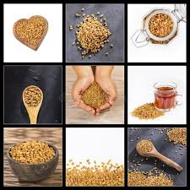
Introduction:
Fenugreek (Trigonella foenum-graecum) is an annual herb that belongs to the Fabaceae family. It has a long history of use in traditional medicine and culinary applications. Fenugreek seeds and leaves are widely used for various purposes, including the production of hair oil.
Synthesis:
Fenugreek hair oil is typically prepared by infusing fenugreek seeds in a carrier oil, such as coconut oil or sesame oil. The process involves heating the oil and adding crushed fenugreek seeds to it. The mixture is then simmered for a period of time to allow the beneficial compounds from fenugreek to infuse into the oil.
Biological sources and family:
Fenugreek (Trigonella foenum-graecum) is the biological source of fenugreek hair oil. It belongs to the Fabaceae family, also known as the legume or pea family.

Chemical constituents:
Fenugreek seeds contain various chemical constituents that contribute to their beneficial properties for hair. Some of the important constituents include alkaloids (such as trigonelline), saponins (such as diosgenin), flavonoids, tannins, and mucilage. These constituents are responsible for the hair-strengthening and conditioning effects of fenugreek oil.
Material and method of collection :
- To prepare fenugreek hair oil, you would need the following materials:
- Fenugreek seeds: Obtain good quality fenugreek seeds from a reliable source.
- Carrier oil: Choose a carrier oil like coconut oil, sesame oil, or olive oil.
Method:
- Crush the fenugreek seeds using a mortar and pestle or a grinder.
- Heat the carrier oil in a pan or double boiler.
- Add the crushed fenugreek seeds to the oil and simmer on low heat for about 30 minutes to an hour.
- Stir occasionally to prevent burning.
- Allow the mixture to cool and strain the oil to remove any solid particles.
- Store the fenugreek hair oil in a clean, airtight container for future use.

Pharmacological action:
- The pharmacological action of fenugreek hair oil is attributed to its bioactive compounds. Fenugreek oil exhibits the following pharmacological properties:
- Antifungal: Helps combat fungal infections on the scalp, which can contribute to dandruff.
- Antibacterial: Helps fight bacterial infections and maintains a healthy scalp.
- Anti-inflammatory: Reduces inflammation on the scalp, promoting a healthy environment for hair growth.
- Antioxidant: Protects hair follicles from oxidative stress and damage caused by free radicals.
- Hair conditioning: Provides moisture and nourishment to the hair, enhancing its texture and appearance.
Uses:

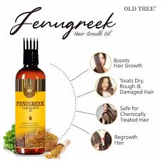
- Fenugreek hair oil is primarily used for promoting hair health and addressing specific hair-related issues.
- Hair growth stimulation: Fenugreek oil is thought to stimulate hair follicles and promote hair growth.
- Dandruff control: The antifungal and antibacterial properties of fenugreek oil can help combat dandruff and soothe the scalp.
- Hair conditioning: Fenugreek oil can moisturize and nourish the hair, making it soft, smooth, and manageable.
- Strengthens hair: The protein-rich composition of fenugreek oil helps strengthen the hair shaft and reduce breakage.
- Prevents hair loss: Fenugreek oil may help prevent hair loss by strengthening the hair roots and improving overall hair health.
Merits:
- Promotes hair growth and reduces hair loss.
- Conditions and nourishes the hair.
- Controls dandruff and soothes the scalp.
- Strengthens hair and reduces breakage.
- Natural and safe to use.
Demerits:
- Allergic reactions: Some individuals may be allergic to fenugreek, so it's important to perform a patch test before using the oil extensively.

- Greasiness: Fenugreek oil can be quite greasy, so it may not be suitable for those with oily hair or scalp.
- Individual variations: Results may vary from person to person, and not everyone may experience the same benefits.

- HENNA
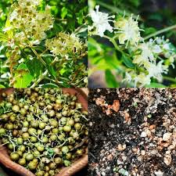
Introduction:
Henna hair oil is a natural oil that is derived from the leaves of the henna plant (Lawsonia inermis). Henna is a small shrub-like plant that is native to tropical and subtropical regions of Africa, Asia, and Australia. It belongs to the family Lythraceae.

Synthesis:
Synthesis of henna hair oil involves the extraction of oil from the leaves of the henna plant. This can be done through various methods such as cold pressing, steam distillation, or solvent extraction. Cold pressing is a commonly used method where the leaves are crushed and pressed to extract the oil.
Biological sources:
The henna plant (Lawsonia inermis) is the primary biological source of henna hair oil. It is cultivated for its leaves, which contain the dye molecule lawsone and essential oils that are beneficial for hair care.
Chemical constituents:
Henna hair oil contains several chemical constituents that contribute to its beneficial properties. The major constituents include lawsone, tannins, essential oils, phenolic compounds, and polysaccharides.
Material and method of collection:
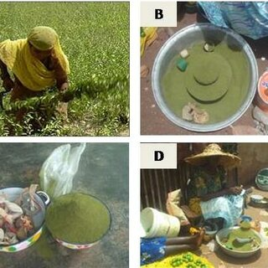

The oil is obtained from the henna plant leaves by harvesting them and then subjecting them to extraction methods such as cold pressing, steam distillation, or solvent extraction. The leaves are typically dried and crushed before the oil is extracted.
Pharmacological actions:
Henna hair oil has various pharmacological actions on the hair and scalp. It acts as a natural conditioner, moisturizer, and anti-inflammatory agent. It nourishes the hair follicles, strengthens the hair shaft, and promotes healthy hair growth. The oil also has antimicrobial properties that help in combating scalp infections and reducing dandruff.
Uses:
Henna hair oil has been traditionally used for hair care and has several benefits. It is known to nourish and condition the hair, promoting strength and luster. The oil helps in reducing hair fall, preventing dandruff, and improving scalp health. Henna hair oil is also used to promote hair growth and enhance the natural color of the hair.
Merits:
- Natural Hair Conditioning: Henna oil acts as a natural hair conditioner, providing deep hydration and nourishment to the hair strands. It helps in making the hair softer, smoother, and more manageable.
- Strengthens and Thickens Hair: Regular use of henna hair oil is believed to strengthen the hair follicles, reducing breakage and hair fall. It can help make the hair appear thicker and fuller.
- Promotes Hair Growth: Henna oil is thought to stimulate hair growth by improving blood circulation to the scalp. It nourishes the hair follicles and may potentially encourage new hair growth.
- Helps with Dandruff and Scalp Issues: Henna oil possesses antifungal and antibacterial properties that may help in reducing dandruff and soothing an itchy scalp. It can provide relief from scalp conditions like psoriasis and eczema.
Demerits:
- Limited Color Options: While henna oil can enhance the color of dark hair, it may not be suitable for those with lighter hair shades. It tends to impart a reddish or orange tone, which may not be desirable for everyone.
- Time-Consuming Application: Applying henna oil can be a time-consuming process as it requires preparation and a waiting period for the oil to penetrate the hair. This might be inconvenient for individuals with a busy schedule.
- Potential Dryness: Henna oil has a drying effect on the hair due to its astringent properties. While it can benefit oily hair types, individuals with dry or damaged hair might experience increased dryness if not properly moisturized.
- Difficult to Remove: The dyeing properties of henna oil can make it challenging to remove from the hair completely. If you decide to stop using henna oil or change your hair color, it may require multiple washes or the use of clarifying agents.

- ECLIPTA
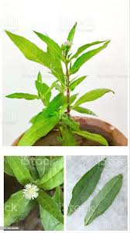
Introduction:
Eclipta, scientifically known as Eclipta prostrata, is a medicinal herb commonly used in Ayurvedic medicine for its many health benefits. One of its common applications is hair oil, which is derived from the leaves and stems of the plant. Let's explore different aspects of Eclipta Hair Oil:
Hair oil composition:
Eclipta hair oil is typically prepared by extracting the beneficial compounds from the plant using a suitable solvent, such as coconut oil or sesame oil. The extraction process involves steeping the oil with Eclipta leaves and allowing it to steep over a period of time to allow the active ingredients to be absorbed into the oil.
Biological sources of hair oil:
The biological source of Eclipta Hair Oil is the plant Eclipta prostrata, also known as false chrysanthemum or bhringraj. This plant is native to India, as well as other parts of Asia, and is cultivated for its medicinal properties.
family:
Eclipta prostrata belongs to the family Asteraceae (or Compositae), which is the largest family of flowering plants. It is famous for its wide variety of species, including various herbs, shrubs, and even some trees.
chemical composition:
Eclipta Hair Oil contains several bioactive compounds that contribute to its beneficial effects on hair. Some of the notable chemical constituents include wedelolactone, eclalbasaponins, beta-sitosterol, triterpenes, flavonoids, and coumestans. These compounds possess antioxidant, anti-inflammatory and hair stimulating properties.
Material and method of collecting hair oil:
To make Eclipta hair oil, fresh leaves and stems are collected from the Eclipta prostrata plant. They are typically harvested during the flowering phase when the plant's active ingredients are most concentrated. After collection, the leaves and stems are dried and crushed before being soaked in a carrier oil, such as coconut oil or sesame oil, using a specific method or traditional recipe.
Pharmaceutical actions of hair oil:
The pharmacological actions of Eclipta Hair Oil are primarily attributed to its active ingredients. The oil displays antioxidant properties that help protect hair follicles from damage caused by free radicals. It also has anti-inflammatory effects, which can reduce irritation and inflammation of the scalp. In addition, Eclipta Hair Oil boosts blood circulation in the scalp, delivers essential nutrients to hair follicles and stimulates hair growth.
Eclipta uses:
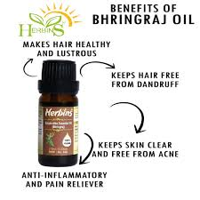
Eclipta Hair Oil is primarily used to promote hair growth, prevent hair loss, and improve overall hair health. It is believed to nourish hair follicles, strengthen hair roots, and reduce scalp inflammation, resulting in healthier, shinier hair. In addition, it may help controldandruff and premature graying of hair.
Merits:
- Hair Care: Eclipta is widely recognized for its hair care benefits. It promotes hair growth, strengthens hair follicles, prevents hair loss, and helps in maintaining overall hair health.
- Liver Health: Eclipta has hepatoprotective properties, meaning it supports liver health and protects it from damage. It may help in improving liver function and preventing liver-related disorders.

- Anti-inflammatory Properties: Eclipta possesses anti-inflammatory properties that can help in reducing inflammation in various parts of the body, such as the skin, joints, and internal organs.
- Antioxidant Activity: The herb is rich in antioxidants that combat oxidative stress and protect the body from free radicals, which can damage cells and contribute to various diseases.
- Skin Health: Eclipta is used in traditional medicine to improve skin health. It may help in treating skin conditions like eczema, dermatitis, and acne. It can also promote wound healing.
Demerits:
- Allergic Reactions: Some individuals may be allergic to Eclipta. If you have known allergies or sensitivities, it is important to consult a healthcare professional before using Eclipta products.
- Drug Interactions: Eclipta may interact with certain medications. If you are taking any prescribed medications, it is advisable to consult your healthcare provider before incorporating Eclipta into your regimen.
- Pregnancy and Breastfeeding: Eclipta should be used with caution during pregnancy and breastfeeding. It is recommended to consult a healthcare professional before using Eclipta products during these periods.
- Digestive Issues: In some cases, Eclipta may cause digestive discomfort, such as an upset stomach or diarrhea. If you experience any adverse gastrointestinal effects, discontinue use and consult a healthcare professional.
- Individual Variations: As with any herbal supplement, the effects and tolerability of Eclipta can vary from person to person. It is important to start with a low dose and monitor your body's response.

- VETIVER
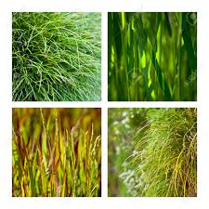
Introduction:
Vetiver oil is a dark brown or amber-colored oil with a strong and earthy aroma. It has been used for centuries in traditional medicine and perfumery due to its distinct fragrance and various therapeutic properties.

Synthesis:
Vetiver oil is obtained through steam distillation of the roots of the Vetiveria zizanioides plant. The roots are washed, dried, and then chopped into smaller pieces. These pieces are then subjected to steam distillation, which extracts the volatile components, including the essential oil.
Biological sources:
Vetiveria zizanioides, commonly known as vetiver or khus, is a perennial grass native to India. It is also cultivated in several other countries, including Haiti, Java, and Réunion.
Family:
Vetiveria zizanioides belongs to the Poaceae family, which is commonly known as the grass family.
Chemical constituents:
The chemical composition of vetiver oil can vary depending on the region and cultivation conditions. Some of the major chemical constituents found in vetiver oil include vetiverol, vetiverone, khusimol, α-vetivone, β-vetivone, and sesquiterpenes. These compounds contribute to the distinctive fragrance and therapeutic properties of vetiver oil.
Material and method of collection:
The hair oil containing vetiver oil is typically prepared by combining vetiver oil with a carrier oil, such as coconut oil or jojoba oil. The carrier oil helps dilute the concentrated essential oil and facilitates its application on the hair and scalp. The hair oil is usually prepared by mixing a few drops of vetiver oil with a larger quantity of the carrier oil.
Pharmacological action:
Vetiver oil exerts its pharmacological actions on the hair and scalp through its various chemical constituents. It possesses antiseptic, anti-inflammatory, and antioxidant properties. These properties contribute to its ability to soothe the scalp, reduce dandruff, and promote healthy hair growth. Vetiver oil is also known to have a relaxing effect on the mind and body, which can indirectly benefit the health of the hair.
Uses:
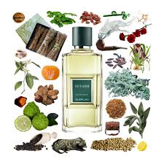
Vetiver oil is commonly used in hair care products, particularly in the form of hair oil. It is believed to have several beneficial effects on the hair and scalp. Vetiver oil can help nourish the hair follicles, promote hair growth, and improve the overall health and texture of the hair. It is also known to have a calming and cooling effect on the scalp, helping to reduce itchiness and irritation.
Merits:
- Nourishes and promotes healthy hair growth
- Provides a calming and cooling effect on the scalp
- Helps reduce itchiness and irritation.
- Enhances the overall health and texture of the hair.
Demerits:
- May cause allergic reactions in some individuals.
- Should be used in moderation, as excessive use may lead to greasy hair.
- Individual results may vary, and not all individuals may experience the same benefit's.

5.NIMBA BEEJI TAILC
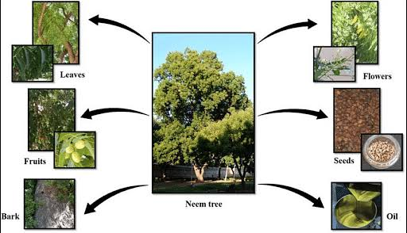

Introduction:
Nimba Beeji Tailc of Hair Oil is a herbal hair oil known for its various benefits in promoting healthy hair growth and improving scalp conditions. It is derived from the seeds of the Nimba tree, scientifically known as Azadirachta indica. This oil has been traditionally used in Ayurvedic medicine for its medicinal properties and is now widely recognized for its effectiveness in hair care.
Synthesis:
The hair oil is prepared through a process known as cold-pressing, where the seeds of the Nimba tree are crushed and pressed to extract the oil. This method helps retain the beneficial properties of the oil while ensuring minimal heat-induced degradation.
Biological Sources:
Nimba Beeji Tailc of Hair Oil is derived from the seeds of the Nimba tree (Azadirachta indica), also known as the Neem tree. The Nimba tree is native to the Indian subcontinent and is widely cultivated in tropical regions for its medicinal and cosmetic uses.
Family:
The Nimba tree belongs to the Meliaceae family, which includes various other plants known for their medicinal properties.
Chemical Constituents:
Nimba Beeji Tailc of Hair Oil contains several bioactive compounds, including:
  - Fatty Acids: Oleic acid, linoleic acid, stearic acid, and palmitic acid.
  - Triterpenes: Nimbin, nimbidin, nimbinin, and nimbidinin.
  - Antioxidants: Quercetin, catechin, and other flavonoids.
  - Azadirachtin: A potent bioactive compound known for its insecticidal properties.
  - Nimbidol: A natural antifungal agent.
Material and Method of Collection:
The seeds of the Nimba tree are collected from mature fruits. The outer shells are removed, and the seeds are thoroughly cleaned. They are then crushed or ground to obtain a fine powder, which is further processed through cold-pressing to extract the oil.
Pharmacological Action:
The pharmacological action of Nimba Beeji Tailc of Hair Oil can be attributed to its various bioactive constituents. The oil exhibits antimicrobial, antifungal, and anti-inflammatory properties. It helps inhibit the growth of microorganisms on the scalp, reducing scalp infections and dandruff. Additionally, the oil nourishes the hair follicles, promotes blood circulation, and stimulates hair growth.
Uses:
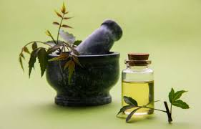
Nimba Beeji Tailc of Hair Oil offers several benefits for hair health and care, including:
- Promoting Hair Growth: The oil nourishes the scalp and hair follicles, stimulating hair growth and preventing hair loss.
- Scalp Health: It helps maintain a healthy scalp by reducing dandruff, itchiness, and scalp infections.
- Conditioning and Moisturizing: The oil moisturizes the hair, making it softer, shinier, and more manageable.
- Strengthening Hair: Regular use of the oil can strengthen the hair shafts, reducing breakage and split ends.
- Anti-inflammatory Properties: It helps soothe the scalp, reducing inflammation and irritation.
Merits:
- Natural and Herbal: Nimba Beeji Tailc of Hair Oil is derived from natural sources and is free from harmful chemicals, making it a safer option for hair care.
- Versatile Benefits: It offers multiple benefits, including promoting hair growth, improving scalp health, and conditioning the hair.
- Traditional Wisdom: The use of Nimba Beeji Tailc of Hair Oil is rooted in Ayurvedic traditions, which have recognized its efficacy for centuries.
Demerits:
- Individual Sensitivity: Some individuals may be allergic or sensitive to certain components of the oil. Patch testing is recommended before widespread use.
- Odor and Texture: The strong, pungent odor and thick consistency of the oil may not be appealing to everyone.
- Individual Variability: The effectiveness of the oil may vary from person to person, and results may take time to manifest.

- JATAMANSI
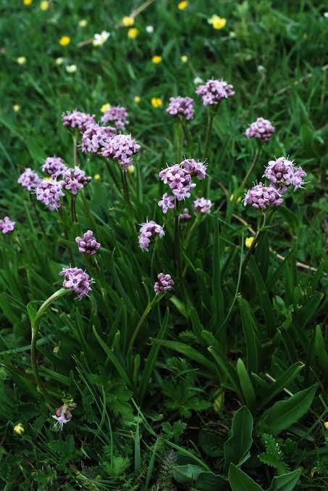
Introduction:
Jatamansi, also known as Nardostachys jatamansi, is a perennial herb that belongs to the Valerianaceae family. It is primarily found in the Himalayan region, including India, Nepal, and Bhutan. Jatamansi has been used for centuries in traditional Ayurvedic medicine for various purposes, including its potential benefits for hair health. It is often used as an ingredient in hair oils due to its reported properties.
Synthesis:
Jatamansi oil is obtained through steam distillation of the dried rhizomes and roots of the plant. The rhizomes and roots are collected, dried, and then subjected to the distillation process to extract the essential oil. This oil is then used as a key component in hair oils and other cosmetic products.
Biological Sources and Family:
Jatamansi (Nardostachys jatamansi) is the primary biological source of jatamansi oil. It is a flowering plant native to the Himalayan region and belongs to the Valerianaceae family.
Chemical Constituents:
The essential oil of jatamansi contains various chemical constituents that contribute to its potential benefits. Some of the major constituents found in jatamansi oil include valeranone, nardosinone, jatamansone, nardostachone, bornyl acetate, and patchouli alcohol. These compounds are believed to have antioxidant, anti-inflammatory, and antimicrobial properties.
Material and Method of Collection:
To collect jatamansi oil, the rhizomes and roots of the plant are typically dug up during the appropriate season. These plant parts are then cleaned, dried, and crushed to prepare them for the distillation process. Steam distillation is the most common method used to extract the essential oil from jatamansi.
Pharmacological Action:
- The pharmacological action of jatamansi oil for hair is not extensively studied. However, some of the reported pharmacological properties of jatamansi oil in general include:
- Antioxidant activity: Jatamansi oil is believed to possess antioxidant properties, which can help protect the hair and scalp from damage caused by free radicals.
- Anti-inflammatory effects: The oil is reported to have anti-inflammatory properties, which may help soothe the scalp and reduce scalp inflammation.
Uses:
- Jatamansi oil is often used in hair care products, including hair oils, due to its potential benefits for hair health. Some of the reported uses of jatamansi oil for hair include:
- Hair growth promotion: Jatamansi oil is believed to stimulate hair follicles and promote hair growth.
- Hair strengthening: The oil is thought to strengthen the hair shaft and prevent hair breakage.
- Anti-dandruff effects: Jatamansi oil is reported to have antimicrobial properties, which may help in reducing dandruff and scalp irritation.
- Natural conditioner: It is often used as a natural conditioner to improve the texture and overall appearance of the hair.
Merits:
- Nourishes and strengthens hair: Jatamansi oil is rich in antioxidants and essential oils that help nourish and strengthen the hair follicles. This can promote healthier, stronger hair growth.
- Reduces hair fall: The antioxidant properties of jatamansi oil may help reduce hair fall by protecting the hair follicles from damage caused by free radicals. It can also improve blood circulation to the scalp, promoting healthier hair growth and minimizing hair loss.
- Calms an irritated scalp: Jatamansi oil has soothing properties that can help calm an irritated or inflamed scalp. It may provide relief from conditions like dandruff, itching, and scalp psoriasis.
- Improves hair texture: Regular application of jatamansi oil may improve the texture of the hair, making it smoother, softer, and more manageable. It can also add a natural shine to the hair.
Demerits:
- Individual sensitivity: Some individuals may be allergic or sensitive to jatamansi oil. It's always recommended to perform a patch test before applying it to the scalp or hair to check for any adverse reactions.
- Greasiness: Jatamansi oil is relatively thick and can be greasy when applied in excess. If not properly washed out, it may leave a greasy residue on the hair, making it appear oily.
- Availability and cost: Jatamansi oil may not be readily available in all regions, and it can be relatively expensive compared to other hair oils. Obtaining genuine, high-quality jatamansi oil can sometimes be a challenge.
- Limited scientific evidence: While jatamansi has been used in Ayurvedic medicine for centuries, there is a relatively limited amount of scientific research specifically on its benefits for hair. More studies are needed to understand its efficacy and potential side effects better

7.NYARGRODHA JATA
Introduction:
Nyargrodha jata refers to the aerial roots of the banyan tree (Ficus benghalensis). It is widely used in traditional Ayurvedic medicine and is considered beneficial for hair health and growth.
Synthesis:
Nyargrodha jata is a natural substance and cannot be synthesized artificially. It is obtained from the banyan tree through a collection process.

Biological Sources:
Nyargrodha jata is derived from the banyan tree (Ficus benghalensis), a species belonging to the Moraceae family. The banyan tree is native to the Indian subcontinent and is also found in other tropical regions worldwide.
Family:
Nyargrodha jata belongs to the Moraceae family, which includes other well-known plants such as figs and mulberries.
Chemical Constituents:
The chemical constituents of Nyargrodha jata can vary, but it typically contains several bioactive compounds such as flavonoids, tannins, alkaloids, saponins, and glycosides. These constituents contribute to its potential benefits for hair health.
Material and Method of Collection:
To obtain Nyargrodha jata for hair oil production, the aerial roots of the banyan tree are carefully collected. These roots are dried and then processed to extract the beneficial constituents. The extracted material is then incorporated into various hair oil formulations.
Pharmacological Action:
Nyargrodha jata has several pharmacological actions that contribute to its effectiveness in hair care. It possesses antioxidant properties, which can help protect the hair and scalp from damage caused by free radicals. It also has antimicrobial and anti-inflammatory properties, which can prevent scalp infections and reduce inflammation. Additionally, Nyargrodha jata promotes blood circulation to the scalp, aiding in the delivery of essential nutrients to the hair follicles and promoting hair growth.
Uses:
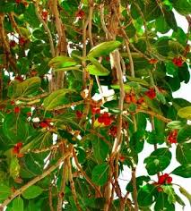
Nyargrodha jata is primarily used as an ingredient in hair oil formulations. Hair oils containing Nyargrodha jata are believed to nourish the scalp, strengthen hair follicles, promote hair growth, and reduce hair fall. It is often used to improve overall hair health, enhance hair texture, and prevent dandruff and scalp infections.
Merits:
- Moisturization: Hair oils can provide moisture to dry and damaged hair, helping to improve its texture and shine.
- Nourishment: Certain hair oils contain essential nutrients and vitamins that can nourish the hair follicles, promoting healthy hair growth.
- Scalp health: Massaging hair oil into the scalp can help improve blood circulation and relieve dryness, itchiness, and dandruff.
- Frizz control: Hair oils can help to tame frizzy hair, reducing flyaways and making the hair more manageable.
- Protection: Some hair oils have protective properties, acting as a barrier against environmental pollutants, heat damage from styling tools, and sun damage.
Demerits:
- Greasiness: Using excessive amounts of hair oil or not rinsing it properly can leave the hair feeling greasy and weighed down.
- Build-up: Frequent use of heavy hair oils without proper cleansing can lead to product build-up on the scalp, which may cause clogged pores and dull-looking hair.
- Allergic reactions: Certain individuals may be allergic to specific ingredients present in hair oils, leading to scalp irritation, redness, or itching.
- Staining: Certain hair oils, especially those with strong pigments or natural dyes, may stain clothing or pillowcases if not fully absorbed or rinsed off.
Dependency: Some individuals may become dependent on hair oil for managing their hair, leading to potential difficulty in maintaining the hair's natural state without the product.

- BRAHMI
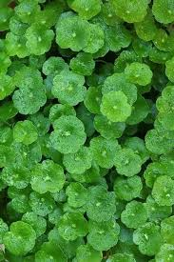
Introduction:
Brahmi hair oil is a herbal oil used for promoting hair growth and enhancing hair health. It is derived from the Brahmi plant, scientifically known as Bacopa monnieri. Brahmi is a popular medicinal plant in Ayurveda, the traditional system of medicine in India. The oil is made by extracting the active compounds from the Brahmi plant and blending them with a carrier oil.
Synthesis:
Brahmi hair oil is typically prepared by macerating the aerial parts of the Brahmi plant in a carrier oil, such as coconut oil or sesame oil. The maceration process involves soaking the plant material in the carrier oil for a certain period to allow the active compounds to infuse into the oil. After maceration, the oil is usually heated gently to enhance the extraction of the constituents. The final product is then filtered to remove any solid particles, resulting in Brahmi hair oil.
Biological Sources and Family:
The biological source of Brahmi hair oil is the Bacopa monnieri plant. Bacopa monnieri belongs to the family Plantaginaceae. It is a small, creeping herb with succulent leaves that is native to wetlands and marshy areas in India, Nepal, Sri Lanka, and other parts of Asia.
Chemical Constituents:
Brahmi hair oil contains various bioactive compounds found in Bacopa monnieri, including alkaloids (e.g., brahmine, nicotine), saponins (e.g., bacosides), flavonoids, and triterpenoid glycosides. These constituents contribute to the hair-nourishing and revitalizing properties of Brahmi hair oil.
Material and Method of Collection:
To prepare Brahmi hair oil, the aerial parts of the Bacopa monnieri plant, including the leaves and stems, are typically collected. The collection is done by gathering the plant material from its natural habitat or cultivated sources. It is important to ensure that the plants are healthy and free from any contaminants. Once collected, the plant material is thoroughly cleaned and dried before being used for oil extraction.

Pharmacological Action:
Brahmi hair oil exhibits several pharmacological actions, including:
Hair growth promotion: The active compounds in Brahmi hair oil stimulate hair follicles, promoting the growth of strong and healthy hair.
Antioxidant activity: The constituents in Brahmi hair oil possess antioxidant properties, protecting the hair follicles and scalp from oxidative damage caused by free radicals.
Anti-inflammatory effects: Brahmi hair oil has anti-inflammatory properties, which help reduce scalp inflammation and itching.
Scalp nourishment: The oil provides essential nutrients to the scalp, nourishing and revitalizing the hair follicles.

Uses:
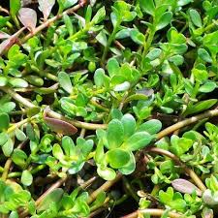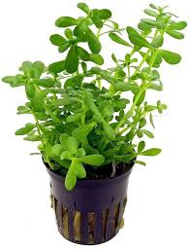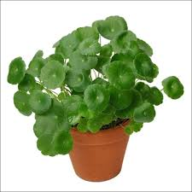
Brahmi hair oil has several uses for hair care, including:
- Promoting hair growth: The active compounds in Brahmi hair oil stimulate the hair follicles, promoting hair growth and preventing hair fall.
- Strengthening hair: Regular use of Brahmi hair oil can strengthen the hair shafts, reducing breakage and split ends.
- Conditioning and nourishing: The oil provides deep conditioning and nourishment to the scalp and hair, making the hair softer, smoother, and more manageable.
- Cooling and soothing the scalp: Brahmi hair oil has a cooling effect on the scalp, helping to reduce scalp itchiness, irritation, and dandruff.

Merits:
- Promotes hair growth and prevents hair fall.
- Strengthens and conditions the hair.
- Soothes and cools the scalp.
- Provides nourishment to the hair follicles.
- Contains natural ingredients and is often free from harmful chemicals.
Demerits:
- Individual results may vary, and not everyone may experience significant hair growth or improvement in hair health.
- Allergic reactions or sensitivities to any of the constituents in Brahmi hair oil are possible, although rare.
- Some formulations may have a strong herbal scent, which may not be preferred by everyone.

