Bioactivity Profiling of Punica granatum L. Fruit parts
Subitha Shajini, R.*, Priyaa, J.C.**, Reka.G.S*** and Beena Lawrence****
*Assistant Professor, Department of Botany, Women’s Christian College, Nagercoil. Affiliated to Manonmanium Sundaranar University, Tirunelveli, TamilNadu.
** Department of Botany, Women’s Christian College, Nagercoil. Affiliated to Manonmanium Sundaranar University, Tirunelveli, TamilNadu.
*** Assistant Professor of Botany, Rani Anna Government College For Women, Affiliated to Manonmanium Sundaranar University, Tirunelveli, TamilNadu.
****Associate Professor, Department of Botany, Women’s Christian College, Nagercoil. Affiliated to Manonmanium Sundaranar University, Tirunelveli, TamilNadu.

ABSTRACT
Punica granatum L. is a traditional medicinal plant highly acclaimed for its fruit. The fruit is used as a remedy to boost immunity during sickness. The fruits are rich in many secondary metabolites of prime importance like flavonoids, alkaloids, polyphenols, tannins etc. In the present investigation an attempt was made to profile the biological efficacy of the peel and pulp of the fruit through phytochemistry, GCMS analysis, anticancer screening and in silico analysis. Phytochemical profiling of ethanolic extract of peel and pulp of fruits showed the presence of more amounts of flavonoids, tannins and alkaloids. The GCMS profiling of peel and pulp ethanolic extract revealed the presence of three and six phytocompounds respectively. Anticancer evaluation of ethanolic peel extract against MCF-7 Breast cancer cell lines, exhibited evident rounding off and loss of adhesion along with shrinking of cytoplasm in the cell lines suggesting apoptosis. Dodecahydropyrido[1,2-b]isoquinolin-6-one, N-Methyl-1-adamantaneacetamide, 2-Ethylacridine, 2-(Acetoxymethyl)-(methoxycarbonyl) Biphenylene and 1,2,5-Oxadiazol-3-amine from the GCMS profile of fruit parts were subjected to in silico analysis using them as ligands against CDK-2 protein. In silico evaluation results showed best binding energy by Dodecahydropyrido[1,2-b]isoquinolin-6-one compared to the other selected compounds. Dodecahydropyrido[1,2-b]isoquinolin-6-one when docked with CDK-2 protein showed a binding energy of -6.54, and its efficiency came to -4.44. The binding energy inhibition constant was 16.18µM with an electrostatic energy of 0.01. The biomolecule was seen making interactions with nine amino acids- phenylalanine, alanine, leucine, glutamine, valine and isoleucine in the receptor pocket of the protein. In the interaction amino acid leucine (83rd position) interacts with CDK-2 using hydrogen bond, while alanine, phenylalanine, valine, isoleucine (at 134 position) makes pi alkyl bonds. The present investigation was an attempt to support the anticancer effect of Punica granatum fruits through molecular profiling and in silico studies, which clearly suggest that this fruit be made a part of our daily diet to counteract the harmful environment of the present day so as to make the body to fight disease like cancer. Moreover the phyto compounds of anticancer importance could be made into lead compound in anticancer trails for future drug designing programs.
Key Words:
Punica granatum, Phytochemistry, Gas Chromatography-Mass Spectroscopy, Cytotoxicity, Anticancer evaluation, in silico analysis

INTRODUCTION
Man relies on plants for his basic needs like food, clothing and shelter. Plants also provides medicines, crafts, cosmetics and also used as a source of income for rural areas. For about thousands of year plants have been used as medicine and World Health Organization has reported that over 50% of the poorest part of Asia and Africa still lacks regular access to essential drugs and traditional medicine offers the major and accessible source in these areas. About 80% of the population in developing countries still relies on plant based medicines to obtain primary health care.
Punica granatum and mainly found in Iran, the Himalayas in northern India, China, USA and throughout the Mediterranean region. The pomegranate (Punica granatum) is a fruit-bearing deciduous shrub in the family Lythraceae. Pomegranate is a shrub or small tree growing 5 to 10 m high, the pomegranate has multiple spiny branches and is extremely long-lived, with some specimens in France surviving for 200 years. Punica granatum leaves are opposite or sub-opposite, glossy, narrow oblong, entire, 3–7 cm long and 2 cm broad. The Punica granatum can be also divided into several anatomical compartments including seed, juice, peel, leaf, flower, bark and root with each possessing interesting pharmacological and toxicological activities. The flowers are bright red and 3 cm in diameter, with three to seven petals. Some fruitless varieties are also grown for the flowers alone. The edible fruit is a berry which is about 5-12 cm in diameter with a rounded hexagonal shape, thick reddish skin and around 600 seeds, each surrounded by a water-laden pulp (aril) ranging in color from white to deep red or purple, the aril is the edible part of the fruit. The seeds are embedded in a white, spongy, astringent pulp (Stover and Mercure, 2007).
Punica granatum has extensively been used as a traditional remedy against acidosis, dysentery, microbial infections, diarrhea, helminth infection, hemorrhage and respiratory pathologies and the seeds have also been shown to contain the estrogenic compounds, estrone and estradiol (Kim and Choi, 2009). Furthermore, the dried pericarp and the juice of the fruit are considered beneficial for treatment of colic, colitis, menorrhagia, oxyuriasis, headache, diuretic, acne, piles, allergic dermatitis, and treatment of oral diseases. Punica granatum contains chemical components in its different compartments, which may possess the various pharmacological and toxicological activities (Seeram et al., 2006). The oil consists of approximately 80% conjugate doctadecatrienoic fatty acids, with a high content of cis 9, trans 11, cis 13 acid (i.e. punicic acid), synthesized in situ from non-conjugated octadecadienoic fatty acid, linoleic acid, itself about 7% of Pomegranate seed oil. The fatty acid component of Pomegranate seed oil comprises over 95% of the oil, of which 99% is triacylglycerols. Minor components of the oil include sterols, steroids, tocopherols, and a key component of mammalian myelin sheaths, cerebroside. Seed matrix includes lignins, fusion products of cell wall components and hydroxybenzoic or cinnamic acids, isoflavones, and potently antioxidant lignin derivatives. The main chemical constituents isolated from pomegranate peel are hydroxybenzoic acids: gallic acid, ellagic acid. Hydroxycinnamic acids: caffeic acid, chlorogenic acid, p- Coumaric acid (Venkata and Prakash, 2018). Oxidative stress produces toxic metabolites which can initiate and promote cancers (Garcea et al., 2005), which can be prevented by consumption of polyphenols and flavonoids.
The antioxidants present in Punica granatum has an ability to counteract oxidative stress that induces lipid peroxidation in arterial macrophages and in lipoproteins (Miguel et al., 2004). Punica granatum contains some species of flavonoids and anthocyanidins (delphinidin, cyaniding and pelargonidin) in its seed oil and juice and shows antioxidant activity three times greater than green tea extract (Okamoto et al., 2004). Studies have also shown the protective effects of Punica granatum on the cardiovascular system, including reduction of cholesterol (Rosenblat et al., 2010), anti-hypertension action by combating oxidative stress induced by diabetes and angiotensin II (Mohan et al., 2010), of carotid arterial stenosis and increase of endothelial nitric oxide (NO) syntheses (Nigris et al., 2007), thereby protecting these organs. These findings suggest that Punica granatum should be a part of diet to counteract oxidative stress mechanism (Basu and Penugonda, 2009). Interestingly, Punica granatum also has shown to inhibit inflammation by different mechanisms. Cyclooxygenase (COX) and lipooxygenase (LOX), which are key enzymes in the conversion of arachidonic acid to prostaglandins and leukotrienes (important inflammatory mediators) respectively, are inhibited by Punica granatum extracts (Rahimi et al., 2011). Studies have shown that Punica granatum has a significant inhibitory effect on osteoarthritis by suppressing the expression of matrix metalloproteinases in osteoarthritis chondrocyte cultures and preventing collagen degradation. It may also inhibit joint destruction and production of proinflammatory cytokines in osteoarthritis patients (Ahmed et al., 2005 and Larrosa et al., 2010).
Punica granatum possesses inhibitory effects on different type of cancers of prostate (Koyama et al., 2010), breast (Sturgeon and Ronnenberg, 2010), colon (Kasimsetty et al., 2010,), and lung (Khan et al., 2007). According to Hong et al., 2008, Punica granatum inhibits NF-k Band cell viability of prostate cancer cell lines in a dose-dependent manner in in-vitro conditions. Ellagitannin-rich extract and whole juice extract of Punica granatum, inhibited gene expression of 3 beta-hydroxysteroid dehydrogenase type 2, aldo-ketoreductase family 1 member C3 and steroid 5 alpha reductase type 1, which are key androgen- synthesizing enzymes of human prostate cancer cells (Seeram et al., 2007). A study by Hartlapp et al., 2001 showed that Punica granatum inhibits prostate cancer cell growth, induces apoptosis highly aggressive prostate carcinoma cells, suppresses invasion of these cells and decreases proliferation of prostate cancer cells in-vitro. Treatment of colon cancer cells by using Punica granatum juice which decrease cyclooxygenase -2 expression, which is a key enzyme in cancer cells and inhibit inflammatory cell signaling processes which may cause cancer initiation and progression (Adams et al., 2006).
MATERIALS AND METHODS
The present investigation was done to evaluate the bioactive efficacy of pulp and peel extract of Punica granatum and evaluation of the anticancer activity of fruit peel through in vitro and in silico method. For this the ethanolic extract of fruit parts from the plant was first profiled phytochemically, followed by GCMS analysis and then the compounds having anticancer properties were evaluated for its properties using in vitro and in silico techniques.
PHYTOCHEMICAL SCREENING
The phytochemical screening was done in the ethanolic extract of dried Punica granatum fruit parts (Pulp and Peel) using standard procedures of Sadasivam and Manickam, 2008).
GCMS (Gas Chromatography and Mass Spectroscopy) (Kakimoto et al., 2015)
The procedure of Kakimoto et al., 2005 was followed for GC-MS analysis was performed using the JEOL GCMATE GC-MS. For GC-MS detection, an electron ionization system was operated in electron impact mode with ionization energy of 70 eV. Helium gas (99.999%) was used as a carrier gas at a constant flow rate of 1 ml/minute, and an injection volume of 2 µ was employed (a split ratio of 10:1). The injector temperature was maintained at 250° C, the ion-source temperature was 200° C, the oven temperature was programmed from 110° (isothermal for 2 minutes), with an increase of 10° C/minute to 200° C, then 5° C/minute to 280° C, ending with a 9 minutes isothermal at 280° C. Mass spectra were taken at 70eV; a scan interval of 0.5 s and fragment from 45 to 450 Da. The solvent delay was 0 to 2 minutes, and total GC/MS running time was time was 36 min. The relative percentage amount of each component was calculated by comparing its average peak area to the total areas. Identification of components was done by Interpretation of spectrum GCMS was conducted using data base of National Institute Standard and Technology (NIST) and Wiley Spectra Libraries. The molecular weight, molecular formula and the number of hits was used to identify the name of the compound from NIST and Wiley spectra Libraries. The relative percentage amount of each component was calculated by comparing its average peak area to the total areas. The compounds were identified using the PubMed online library.
ANTICANCER ANALYSIS
Cell culture and 3-(4,5-dimethylthiazol-2-yl)-2,5-diphenyl-2H-tetrazolium bromid (MTT) assay
Cell culture and MTT assay was done following the procedure of Florento et al., 2012. Breast cancer cell lines (MCF-7) was plated separately using well plates with the concentration of 1×104cells/well in RPMI media with 1X Antibiotic Antimycotic Solution and 10% fetal bovine serum (Himedia, India) in CO2 incubator at 37˚C with 5% CO2. The cells were washed with 200 μL of 1X PBS, then the cells were treated with various test concentration of compound in serum free media and incubated for 24 h. The medium was aspirated from cells at the end of the treatment period. 0.5mg/mL MTT prepared in 1X PBS was added and incubated at 37˚C for 4 h using CO2 incubator. After incubation period, the medium containing MTT was discarded from the cells and washed using 200 μL of PBS. The formed crystals was dissolved with 100 μL of DMSO and thoroughly mixed. The development of color intensity was evaluated at 570nm. The formazan dye turns to purple blue color. The absorbance was measured at 570 nm using microplate reader. Anticancer activity of selected phytocompound Dodecahydropyrido[1,2-b]isoquinolin-6-one was done in this procedure.
MOLECULAR DOCKING AND ANALYSIS
Retrieval of protein and ligands
The three dimensional crystal structure of the target CDK2 (PDB ID: 3FZ1) was downloaded from RCSB Protein Data Bank (https://www.rcsb.org/). The Protein Data Bank (PDB) is a repository for the 3-dimensional structural data of biological macromolecules, such as proteins and nucleic acids. The data typically determined by X-ray crystallography or NMR spectroscopy and submitted by experts globally, are freely accessible on the Internet. The PDB is managed by an organization called the Worldwide Protein Data Bank.
Preparation of protein and ligands
Effective docking requires good quality receptor and ligand coordinates. Hence optimization of the protein was done by separating the macromolecule from the solvent and non-standard residue, adding a polar hydrogen atom, and repairing the force field by adding a Gasteiger charge. The mol format of the ligand coordinates is converted into .pdb format by using a chemical toolbox, OpenBabel (O’Boyle et al., 2011). AutoDock use a simplified representation of the molecules, which is stored in a modified PDB file format, called PDBQT.
Molecular docking
The selected compounds from Punica granatum were further subjected to grid based molecular docking using Auto dock (Huey and Morris 2008). The grid boxes were set with the dimension of X=126; Y=126; Z=126. The docking procedure was done using the Lamarckian genetic algorithm for 100 runs. One best conformation from 10 different conformations generated by auto dock was considered. The complex structures showing least binding energy, ligand efficiency, with more number of hydrogen bonds were selected for proficient results.
Analysis of docking results
The interaction analysis of protein- ligand complexes and their amino acid position with bond distances and the types of bonds involved were analysed and visualized through Discovery studio (DS) visualizer (BIOVIA, 2021). Discovery studio visualizer is a feature-rich molecular modelling application for viewing and analysing macromolecular data. DS automatically plots protein-ligand interactions. It creates pictorial representations of protein-ligand interactions for a given PDB file. DS represents the Hydrogen bonds as dashed lines between the atoms involved, and hydrophobic contacts by an arc with spokes radiating towards the ligand atoms they contact. The contacted atoms are presented with spokes radiating back.
RESULTS AND DISCUSSION
Nine metabolites like tannins, flavonoids, alkaloids, phlobatannins, saponins, cardiac glycosides, coumarins, quinone and terpenoids were screened in the peel and pulp of P. granatum. Among the metabolites screened flavonoids and tannins was seen in higher levels in the peel sample followed by alkaloids and terpenoids (Table 1). The presence of phlobatannins, saponins, cardiac glycosides, quinones and terpenoids were detected in the peel. In the fruit pulp flavonoids, tannins were seen in moderate levels while all other phytochemicals were detected in lesser amounts. More of tannins, terpenoids and alkaloids was observed in the peel rather than the pulp of the fruit extract (Table 1).
Flavonoids are now considered as an indispensable component in a variety of nutraceutical, pharmaceutical, medicinal and cosmetic applications (Panche et al., 2016). The peel, aril and pulp of pomegranate are abundant in flavonoids of diverse structures, including the aglycones and glycosides of chalcones, flavanones, flavones, flavonols, flavan-3- ols and procyanidins (Wu and Tian, 2017). In the present study, flavonoids could be detected in high levels in the peel compared to the pulp of the fruits (Table 1). According to Elango et al., 2011, pomegranate is rich in a variety of flavonoids which comprises 0.2 to 1% of the fruits. Karthikeyan and Vidya, 2019, has detected the presence of flavonoids in the aqueous extract of pomegranate peel and pulp. These flavonoid rich fruit parts is responsible for anticancer properties by the mechanism of apoptosis and proliferation inhibition. According to Kopustinskiene et al., 2020, flavonoids have dual action regarding ROS homeostasis—they act as antioxidants under normal conditions and are potent pro-oxidants in cancer cells triggering the apoptotic pathways and downregulating pro-inflammatory signaling pathways. Flavonoids acting as pro-oxidants could suppress proliferation of cancer cells by inhibition of epidermal growth factor receptor/mitogen activated protein kinase, phosphatidylinositide 3-kinases, protein kinase B as well as nuclear factor kappa-light-chain-enhancer of activated B cells which was explained by Rodriguez-Garcia et al., 2019.
Table 1- Phytochemical profiling of fruit parts.
No. | Secondary metabolites | Peel | Pulp
1 | Flavonoids | +++ | ++
2. | Tannins | +++ | ++
3. | Phlobatannins | + | +
4. | Alkaloids | ++ | +
5. | Cardiac glycosides | + | +
6. | Saponins | + | +
7. | Quinones | + | +
8. | Coumarins | + | +
9. | Terpenoids | ++ | +
Tannins are medicinally significant due to their astringent properties. They are used in the treatment of various ulcers, minor burns, hemorrhoids as well as inflammation of gums (Das et al., 2020). Hydrolyzable tannins are the most studied phytochemicals in pomegranate; they can be further grouped into ellagic tannins and gallotannins based on the different phenolic acids at are esterified to the core cyclic polyol molecule (glucose molecule). In the present study, tannins were found in higher quantities in the aqueous extract of peel and pulp of pomegranate (Table 1). Similar to the present work tannins were also detected in higher amounts in the peel and pulp of pomegranate by Karthikeyan and Vidya, 2019. According to Noda et al., 2002 the fruits (peel and pulp) of Punica granatum are rich in tannins which may play a role in preventing heart diseases.in humans consuming this fruit. Pomegranate fruit peel is rich in hydrolyzable tannins, particularly ellagitannins, methylated ellagitannins and their glycosidic derivatives have also been found in the fruit peel and pulp (Wu and Tian, 2017).
In the present investigation, only traceable amount of phlobatannins were detected in the methanol extract of peel and pulp of pomegranate (Table 1). Similar to this work, phlobatannins were observed only in traceable amount in the ethanolic extract of peel and pulp of pomegranate (Hasona et al., 2016). However, Karthikeyan and Vidya, 2019, phlobatannins could not be detected in the aqueous extract of pomegranate peel and pulp, which was contrary to the present work.
Alkaloids are the important secondary metabolites that are known to possess therapeutic properties and are able to prevent the onset of various degenerative diseases by free radical scavenging or binding with the oxidative reaction catalyst (Roy 2017). Alkaloid compound 2,5- diphenyl -N- methylpyrrolidine was characterized in pomegranate fruit peel by Wu and Tian 2017. In the present study, alkaloids are present in higher quantities in the extract of pomegranate peel than the pulp. As per the studies done by Karthikeyan and Vidya 2019, alkaloids were present in the peel and pulp of pomegranate.
Cardiac glycosides are a diverse family of naturally derived compounds that bind to and inhibit Na+/K+-ATP ase. Members of this family have been in clinical use for many years for the treatment of heart failure and atrial arrhythmia, and the mechanism of their positive inotropic effect is well characterized (Prasaas and Diamandis, 2008). In the present study, cardiac glycosides were detected in higher quantities in the methanol extract of the pulp than the peel (Table 1). According to Karthikeyan and Vidya, 2019, the cardiac glycosides were found in low quantities in the peel and pulp of pomegranate. These authors agrees with the present work.
Saponins are surface active sterol or triterpene glycosides. They occur in a large number and a wide variety of plants but only about 28 of these are regularly used as food by man. The presence of saponins in plant extracts is readily indicated by their hemolytic activity. Dietary saponins, either isolated or as saponin containing food plants, lower plasma cholesterol levels in several mammalian species. They are therefore probably important in human diets to reduce the risk of coronary heart disease (Oakenfull, 1981). Karthikeyan and Vidya, 2019 estimated saponins in minor quantities in the peel and pulp of pomegranate. In the present work too only minor quantities of saponins could be detected both in pulp and peel (Table 1).
Quinones are ubiquitous in nature and constitute an important class of naturally occurring compounds that are found in plants, fungi, and bacteria and that function primarily as components of the electron transport chains involved in cellular respiration and photosynthesis. Quinones have been employed extensively as models to study cellular mechanisms of chemical- induced toxicity (Monks et al., 2002). In the present work, quinone are detected only in minor quantities in the peel and pulp of pomegranate (Table 1). Similar to the present work, quinones were estimated in the minor quantities in the leaves of pomegranate (Yuniarto et al., 2018). According to Karthikeyan and Vidya, 2019, quinones could not be detected in the aqueous extract of peel and pulp of pomegranate.
Coumarins are classified as a member of the benzopyrone family. All of which consist of a benzene ring joined to a pyrone ring. Umbelliferone, esculetin and scopoletin are the most widespread coumarins in nature. The coumarins are of great interest due to their pharmacological properties. In the present work low levels of coumarins were detected. Coumarins are known to have bacteriostatic and anti-tumor activity makes these compounds attractive backbone lead molecules for as novel therapeutic agents (Jain and Joshi, 2012). Coumarins were estimated by Karthikeyan and Vidya, 2019, in small quantities in the pomegranate peel and pulp. In the present study, coumarins were found to be higher quantities in the peel than the pulp (Table 1). Coumarins were estimated by Karthikeyan and Vidya, 2019, in small quantities in the pomegranate peel and pulp. However in contrary to the report by Karthikeyan and Vidya, 2019, in the present study, coumarins were found to be higher quantities in the peel than the pulp.
Terpenoids, also known as isoprenoids, are the most numerous and structurally diverse natural products found in many plants. Several studies, in vitro, preclinical, and clinical have confirmed that this class of compounds displays a wide array of very important pharmacological properties. The diverse collection of terpenoid structures and functions have provoked increased interest in their commercial use resulting in some with established medical applications being registered as drugs on the market (Ludwiczuk et al., 2017). Terpenoids have been found in pomegranate fruit peel, seed, leaf, flower and bark tissues (Wu and Tian 2017). In the present investigation, terpenoids were detected in higher quantities in the methanol extract of the fruit pulp while lesser amounts in the peel of pomegranate (Table 1). Karthikeyan and Vidya, 2019, also detected terpenoids in the aqueous extract of pomegranate peel and pulp.

GCMS ANALYSIS
Gas Chromatography helps to separate and analyse multi component mixtures present in samples and mass spectrum analysis provides the structure, molecular weight and name of the compound. This helps to find out whether any novel compounds are present in the analysed sample. This technique is widely used for identifying compounds, qualitatively, quantitatively and for purification of compounds. This will help to find the availability of plant compounds and thereby helps in discovery of therapeutic agents as plants are the reservoir of bioactive compounds which helps in human health, non-phytotoxic and chemotherapeutants. In the present work GCMS analysis of the peel and pulp extract of the fruit were profiled.
Fig-1 Chromatogram of Fruit Peel Extract
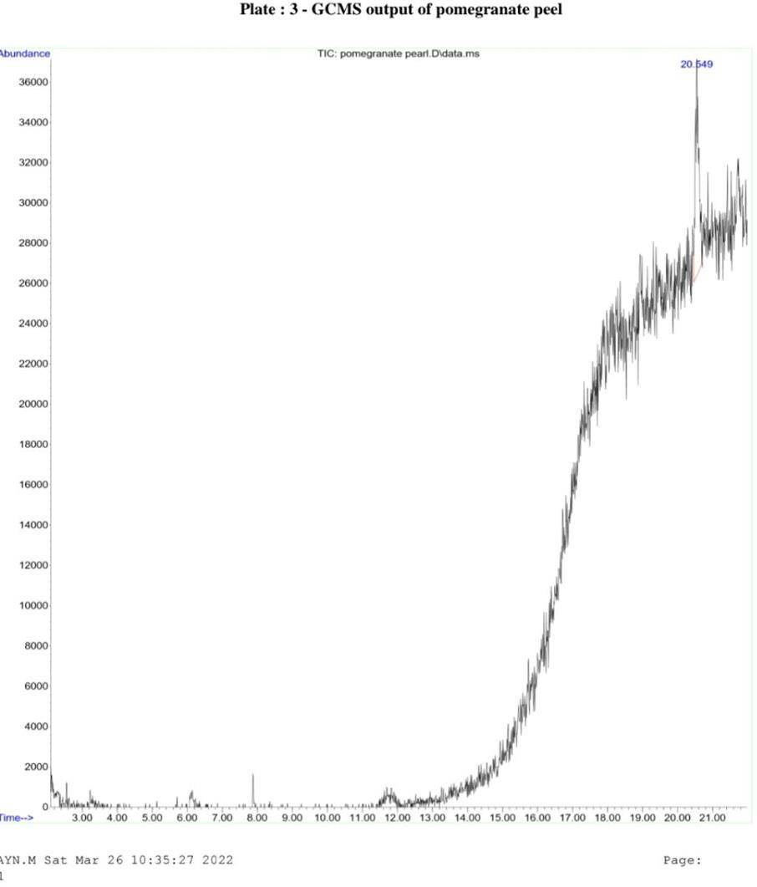

Table 2- Showing compounds profiled in the fruit peel extract
Peak no | Compound name | Retention Time (min.) | Molecular Weight (G/mol.) | Molecular formula | Structure of the compound
1 | Arsenous acid, tris(trimethylsilyl) ester | 20.553 min | 342.49 | C₉H₂₇AsO₃Si₃ | 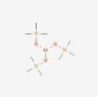
 | Cyclotrisiloxane, hexamethyl- |  | 222.46 | C6H18O3Si3
 | 2-Ethylacridine |  | 207.27 | C15H13N | 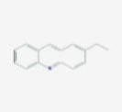

The GC- MS analysis of the ethanolic extract of fruit peel revealed the presence of 3 compounds namely, Arsenous acid, tris(trimethylsilyl) ester, Cyclotrisiloxane, hexamethyl and 2- Ethylacridinedistributed in a peak at retention time of 20.553 minutes (Fig 1: Table 2).Arsenous acid, tris(trimethylsilyl) ester occurred in peak 1 at retention t ime 20.553 minutes. The molecular formula is C₉H₂₇AsO₃Si₃ and the molecular weight is 342.49 G/ mol (Table 2). According to Barathikannan et al., 2016 Arsenous acid, tris(trimethylsilyl) ester has earlier been detected in the pomegranate peel, similar to the present investigation. Cyclotrisiloxane, hexamethyl is the second compound which occurred at peak 1 at retention time 20.553 minutes. The molecular formula is C₆H₁₈O₃Si₃ and the molecular weight is 222.46 G/mol (Table 2). Cyclotrisiloxane has a cyclic dimethyl polysiloxane and is known to possess antibacterial and antioxidant activity. According to Barathikannan et al., 2016, Cyclotrisiloxane, hexamethyl has earlier been detected in the peel of pomegranate peel. In the present work Cyclotrisiloxane, hexamethyl however has been detected in both the peel and pulp of the fruit (Table 2 & 3).
2-Ethylacridine occurred at retention time 20.553 minutes with a molecular formula C₁₅H₁₃N and the molecular weight is 207.27 G/mol is the third compound detected (Table 2 & 3). 2-Ethylacridine is an organic compound and a nitrogen heterocycle with the formula C₁₃H₉N. Acridine derivatives have been extensively explored as potential therapeutic agents for the treatment of a number of diseases, such as cancer, Alzheimer's, and bacterial and protozoan infections. Their mode of action is mainly attributed to DNA intercalation and the subsequent effects on the biological processes linked to DNA and its related enzymes
Fig 2- Chromatogram of Fruit Pulp Extract
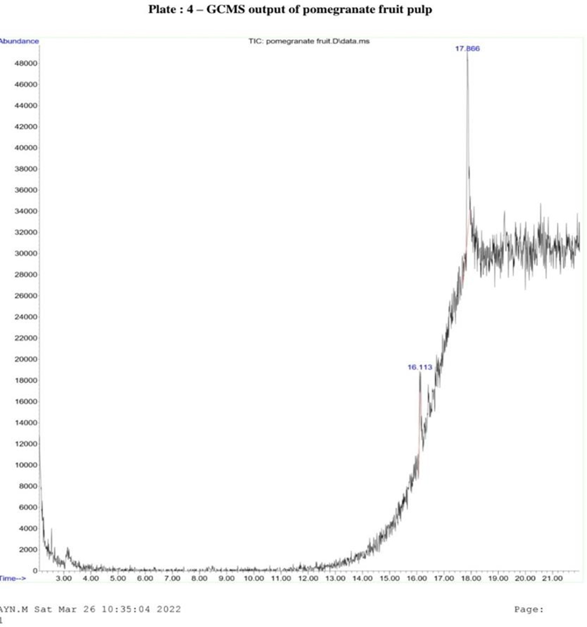
Table 3- Showing compounds profiled in the fruit pulp extract
Peak no | Compound name | Retention Time (min.) | Molecular Weight (G/mol.) | Molecular formula | Structure
1 | Dodecahydropyrido[1,2- b]isoquinolin-6-one | 16.109  min | 207.31 | C₁₃H₂₁NO | 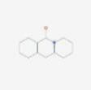
 | Cyclotrisiloxane, hexamethyl- | 16.109  min | 222.46 | C6H18O3Si3
 | 1,2,5-Oxadiazol-3- amine,4-(4- methoxyphenoxy)- | 16.109  min | 207.19 | C₉H₉N₃O₃ | 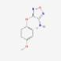
2 | N-Methyl-1- adamantaneacetamide | 17.868  min | 207.31 | C₁₃H₂₁NO | 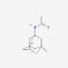
 | 2-Ethylacridine | 17.868  min | 207.27 | C15H13N | 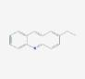
 | 2-(Acetoxymethyl)- (methoxycarbonyl) biphenylene | 17.868  min | 282.29 | C17H14O4 | 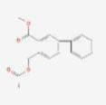

The GCMS analysis of the ethanolic extract of fruit pulp revealed the presence of six compounds namely Dodecahydropyrido[1,2-b]isoquinolin-6-one, Cyclotrisiloxane, hexamethyl-, 1,2,5-Oxadiazol-3-amine, 4-(4-methoxyphenoxy)-, N-Methyl-1-adamantaneacetamide, 2- Ethylacridine and 2-(Acetoxymethyl)-(methoxycarbonyl) Biphenylene distributed through 2 peaks at retention time ranging from 16.109 to 17.868 minutes (Table 3 : Fig 2). Dodecahydropyrido[1,2- b]isoquinolin-6-one occurred in peak 1 at retention time 16.109 minutes. The molecular formula is C₁₃H₂₁NO and the molecular weight is 207.31 G/mol. 1,2,5- Oxadiazol-3-amine occurred in peak 1 at retention time 16.109 minutes. The molecular formula is C9H9N3O3 and the molecular weight is 207.19 G/mol (Table 3). 1,2,5-Oxadiazol-3-amine, 4-(4-methoxyphenoxy, Dodecahydropyrido[1,2- b]isoquinolin-6-one these both are synonym compounds present in P. granatum pulp. Its biological activity has not been found. These compounds however show different retention time.
2-(Acetoxymethyl)-3-(methoxycarbonyl)biphenylene occurred in peak 2 at retention time 17.868 minutes (Table 3). The molecular formula is C₁₇H₁₄O₄ and the molecular weight is 282.29 G/mol. 2-(Acetoxymethyl)-3- (methoxycarbonyl)biphenylene is a component of flavoring agents in food. The 2- (Acetoxymethyl)-3-(methoxycarbonyl) biphenylene provided a novel self-crosslinking antireflective coating polymers which can be used to reduce outgassing. It is used as a pharmaceutical antiviral agent for reducing the duration of cold sores caused by herpes simplex virus in OTC medication. It also used traditionally as an emollient, emulsifier and thickener in cosmetics and nutritional supplement (as an individual entity and also as a constituent of policosanol). According to Brintha et al., 2021, 2-(Acetoxymethyl) - 3- (methoxycarbonyl)biphenylene was detected in the zapota fruits. In the present work 2- (Acetoxymethyl)-3-(methoxycarbonyl) biphenylene has been detected only in the pulp of the fruit (Table 3). N-Methyl-1-adamantaneacetamide occurred in peak 1 at retention time of 17.868 minutes (Table 3). The molecular formula is C₁₃H₂₁NO and the molecular weight is 207.31 G/mol. N-Methyl-1-adamantaneacetamide has a role as a plant metabolite and a pheromone. It is a cyclopentapyridine and a pyridine alkaloid. According to Barathikannan et al., 2016, N-Methyl-1-adamantaneacetamide has been detected in the peel of this fruit in an earlier work. In the present work however, N-Methyl-1-adamantaneacetamide has been detected only in the pulp of the fruit. 2-Ethylacridine and Cyclotrisiloxane, hexamethyl has been detected in the peel and pulp of the fruit.
ANTICANCER ANALYSIS
Anticancer analysis of the selected bioactive compound was screened in MCF-7 Breast Cancer cell line cultures. The results showed that this compound has good efficacy to inhibit the proliferation of cancer cell line, without affecting the normal cells. According to Zaorsky et al., 2016, cancer is a major public health problem is one of the chief causes of death in the world. The existing methods for cancer treatment like chemotherapy, radiotherapy and targeted therapy, are commonly used in clinical treatment. But their applications are greatly restricted due to various toxic side effects, such as drug resistance and cardiotoxicity. Numerous literature has cited the positive anticancer effect of phytocompounds by regulating proliferation, autophagy, metastasis, invasion, and radio resistance of tumor cells (Li et al., 2018: Kim et al., 2020). It is with this in mind the anticancer properties of Punica granatum peel of the fruits were evaluated as this part of the fruit showed more number of compounds compared to pulp. .
The results showed good cancer cell growth inhibition of MCF-7 Breast cancer cell lines by the ethanolic peel extract when compared with the pulp extract. Cytoxicity evaluation of the extract showed a dose dependent activity. At 25 µg/ml, of the extract 96.78% of cell viability was observed compared to the control (Fig 4). However increase in concentration of the peel extract showed a decrease in in cell viability, at 500 µg/ml, of the extract only 6.36 % of cell viability was noticed (Fig 4). This observation was also supported by IC ₅₀ values of the same (Fig 5).

Fig -4 Showing Percentage of Cell Viability Fig -5 Showing IC ₅₀ Values

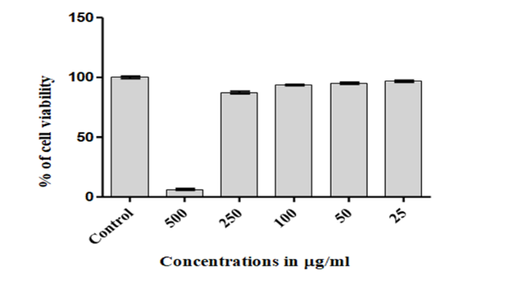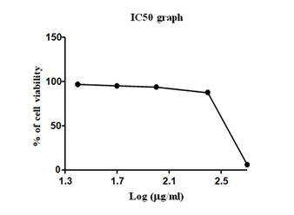

The cancer cell lines showed characteristic morphological changes leading to apoptosis in the growth medium incorporated with ethanolic extract of peel from Punica granatum fruits. The cancer cells showed evident rounding off and loss of adhesion. The morphological changes observed in the cell lines may be due to double-stranded DNA breaks that leads to apoptosis which is due to constituents of the extracts triggering different apoptotic pathways in (Lim et al., 2011). According to Hengartner, 2001, characteristic of cell death due to apoptosis occurs when cells lose contact with neighbouring cells and begin to form bulges on the plasma membrane known as bullae; the cells shrink, and finally, the bullae become well-known apoptotic bodies. In the present work, these morphological changes, was observed in a concentration-dependent manner. When the concentration of ethanolic extract of Punica granatum fruit peel was raised to 100 µg/ml from 25 µg/ml, there was drastic changes in cancer cell line morphology suggesting cell death and apoptosis (Plate 1). At 500 µg/ml of the extract in the cancer cell line growth medium complete necrosis of cells were seen (Plate 1). The various morphological characteristics, such as dilation of the organelles, and in some cases, chromatin condensation and inflammation occur. According to Gonzalez-Polo, 2005, in the case of autophagic and non-lysosomal cell death, the first is characterized by numerous vacuoles in the cytoplasm being filled with cellular debris, and the second shows the dilatation of organelles and empty spaces.
Earlier reports by Yujue Li et al., 2016 has proved that Punica granatum peel extracts can stop proliferation of thyroid carcinoma. Another study by Sharma et al., 2022, the fruit peel extracts can inhibit many forms of cancer and the reason for this effect is the presence of polyphenols like punicalin, punicalagin, and ellagic acid. Panth et al., 2018, explains that potential health benefits of pomegranate (Punica granatum) fruit and the underlying mechanism of its inhibition of cancer progression. Pomegranate has demonstrated anti-proliferative, anti-metastatic and anti-invasive effects on various cancer cell line in vitro as well as in vivo animal model or human clinical trial.
Plate 1–Showing Morphological Changes in Breast Cancer Cell lines MCF-7 Exposed to Varying Concentrations of Ethanolic Extract of Punica granatum Fruit Peel in the Growth Medium.

500µg/ml  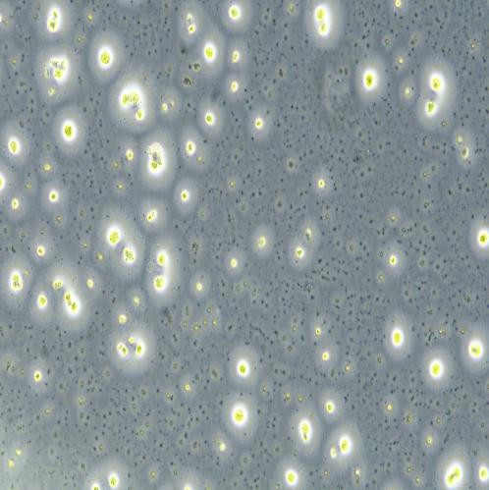 | 250µg/ml  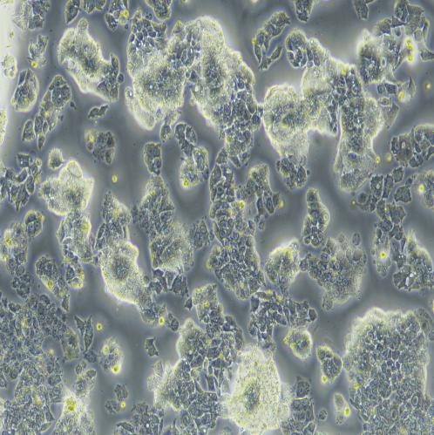
100µg/ml  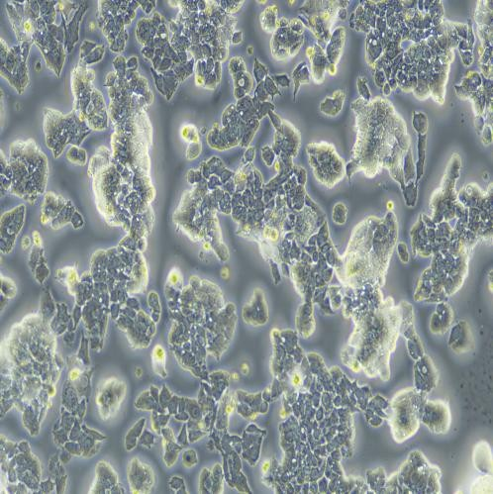 | 50µg/ml  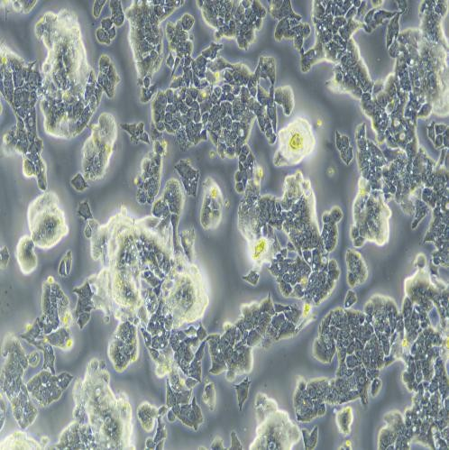
25 µg/ml  25µg/ml  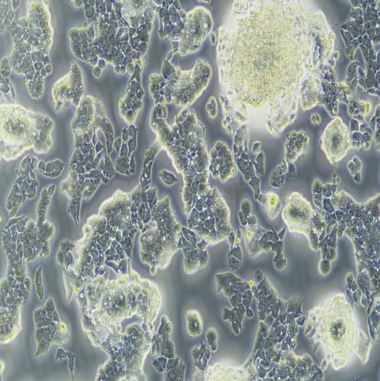 | Control  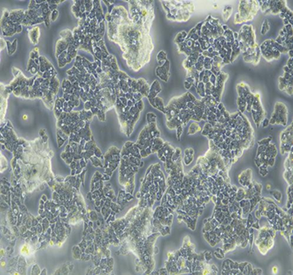

MOLECULAR DOCKING ANALYSIS
The in vitro anticancer activity screening of Punica granatum fruits (Pulp and peel), was followed by in silico evaluation of this property of the peel extract in the selected phyto compounds from the GCMS profile of the same. The docking analysis of the target proteins with the phytochemical ligands was performed using DS visualizer. The docking scores and analysis of the interactions of the phyto compounds with target proteins suggest that important molecules like have the ability to bind to multiple targets involved in inflammatory hyperalgesia. Compounds like Dodecahydropyrido [1,2-b]isoquinolin-6-one, N-Methyl-1-adamantaneacetamide, 2-Ethylacridine, 2-(Acetoxymethyl)-(methoxycarbonyl) Biphenylene and 1,2,5-Oxadiazol-3-amine from the GCMS profile of fruit parts were subjected to in silico analysis
Table 4: Docking results of the selected phytochemicals with CDK2 protein
Protein | Ligand | Binding Energy | Ligand Efficiency | Inhibition Constant(µM) | Electrostatic Energy | Ref RMS
CDK-2  (PDB ID: 3FZ1) | 5-Fluorouracil (Control) | -4.34 | -0.48 | 659.77 | -0.34 | 62.23
 | Dodecahydropyrido[1,2-b]isoquinolin-6-one | -6.54 | -0.44 | 16.18 | 0.01 | 28.43
 | N-Methyl-1-adamantaneacetamide | -5.12 | -0.34 | 177.45 | -0.14 | 41.64
 | 2-Ethylacridine | -6.16 | -0.43 | 9.36 | -0.03 | 31.38
 | 2-(Acetoxymethyl)-(methoxycarbonyl) Biphenylene | -5.1 | -0.24 | 182.74 | -0.01 | 30.7
 | 1,2,5-Oxadiazol-3-amine | -5.08 | -0.34 | 187.37 | -0.12 | 30.78

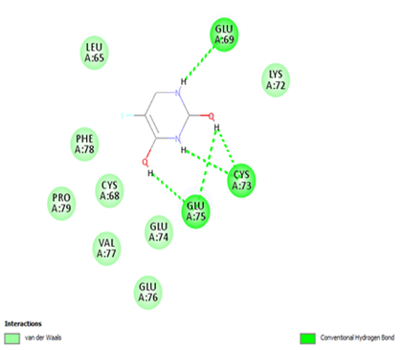

Figure 1: Interaction of 5-Fluorouracil with CDK2. A) 5-Fluorouracil -CDK2 complex. The protein is represented in green and red represents the ligand. B) 2D plot of the complex generated by DS visualizer.

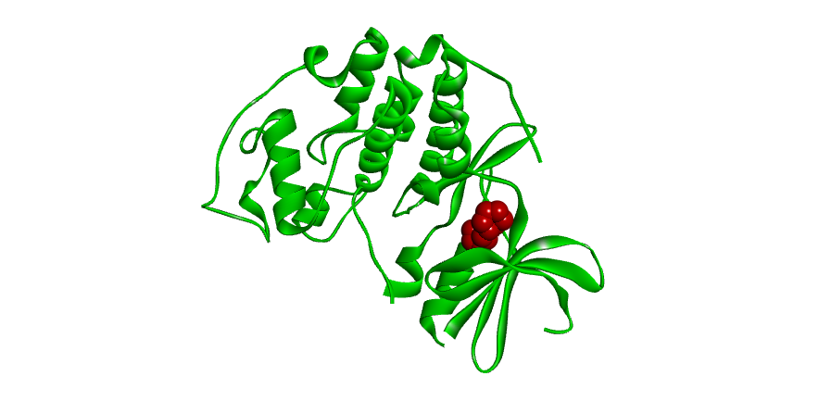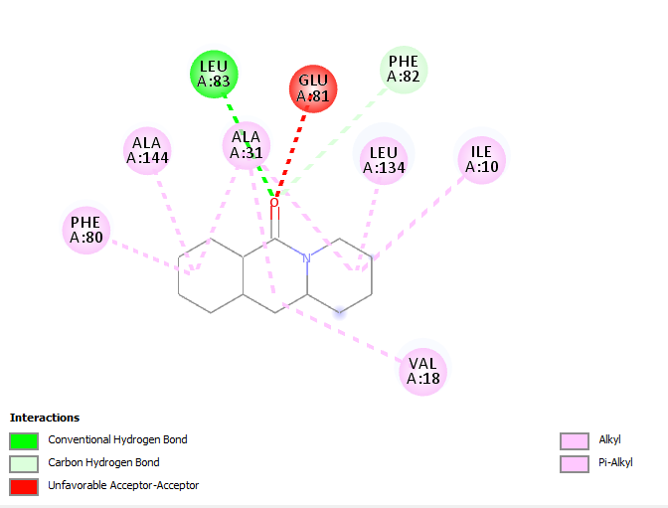

Figure 2: Interaction of 530305 with CDK2. A) 530305 - CDK2 complex. The protein is represented in green and red represents the ligand. B) 2D plot of the complex generated by DS visualizer.

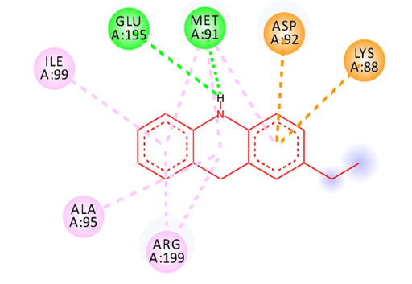
Figure 3: Interaction of 530305 with CDK2. A) 530305 - CDK2 complex. The protein is represented in green and red represents the ligand. B) 2D plot of the complex generated by DS visualizer.
Dodecahydropyrido[1,2-b]isoquinolin-6-one from the methanolic extract of fruit peel when subjected to grid based molecular docking with CDK -2 protein (Cyclin Dependent Kinase-2) using Autodock showed the best results in terms of interaction with the cancer inducing enzyme CDK 2 (Table 2, Fig 3 & 4). The CDK-2 protein controls cell proliferation and in cancerous cells this protein works abnormally by promoting nonstop cell division. The grid boxes were set with the dimension of X=126; Y=126; Z=126. The docking procedure was done using the Lamarckian genetic algorithm for 100 runs. One best conformation from 10 different conformations generated by autodock was considered. The complex structures showing least binding energy, ligand efficiency, with more number of hydrogen bonds were selected for proficient results. The molecule Dodecahydropyrido[1,2-b]isoquinolin-6-one when docked with CDK-2 protein showed a binding energy of -6.54, and its efficiency came to -4.44. The binding energy the inhibition constant was 16.18µM with an electrostatic energy of 0.01. The biomolecule was seen making interactions with nine amino acids- phenylalanine, alanine, leucine, glutamine, valine and isoleucine in the receptor pocket of the protein. In the interaction amino acid leucine (83rd position) interacts with CDK-2 using hydrogen bond, while alanine, phenylalanine, valine, isoleucine (at 134 position) makes pi alkyl bonds. The less binding energy suggest strong bonding with the CDK-2 protein. This bonding will lead to inhibition of the activity of the protein thereby arresting the progression of cancer. Earlier in silico studies of phytochemicals from Punica grantum by Shefin et al., 2022, was done against the protease enzyme of SARS Cov 2, while Andi Alfira Ratna Dewi et al., 2020, proved through in silico studies that quercetin, a compound in the pomegranate can bind to the α-amylase enzyme there by lower blood glucose levels.
The present investigation has shown that Punica granatum fruit parts have high medicinal efficacy that could be exploited in the future for designing ligands in order to obtain novel molecules for the treatment and management of diseases mainly cancer which is on an increase in present era. Though, literature proves that pomegranate has been identified as a candidate for various cancer treatment, it is necessary to replicate and validate its therapeutic efficacy by multiple clinical studies in order to formulate pomegranate products as an integral part of the dietary and pharmacological intervention in anticancer therapy. However this promising study can lead to the designing of a new anticancer drug in the near future.
ACKNOWLEDGEMENT
We the authors acknowledge, the Tamil Nadu State Council for Science and Technology and Manonmanium Sundaranar University, Abhishekapetti, Tirunelveli, Tamil Nadu, India.
BIBILIOGRAPHY
1. Adams L. S., Seeram N. P., Aggarwal B. B., Takada Y., Sand D. and Heber D. (2006), ‘Pomegranate juice, total pomegranate ellagitannins, and punicalagin suppress inflammatory cell signaling in colon cancer cells’, J. Agric. Food Chem., Vol. 54, pp. 80– 985.
2. Ahmed S., Wang N., Hafeez B. B., Cheruvu V. K. and Haqqi T. M. (2005), ‘Punica granatum L. extract inhibits IL-1beta-induced expression of matrix metalloproteinases by inhibiting the activation of MAP kinases and NF-kappa B in human chondrocytes in-vitro’, Nutr., Vol. 135, pp. 2096–2102.
3. Andi Alfira Ratna F Dewi., Muntholib and Subandi. (2020). ‘In vitro and In silico Analysis of Pomegranate (Punica granatum L.) Fruit Powder as Pancreatic Lipase and αAmylase Inhibitor’ Journal of Physics: Conference Series, Vol. 1665. 5 012004.
4. Basu A. and Penugonda K. (2009), ‘Pomegranate juice: a heart-healthy fruit juice’, Nutr. Rev, Vol. 67, pp. 49–56.
5. BIOVIA 2021-Discovery Studio Visualizer Software, Version 4.0. http://www.accelrys.com.
6. Brintha, M., Prabha, M., Thampi Raj, S. and Beena Lawrence, (2021). ‘In vitro and in silico evaluation of Citrus limon (L.) Burm. F. ethanolic fruit extract for its anticancer activity’. The International Journal of Analytical and Experimental Modal Analysis. Vol. 13 pp: 293-309.
7. Florento L, Matias R, Tuaño E, Santiago K, Dela Cruz F, Tuazon A.2012. ‘Comparison of Cytotoxic Activity of Anticancer Drugs against Various Human Tumor Cell Lines Using In Vitro Cell- Based Approach’. Int J Biomed Sci. Vol. 8(1):76-80.
8. Garcea G., Dennison A. R., Steward W. P. and Berry D. P. (2005),‘Role of inflammation in pancreatic carcinogenesis and the implications for future therapy’, Pancreatol, Vol. 5, pp. 514–529.
9. Gonzalez-Polo, R.A.’ The apoptosis/autophagy paradox: Autophagic vacuolization before apoptotic death’. J. ell Sci. 2005, 118, 3091–3102
10. Hartlapp I., Abe R., Saeed R. W., Peng T., Voelter W., Bucala R. and Metz C. N. (2001), ‘Fibrocytes induce an angiogenic phenotype in cultured endothelial cells and promote angiogenesis in-vivo’, The FASEB Journal, Vol. 15, pp. 2215–2224.
11. Hasona N. A., Ahmed M. Q., Alghassab T. A., Alghassab M. A. and Alghabban A. (2016), ‘Anti-hyperlipidemic effect of pomegranate peel and Iranian Fenugreek extracts on cholesterol- rich diet induced hypercholesterolemia in guinea pigs’, Merit Research Journals, Vol. 4, No. 4, pp. 196-203.
12. Hengartner, M.O.2001. ‘Apoptosis: Corralling the corpses’. Cell Vol. 104, 325–328
13. Hong M. Y., Seeram N. P. and Heber D. (2008), ‘Pomegranate polyphenols down-regulate expression of androgen-synthesizing genes in human prostate cancer cells overexpressing the androgen receptor’, J. Nutr. Biochem., Vol. 19, pp. 848–855.
14. Huey,R and Morris,G.M (2008), ‘Using AutoDock 4 with Auto Dock tools: A tutorial’. La Jolla, CA, USA: The Scripps Research Institute, Molecular Graphics Laboratory. Pp. 54-56
15. Jain, P.K. and Joshi, H. 2012. ‘Coumarins Chemical and Pharmacological Profile’. J. Appl. Pharam. Sci. vol. 6 pp: 336-340.
16. Kakimoto Y., Naetoko Y., Iwasaki Y., Nakamura S. and Zasshi H. S. E. (2005), ‘Multiresidue method for determination of pesticides in fruit and vegetable by GC/MS(SCAN) and LC/MS (SIM)’, Journal Of The Food Hygienic Society of Japan, Vol. 46, No. 4, pp.153- 142.
17. Kaliyan Barathikannan., Babu Venkatadri, Ameer Khusro, Naif Abdullah Al-Dhabi, Paul Agastian, Mariadjas Valan Arasu, Han Sung Choi and Young Ock Kim (2016), ‘Chemical analysis of Punica granatum fruit peel and its in vitro and in vivo biological properties’, BMC Complementary and Alternative Medicine, Vol.16 (1):264
18. Karthikeyan G. and Vidya A. K., (2019), ‘Phytochemical analysis, antioxidant and antibacterial activity of pomegranate peel’, Research Journal of Life Sciences, Bioinformatics, Pharmaceutical and Chemical Sciences, Vol. 5, No. 1, pp. 218-230.
19. Kasimsetty S. G., Bialonska D., Reddy M. K., Ma G., Khan S. I. and Ferreira D. (2010), ‘Colon cancer chemopreventive activities of pomegranate ellagitannins and urolithins’, J. Agric. Food Chem., Vol. 58, pp. 2180–2187.
20. Khan N., Afaq F., Kweon M. H., Kim K. and Mukhtar H. (2007), ‘Oral consumption of pomegranate fruit extract inhibits growth and progression of primary lung tumors in mice’, Cancer Res., Vol. 67, pp. 3475–3482.
21. Kim SY, Hwangbo H, Lee H, Park C, Kim GY, Moon SK, Yun SJ, Kim WJ, Cheong J, Choi YH.2020. ‘Induction of Apoptosis by Coptisine in Hep3B Hepatocellular Carcinoma Cells through Activation of the ROS-Mediated JNK Signaling Pathway’. Int J Mol Sci. Vol.21 (15):5502. doi: 10.3390/ijms21155502. PMID: 32752099; PMCID: PMC7432186.
22. Kim Y. H. and Choi E. M. (2009), ‘Stimulation of osteoblastic differentiation and inhibition of interleukin-6 and nitric oxide in MC3T3-E1 cells by pomegranate ethanol extract’, Phytother. Res, Vol. 23, pp. 737–739.
23. Kopustinskiene DM, Jakstas V, Savickas A, Bernatoniene J. (2020), ‘Flavonoids as Anticancer Agents’. Nutrients.12:12(2):457. doi: 10.3390/nu12020457. PMID: 32059369; PMCID: PMC7071196.
24. Koyama S., Cobb L .J., Mehta H .H., Seeram N. P., Heber D., Pantuck A. J. and Cohen P.(2010), ‘Pomegranate extract induces apoptosis in human prostate cancer cells by modulation of the IGF-IGFBP axis’, Growth Horm. IGF Res., Vol. 20, pp. 55–62.
25. Larrosa M., González-Sarrías A., Yáñez-Gascón M. J., Selma M. V., Azorín-Ortuño M., Toti S., Tomás-Barberán F., Dolara P. and Espín J. C. (2010), ‘Anti-inflammatory properties of a pomegranate extract and its metabolite urolithin-A in a colitis rat model and the effect of colon inflammation on phenolic metabolism’, J. Nutr. Biochem. Vol. 21, pp. 717–725.
26. Li, K., Yuan, D., Yan R., Meng, L., Zhang, Y and Yu, K. (2018). ‘Stigmasterol exhibits potent antitumor effects in human gastric cancer cells mediated via inhibition of cell migration, cell cycle arrest, mitochondrial mediated apoptosis and inhibition of JAK/STAT signalling pathway’. JBUON, Vol.23 (5):pp. 1420-1425
27. Lim, S.W.; Ting, K.N.; Bradshaw, T.D.; Zeenathul, N.A.; Wiart, C.; Khoo, T.J.; Loh, H.S. (2011). ‘Acalypha wilkesiana extracts induce apoptosis by causing single strand and double strand DNA breaks’. J. Ethnopharmacol. Vol. 138, 616–623.
28. Ludwiczuk A., Skalicka-Wozniak K. and Georgiev M. I. (2017), ‘Terpenoids’, Pharmacognosy, pp. 233-266.
29. Miguel G., Dandlen S., Antunes D., Neves A. and Martins D. (2004), ‘The effect of two methods of pomegranate (Punica granatum L) juice extraction on quality during storage at 4˚C’, J. Biomed. Biotech, Vol. 5, pp. 332–337.
30. Mohan M., Waghulde H. and Kasture S. (2010), ‘Effect of pomegranate juice on angiotensin II- induced hypertension in diabetic Wistar rats’, Phytother. Res. Vol. 2, pp. 196–203.
31. Monks TJ, Jones DC. (2002). ‘The metabolism and toxicity of quinones, quinonimines, quinone methides, and quinone-thioethers’. Curr. Drug Metab. Vol.3:425–438.
32. Noda Y., Kaneyuki T., Mori A. and Packer L. (2002), ‘Antioxidant activities of pomegranate fruit extract and its anthocyanidins: delphinidin, cyanidin, and pelargonidin’, J. Agric. Food Chem, Vol. 50, pp. 166–171.
33. Oakenfull D. (1981), ‘Saponins in food- a review’, Food chemistry, Vol. 7, No. 1, pp. 19-40.
34. O’Boyle, N.M., Banck, M., James, C.A., Morley, C., Vandermeersch, T., Hutchison, G.R. (2011) ‘Open Babel: An open chemical toolbox’. Journal of Cheminformatics 3, 33 (2011), doi:10.1186/1758-2946-3-33
35. Okamoto J. M., Hamamoto Y. O., Yamato H. and Yoshimura H. (2004), ‘Pomegranate extract improves a depressive state and bone properties in menopausal syndrome model ovariectomized mice’, J. Ethnopharmacol, Vol. 92, pp. 93–101.
36. Panth N, Manandhar B, Paudel K.R. (2017). ‘Anticancer Activity of Punica granatum (Pomegranate): A Review’. Phytotherapy Research. Vol. 31(4):568-578.
37. Prassas I. and Diamandis E. D. (2008), ‘Novel therapeutic applications of cardiac glycosides’, Nature reviews Drug discovery, Vol. 7, No. 11, pp. 926-935.
38. Rahimi H. R., Arasoo M. and Shiri M. (2011), ‘Punica granatum is more effective to prevent gastric disorders induced by Helicobacter pylori or any other stimulator in humans’, Asian J. Plan. Sci., Vol. 10, pp. 380–382.
39. Rodriguez-Garcia, C.; Sanchez-Quesada, C. ‘Dietary Flavonoids as Cancer Chemopreventive Agents: An Updated Review of Human Studies’. Antioxidants 2019, 8, 137.
40. Roy A. (2017), ‘A review on the alkaloids an important therapeutic compound from plants’, International Journal of plant biotechnology, Vol. 3, No. 2, pp. 1-9.
41. Sadasivam, S. and Manew Delhiickam, A. 2008. Biochemical Methods. New Age Publishers/9P) Ltd. New Delhi.
42. Seeram N. P., Aronson W. J., Zhang Y., Henning S. M., Moro A., Lee R. P., Sartippour M., Harris D. M., Rettig M., Suchard M. A., Pantuck A. J., Belldegrun A. and Heber D. (2007), ‘Pomegranate ellagitannin-derived metabolites inhibit prostate cancer growth and localize to the mouse prostate gland’, J. Agric. Food Chem., Vol. 55, pp. 7732–7.
43. Seeram N. P., Schulman R. N. and Heber D.(2006),‘Pomegranates: Ancient Roots to Modern Medicine’, Boca Raton: Taylor and Francis Group, pp . 5–8.
44. Sharma K, Kesharwani P, Prajapati SK, Jain A, Jain D, Mody N, Sharma S. 2022. ‘An Insight into Anticancer Bioactives from Punica granatum (Pomegranate)’. Anticancer Agents Medical Chemistry Vol.:22(4):694-702.
45. Shefin, B, Sreekumar, S and Biju, C.K. 2022. ‘In silico evaluation of anti-SARS-CoV-2 activity of Punica granatum L. phytochemicals’. Corona virus Drug Discovery. Vol 3: pp. 335-354.
46. Stover E. and Mercure E.W. (2007), ‘The pomegranate: a new look at the fruit of paradise’, Hort. Sci., Vol. 42, pp. 1088–1092
47. Sturgeon S. R. and Ronnenberg A. G. (2010), ‘Pomegranate and breast cancer: possible mechanisms of prevention’, Nutr. Rev., Vol. 68, pp. 122–128.
48. Venkata C. S. P., Prakash I. (2011), ‘Bioactive chemical constituents from pomegranate (Punica granatum) juice, seed and peel-a review’, Int. J. Res. Chem. Environ., Vol. 1, No. 1, pp. 1- 18.
49. Wu S. and Tian L. (2017), ‘Diverse phytochemicals and bioactivities in the ancient Fruit and modern functional food’, Molecules, Vol. 22, pp. 1-17.
50. Yujue Li, Tinghong Ye, Fangfang Yang, Mingxing Hu, Libo Liang, He He, Zhipeng Li,a Anqi Zeng, Yali Li, Yuqin Yao, Yongmei Xie, Zhenmei An and Shuangqing Lia .2016. ‘Punica granatum (pomegranate) peel extract exerts potent antitumor and anti-metastasis activity in thyroid cancer’. RCS Advanced Vol 87, pp:1-28.
51. Yuniarto A., Sukandar E. L., Fidrianny I., Artisan F. and Adnyana I. K. (2018), ‘Antiobesity, Antidiabetic and Antioxidant activities of Senna (Senna alexandria Mill.) and pomegranate (Punica granatum L.) leaves extracts and it’s fractions’, International Journal of pharmaceutics and phytopharmacological Research, Vol. 8, No. 3, pp. 18-24.
52. Zaorsky N, Churilla T, Egleston B, Fisher S, Ridge J, Horwitz E, 2016. ‘Causes of death among cancer patients’. Ann Oncol. doi: 10.1093/annonc/mdw604.

