MRI Relaxometry: Applications, Challenges and Future Directions

Ms. Deepega S
Assistant Professor
Department of Radiology and Imaging Technology
School of Allied Health Sciences
Vinayaka Mission’s Research Foundation – DU
AVMC & H Campus, Puducherry, India
E-mail: deepegasanthanam16@gmail.com

ABSTRACT

The use of MRI as a quantitative tool has attracted great interest in the research field. The improvement in the sensitivity and the reduction of subjectivity of visual evaluation created a significant impact on diagnosis of tissue abnormalities. Conventional MR images are qualitative and subjective, and their signal intensity is dependent on several contrast mechanisms manipulated by MR hardware and software. Quantitative relaxometry refers to the measurement of bio-physical parameters - T1, T2 and T2* reflecting the local tissue environment and have a physical interpretation often expressed in absolute units. In addition to providing an unbiased metric for comparing MR scans. Quantitative relaxometry uses the relationship between MR maps and physiology to provide a noninvasive surrogate for biopsy and histology. This study provides an overview of some promising clinical applications of quantitative relaxometry – T2 & T2* mapping, followed by description of the methods and challenges of acquiring accurate and precise quantitative MR maps.

Keywords: Radiology, Relaxometry, T2 Mapping, T2* Mapping, Cartigram, Iron overload, Multiple sclerosis.

- INTRODUCTION

Quantitative MRI refers to the measurement of biophysical parameters through decoupling the different contrast mechanisms that contribute to the overall MR signal. Some of the fundamental quantitative MRI parameters reflecting the local tissue environment are the relaxation times T1, T2, and T2*. One obvious advantage is the removal of influences unrelated to tissue properties, such as those involving operator dependency, differences in scan parameters, spatial variation in the magnetic field, and image scaling. Ultimately, the value of quantification is fully reaped when MRI can provide “measurements” of biological properties in a way similar to current gold-standard techniques such as biopsy and histology. By providing quantitative physiologically relevant information in a non-invasive manner and throughout a three-dimensional (3D) volume at high spatial resolution, quantitative MRI can potentially serve as the ideal surrogate, overcoming the conventional limitations of limited biopsy sampling or the possibility of sampling error.

PHYSICS OF RELAXOMETRY

The relaxation times T1, T2, and T2* are physical parameters determined by intrinsic biophysical properties of tissue.T1 Relaxation is the recovery of longitudinal magnetization is caused by a process called as T1 Recovery. T1 recovery is caused by the nuclei giving up their energy to the surrounding environment or lattice, and it is termed Spin lattice relaxation. T2 Relaxation is the decay of transverse magnetization is caused by a process termed T2 Decay. T2 decay is caused by the magnetic fields of neighboring nuclei interacting with each other is termed as spin - spin relaxation ^{[1]}.

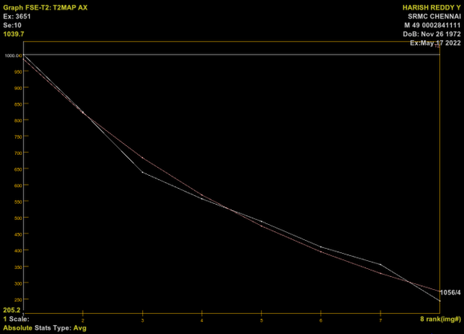
Relaxometry is the measurement of relaxation rates based on the physical aspects of nuclei relaxation to the ground state after being excited by an RF pulse. Relaxometry maps are the images representing the spatial distribution of relaxation times. It can be generated either by spin-echo or gradient echo sequences. Example. T1 map, T2 map & T2* map. Relaxometry maps are generated representing number of echoes on x-axis and signal intensity on y-axis (Figure 1). A map of relaxation rate (R2 = 1/T2) or relaxation time (T1 or T2), using spin echo sequences and it requires at least two images to generate the map.
Echo
Signal intensity

Figure 1: System generated relaxometry map
- T2 RELAXOMETRY

The gold standard imaging of T2 relaxometry is Carr-Purcell-Meiboom-Gill sequence (Figure 2) which is a multiple spin-echo sequence. In this sequence, 90-degree excitation pulse is followed by a series of 180 degree refocusing pulses, and signal is measured at the mid-points between refocusing pulses where the spin-echo is formed and B0 inhomogeneities are removed. On multiple repetitions of the 180° pulse, the height of the multiple echoes decreases successively as a consequence of T₂ de-phasing ^{[2]}. It involves the acquisition of T2 relaxation time of each voxel in the image. The sensitivity of this technique depends on sequence - Time of repetition (TR), Time of echo (TE). The number of images acquired with different TE. The number of TE’s should be chosen in a range centered close to the values of T2 for the sample.
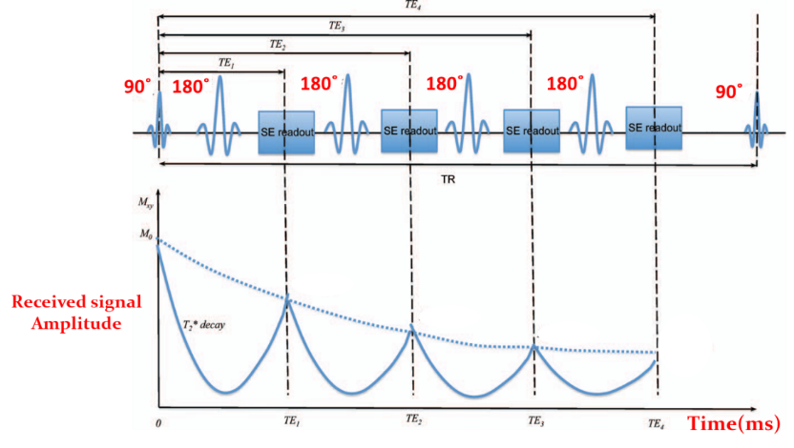

Figure 2: Schematic of a multi-echo spin echo sequence (CPMG) and the T2 relaxation curve.

- T2 RELAXOMETRY - APPLICATIONS
- BRAIN
Brain pathology is often associated with prolongation of the T1, T2, and T2* relaxation times. In hippocampus, visual assessment of T2-weighted changes (hyperintense signal on T2-weighted images and atrophy) is the earliest method that demonstrates pathology of hippocampal sclerosis. T2 relaxometry is another quantitative technique to determine the frequency and severity of T2 abnormality. T2 Relaxation times of the hippocampus increases in patient with hippocampal sclerosis (reflect gliosis in the hippocampus) ^{[3] [4]}. Increase in the hippocampal T2 relaxation time is significant enough to suggest the possibility of more severe degree of hippocampal damage.
T2 relaxation times were measured using 16-echo sequence which is a multiple spin-echo sequence (Figure 3) were obtained for each oblique coronal slice at echo times ranging from 22 to 352 ms. The T2 maps were acquired using a computer program that made a single exponential to the signal intensity data from equivalent pixels from all 16 echoes.
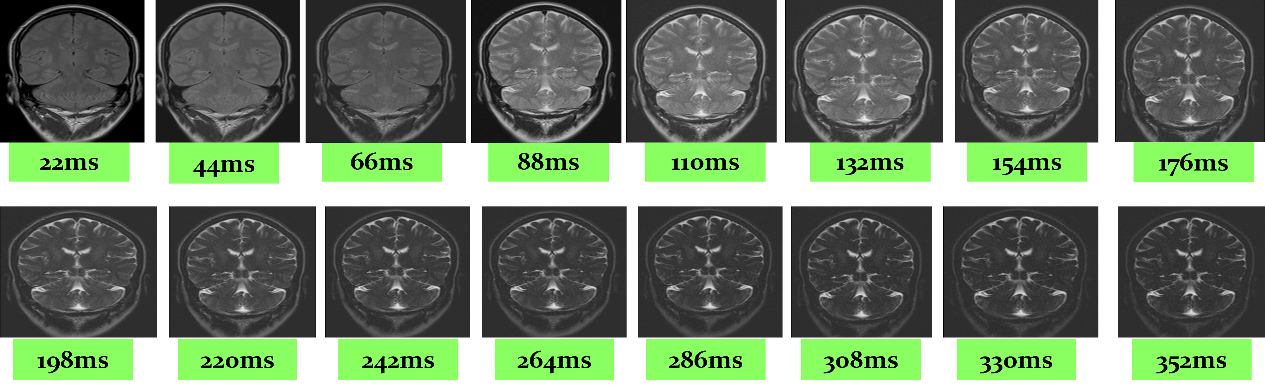

Figure 3: Representing series of images acquired in single TR = 2530ms with multiple TEs.
- MUSCULOSKELETAL

Osteoarthritis, rheumatoid arthritis, and other degenerative conditions of the cartilage have benefited greatly from quantitative relaxometry to detect early chondral degeneration and biochemical changes before gross morphological alterations occur. It includes the collagen breakdown and hence increase the mobility of water in the cartilage and thereby increase the prolongation in T2 relaxations times.
T2 mapping enables the prediction of early biochemical changes in cartilage degeneration, prior to morphological changes in early osteoarthritis. Increase in T2 relaxation times within cartilage has been associated with collagen matrix. Automatically generates color-maps based on a scale of T2 values that allows visualization of changes in the composition of articular cartilage before changes in the thickness can be seen. It is based on a multi-echo pulse sequence that can create up to 8 echoes per single acquisition not more than eight echoes are acquired, due to the cartilage short T2 relaxation times. It is widely employed in knee ^{[5]}, shoulder etc (Figure 4).

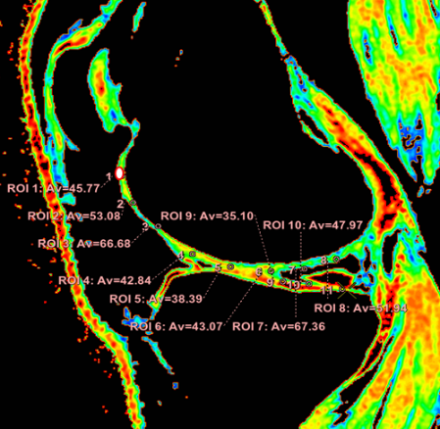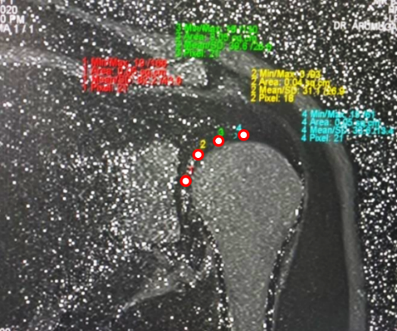
(A) (B)
Figure 4: (A) T2 Color mapping evaluation in knee joint (B) T2 Color mapping in shoulder articular cartilage.
- T2* RELAXOMETRY

T2* relaxation refers to decay of transverse magnetization caused by a combination of spin-spin relaxation and magnetic field inhomogeneity. R2* is measured from the rate of exponential signal decay of the gradient echo signal. T2* mapping is performed with a spoiled gradient-echo sequence with multiple echoes.
T2* relaxometry is the key indicator in the management of patients with hereditary hemochromatosis (HH), thalassemia, sickle cell disease (SCD), continuous blood transfusion, parenteral & dietary iron overload. It is one of the non-invasive methods of measuring iron concentration in both liver and myocardium and is more accessible than invasive procedures like biopsy. In tissues with iron overloading (e.g., Liver) with paramagnetic properties, leads to decrease in signal intensity in the parenchyma thereby decreases the T2 relaxation times of sample tissue.

- IRON OVERLOAD - LIVER
In relaxometry, a series of images is acquired with increasing echo times, the signal intensity of the tissue of interest is modeled as a function of echo time, and signal decay constants T2* is calculated. Signal intensity on T2*W image decreases with an increase in iron concentration result in increased R2*. Iron effect and decrease of the T2* is proportional to the magnetic field ^{[6]}. Iterative Decomposition of water and fat with Echo Asymmetry and Least-squares estimation (IDEAL) is a novel 3-point Dixon imaging technique for separating fat and water. It is employed widely in liver imaging (Figure 5).

Figure 5: T2* Color map evaluation in liver parenchyma
- IRON OVERLOAD - HEART
Myocardial iron overload can be very difficult to detect with commonly used tests such as serum ferritin levels. T2* relaxation times can be used to guide iron chelation therapy in patients with myocardial iron overload ^{[7]}.
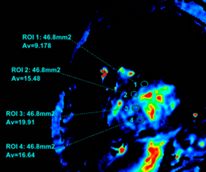

Figure 6: T2* Color map evaluation in myocardium

- IRON OVERLOAD – PARKINSON’S DISEASES
Iron is stored in compounds such as ferritin. However, if iron is present in an unbound form in tissues, it becomes toxic and may lead to cell death. In patients with PD, significant iron accumulation occurs in the basal ganglia (substantia nigra, red nucleus). Iron accumulation in tissues results in a decrease T2∗ and an increase R2^{* [8]}.

- ADVANTAGES
It offers an advantage of removal of influences unrelated to tissue properties and aids in the comparison between different patients. Reduction of biases and reproducibility are significant. It pprovides measurements of biological properties similar to biopsy and histology. T2 relaxometry is a quantitative magnetic resonance tool that can be used to increase the sensitivity of identifying tissue abnormalities above that of visual assessment alone. Relaxometry, non-invasive reproducible technique provides relevant information throughout a three-dimensional volume at high spatial resolution, and can potentially serve as an ideal replacement to invasive procedures like biopsies, unrestricted by conventional limitations like limited biopsy sampling.

REFERENCES
[1] Westbrook C, Talbot J. MRI in Practice. John Wiley & Sons; 2018 Oct 22.
[2] Margaret Cheng HL, Stikov N, Ghugre NR, Wright GA. Practical medical applications of quantitative MR relaxometry. Journal of Magnetic Resonance Imaging. 2012 Oct;36(4):805-24. Clinical applications of MR Relaxometry, Nikola Stikov.et.al.
[3] Nataraja V, Farook AS, Elangovan V, Ahmed A, Magudeeswaran PK. Magnetic Resonance Imaging Evaluation of Hippocampus with T2 Relaxation Time. INTERNATIONAL JOURNAL OF SCIENTIFIC STUDY. 2017;5(1):116-20.
[4] Winston GP, Vos SB, Burdett JL, Cardoso MJ, Ourselin S, Duncan JS. Automated T2 relaxometry of the hippocampus for temporal lobe epilepsy. Epilepsia. 2017 Sep;58 (9):1645-52.
[5] Frank LR, Wong EC, Luh WM, Ahn JM, Resnick D. Articular cartilage in the knee: mapping of the physiologic parameters at MR imaging with a local gradient coil—preliminary results. Radiology. 1999 Jan;210(1):241-6.
[6] Hernando D, Levin YS, Sirlin CB, Reeder SB. Quantification of liver iron with MRI: state of the art and remaining challenges. Journal of Magnetic Resonance Imaging. 2014 Nov;40(5):1003-21.
[7] Elfawal SK, Emara DM, Shehata AA. Assessment of hepatic and cardiac iron overload in thalassemia patients by magnetic resonance imaging: Our experience in Alexandria University. The Egyptian Journal of Radiology and Nuclear Medicine. 2018 Jun 1;49(2):323.
[8] Rossi M, Ruottinen H, Soimakallio S, Elovaara I, Dastidar P. Clinical MRI for iron detection in Parkinson's disease. Clinical imaging. 2013 Jul 1;37(4):631-6.

