Bombay Stock Institute
Phiroze Jeejeebhoy Towers, Dalal St, Kala Ghoda, Fort, Mumbai, Maharashtra 400001

Title of the project:
McDonalds and its new product introduction

Submitted by:
Riya Sanjay Mishra BMS2130 (PJ towers: SEM – V)

Abstract: The project undertaken gives a detailed analysis of market segmentation by McDonald’s and how to penetrate respective segments of the market using various strategies. McDonald’s one of the multinational in the food industry has also hidden strategy of earning through Real estate. The project undertaken has shed light on various marketing strategies adopted by McDonalds which has helped generate higher sales and increased revenue

In this project the secondary data was browsed using the internet whereas a Google form was circulated among the respondents to collect the primary data. Data analysis and interpretation was done using the graphs and the pie charts. The findings clearly show that the customers are attracted towards the marketing strategy and the sales promotion adopted by McDonald’s. The introduction of the new variant understanding the taste, preference and habit of the customer’s i.e. introducing McAloo tikki in the Indian markets has reached to the common masses. This strategy has really worked well, and has helped McDonald’s earn good profits.

Objective:
To understand market segmentation of McDonald’s
To study various marketing strategy adopted by McDonald’s
To know the consumers liking toward McDonald’s product

Introduction to food industry:
Over the past 50 years, the food business has expanded quickly to fulfill both the demands of the population and adapt to shifting lifestyles. Operations in the food sector include a variety of tasks such as food production, processing, distribution, and sales. It is a vital part of the global economy and is crucial in ensuring that the nutritional requirements of the entire world's population are met. Adapting to sociological, technological, and economic considerations, the food business is a creative and dynamic sector. It is essential to providing food for everyone on the planet and is always changing to take advantage of new opportunities and difficulties.

Introduction to McDonald’s:

McDonald's has a long, distinguished history and is one of the largest and most well-known fast-food restaurant chains in the world. In San Bernardino, California, Richard and Maurice McDonald started the business as a barbecue joint in 1940. Their limited menu consisted of burgers, cheeseburgers, soft drinks, milkshakes, and French fries. In 1955, Ray Kroc, a successful businessman, became a franchise agent for the company. Realizing the potential of the brand, he started expanding the business before buying the McDonald's name from the McDonald brothers. Thanks to Kroc's successful franchise business plan, McDonald's became a global phenomenon.

The famed Golden Arches logo, consistent food options, and rapid service make McDonald's famous. Over time, the brand's menu has grown to include a variety of dishes, including well-known dishes like the Big Mac, Quarter Pounder, Chicken McNuggets, and Egg McMuffin. It also offers a variety of drinks, salads, and desserts.

McDonald's has established a reputation as a global cultural institution and an essential component of many people's lives due to its emphasis on accessibility, affordability, and quick service. It is a big player in the fast food sector and has restaurants in almost every country on earth.

Review of literature:

A STUDY OF THE CHALLANGES FACED BY MCDONALD’S WHILE ENTERING THE MARKET OF INDIA

Nikhil Goyal, Shivangi Singh, Manveer Singh, Shikha Tilwani, and Vijesh Patel In India, McDonald's first opened its doors about 23 years ago. It currently has more than 400 locations and is one of India's favorite fast food companies. The difficulties McDonald's had when entering the Indian market are the main topic of this research study. The project's first phase focuses on the difficulties McDonald's had when trying to gain market share in India. These difficulties included environmental, political, and cultural problems. In an effort to achieve popularity in the Indian souk, the second section compares McDonald's to its main rival KFC. The secondary data for this study was gathered from a variety of articles, research papers, and websites. The fourth stage concerns McDonald's future goals and strategies for overcoming obstacles and dominating the Indian market. KFC and Burger King are the two primary rivals, although McDonald's continues to dominate the market in terms of quality, cost, and consumer preference. The best fast food chain, which is favored by the majority of individuals, is also supported by graphs and analyses in the study.
https://ijcrt.org/papers/IJCRT2004094.pdf

―A STUDY ON MARKETING STRATEGY ON MCDONALDs

By Mr. Vishal Shendage
McDonald's is a highly successful fast food chain worldwide. It has seen tremendous success since its inception and is expanding on a global scale. Strong franchisee entrance, standardization, and adaption strategies all contributed significantly to McDonald's enormous growth and positive brand image. In contrast to its rivals, McDonald's has differentiated itself by the standardization of its goods' processing, presentation tactics, and adaption strategy. Knowing the strategies of one of the most successful fast-food companies would certainly assist me out because marketing is my area of interest. Finding out how satisfied customers are with McDonald's services is the main goal. The information was gathered via a questionnaire. The study's findings indicate that McDonald's is India's preferred fast food restaurant. Studying McDonald's and its marketing system has greatly aided my ability to comprehend marketing concepts, marketing strategies, and the actual application of McDonald's standardization and adaptability strategies.

https://www.iimspune.edu.in/

McDonald’s: ―think global, act local – the marketing mix

This essay focuses on McDonald's marketing strategy demonstrates how the business blends globalization and internationalization features in accordance with diverse fast food marketplaces. The case highlights the impact of McDonald's on the global environment and how they adapt to local communities using the effects of strategically and tactical strategies, explains McDonald's future franchise intentions.

https://www.emerald.com/insight/content/doi/

Online branding: the case of McDonald’s

The tactics for delivering brand messaging via a website are examined in this article using one of the most well-known brands, McDonald's, as a case study. The importance of brands and branding in the contemporary economy, which is defined by digitalization and globalization, is heavily stressed. Because the current McDonald's "I'm lovin' it" campaign is incorporated into every element of the business, including its website, this campaign is a wonderful opportunity to evaluate how the Internet channel supports brand growth. The examination of this case study is conducted on two levels: the specific ways in which the website's elements support brand messages and the more general ideas behind the brand strategy, such as channel integration, globalization, and community.
https://www.emerald.com/insight/content

Working at McDonalds: some redeeming features of McJobs

Fast food employment is portrayed as having limited advantages for employees in several important research papers. In reality, the derogatory term "McJob" has come to refer to low-skill, low-pay, dead-end, boring job in the service sector as a whole. Contrarily, literature written for employers presents fast-food jobs more favorably and even highlights their benefits for the workforce. This study looks at survey data from a sample of Australian McDonald's restaurants to find out how both employers and employees feel about these so-called McJobs. Employees perceive their work as consisting of repeating a small number of easy tasks, whereas managers find more rewarding parts of their work, according to studies. It has been demonstrated that working in the fast food industry has benefits in terms of human resources, potential career paths, and, for some people, desired work organization styles. There is proof that working in fast food has its benefits in terms of human resources, future career options, and for certain people, desired types of work.

https://journals.sagepub.com/doi/abs/

6. Effective Marketing strategies of McDonald’s in Malaysia and Indonesia

Examining McDonald's effective marketing initiatives in Malaysia and Indonesia is the goal of this study. Online surveys were employed as the study method, and SPSS version 24 was used for analysis. To support the gathered data, journal articles, papers, and literature reviews are also examined. According to the results, 87.07% of respondents are happy with the services as they are now, while just 69.83% are happy with McDonald's food. The research also revealed that the majority of customers were familiar with McDonald's because to social media. The findings include recommendations for further study and development offered by McDonald, particularly for providing more options and more discounts in their services.
http://www.ejournal.aibpmjournals.com/index.php/IJABIM/article/view/
Secondary Research:
The secondary data was gathered by looking through several websites. It provided the researcher with various articles and subject-related information. The researcher was able to gain a thorough understanding of earlier investigations on the subject with the help of review of literature

McDonald’s Mission Statement:

The primary goal of the mission statement is to guarantee that customers enjoy their meals at one of their venues. The company strives to make everyone's dining experience at a McDonald's restaurant enjoyable and interesting. McDonald's strives to provide each client with a positive dining experience from beginning to end, including efficient and polite service, top-notch food, attention to the small things, and spotless surroundings.

McDonald’s Vision Statement

The defining phrase from the McDonald's Vision Statement is "to move with velocity to drive profitable growth and become an even better McDonald's, serving more customers delicious food each day around the world." This statement makes it clear that the company's top priorities are upholding a high level of food quality while also making investments in its workforce, technology, and other resources to support future growth. Increasing customer satisfaction while achieving profitable growth is a big part of McDonald's fundamental goal.

It emphasizes the importance of striving to be "even better." This demonstrates how McDonald's is always seeking for ways to improve the experience of their customers by providing better goods and services.

McDonald’s around the world:

A well-known worldwide fast food chain with a huge global footprint is McDonald's. Since 1955, McDonald's has pledged to offer customers excellent experiences everywhere they go. The company, which seeks to improve the convenience of people's lives, has opened more than 38,000 restaurants in more than 100 countries and regions, providing food to around 70 million customers every day. In order to provide customers with more engaging experiences and create unforgettable feelings for them, McDonald's places a focus on ensuring that every restaurant operates in accordance with high standards of quality, service, and cleanliness.

McDonald’s core values:
Quality, service, inclusivity, and value are the cornerstones of McDonald's core values. The company is dedicated about pursuing ethical business practices and corporate responsibility as part of these key beliefs. This covers things like helping out local communities, providing a secure workplace for all employees, safeguarding the environment through moral behavior, providing a suitable menu while following food safety regulations, and acting honorably in all of one's contacts with other people.

- Quality: McDonald's is dedicated to giving its customers high-quality food and drinks. Fresh ingredients are used, and strict quality control requirements are upheld.
- Service: In order to give customers a positive and memorable dining experience, McDonald's strives to provide great customer service.
- Cleanliness: The business prioritizes sanitation and keeping a sanitary atmosphere in its dining establishments.
- Value: McDonald's makes an effort to provide consumers with meals that are both reasonably priced and filling.

Objective of the company:

- Customer Satisfaction: McDonald's aims to provide its customers with premium products, outstanding service, and an enjoyable experience. They put a lot of effort into satisfying customer demands and fostering brand loyalty.
- Global Expansion: McDonald's has focused on expanding its presence abroad by building stores in several countries. Serving customers from many nations and cultures is their aim.
- Menu Innovation: McDonald's continuously tests out new menu items to keep up with changing consumer preferences and dietary. They preserve the traditional favorites and add fresh ones.
- Sustainability: McDonald's has been working to implement more environmentally friendly policies, such as using eco-friendly packaging, promoting moral food procurement, and reducing its carbon impact.
- Employee Development: In addition to building a great work atmosphere and promoting cooperation, McDonald's seeks to provide its workers chances for growth and development.
- Community Engagement: The Company participates in the local communities through a range of programs, such as charity collaborations, scholarships, and financial assistance for community events.

SWOT Analysis of McDonald’s:

Strengths:
- Global Presence: McDonald's is one of the most well-known and recognizable fast-food companies in the world because to its extensive global presence in more than 100 nations.
- Strong Brand Image: A strong brand identity has been shaped by the "Golden Arches" image and the brand's link with fast food, accessibility, and convenience.
- Standardized Operations: McDonald's has built effective, standardized operating processes that guarantee uniformity in the calibre of the food and the level of service throughout all of its locations.

Weaknesses:
- Health Concerns: McDonald's meal offerings have come under fire for their nutritional content, raising worries about public health and obesity.
- Slow Response to Trends: The business has occasionally come under fire for moving slowly in response to shifting customer tastes and health trends, which resulted in some market share loss.
- Reputation Challenges: Concerns over labour methods, the environment, and animal welfare have put McDonald's under public relations pressure. The reputation and brand image of the business may be affected by these problems.

Opportunities:
- Menu Innovations: By adding healthier alternatives and catering to shifting consumer tastes, McDonald's has the chance to keep innovating its menu.
- Expanding in Emerging Markets: McDonald's may concentrate on strengthening its footprint in fast developing areas in Latin America, Africa, and Asia.
- Embracing Technology: Customers' convenience may be increased by implementing technology-driven solutions like mobile ordering, delivery services, and automated processes.
Threats:
1. Severe Competition: Other fast-food businesses, neighborhood restaurants, and new cuisine trends all pose a serious threat to McDonald's.
2. Health laws: Increasing fast-food laws because of nutrition and health issues may have an effect on McDonald's business operations and profits.
3. Economic factors: Changes in the state of the global economy may have an influence on consumer spending patterns and McDonald's sales.

PESTEL Analysis:

Political Factors:
- Governmental policies: The success of McDonald's operations abroad depends on the political stability of such nations. The business climate of an organization can be impacted by government rules, taxes, and policies.
- International trade policy: Because McDonald's depends on importing and exporting goods, changes in trade agreements or tariffs may have an impact on the profitability of its supply chain.
- Regulations pertaining to health and food safety: The Corporation is subject to strict laws controlling the caliber, security, and nutritional labeling of food, which may have an effect on its menu and marketing plans.

Economic Factors:
- Economic growth and stability: The success of McDonald's is influenced by the state of the economy in each of the nations where it conducts business. Consumer spending on eating out may decrease during economic downturns.
- Exchange rates: Because it is an international company, McDonald's is susceptible to currency fluctuations, which can harm sales and profitability, especially in nations with unstable exchange rates.
- Income levels: The target market's disposable income affects the company's sales and profitability. Spending on fast food increases often with increases in its disposable income.

Social factor:
- Changing customer tastes: McDonald's menu and sourcing strategies may need to be modified in response to consumer desires for healthier meals, sustainability, and ethical practices.
- Demographics: The target market and marketing strategies of McDonald's may be impacted by changes in population size, age distribution, and family structures.
- Cultural considerations: When entering new areas, McDonald's must respect local cultural customs and preferences. As a consequence, the menu is altered, and tailored marketing initiatives are made.
Technological factor:
- Automation and digitalization: McDonald's keeps making technological investments like self-service kiosks, smartphone ordering systems, and delivery platforms to improve operational effectiveness and the customer experience.
- Data privacy and cyber security: The Company must handle data privacy issues while guarding against cyber security dangers as it collects and keeps user data.
Environmental factor:
- Sustainable sourcing and packaging: McDonald's has to concentrate on eco-friendly packaging and sustainable ingredient sourcing in order to reduce its environmental impact.
- Energy consumption: The company may benefit from energy-efficient procedures and renewable energy sources to lessen its impact on the environment.

Legal factors:
- Employment laws: In different nations, McDonald's must comply with a variety of labour laws and regulations that have an impact on employee rights, salaries, and working conditions.
- Intellectual property protection: To maintain its brand image and stop unlawful usage of its assets, McDonald's must protect its intellectual property and trademarks.

Porters 5 Forces:

- Threat of New Entrants: Newcomers entering the consumer food industry face a number of obstacles. In this business, few newcomers succeed since it takes time to discover what consumers want, but the incumbents are knowledgeable and have actually improved with client loyalty over their products through time. McDonald's has a low risk of competition due to its extensive global distribution network and stellar reputation.
- Bargaining Power of Suppliers: McDonald's has some sway on its suppliers because it is a significant and well-respected buyer in the fast-food sector. The firm uses a range of materials and substances in its goods, and it depends on a wide range of suppliers to maintain a reliable supply chain. Despite the minimal bargaining strength that individual suppliers may have, any large interruption or shortage of a particular supply might have an impact on McDonald's business operations and profits.
- Bargaining Power of Buyers: In the fast food market, consumers have a little amount of negotiating leverage. When it comes to fast food restaurants, customers have a lot of alternatives, which provides them some negotiating power over the cost and expected level of quality. However, McDonald's has a devoted clientele and offers a wide selection of goods at different price points, providing it some power to keep clients and keep prices competitive.
- Threat of Substitutes: Since consumers have several options for dining, the danger of replacements is rather strong in the fast-food sector. Other fast-food businesses, informal eating establishments, home-cooked meals, and healthier food choices are some of these substitutes. McDonald's combats this challenge by updating its menu often, introducing fresh goods, and adjusting to shifting consumer tastes.
- Industry Rivalry: McDonald's confronts fierce competition from other significant fast-food companies including Burger King, Wendy's, KFC, and Subway, among others, in the highly competitive fast-food sector. Price, product differentiation, brand reputation, and marketing tactics are just a few examples of the elements that influence competition. McDonald's great brand awareness, worldwide presence, and operational effectiveness provide it a competitive advantage.

Marketing Strategy of McDonald’s:

I’m Lovin’ It…. Para Pap Pap Paa.

“I’m Lovin’ It… Para Pap Pap Paa” is a very well-known jingle that has been used by McDonald’s for a very long time now.
This jingle emphasizes the satisfying experience one may have in a McDonald's restaurant. Because it describes how satisfied customers are with their meals there and how helpful and polite the staff are, the jingle is unforgettable.

McAloo Tikki:

Localization has been one of McDonald's primary strategies in India. To accommodate the tastes and customs of Indians, they modified their menu. For instance, they provide vegetarian versions like the wildly popular McAloo Tikki burger in India.

It is a true "glocal" burger, made with local flavors and tastes combined with McDonald's renowned worldwide procedures and methods.

The "McAloo Tikki" burger, which is the most popular in India, has been added to McDonald's menu. The fast food chain said that the burger is now available at its Chicago, United States, location.

The Tomato Ban:

No tomatoes now in your McDonald’s burger as prices soar to Rs 180 per kg.

The choice was made as a result of the expensive and subpar tomatoes.
In majority of its restaurants in the north and east of the country, McDonald's has discontinued using tomato in its meal preparations due to a lack of high-quality options and a rise in price of up to Rs 200 per kilogram of the ingredient.
Tomatoes won't be included on the menu owing to seasonal concerns, the fast-food chain's spokeswoman stated in a statement.

"As a company dedicated to the greatest standards of food quality and safety, we only utilize ingredients that have passed stringent inspections. Despite our best efforts, we are unable to find tomatoes that meet our demanding, world-class quality standards owing to seasonal problems, the statement said.
"As a result, we are forced to use tomatoes in certain of our menu items at our restaurants. This is only a short-term problem, and we want to reassure our consumers that we are working on finding a means to quickly reinstate tomatoes on our menu.

McDonald’s: Growth Plan and Accelerators:
The business model and customer-centric approach for McDonald's, known as the Velocity Growth Plan, was unveiled in 2017 and focuses on three essential aspects of the company's operations: food, value, and customer experience.

Emphasizing markets where it already has a strong presence, such as family gatherings and food-focused brunches, would help retain current clients.
Gaining back fewer frequent visitors: Reaffirming its dedication to its historical advantages, including food's superior flavor, quality, and convenience.
Converting transient users into loyal ones: boosting snack and treat options while reinforcing and growing the McCafé coffee brand in order to foster long-lasting relationships with consumers and encourage frequent visits.

McDonald’s competitors:
Burger King: Is the biggest direct rival of McDonald's with more than 18,000 outlets and presence in more than 90 countries, has around 90% of its eateries owned by franchisees;
Subway: With more than 37,000 locations in more than 80 countries, the privately-owned Subway is one of the largest QSR chains in terms of scale;
Chipotle: This chain of more than 2,800 restaurants works under the tagline "Food with Integrity" and none of its locations are franchised. They provide quick cuisine that is a little different, such tacos, salads, and burritos, but at pricing that are higher than those of its rivals.

McDonald’s Real Estate: How They Really Make Their Money

Therefore, McDonald's does not profit on the sale of hamburgers.
Many of us are unaware that McDonald's isn't actually a network of burger-flipping restaurants. It is, but not exclusively. The corporate entity is actually a fantastic real estate firm when you peel back the layers. Even Harry J. Sonneborn, a former CFO of McDonald's, is cited as saying, "We are not technically in the food industry. Our line of work is real estate. The only reason we offer hamburgers for fifteen cents is because they are our biggest source of income from which we can collect rent from our renters.

Today, McDonald's has two strategies to profit from real estate. In addition to buying and selling hot properties, its real estate company will also collect rent at each of its franchised sites. Over 100 nations have McDonald's outlets, and they have likely served over 100 billion hamburgers. Only 15% of the more than 36,000 sites throughout the world are directly owned and run by the McDonald's business. The remainder are run by franchisees.

It's an excellent plan. They are protected from the ups and downs of the burger-flipping business because to their ability to collect rent.

Primary research:
A Google form was circulated among the respondents and in all 66 responses was collected. The data was analyzed using the statistical charts and graphs.
Google form link: https://forms.gle/UvSPJQFH6nhHJWHq7

Data Analysis:

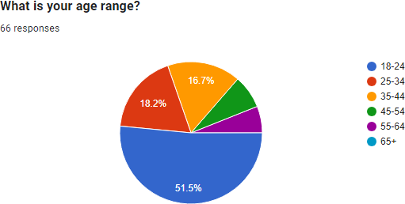

Majority i.e. 51.1%of the respondents belong from the age group of 18-24 years. The other remaining are from different age brackets

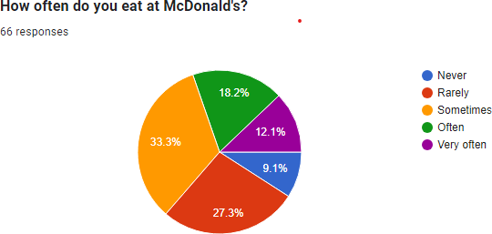

From the above pie chart it is seen that 69.69% respondents on an average often visit to McDonald‟s. It helps in understanding the frequency of visits to the fast-food chain and the level of engagement of the respondent.

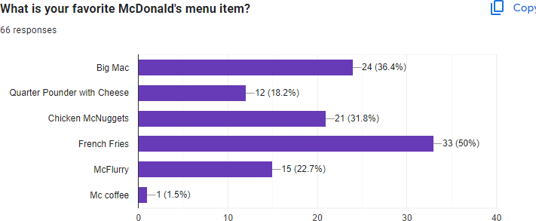

The Bar chart shows that the respondents prefer French fries the most i.e. 50% of the respondents. It is seen that different respondents have different choices.

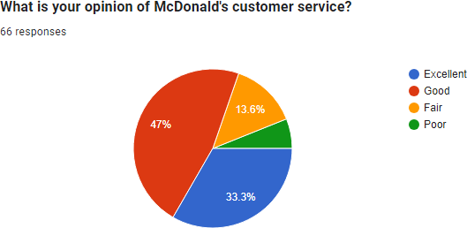

80.3% of the respondents have responded positively to the question. This generally indicates customer satisfaction and a positive perception of the brand.

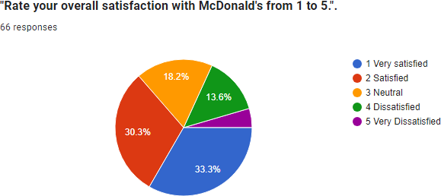

  - % of the respondents have shown a higher level of satisfaction towards McDonald‟s. They had an excellent experience and are very happy with the products or services they received.

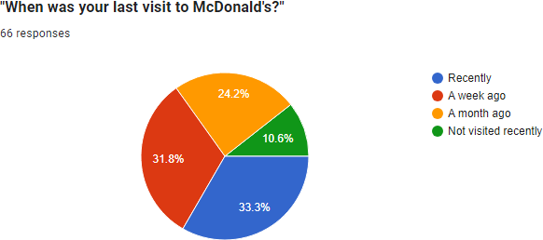

From the chart we can see that maximum number of respondents visited McDonald‟s recently. There are respondent responding with a different answer.

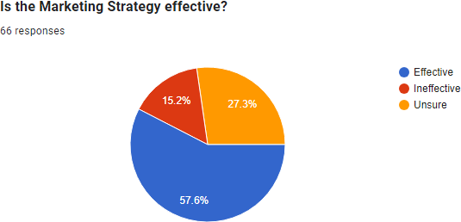

Yes the respondents do believe that McDonald‟s have a great and effective marketing strategy. 57.6% of the respondents has given a positive response to the above question.

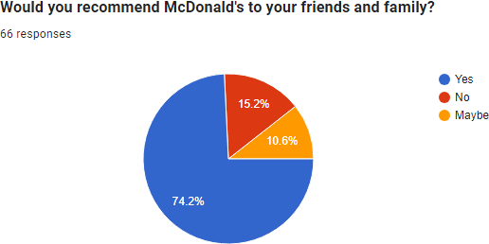

Higher percentages of positive responses indicate a high level of customer satisfaction and loyalty. Customers who are willing to recommend McDonald's to their friends and family are likely to be brand advocates.
The chart shows that 74.2% of the respondents would definitely recommend McDonald‟s to their friends and family.

Limitation of the study:
    - The study undertaken by the researcher is based on primary data, with limited respondents.
    - The secondary data available through sources was not objective specific and was available in bits and pieces.
    - The biasness of the responded towards the data collected cannot be overlooked.

Conclusion:

The project undertaken has shed light on various marketing strategies adopted by McDonalds which has helped generate higher sales and increased revenue. Given its size and reputation, McDonald's consistently conducts research and executes initiatives to keep up with shifting consumer preferences, market conditions, and business trends. Their business-related strategies frequently center on a variety of business-related issues, including menu innovation, marketing initiatives, sustainability initiatives, technology adoption, and expansion plans.

A primary research was conducted by circulating a Google form and 66 responses were collected. The data was collected using various charts and graphs. The findings clearly show that the customers are attracted towards the marketing strategy and the sales promotion adopted by McDonald‟s

References:
- https://businessmodelanalyst.com/mcdonalds-mission-and-vision-statement/
- https://www.ehow.co.uk/
- https://businessmodelanalyst.com/
- https://www.latestly.com/agency-news/india-news
- https://jungleworks.com/mcdonalds-business-model-and-marketing-strategies
- https://www.wallstreetsurvivor.com/mcdonalds-beyond-
- http://www.ejournal.aibpmjournals.com/index.php/IJABIM/article/view/1167
- https://journals.sagepub.com/doi/abs/
- https://www.emerald.com/insight/content
- https://www.wallstreetsurvivor.com/mcdonalds-beyond-the-burger/
- https://www.mcdonalds.com/us/en-us.html

