Stress-Strain Analysis of Cubic Crystals
Maninder Kaur,
PG Department of Physics,
DAV College,
Katra Shar Singh, Amritsar,
Punjab, India.
mannu_711@yahoo.co.in

I. Introduction

Condensed matter physics is the branch of physics that deals with the microscopic and macroscopic physical properties of the condensed states of matter. We study condensed matter physics because it explains the world around us. Almost all the physical world that we see is condensed matter. It answers questions such as why the metals are shiny and why they feel cold. Why is the glass transparent? Why is the water fluid and why does the fluid feel wet?
Finally, it is very useful. Over the last century, our command of condensed matter physics has enabled us to do remarkable things. We have engineered new materials to change our world completely. The most remarkable example is the invention of semiconductor technology which revolutionized computers, iPhones, and the whole e-world.

- Motivation behind this chapter
We need to know Bulk Modulus, Poisson’s Ratio, Young’s Modulus, and Rigidity Modulus for engineering work. These are expressed in terms of the elastic compliance constant and elastic stiffness constant. The relation between elastic compliance constant and elastic stiffness constant has been derived only partially in all the leading textbooks like R.L. SINGHAL, A.J. DEKKER & CHARLES KITTEL, etc. This chapter aims to fully derive the relation between the elastic compliance constant and elastic stiffness constant to facilitate the understanding of this topic of the Post Graduate Condensed Matter Physics 1.

- Stress-strain analysis
Stress-Strain Analysis is a technique that uses many methods to determine the stresses and strains in materials and structures related to forces. In continuum mechanics, stress is a physical quantity that expresses the internal forces that constituent particles of a continuous material exert on each other, while strain is the deformation of the material.
In simple terms, we can define stress as the force of resistance per unit area, offered by a body against deformation. Stress is the ratio of force per unit area i.e., S=R/A, where S → Stress, R → Internal resisting force, and A → cross-sectional area. Strain is the ratio of change in length to the original length when a body is subjected to some external force.

- General principle
Stress analysis is specifically concerned with solid objects. The study of stresses in liquids and gases is the subject of fluid mechanics. Stress analysis adopts the macroscopic view of materials and characteristics of continuum mechanics. The smallest particle considered in stress analysis contains an enormous number of atoms, and its properties are averages of the properties of those atoms. In stress analysis one normally disregards the physical causes of forces or the precise nature of the materials. Instead, one assumes that the stresses are related to the strain of the material through known constitutive equations.

II. Elastic Constants

When an elastic body is subjected to stress, a proportionate amount of strain is produced. The ratio of the applied stresses to the strains generated will always be constant. The elastic constant represents the elastic behavior of objects. There are four types of elastic constants: -
- Young’s Modulus
- Bulk Modulus
- Rigidity Modulus
- Poisson’s Ratio

- Young’s Modulus
According to Hook’s Law, when a body is subjected to tensile stress, the stress applied is directly proportional to the strain within the elastic limits of that body. The ratio of applied stress to the strain is constant and is known as Young’s modulus.

- Bulk Modulus
When a body is subjected to mutually perpendicular direct stresses which are alike and equal, within its elastic limits, the ratio of direct stress to the corresponding volumetric strain is found to be constant. The ratio is called bulk modulus.

- Rigidity Modulus
When a body is subjected to shear stress the shape of the body gets changed, the ratio of shear stress to the corresponding shear strain is called rigidity modulus.

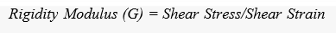

- Poisson’s Ratio
When a body is subjected to simple tensile stress within its elastic limits, then there is a change in the dimensions of the body in the direction of the load as well as in the opposite direction. When these changed dimensions are divided from their original dimensions, longitudinal strain, and lateral strain are obtained. The ratio of the Lateral strain to the Longitudinal strain is called Poisson’ ratio.

Iii. Components Of Stress

Let us Imagine a small cube of sides dx, dy, and dz removed from the solid, on which stress is applied. On each face of the cube, the forces can be resolved into three mutually perpendicular components, one is normal to face which results in normal stress and two are lying in the plane of the face that form shear stress.

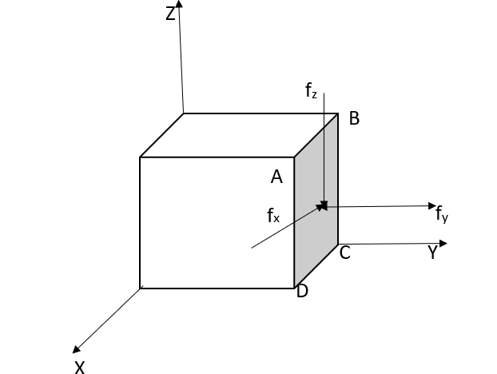
Figure 1: Components of force

Here f_{y} results in normal stress, and both f_{x} and f_{z} result in shear stress. However, when the cube is in dynamic equilibrium, forces on opposite faces must be equal in magnitude and opposite in sign.

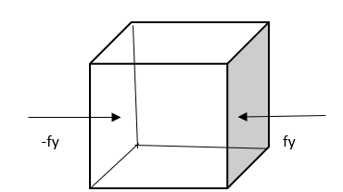
Figure 2: Dynamic Equilibrium
Thus, to describe the stress condition of the cube Nine components are required. Three stresses are normal to cube faces and Six stresses act across the cube faces.
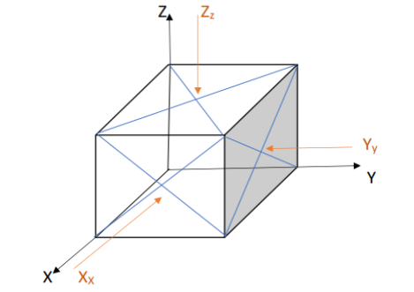
Figure 3: Components of stress

Stress components in matrix form are,
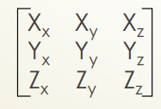
Figure 4: Stress Matrix

Where the Capital letter indicates the direction of force and its subscripts indicate the direction of normal to the plane on which force is acting. The number of independent stress components reduces further to six if the cube is in static equilibrium, i.e., the cube does not rotate.
- Under this condition
X_{y} = Y_{x} ; Z_{y} = Y_{z} ; Z_{x} = X_{z}
- The six independent stress components then are, X_{x}, Y_{y}, Z_{z}, X_{y}, Y_{z}, Z_{x}
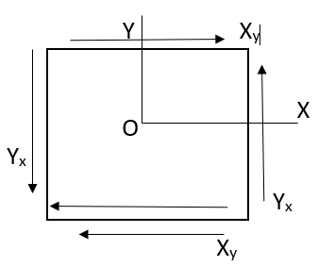
Figure 5: Static Equilibrium
IV. Components of strain
Consider an unstrained solid with orthogonal unit vectors i, j, and k as shown in Figure 6. For an orthogonal system, Δa, Δb, Δc, Δα, Δβ, Δϒ correctly define the six components of elastic strain. Where α,β, ϒ is the angle between the unit cell axes a,b,c.
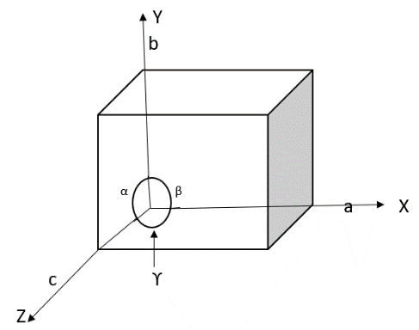
Figure 6: Orthogonal System

However, for the non-orthogonal axis, this leads to mathematical complications. Hence, a general situation strain is specified in terms of six components e_{xx}, e_{yy}, e_{zz}, e_{xy}, e_{yz}, and e_{zx} as defined below.
Suppose a small uniform deformation i.e., deformation in which each primitive cell of crystal is deformed in the same way, of the solid that results in distorted orientation and length of axes as shown in figure.7,
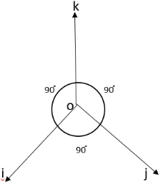
Figure 7: Non-Orthogonal System
The new axis i’, j’, k’ than written in terms of the old axis are given below
i’ = (1+ϵ_{xx})i + ϵ_{xy}j + ϵ_{xz}k …….1(a)
j’ = ϵ_{yx}i + (1+ϵ_{yy})j + ϵ_{yz}k ……..1(b)
k’ = ϵ_{zx}i + ϵ_{zy}j + (1+ϵ_{zz})k ………1(c)
where the coefficients ϵ_{xx}, ϵ_{xy}, ϵ_{xz,} etc. define the deformation; they are dimensionless quantities with values <<1, if the strain is small. Also, the fractional changes in the length of axis i, to the first order, is ϵ_{xx}, and that of j and k axes are ϵ_{yy} and ϵ_{zz}. Thus ϵ_{xx}, ϵ_{yy}, ϵ_{zz} represents linear strain components which are defined as
e_{xx} = ϵ_{xx}, e_{yy} = ϵ_{yy}, e_{zz} = ϵ_{zz} ……(2)
Similarly, i’. j’ ≅ ϵ_{yx} + ϵ_{xy}, which gives a measure of change in orientation between i’& j’ due to stress. Thus, e_{xy} = change in angle between axes i’& j’.
Thus
e_{xy} = i’. j’ ≅ ϵ_{yx} + ϵ_{xy}
e_{yz} = j’. k’ ≅ ϵ_{yz} + ϵ_{zy}
e_{zx} = k’.i’ ≅ ϵ_{zx} + ϵ_{xz} ..….(3)
Now merely rotating the axes does not change the angle between them. So using equation (3), a pure rotation represented by ϵ_{yx} = -ϵ_{xy}, ϵ_{zy} = -ϵ_{yz} & ϵ_{zx} = -ϵ_{xz} are excluded. Further taking ϵ_{yx} = ϵ_{xy}, ϵ_{zy} = ϵ_{yz} & ϵ_{zx} = ϵ_{xz} .values in equation (3) , we get
e_{xy} = 2ϵ_{xy}; e_{yz} = 2ϵ_{yz}; e_{zx} = 2ϵ_{zx} ……(4)

V. RELATION BETWEEN STRESS ANS STRAIN COMPONENTS

According to Hook’s Law, when a body is subjected to tensile stress, the stress applied is directly proportional to the strain within the elastic limits of that body. So that the strain components are linear functions of stress components :

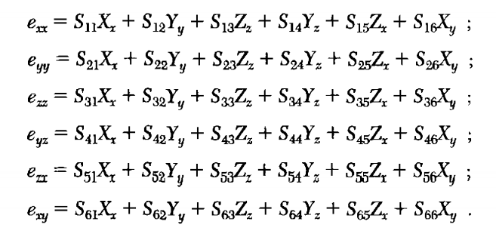
……(5)
Conversely, the stress components are linear functions of the strain components:

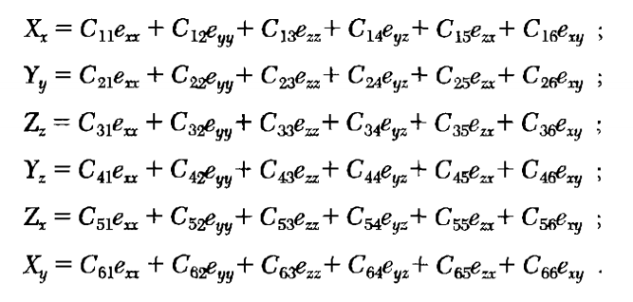
……(6)
The coefficients S₁₁, S₁₂……….are called ELASTIC COMPLIANCE CONSTANT, and the coefficients C₁₁, C₁₂..…are called the ELASTIC STIFFNESS CONSTANT. The S’s have the dimensions of [area/force] or [volume/energy]. The C’s have the dimensions of [force/area] or [energy/volume].

VI. DERIVATION OF STRESS-STRAIN COMPONENTS FOR CUBIC CRYSTAL

We will show that cubic crystals have only three independent stiffness constants. Here we start with the assertion that the elastic energy density of a cube crystal is given as

U = 1/2C₁₁(e²_{xx} + e²_{yy} + e²_{zz}) + 1/2C₄₄(e²_{yz} + e²_{zx} + e²_{xy}) + C₁₂(e_{yy}e_{zz} + e_{zz}e_{xx} + e_{xx}e_{yy})
……(7)
and no other quadratic terms like

(e_{xx}e_{xy} + ……..); (e_{yz}e_{zx} + ……..); (e_{xx}e_{yz} + ………); ………. ……(8)

occur. This result follows from the minimum symmetry requirement of a cubic crystal, which is the existence of four three-fold rotation axes passing through the body’s diagonal directions. Let us consider one such rotation axis shown in Figure 7. Now a rotation of 2π/3 (120֯ ) about this axis changes x → y, y → z and z → x . Incorporating this change in equation (7) gives

U = 1/2C₁₁(e²_{yy} + e²_{zz} + e²_{xx}) + 1/2C₄₄(e²_{zx} + e²_{xy} + e²_{yz}) + C₁₂(e_{zz}e_{xx} + e_{xx}e_{yy} + e_{yy}e_{zz})

Hence, equation (7) is invariant under the operation considered.
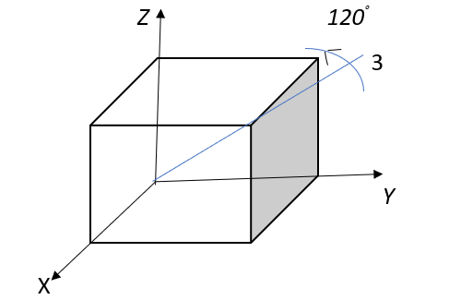
Figure 7: Rotation by 2π/3 about body diagonal
Hence, equation (7) is invariant under the operation considered. Similar rotations about the other axis of rotations change:
[ -x → z, z → -y and -y → -x];
[ x → z, z → -y and -y → x];
[ -x → y, y → z and z → -x].

These rotations will again leave equation (7) invariant. However, if the odd terms as in equation (8) are included in the energy density term, it may result in a change of sign after the rotation operations. E.g., e_{xy} = -e_{x(-y)}. Hence the terms in equation (8) are not invariant under the rotation operations, and hence should not be considered in the energy density expression. This proves that our assertion is true.
Now, differentiating equation (7) w.r.t. e_{xx}, we get

$$\frac{∂U}{∂e_{xx}}=C_{11 }e_{xx}+ C_{12}(e_{yy}+ e_{zz})$$
But,
$\frac{∂U}{∂e_{xx}}= X_{x}$
Hence $,$
$$X_{x}=C_{11 }e_{xx}+ C_{12}(e_{yy}+ e_{zz})$$
Comparing it with,

$$X_{x}=C_{11 }e_{xx}+ C_{12}e_{yy}+C_{13}e_{zz}+ C_{14}e_{yz}+ C_{15}e_{zx}+ C_{16}e_{xy}$$
we get,
C₁₂ = C₁₃ and C₁₄ = C₁₅ =C₁₆ = 0 …….(9)
Similarly Comparing
$X_{y}=$ $\frac{∂U}{∂e_{xy}}=C_{44 }e_{xy}$
With,
$$X_{y}=C_{61 }e_{xx}+ C_{62}e_{yy}+C_{63}e_{zz}+ C_{64}e_{yz}+ C_{65}e_{zx}+ C_{66}e_{xy}$$
we get,
C₆₁ = C₆₂ = C₆₃ = C₆₄ = C₆₅ = 0 and C₆₆ = C₄₄ ……(10)
Carrying out similar comparisons along with equations (9) and (10), we find that the array of values of elastic stiffness constants is reduced for a cubic crystal to the matrix;

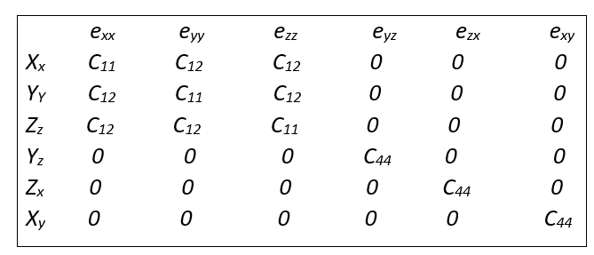……..(11)

This shows that there are only three independent elastic stiffness constants for a cubic crystal: C₁₁, C_{12,} and C₄₄. Here constants C₁₁ relate the compression stress and strain along the X, Y, or Z axis, while C₄₄ relates the shear stress and strain in the same direction i.e., Y_{z} = C₄₄e_{yz}, Z_{x} = C₄₄e_{zx} and so on. The constant C₁₂ relates the compression stress in one direction to the strain in another direction i.e. e_{yy} with X_{x}, e_{zz} with X_{x}, e_{xx} with Y_{y} & Z_{z}, e_{zz} with X_{x} & Y_{y} as seen from matrix (11).

Similarly, the inverse matrix matrix can be calculated as;

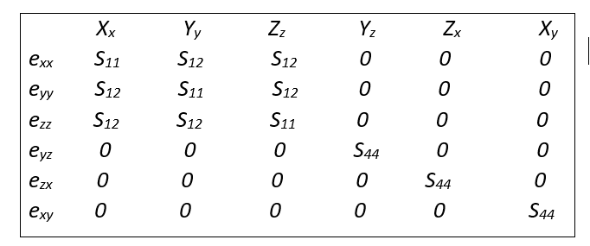……..(12)

Now from matrix (11)
$$X_{x}=C_{11 }e_{xx}+ C_{12}e_{yy}+C_{12}e_{zz}$$
$$Y_{y}=C_{12 }e_{xx}+ C_{11}e_{yy}+C_{12}e_{zz}$$
$$Z_{z}=C_{12 }e_{xx}+ C_{12}e_{yy}+C_{11}e_{zz}$$
.…..(13)
Also from matrix (12)
$$e_{xx}= S_{11}X_{x}+ S_{12}Y_{y}+ S_{12}Z_{z}$$
.…..(14)
From equation (13) and (14)
$e_{xx}= S_{11}\left(C_{11 }e_{xx}+ C_{12}e_{yy}+C_{12}e_{zz}\right)+ S_{12}\left(C_{12 }e_{xx}+ C_{11}e_{yy}+ C_{12}e_{zz}\right)+ S_{12}($ $C_{12 }e_{xx}+ C_{12}e_{yy}+C_{11}e_{zz})$ ……(15)
$e_{xx}= \left(S_{11 }C_{11}+ S_{12}C_{12}+S_{12}C_{12}\right)e_{xx}+\left({ S_{11}C}_{12}+ S_{12}C_{11}+S_{12}C_{12}\right)e_{yy}+ ($ $S_{11 }C_{12}+ S_{12}C_{12}+S_{12}C_{11})e_{zz}$ ……(16)

Equating coefficients on L.H.S. & R.H.S.
$\left(S_{11 }C_{11}+ S_{12}C_{12}+S_{12}C_{12}\right)$ = 1 .…..(17)
$\left({ S_{11}C}_{12}+ S_{12}C_{11}+ S_{12}C_{12}\right)$ = 0 ……(18)
Rearranging equation (18)
$S_{11}= \frac{-S_{12}(C_{11}+ C_{12}) }{C_{12}}$ .…..(19)
Putting equation (19) in (17)
$\frac{-S_{12}(C_{11}+ C_{12}) }{C_{12}}+ 2S_{12}C_{12}=1$ …...(20)
$$S_{12}\left[2C_{12}- {C_{11}}/{C_{12}}\left(C_{11}+C_{12}\right)\right]=1$$
$$-S_{12}\left[C_{11}^{2}+C_{11}C_{12}-2C_{12}^{2}\right]=C_{12}$$
$$-S_{12}\left[C_{11}^{2}+2C_{11}C_{12}-C_{11}C_{12}-2C_{12}^{2}\right]=C_{12}$$
$$-S_{12}\left[ C_{11}\left(C_{11}+2C_{12}\right)-C_{12}{(C}_{11}+2C_{12})\right]=C_{12}$$
$S_{12}=\frac{-C_{12}}{{(C}_{11}-C_{12})(C_{11}+2C_{12})}$ .…..(21)
Putting equation (21) in (19)
$$S_{11}=\frac{(-1)({-C}_{12})}{{(C}_{11}-C_{12})(C_{11}+2C_{12})} \left(\frac{C_{11}+C_{12}}{C_{12}}\right)$$

$$S_{11}=\frac{C_{11}{+C}_{12}}{{(C}_{11}-C_{12})(C_{11}+2C_{12})}$$

…… (22)

Similarly from matrix (11)
$Y_{z}=e_{yz }C_{44};$ $Z_{x}=e_{zx }C_{44};$ $X_{y}=e_{xy }C_{44}$.
and from matrix (12)
$e_{yz}=S_{44 }Y_{z};$ $e_{zx}=S_{44 }Z_{x};$ $e_{xy}=S_{44 }X_{y}.$
Which leads to,
$$Y_{z}=C_{44 }S_{44} Y_{z}$$
$$S_{44}=\frac{1}{C_{44 }}$$

……(23)

From matrix (12), it is clear that tensile stresses X_{x}, Y_{y}, Z_{z} does not produce any shear strain i.e. e_{yz} = e_{zx} =e_{xy} = 0 for X_{x}, Y_{y}, Z_{z}. Also pure shear stresses Y_{z}, Z_{x}, X_{y} produce the pure shear strain only i.e. $e_{yz}=S_{44 }Y_{z};$ $e_{zx}=S_{44 }Z_{x};$ $e_{xy}=S_{44 }X_{y}$. Thus it is concluded that terms S₁₁ measures the amount of strain i.e. tensile strain in x-direction produced by an x-axis tensile stress of unit magnitude. And term S₁₂ measures the amount of y-axis or z-axis strain that results from the x-axis tensile stress.
The two-dimensional view is like,
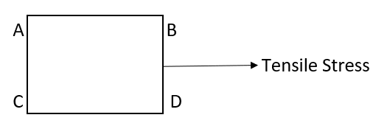
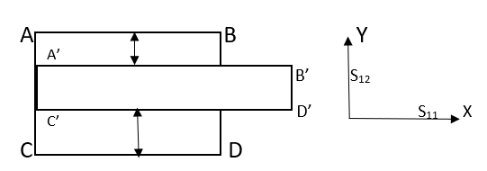
Thus, S₁₂ is equivalent to the lateral strain which acts at right angles to the direction of applied stress.

- KNOWING THE PROPERTIES OF CUBIC CRYSTALS IN TERMS OF STRESS-STRAIN COMPONENTS
We know that Young’s Modulus or modulus of elasticity is defined as the ratio of tensile stress or compressive stress to the corresponding strain i.e.
Young’s Modulus(E) = Tensile Stress/Tensile Strain
Hence, it is clear that
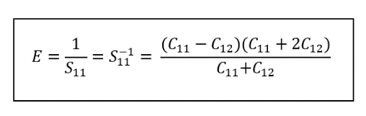…… (24)
Similarly, Poisson’s ratio is defined as the ratio of lateral strain to longitudinal strain i.e.

Poissons’s ratio (µ) = lateral strain/longitudinal strain

Hence, it is clear that.
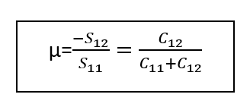…... (25)
Also, the shear modulus or modulus or modulus of rigidity G is defined as the ratio of shear stress to shear strain i.e.

Rigidity Modulus (G) = Shear Stress/Shear Strain
Hence, it is clear that

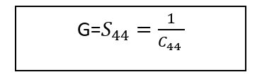…...(26)
Further the bulk modulus is defined as the change in volume of a body produced by a unit compressive or tensile stress.
For this condition a uniform dilation of crystal:
$$e_{xx}=e_{yy}=e_{zz}=\frac{1}{3}δ$$
Hence,
$$U=\frac{1}{2}C_{11}\left[\frac{1}{9}δ^{2}+\frac{1}{9}δ^{2}+\frac{1}{9}δ^{2}\right]+C_{12}\left[\frac{1}{9}δ^{2}+\frac{1}{9}δ^{2}+\frac{1}{9}δ^{2}\right]$$
U = $\frac{1}{2}C_{11}\left[\frac{3}{9}δ^{2}\right]+C_{12}\left[\frac{3}{9}δ^{2}\right]$
U = $\frac{1}{6}C_{11}δ^{2}+\frac{1}{3}C_{12}δ^{2}$
U = $\frac{1}{6}(C_{11}+2C_{12})δ^{2}$
Now the Bulk Modulus is defined by the relation.
$$U= \frac{1}{2}Bδ^{2}$$
Hence,
$B=\frac{1}{3}(C_{11}+C_{12})$ .…..(27)
Further, the compressibility K is the defined as
$K=\frac{1}{B}=\frac{3}{C_{11}+2C_{12}}$ ……(28)
If C₁₂=0, from equations (24), (25), (27) & (28), We get
E=C₁₁, µ=0, B=1/3 C₁₁ & K=3/C₁₁
Which corresponds to the case of no transverse contraction accompanying the longitudinal expansion. This approximation is used when working with a one-dimensional lattice.
Further, if the crystal is an isotropic,
C₁₂ + 2C₄₄ = C₁₁ [ or S₄₄ = 2(S₁₁ – S₁₂)]
i.e. there are only two independent moduli.

- APPLICATIONS: -
- Stress-Strain Analysis used in the design of structures such as tunnel, bridges and dams etc.
- It is primarily used for civil mechanics and aerospace engineers.
- It is used for the maintenance of structures and to figure out the cause of structural failures.

- REFERENCES: -

- Introduction Solid State Physics by CHARLES KITTEL

- Elements of Solid-State Physics by J.P. SRIVASTAVA

- http://en.m.wikipedia.org/wiki/Stress%E2%80%93strain_analysis

- Introduction to Solid State Physics by ARUN KUMAR

- Solid State Physics by A.J. DEKKER

- Solid State Physics by R.L. SINGHAL

- Solid State Physics by M A WAHAB

