Super-lift Boost Converter Evaluation and Modelling

¹P.Manigandan ²P.Elangovan ³Nalinkant Mohanty
¹Department of EEE, SRM TRP Engineering College, Tiruchirappalli, India
²Department of EEE, B.S.Abdur Rahman Crescent Institute of Science & Technology, Chennai, India
³Department of EEE, Sri Venkateswara College of Engineering, Chennai, India
Email: elangoeee2007@gmail.com

Abstract— This article is about using a Positive Output Super-lift Luo Boost Converter circuit to convert DC power. In recent times, the process of converting DC to DC has become more significant in many different fields for various uses. This DC-DC conversion can be easily achieved using the Super-lift Luo Boost converter. The voltage output is gradually increased using a method called voltage lift, which goes up in regular steps. Super-lift Luo converters have been widely used for a long time in applications where high output voltage is needed. These converters greatly improve the amount of voltage transferred. The Super-lift Luo Boost Converter is simulated using the MATLAB or Simulink software programme.

Keywords— Super lift luo boost converter, DC-DC converter

I. INTRODUCTION
DC-DC transition is extremely important in the energy transformation process. For many mechanical applications, voltage boosting is necessary. In DC-DC transformers, there are two techniques: the super lift process, which provides increased voltage pick-up, and the specialized voltage lift technique. The yield advances numerically in the voltage lift approach and geometrically in the super lift technique. Because of their high productivity, Applications that make use of fuels from renewable sources employ DC converters. The control of figure pick-up progresses thanks to the super lift method. This is where the term "super lift Luo boost converters" comes from. These super lifting converters are separated into groups for the fundamental arrangement and the supplemental arrangement. There are one switch (s), n inductors as well 3n-1 diodes, & 2n capacitors in the circuit having the most components. "F" stands for the repetition of trading. I0 is the yield current for the stack. One switch is always used, and the stages of operation are made larger by adding more passive components. The voltage interchange pick up is G=V0/Vin if there is no control problem at that moment Vin * Iin=Vout *Iout. The improvement of the converter that takes place as a result of the development of the nth stage is equivalent to raising a super lift circuit to the nth control. The advantages of SLLBC include greater voltage swap pick up, height control width, larger efficacy, and reduced expands in yielded voltage & yield current. These are used in mechanical applications, SMPS for HV projects, and specialized computer equipment. Two main techniques are studied in Luo Converter. (Super lift technique and voltage lift approach). Here is a depiction of the voltage improve technique in the region 3. This includes the converter's usage and strategy. with the voltage lift approach in comparison.

II. DC-DC CONVERTER
DC-DC converters change the level of the input voltage. There are several varieties of DC-DC converters on the market. buck, boost, buck-boost, and cuk converters. In this post, the super lift luo boost converter is updated. The voltage boost approach could be a great way to enhance the circuit's features. After a long time, this technique was ultimately completed for DC-DC converters. Additionally, this converter is used in microelectronics. DC-DC converters with a high step-up ratio are used in control systems that provide electrical control. Finding out how the closed loop exchange works requires modelling the control converter. DC-DC converters are used in computer accessories, boat hoists, and cars. To achieve excellent productivity, the DC change technique is used.

From low voltage to high voltage change’s using the control semiconductor switch on the national Lattice, a DC-DC converter may be used for many purposes. In support of a camera streak. This requires brief bursts of elevated voltage, but it must be run on LUO voltage. AC transformers are used to change voltage levels prior to DC-DC converters, despite the fact that they are more expensive and inefficient due to the DC-AC and AC-DC shift.
The two types of controllers are straight and switch type. The voltage is controlled by the straight converter using a combination of dynamically operating transistors and a variable resistor. The tragedy is considerable and the conductivity proficiency is modest (30–60%). Conduction misfortune is lower, exchanging misfortune is higher, and effectiveness improves for switch mode converters. They are heavily used couple to tall exchanging repetitions despite difficult and high EMI (electromagnetic obstructions). The basic idea is to charge and discharge critical parts into Stack, by repeatedly turning on and off the direct current, or DC, source, you may control the voltage, charge level, and output. Freewheeling diodes are utilized to provide protection from imposing inversion streams. Capacitors are used to prevent inconsistent yield voltage and channel swells.

III. LUO CONVERTER

Luo converter was designed by Tooth Lin Luo. They have other financial concepts stated in them. The execution is primarily concerned with voltage variations and the smallest yield voltage increases. They fall within the voltage raise and super raise converter categories. As with buck boost converters, there is less exchange weight loss when using luo converters. When compared with voltage raise method, super lift method has the most severe voltage pick up. Utilized for modelling the luo converter is state space analysis. Today, renewable energy sources are used as a stack. Future versions of this process will use hybrid energy sources.

A recent innovation in converter architecture is the luo boost converter. This converter has a fairly straightforward construction and a low-cost topology. Low yield swell and elevated voltage pick-up are two metrics used to assess the converter's yield efficiency. The DC voltage may be changed with this converter. A buck-boost converter-like device, it operates. The main purpose of a luo converter is to convert an uncontrolled voltage to a controlled voltage. The capacitor and inductor in the yield side luo converter store and transmit energy to the stack. To achieve the required voltage levels, control semi-conducting switches and the control electrically powered converters are boosted. Luo converters are used on either the capacitor side or the inductor side, depending on the application. Luo converter is a casing for a DC-DC converter used in control electronics. angles of investigation. includes straightforward execution productivity, the need for swapping, a genuine circuit reaction, we may infer information about the converter's capabilities and applications from the findings, as well as compared to different DC to DC converters. The voltage increase method is widely used. It resulted in a high voltage picking up and decreased issues caused by parasitic components.

3.1 Circuit having a positive output

The voltage lift fundamental circuit is analogous to super lift operation. It has the ability to increase or decrease voltage at low duty cycle levels. Signal generators are used to regulate semiconducting switch MOSFETs. In order to function as a moo pass channel, inductor and capacitor are connected in parallel. Input current is divided by IL1 and IC1 while S1 is in the on condition.
For a two-way configuration, the voltage pick-up is given by

M=V0 /Vi=k/1-k (1)

When the switch is closed, the current is isolated. Source Inductance L2 maintains the life of Inductor L1. IL1 and IL2 increases as of today. The energy in L1 flows to C after the switch is flipped on. The resultant voltage over stack increases along with a rise in voltage Vc. With the help of a diode and a stack, IL2 continuously generates current. The ripple's magnitude is, on the other hand, inversely related to L2, C0 & square of the exchange repetition. Capacitor C0 and Inductor IL2 form the moo pass channel that determine the converters yield swell.
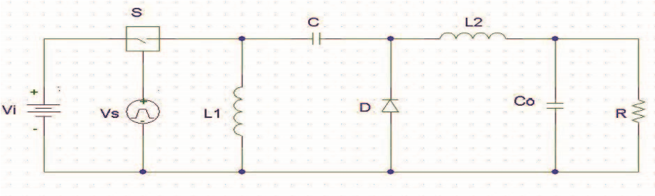
Fig1.Positive output elementary circuit
Circuit shifted into an erratic state. In the event that the switch is off, the current will be zero. This has a yield. It is difficult to predict the voltage that corresponds to the resistor, or the voltage increases with stack resistor. As a result, this mode cannot be completed.
V0 is equal to k(1-k)(r/2fl)Vi, where L is the total inductance. Approximately, all one-stage transformers deliver to the PV module half of the network's capacity. This process wavers, for example, at 115V/50 HZ in many European utility networks with 230 V/50 HZ. This affects Sunny Boy and Sunny Scaled Down Central Inverters with the suffix "TL" in the item title.Motions in three stage transformers and inverters have lower sufficiency and spillage current for ordered reasons.PV modules typically receive smothered AC voltage. It applies to any tri control inverters that get enough of sun.
It is the best super lift converter and the source of every other positive yield super lift converters. When compared to a voltage raise basic circuit, it operates similarly.

3.2 voltage lift techniques
The fundamental circuit layout and the buck converter are compared to determine the execution. Both the converters operate with 24 V DC supply with a pick-up of 0.5 and a minimum gearbox power of 20W. In reality, the present mode converters maintain a steady yield even if it may be a generator of swapped flags.
• Ultra-light technique
• Movement in geometry
Super lift converters possess the geometric ability to pick up at high elevations. And it is its greatest benefit. The enlarge by organizing pick up is similar to the voltage raise inverters. These converters increase in control arrangement, when each stage is added.
G=V0/Vin =n/(1-k) (2)

Pick up of n extra stages for the voltage lift basic circuit
G=V/Vin=(2-k)n/(2-k) (3)
Selection of additional levels for the super-lift basic circuit. These equations tell us that various organize take up is high in super lifting converters because n is the control. Super lift converters are therefore used in a variety of mechanical applications.

Switch On condition:

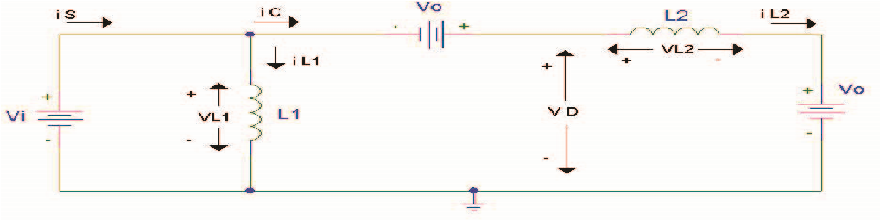

Fig2.switch on condition

When switch S1 is switched on, L1 and C1 are linked in parallel at the same time. In this instance, the capacitor C1 receives a charge from the electric current flowing through L1.
The total amount of electricity energy or force which is delivered by a device or electrical network is known as the voltage. By strengthening the forward bias, it can be accomplished.
Electric current can only travel in one direction through D1, but it can in both directions through D2.

Switch Off condition:

The inductor and capacitor are coupled one after the other while switch S1 is off. D1 refuses to allow current to pass through it as a result. In this condition, the potential in C2 is raised using C1 and Vin.

IV. EXISTING SYSTEM

In the current setup, unique DC-generating panels are used to collect solar energy. Direct current (DC) is transformed into alternating current (AC) using an inverter. which is then suitable for our gadgets. Next, weight is placed on the top of it. The load receives energy from the PV panel’s electricity. Since the produced DC is not particularly powerful, it cannot be utilized for applications requiring a substantial amount of DC power.
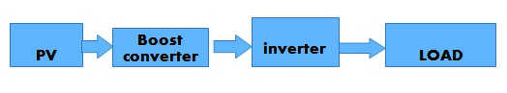
Fig3.Block diagram (existing)
This issue is resolved by the suggested system. You will learn about the concept of how to apply it in variable DC scenarios using this method.

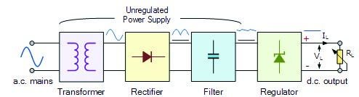

Fig.4 electrical circuit

A transformer that divides the input & output is present in a typical power supply. A regulator circuit that includes a zener diode is also included. The benefit of utilizing a linear regulator like this is that the electric power circuit needs input and output capacitors as well as feedback resistors to regulate the output voltage.

4.1 PROPOSED SYSTEM

PV panels in the new system convert sunshine into electricity. To raise the voltage preceding the inverter, we utilised a luo boost converter. Different DC applications can make use of this increased voltage. The DC electricity is subsequently transformed into AC power via the inverter. To put it another way, the power has been raised and our loads have been connected to the system. This is the concept of our method, and it is being put into practise and is successful.

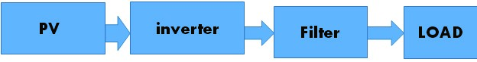
Fig5. Block diagram (Proposed)

The benefits of using luo boost converter are explained as follows.
• Low-cost
• Very effective and productive
• Finding the optimal power point to make the most efficient use of a solar cell.

V. MATLAB SIMULATION

5.1 MATLAB
Below is a link for a simulation model of the suggested system. The output parameter that was determined was increased voltage.

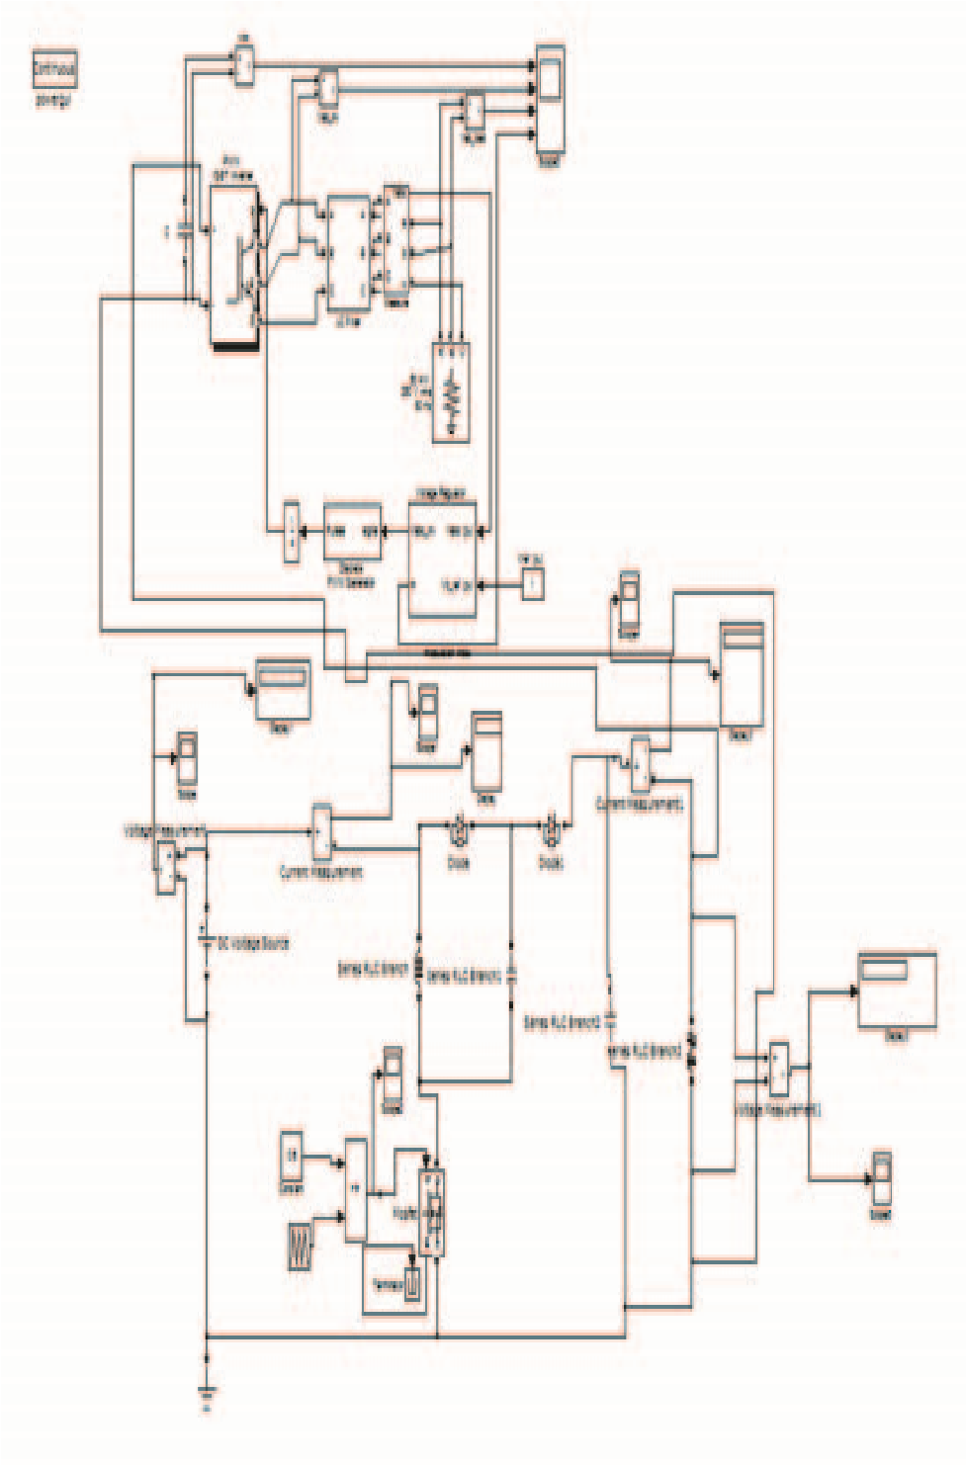
Fig.6 Simulink model

5.2 Dialog Box and Parameters

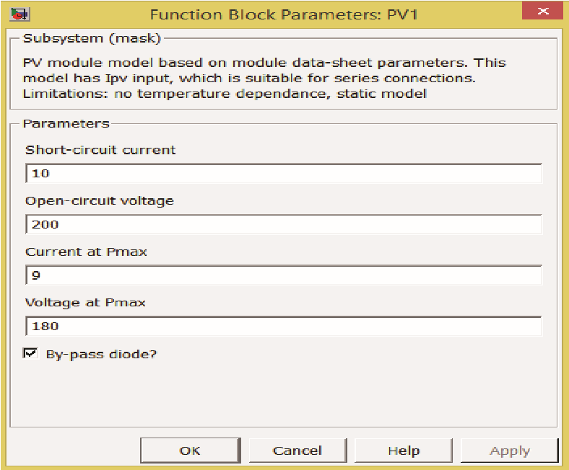

5.3 Simulation Results:

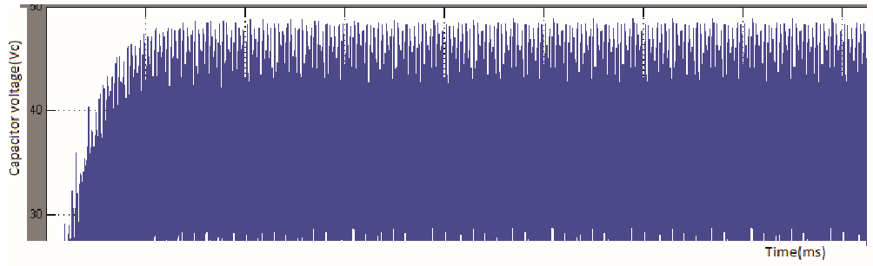
Fig7.Capacitor voltage

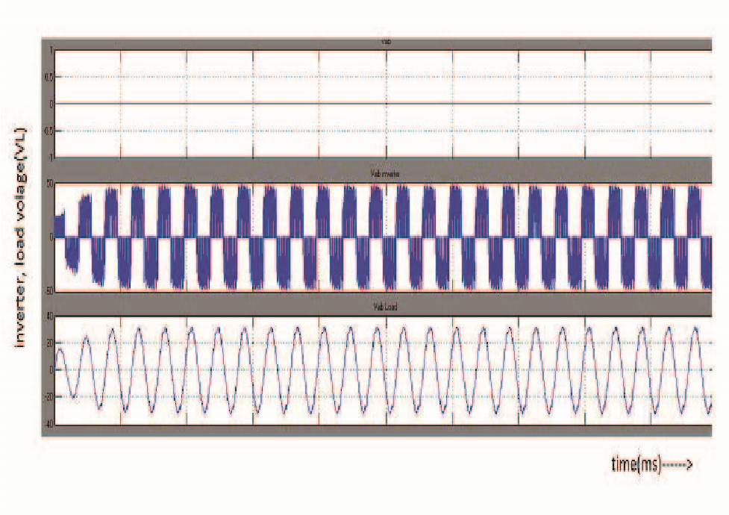
Fig8.Overall output waveform

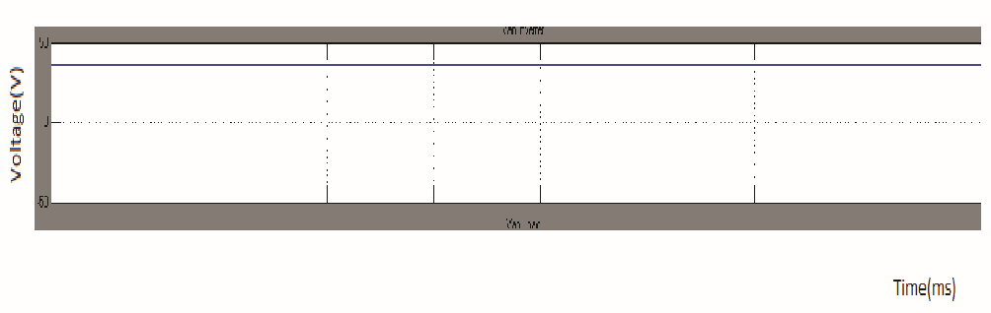
Fig9.Modulation index
Fig10.Pulse Width Modulation

VI. HARDWARE DESCRIPTION

Changed square wave form:
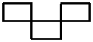
Fig11. Square wave

The digital storage oscilloscope displays the hardware output. The conclusion is decided upon before the level of intensity, though. 5 V are supplied as the converter's input voltage. The voltage that was released increased and reached 36 volts. The voltage that comes out is three time greater than the input voltage, as can be seen from this.

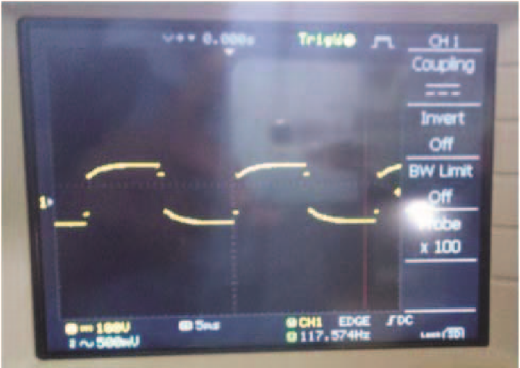
Fig12.Hardware output before the step-up voltage

VII. CONCLUSION
This article uses the MATLAB Simulink tool to simulate the outcome of a recommended technique. This essay discusses the super lift converter and the challenges involved in developing and using it. It may be applied to tasks that require less power but yet produce quality outcomes. The device's performance at elevated power levels when its gain has been set to a high level will be discovered in the future.

