Nanotechnology: Drug Delivery System

Author: Tambolkar Madhura Laxman
Department of pharmacy practice, ASPM’S K.T Patil College of Pharmacy, Osmanabad, Maharashtra 413 501.
Corresponding author’s email- Madhuratambolkar123@gmail.com
Abstract:
In recent times, nanomedicine and nanotechnology-based drug delivery systems are relatively new but rapidly developing fields of medical science where medicines, therapeutic agents, and various diagnostic tools are designed in a controlled manner. Nanotechnology may have a significant impact on disease prevention, diagnosis, and treatment, according to recent developments. Faster drug absorption, controlled dose release, and reduced side effects are all made possible. Surgery and the early diagnosis of diseases like cancer are being revolutionized by nanotechnology. With the aid of nanotechnology, drugs with a high potential for toxicity can be administered with greater safety. The main objective of this article is to study different types of drug delivery systems, their applications, advantages, and challenges in brief.
Keywords:
Nanotechnology, drug delivery system, nanoparticle, nanomedicine.

Introduction:
In the world of pharmaceuticals and medicine, nanotechnology is regarded as a recent and rapidly developing sector. As drug delivery vehicles, nanoparticles offer several benefits that improve efficacy and decrease adverse drug reactions. It played a very important role in overcoming some of the drawbacks of conventional dosage forms. Nanomedicine, which uses nanotechnology to provide extremely specialized medical treatments for the prevention, diagnosis, and treatment of diseases, is one of the most active research fields in nanotechnology.
Innovative drug delivery technologies that are currently being developed may strategically include nanotechnology to increase drug market opportunities. A lot of research in this field in the last two decades has already led to the filing of more than 1500 patents and the completion of several dozen clinical trials. There are presently significant commercialization efforts being made worldwide as a result of the recent boom in nanomedicine research, with numerous products now available and more on the way. Currently, drug delivery systems dominate nanomedicine, making up more than 75% of all sales. Drugs chosen for full-scale development based on their safety and efficacy data but unable to proceed with clinical development due to poor bio pharmacological characteristics would be subject to such a plan.
In this study, we emphasize many areas of opportunity where present and developing nanotechnologies could enable new kinds of therapies while concentrating primarily on the use of nanotechnology in drug delivery [1] [2]. We examine issues and broad trends in pharmaceutical nanotechnology, as well as possible solutions to drug delivery problems using nanotechnology. This article, however, can only give people a brief overview of this quickly evolving sector and what might come in the future.

Applications of drug delivery system based on nanotechnology
Gold nanoparticles:
For a longer period of time, disorders like cancer, rheumatoid arthritis, multiple sclerosis, and neurological conditions like Alzheimer’s disease were treated with colloidal gold particles. Gold nanoparticles have proven to have anti-angiogenesis and anti-inflammatory properties and can be used to treat retinal diseases. Due to their potential as a scaffold for drug and gene delivery, noble metal nanoparticles, like gold nanoparticles, have gained attention. They are a valuable addition to more conventional delivery vehicles. In the previous laser-induced choroid neovascularization (CNV) animal model, intravenous injection of gold nanoparticles showed significant anti-angiogenic properties. It has been demonstrated that the gold nanoparticles have a size smaller than 50 nm and may pass BBB. The most important characteristic of nanoparticles is their multifunctionality. For accurate drug delivery and cellular uptake, nanoparticles can be combined with ligands, imaging labels, therapeutic agents, and other functionalities.
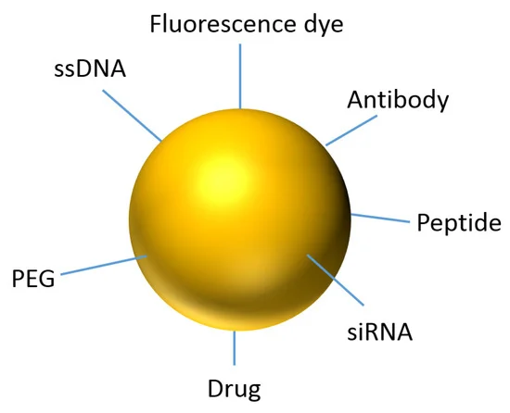
Fig. No. No. 1- gold nanoparticle

Gold nanoparticles with functionalized properties to increase the active ingredient in a medication. Consequently, gold nanoparticles play a significant role in the treatment of cancer. For example, Doxorubicin, an anti-cancer prescription drug, can be combined with gold nanoparticles to boost its potency. So doxorubicin's cytotoxic action is enhanced. Gold nanoparticles functionalize weakly active drugs into highly active drugs[6]. As a result, gold nanoparticles have been essential for HIV treatment as well as cancer therapy and cancer cell diagnostics.
Magnetic nanoparticles:
Magnetic nanoparticles have become one of the most studied and applied nanotechnologies in the past few years. The super paramagnetic properties of iron (II) oxide particles can be used to guide microcapsules in place for delivery by external magnetic fields. The hyperthermia effect, or the ability to hear the particles after internalization, is another benefit of employing magnetic nanoparticles[12]. The most significant advantages of super paramagnetic NPs over conventional cancer therapies are their reduced invasiveness, ability to approach hidden tumors, and low side effects.

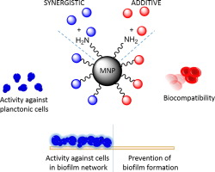

Fig. No. No. 2- Magnetic nanoparticles

There have been observations about magnetic nanoparticles that can be loaded with drugs while maintaining their MRI characteristics. The anticancer drugs doxorubicin and paclitaxel were loaded onto the iron oxide nanoparticles with a loading efficiency of up to 95% after being coated with oleic acid. Magnetic nanoparticles are also used for magnetic recording as well as therapeutic applications in the treatment of cancer and magnetic resonance imaging (MRI).
Ceramic nanoparticles:
Ceramic NPs are made of inorganic materials with porous characteristics, such as oxides, carbides, phosphates, and carbonates of metals and metalloids like titania, alumina, and silica. Among them, silica Nanoparticles have drawn a lot of scientific interest because of their biocompatibility, simplicity of manufacture, and ability to be surface modified. The simple process of preparation for these particles is one of its benefits. Temperature or pH changes have no effect on them[13]. The size, shape, porosity, inertness, and other characteristics of these nanoparticles can all be easily altered so that different biomolecules can be attached. They are typically about 50 nm in size. Ceramic nanoparticles have been successfully used as drug delivery systems against a number of diseases, such as bacterial infections, glaucoma, etc., and most widely, cancer.
Liposomes:
Liposomes, discovered in the mid-1960s, were the original models of nanoscale drug delivery devices. Amphiphilic phospholipids have been utilized for producing the artificial vesicles known as liposomes[8]. These vesicles can range in size from 50 nm to several micrometers, and they are made up of a spherical bilayer structure that wraps around an aqueous core domain. They can be used as effective drug delivery systems. Cancer chemotherapeutic drugs and other toxic drugs like amphotericin and hamycin, when used as liposomal drugs, produce much better efficacy and safety as compared to conventional preparations.
The most widely used nanosystems for delivering drugs are liposomes. The efficacy of their use has been shown to reduce toxicity and systemic effects while also decreasing drug clearance. Excellent pharmacokinetic profiles for the transport of DNA, antisense oligonucleotides, siRNA, proteins, and chemotherapeutic drugs have been demonstrated for modified liposomes at the nanoscale.

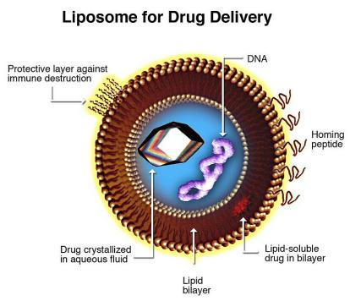
Fig. No. 3- Liposome

Drugs delivered by liposomes can be directed to a specific organ or tissue using both passive and active means. Liposomal drugs have a superior safety profile than non-liposomal drugs since they have a negligible effect on other tissues[3]. Doxorubicin is a common anticancer medication that is used to treat a variety of tumor types. Due to its severe toxicity, which affects not only tumor tissue but also heart and renal tissue, its therapeutic uses are constrained. But the creation of doxorubicin enclosed in liposomes resulted in the development of an acknowledged nanomedical drug delivery system. This novel liposomal formulation has resulted in reduced delivery of doxorubicin to the heart and renal system while elevating the accumulation in tumor tissue by the EPR effect.
Niosomes:
optimistic vehicle for drug delivery and being non-ionic; it’s less cytotoxic and improves the therapeutic index of the drug by prescribing its action to focus on target cells[1]. Niosomes are ideal as drug delivery vehicles in conditions affecting these organs since they are taken up by tissues like the liver and spleen. Furthermore, they are utilized to target cancer cells. Niosomes are mainly composed of 1. non-ionic surfactants; 2. Cholesterol; 3. Charge inducers; and 4. hydration medium.
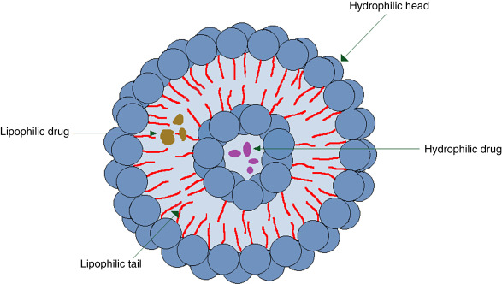
Fig. No. 3- Niosome
Niosomal antigens can be used as adjuvants in the delivery of vaccines as they are effective stimulators of the cellular and humoral immune responses. When using niosomes compared to traditional methods of administration, high levels of drugs were observed in the target area. They have also been used in conjunction with anti-infective and anti-inflammatory medications. Additionally, a number of liposomal drugs are now being researched, including antibiotics like vancomycin and amikacin, as well as chemotherapy drugs like camptothecin and paclitaxel.
Dendrimers:
Synthetic, branched macromolecules known as dendrimers possess a structure resembling a tree[5]. Dendrimers' chemical makeup and molecular weight can be carefully controlled, unlike most linear polymers, thus making it comparatively simple to predict their biocompatibility and pharmacokinetics. Dendrimers are frequently created with dimensions that are incrementally grown in approximative nanometer steps from 1 to over 10 nm. They are extremely uniform and exhibit extremely low polydispersities.

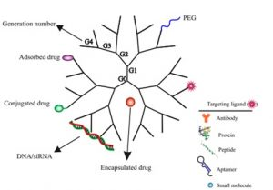
Fig. No. 4- Dendrimer
The dendrimer molecule has been used as a contrast agent and diagnostic reagent for tumor imaging by magnetic resonance imaging. These compounds can be used for a variety of particular imaging purposes by altering their size and hydrophilicity as well as by combining with tumor-targeting antibodies. The most common route of administration for treating a variety of ocular conditions is to apply active medications topically to the eye. For the delivery of ophthalmic drugs, dendrimers offer exceptional solutions to challenging delivery problems. An ideal approach to delivering drugs to the eyes should be non-irritating, biocompatible, sterile, isotonic, and biodegradable. PAMAM (polyamidoamine) dendrimers with carboxylic or hydroxyl surface groups were used to solve the recent issues with ocular drug administration that focused on lengthening the residence period of pilocarpine in the eye. [6]It was anticipated that these dendrimers with modified surfaces would improve pilocarpine bioavailability.
Carbone nanotubes:
Proteins, nucleotides, and medicinal molecules can all be transported using arbone nanotubules. Carbon nanotubes can infiltrate living cells due to their shape and size without resulting in cell death or obvious cell damage. Because they can be surface functionalized for the grafting of nucleic acids, peptides, and proteins, carbon nanotubules have garnered considerable interest. For use in drug delivery, carbon nanotubes, fullerene, and nanodiamonds have all been thoroughly investigated. Single-wall nanotubes (SWNTs), multiwall nanotubes, and C60 fullerenes are all appealing options for use as drug carriers due to their size, shape, and surface properties[14].

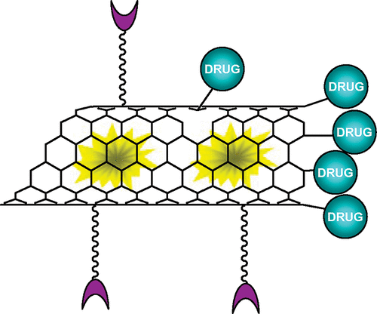
Fig. No. 5- Carbone nano tubule

Amphotericin B41, which is typically insoluble and toxic due to its tendency for aggregation, is one of the medications that has been successfully given. Improved solubility, limited aggregation (and hence lower toxicity), and improved anti-fungal efficacy were all seen when carbone nanotubes were used for delivery. Carbone nanotubes have been used for a variety of therapeutic uses, including gene and siRNA transfer, boron neutron capture treatment (BNCT), and triggering an immune response. However, it seems that the most significant issue with carbon-based nanomaterials is their toxicity[10]. Carbone nanotubes can cause apoptosis and reduce cell proliferation, according to experiments. The toxicity of carbone nanotubes increases considerably when carbonyl, carboxyl, and/or hydroxyl functional groups are present on their surface, despite the fact that they are less poisonous than carbon fibers and nanoparticles.
Nanopores:
Desai and Ferrari (1997) created nanopores, which are made of wafers that have numerous tiny pores (20 nm in diameter). Oxygen, glucose, and other substances like insulin can flow through the pores.

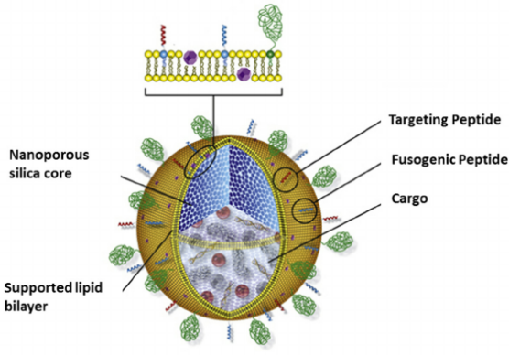
Fig. No. 6- Nanopores

However, it prevents cells and immunoglobulin from passing through them. Utilizing the beneficial effects of transplantation, nanopores can be utilized as devices for protecting transplanted tissues from the host immune system[13]. Pancreatic cells may be enclosed within a nanopore device and inserted into the body of the recipient. This tissue sample absorbs nutrients from the surrounding tissues while escaping immune detection and without being rejected as a result. This could be a new treatment for insulin-dependent diabetes mellitus, and it can also be used in DNA sequencing. It has the ability to differentiate the DNA strands based on the differences in the base pair sequence.
Nanoemulsion:
A colloidal dispersion of two immiscible liquids that is thermodynamically unstable is referred to as a nanoemulsion. One liquid serves as the dispersed phase, and another serves as the dispersing medium in a nanoemulsion. Each droplet in a nanoemulsion contains a protective coating of emulsifier molecules with a diameter of 10 to 200 nm. Microemusion is an isotropic and thermodynamically stable formulation.
The difference between microemulsions and emulsions is that the latter are opaque mixtures of two immiscible liquids that are thermodynamically unstable and usually require the application of high-torque mechanical mixing or homogenization to produce dispersed droplets in the range of 0.2–25 mm. Water-in-oil (w/o) or oil-in-water (o/w) versions of both types are available. The hydrophilicity of the model drug determines the choice of dispersed and continuous phases for microemulsion formulations[11]. In addition, surfactants with hydrophilic-lipophilic balances (HLB) of 3-6 tend to encourage the production of o/w microemulsions, whereas those with HLB values of 8–10 prefer to do the opposite. It has been noted that the interfacial tension between the dispersed and continuous phases has significance in the formulation and stabilization of microemulsions[1].
Ostwald ripening, which results in the dissolution of the small droplets and an increase in the size of the large droplets, can be caused by microemulsion instability. As a result, stabilization against Ostwald ripening is essential because the resulting change in the size of the droplets could result in the loss of physical stability of the dosage form. The stability of microemulsions is affected by component choices. Another essential factor that needs to be taken into consideration while choosing components is safety.
It has been reported that using microemulsions as drug delivery systems will improve drug penetration across biological membranes. The following are some benefits of microemulsions: (i) Improved medication solubility and stability; (ii) ease and economy of scaling up. The following are some drawbacks: (a) premature drug leakage or release; (b) phase inversion; (c) many effective surfactants and/or cosurfactants lack a toxicity profile that is acceptable for pharmaceutical use; and (d) the development of complex, time-consuming microemulsion systems is frequently necessary[2].
Nanosuspension:
Pharmaceutical nanosuspensions are aqueous dispersions containing insoluble drug particles that are stabilized at the nanoscale by surfactants. In contrast, drug carriers in nanoparticles are either polymeric or lipid colloidal. Particles in nanosuspension do not settle due to Brownian motion, which thereby improves their physical stability [7]. Useful nanosuspensions include those that keep these drugs in their ideal crystalline state and are sufficiently small to be administered intravenously. Due to the drug's solid nature, they can also reach even higher levels of drug loading. Numerous studies have shown the use of nanosuspensions for enhanced effectiveness and release of drugs.
Nanocrystals:
Due to the larger surface-to-volume ratio, the production of crystalline nanoparticles or nanocrystals can enhance solubility, permeability, and ultimately bioavailability. All frequently used routes of administration, including oral, injectable, pulmonary, ophthalmic, and topical administrations, are suitable for the delivery of crystalline nanoparticles. A "cluster" formed by several hundred to tens of thousands of atoms is referred to as a nanocrystal. These aggregates typically range in size from 10 to 400 nm, and their physical and chemical characteristics fall between those of bulk solids and molecules. Other characteristics, like the bandgap, charge conductivity, crystalline structure, and melting temperature, can be changed by adjusting the size and surface area. Stabilization of the crystals is necessary to stop the formation of bigger aggregates[3]. Nanosonication is used to create nanocrystals. The ability to solubilize poorly soluble drugs, high bioavailability, a significant decrease in dosage volume, and an increase in tolerable dose are all advantages associated with nanocrystallization.
Micelles:
Micelles are spherical lipid nanostructures, though they lack an inner cavity or bilayer. A spherical configuration is created by the hydrophobic ends of the phospholipids pointing inward and the hydrophilic ends facing outward. Micelles used in pharmaceutical applications typically range in size from 10 to 80 nm. Because they are smaller than liposomes, micelles circulate through the body more quickly. Due to the enhanced permeability and retention (EPR) effect, they do have the benefit of being able to enter tumor cells more quickly because of EPR effect[5].
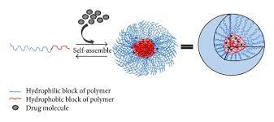
Fig. No. 7- Micelles
Polymers can also be used to create micelles. Block copolymers made of hydrophilic and hydrophobic monomer units ultimately create polymeric micelles. shorter hydrophobic blocks and longer hydrophilic blocks. They are stabilized by a hydrophobic core. hydrophilic units. These micelles are more stable than conventional micelles and are preferred for drug delivery applications as the circulation time is longer and they offer better biodistribution. Micelles consisting of lipid polymers can also be produced. They are capable of transporting a variety of substances, including captothecin, diazepam, and paclitaxel. They also have good stability and lifespan. Micelles that have been coupled with transferrin can carry DNA to cancer cells. Adriamycin has also been delivered to cancer cells via folate residues bound to micelles. Due to their smaller size and ease of movement to the target site, these agents have an advantage in that they penetrate targets more effectively.
Advantages:
Nanotechnology is an entirely new, rapidly developing field of technology that is expected to drastically alter the world. Since nanotechnology is still in its early stages of development, even its concept and core principles are not completely agreed upon. Some believe that, despite being a distinct area of study, nanotechnology can be defined as a general-purpose technology.
Various nanoforms have been tried as drug delivery systems, ranging from chemical substances like polymeric polymers and solid metal-containing NPs to biological materials like albumin, gelatin, and phospholipids for liposomes. High-size variation polymer-drug conjugates are typically not regarded as NPs. However, they are also incorporated into these nanodelivery systems because their size can still be controlled to within 100 nm. The EPR effect involves site-specific traits that are not associated with healthy tissues or organs, leading to more precise targeting. These characteristics make nanodrug delivery systems particularly advantageous. Including-

- Increasing the stability of hydrophobic medicines so they can be administered;
- Enhancing pharmacokinetics and biodistribution for greater effectiveness;
- Decreasing the adverse effects caused by preferential accumulation at targeted sites;
- Biocompatible nanoparticles are used to reduce toxicity.
- Nanoparticles that transmit chemotherapy drugs.
- Qdots that detect cancer cells in the body precisely at cancer cells to minimize harm to healthy cells.
- Nanoshells that focus infrared light heat to kill cancer cells with little effect on neighboring healthy cells
- Nanotubes are used to treat broken bones and support the formation of new bone tissue.
- Recognize a specific disease in a blood sample.
Challenges of nanotechnology in drug delivery system :
Although several nanodrug products on the market show that nanotechnology in drug delivery has been successful, not all methods have had the same level of success. There are difficulties with developing new nanomaterials that must be overcome.
Biological availability: The physicochemical properties of the nanomaterials have been altered to improve qualities like long blood circulation, increased functional surface area, protection of the incorporated drug from degradation, crossing of biological barriers, and site-specific targeting, among others, and this work is still ongoing.
Safety issues: A field of research called nanotoxicology has also developed in parallel to the growth of nanomedicine. The study of the potentially adverse effects of interactions between nanoparticles and biological systems is known as nanotoxicology. The possibility that nanomaterials may contribute to the generation of free radicals has been raised as a result of certain preliminary nanotoxicity experiments by the Nanomedicine Future Scientific Group. According to various factors generated from physiochemical characteristics, physical characteristics, and environmental conditions, a number of processes have been proposed to affect the toxicity of nanomaterials. For example, raw quantum dots exhibit cytotoxicity through the generation of reactive oxygen species (ROS), which cause damage to the nucleus, mitochondria, and plasma membranes.
Manufacturing problems: Large-scale production is a problem in the research and development (R&D) of nanomaterials for drug delivery. For ultimate commercialization, laboratory or pilot technology must always be scaled up. Due to the nature of the method of manufacturing and the high cost of the materials used, some nanodrug delivery systems might not be suitable for large-scale production. A small amount of nanomaterials, agglomeration, and the chemical process are hurdles to scaling up. At the laboratory scale, it is considerably simpler to modify or preserve the size or composition of nanomaterials for better performance than it is at a wide scale.
Economic and financial challenges: Nanomedicine implementation may also be limited by economic and financial limitations. The deployment of personalized medicine in general has been hampered by the limited availability of reimbursement by public and private health insurers for relatively expensive new diagnostic tests, and nanoproducts are likely to face even greater challenges due to their costs and complexity. Despite the number of patents for nanodrug delivery technologies, commercialization is still in its early stages. Startup companies have little chance of bringing products to market without assistance from "Big Pharma," which is able to provide the financial resources and knowledge required to achieve regulatory and commercial success. This is due to the high development costs of nanodrugs and medical devices.
Conclusion:
The recent developments in nanomedicine—including technological advancements in drug delivery for both traditional and novel medications as well as unique diagnostic approaches—are covered in this review. Nanotechnology offers the ability to develop large numbers of products that are extremely powerful by today's standards. With the help of nanotechnology, several goods with extraordinary power by today's standards could be created. Both opportunity and risk are generated by this potential. Given that nanotechnology has already started to permeate many other sectors of research, it would be difficult to dismiss the potential advantages of the subject and limit the advancement of related research. To ensure that the technology does not become too potentially dangerous, guidelines might be used in the development of nanotechnology. Humans have the potential to live healthier lives in the near future due to the innovations of nanotechnology. Like this disease diagnosis, prevention and treatment of disease, a better drug delivery system with minimal side effects, and tissue reconstruction.
Acknowledgement:
The author is thankful to The principal of ASPM’s K. T. Patil College of Pharmacy for providing the facilities she needed for study.
Reference:
- Nanotechnology in therapeutics: a focus on nanoparticles as a drug delivery system by Suwussa Bamrungsap1 , Zilong Zhao2,3, Tao Chen3 , Lin Wang4 , Chunmei Li3 , Ting Fu2 & Weihong Tan*2,
- Lobatto M, Fuster V, Fayad Z, Mulder W.Perspectives and opportunities for nanomedicine in the management of atherosclerosis. Nat. Rev. Drug Discov. 10(11), 835–852 (2011).
- Kipp JE. The role of solid nanoparticle technology in the parenteral delivery of poorly water-soluble drugs. Int. J. Pharm. 284, 109–122 (2004)
- Nanotechnology in novel drug delivery system Aruna kapil, *geeta aggarwal, sl harikumar journal of drug delivery and therapeutics
- LaVan DA, Langer R. Implications of nanotechnology in the pharmaceutics and medical fields. In: Societal Implications of Nanoscience and Nanotechnology. Bainbridge WS (Ed.). Springer, NY, USA, 77–83 (2001).

- Riehemann K, Schneider SW, Luger TA, Godin B, Ferrari M, Fuchs H. Nanomedicine – challenge and perspectives. Angew. Chem. Int. Ed. Engl. 48(5), 872–897 (2009).
- Wagner V, Dullaart A, Bock A, Zweck A. The emerging nanomedicine landscape. Nat. Biotechnol. 24(10), 1211–1217 (2006).Tolia G.T, Choi H.H, Ahsan F. The role of dendrimers in drug delivery. Pharmaceut. Tech 2008; 32: 88–98.
- Vandamme T.F, Brobeck L. Poly (amidoamine) dendrimers as ophthalmic vehicles for ocular delivery of pilocarpine nitrate and tropicamide. J. Control. Release 2005; 102: 23–38.
- Star A, Stoddart JF, Steuerman D, Diehl M, Boukai A, Wong EW. Preparation and properties of polymer-wrapped singlewalled carbon nanotubes. Angew Chem Int 2001; 40: 1721-1725.
- 40. Lin Y, Rao AM. Bon nanotubes with aminopolymers. J Phys Chem B 2002;106: 1294 -1298.
- . Wu W, Wieckowski S, Pastorin G, Benincasa M, Klumpp C, Briand JP. Targeted delivery of amphotericin B to cells by using functionalized carbon nanotubes. Angew Chem Int 2005; 44: 6358-6362.

- Farokhzad OC, Langer R. Nanomedicine: developing smarter therapeutic and diagnostic modalities. Adv. Drug Deliv. Rev. 58(14), 1456–1459 (2006).
- LaVan DA, Langer R. Implications of nanotechnology in the pharmaceutics and medical fields. In: Societal Implications of Nanoscience and Nanotechnology. Bainbridge WS (Ed.). Springer, NY, USA, 77–83 (2001).
- Kharb V, Bhatia M, Dureja H, Kaushik D. Nanoparticle technology for the delivery of poorly water-soluble drugs. Pharm. Technol. 30(2), 82–92 (2006).
- Merisko-Liversidge E, Liversidge GG, Cooper ER. Nanosizing: a formulation approach for poorly-water-soluble compounds. Eur. J. Pharm. Sci. 18, 113–120 (2003).

