Kasaba Ganpati Temple, Pune: A Further Study of Architectural Heritage with sustainable design
¹Ar. Gautami Bura, ²Dr. Parag Govardhan Narkhede
¹M.Arch.(S.A.) Student at BVDU COA, Pune; ²H.O.D. at BKPS COA, Pune
22.gautami.b@bvcoa.in , parag@bkps.edu

Abstract:
Pune city is the land of rich historical background and heritage buildings. The Wadas, temples, the fort, churches and many remarkable buildings are still inspirable and describe the history of the city. Pune city started from a small informal settlement on the banks of River Mula Mutha which is known as ‘Kasaba Peth’. This settlement was named by the iconic Kasaba Temple which was initially built by Jijabai (mother of the King of Maratha Empire Chhatrapati Shivaji Maharaj) It was later extended by the Peshwas and nearby residential development increased. Today it lies in the heart of the city which is a very congested area full of traffic, buildings and noise. During Ganpati festival the lord Ganpati of Kasaba temple is given prime importance known as the first Manacha Ganpati. This research study focuses on studying the current sustainable strategies of the building by analyzing the architectural design, orientation, climate, daylight and natural ventilation. All the heritage buildings are sustainable, as they have lasted longer, they have certain importance and well preserved, well planned with the use of local materials. They do not contribute to the depletion of resources, climate crisis or any other global issues.
Keywords: sunlight, sustainable, temple, architecture, ventilation.
Introduction:
Heritage and environmentally responsible design are inextricably linked. The concept of sustainable design is not a new one; in fact, its application dates back to the early ages. However, as a result of advances in technology, a rise in population, and the emergence of contemporary styles in architectural design, these ideas became obsolete and were abandoned. These kinds of achievements led to the nation's overall economic growth and development, as well as to the construction of large buildings that can house a very large number of people, to the flexibility in the form of the building that was made possible by steel and concrete, and to the construction of skyscrapers, which minimise the amount of land that is used and allow more room for people to utilise. Heritage buildings go through processes of conservation and adaptation in order to ensure their continued existence. Every single one of the heritage buildings contributes to the city's cultural, social, and architectural significance, which ultimately forms the city's identity. We characterise a city by the extent of its historical pre-eminence; the greater that pre-eminence, the greater the city's prominence. For instance, we are familiar with Agra due to the Taj Mahal, which is the image that immediately comes to mind when we think of the city. The delegates are continually conducting research in the area of the conservation of heritage buildings. This research goes one step further to investigate the heritage building's sustainability by analysing its various features. Dr. Parag Narkhede, the author of this work, conducted research on the Kasaba Ganpati temple in Pune in the year 2009. The evaluation of the temple has progressed to the next level, which is to do this research. In order to offer significant data to academic study, the difficulties that are encountered in the current condition of urbanisation and its current performance in a sustainable manner are studied. You can see the link to the earlier study by clicking here:
https://www.researchgate.net/publication/360937837_Kasaba_Ganpati_Temple_Pune
Aim: To study the sustainable aspects of heritage building: Kasaba temple
Objectives:
- Literature review
- Case study and survey
- Analysis & discussion
Methodology:
Reviewing scholarly publications of research that explore the environmentally responsible components of heritage building is the methodology that will be utilized in this research report. This will provide a context for the significance of the research study while also providing justification for the approach that should be used. The research study begins with an examination of the meteorological data for the city of Pune in order to gain an understanding of the many approaches that are appropriate for design. The case study of the Kasaba temple involves making observations, going to the location, and using a lux meter to measure the amount of daylight that is present when the sky is clear. In order to evaluate the circulation of air and the amount of natural light that enters the space, a wind rise diagram and a sun route diagram are analyzed. A deeper knowledge can be demonstrated by analysis using diagrams and concepts that are shown in the elevation and sections of the building.
Literature Review:
David N Benjamin explores the timber and stone heritage of Nordic countries. Building design knowledge can be broken down into two categories: knowledge of building design, component/assembly manufacture, and materials, and capabilities relevant to design practise and research. Building design knowledge can be broken down into two categories. These abilities can be obtained via participation in activities such as building and restoring historical structures. (Benjamin, David & Ap, 2009). These include a sensitivity to colour, lighting, and the overall comfort of the space, in addition to technical talents in natural pigments and material finishes. For sustainable design, life cycle analysis, energy analysis, climatic design, participatory design, and charrette management, these knowledge and skill sets are absolutely necessary. Norway's Raulandsstua, a timber dwelling constructed in 1250 A.D., exemplifies the resilience of the vernacular of peripheral societies. For the purpose of reducing greenhouse gas emissions, modern architects and engineers should examine the building techniques of ancient and contemporary vernacular societies. The complex layout of the dwelling facilitates communal activities such as washing, food preparation, and tool and garment storage. Modern architecture should return to the prudence of the Raulandstua by emphasising materials, scale, assemblies, flexibility, repairability, and level of complexity.
Naveen, Nishant and Bijay Kumar Das state that the architectural design of Hindu temples has held great importance within the realm of Hindu philosophy since ancient periods. (Nishant, et.al., 2022). The primary foundation of Hindu temple design is derived from the intricate geometric principles of Vastupurusha Mandala and Vedic Architecture, which places emphasis on the human body as a whole entity. The construction of ancient Indian structures is predicated upon the utilization of conventional measurement units, which may be readily assessed and standardized through the application of existing measurement systems. In India, Hindu temples adhere to a similar architectural framework as residential structures, with the construction of new temples necessitating the performance of a Pranapratistha ceremony. This ritual serves to infuse dormant energy within the temple, transforming it into a vibrant and animated entity. Hinduism is a comprehensive concept that underscores the significance of situating architectural constructions, sustainable design and human endeavors in accordance with their respective requirements. The research report finds that each facet of temple construction holds its own inherent meaning, drawing a direct parallel between the Hindu temple and the developmental process of humans and other living beings as depicted in the Vastupurusha Mandala.
Case Study: Kasaba Ganpati Temple, Kasaba Peth, Pune
- Kasaba Ganpati temple is located in Kasaba Peth near Shaniwar Wada in the central part of Pune City.
- The temple is elongated in North-South direction and West façade facing the main road.
- The temple is surrounded by residential buildings and densely situated. The nearby resident’s worship and maintain the temple.
- The temple has very close buildings at three sides which blocks external views.
- The temple has a stone made garbhagriha and the mandapa is made of timber columns and beams.
- The temple has another storey above which is now inaccessible due to poor structural stability.

Surveys conducted by The Temple Trust reveal distinct visitor tendencies, such as peak hours, weekdays, and festivals. Six to nine in the morning and evening are prime hours. Tuesday is the busiest day, with over one thousand visitors. Sankashti Chaturthi and Ganeshotsav are significant festivals that increase the number of tourists, while Ganesh Jayanti and Ganesh Jayanti occur in January or February. The upper levels of the temple are unoccupied and thus closed. During significant religious occasions, the ground floor experiences heavy foot traffic, while the upper floors are unoccupied. It is crucial to the temple's overall prosperity to address visitor traffic during peak times.
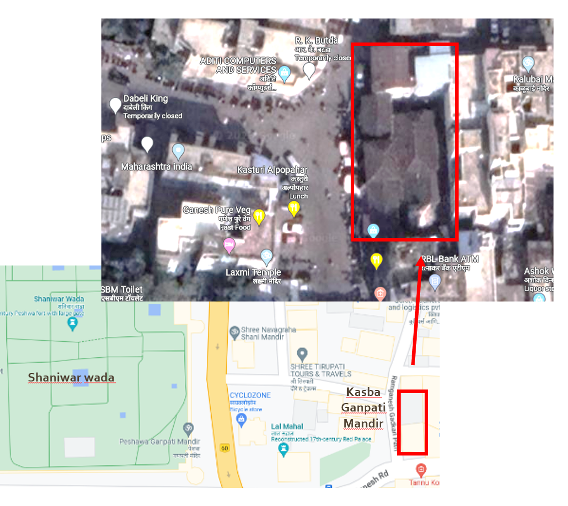
Figure no. 1: Location map of the temple
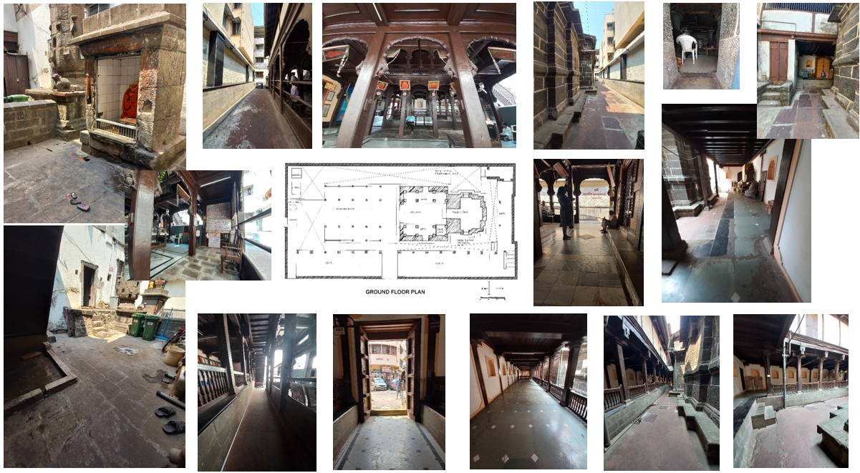
Figure no. 3: Photographs of the temple during daylight measurement
Climate study:
According to the ECBC Code, the climate zone of Pune city is Warm and Humid. The city of Pune is located close to the metropolis of Mumbai. When studying the weather in Pune, the data from the IMD are referenced. May, which is considered to be part of the summer season, is the month in which the highest mean temperature recorded was obtained. The month of January, which coincides with the winter season, has the coldest average temperature. Because the humidity is higher than 60 percent, the environment in Pune requires ventilation. Whenever there is a significant amount of humidity present, the wind tends to blow from the west. The amount of radiation that is received on the horizontal surface is the maximum, and it can reach over 600 during the month of May. The sun in Pune is not as intense as it is in other cities, and the city's climate helps keep the city's interiors at a nice temperature throughout the year. During the monsoon season in Pune, there is nonstop precipitation throughout the day, and the sky is cloudy for a string of ten to fifteen days in a row. After 15 days, there is a chance that the sky will clear up, at least somewhat. The rain continues to fall throughout the day since the humidity levels are so high, and it does not stop any sooner. During the monsoon, this has an impact on the amount of daylight. When there is cloud cover in the sky, the amount of daylight that enters a building through vertical openings is significantly reduced, but skylights and horizontal openings continue to function normally.
Table no. 1: Climatic Data of Pune
City –Pune, Latitude:-18°32'n, Longitude:-73°51'n, Height Above Sea Level:-652 M
A | Temperature | JAN | MAY | AUG |  | NOV
1 | Mean Monthly Maximum | 30.3 | 37.1 | 27.6 |  | 30.3
2 | Mean Monthly Minimum | 11.7 | 22.4 | 21.4 |  | 14.7
B | Humidity And Rainfall | JAN | MAY | AUG |  | NOV
1 | R.H. Morning % | 69 | 61 | 84 |  | 76
2 | R.H Evening (%) | 25 | 32 | 74 |  | 35
3 | Mean Monthly Total Rainfall | 1.5 | 26.9 | 90.2 |  | 27.4
4 | Mean Annual Rainfall (Mm) | 672.8
5 | Heaviest With In 24 Hrs. (Mm) | 149.1
C | Wind | JAN | MAY | AUG |  | NOV
1 | Wind Direction -Morning | C/S | W/NW | W/SW |  | C/E
2 | Wind Direction- Evening | C/W | W/NW | W/NW |  | E/C
3 | Mean Monthly Wind Speed Km.Hr | 5.95 | 14.65 | 14.32 |  | 5.95
D | Radiation | JAN | MAY | AUG | NOV
1 | Horizontal | 374 | 607 | 595 | 359
2 | East Or West | 167 | 239 | 239 | 161
3 | South East Or South West | 292 | 143 | 166 | 297
4 | South | 380 | 8 | 33 | 392
5 | North East Or North West | 26 | 194 | 172 | 21
6 | North | 0 | 79 | 42 | 0

The sky condition graph is generated by analysis of IMD data and oktas. The graph shows that clear sky is available at most of the time during the year except monsoon. Sky condition graph and radiation is important to analyze the available daylight and formulate the strategies.

Figure no. 3: Sky condition of Pune throughout the year
Sunpath and wind:
The sun path determines the position and angle of sun. This is useful to find out at which time and month of the year, sunlight enters a particular space. Kasaba Ganpati temple is oriented towards North-South direction. The east and west sun enter the temple space only at a particular time i.e. 8am to 10 am and 2pm to 4 pm. The rest of the sunlight passes through the open to sky spaces and reflects light into the space. The Windrose and sun path diagram are essential while designing daylight and natural ventilation. Climatic data is available by the Indian Meteorological department. Ref. Fig no. 4
The temple is double storeyed having galleries and a double height in the central space which allows warm air to rise up, making a stack effect. Ref fig no. 5 section of temple. As the wind direction of Pune is West, the wind draws inward and is precooled due to the internal materials that absorb heat and become cool. The stone walls and stone tiles are cooler as they donot receive much direct sunlight and reflected sunlight carries less amount of heat. Due to the materials used in the construction of the temple, a temperature difference of 3-5 degrees occurs between the indoors and outdoors at the road. The temple has no windows and is enclosed by dense construction from three sides. Although so many challenges, the temple maintains a comfortable environment in the indoors. During peak rush of visitors, the temple faces ventilation issues as the capacity exceeds. Reflected daylight is measured at various points of the temple and dark spaces are identified. Ref fig no. 6
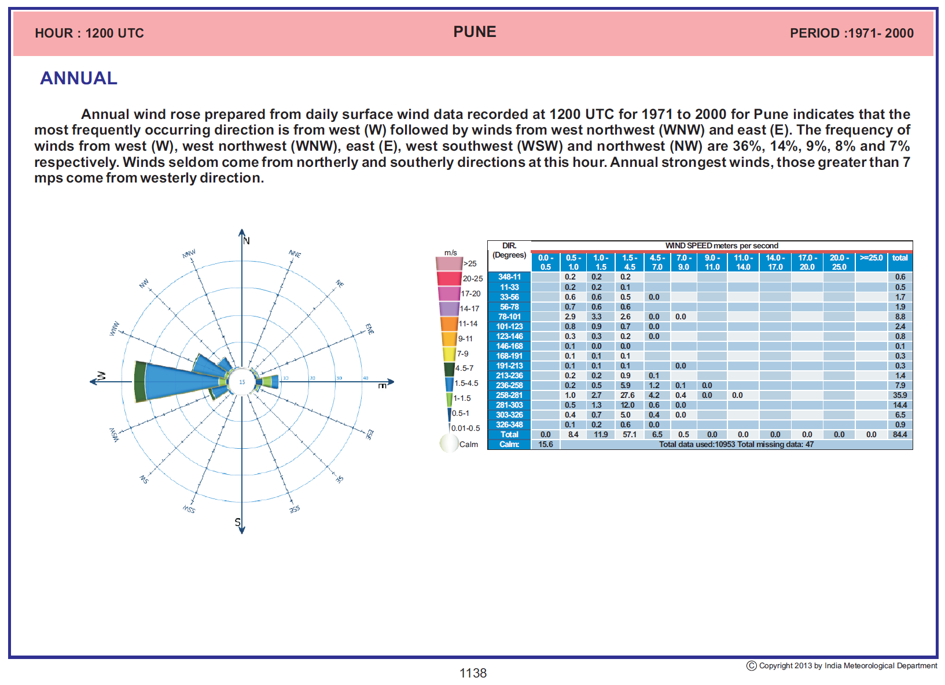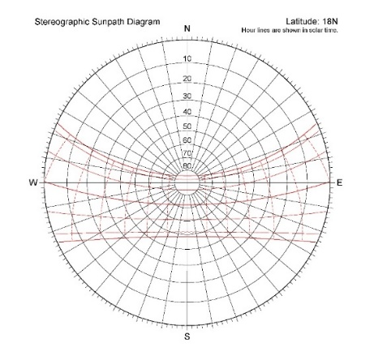
Figure no. 4: Windrose diagram (IMD) and Sunpath diagram of 18 degree North latitude.
Inferences from climatic data:
- Humidity ranges between 60-85% which is very high.
- Horizontal surface receives highest radiation.
- During winters the radiation is maximum at the south while in summers maximum radiation is at east west and horizontal.
- Greater part of the year has clear sky condition, monsoon months are dominated by overcast sky.
- Sky clearance is above 75% for whole year, except in monsoon months, in July it is minimum; with 0% clear sky condition
- Kasaba Temple has no windows, the main door opens at the West, the spaces which are open to sky are the key access of daylight.
- Wind direction is the West thus inlets at West are workable.
- Though east and West are critical surfaces, due to the dense construction, it creates obstacles of direct sunlight and heat penetration.
- During monsoon overcast sky condition, according to Sun, Wind and Light book by Mark Decay, it mentions that the sky brightness is maximum at the zenith (horizontal surfaces) than the horizon. The ratio of brightness of Zenith to horizon is 3:1.
- Thus, the temple works well in overcast sky condition, the only challenge of daylight is during clear day which is the maximum days. Hence actual lux levels are measured during clear day and afternoon hours to record the daylight level during best conditions.
Daylight Analysis:
Daylight analysis was conducted during the summer and in the afternoon, between 1 and 2 p.m., as this is the optimal period for maximum illumination. This is to determine, under optimal conditions, which areas do not receive sufficient radiation. A map with legend ranging from below 50 lux to above 1000 lux has been generated. The minimum amount of light required to observe an object is 0 lux. In a few locations, the readings from the lux metre indicate extremely low light levels below 50 lux. 25% of the area has less than 50 lux of illumination. While 25-30% of the space has increased levels of illumination ranging from 900-1100 lux. The majority of these areas are sky-facing. The garbhagriha is the primary location of the deity, so despite the low lux levels, the cultural aspect takes precedence. A perpetual Diya/lamp is lit in front of the deity. This illuminates the space, and additional lighting is required to maintain the focus on God. Daylight analysis yields the following significant inferences:
- There is need of more light at the west and south spaces of the temple.
- The reflected light has reduced heat gain and the materials absorb heat and provide reduced temperature.
- The ambience is quite and pleasing suitable for prayer and meditation
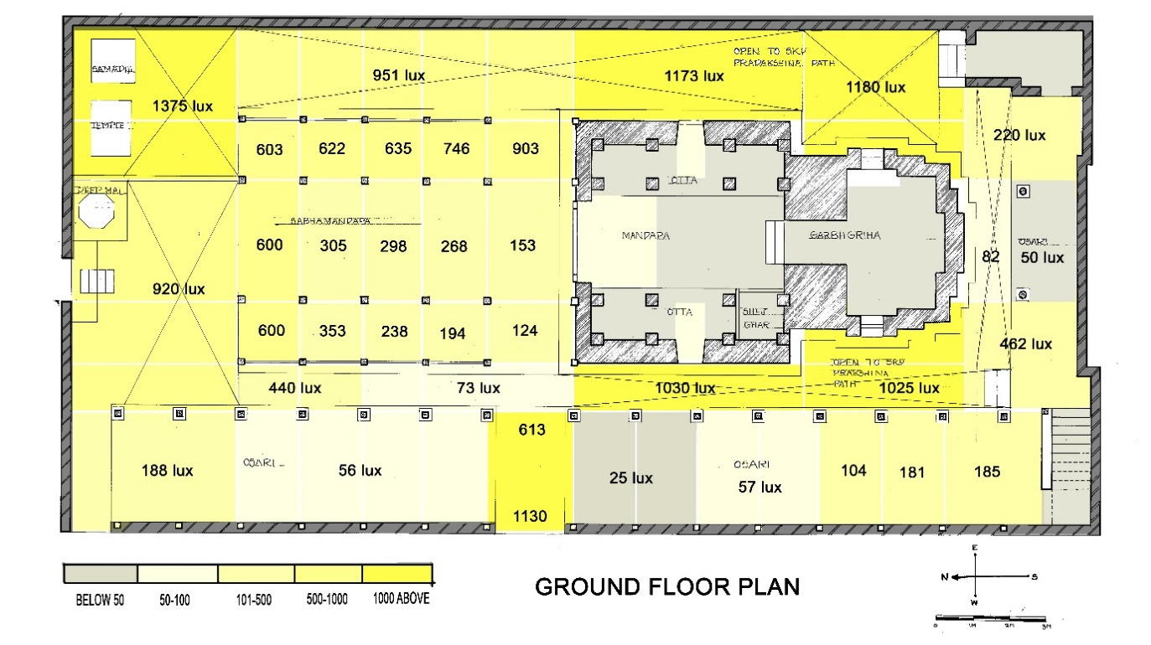
Figure no. 5: Daylight distribution in lux
Architectural characteristics:
There are multiple eras of construction at the Temple. Stone was used to construct the garbhagriha and mandapa, while lumber was used for the latter and brick was used for the adjoining homes and the walls surrounding the temple. The temple is a priceless piece of history. Elevational details reflect Hindu aesthetics and organic patterns. The shikhara, arches typical of Peshwa architecture, the hefty timber entrance, the timber balconies, and the Wada-inspired design all stand out. Recent years have seen conservation efforts made, with ongoing support coming from private agencies and contributions………………………………………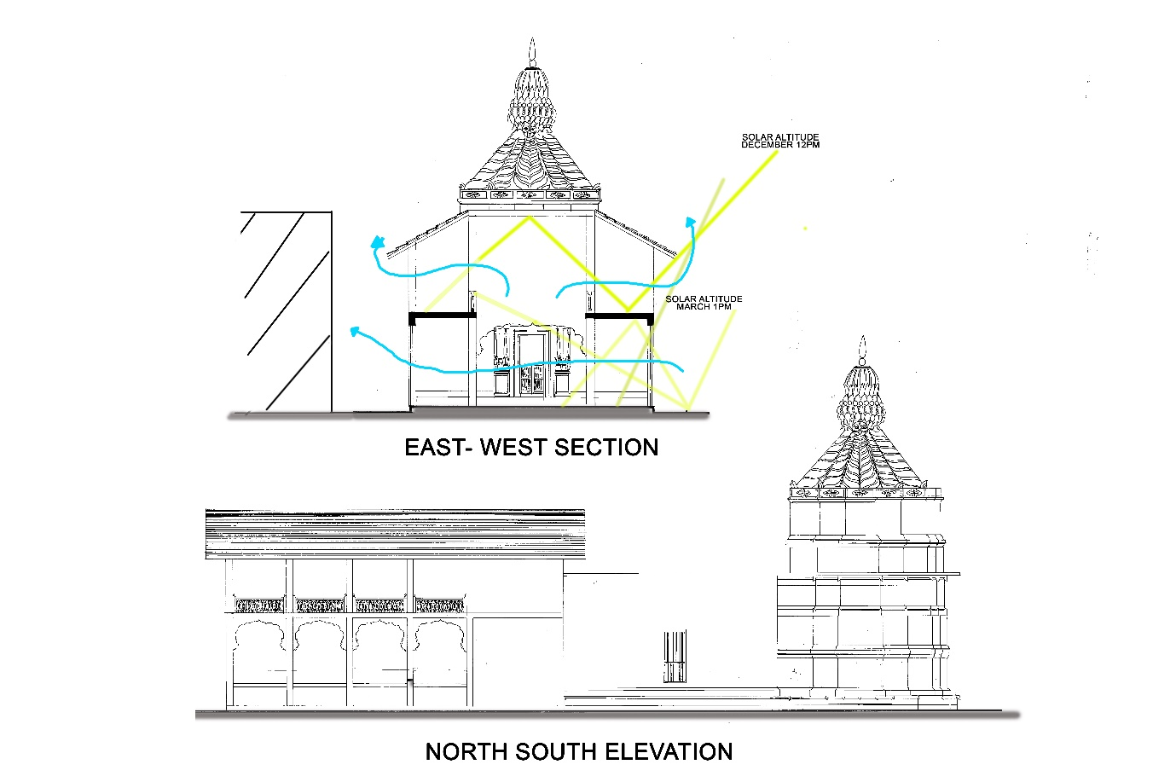
Figure no. 6: Section and elevation of the temple
Discussion:
With the use of this research study, we are able to figure out that heritage buildings that are several decades old have been subjected to a wide variety of situations, individuals, architectural styles, and settlement patterns, among other things. As the buildings go through these generations, they may be exposed to many environmental conditions that have an impact on the design of the sustainable building. In the case of this temple, the proximity of the dense development that was built nearby hindered its capacity to deliver an acceptable amount of natural light and ventilation. Even if there were many obstacles to overcome, the construction of heritage buildings consists of attractive designs, the use of local resources, and still provides a pleasant atmosphere. This is something that cannot be found in modern buildings. Because of this, many historically significant buildings have been maintained. The design of the sustainable building could be harmed, but it could also be improved using contemporary methods.
Inferences:
- Light pipes and solar collector tubes are modern technique of directing sunlight without heat into the space where access to daylight is not possible during the day.
- Exhaust fans and wind catchers can be installed for adequate ventilation during peak rush hours
- Stack tubes with glass material facing the south constructed at certain points will enhance the ventilation of the temple.
Conclusion:
This study was conducted to bring attention to the significance of the conservation and restoration of the sustainable design of the building for which it was originally constructed for. Sustainable design and heritage have been inextricably linked ever since the beginning of time. The material, architectural feature, and design that are considered to be of the utmost importance in conservation efforts are prioritized. When it comes to the preservation of historic buildings with environmentally friendly designs, there is room for improvement. It was vital to conduct this study so that architects and other stakeholders would be aware of what happens to a building as it ages and how it may be evaluated to determine what preventative steps should be taken. The Kasaba Ganpati temple is the most significant piece of the city of Pune's cultural history. To keep the historic buildings in their greatest condition, preservation efforts absolutely require improvements and study in this area.
References:
Benjamin, David & Ap,. (2009). Title: Architectural Heritage: A Challenge to Sustainable Design Practices and An Opportunity for Learning from The Past. SASBE conference.
Balasri Prasad Kamarapu1, Dr. B. Saritha. (2023). Factors affecting sustainable development of Temple Tourism – A case of Telangana. Conference: Sustainable Tourism At: Nalgonda, Telangana, India
Gandotra, A. (2011) Indian Temple Architecture. 2011th edn. Gurgaon,India: Shubhi Publications, Gurgaon -122002, Haryana, India.
Indian Meteorological Department, Ministry of Earth Sciences
Narkhede Parag. (2009) Kasaba Ganpati Temple, Pune. Context-Built, Living and Natural. Vol. VI, Issue-1 Summer-2009. Gurgaon: DRONAH-Development and Research Organization for Nature, Arts and Heritage. pp 05-13.
Nishant, Naveen & Das, Bijay. (2022). A living structure: Fundamentals of Hindu Temple Architecture. Dongbei Daxue Xuebao/Journal of Northeastern University. 25. 4034-4043.

