An Exclusive Network Portico for Tracking Client Construction Transaction

Vidya Sagar S D¹  Department of Master of Computer Applications  Nitte Meenakshi Institute of Technology  Bengaluru, India  vidyasagarsd@gmail.com | Sreekanth Rallapalli ²  Department of Master of Computer Applications  Nitte Meenakshi Institute of Technology  Bengaluru, India  rsreekanth1@yahoo.com
Navaneeth A V ³  Department of Master of Computer Applications  Nitte Meenakshi Institute of Technology  Bengaluru, India  avnavaneeth25@gmail.com | Sashikanth Reddy Avula ⁴  Department of Master of Computer Applications  Nitte Meenakshi Institute of Technology  Bengaluru, India  askr1985@gmail.com
Shweta Dhareshwar ⁵  Department of Master of Computer Applications  Nitte Meenakshi Institute of Technology  Bengaluru, India  shwetashine.dhareshwar@gmail.com | Rakesh S N ⁶  Department of Master of Computer Applications  Nitte Meenakshi Institute of Technology  Bengaluru, India  rakeshsn2000@gmail.com

ABSTRACT
Construction – The Construction Transaction Tracking Web Portal is a cutting-edge platform that revolutionizes construction companies' management and monitoring of client transactions. In the fast-paced and dynamic construction world, efficient transaction management is essential for project success, and this web portal aims to streamline the entire process. This software has been designed with the purpose of addressing the challenges associated with the manual maintenance of Construction reports by providing a web-based transaction portal. The system offers comprehensive automation capabilities for converting manual recordings into a web portal interface. The mechanism employed in this context is the utilization of Approvals, which necessitates the approval of both the Super admin and Client in order to validate the transaction. The primary goal is monitoring and overseeing all client construction tasks while ensuring secure management. Having a comprehensive and detailed understanding of the management practices from the previous year can be beneficial. The offered search feature allows users to look for the corresponding client due to the recording of numerous transactions from diverse clients. Moreover, the organization is capable of effectively tackling the issue of manual transactions while also employing cloud technology to ensure the security and integrity of all data. Due to the increased number of transaction records between the Clients and the Super admin in this project, the process of Constructions task tracking transactions has been facilitated.

Keywords— Construction Transaction Tracking, Construction Collaboration, Construction Collaboration

INTRODUCTION

In the fast-paced and dynamic world of construction, effective management of client transactions plays a pivotal role in determining the success of any project. As the construction industry continues to evolve and embrace technological advancements, the need for streamlined and transparent transactional processes becomes increasingly apparent. In response to this demand, we are proud to present our cutting-edge Construction Transaction Tracking Web Portal, an innovative solution designed to revolutionize the way construction companies manage and monitor their client transactions. Our web portal’s heart is a commitment to transparency, efficiency, and seamless communication. We understand that construction projects involve intricate interactions between multiple stakeholders, including clients, suppliers, contractors, and project managers. Often, the sheer complexity of these transactions can lead to challenges in maintaining a clear and real-time view of project progress and financials. However, with our web portal, these challenges become a thing of the past.
One of the core features of our Construction Transaction Tracking Web Portal is real-time tracking. Clients and project managers can now gain insight into project developments, financial transactions, and communication exchanges. No longer will there be a need to wait for status updates or waste time on lengthy phone calls and emails. Users can access a comprehensive dashboard with a few clicks displaying all relevant information, allowing for better decision-making and timely actions. In addition to real-time tracking, our web portal facilitates seamless communication between all parties involved in the construction project. Clear and effective communication is crucial in avoiding misunderstandings, delays, and costly mistakes. Through our platform, users can centralize all communication channels, ensuring everyone stays on the same page and that key messages and updates are delivered promptly. This heightened level of collaboration fosters a more cohesive and productive work environment, driving projects toward successful outcomes.
Another integral aspect of our web portal is document management. Construction projects generate numerous documents, ranging from contracts and proposals to drawings and invoices. Keeping track of these documents can be overwhelming, leading to potential errors and delays. Our portal provides a secure and organized repository for all transaction-related documents, simplifying document retrieval and ensuring data integrity. Financial insights are also a focal point of our Construction Transaction Tracking Web Portal. We recognize the importance of financial management in construction projects, and our platform equips users with detailed reporting and analytics tools. Users can monitor budget allocations, track expenses, and assess real-time cash flow. With this vital financial information, project managers can make informed decisions to keep projects on budget and schedule.
Security is a paramount concern for us, and our web portal is built with robust measures to safeguard sensitive information. We employ state-of-the-art encryption protocols and authentication methods to protect user data from unauthorized access. Clients can trust that their information is safe and they have complete control over access permissions. We understand that every construction project is unique, with its specific workflows and requirements. Our web portal is highly customizable to address this, allowing clients to tailor the platform to their individual needs. This adaptability ensures that the portal seamlessly integrates into existing processes, making the transition to our platform smooth and efficient.
Furthermore, the portal's integration of advanced security measures guarantees the protection of sensitive project information, ensuring the confidentiality and integrity of critical data throughout the construction lifecycle. As the construction industry continues to evolve and embrace technological advancements, the Construction Transaction Tracking Web Portal stands as a testament to the potential of digital innovation in transforming traditional processes. This tool empowers construction professionals to stay ahead of the competition, enhance project outcomes, and ultimately deliver high-quality results to clients.
In a world where time and efficiency are paramount, this web portal emerges as a pivotal asset in optimizing construction project management, ultimately contributing to the growth and success of construction ventures across the board. Embracing this technology is not just a choice but necessary for construction companies looking to thrive in a rapidly evolving landscape. By harnessing the portal's capabilities, construction professionals can embark on a new era of productivity, collaboration, and success.

Literature Survey

A literature survey on the topic of the Construction Transaction Tracking Web Portal reveals several relevant studies, and reviews are as follows. Forcael et al. [1] discuss various concepts related to construction, including the Internet of Things, Computer-Aided Design Technologies (BIM), 3D Printing, Big Data, Artificial Intelligence, and Robotics. While it does not explicitly focus on Construction Transaction Tracking Web Portals, it provides insights into the technological advancements in the construction industry. Ermakova et al. [2] Although this paper focuses on web tracking, it provides insights into the relevance and research methods in this field. While not directly related to Construction Transaction Tracking Web Portals, it may offer valuable information on tracking technologies and methodologies.

Ye et al. [3] This study examines explicitly intelligent contract applications in the construction industry. While it does not focus on Construction Transaction Tracking Web Portals, it provides insights into the potential benefits and challenges of implementing smart contracts in construction. Scott et al. [5] These reviews explore the use of blockchain technology in the construction industry. While not explicitly focused on Construction Transaction Tracking Web Portals, they discuss the potential applications of blockchain in improving performance and efficiency in construction processes. Based on the available literature, there appears to be limited research specifically addressing Construction Transaction Tracking Web Portals. However, the broader literature on construction technology, smart contracts, and blockchain in the construction industry can provide valuable insights and context for understanding the potential benefits and challenges of implementing such a web portal. Further research and analysis may be necessary to gather more specific information on Construction Transaction Tracking Web Portals.

The benefits of using a construction transaction tracking:

- Instantly locate assets: A construction transaction tracking web portal allows for real-time tracking of assets, enabling construction companies to quickly locate and manage their equipment and materials.
- Accurate data and up-to-date records: By using a web portal, construction companies can maintain accurate and up-to-date records of transactions, including purchases, sales, and transfers. This helps in maintaining transparency and accountability.
- Efficient communication: Web-based software allows for efficient communication between different stakeholders involved in construction projects. It keeps everyone connected, regardless of location, and facilitates seamless collaboration.
- Organized work order management: Construction transaction tracking web portals provide a centralized platform for managing work orders. This helps in streamlining the workflow, assigning tasks, and tracking progress.
- Improved job costing: Construction companies can accurately track and allocate costs to specific jobs using a web portal. This helps in better estimating project costs, reducing the risk of losses, and improving profitability.
- Compliance and proof of work: A construction transaction tracking web portal can help companies demonstrate compliance with local and national regulations. It provides a record of transactions and activities, which can be used as proof of work.
- Enhanced asset management: Construction asset tracking is integral to using a web portal. It allows companies to tag and track valuable equipment, ensuring that assets are properly managed and utilized.
- Streamlined supply chains: There are additional benefits in the context of blockchain technology, which can be integrated into a construction transaction tracking web portal. Blockchain can streamline supply chains by enabling transparent and secure transactions, reducing delays, and improving efficiency.
Overall, a construction transaction tracking web portal offers numerous benefits, including improved asset management, streamlined communication, accurate record-keeping, and enhanced project efficiency. It helps construction companies optimize operations, reduce costs, and improve overall project outcomes.

Some potential problems of using a construction transaction tracking web portal
- Transaction-related issues: According to a study on transaction-related issues and construction project performance, transaction costs and uncertainty in the transaction environment can negatively impact project outcomes. A construction transaction tracking web portal may not necessarily solve these issues and may even add complexity to the transaction process.
- Security concerns: Without proper security measures, a construction transaction tracking web portal may be vulnerable to cyber-attacks or data breaches. This can compromise sensitive information and lead to financial losses.
- Implementation challenges: Implementing a construction transaction tracking web portal can be challenging, especially for companies lacking technical expertise. It may require significant investment in hardware, software, and training.
- Limited adoption: Despite the potential benefits, some construction companies may hesitate to adopt a web-based tracking system due to concerns about cost, complexity, or resistance to change.
- Integration issues: Integrating a construction transaction tracking web portal with existing systems and processes can be difficult. It may require significant customization and testing to ensure compatibility and avoid disruptions to ongoing operations.
Overall, while a construction transaction tracking web portal offers many benefits, there are also potential challenges and limitations that need to be considered. Companies should carefully evaluate their needs and capabilities before implementing such a system.

III PROPOSED APPROACH OF CONSTRUCTION TRANSACTION TRACKING WEB PORTAL

A. Methodologies
The Construction Transaction Tracking Web Application is a powerful and innovative platform designed to streamline construction project management by efficiently tracking and managing all financial transactions. At its core, the web application is a robust transaction tracking tool, ensuring transparency, accuracy, and security throughout the project lifecycle. The underlying assumption of the system is that for proper business transactions to take place in the construction industry, there must be a transparent and accountable process. The web application addresses this assumption by providing a centralized and structured approach to handling financial transactions related to construction projects.

The primary method employed by the Construction Transaction Tracking Web Application is to meticulously track all transactions initiated by clients and effectively manage them in a secure manner. This includes monitoring client payments, recording project expenses, and handling any additional financial activities within the project scope. One unique feature of the web application is its dual-approval process for transactions. Both the Super Admin and the client play pivotal roles in the approval of transactions. This ensures a high level of accountability and accuracy in financial matters. The Super Admin, who holds administrative control, reviews and approves transactions from their end, guaranteeing financial oversight and control over the entire system.

On the other hand, clients’ involvement in approving transactions fosters transparency and trust. Clients are active participants in the financial aspect of their construction projects, allowing them to validate and confirm the accuracy of payments, budgets, and any modifications requested. This dual-approval method not only enhances data accuracy but also ensures that all stakeholders are actively engaged and informed throughout the transaction process. It strengthens the collaboration between the Super Admin and clients, fostering a cooperative working environment and ultimately leading to the successful execution of construction projects.
Moreover, the Construction Transaction Tracking Web Application employs robust security measures to safeguard sensitive financial data. Utilizing encryption and other cloud technologies, the application ensures that client information, budgets, and transaction details remain secure from unauthorized access or data breaches. The Construction Transaction Tracking Web Application revolutionizes construction project management by offering a sophisticated and transparent approach to financial tracking. With its dual-approval system, it promotes accountability and collaboration between the Super Admin and clients, thereby empowering construction professionals to effectively manage and execute projects in a secure and efficient manner.

B Technologies

Table 1: Technical details of the technology used in the website development.

Sl. No. | Technology | Description
 | HTML | HTML is the standard markup language for creating Web pages. HTML describes the structure of a Web page. It consists of a series of elements, and elements tell the browser how to display the content. HTML elements label pieces of content such as "this is a heading", "this is a paragraph", "this is a link", etc.
 | CSS | A template language called Cascading Style Sheets (CSS) represents the opening of an HTML or XML archive (counting XML lingos, for example, SVG, MathML, or XHTML). CSS illustrates how elements should be shown on a screen, on paper, in conversation, or other media.
 | Bootstrap | A free, open-source HTML, CSS, and JavaScript framework called Bootstrap is used to quickly build responsive websites.
 | JavaScript | JavaScript, often abbreviated JS, is a programming language that is one of the core technologies of the World Wide Web, alongside HTML and CSS. JavaScript is an ECMAScript-compliant, high-level, frequently just-in-time compiled language. It features first-class functions, prototype-based object orientation, and dynamic typing.
 | Angular JS | An open-source front-end web framework for single-page apps, AngularJS was based on JavaScript. It was mostly kept up by Google and a group of people and businesses. It provided a framework for client-side model-view-controller (MVC) and model-view-view-model (MVVM) architectures together with commonly used web applications and progressive web application components in an effort to streamline both the building and testing of such applications.
 | Cloud-Hosting for web application and database Management | Cloud hosting offers scalability, allowing the application to handle varying data loads and user traffic efficiently. Moreover, cloud infrastructure minimizes the risk of application failures, ensuring uninterrupted access and improved reliability for all stakeholders involved in construction projects.

IV PROPOSED ALGORITHM

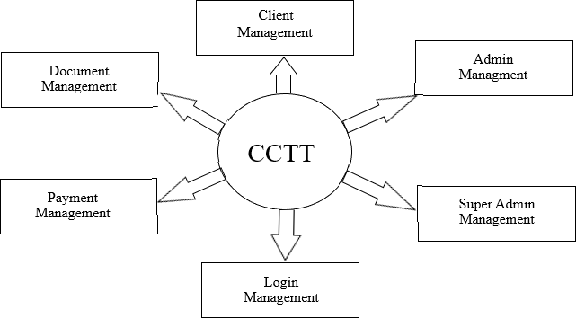

Figure. 1: Data Flow Diagram of Construction Transaction Tracking.

The Construction Transaction Tracking Web Application incorporates several key features, as shown in Figure 1 and Figure 2 that enhance the efficiency and security of construction project management. The following functionality incorporated in the website for Construction Transaction Tracking Web Portal are given below
Separate Login Credentials for Clients: As shown in Figure 3, the Super Admin manages multiple construction projects and clients, ensuring data privacy and access control is vital. By creating separate login credentials for each client, the web application ensures that clients can only access information and data relevant to their respective projects. This personalized authentication process enhances security, prevents unauthorized access, and fosters a transparent and trustworthy relationship between the Super Admin and clients.
Request for Modified Instructions: The web application facilitates seamless communication between clients and the Super Admin. Clients can easily submit requests for modifications or additional work through the portal. By streamlining this request process, the application ensures that clients' specific needs and changes are recorded, preventing misunderstandings and improving project collaboration.
Approval of Client Transactions and Budget Additions: Once clients make payments related to their projects, the transactions are subject to approval by the Super Admin. By verifying and approving these transactions, the Super Admin maintains control over the financial aspect of the project, ensuring accuracy and accountability. Additionally, when clients approve a specific budget for their project, the Super Admin can efficiently add and allocate it using the web application.
Resolution of Manual Transaction Issues: The web application effectively eliminates the reliance on manual transaction processes. Manual processes can be time-consuming, error-prone, and difficult to track, leading to potential delays and inefficiencies. By automating transactional activities, such as budget allocation, payment tracking, and invoice generation, the application mitigates the risk of human errors and ensures a more streamlined project management workflow.
Increased Flexibility: Construction projects vary in complexity and requirements, making flexibility a crucial aspect of the web application. By offering customizable features and adaptable functionalities, the application caters to the unique needs of different clients and projects. The user-friendly interface allows the Super Admin and clients to tailor the application to suit their specific project management preferences, ultimately enhancing overall productivity and effectiveness.
Cloud Hosting for Reliability: The decision to host the web application in the cloud brings numerous advantages. Cloud hosting offers scalability, allowing the application to handle varying data loads and user traffic efficiently. Moreover, cloud infrastructure minimizes the risk of application failures, ensuring uninterrupted access and improved reliability for all stakeholders involved in construction projects.
Data Security with Cloud Technologies: Recognizing the sensitivity of project-related data, the web application employs robust cloud technologies to ensure data security. Cloud platforms typically employ advanced encryption mechanisms, secure access controls, and regular data backups. By storing data in highly secure data centers, the application safeguards against potential data breaches or unauthorized access, assuring clients and the Super Admin that their confidential information remains protected.

In conclusion, the Construction Transaction Tracking Web Application provides secure and efficient project management capabilities. With features like separate client credentials, automated transaction processing, and cloud-based hosting, the application fosters transparency, collaboration, and data integrity, contributing to the success of construction projects and the satisfaction of all stakeholders involved.

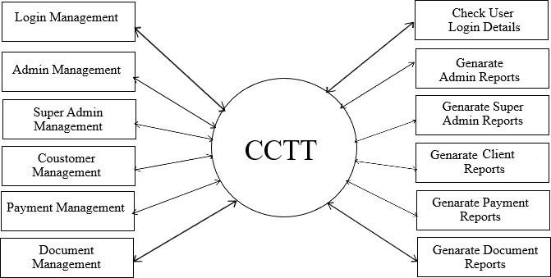
Figure 2: Functionality of Construction Transaction Tracking.

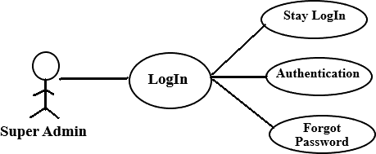
Figure 3: Login Module Use Case Diagram

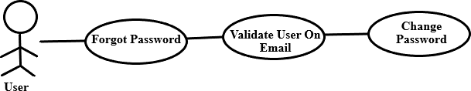
Figure 4: Forgot Password Module Use Case Diagram
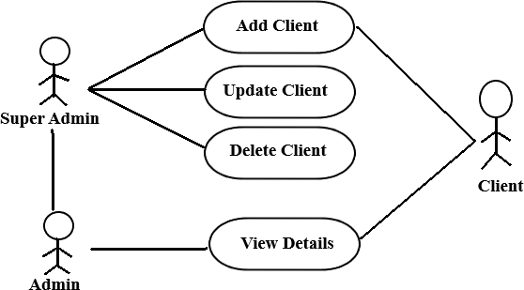

Figure 5: Super Admin, Admin, and Client Module Communication Model

V RESULTS

The implementation of these will help the client to get feedback and suggestions from their customers and help them and the company to provide a better experience with ease. The website will provide an interactive interface for the customers to better their experience with the company. Online surveys work best when combined with other research techniques to perform global user research and get opinions and recommendations from customers depending on a particular market. These might be valuable and affordable methods to gain global insight into your customer base.
The key benefit of online surveys for researchers is increasing output while cutting labor costs. Data is immediately available and may be easily given to individual clients to improve customer service. Compared to paper surveys, telephone surveys, and one-on-one surveys, online surveys are more accurate. These kinds of questionnaires don't offer a helpful way to get input.
It is not the best way to conduct the survey because there is occasionally a chance that the data will be erroneous or that customers won't answer the call. This will facilitate communication between the client and a vast consumer base worldwide, boost productivity by raising response rates, and serve as a dependable and ready-to-analyze tool based on customer feedback.

Figure 6: CCTT Module Landing Page

As shown in Figure 6. Upon visiting the CCTT Landing Web Page, users are greeted with a clean and intuitive interface showcasing the web application's key features and benefits. The landing page is designed to be visually appealing, featuring high-quality images representing various construction projects and professionals at work, instilling confidence in the platform's capabilities.
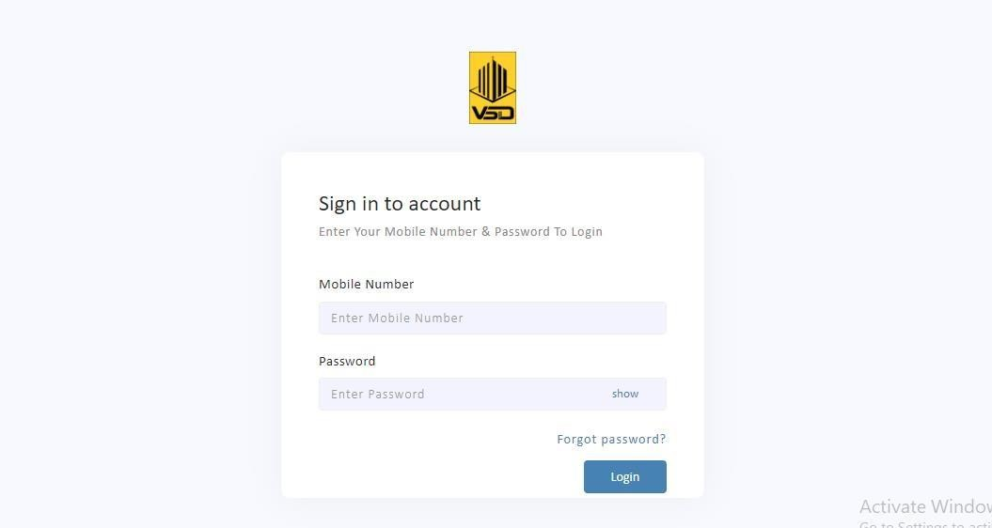
Figure 7: CCTT Module Login Page

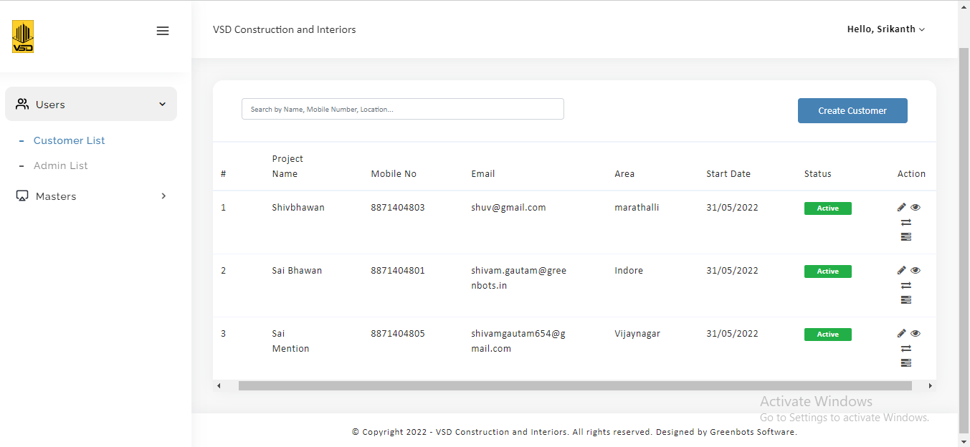
As shown in Figure 7. the Construction Transaction Tracking Web Application Module Login Page is a secure, user-friendly, and aesthetically appealing entry point to the web application. By providing a seamless and reliable login experience, the page sets the foundation for users to access the powerful project management tools and features offered by the web application, ultimately contributing to the success and efficiency of construction projects.
Figure 8: CCTT Customer List Page

As shown in figure 8. The Customer List Page within the Construction Transaction Tracking Web Application is a comprehensive and organized hub that displays vital information about the various customers and their associated projects. This page provides the Super Admin and authorized users with an at-a-glance overview of all customers and allows for efficient management and tracking of ongoing construction projects.

Key parameters displayed on the Customer List Page include:
Project Name: The page prominently showcases the names of all construction projects associated with each customer. This lets users quickly identify and access specific projects for further details and updates.
Mobile Number and Email: Contact information such as the customers' mobile numbers and email addresses are conveniently presented in the list. This facilitates easy communication and outreach between the Super Admin and clients, ensuring smooth collaboration throughout the project lifecycle.
Area: The Customer List Page displays the geographical area or location of each project. This information helps quickly identify the construction site, which is particularly useful when managing multiple projects in different areas.
Start Date: The start date of each project is clearly displayed, enabling the Super Admin to track project timelines and deadlines effectively. This assists in keeping construction progress on schedule and addressing any potential delays promptly.
Status: The status column indicates each construction project's current stage or status. It may include statuses such as "In Progress," "Completed," "On Hold," or "Cancelled." This visual representation lets users grasp the overall progress of projects at a glance.
Action: The "Action" column provides relevant interactive options for each customer entry. Users can perform various actions, such as accessing detailed project information, editing project details, approving client transactions, or initiating additional work requests.
The Customer List Page has a user-friendly interface featuring easy-to-read tables and intuitive navigation options. The data is presented well-organized, allowing users to sort, filter, and search for specific customer or project details effortlessly. To enhance usability, the page may incorporate pagination or infinite scrolling, especially if there are many customers or projects. This ensures that users can access all information without overwhelming the interface. Additionally, the Customer List Page is responsive, adapting to different screen sizes and devices, allowing users to access and manage project data conveniently from desktop computers, laptops, tablets, or smartphones.
The Customer List Page is a fundamental component of the Construction Transaction Tracking Web Application. It provides an overview of essential project details for each customer, streamlining project management and enhancing communication between the Super Admin and clients. With its intuitive layout and essential parameters, the page empowers users to efficiently track, monitor, and manage multiple construction projects simultaneously, contributing to successful project outcomes.

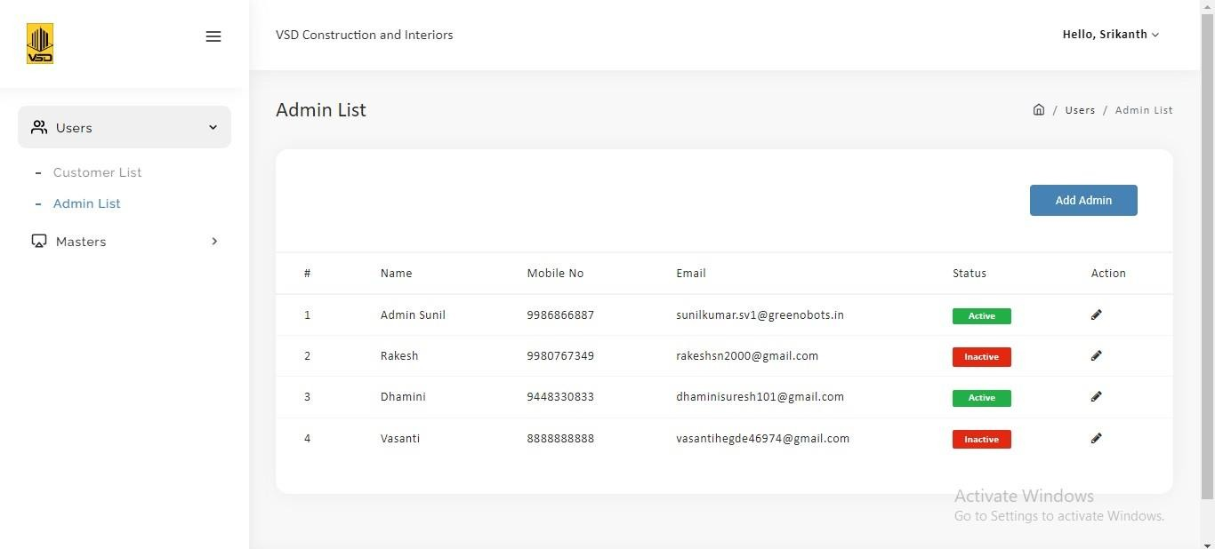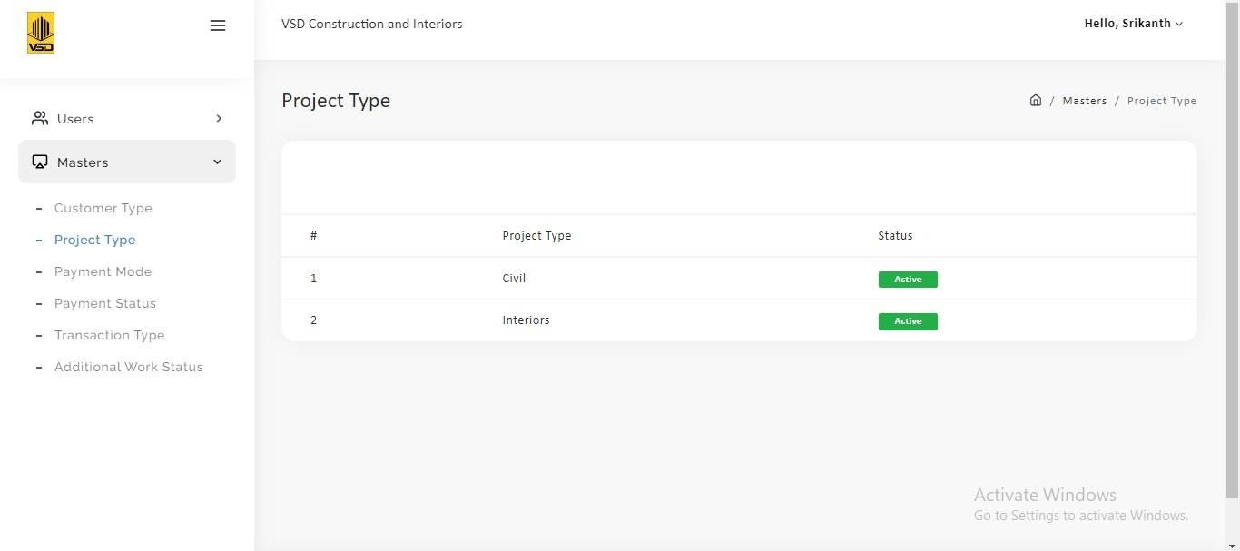
Figure 9: CCTT Admin List Page
As shown in the figure 9, the Construction Transaction Tracking Web Portal Admin List Page is an essential tool that empowers the Super Admin to efficiently manage and oversee various construction projects based on their types and statuses. Its user-friendly interface and comprehensive presentation of project data facilitate informed decision-making, promote effective project management, and contribute to the successful execution of construction projects. By providing real-time insights into project types and statuses, the Admin List Page enhances transparency, streamlines project tracking, and fosters efficiency and collaboration among project stakeholders.

Key parameters displayed on the Admin List Page include:
Project Type: The Project Type parameter categorizes construction projects based on different criteria such as commercial, residential, infrastructure, or renovation. This classification helps the Super Admin quickly identify and analyze the distribution of different project types, enabling strategic decision-making and resource allocation.
Status: The Status parameter offers valuable insights into the progress and current state of each construction project. It typically includes statuses such as "In Progress," "Completed," "On Hold," or "Cancelled." This visual representation allows the Super Admin to promptly assess the status of various projects at a glance, ensuring effective project tracking and timely intervention if required.

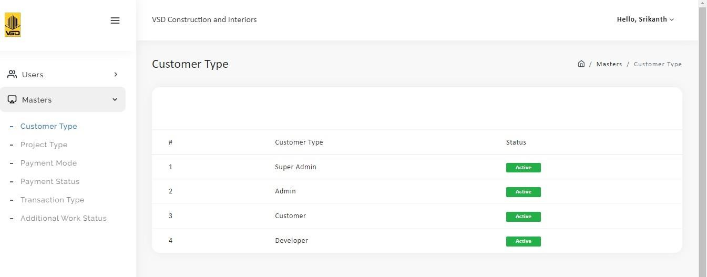
Figure 10: CCTT Master Module Page
As shown in Figure 10, This page is pivotal in streamlining project management and ensuring efficient decision-making. Customer type and status are the 2 parameter which help them to take the decision based on the certain rule based conditons.

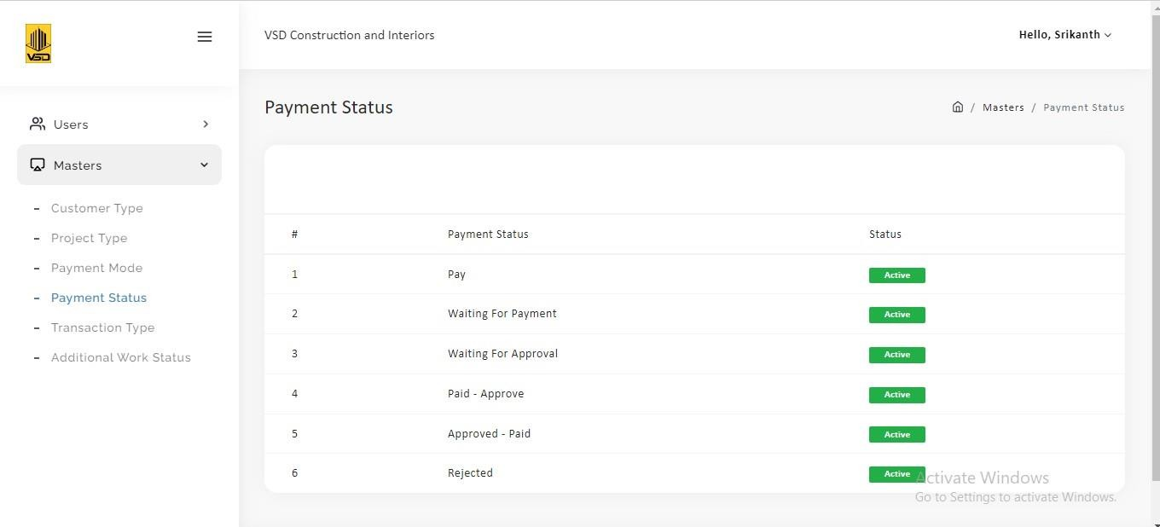
Figure 11: CCTT Payment Status Page

As shown in figure 11, The Payment Status Page is designed with a user-friendly interface, featuring organized tables or cards that present payment information in a clear and structured format. The page may also include sorting and filtering options, enabling users to customize their view based on specific criteria, such as client IDs, payment statuses, or project statuses.
Key parameters displayed on the Payment Status Page include.
Client ID: The Client ID parameter uniquely identifies each client within the system. This ID helps quickly associate payment details and work descriptions with the corresponding client, streamlining data organization and retrieval.
Payment Status: The Payment Status parameter showcases the current status of each client payment for their respective projects. This status may include categories such as "Paid," "Pending," "Overdue," or "Cancelled." This visual representation allows users to monitor the financial health of projects and promptly address any payment-related issues.
Status: The Status parameter offers an overview of the general progress and development stage of each construction project. It may include status updates like "In Progress," "Completed," or "On Hold." This parameter provides context to the payment status and helps stakeholders understand the project's overall status at a glance.
Description of Work: The Description of Work parameter summarizes the tasks and services associated with each payment the client makes. It clarifies the specific work covered by the payment, ensuring transparency and reducing the likelihood of misunderstandings.
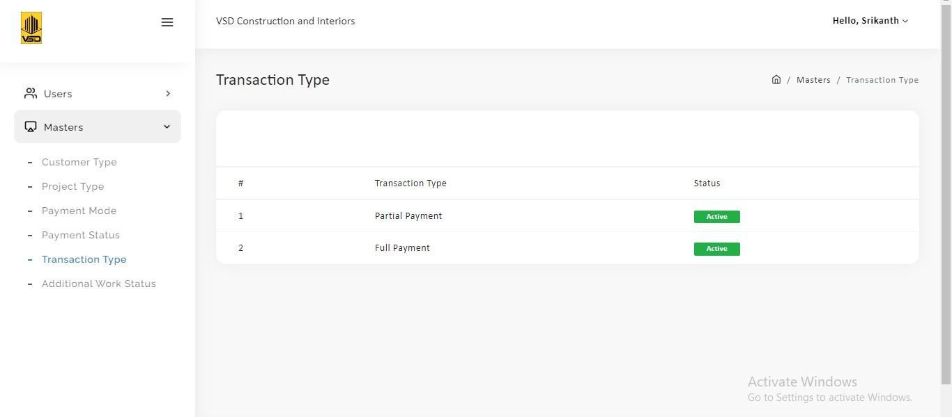

Figure 12: CCTT Transaction Type Page

As shown in Figure 12, The Construction Transaction Tracking Web Portal Transaction Type Page is a dedicated section within the web application that allows users to manage different transaction types related to construction projects. This page offers a clear and organized overview of three essential transaction types: "Partial Payment," "Full Payment," and "Payment Cancelled."
Key parameters displayed on the Transaction Type Page include:
Partial Payment: The "Partial Payment" parameter represents financial transactions where the client makes a payment for a portion of the project cost rather than the full amount. This transaction type is commonly used when clients pay in installments or based on project milestones. The page provides detailed information about the partial payment transactions, including payment amounts, dates, and associated projects.
Full Payment: The "Full Payment" parameter indicates financial transactions where the client makes a complete payment covering the entire cost of the project. This transaction type is applicable when the client pays the entire project amount upfront or upon project completion. The Transaction Type Page displays the relevant details of total payment transactions, facilitating easy tracking and documentation.
Payment Cancelled: The "Payment Cancelled" parameter denotes transactions where the client's payment is canceled or rejected for various reasons, such as non-approval by the Super Admin, insufficient funds, or client requests. The page provides insight into canceled payment transactions, helping the Super Admin and stakeholders address payment-related issues promptly.
the Construction Transaction Tracking Web Portal Transaction Type Page is a critical component of the web application, enabling users to manage and monitor various transaction types with ease. Its user-friendly interface and comprehensive presentation of transaction data facilitate informed financial decision-making, promote transparency, and contribute to the successful execution of construction projects. By providing real-time insights into partial payments, full payments, and payment cancellations, the Transaction Type Page enhances financial tracking, streamlines project management, and fosters efficient collaboration among project stakeholders.

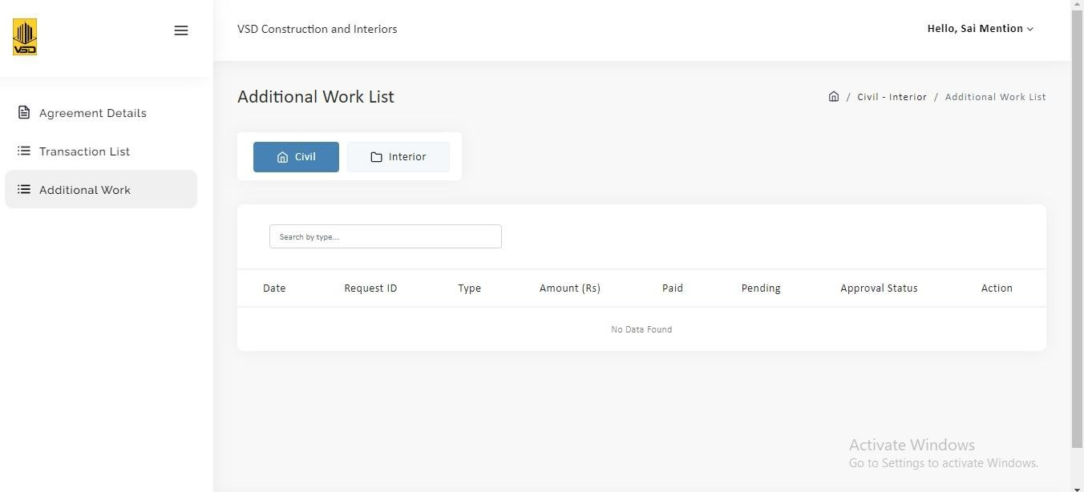
Figure 13: CCTT Additional Work List Page

As Shown in Figure 13, The Additional Work List Page is designed with a user-friendly interface, featuring a well-organized layout that allows users to access and manage additional work requests efficiently.
Key parameters displayed on the Additional Work List Page include:
Date: The "Date" parameter indicates the date when the additional work request was made by the client. This information enables stakeholders to track the timeline of requests and prioritize them accordingly.
Request-ID: The "Request-ID" parameter uniquely identifies each additional work request, making it easier for users to reference and manage specific requests.
Type: The "Type" parameter specifies the type or nature of the additional work requested by the client. This can include tasks such as design changes, material upgrades, or scope adjustments.
Amount: The "Amount" parameter represents the financial value or cost associated with the additional work request. It provides a clear indication of the financial impact of the requested changes.
Paid: The "Paid" parameter indicates the amount that has already been paid to the contractor for the approved additional work. This information allows stakeholders to track the financial transactions related to the additional work.
Pending: The "Pending" parameter shows the remaining amount that is yet to be paid for the approved additional work. This assists in tracking outstanding payments and managing project finances effectively.
Approval Status: The "Approval Status" parameter displays the status of the additional work request, indicating whether it has been approved, rejected, or is pending approval. This information ensures transparency and accountability in the decision-making process.
Action: The "Action" parameter provides interactive options for each additional work request, allowing users to take specific actions related to the request. For example, users may be able to approve or reject the request, initiate payments, or communicate with clients regarding the request.
the Construction Transaction Tracking Web Portal Additional Work List Page is a critical tool that empowers stakeholders to efficiently manage and track additional work requests during construction projects. Its user-friendly interface and comprehensive presentation of data promote financial transparency, streamline communication, and contribute to the successful execution of construction projects. By providing real-time insights into additional work requests, the Additional Work List Page enhances collaboration, supports informed decision-making, and fosters efficient project management among all stakeholders involved.

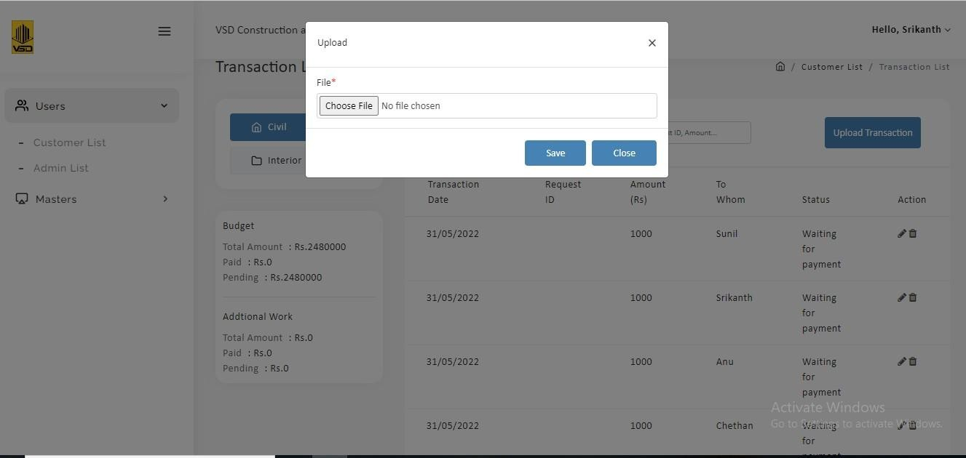

Figure 14: Upload Form in Super Admin

As shown in Figure 14, The Construction Transaction Tracking Web Portal Upload Form in the Super Admin section is a powerful tool that allows the Super Admin to easily manage and track various financial transactions within construction projects. This form facilitates the seamless uploading of transaction data, ensuring accuracy and transparency in financial records.
Key parameters displayed in the Upload Form include:
Transaction Date: The "Transaction Date" parameter indicates the date on which the financial transaction occurred. This information is crucial for maintaining accurate financial records and tracking the timeline of transactions.
Request-ID: The "Request-ID" parameter uniquely identifies each transaction, providing a reference point for easy tracking and managing specific transactions.
Amount: The "Amount" parameter represents the monetary value of the transaction, indicating the financial impact of the transaction on the construction project.
To Whom: The "To Whom" parameter specifies the recipient or beneficiary of the transaction. It could be a client, a vendor, or any other relevant party involved in the construction project.
Status: The "Status" parameter displays the current status of the transaction, indicating whether it is "Pending," "Completed," or "Cancelled." This helps the Super Admin and stakeholders stay updated on the progress of transactions.
Action: The "Action" parameter provides interactive options for each transaction, allowing the Super Admin to perform specific actions related to the transaction. For instance, the Super Admin may be able to approve the transaction, initiate a refund, or communicate with relevant parties about the transaction.
the Construction Transaction Tracking Web Portal Upload Form in the Super Admin section is a crucial tool that streamlines the process of managing and tracking financial transactions within construction projects. Its user-friendly interface and comprehensive presentation of transaction data enhance financial transparency, streamline communication, and contribute to the successful execution of construction projects. By providing real-time insights into transaction details, the Upload Form empowers the Super Admin to efficiently handle financial records, enabling informed decision-making and fostering a well-organized financial management process.

VI. CONCLUSION

the Construction Transaction Tracking Web Portal is a game-changing solution that has significantly improved construction project management by providing real-time tracking, seamless collaboration, and enhanced security. Its user-friendly interface, automated processes, and comprehensive reporting capabilities have streamlined the entire project lifecycle, minimizing errors and facilitating informed decision-making. By centralizing transactional data and documentation, the portal has brought unprecedented transparency and efficiency to the construction industry, empowering stakeholders to deliver high-quality projects to clients with confidence. the Construction Transaction Tracking Web Portal has transformed construction project management and set new standards for efficiency, transparency, and collaboration. Embracing future enhancements, such as intelligent analytics, mobile applications, and blockchain integration, will further empower construction professionals, optimize project outcomes, and drive the industry toward a more digital and connected future. The possibilities for improvement and innovation are limitless, and the web portal is well-positioned to continue revolutionizing the construction landscape for years to come.

REFERENCES
- Forcael, Eric, Isabella Ferrari, Alexander Opazo-Vega, and Jesús Alberto Pulido-Arcas. 2020. "Construction 4.0: A Literature Review" Sustainability 12, no. 22: 9755. https://doi.org/10.3390/su12229755
- Ermakova, Tatiana, Benjamin Fabian, Benedict Bender, and Kerstin Klimek. "Web tracking-A literature review on the state of research." (2018).
- Ye, Xuling, Ningshuang Zeng, and Markus König. "Systematic literature review on smart contracts in the construction industry: Potentials, benefits, and challenges." Frontiers of engineering management 9, no. 2 (2022): 196-213.
- https://epar.evans.uw.edu/sites/default/files/lit_review_slide_deck_1.3.18_final.pdf
- Scott, Denis J., Tim Broyd, and Ling Ma. "Exploratory literature review of blockchain in the construction industry." Automation in Construction 132 (2021): 103914.
- https://www.ftsgps.com/resource-center/8-benefits-of-construction-asset-tracking/
- https://www.viewpoint.com/blog/8-benefits-of-using-web-based-software-in-construction
- https://gocodes.com/tool-tracking-system-benefits/
- https://gocodes.com/construction-asset-tracking-benefits/
- https://www.quickbase.com/blog/construction-cost-tracking-software
- https://www.ftsgps.com/resource-center/8-benefits-of-construction-asset-tracking/
- https://www.quickbase.com/blog/construction-cost-tracking-software
- https://hedera.com/learning/smart-contracts/smart-contracts-construction

