Dual source and Dual energy computed tomography
Sanjay Yadav
M.Sc. Radio-Imaging Technology
SGT University, Gurugram
Ydvsanjay880@gmail.com

Nakul Tyagi
M.Sc. Radio-Imaging Technology
SGT University, Gurugram
Tyaginakul876@gmail.com

Hitesh Sharma
M.Sc. Radio-Imaging Technology
SGT University, Gurugram
Hiteshsharma2201@gmail.com

Yogita Janghu
M.Sc. Radio-Imaging Technology
SGT University, Gurugram
yogitajanghu28@gmail.com

Navreet Boora
Assistant Professor
Department of Paramedical
SGT University, Gurugram
Navreet999@gmail.com

Mohit Deswal
Assistant Professor
Department of Paramedical
SGT University, Gurugram
Mohitdeswal.md.md@gmail.com

Differentiating and categorizing various types of tissues in computed tomographic (CT) imaging is exceedingly difficult since materials with different elemental contents can be characterised by CT numbers that are identical or remarkably comparable.. The challenge in distinguishing between calcified plaques and blood that contains iodine is a well-known example. a number of factors, including the volume densities or iodine amount found in both materials, plaque with calcification or adjacent bone may appear identical to iodinated blood on a CT scan despite having drastically distinct atomic numbers. Multiple tissue kinds make it harder to distinguish and categories different tissue types, and they also reduce the precision with which material concentration can be evaluated. When assessing the degree of iodine enrichment of a soft-tissue lesion, the computed average CT numbers over the lesion, for example, shows both the enhancement that results from the iodine and the CT number of the tissue beneath it.
In dual-energy CT, attenuation data at a second energy allow a mixture of two or three materials to be broken down into its component constituents. There are several technical methods for collecting dual energy data, such as quick tube potential switching, multilayer detectors, sequential acquisition of two separate scans, and dual x-ray sources. A new method of collecting more than two energy measurements is represented by energy-resolving, photon-counting detectors; this could lead to new applications like K-edge energy subtraction methods dual energy Digital monoenergetic visualisation, programmed bone expulsion in CT angiography, perfused bloodstream imaging, virtual non-contrast material-enhanced scanning, plaque elimination. virtual non-calcium imaging, the urinary stone evaluation, imaging on crystalline arthropathies, as well as silicone from surgical implants recognition are just a few of the many current and future clinical applications for CT.
Approaches Technical to Dual-Energy CT
Alvarez and Macovski later looked into dual-energy CT techniques in 1976. They demonstrated that even with Poly energetic x-ray spectra, it was still able to discern among the impacts from Compton scattering processes and the photoelectric effect in the estimated attenuated coefficients. Many technological methods have been invented since this initial attempt to get the dual-energy collection of data.
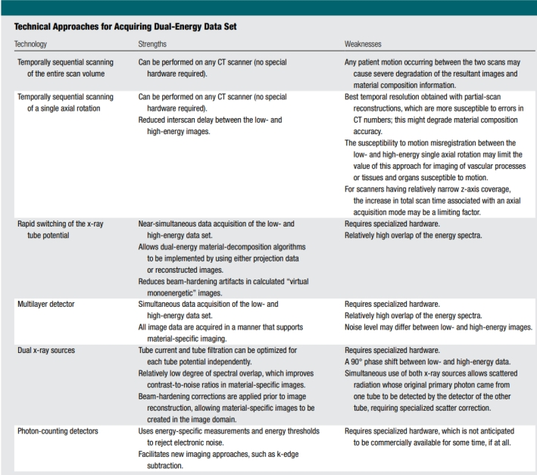

1) Two Temporally Sequential
Evaluates the anatomy of soft tissues such as the liver, as well as the lungs was the main emphasis of the initial applications. The data was collected at each of the two tube potentials using two temporally sequential scans. Patient movement between the two scans, which was not recorded concurrently, severely degraded the final pictures and the information on the material composition. A modified method has been suggested with the aim to minimize the time delay associated with two successive scans of the entire anatomic volume of interest. Specifically, single axial scan (i.e., a single tube revolution) is performed at every single tube possibilities before the table incrementation. The interval amongst scanning of low- and high-energies images is shortened as a result. In this instance, the highest temporal resolution might be achieved through partial scan reconstruction algorithms.
This method collects 180°+ fan projection data for every single tube prospective having a brief lag from shots to allow changing among tube possibilities and tabulation. This method may be beneficial for organs or tissues that are often immobile. Nevertheless, mis-registration of the motion across a minimal and a tinformation of high energy could restrict the application of this technology for dual-energy scanning of tissues, organs, and vascular procedures due to the considerable time intervals among scans. The increase in overall scan duration can potentially be a limiting problem for scanners with a fairly small z-axis coverage.
2) Rapid Switching of X-Ray Tube Potential
The main objective of this technique's clinical application centered on densitometry of bones findings. Nevertheless, the tube's voltage and current could not increase enough rapidly to achieve comparable noise levels in both the high- and low-frequency tube potential knowledge sets. The applicability of this noise difference approach is restricted to bone densitometry. The tube potential must change from the lowest to the higher tube voltage in less than a millisecond in order to be changed across consecutive observations. Furthermore,Frequent shifting is necessary to optimize the energy barrier among the information being measured, despite the fact that the difficulties in swiftly adjusting the radiation source's current can result in either an improper dosage from the higher-energy forecasts or severe aberration values in the low efficient data. Asymmetrical sampling can be used to address this problem for both low- and high-energy forecasts.
By using a longer sample interval for the low-energy information this approach achieves the spike in tubes current-time pairing that is required for accurate low-energy estimations without dramatically raising the tube current. Nevertheless, improving the spectral screening of the pair of low- and high-energy images is exceedingly difficult because the same x-ray tube is used for each collection of data.
In order to avoid decreasing in-plane spatial resolution shortly after assigning a fraction of the samples gathered to every energy's frequency set, extremely rapid data sampling is lastly necessary.Nearly instantaneous data collection of both lowest and high-energies sets of information is made possible by the extremely brief time delay (less than 1 millisecond) between the viewpoints. To eliminate streak artefacts, a correction must be made to the one-view mis-registration; nonetheless approach makes it possible to develop dual-energy material disintegration methods using two-way elongation information or reconstructed images. Using projection data helps reduce beam-hardening artefacts in "virtual monoenergetic" images that are obtained.

3) Multilayer Detector
A third technique for gathering dual-energy CT projection data uses stacked or "sandwich" scintillation detectors with a single higher tube potential irradiation. The first or closest detector layer collects low-energy data, whereas the rear or furthest detector layer collects high-energy data. This is similar to using layered sensors for dual-energy radiography.
Diverse detector diameters are employed to attain comparable noise in both low- and high-energies images. This method has the benefit of concurrently acquiring low- and high-energies data sets, as well as continuously recording data from both the inside and outside detector layers. This enables dual-energy analysis on every data set collected. In other words, the system is constantly in "dual-energy mode."
Approaches to Multi-Energy CT on a Technical Level
Photon-counting Detectors
Photon counting detectors with energy resolution may be the most resilient alternative enabling dual-energy, or multi-energy, collection of data. These detection devices, that allow for distinct photons interactions, are still in development and are not yet economically accessible through CT platforms, although they're employed in the spectral mammography & radiation therapy. Counts are assigned to several groups of energy criteria data by considering the number of energy thresholds chosen and the energy value of each photon. Data related to certain window power usage can be retrieved by removing each energy threshold data. Dual-energy imaging using photon-counting sensors is possible when there are n = 2 energy windows.
Utilising, with pulse-height discrimination, the transmitted x-ray spectrum has been divided into many distinct energy bins, the total amount of which is established by the design of the embedded circuit particular to the application and linked to the energy-resolving detector. The most likely substances for transforming the electromagnetic radiation of an absorbing x-ray into an electrical signal whose amplitude is proportionate to the energy of the photon that enters it are cadmium telluride (CdTe) as well as cadmium zinc telluride. Handling with the high radiation intensities required for CT imaging presents hurdles, even though similar detectors are already on the market and in use in other industries. At the highest x-ray radiation levels used for CT imaging (about 109 counts/sec/mm2), the present detector loses counts owing to spike aggregation effects and may finally become totally paralysed. The accuracy of recorded energy may be reduced by the uneven allocation of a photon's energy throughout many sensor pixels (often referred to as energy splitting) or by the reemission of a characteristic x-ray (commonly referred to as K-escape).
A charging-summing method has been created in which hardware circuits are used to generate contact amongst close detector pixels in order to offset the impacts of charge sharing.
When adjacent pixels have simultaneous frequencies, their charges are added together, and the component with its greatest charge receives the total charge.
Significant gains in wideband performance have been recorded using this method.
Many possible advantages, including enhanced dosage efficiency and spectrum separation, are propelling extensive research and development in this area. For example, photon-counting detectors have a geometrical efficiency that is approximately 30% higher than that of energy-integrating detectors, and counts that are just the result of observable electronic noise can be rejected by applying an energy threshold.
Past the threshold level, electronic noise has no influence on photon counts and only changes the calculated energy of each photon. This detector technique can also do K-edge imaging.
Material Decomposition Algorithms
Multiple or dual energies the skill of CT to dissect a material into its constituent parts is based on the liveliness and element-dependent properties of x-ray attenuation. The main causes of x-ray beam attenuation of matter in the medically spectrum of energies (E, 150 keV) are photoelectric impact along with Compton scattering mechanisms.
That is a smooth and monotone function for components lacking K- or L-edges that's beneficial to diagnostic x-ray imaging. The coefficient of attenuation of a given material can be expressed as an exponential sum of photonic & Compton collisions in the absence of a K- or L-edge.
By simulating the dependence of the photovoltaic & Compton interaction processes on the material density as well as mass (r) and atomic number (Z), r and Z map may be produced and material-specific information can be retrieved.
Because both of these processes of interaction dominate x-ray attenuation, the coefficient of attenuation of every substance may be described as a straight-line sum of the absorption coefficient of two underlying basic substances. The methods employed in the pre-reconstruction (projection) field to build basis material image pairs or r-Z pair pictures were the focus on initial dual energy CT material breakdown research.
Theoretically, the use of projected data can minimize beam-hardening artefacts within reconstructed images. However, beam-hardening distortions might not be totally avoided in practice due to inadequate equipment calibration sessions.
This highlights the necessity of constant system calibration sessions, irrespective of the algorithm's domain (projection or imaging space), that develop a relationship between presenting measurements and acknowledged concentrations of foundation assets, or CT numbers and known depths of fundamental substances.

REFFERENCE
- Johnson, T. R. C. (2012). Dual-energy CT: General principles. AJR. American Journal of Roentgenology, 199(5_supplement), S3–S8. https://doi.org/10.2214/ajr.12.9116
- Kambadakone, A., Andrabi, Y., Patino, M., Das, C., Eisner, B., & Sahani, D. (2015). Advances in CT imaging for urolithiasis. Indian Journal of Urology: IJU: Journal of the Urological Society of India, 31(3), 185. (Hsu, 2014)https://doi.org/10.4103/0970-1591.156924
- Parakh, A., Lennartz, S., An, C., Rajiah, P., Yeh, B. M., Simeone, F. J., Sahani, D. V., & Kambadakone, A. R. (2021). Dual-energy CT images: Pearls and pitfalls. Radiographics: A Review Publication of the Radiological Society of North America, Inc, 41(1), 98–119. https://doi.org/10.1148/rg.2021200102
- Hsu C, Sharma R, Murphy A, et al. Dual energy CT. Reference article, Radiopaedia.org (Accessed on 25 Aug 2023) https://doi.org/10.53347/rID-31353
- Hacking, C., & Hsu, C. (2014). Dual energy CT. In Radiopaedia.org. Radiopaedia.org. https://doi.org/10.53347/rID-31353
- McCollough, C. H., Leng, S., Yu, L., & Fletcher, J. G. (2015). Dual- and multi-energy CT: Principles, technical approaches, and clinical applications. Radiology, 276(3), 637–653. https://doi.org/10.1148/radiol.2015142631
- Sanghavi, P. S., & Jankharia, B. G. (2019). Applications of dual energy CT in clinical practice: A pictorial essay. The Indian Journal of Radiology & Imaging, 29(03), 289–298.

