Quantitative Stability Indicating Bio-analytical Method Development and Validation of Apalutamide - Apalutamide D3 by Using Ultra Performance Liquid Chromatography in Human Plasma
D. China Babu*¹, G. Sai Sri Harsha¹, Goli Venkateswarlu¹, Nem Kumar Jain¹,
M. Alagusundaram¹, SK. Aleesha²
¹School of Pharmacy, ITM University Gwalior, Madhya Pradesh – 474001, India
²Narayana Pharmacy College, Nellore, Madhya Pradesh- 524002, India
*Corresponding Author:
Mr. D. China Babu
Asst. Professor,
Dept. of Pharmaceutical Analysis,
ITM University, Gwalior,
Madhya Pradesh, India.

ABSTRACT
A simple, convenient, specific, precise, and highly conventional stability indicating ultra-performance liquid chromatographic diode array method was developed for the quantification of Apalutamide in human plasma. The phenomenex Luna (100x4.6x5µ) column was used for apalutamide separation, and the mobile phase was composed of 5 mM ammonium fumarate and acetonitrile in a ratio of 15:85 v/v and buffer pH 3.5 was adjusted with glacial acetic acid and detected at 345 nm. The Apalutamide-D3 used as an internal standard, and K2-EDTA used as a coagulant. The liquid-liquid extraction process used for the extraction of drugs from human plasma with tert butyl methyl ether the retention times of Apalutamide and Apalutamide D3 (ISTD) were 1.48 min and 1.97 min, respectively. The assay of the method was validated in human plasma in the concentration range of 307.26-200013.87 pg/ml, with accuracy and precision ranging from 3.86 to 4.87. Recovery studies were found to be 103.79%, 90.93%, and 96.83% for HQC, MQC, and LQC, respectively. The stability of the drug was evaluated in human plasma under different conditions of auto-sampler, freeze-thaw, bench-top, short-term and long term stability studies. The method was proved to be highly sensitive and selective for the quantification of Apalutamide and determined at the picogram level. There was no matrix effect observed, which proved to be a stability indicating method.
Keywords: Apalutamide, Acetonitrile, Di Potassium ethylene diamino tetra acetic acid, High Quality control, Medium Quality control.

INTRODUCTION
Apalutamide is an anti-androgen (Figure 1). The drug's IUPAC name is 4-7-[6-cyano-5-(trifluoromethyl) pyridine-3-yl].Figure 1 depicts -8-oxo-6 sulfanylidine 5,7diazaspiro [3.4] octan-5-yl-2-fluoro-N-methylbenzamide. It demonstrates an antagonistic impact on androgenic receptors. The medication falls under the category of non-steroidal anti-androgens. It is an androgen receptor antagonist of the second generation [Anjaneyulu Reddy et al., 2019]. It is designed to inhibit the androgen receptor-mediated proliferation of prostate cancer cells [Vadim Koshkin S et al., 2018]. Evaluation of the efficacy and safety of apalutamide in high-risk patients with non-metastatic castration-resistant prostate cancer by conducting multicenter phase-2 trials on nm-CRPC patients with a high risk of progression. [Smith MR et al., 2016, Zhou, Z., and Hu.X. Hu, 2018].Men with non-metastatic castration-resistant (nmcr) prostate cancer were evaluated for the efficacy of apalutamide in the development of metastasis in high-risk patients. [Smith MR et al., 2018, Small EJ et al., 2018] They conducted a double-blind, placebo-controlled, phase 3 trial of nmcr prostate cancer and a prostate specific antigen doubling time of 10 months or less in male patients. Patients were administered apalutamide (240 mg per day) or a placebo. The continuation of androgen deprivation therapy for patients.Metastasis-free survival was the primary endpoint [Sandler HM et al., 2016; Rathkopf DE et al., 2017]. Patients with progressive metastatic castration-resistant prostate cancer were evaluated for the efficacy of apalutamide with abiraterone acetate and prednisone [Suresh P Sulochana et al., 2018, Dellis A et al., 2018]. Chemotherpy is more effective in treating CRPC [Ranjan RK et al., 2018; Khan Z.G et al., 2016]. On its related and central molecule of Apalutamide, few analytical methods have been reported [Sandhya Rani J, et al.,2018, Anjaneyulu Reddy R., et al. 2019, Ashok Zukkala et al. 2019, Chinababu D et al 2021, Sai Uday Kiran, G., Sandhya P. 2020].
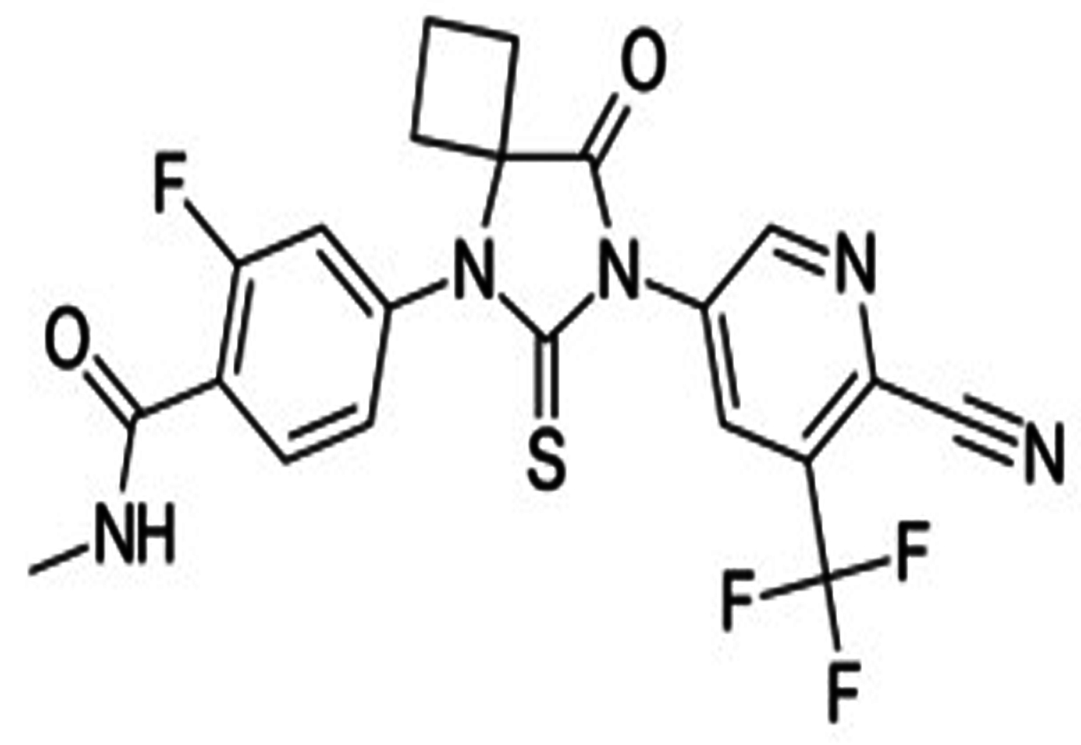

Figure1: Structure of Apalutamide
MATERIALS AND METHODS
Materials and reagents
Ajanta Pharma LTD, Mumbai, India, provided both the apalutamide medication and the apalutamide D3 internal standard. Using milli-Q water purification apparatus acquired from Millipore in Mumbai, India, water for analysis was prepared. Merk in Mumbai, India supplied acetonitrile of HPLC purity. SD fine chem in Mumbai, India, supplied ammonium fumarate, K2-EDTA, tert-butyl methyl ether, and glacial acetic acid of analytical quality. Santhiram Medical College in Nandyal, Andhra Pradesh, India, provided the plasma sample.
Instrumentation
Shimadzu UPLC 2010 CHT (Shimadzu Corporation, Kyoto, Japan) liquid chromatographic system with quaternary pump, column heater, and solvent degasser was used. Phenomenex Luna (100 x 4.6mm x 5) Waters Corporation, Milford, USA, was used for separation. The column temperature was kept constant at room temperature, while the mobile phase flow rate was kept constant at 1mL/min. A photodiode array detector was used to detect the analyte at 345 nm. The auto sampler temperature was maintained at 15℃ and pressure of the system was maintained at 6000 psi.
Methodology
Statistical analysis
The developed method in UPLC was validated to ensure the stability of the analytical method and the consistency of the results. The statistical analysis was performed with one-way variance analysis treatments.
Preparation of standard solution
Apalutamide (1mg/ml) and internal standard Apalutamide D3 standard solutions were prepared in a separate 10 ml volumetric flask in the mobile phase. Apalutamide D3 internal standard, 0.5 µg/ml solution, was prepared by diluting its stock solution with ammonium fumarate: acetonitrile (15:85 v/v). The plasma-spiked working standard solutions prepared for apalutamide range in concentration from 200013.9 pg/ml (STD 1) to 307.3 pg/ml (STD 10).
Quality control samples
Quality control samples of the APA were prepared for the qualitative evaluation of calibration curve. Lower limit of quantification (LLOQ), low quality control (LQC), Middle quality control 1 & 2 (MQC 1 & 2) and high quality control (HQC) has been prepared in drug free plasma and solutions were stored at 4℃.
Extraction of APA from plasma
Before preparation, the plasma samples were frozen at -70 °C and thawed at room temperature. After transferring 200 µl of plasma to the Ria containers, 50 µl of IS working standard solution at 0.5 g/ml was spiked and vortexed for 10 seconds with 100 µl of 2% formic acid. 2.5 ml of tert-butyl methyl ether was added, and the mixture was vortexed for 10 minutes. After 10 minutes of centrifugation at 3000 RPM, the organic layer was transferred to new RIA vessels and dried under a gentle stream of nitrogen gas at 45 °C. After reconstituting the residue with 150 µl of the mobile phase, 10 µl aliquots were injected into the UPLC system.
Preparation of buffer
Ammonium fumarate was prepared as a 1M solution from the 5 mL collected and transferred into a 1000 mL volumetric flask. The volume was filled with water to the mark, and 5 mM ammonium fumarate was obtained.
Mobile phase
Buffer and acetonitrile was taken in the ratio of 15:85 v/v used as mobile phase.
RESULTS & DISCUSSION
Bio-analytical method validation
The validation was performed based on guidance for industry: Bio- analytical method validation from the US-FDA [US FDA Bio-analytical validation guidelines 2001, Smith G,2012, Zakkula A et al.,2019].
Optimised parameters
The separation was obtained with 5 mM ammonium fumarate: acetonitrile in the ratio of 15:85 v/v, buffer pH 3.5 was adjusted with glacial acetic acid and other optimized parameters discussed in Table 1. The standard chromatogram was shown in Figure 2.

Table 1: Optimised parameters of the bio-analytical method
S.No | Parameters | Conditions
1 | Column | Phenomenex Luna (100x4.6x5µ)
2 | Mobile phase | 5mM Ammonium fumarate: acetonitrile (15:85 v/v) and pH 3.5
3 | Column temperature | Ambient
4 | Biological Matrix | Human plasma
6 | Anti-coagulant | K2-EDTA
7 | Flow rate | 1 mL/min
8 | Wavelength | 345 nm
9 | Run time | 3.5 min
10 | Injection volume | 5 µL
11 | Retention time | Apalutamide 1.48 min  Apalutamide D3 1.97min

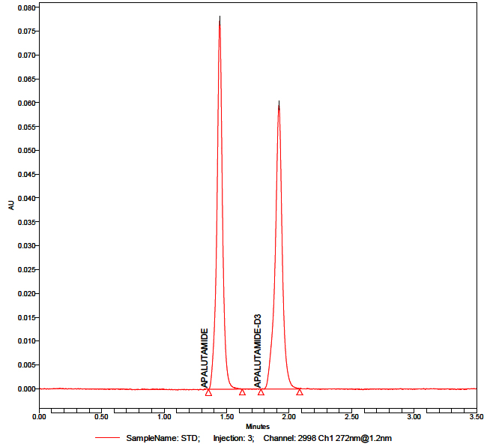
Figure 2: Standard chromatogram of Apalutamide
System Suitability
System suitability of current method was checked by injecting six replicate injections using an aqueous standard mixture equivalent to the MQC concentration of the calibration curve. The validation of the method on each day was started with system suitability as a first experiment.
Specificity/ Selectivity
The method's specificity was determined by analysing standard blanks from various commercial quantities of human plasma. For the experiment's specificity, a separate batch of plasma was analysed. Seven out of ten samples were intended anticoagulant plasma, one contained hemolytic plasma, another contained lipidemic plasma, and one contained heparin as an anticoagulant. At the drug and ISTD retention times, no substantial interferences were observed in the investigated human plasma samples (Figure 1). The peak area of the drug in standard blank samples at the retention time was less than 20.00% of the peak area of the drug in the extracted LLOQ sample; for ISTD, it was less than 5.00%. The standards and quality constraints for the calibration curve were derived from a blank matrix of pooled plasma samples.
Linearity and Quality controls
The linearity of the method was assessed by a ten point standard curve. The weighted least squares regression analysis 1/x² was used for the study of linearity from standard plots associated with a ten point standard curve. All three calibration curves analysed during the course of validation were found to be linear from the standard concentration, ranging from 200013.87 to 307.26 pg/mL, and the regression coefficient value was 0.999. A good linear relationship was shown between the peak area ratios of APA/ISTD.
Recovery studies
The analyte was recovered from the plasma samples was studied at different levels of quality controls of LQC,MQC-2 and HQC. The % recovery values of LQC, MQC-2 & HQC were found 96.83%, 93.90% and 88.65% respectively for apalutamide.
Matrix effect
The matrix effect of UPLC method was determined (Table 2) by using six different lots of chromatographically screened human plasma, with each lot of plasma, sample concentrations equivalent to LQC and HQC of apalutamide solution was prepared and injected triplicate in each other. The mean percentage values were found to be 102.59% & 102.01% for HQC & LQC respectively.
Table 2: Results of Matrix effect proposed UPLC-DAD method
S. No. | QC | HQC (167199.079) | LQC (912.907)
 | Nominal Concentration (pg/mL) | 142119.217– 192278.94* | 730.325 – 1095.48*
 |  | Calculated Concentration (pg/mL) | Calculated Concentration (pg/mL)
Mean |  | 171543.57 | 931.31
SD |  | 7981.61 | 62.20
% CV |  | 4.65 | 6.67
% Mean Accuracy |  | 85.73 | 91.19

Accuracy and Precision
The precision was studied by % CV at different concentration levels corresponding to LLOQ, LQC, MQC1, MQC2 and HQC (Fig.3A- 3E) during the process of validation. The assay was assessed through accuracy by the ratio of the calculated mean values of the quality control samples to their respective nominal values expressed as a percentage. The Within batch and between the batch accuracy and precision was determined and % accuracy values were obtained 90.66%,95,05%,97.56%,98.15% & 93.16% for HQC,MQC-1,MQC-2,LQC & LLOQ. The accepted limits of % accuracy for all QC samples except LLOQ were 85%-115% and 80%-120% for LLOQ. The results were shown in Table 3.
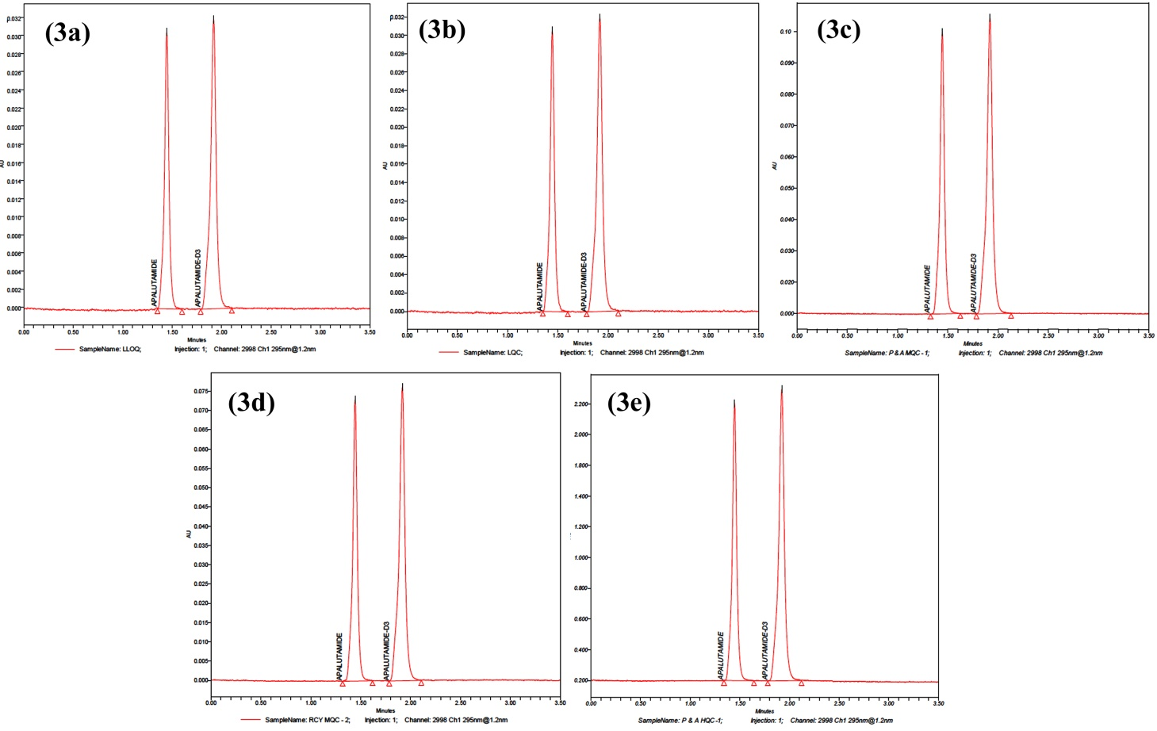
Figure (3a-3e): Representative accuracy & precision chromatograms of LLOQ, LQC, MQC-I, MQC-II & HQC
Table3: Data of Accuracy and Precision for proposed UPLC-DAD method
Nominal Concentration (pg/mL) | HQC  171316.60 | MQC1  102789.96 | MQC2  51394.98 | LQC  868.57 | LLOQ QC  312.687
 | 14561911 – 197014.09* | 87371.47 – 118208.45* | 43685.733 – 59104.2282* | 590.631 – 1042.29* | 250.1496 – 375.224*
Mean | 177297.45 | 110956.96 | 55544.30 | 799.87 | 290.83
SD | 17753.36 | 5449.29 | 2157.49 | 34.64 | 33.95
% CV | 10.01 | 4.91 | 3.8842 | 4.33 | 11.67
% Mean Accuracy  Accuracy | 90.66 | 95.05 | 97.56 | 98.15 | 93.16

$$\% Mean accuracy=\frac{Mean concentration QCs}{Nominal concentration}x 100$$

* The percentage deviation ± 15 % from 100% of nominal concentration for all QC samples except for LLOQ (percentage deviation ± 20 %.
Stability studies
Stability studies were performed to determine the stability of apalutamide and its internal standard in human plasma during sample preparation and sample analysis at different stress conditions. Benchtop stability was determined for the spiked QC samples for a period of 6 hours at room temperature. Short-term stability was studied for QC spiked samples for a period of 21 hours, 40 minutes for the analyte and 21 hours, 30 minutes for the ISTD. Long term stock solution and working standard solution stability of the analyte and ISTD were determined by using a standard equivalent to HQC and LQC concentrations after a storage period of 6 days at 5± 3℃. The freeze-thaw stability of spiked QC samples was determined after the third freeze thaw cycle stored at -28℃ ± 5℃. Auto sampler stability of QC was determined for a period of 54 hours and 6 minutes by storing them in an auto sampler maintained at a temperature of 5℃ ± 3℃. For all stability studies, the concentrations of apalutamide and apalutamide D3 were compared with nominal values.The results were tabulated in Table 4.
Table 4: Results of stability studies of proposed UPLC-DAD method

Stability | QC Level | Mean Measured concentrations (pg/ml); (n=6) |  | % Change | %CV | % Mean stability
 |  | Comparison sample | Stability sample
Auto sampler | HQC | 176633.75±  25310.24 | 184439.23±  8586.55 | 4.42 | 4.66 | 107.65
 | LQC | 809.72±  38.75 | 757.78±  46.58 | -6.41 | 6.14 | 87.24
Bench top | HQC | 170142.07±  23801.80 | 194207.65 ± 4718.00 | 14.14 | 2.71 | 106.11
 | LQC | 834.96±  37.45 | 780.14±  42.56 | -6.56 | 5.45 | 93.43
Freeze-Thaw | HQC | 185805.57±  5921.49 | 177829.18 ±  4342.64 | -4.29 | 2.44 | 95.70
 | LQC | 772.37  ±  37.96 | 774.91  ±  131.30 | 0.32 | 16.94 | 100.32
Short term | HQC | 166454.76  ±  11787.23 | 194363.99  ±  4718.00 | 16.76 | 2.91 | 108.74
 | LQC | 875.30  ±  22.53 | 853.15  ±  94.42 | -2.53 | 2.12 | 106.62
Long term | HQC | 173236.57  ±  21081.57 | 187812.47  ±  14960.47 | 8.41 | 1.69 | 98.65
 | LQC | 923.78  ±  92.30 | 901.63  ±  57.75 | -2.39 | 3.35 | 109.47

$$\% Change=\frac{Mean stability sample-Mean comparision}{Mean comparision}x 100$$

CONCLUSION
Bio-analytical method of Apalutamide by using UPLC
Apalutamide is used for the treatment of urinary bladder cancer. The proposed method was performed in human plasma, and no analytical method was reported on UPLC or LC/MS for this drug.
The bio-analytical method was developed with a suitable solvent system, column, nitrogen evaporator, UPLC system, mobile phases, vacuum pump, and sonicator. The mobile phase was 5 mM ammonium fumarate and 15:85 v/v acetonitrile. The pH was adjusted to 3.5 with glacial acetic acid, which was also used as the mobile phase and to make sample solutions. The λmax was obtained at 345 nm, at this wavelength, total analysis was done. The flow rate of the mobile phase was maintained at 1 ml/min. The retention times were found to be 1.48 min for APA and 1.97 min for ISTD. The system suitability test was performed each day (6 days) % CV values of APA were found to be 0.58–1.67 and 0.29–1.68 for ISTD. Linearity concentrations were found to be 200013.87307.26 pg/mL and the R² value was found to be 0.999. The recovery of the sample from the matrix was studied at HQC, MQC-2 and LQC levels. The % mean recoveries of HQC, MQC-2, and LQC were found to be 88.65%, 93.90%, and 96.83%, respectively. The precision and accuracy of the method have been tested on APA at the levels of HQC, MQC-1, MQC-2, LQC and LLOQC. The matrix effect was studied at HQC and LQC levels, and results were found to be 102.59 and 102.01 for HQC and LQC respectively. The % mean accuracy results were found to be 90.66, 90.05, 97.56, 98.15, and 93.16%, respectively, for HQC, MQC-1, MQC-2, LQC, and LLOQC. The acceptance criterion is % mean accuracy for all QC samples except LLOQ QC, which should be in the range of 85–115%. LLOQ QC is 80–120%. Different stability studies were performed, like freeze-thaw, bench-top, auto-sampler, short-term and long-term stability studies at HQC and LQC levels. The % mean stability of HQC and LQC obtained as 95.70% & 100.32%, respectively, and the bench top % mean stability was found to be 106.11% and 93.43% for HQC and LQC respectively. The auto-sampler % mean stability was 104.41% for HQC and 93.58 for LQC. The % mean stability was obtained for HQC and LQC 108.74% and 106.62% in short term stability and 98.65% and 109.47% in long term stability. The validation parameters of the bioanalytical method passed FDA guidelines.
ACKNOWLEDGEMENT
We heart fully thank to the ITM University ,Gwalior, Madhya Pradesh, India and Ajanta Pharma Ltd for providing Apalutamide API and ISTD.
Funding Support
The authors declared that they have no funding support for this study.
Conflict of Interest
The authors are not declared conflict of interest. The authors are only responsible for content and writing of article.
REFERENCES
Anjaneyulu Reddy, R., et al.2019.A validated stability indicating RP-HPLC method development for anticancer drug Enzalutamide in bulk and pharmaceuticals. Int jour of pharm sci & drug res,85-90.
Ashok Zukkala, et al. 2019. RP-HPLC-UV method for simultaneous Quantification of second generation non-steroidal androgens along with their active metabolites in mice plasma: Application to a pharmacokinetic study. Drug Res, 69: 537-544.
Chinababu, D., Madhusudhana Chetty, C., Mastanamma, SK. 2021. Forced indicating UPLC-DAD method development and validation for estimation of Apalutamide in bulk and in pharmaceutical dosage form. Indian Drugs, 58(09): 73-75.
Dellis, A., Papatsoris, A.G.2018. Apalutamide: The established and emerging roles in the treatments of advanced prostate cancer. Expert Opinion on Investigational Drugs,27(6) :553-559.
Khan, Z.G., et al.2016. Validated RP-HPLC method for Determination of Enzalutamide in Bulk drug and pharmaceutical Dosage form. Indian Drugs, 53(11): 46-50.
Rathkopf, DE., et al.2017. Safety and antitumour activity of apalutamide (ARN-509) in metastatic castration-resistant prostate cancer with and without prior abiraterone acetate and prednisone. Clin Cancer Res, 23: 3544-3551.
Ranjan, RK.,Chandra, A.2018. Apalutamide : a better option for the treatment on non-metastatic castration resistant prostatic carcinoma. Int.J.Basic.Clin.Pharmacol,7(9) :1853-1856.
Sandler, HM., et al.2016. ATLAS:a randomized, double blind, placebo-controlled, phase 3 trial of apalutamide (ARN-509) in patients with high-risk localized or locally advanced prostate cancer receiving primary radiation therapy. J.Clin Oncol ,34: 5087.
Sandhya Rani,J., Devanna,N.2018.Method development and validation of Enzalutamide pure drug substance by using liquid chromatographic technique. Jour of chem pharm sci,1: 5-9.
Small, EJ., et al.2018. MP52 20 patient reported outcomes (PROs) in SPARTAN, a phase 3, double-blind, randomised study of apalutamide (APA) plus androgen deprivation therapy (ADT) Vs placebo plus ADT in men with non-metastatic castration-resistant prostate cancer (nm-CRPC). Journal of Urology, 99: 703-704.
Smith, MR., et al.2016. Phase 2 study of the safety and anti-tumour activity of apalutamide (ARN-509), a potent androgen receptor antagonist, in the high-risk non-metastatic castration-resistant prostate cancer cohort. Eur Urol, 70: 936-970.
Smith, MR., et al.2018.Apalutamide treatment and metastatic- free survival in prostate cancer. N. Engl. J. med, 378: 1408-1418.
Smith, G. 2012. European medicines agency guideline on bio-analytical method validation: what more is there to say?, Bioanalysis, 4(8): 865-868.
Suresh P Sulochana., et al.2018. Validation of an LC-MS/MS method for simultaneous quantitation of enzalutamide, N -desmethylenzulatamide, apalutamide, darolutamide and ORM-15341 in mice plasma and its application to a mice pharmacokinetic study. J. Phar and Biomed Anal,156: 170-180.
US Department of Health and Human Services (2001) Guidance for Industry, Bioanalytical Method Validation, Food and Drug Administration Centre for Drug Evaluation and Research (CDER),Centre for Veterinary Medicine (CVM),BP. Available at: https://www.fda.gov/files/drugs/published/Bioanalytical-Method-Validation-Guidance-for-Industry.pdf
Sai Uday Kiran, G., Sandhya P. 2020. Method development and validation for the analysis of Apalutamide in human plasma by LC-MS/MS. International Journal of Current Research and Review, 14(4): 74-79.
Vadim Koshkin, S.,Eric Small,J.2018. Apalutamide in the treatment of castrate-resistant prostate cancer: evidence from clinical trials. Ther adv in urol, 10(12) :445-454.
Zakkula, A., et al.2019.RP-HPLC UV method for simultaneous quantification of second generation non-steroidal antiandrogens along with their active metabolites in rat plasma: Application to a pharmacokinetic study. Drug Res, 6(10): 537-544.
Zhou, Z., Hu.X. 2018. PCN-153-Cost effectiveness analysis of apalutamide for treatment in non-metastasis castration-resistant prostate cancer. Value in Health, 21(3): S40-S41.

