Redefining Supramolecular Applications: Functionalized Calix[4]pyrroles as Versatile Building Blocks
Bhargav Dave, Keyur Bhatt*
Department of Chemistry, C.U. Shah University, Wadhwan-363001, Gujarat, India
Department of Chemistry, Ganpat University, Kherva-384012, Gujarat, India

Supramolecular chemistry has emerged as a fascinating field, enabling the design and synthesis of intricate molecular architectures for diverse applications. Among these, functionalized Calix[4]pyrroles have gained significant attention due to their unique structural features and versatile supramolecular properties. This abstract highlights the diverse applications of functionalized Calix[4]pyrroles in the realm of supramolecular chemistry. Functionalized Calix[4]pyrroles possess a cup-shaped macrocyclic structure with an intrinsic ability to host a variety of guest molecules within their hydrophobic cavities. This property has paved the way for their utilization as molecular receptors in the selective recognition and binding of analytes such as ions, small molecules, and biomolecules. The precise tailoring of functional groups on the macrocycle periphery allows for fine-tuning of host-guest interactions, leading to enhanced binding affinities and selectivity.

Keywords: Supramolecular Chemistry, Calix[4]pyrrole, Nanomaterial, Anion and cation Sensors
Corresponding author: Keyur Bhatt (kdb01@guni.ac.in)

Calix[4]Pyrrole for sensor of Nanoparticles

The development of nanosensor systems for the rapid identification of cations, anions, biomolecules, threat (or weaponized) agents such as chemical and biological warfare materials, radioactive/nuclear materials, and explosives is extremely beneficial to society (1,2). Coleman et al. demonstrate the discrimination of different animal species on silver nanoparticles using variable temperature fluorescence spectroscopy. The calixarenes that act as a anionic sensor are used for the trapping of silver nanoparticles. Fluorescence spectroscopy method is used to evaluate the site of attachment of the particles to the different serum albumins (3). Haibing Li et al. synthesized modified gold nanoparticles (pSC6-AuNps) Infrared spectroscopy, ultraviolet-visible spectroscopy, transmission electron microscopy, and other techniques were used to characterize aqueous media modified by p-sulfonato-calix[6]arene (4). The pSC6-AuNps proved to be a colorimetric probe for detecting the isomer of diaminobenzenes (DABs). Because of the intense surface plasmon absorption band centered at 520 nm, the pSC6-AuNps are red in solution. DABs bridge the nanoparticles via electrostatic interaction and a host-guest interaction bridge, which induces nanoparticle aggregation and results in a deep purple colour due to the broadening of the surface plasmon absorption band caused by the aggregation. The sensitivity of pSC6-AuNps to other amines, such as o-diaminobenzene, o-nitroaniline, m-nitroaniline, p-nitroaniline, o-chloroaniline, p-chloroaniline, o-toluidine, m-toluidine, p-toluidine, and aniline, was discovered (5,6). Gold nanoparticles are a type of colorimetric transducer that exhibits a bright red colour due to surface plasmon resonance absorption. Paul et al. employ a calixarene derivative with a dithiocarbamate unit to produce gold nanoparticles (7,8). In the presence of Co(II) ions, these gold nanoparticles exhibit naked eye contact, i.e., a distinct colour change from pink to blue. Moreover, these nanoparticles have been employed for electrochemical detection of Co(II) in aqueous media. Extremely stable silver nanoparticles produced in aqueous solutions using a one-pot procedure were modified using p- sulfonatocalix[n]arene (n = 4, 8). These p-sulfonatocalix[4]arene modified silver nanoparticles demonstrated an unique colorimetric probe for optimal (a pesticide) with a detection limit of up to 10⁻⁷ molar (9,10). (Fig. 1.1)

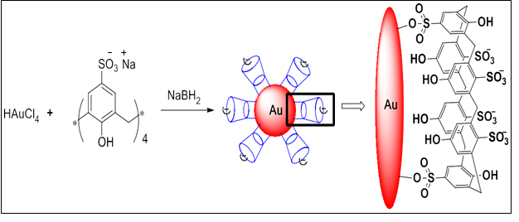
Figure 1.1 para-sulfonatocalix[6]arene - Gold Nanoparticles.

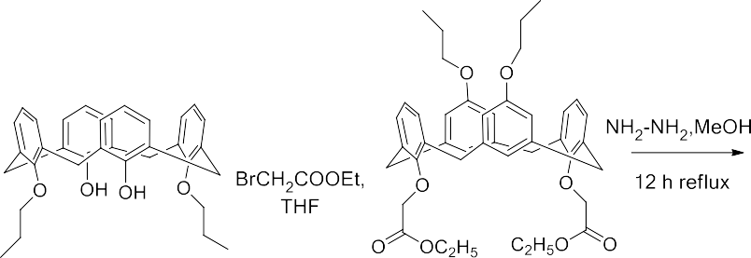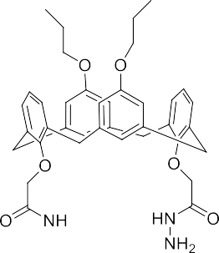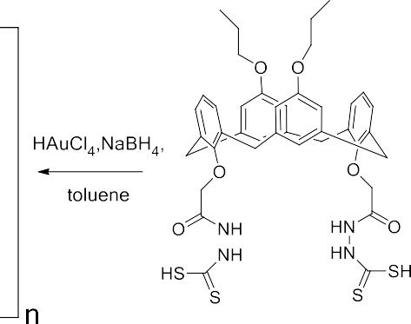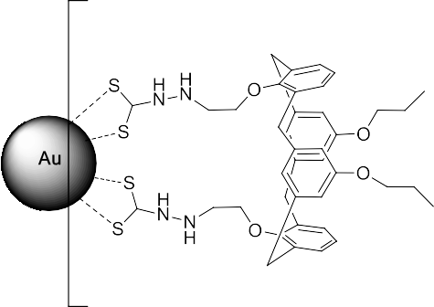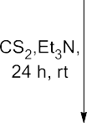
Figure 1.2 Synthesis of Calixarene functionalized gold nanoparticles

Jain et al. used calix[4]arene polyhydrazide (CPLH) as both a reducing and capping agent to create water stable gold nanoparticles. UV/vis, particle size analyzer (PSA), and transmission electron microscopic analysis were used to evaluate the calix[4]arene polyhydrazide reduced gold nanoparticles (CPLH-AuNps). The results demonstrated the remarkable stability of CPLH-AuNps in aqueous solution over time and at different pH levels. Furthermore, CPLH-AuNps have been studied for use as a "switch off" fluorescence sensor for Hg[II] ion. (Fig. 1.2). A concentration of Hg[II] ion in the limit of 10 nanomolar to 10 micromolar can be sensed by the decresing in the fluorescence intensity by the CPLH-AuNps (11,12). (Fig. 1.3)

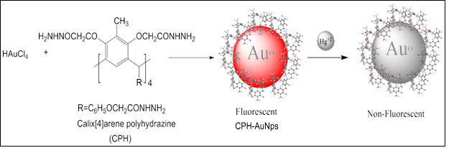
Figure 1.3 Graphical image of fluorescence quenching of Functionalized AuNPs in presence of Hg2+

Jain et al. previously described the production of water dispersible stable gold nanoparticles (AuNps) utilising calix[4]pyrrole octa-hydrazide (CPOH) as a reducing and stabilising agent. Only Co(II) ions, out of all the metal ions studied, produce a sharp colour change from ruby red to blue that is plainly detectable with the naked eye. Because CPOH-AuNps are fluorescent in nature, they have a high sensitivity and selectivity for Co(II) ions. Co(II) ions can be identified selectively at very low concentration levels of 1 nanomolar using a simple fluorescence quenching method (13). (Fig. 1.4)
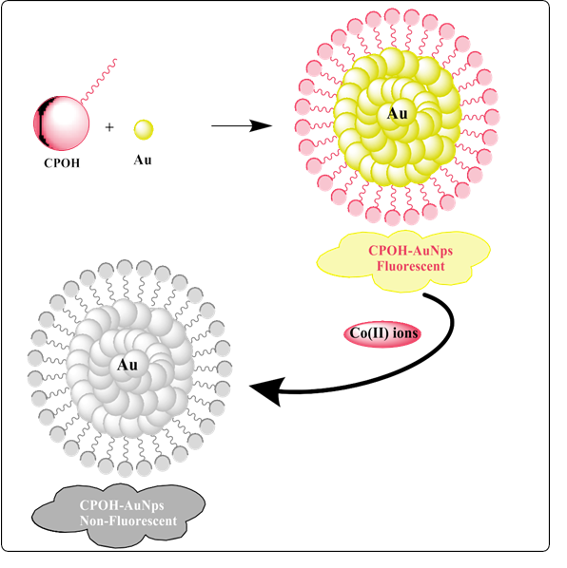
Figure 1.4 Schematic explanation of fluorescence enhancement of Functionalized- AuNps with Co(II) ions
- Calix[4]pyrole as cationic sensor
The first tetrapyrrole macrocycle, meso-Octamethyl calix[4]pyrrole, which was produced by Baeyer and reported by Sessler and colleagues, forms compounds in both the solution and solid states. Polasek et al. demonstrated the interaction of meso-octamethylcalix[4]pyrrole with the Cs+ ion using the ESI-MS technique. Cesium dicarbollylcobaltate (Cs+DCC-) is formed in the gas phase by the combination of 39 and Cs+DCC- in acetonitrile/chloroform (1:1). Whereas the peak at m/z 561 indicates the presence of the cationic complex that, when collisional activated, dissolved into neutral calix[4]pyrrole and a univalent charge on the cesium ion Cs, the signal at m/z 133 in ESI-MS indicates the presence of the Cs+ cation (14).
Majid et al. effectively constructed an ionophore based on meso-octa methylcalix[4]pyrrole (OMCP) as a selective membrane electrode for Ti3+. In the precise detection of Ti3+ ions from waste and tap water samples, the suggested sensor functions as accurate and selective. Investigating TiOH2 interaction +'s with OMCP involved using the DFT. The data obtained demonstrated TiOH2+ coordination with OMCP, indicating their powerful and focused interaction. The repeatability of the synthesized receptor with a response time of 25 seconds was better in around 3 months. The receptor demonstrated accurate analytical performance in sensing of Ti3+, even in smaller levels and in the presence of other interfering ions.
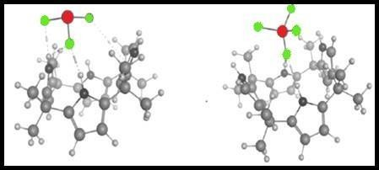
De Namor's investigation of the calix[4]pyrrole receptor revealed interactions with As(III) and As (V). Calix[4]pyrrole receptor synthesis was accomplished in a single reaction step. Synthesized receptor helps to selectively feel and remove As(III) and As(V) from water (Fig. 2.1). Actual water samples were taken from various contaminated areas, and more than 85% of the arsenate ions were taken out (15).

Figure 2.1 CP complexed with arsenite andarsenate

In acetonitrile medium, Angela created meso-tetramethyl-tetrakis-(4-N,N-diethylacetamidephenoxymethyl)calix[4]pyrrole(CPA) with both cationic sites. F. Danil In order to create a mercury-selective electrode, the synthesised receptor interacts as 1:1 complexes with other metal ions while forming a 1:2 complex with Hg(II) ions (ISE). The invention of an analytically applicable mercury sensitive electrode for quantitative measurement was made possible by the ability of the Hg(II) ion to be selectively recognized even in the presence of other cations. (16)

By the condensation and cyclization of dialkyldipyrromethanes with p-nitro-acetophenone under the influence of an acid catalyst, Ying Han and colleagues created a series of disubstituted calix[4]pyrroles. By observing a significant shift in the absorption spectra after introducing Zn2+ ions to the receptor [67], spectroscopy research demonstrates that the receptor is preferentially responsive to Zn2+ ions. A 1:1 complex formation conforming to a Zn2+ selective electrode was also demonstrated by the mole ratio and stochiometric response.
Hemangini et al. created a novel fluorescent receptor called calix[4]pyrrole-N-(quinoline-8-yl) acetamide (CAMQ) that has a pyrrolic ring connected via the meso-position. Even at low concentrations, the receptor had improved selectivity for Pb(II) and Cu(II) ions in DMSO. When Pb(II) and Cu(II) were exposed to receptors, there was a turn-off of the fluorescence, which resulted in the production of a metal complex. Even in the presence of other metal ions, the receptor specifically senses them (17). (Fig. 2.2)
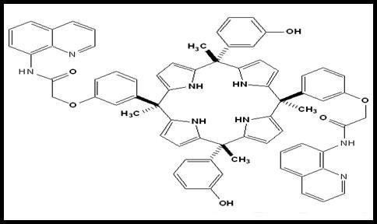

Figure 2.2 Quinoline modified Calix[4]pyrrole

Hemispheroid strapped calix[4]pyrrole, an ion pair receptor that preferentially recognizes and extracts LiNO3 in both solid-liquid and liquid-liquid conditions even in the presence of NaNO3 and KNO3 selectively, has been created by Qing He et al. Even in the presence of other ion pairs like sodium nitrite and potassium nitrite in both solid and liquid conditions, the synthesized receptor exclusively detects and extracts the ion pair of lithium nitrate. Lithium salts can form 1:1 complex in both solid and organic forms, according to DFT research (18). (Fig. 2.3)

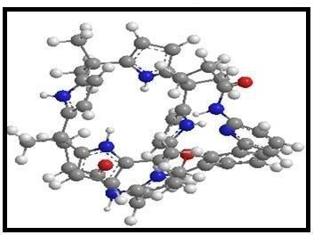 Figure 2.3 Hemi strapped calix[4]pyrrole

3. Calix[4]pyrrole based anion sensor
Yongjun carried out the calix[4]pyrrole-based boradiazaindacene dye synthesis. In the presence of tetra ammonium ions, dye binds specifically to the F ion. With regard to fluoride salts, the receptor displayed red shifts in absorbance, quenching in fluorescence spectroscopy, and downfield shifts of NH signals in NMR spectroscopy. Due to their cation size and ion pairing, Youngjun measured the association of various salts and discovered that they were in the following order: KTMA+ > KTEA+ > KTBA+. He hypothesised that the F tetraalkylammonium cations were positioned upper and lower in a bowl-shaped calix[4]pyrrole cup to an ion pair complex, respectively[68-69]. (Fig. 3.1). Further investigation revealed a 90 nm red shift in the absorption spectrum, a quenching of the fluorescence, and a change in colour from fuchsia to purple (19).
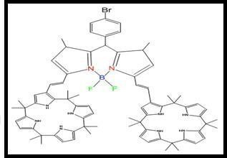
Figure 3.1 Calix[4]pyrrole Dye

Tanaji K. Ghorpade et al. have created a substituted octamethylcalix[4]pyrrole receptor that use both colorimetric and fluorometric techniques to selectively bind an anion. For the large-scale production of iodo-octamethyl calix pyrrole an effective and affordable approach has been established. While no changes were seen for other anion, selective anion like fluoride, cyanide, phosphate, and acetate showed a decrease in emission intensity as well as a change in colour. Furthermore, when CN- ion was added, a stark difference in hue was seen, suggesting the presence of a CN- ion sensor. Up to 1.15 ppm and 0.025 ppm of anion could be visually detected under visible and UV light, respectively (20).

By creating complexes, Valderry et al. created a calix[4]pyrrole macro tricyclic that can specifically bind two cyanide or chloride ions as TBA ion pairs. In the cascade-like arrangement of the ion pairs in the metal receptor complex binding, one pair bind tightly to geometry while the other pair stays apart (21).

Derivatives were produced in one step by He et al.. A remarkable selectivity of the receptor towards the fluoride ion in the chloroform solvent system is revealed by a UV and 1H NMR spectroscopy analysis. Stoichiometric complexes with a ratio of 1:1 (ligand: anion) are formed (22).
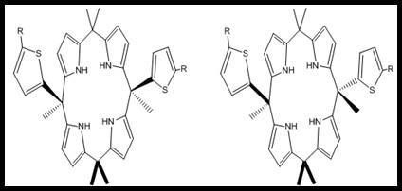
Kumar et al synthesized isomeric (cis a and trans b) “two- walled”calix[4]pyrrole receptor with a thiophene ring attached to it. (Fig. 3.2). Binding strength of isomeric calix[4]pyrroles with halide anion were investigated through NMR, mass spectrometry and computational methods in gas phase. Among halide ion F⁻ anion bounded strongly Shifts in thiophene protons were observed in NMR titrations indicating contribution of thiophene rings. In both gas as well as solution phase anion gets stabilize via anion−π interactions of thiophene ring. F⁻ anion binds strongly forming 1:1 stoichiometric complex formation.

Figure 3.2 Cis and Trans Isomers of calix[4]pyrrole

Ritwik Samanta et al. have synthesized four novel calix[4]pyrroles using the ortho-linkage of aromatic components and a naphthalene-derived fluorescent receptor with the shortest strap conceivable. Isothermal titration, 1H NMR, and fluorescence spectroscopic analysis all showed that the synthesized receptor had a strong affinity for the fluoride ion (23). (Fig. 3.3)
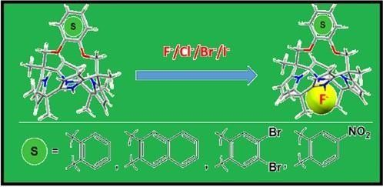
Figure 3.3 Calix[4]pyrrole binds with anion
Andreia S. Farinha synthesized new chromogenic anion molecular probes possessing a mixture of isomer at the calix[4]pyrroles with two formyl ethenyl groups via Knoevenagel reactions. Spectroscopic techniques as well as NMR technique shows formation of 1:2 complexes with high affinity. A drastic colour change was observed on addition of fluoride ion showing it to be selective anion sensor (24). (Fig. 3.4)
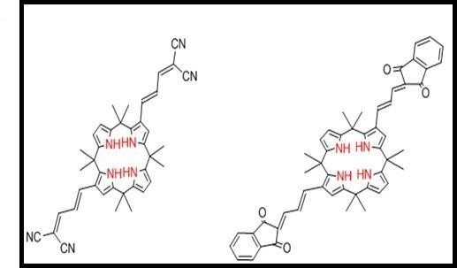
Figure 3.4 Formyl ethenyl-substituted Calix system
Sung Kuk Kim created a cryptand-like compound based on calix[4]-pyrroles that has a remarkable affinity for sulphate anion in organic media. For other anion as compared to fluoride ion, a considerable anion binding as well as higher selectivity was reported. Strong binding interaction between and with sulphates in an organic solvent. The bipyrrole unit's participation in anion binding is Figure 1.40 Graphical abstract : Extrction of anion from the Solution thought to be the cause of the high affinity. Comparative to calix[4]pyrrole, hydrophilic sulphate anion extraction from aqueous media was improved tenfold (25).
Research demonstrates that the cis isomer is more tightly attached to the anion than the trans isomer is through hydrogen bonds and anion interactions. The results of a binding research further show that the trans isomer responds to anions more selectively than the cis isomer and exhibits cross reactivity as well as a greater affinity of 105-106 M1. There were two-fold anion contacts via pyrrole side arms to anion binding in cis and only trans-1 isomer connection with receptor-anion complex. More research is needed due to this unknown divergence of the calix[4]pyrrole isomeric receptor's binding mechanism (26). (Fig. 3.5)

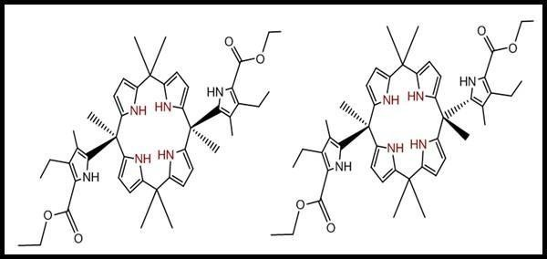

Figure 3.5 Meso substituted hexa-pyrrolic calix[4]pyrrole

By using tetrel bonding, Bauza et al. created calix[4]pyrrole attached with four silicone group. Receptor research revealed anion selectivity. Due to the additional +ve potential provided by four -holes of the Si atoms, which mostly point towards the receptor cavity, the binding investigation demonstrated that receptors with four -SiF3 groups are able to sum up halides and pseudohalides more successively than parent receptors (Fig-3.6) (27).

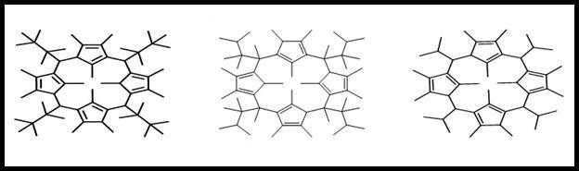
Figure 3.6 Receptors having SiF₃.

shows the sensing between nitrate oxo-anion (biologically relevant) and “two-wall” aryl extended calix[4]pyrroles. An excellent ion transports activity via lamellar membrane was shown by “two-wall” aryl-extended calix[4]pyrroles. The receptor forms a tetrapyrrolic core of calix[4]pyrrole by one of oxygen atom of nitrate anion with four hydrogen bonds and rest two oxygen of nitrate interacts with aromatic walls of calix[4]pyrrole. A selective transport of nitrate anion over other makes receptor remarkable in various biological processes (28).
The two novel isomeric strapped calix[4]pyrroles that Samanta et al. created have diether straps that operate as fluorescence units fluorometric units, which improves selectivity and sensitivity towards anions. The 2, 3-dihydroxynaphthalene-derived receptor among the two manufactured isomeric strapped units displayed sensitivity to the chlorine ion, whereas the 2, 7-analogue-derived receptor displayed sensitivity to the fluorine ion (23).

A novel receptor of calix[4]pyrrole moiety with an electro polymerizable EDOT substituent that specifically senses halide ions from acetonitrile medium was synthesized and described by Abdullah Aydogan et al. The ability of the receptor to sense fluoride ions within a detection limit of 0.1 ppm was demonstrated by testing it in both solid and solution states (Fig. 3.7). The best receptor for sensing halide ions in low concentrations has been designed, and it is inexpensive and simple to make (29).

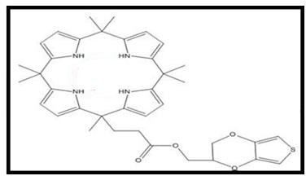
Figure 3.7 Calix[4]pyrrole with EDOT

Conclusion
In conclusion, functionalized Calix[4]pyrroles represent a versatile class of supramolecular molecules with diverse applications in sensing, drug delivery, and catalysis. The ability to tailor their structural and functional properties offers exciting prospects for advancing the field of supramolecular chemistry and addressing challenges in various scientific and technological domains. Continued research into the design, synthesis, and characterization of these molecules will undoubtedly lead to further innovations and applications in the future.
References
1. Hu Z, Deibert BJ, Li J. Luminescent metal–organic frameworks for chemical sensing and explosive detection. Chem Soc Rev. 2014;43(16):5815–40.
2. Sharma M, Sharma B, Gupta AK, Pandey D. Recent developments of image processing to improve explosive detection methodologies and spectroscopic imaging techniques for explosive and drug detection. Multimed Tools Appl. 2023 Feb 10;82(5):6849–65.
3. Tauran Y, Brioude A, Kim B, Perret F, Coleman AW. Anionic calixarene-capped silver nanoparticles show species-dependent binding to serum albumins. Molecules. 2013;18(5):5993–6007.
4. Niu Z, Liu Y, Li X, Zhu H, Zhang M, Yan K, et al. Colorimetric detection of sulfamethazine based on target resolved calixarene derivative stabilized gold nanoparticles aggregation. Microchimica Acta. 2022;189(2):71.
5. Tauran Y, Kim B, Coleman AW. Bio-applications of calix [n] arene capped silver nanoparticles. J Nanosci Nanotechnol. 2015;15(9):6308–26.
6. Zhang F, Sun Y, Tian D, Shin WS, Kim JS, Li H. Selective molecular recognition on calixarene-functionalized 3D surfaces. Chemical Communications. 2016;52(86):12685–93.
7. Abd Karim NFN, Supian FL, Musa M, Ayop SK, Azmi MSM, Yazid MD, et al. Calixarene Derivatives: A Mini-Review on their Synthesis and Demands in Nanosensors and Biomedical Fields. Mini Rev Med Chem. 2023;23(6):734–45.
8. Tshikhudo TR, Demuru D, Wang Z, Brust M, Secchi A, Arduini A, et al. Molecular recognition by Calix [4] arene‐modified gold nanoparticles in aqueous solution. Angewandte Chemie International Edition. 2005;44(19):2913–6.
9. Menon SK, Modi NR, Pandya A, Lodha A. Ultrasensitive and specific detection of dimethoate using a p-sulphonato-calix[4]resorcinarene functionalized silver nanoprobe in aqueous solution. RSC Adv. 2013;3(27):10623.
10. Makwana BA, Darjee S, Jain VK, Kongor A, Sindhav G, Rao M V. A comparative study: Metal nanoparticles as fluorescent sensors for biomolecules and their biomedical application. Sens Actuators B Chem. 2017;246:686–95.
11. Vyas DJ, Makwana BA, Gupte HS, Bhatt KD, Jain VK. An efficient one pot synthesis of water-dispersible calix [4] arene polyhydrazide protected gold nanoparticles-A “turn off” fluorescent sensor for Hg [II] ions. J Nanosci Nanotechnol. 2012;12(5):3781–7.
12. Makwana BA, Vyas DJ, Bhatt KD, Jain VK, Agrawal YK. Highly stable antibacterial silver nanoparticles as selective fluorescent sensor for Fe3+ ions. Spectrochim Acta A Mol Biomol Spectrosc. 2015;134:73–80.
13. Bhatt KD, Vyas DJ, Makwana BA, Darjee SM, Jain VK. Highly stable water dispersible calix [4] pyrrole octa-hydrazide protected gold nanoparticles as colorimetric and fluorometric chemosensors for selective signaling of Co (II) ions. Spectrochim Acta A Mol Biomol Spectrosc. 2014;121:94–100.
14. Escobar L, Sun Q, Ballester P. Aryl-Extended and Super Aryl-Extended Calix [4] pyrroles: Design, Synthesis, and Applications. Acc Chem Res. 2023;56(4):500–13.
15. de Namor AFD, Al Hakawati N, Abou Hamdan W, Soualhi R, Korfali S, Valiente L. Calix [4] pyrrole for the removal of arsenic (III) and arsenic (V) from water. J Hazard Mater. 2017;326:61–8.
16. Danil de Namor AF, Abbas I, Hammud HH. A new calix [4] pyrrole derivative and its anion (fluoride)/cation (mercury and silver) recognition. J Phys Chem B. 2007;111(12):3098–105.
17. Bhatt KD, Shah HD, Panchal M. A switch‐off fluorescence probe towards Pb (II) and cu (II) ions based on a calix [4] pyrrole bearing amino‐quinoline group. Luminescence. 2017;32(8):1398–404.
18. Xie J, Feng W, Lu P, Meng Y. Theoretical study on halide anion recognitions by pyrrole-and benzene-strapped calix [4] pyrroles. Comput Theor Chem. 2013;1007:1–8.
19. Lv Y. SPECTROSCOPIC STUDY OF EFFECTS OF TETRAALKYLAMMONIUM CATIONS ON F--SENSING PROPERTIES OF CALIX [4] PYRROLE BORADIAZAINDACENE DYE. Quim Nova. 2016;39:832–5.
20. Ghorpade TK, Patri M, Mishra SP. Highly sensitive colorimetric and fluorometric anion sensors based on mono and di-calix [4] pyrrole substituted diketopyrrolopyrroles. Sens Actuators B Chem. 2016;225:428–35.
21. Valderrey V, Escudero‐Adán EC, Ballester P. Highly cooperative binding of ion‐pair dimers and ion quartets by a bis (calix [4] pyrrole) macrotricyclic receptor. Angewandte Chemie International Edition. 2013;52(27):6898–902.
22. He YC, Pan JG. Meso-piperidine calix [4] pyrrole: synthesis, structure and ion binding studies. Tetrahedron. 2015;71(42):8208–12.
23. Samanta R, Kumar BS, Panda PK. Calix [4] pyrroles with shortest possible strap: Exclusively selective toward fluoride ion. Org Lett. 2015;17(17):4140–3.
24. Farinha ASF, Fernandes MRC, Tomé AC. Chromogenic anion molecular probes based on β, β’-disubstituted calix [4] pyrroles. Sens Actuators B Chem. 2014;200:332–8.
25. Kim SK, Lee J, Williams NJ, Lynch VM, Hay BP, Moyer BA, et al. Bipyrrole-strapped calix [4] pyrroles: strong anion receptors that extract the sulfate anion. J Am Chem Soc. 2014;136(42):15079–85.
26. Chang KC, Minami T, Koutnik P, Savechenkov PY, Liu Y, Anzenbacher Jr P. Anion binding modes in meso-substituted hexapyrrolic calix [4] pyrrole isomers. J Am Chem Soc. 2014;136(4):1520–5.
27. Bauzá A, Ramis R, Frontera A. Computational study of anion recognition based on tetrel and hydrogen bonding interaction by calix [4] pyrrole derivatives. Comput Theor Chem. 2014;1038:67–70.
28. Adriaenssens L, Estarellas C, Vargas Jentzsch A, Martinez Belmonte M, Matile S, Ballester P. Quantification of nitrate− π interactions and selective transport of nitrate using calix [4] pyrroles with two aromatic walls. J Am Chem Soc. 2013;135(22):8324–30.
29. Aydogan A, Koca A, Şener MK, Sessler JL. EDOT-functionalized calix [4] pyrrole for the electrochemical sensing of fluoride in water. Org Lett. 2014;16(14):3764–7.

