CAR PARKING SYSTEM USING IOT
¹Mr Muppidi Mahesh,²T. Chandana Sai
¹Assistant Professor, ²UG Scholar
^{1,2}Department of CSE(AI&ML)
¹mahigoud521@gmail.com,
Vignan Institute of Technology and Science
ABSTRACT
In today's crowded cities, finding a parking space can be exceedingly challenging. There are too many automobiles on the road but not enough parking spots. One of the biggest problems is arriving at a parking spot only to discover there are no available places. Another significant problem is the challenge we have while trying to find an empty parking space after entering a big parking lot. These two problems may have periodically troubled us all, squandering time. We developed the "Car Parking System Project" to address this problem. This project enables drivers to park their cars effectively and swiftly by providing precise information regarding parking space availability.
Keywords: Arduino, Bluetooth, Parking system, Internet of Things
1. INTRODUCTION
Concerning identity The Internet of Things (IoT) concept first appeared in communication devices. The devices may be handled, monitored, or tracked using distant computers linked to the Internet. By facilitating communication between networks of devices and actual objects, or "Things," or real objects, IoT increases the usage of the Internet. The two key keywords in IoT are "things" and "internet". The phrase "Internet" refers to a massive global network of servers, computers, tablets, and mobile devices that are connected through commonly used connecting systems and protocols. Information can be transmitted, received, or communicated thanks to the internet. In English, the word "thing" has several different meanings. The word "thing" can be used to refer to a tangible object, an action or idea, a situation or an activity when we don't want to be precise. IoT, in general, is a network of connected physical objects and gadgets. A large number of these items have the capacity to collect data from remote areas and communicate with the units in charge of gathering, organising, and interpreting the data for use in procedures and services. It paints a picture of a world in which commonplace items (like clothing, watches, alarm clocks, home appliances, and other things around us) behave intelligently and come to life thanks to tiny devices that have been implanted and can sense, compute, and communicate with nearby objects or people as well as with objects or people in other parts of the world.
The demand for transport is growing at an alarming rate in tandem with the population growth rate. During rush hour, most areas are too crowded. The number of automobiles on the roadways is rising in order to match the demand. The absence of a suitable parking system, however, is the most important issue. Most people block the roadway and roadside area by haphazardly and randomly parking their cars. People still use manual parking methods, which allow them to park their vehicles anywhere they like and disregard all rules. Moving cars via the arrival and exit points becomes difficult; eventually, due to a shortage of space, cars may collide against each other, causing damage. It results in money being wasted on restoring the damaged car, and a massive traffic bottleneck also causes misery for bystanders. It takes a lot of time and effort in a standard parking system to locate a vacant parking space in the lowest amount of time. Most significantly, there is no vehicle security in this sort of parking system, where cars are parked on both sides of the highway. In this regard, a system for automatic cars based on RFID is created. An automated automobile parking system is a mechanical device that is methodically utilised to park cars in order to minimise the volume or area required. It is an autonomous vehicle manoeuvring device that moves the car from a specific location to a parking space to execute various parallel, perpendicular, or angle parking systems. Automated car systems have ambitions to increase driving comfort in circumstances when the driver needs to use a lot of judgement and skill [1]. The parking spaces in the system we created for cars can rotate from their starting position and return to it after the car is parked or removed. It is an RFID-based horizontal rotating parking system. Every car has a unique identification, and for a single RFID card, an RFID reader will verify the card and show the available parking slot to LED. RFID is a wireless technology for communication that allows tagged objects or persons to identify, and it ensures entry to the parking lot for only approved individuals [2]. It then permits the automobile to move into the available parking space. Additionally, since cars don't require any turns or angles in the path, a significant amount of area is saved.
2. MOTIVATION
The parking system is not considerably evolving in response to the rising number of automobiles. There is always a rush at peak hours in the majority of commercial locations, including shopping malls, amusement parks, hospitals, residential neighbourhoods, and offices. Many of the vehicles arrive in the parking lot at the same time. As a result, it becomes challenging for automobile owners to park their vehicles on time, which results in time wastage and complete lack of security. These increase car owners' awareness of the importance of keeping their vehicles safe and secure. The worry of cars being stolen pervades present situations. As a result, it has grown into a serious problem that can be fixed by creating this system. Therefore, this parking system was created to lessen car owners' discomfort and to safeguard the automobiles. It can quickly have a positive impact and make significant improvements. The following are a few noteworthy advantages: i. The quickest possible time to find an empty stopping space. ii. To lessen the clogged traffic caused by looking for parking spots. iii. To keep the cars in the parking lot in the strictest of security. iv. Because this system functions effectively, there is no need to worry about any obstacles, car collisions, or damage.
3. RELATED WORKS
Using a combination of the Wireless Sensor Network (WSN), RFID, Adhoc Network, and the Internet of Things, [3] seeks to provide safe and intelligent parking tracking, control, and management systems. The automatic parking system in [4] is created and put into use using RFID and passcode technology. A three-story parking tower and two slots per floor on either side were included in the central elevator's amenities. One application of radio frequency that raises reliability and safety problems is the use of RFID technology to control the entrance and exit points of parking lots. The central elevator was equipped with a three-story parking structure and two slots on either side of each floor. One of the uses for radiofrequency identification technology (RFID) that raises serious safety and reliability concerns is the control of parking entry and departure points. This system's eight stages for achieving precision are discussed in [5]. The I.D. must first be added to a tag before being assigned to a vehicle. The second phase involves deciphering the RFID tags. Searching through the tags is the third stage. The decision to open the door is made in the fourth phase. In the fifth step, the camera takes a picture of the car and saves it until the start time. Opening the door and changing the light to green constitute the sixth stage. Phase 7 uses the loop sensor to inspect the area beneath the gate arm. Finally, the gate is shut and the light is turned red. The system in [6] uses contemporary communication and control systems for Intelligent Infrastructure for Vehicles (I2V), based on the Hall Effect sensor for very accurate vehicle speed readings and RFID technology to recognise road transport signs.
4. HARDWARE COMPONENTS

A solderless breadboard serves as a flexible work surface for building electronic circuits without the need of solder. It has tiny holes in which electronic components, such as cables, resistors, and LEDs, can be put. With these components, it is simple to connect and test out your circuit ideas due to how snugly they fit.
The ATmega328P microcontroller is the foundation of a microcontroller board known as the Arduino Uno.With both digital and analogue input/output connections, it enables simple interface with a variety of sensors, actuators, and electrical components. Programmers can create and upload code to the device using the Arduino IDE to change how it behaves.
IR SENSORS: IR (Infrared) sensors are widely used to detect the presence or absence of objects, obstructions, and environmental changes. They work by transmitting and receiving infrared radiation, which is invisible to the human eye but can be detected by the sensor.
The SG-90 servo motor is a popular servo motor. It is a small, lightweight servomotor of a specific brand that can rotate an output shaft to a predetermined angle. It functions by absorbing electrical impulses that instruct it where to go, often in the form of pulses.
LCD DISPLAY: Electronics equipment employ LCD displays to graphically convey information. They display text, numbers, and images on screens and are widely found in smartphones, TVs, and digital watches. They provide a straightforward user interface for displaying data and graphics.
Information is visually shown on LCD displays in electronics devices. They display text, numbers, and images on screens and are widely found in smartphones, TVs, and digital watches. They provide a straightforward user interface for displaying data and graphics.
A resistor is an electronic component that controls the amount of electrical current that passes through a circuit. The resistance value of a resistor is expressed in ohms. A unit sign, such as "R" for ohms or "K" for kilo-ohms, is typically followed by a number when specifying resistor values.
JUMPER WIRES: Jumper wires serve as electrical bridges in electronics. On a breadboard or prototyping board, they serve as connectors at both ends of short wires that are used to connect different circuit components. The availability of jumper wires in a range of colours and lengths makes connection tracking easier.
An 18650 battery holder for 2 cells is a useful container designed to house two 18650 lithium-ion batteries. The battery is 65 mm long and 18 mm in diameter, hence the name 18650. The holder has slots into which the batteries can be placed, and it typically has metal connections that allow the batteries to be connected in a series (end-to-end) configuration. The voltage is doubled in this design while the capacity remains same.
ON/OFF SWITCH: A switch is a tool that, like an electrical gate, may open or close a circuit. It is a simple device that allows you to control electricity flow. When the switch is in the "on" position, it connects the circuit and allows current to flow. When it is in the "off" position, it breaks the circuit and stops the flow of current.

5. SAMPLE CODE
#include<LquidCrystal.h>// initialize the library with the numbers of the interface pins Liquid Crystal lcd(A0, A1, A2, A3, A4, A5);
#include <Servo.h> //includes the servo library
Servo myservo1;
int ir_s1 = 2;
int ir_s2 = 4;
int Total = 5;
int Space;
int flag1 = 0;
int flag2 = 0;
void setup() {
pinMode(ir_s1, INPUT);
pinMode(ir_s2, INPUT);
myservo1.attach(3);
myservo1.write(100);
lcd. begin(16, 2);
lcd. setCursor (0,0);
lcd. print(" Car Parking ");
lcd. setCursor (0,1);
lcd. print(" System ");
delay (2000);
lcd. clear();
Space = Total;
}
void loop()
{ if (digitalRead (ir_s1) == LOW && flag1==0){
if(Space>0){flag1=1;
if(flag2==0){myservo1.write(0); Space = Space-1;}
}else{
lcd. setCursor (0,0);
lcd. print(" Sorry not Space ");
lcd. setCursor (0,1);
lcd. print(" Available ");
delay (1000);
lcd. clear();
}
}
if(digitalRead (ir_s2) == LOW && flag2==0){flag2=1;
if(flag1==0){myservo1.write(0); Space = Space+1;}
}
if(flag1==1 && flag2==1){
delay (1000);
myservo1.write(100);
flag1=0, flag2=0;
}
lcd. setCursor (0,0);
lcd .print(“ Total Space: ");
lcd .print(Total);
lcd.setCursor (0,1);
lcd.print(“ Have Space: ");
lcd.print(Space);

6. RESULTS
In order to enable better vehicle movement in less space, the RFID-based automated car parking system is designed with three horizontal rotating parking slots. Additionally, it takes up little room in a parking place, where extra space is not needed to turn cars around in tight spaces that could damage them. In addition, entry to the parking spaces requires authorisation. Because automobile owners just need to drive to the parking spot designated by their RFID card and remove their vehicles in a similar manner, this automated parking system reduces the need for human interaction. Many major issues with the critical events in our conventional parking system, such as simultaneous arrival and departure of cars in the parking area, unauthorised parking of vehicles, car theft, difficulties in searching empty parking areas, and time wastage, can be easily eliminated by implementing this automated car parking system. The organisation of this parking system, which prevents traffic bottlenecks and pavement obstruction, is of utmost importance.
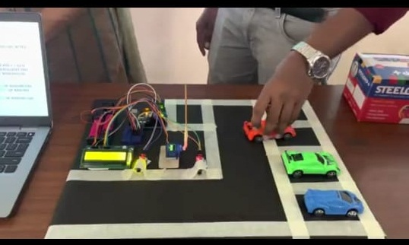 | 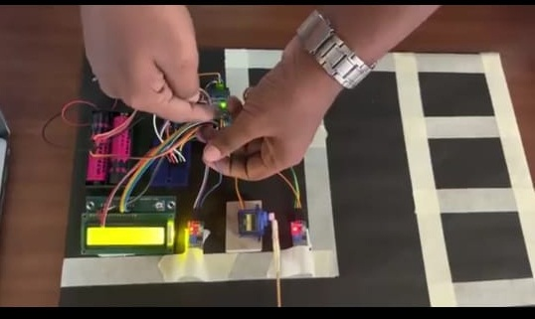

7. CIRCUITDIAGRAM:
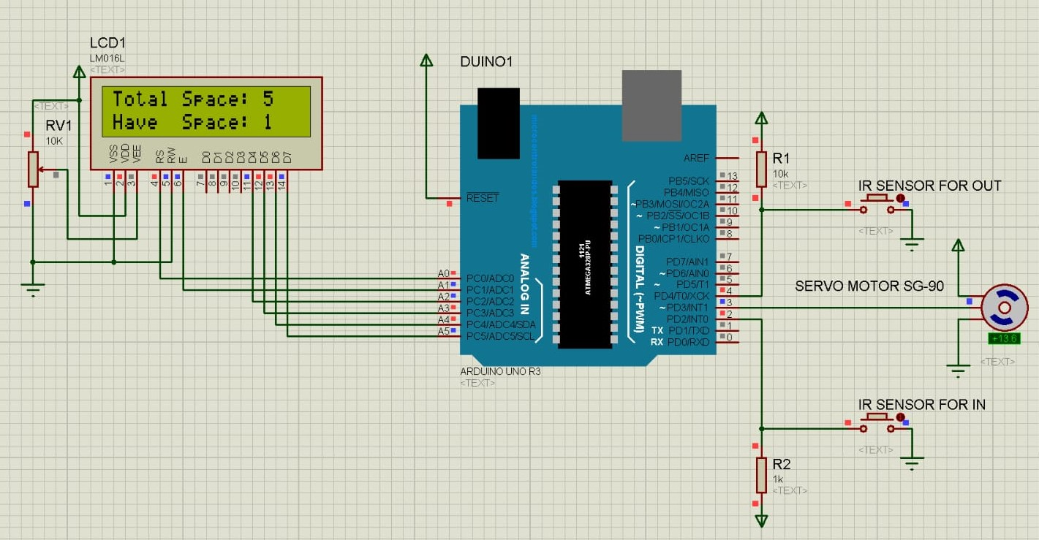

8. CONCLUSION:
The concept of smart cities has long been aspired to by humanity. Over the past few years, significant progress has been achieved in the development of smart cities. Technology advancements in the cloud and Internet of Things have created new possibilities for smart cities. The creation of intelligent parking structures and traffic management systems has long been the cornerstone of building smart cities. In this research, we address the parking issue and offer an IoT The amount of time spent looking for parking is significantly reduced by using a parking management system, which also offers relevant data on parking area availability, precisely designates parking spaces, and offers guidance and suggestions for secure car parking.
9. REFERENCES:
[1] Idris, M. I., Leng, Y. Y., Tamil, E. M., Noor, N. M., & Razak, Z. (2009). Car park system: A review of smart parking system and its technology. Information technology journal, 8(2), 101-113.
[2] Arman, S. S., Banik, S. C., & Raxit, S. (2021). Automated Car Parking System.
[3] Abdulkader, O., Bamhdi, A. M., Thayananthan, V., Jambi, K., & Alrasheedi, M. (2018, February). A novel and secure smart parking management system (SPMS) based on integration of WSN, RFID, and IoT. In 2018 15th Learning and Technology Conference (L&T) (pp. 102-106). IEEE.
[4] Aye, K. N., Oo, P. Z., & Naing, W. W. (2019). RFID based automatic multistoried car parking system. Int. J. Sci. Engineer. Applicat, 8(7), 172-175.
[5] Al-Baghdadi, Ahmed, Mahmoud Al-Shammari, and Ali Al-Sherbaz. ‘Double tag car parking secure system based on RFID’ Journal of Telecommunications 27.1 18-23, 2014.
[6] Pérez, J., Seco, F., Milanés, V., Jiménez, A., Díaz, J.C. and De Pedro, T, ‘An RFID-based intelligent vehicle speed controller using active traffic signals’, Sensors, 10(6), pp.5872-5887,2010.

