Emergence of decentralized data-driven citizen science-assisted research in astrophysics

Ananda Hota (1, 2)
1. UM-DAE Centre for Excellence in Basic Sciences, University of Mumbai
Kalina, Santacruz-East, Mumbai, India
hotaananda@gmail.com

Arundhati Purohit (2)
2. RAD@home Astronomy Collaboratory Kharghar, Navi Mumbai
Mumbai, India
radathomeindia@gmail.com

ABSTRACT
Since the Galilean-era the method of astronomical discoveries have changed from amateur individuals to public-funded institutions. Currently it is turning into multi-national collaborative projects like the first imaging of the shadow of the black hole by the Event Horizon Telescope team. Due to such powerful instruments the amount of data has become almost unmanageable by professional astronomers which has led to the emergence of citizen science research (CSR). CSR has other important implications like being an important medium to achieve Sustainable Development Goals (SDG). Unexpected breakthrough discoveries that Artificial Intelligence(AI) or Machine Learning(ML) can not achieve may possibly be achieved through CSR. We have discussed various types of CSR and focused on RAD@home which is the only CSR platform in Indian astronomy making discoveries using Indian telescopes. A CSR-collaboratory model that RAD@home has evolved is a result of ten years of efforts in the field of multi-wavelength observational study of blackhole galaxy co-evolution through merger and AGN feedback. The recent CSR-discovery of a rare jet-galaxy interaction in RAD12, with data from GMRT, is a potential demonstration. It has been proven to be successful and with international support has started its expansion to other countries to assist the existing education-research systems in Universities. In the upcoming Square Kilometre Array (SKA) era the ultimate aim of the CSR-collaboratory to convert the big data to a big opportunity can not be very far.

Keywords—component; formatting; style; styling; insert (key words)

INTRODUCTION

Ancient positional astronomy of thousands of years took a new turn, nearly 400 years ago, when Galileo Galilee, as an individual scientist, got the idea, made a telescope, observed the sky and published his astronomical discoveries in a book. Soon after this, resource-driven research flourished with addition of imaging by photographic films and spectrographs replacing subjective statements of the human eye and hand-drawn sketches with objective statements from machine-made images. After the world war-II jobless engineers turned their radars towards the sky and initiated the first branch of astronomy invisible to human eyes, namely radio astronomy. Then during the cold-war era, astronomy using rocket-launched space-telescopes expanded our reach to ultraviolet (UV), Infrared (IR), X-ray, Gamma ray exploration of the Universe. Today, we have gone far beyond the electromagnetic spectrum and are now analyzing the sky in cosmic-ray particles, neutrinos and gravitational waves as well.

In this process, the Galilean-era astronomy by the amateur scientist or a passionate individual has evolved to astronomical discovery by professional astronomers who are salaried by Institutions which are investing on building world-class telescopes and hiring engineering, technical and administrative and financial support staff to enable astronomical discoveries. Time has come that in the quest for ultimate truth of nature, the cost and complexity of the telescope and the observatories hosting it has grown so big that not only multiple institutions collaborate for building and maintaining it but multiple countries are investing to design observatories for which technology does not exist at the present time but will be developed in the future. Hence, discoveries are not being made by individual professional astronomers but by collaborations with credit to the leading scientist and hundreds of astronomers listed in publications often in alphabetical order. The best example of such an astronomical research is the first image of the shadow of the black hole, in the galaxy M87, by the Event Horizon Telescope (EHT) Collaboration led by the founding director Dr. Sheperd Doeleman with a series of eight papers published in 2019 [1]. EHT is not a telescope made for this dedicated purpose of imaging black holes but a virtual combination of coordinated observation of more than eight different telescopes belonging to dozen different institutions and located in different continents and obviously not physically connected. It is an example of world-wide collaboration to achieve the first imaging of the enigmatic black hole which has kept the imagination of the whole human civilization like alien life.
As science is a resource-driven experimental research, observational astronomers share their data freely to the whole world, after a proprietary period, primarily because most telescopes/observatories are funded by tax-payers money and data never loses its value, even after the first use, and can lead to more dramatic discoveries never imagined before. Primarily due to the invention of the Internet, the concept of Institutes has been evolving to Collaboratories where physical-proximity of scientists working on the same research topic is not mandatory but having a world-wide collaboration is actually more welcome and growing as a norm for various socio-scientific and socio-political benefits like Universal brotherhood. We have almost reinvented how discoveries are to be made. For detailed understanding readers can refer to the book titled “Reinventing Discoveries” [2].
These scientists access the observational data from giant powerful telescopes in world-class observatories located in often inhospitable and inaccessible locations like sub-zero temperature mountain peaks, south/north poles or cold/hot dry deserts, or vacuum of outer space. The same data is actually accessible to any citizen of any country located in similarly inhospitable or inaccessible location, far from the main stream of development of his/her nation, as long as he/she has access to the internet through a computer to properly analyse the data. Most of the data analysis tools and published journal papers are also completely free to download.
This aspect of modern science where data from the instrument at an unreachable location can reach an individual with almost unreachable location has been realized to have a huge implication towards achieving the seventeen Sustainable Development Goals (SDGs) as defined by United Nations in the year 2015 [3] and Universal Human Right [4]. Some have even argued for a human right to citizen science [5]. Thus data generated by instruments built with tax-payers money can now reach tax-payers for their career-development alleviating various socio-economic and geo-political constraints on their growth. This concept of direct public participation in data-driven scientific research through the Internet can be called citizen science research (CSR). It has now been widely accepted as a potential way to achieve SDG. To facilitate the process, the International Astronomical Union (IAU, Paris) has established its Office of Astronomy for Development (OAD) in South Africa which is funding various educational projects all over the world and producing amazing results [6]. Future mega-observatories like Thirty Meter Telescope (TMT) and Square Kilometer Array Observatory (SKAO) are prominently including CSR initiatives of the member countries from the very beginning of their telescope construction proposals. The already successful three billion dollar proposal by SKAO has included two CSR programmes Radio Galaxy Zoo in the Netherlands using Low Frequency Radio Array (LOFAR) data and RAD@home of India using Giant Metrewave Radio Telescope (GMRT) data [7]. Naturally such CSR works as a socio-scientific justification for the scientists requesting huge grants from their respective governments. In this chapter we shall discuss various aspects of CSR contributing to research in galaxy black hole co-evolution studies with special emphasis on RAD@home collaboratory which is not only the first Indian CSR but even after ten years of its establishment in 2013 is still the only Indian CSR platform to make discoveries with Indian telescopes.

CHANGING ASTRONOMY LANDSCAPE
Similar to the role of fossils in understanding how various life forms, both plant and animals, were millions of years ago, we have the opportunity to see how the galaxies of the Universe were billions of years ago that is close to the formative era of our Universe. Due to the vastness of the Universe, finite speed of light and near transparency of the Universe we can take images and take a spectrum of far away galaxies with bigger and bigger telescopes to understand galaxies farther back in time. This transparency of the Universe comes from two simple facts that the gaseous medium in between galaxies, called Intergalactic medium (IGM), is actually of extremely low density (about 1 to 10 particles per cubic metre), warm-hot (10⁵ – 10⁷ Kelvin) and is primarily ionized medium or plasma due to the ionizing UV and X-ray radiations coming from surrounding stars, galaxies in the Universe. Every galaxy is also surrounded by a similar medium called Circum-galactic medium which likely affects the evolution of galaxies more closely [8]. Note that this IGM has a filamentary structure consisting primarily of baryons but is seen in simulations only and never been imaged in emission maps. To observe finer details of galaxies located farther than previously known astronomers need to observe with larger telescopes and use longer time of integration. For the famous Hubble's Deep Field image Hubble Space Telescope looked at a fixed part of the sky, effectively, for more than four days, over a eleven day time period. Sensitivity of the telescope (root mean square (rms) noise in the image) increases (decreases) with the square root of the collecting area of the objective lens/mirror. Similarly, rms also decreases with the square root of the integration time (time duration for which the telescope is staring at the galaxy). This can be easily comprehended from the following logic that the noise in the astronomical image is of thermal origin and in an empty region of an astronomical image, the noise can be considered close to normal distribution or a histogram of the pixel values will follow a Gaussian distribution. Lower the rms value, higher will be the confidence level or signal to noise ratio of a faint galaxy, seen in the image to be claimed as a real distant (high redshift) galaxy. A false-color 150 MHz image from TIFR GMRT Sky Survey (TGSS ADR1 [9]) for the Abell 85 galaxy cluster has been presented in Figure 1. where the histogram of the pixels from a region devoid of any source (red circle) has been shown in the inset. The number of pixels with a particular pixel value, in the unit of Jansky per beam, shows roughly a normal distribution which can be expressed quantitatively and significance of the bright source in the image in comparison to this noise statistics. We know about 99.7% of pixels belonging to the noise are within 3 times the standard deviation. Thus any source which is above three times the rms value can be highly reliable detection of a radio source. Contours are typically drawn three times the rms in radio astronomy images, as shown in the next figure. In Figure 2 we present an image of the same cluster in contours (TGSS shown in red channel along with other data, discussed later).

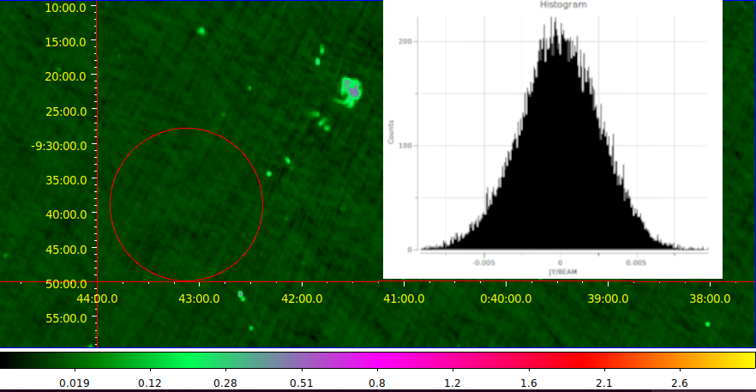
Figure 1: False color 150MHz GMRT image from the TGSS ADR1 of the Abell 85 cluster of galaxies with a prominent radio relic (extended blob of emission). The image inset shows histogram of pixels extracted from a source-free region marked by the red circle. This noise histogram, fitted with a Gaussian distribution function shows a statistics of standard deviation and similar rms values of 0.00264 Jy per beam (25 arcsecond).
Redshift (z) is a concept exclusive to astronomy that requires understanding and appreciation by scientists in all fields. Before we understand this two prerequisites are the Doppler Effect and Hubble's Law. The Doppler Effect of sound can be experienced by everybody in a day-to-day life but for light, it is difficult to observe in any University in undergraduate laboratory experiments. However, it can easily be observed by a college-student experiment of a small radio telescope in an observation of a 21cm emission line from neutral atomic hydrogen gas clouds of our own Milky Way galaxy. A zenith telescope, constantly looking over the head, named PICTOR radio telescope gives open access to the public with close to instant observation of the 21cm line of our Milky Way [10]. So applying this effect, a shift in the location of a spectral line (say H-alpha line of 656.46 nm) can suggest how fast a galaxy may be going away from our solar system (heliocentric systemic velocity). With independent distance measurements, Hubble first showed that galaxies farther away show higher recession velocity as expected from application of Doppler effect. Redshift, z, is the fractional change of the wavelength due to this motion of the source of light z= (Wavelength_observed – Wavelength_emitted)/Wavelength_emitted, which also leads to the approximate value of z = v/c. What is puzzling is when this observed value of z for a particular galaxy approaches close to unity. Does this mean the galaxy is moving at the speed of light and if z is 2-5, a galaxy can move faster than light. Obviously no, it can't violate relativity. Hence, a routine observation of galaxies in these astronomical images and spectrum pushes us to accept that it is not the recession of the galaxies but the expansion of space that happens in our Universe.

The primary goal of building the Giant Metrewave Radio Telescope, led by Prof. Govind Swarup, was to detect the redshifted 21cm line emission from galaxies (proto-clusters of galaxies) from high redshift [11]. GMRT can regularly observe in the 21cm (1400 MHz) band till 2m (150 MHz). That means a galaxy cluster containing the basic element neutral atomic hydrogen, emitting a 21 cm line (1420.405751768(2) MHz), located at redshift z=9, can be observed in the 150 MHz band (Wavelength_observed=(1+z) Wavelength_emitted). In such a case, light would have taken ~13 billion years from that cluster of galaxies to reach GMRT. In other words, GMRT would be seeing that cluster of galaxies just ~500 million years after the Big Bang. Note that GMRT would not detect such line emission because in the current understanding of the Universe, known as hierarchical structure formation, does not favor massive hydrogen clouds of proto-clusters but small galaxies which would merge and form larger galaxies as the Universe evolves with passage of time.
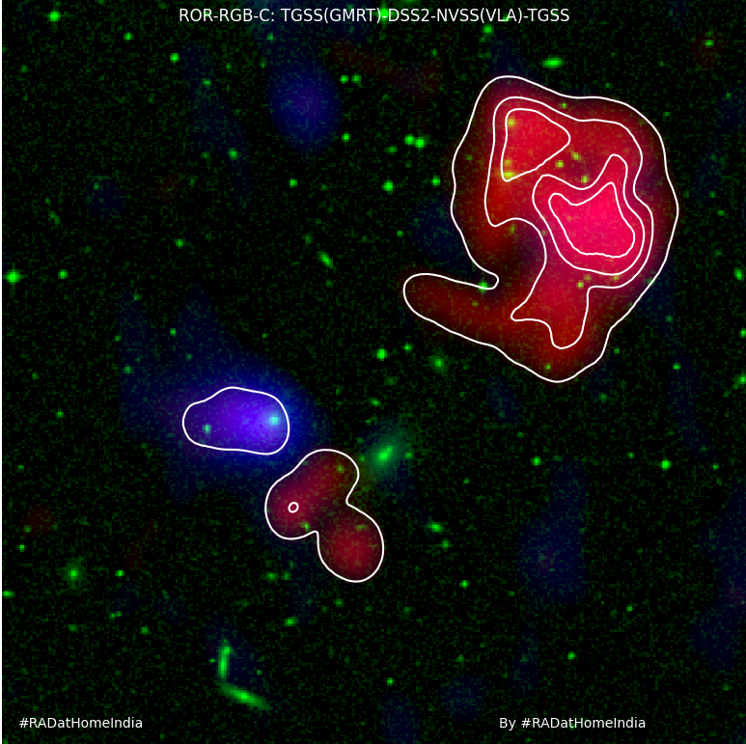Figure 2: Zoomed in View of the same Abell 85 cluster with standard Radio-Optical-Radio RGB image from RAD@home RGB-maker web-tool. The TGSS contour levels are at 0.015, 0.143, 0.271 and 0.399 Jy per beam (25 arc sec).
At this low frequency of 150 MHz, GMRT has imaged nearly 90% of the whole sky, except a small fraction around the south pole that it can not see simply because it is located near Pune (Khodad, Narayangaon, Maharastra, India) in the northern hemisphere on the Earth. This imaging or all sky survey has been named TIFR GMRT Sky Survey (TIFR: Tata Institute of Fundamental Research). National Centre for Radio Astrophysics (NCRA) which is a field station of the TIFR has built and continues to operate GMRT. Interestingly four of the NCRA scientists (Dr S.K.Sirothia (Principal Investigator), Dr Nimisha Kantharia, Dr Ishwara Chandra and Prof. Gopal Krishna) who led this TGSS data collection could only release 10% of their data for the world astronomy community (Data Release (DR-1 in 2010 to DR5) before the raw data became publicly available, as per the observatory rule. Then an international team published images of the whole sky, in 2017, which was obviously named Alternative Data Release 1 ( TGSS ADR1 [9]). The astronomers involved in this are H. T. Intema, P. Jagannathan, K. P. Mooley, and D. A. Frail with affiliations in the Netherlands, USA, Republic of South Africa and UK. This paper has already received 640 citations which obviously include many discoveries reported from the TGSS ADR1 data.. Soon after this re-analyzing the GMRT 150MHz data and combining it with NVSS VLA data (1400 MHz), a spectral index map of the whole sky has been released and that too was by an international team from USA and Europe (Francesco de Gasperin (Leiden), Huib T. Intema (Leiden) & Dale A. Frail (NRAO) [14]). Such astronomical data releases by people not associated with the observatory is unprecedented in radio astronomy, demonstrating the changing landscape of data-driven decentralized open science culture in astronomy. It would be interesting for the public and policy makers to note that about 50% of the observing time of GMRT has been used, by principal investigators from foreign countries. This process of observing time allocation to Principal Investigators based on their formally submitted written proposals is a peer-reviewed merit-based open competition, welcoming participation from world astronomers. This was the same culture for the previous such interferometric array radio telescopes like VLA (NRAO, NSF, USA). All the papers published using GMRT data acknowledge GMRT with a standard sentence. With a literature search for GMRT in the acknowledgment, during writing of this article, returned 1245 number of publications with 45,853 citations [15]. TGSS data release is naturally the fifth most-cited publication. Interestingly, the top 25 papers do not include any publication led by an author with Indian affiliation. However, if we count the top leading institutions to which the authors are affiliated to, TIFR leads it with 488 counts followed by Curtin Univ. (276), Univ of Western Australia (274), Univ. of Leiden (242), INAF (222), Univ. of Sydney(199), Max Planck Institute (195), Univ of Edinburgh (179), Swinburne Univ. of Technology (158), CNR (155). This data leads to a rough h-index of GMRT to be 89 which means there are 89 papers published with 89 or more citations. This makes GMRT, pride of the nation, a true global research facility to further knowledge of human civilization.
GMRT has made a significant upgrade in almost all aspects except the civil and mechanical design of the giant 45m dishes [16]. It has further plans to expand the array with additional dish antennas which will keep its global competitive edge. During the early days of GMRT data analysis, since commissioning in 2000, astronomers were using the calibration source catalogue and imaging software (AIPS) which was created by NRAO (USA) and openly provided to all astronomers. Apart from openly providing all archival data for public use, GMRT also releases data analysis pipelines, specially designed for GMRT, named CAPTURE [17]. This will further the use of GMRT by general astronomers who can not be called radio astronomy experts. with/without collaboration with NCRA-TIFR astronomers.
Such a collaboration, although led by NCRA scientists, has made an important discovery recently in the field of gravitational waves. The collaboration is named Indian Pulsar Timing Array (InPTA) and details can be found in a website hosted by Indian Institute of Technology, Ropar, India [18]). In collaboration with the European Pulsar Timing Array team InPTA has recently discovered the nano Hertz gravitational waves by observing multiple millisecond pulsars. As the gravitational wave passes through, it compresses and stretches the space-time fabric, causing variation in the arrival time of the, otherwise periodic, pulses of radio emission. These waves are produced by the merger of supermassive black holes during galaxy mergers. The time-scale of this change is 1-10 years and size-scales in light years. Interestingly, InPTA collaboration was led by its founding director Prof Bhal Chandra Joshi, scientist of NCRA-TIFR. Out of thirty nine team members, only three faculty are radio astronomers of NCRA [19]. Such sharing of the research facility and community-contribution, through a formal collaboration, is indeed unprecedented.
Such sharing of resources was probably not possible when Indian astronomers built the Ooty Radio Telescope (ORT), still the longest cylindrical (530m long 30m wide) and steerable radio telescope on earth [20]. ORT was so unique and powerful that it has helped Indian astronomers produce a dozen discoveries in high-impact Nature magazine. Interestingly, dozen Nature/Science articles have been published using GMRT but probably only one led by any Indian astronomer with Indian affiliation [21]. It has become a norm that astronomers who built the telescope have published less number papers and achieved less citations than astronomers who used it from open competitive use of the telescope or purely from the public data releases. This does not put lower values to the instrument-building scientists or give higher importance to the astronomers discovering any new source in the sky and may be appearing in news media. This simply means the changing working culture of science as a pursuit of universal truth by the humanity, not individuals or institutions.
Without the internet one can never imagine worldwide usage of any research facility and millions of humans registering in a single program/platform and contributing directly to the publication of research results or scientific discoveries. This precise program is called GalaxyZoo which later got renamed to Zooniverse [22]. There are many similar CSR projects involving hundreds and thousands of world citizens. The science here has become so decentralized that the citizen-scientists who are getting co-authorship in research papers, being published by these professional astronomers of Zooniverse, are people who have never paid tax to build the telescope or contribute to the salary of the astronomers employed. Their hard work as direct contribution to research is not just being recognized in co-authorship and acknowledgments but it also helps them grow in their academic career or simply recognition in the society and personal intellectual happiness. There are many indirect benefits of citizen science that are beyond science and contribute to societal transformations like contributing to scientific temper or creating better informed citizenship and participation in good governance.

METHODS OF CITIZEN SCIENCE RESEARCH
Let's try to understand briefly how a basic citizen science research program works. Every science-enthusiast need not be knowing the advanced technical details of precious gold like its atomic number or characteristic wavelength of its spectral line emission but basic properties are easy to identify like its a metal yellow in colour and shines brightly in sunlight. Similar to gemstone mining, if the public can be trained to recognise patterns in the imaging or spectral data and asked to perform the task through a website displaying such images and record their responses, a basic simple but tedious/boring or repetitive task for the scientist gets done. In this process big data, almost unmanageable by scientists, created by most powerful scientific instruments gets through the first round of filtering out the junk or a rough classification into different classes by thousands of people enjoying the work, sitting anywhere in the world. What if citizens make mistakes in classification? Not a problem, as the same dataset can be given to 10-20 different people to avoid human error.
If in the process, an image with a never seen before feature appears on the screen and the participant is intelligent enough to spot it and report, s/he may get credit or co-authorship of that citizen science discovery. Discovery of quasar ionisation-echo in 2007 by a Dutch school teacher, Hanny van Arkel, thus opened a new branch of understanding black hole galaxy co-evolution [23]. In honour of this citizen scientist such objects are now known as Hanny's Voorwerp (position in the Sky RA: 09h 41m 03.81 s Dec: +34d 43' 34.3" (J2000.0)). A follow up observation with the LOFAR telescope have revealed very interesting results [24]. The supermassive black hole at the centre of the large galaxy is no longer an active quasar or a radio galaxy with jets and lobes. The fuzzy ionised gas cloud that is seen to the south of the galaxy is a relic of the past ionisation by the Quasar, which is still cooling, emitting some spectral line emission. Similarly the same region was seen still emitting some radio emission but only in the low-frequency bands representing old relativistic magnetised plasma emitting synchrotron radiations. Future follow up of other similar objects may reveal more details and help understand AGN feedback better. Description on various kinds of CSR in astronomy can be seen in an extensive review here [25]

The second variety of citizen science research is roughly opposite to the above in terms of data flow and research instruments used. In this form citizen scientists create the primary data and report to the Project leaders through the observation they conduct at their respective location using smaller instruments/tools for digitised data creation and upload to the project. Naturally, there is a subjective judgment involved in the observation process and the quality of the instruments used need not be uniform over the network of reporting. Expert team will have to maintain a standard for reporting the work to a peer reviewed international quality research journal. Especially in Environmental science this mode of research is critically needed for example reporting butterflies, migratory birds, flowering, rare plant and animal species study etc. Since a high-end research instrument and high quality expert can not be present in all places and all the time, this mode of research, despite the irregularities involved, is critically needed.

It will be hard to define what version of a collaboration between professional-amateur (Pro-Am) would be called a citizen science research and what can not be. A couple of more variants of this form of research is going to give a better understanding. SETI@home is one of the very famous and earliest forms of CSR. Where the volunteers would agree to share their computers for the SETI project scientists to run their processing codes when the computer-owners are not using their machines. This way citizens were sharing their resources to the project by the professionals but were not contributing to the intellectual or financial growth of the participating citizens. Thus participants can be acknowledged for their support but can not be given credit as discoverer for any new finding. Similar to this where the participants have no control on which dataset comes to their computer in the Zooniverse like projects too, participants have no control on which galaxy image comes to their screen for classification or a possible discovery. The same data also goes to many participants for classification diluting credit for the first person who classified that particular data. Since the professional team members are small in number compared to thousands of classifiers, such a passive-mode of working was needed.

On the other extreme, if the number of participants can be limited, a team of professional astronomers can afford to have almost one-to-one or face-to-face (offline or online) interactive training for a task more complicated than passive “click-worker” or “image-classifier” usually does. This demands dedicated time and effort of the scientists but can lead to significant growth of the participants or human resource development. This can generate a nice hybrid of Research, Education and Outreach. Depending on the exposure level or expertise acquired or intellectual contribution provided, participants can be placed hierarchically. Where most-involved are researchers deserving co-authorships and rest as per their life permits may see the programme participation as educational or a passive outreach event. Example of such a programme is RAD@home, the first Indian citizen science research in astronomy, launched more than a decade ago.

RAD@HOME COLLABORATORY MODEL
RAD@home was launched with a Facebook Group & Google user account on 15th April 2013 as a zero-funded, zero-infrastructure human resource network [26]. The idea of CSR with the GMRT came up in 2011 with the serendipitous discovery of a spiral host episodic radio galaxy named Speca [27]. The exotic galaxy was clearly visible in decades old DSS, NVSS, FIRST, GALEX data but nobody correlated these heterogeneous data to interpret its exotic nature. Possibly because, the non-detection of bright NVSS-emission components in the more sensitive and higher angular resolution FIRST images, both at same 1400MHz frequency and same telescope VLA, non-trivial for astronomers not aware of angular-scale sensitive nature of radio interferometric images.
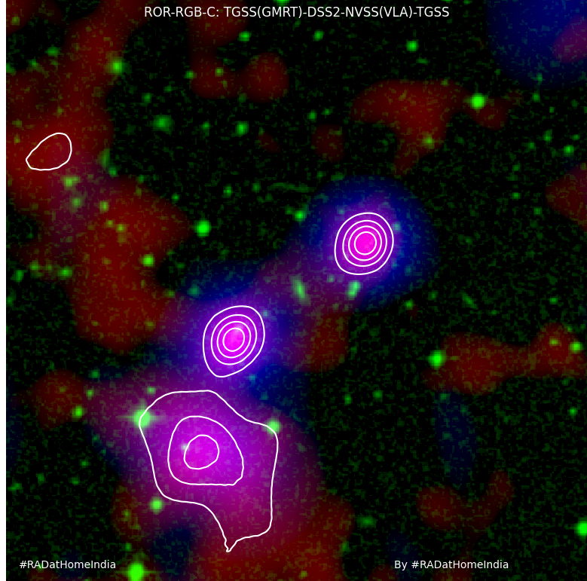Figure 3: The standard Radio-Optical-Radio RGB-contour image of Speca from RAD@home RGB-maker web-tool.

To explain this we present a multi-wavelength images of Speca in Figure 3 and Figure 4. Normal spiral and elliptical galaxies do not emit appreciable amounts of radio emission from the star formation process in its spiral arms or from the region where emission from stellar lights is seen [28]. However, radio galaxies emit several orders of magnitude more radio emission from regions far far away from stellar light distribution and are energetic enough to affect the host galaxies as well as the environment [29]. These radio emissions are seen from jets and lobes consisting of non-thermal plasma or electrons and protons/positrons moving at relativistic speeds, in the jets, and gyrating around the magnetic field lines in the lobes. Thermal, black body radiation from the star formation process diminishes at low radio frequencies but non-thermal, power-law, synchrotron radiation becomes increasingly bright. This makes lobes visible in radio images which have no spatial correlation in optical images. However these lobes are fed by radio jets launched from the centres of galaxies where a supermassive black hole would be accreting gas/dust/stars onto itself. So, on either side of a large elliptical galaxy, seen in optical images, two huge lobes are seen in radio images. This simple task makes the first lesson in extragalactic radio astronomy to associate a central optical host galaxy with two elongated radio lobes. Figure 3 presents the exotic radio galaxy Speca combining three different wavelength images from three different telescopes in a standard RAD@home red-green-blue (RGB)-contour image. The optical image (seen in green) shows the stellar emission from the faraway galaxies seen superposed with 1400 MHz (blue) and 150 MHz (red) images from VLA and GMRT respectively. Two bright radio lobes can be seen on either side of an edge-on spiral/disk galaxy, named Speca [27]. This image has been made using Python-based RAD-RGB-maker web-tool collecting FITS image data from various telescopes via NASA Skyview [30]. Note that the linear jet-connection between the host galaxy and the radio lobes are not always seen due to poor resolution and sensitivity. What is the third blob of radio emission which is slightly fainter but more extended? The same part of the sky is now presented in the next image with contours from same NVSS (cyan) and TGSS (purple) along with FIRST (yellow) in the next, Figure 4.
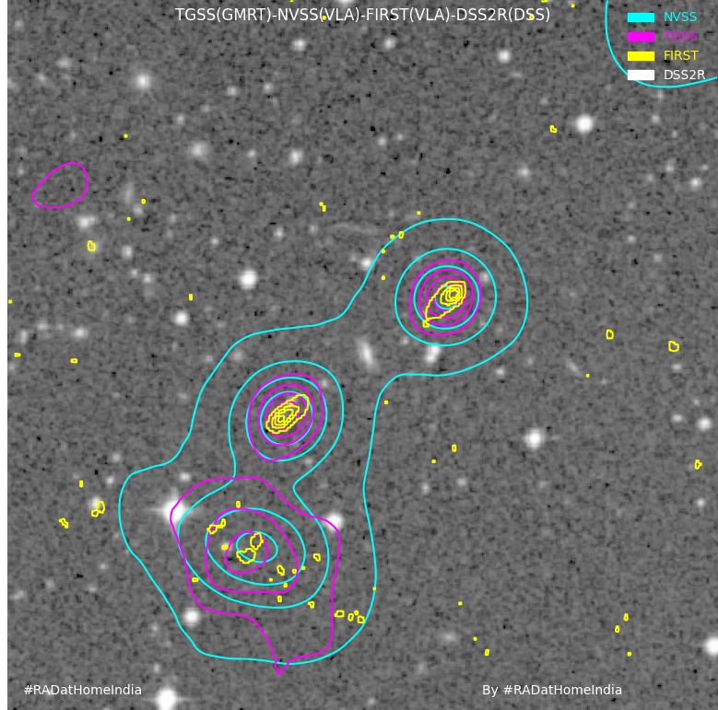Figure 4: Conposite Contour image of Speca radio galaxy from RAD@home RGB-maker web-tool.

Both NVSS and FIRST are from the same VLA telescope and at 1400MHz, they can be compared carefully. The rms sensitivity of FIRST, 0.000150 Jy per beam is better than that of NVSS, 0.00045 Jy per beam. Similarly the angular resolution of FIRST, 5 arcsec, is better than that of NVSS, 45 arcsec. This has revealed balloon-shaped (edge-brightened) structure of both radio lobes of Speca. However, the extended emission blob on the south-east is clearly seen in NVSS ( contour levels 0.0015 0.01 0.0185 0.0271 Jy/b) but FIRST barely detects it as a structure with a single contour at 0.0005 Jy/b. Such a peculiarity is not seen in any other band (X-ray, UV, optical or IR). The interpretation is that the emission blob has no compact source of emission but the plasma there is diffuse in nature. This was the clue for the astronomers to suspect it as a diffuse, relic or old plasma blob from a previous episode of Speca. Note that a similar diffuse blob is also seen on the north-western side but not shown in the presented image (Figure 3, 4). Observation with the GMRT, well-suited for detection of old plasma, confirmed its relic nature and episodic behavior of this giant radio source [27].

The most striking aspect of Speca is its host galaxy. Radio galaxies are not seen to be hosted in spirals but always elliptical galaxies. This is why it was well-established in the astronomy community that a supermassive spinning black hole is required to launch 200-300 kpc large radio lobes out of the host galaxy. Such massive black holes can grow only through major galaxy mergers leading to them being hosted in merger-products ellipticals. Discovery of Speca, confirmed case due to its episodic nature, ruling out chance coincidence, revived interest of the community and by now close to a dozen such galaxies are known [31]. It was realised that to discover more Speca-like exotic radio galaxies, it was necessary to train science undergraduate students in this complex interpretation of multi-wavelength data including radio interferometric images specially including them in the new TGSS data being released at that time (2011).

In the early days of RAD@home, radio optical overlays made using Skyview were being discussed in the Facebook group which was not only widely used by young students but did not cost any money for any amount of image uploads and text comment-based discussions at any time from anywhere. After a reasonable maturdity in radio galaxy characterisation, through such discussions, participants were selected for an advanced training in a research institute free-of-cost. This CSR-training is called RAD@home Discovery Camps. TGSS DR1/DR5 FITS files were assigned to these Camp-trained citizen scientists aka e-astronomers to discover “faint-fuzzy” radio sources unpublished in literature. This faint-fuzzy structural defination naturally selects relic lobes as in the case of Speca. Furthermore TGSS is best-suited to discover relic lobes and automated pattern recognition algorithms struggle at the fain-fuzzy level unlike eye-brain combinations of humans. For a better analysis e-astronomers were trained to use SAO-ds9, NASA Extragalactic database and ADS search. Any possible discovery was first discussed by the members in a Facebook group post and then after its discovery potential is realised by the Principal Investigator, it was reported through a Google Document and/or a Google form. The discussion and discovery reporting continued after the week-long camps. The discussion can remain active throughout the year and was boosted during online weekend e-classes through Facebook Messenger Chats and later through Google Meet video calls.

These efforts started producing good TGSS sources worthy of follow up observations with the GMRT. Keeping the e-astronomers as Co-Investigators of the RAD@home collaboratory, formal proposals were submitted to GMRT Time Allocation Committee (GTAC) in a series of proposals named GMRT Observation of Objects Discovered by RAD@home Astronomy Collaboratory (GOOD-RAC). Without any special consideration towards CSR the GTAC has approved nearly 50 hours of observing times through four different cycles. Due to regular online-weekend and social-media interactions many e-astronomers got sufficiently skilled and were recommended for MS/PhD positions. This way, an innovative way of student involvement in research and early boost to their astronomical career got initiated in India benefiting thousands of citizens with various amount of involvement.

A recent publication titled “RAD@home citizen science discovery of an active galactic nucleus spewing a large unipolar radio bubble on to its merging companion galaxy” was given a press release by Royal Astronomical Society and NCRA-TIFR [32]. This received large media attention specially due to new technologies in the social media. This target galaxy was realised to be peculiar because the citizen scientist felt puzzled that instead of two radio blobs seen on either side of an optical galaxy here is the case of one radio blob seen in between two optical galaxies with equal potential to be the elliptical host[26]. Since participants were trained to understand how a radio galaxy jet may interact with the host in providing the so called AGN feedback they could anticipate some jet-galaxy interaction in this system named RAD12 [33, 34]. With the GMRT follow up at 325MHz and incorporation of L-band MeerKAT data the true exotic nature of RAD12 as a possibly one sided jet hitting a neighboring elliptical galaxy, in the process of merger, and bouncing back as a radio bubble of 137 kpc size was realised [32]. There are many other pre-discovery reports that have been followed up with the GMRT through GOOD-RAC and currently in the process of manuscripts being written up.

Wide implication of this Collaboratory model of CSR was realised over time and international attention with both cash and kind support have been received for expansion to other nations, specially to south-Asian countries lacking GMRT-like facilities [35]. Recognition and support by the International Astronomical Union (IAU), Square Kilometre array Organisation (SKAO), Nature Index and awards to the founding Director and Principal Investigator of the Collaboratory have helped build public trust and in turn serious participants with formal support from their own affiliations. With members of the Collaboratory formally participating in the Square Kilometre Array India Consortium, the ultimate aim of the collaboratory to convert Big Data problem to Big Opportunity for Big population can not be very far [7, 34].

REFERENCES

- The Event Horizon Telescope Collaboration et al. 2019, ApJL, 875, L1 (EHT)
- Nielsen, M. 2011, Reinventing Discovery, Princeton University Press.
- United Nations Sustainable Development Goals (2015) https://sdgs.un.org/goals
- Universal Human rights https://www.un.org/en/about-us/universal-declaration-of-human-rights
- Vayena, E., Tasioulas, J. “We the Scientists”: a Human Right to Citizen Science. Philos. Technol. 28, 479–485 (2015).
- IAU Office of Astronomy for Development https://www.astro4dev.org/
- SKA Construction Proposal https://skao.canto.global/s/M8159?viewIndex=0
- Tumlinson J., Peeples M.S. Werk J.K., Annual Review of Astronomy and Astrophysics 2017 55:1, 389-432
- Intema H. T., Jagannathan P., Mooley K. P., Frail D. A., 2017, A&A , 598, A78
- PICTOR HI Radio Telescope https://pictortelescope.com/observe
- Swarup G., Ananthakrishnan S., Kapahi V. K., Rao A. P., Subrahmanya C.R., Kulkarni V. K., 1991, Curr. Sci., 60, 95
- Becker R. H., White R. L., Helfand D. J., 1995, ApJ , 450, 559
- Condon J. J., Cotton W . D., Greisen E. W ., Yin Q. F., Perley R. A., Taylor G. B., Broderick J. J., 1998, AJ , 115, 1693
- de Gasperin F., Intema H. T., Frail D. A. 2018, MNRAS, Volume 474, Issue 4, p.5008-5022
- https://docs.google.com/document/d/1EkBQgtiB6qmlEXilSZzD6jgr_mj7U8dY4l71ds0S88w/
- Gupta Y. et al. 2017, CURRENT SCIENCE, VOL. 113, NO. 4
- Kale R. & Ishwara-Chandra C.H. 2021, Experimental Astronomy, Volume 51, Issue 1, p.95-108
- InpTA Collaboration https://inpta.iitr.ac.in/
- Joshi B.C. et al. 2022, Journal of Astrophysics and Astronomy, Volume 43, Issue 2, article id.98
- Ooty Radio Telescope http://rac.ncra.tifr.res.in/
- Chowdhury, A., Kanekar, N., Chengalur, J.N. Sethi S. & Dwarakanath K.S., Nature 586, 369–372 (2020)
- Zooniverse https://www.zooniverse.org/
- Lintott, C. J., Schawinski, K., Keel, W., van Arkel, H. et al. 2009, MNRAS, 399, 129
- Smith DJB, Krause MG, Hardcastle MJ, Drake AB, 2022, MNRAS, Volume 514, Issue 3, August 2022, Pages 3879–3885
- Marshall, P. J., Lintott, C. J., Fletcher, L. N. 2015, ARA&A, 53, 247.
- Hota A. et al., 2014, in Chengalur J. N., Gupta Y., eds, ASI Conf. Ser. Vol. 13, New results on the exotic galaxy `Speca’ and discov ering many more Specas with RAD@home network. p. 141
- Hota, A., Sirothia, S. K., Ohyama, Y., Konar, C., Kim, S, Rey, S.-C., Saikia, D. J., Croston, J. H., Matsushita, S. 2011, MNRAS, 417L, 36.
- Condon, J. J. 1992, ARA&A, 30, 575
- Hardcastle M. J., Croston J. H., 2020, New Astron. Rev. , 88, 101539
- Kumar A., Avinash Ck., Purohit Arundhati, Hota A., 2023 in IAU Symposium 375: The Multimessenger Chakra of Blazar Jets (in Press)
- Wu Z., Ho L.C., Zhuang, M-Y., 2022, ApJ, 941, 95
- Ananda Hota, Pratik Dabhade, Sravani Vaddi, Chiranjib Konar et al. Monthly Notices of the Royal Astronomical Society: Letters, Volume 517, Issue 1, November 2022, Pages L86–L91
- Hota A., Rey S.-C., Kang Y., Kim S., Matsushita S., Chung J., 2012, MNRAS, 422, L38
- Hota A. et al., 2016, JA&A , 37, 41
- Rajoria M., Purohit A., Hota A., 2023 in IAU Symposium 375: The Multimessenger Chakra of Blazar Jets (in Press)
===============

