IoT and locomotor disability

Innovation in technology that makes things possible for people with disability

1. Introduction
   1. locomotor disabilities
   2. Assistive technology
   3. Internet of things definition and evolution and how it works
   4. Features of IoT
2. Advantages of IoT
3. Disadvantages of IoT
4. Application of IoT
5. IoT in disabilities
6. Iot and AT for the people with locomotor disabilities
   1. smart crutch
   2. smart walker
   3. smart wheelchair
   4. IoT in prosthetics
   5. IoT in orthotics

**Abstract**

Disability is a consequence of a limitation that restricts a person's capacity to engage in daily activities. This disability may be mental, physical, physical, sensory, personal, growth-oriented, or a combination of these. Walking, running, gripping, moving goods, using pens, and other fine motor skills are all affected by locomotor deficits. Locomotor problems include cerebral palsy, spinal cord damage, muscular dystrophy, cerebrovascular accidents, spinal cord injury, and other locomotor disorders. To support these people financially and socially, particular devices or technology, i.e., assistive Technology, are constantly needed to enhance their involvement in daily activities and so make them independent. AT is an area of engineering focused on the development of methods, systems, and technologies to assist people with impairments in doing daily tasks. In this respect, an assistive technology device is one that can be utilized to increase or improve the functioning abilities of any impaired individual also, these technologies can aid in reducing or removing disability, ensuring PwDs live dignified and independent lives. The Internet of Things (IoT) is made up of everyday objects that have computational, sensory, and networking capabilities for data collection and transfer. Low-cost CPUs and simple-to-install wireless networks are essential IoT technologies. Sensors can collect and transmit data in real time to servers with minimal or no human involvement. Advances in artificial intelligence, data transmission, and cloud computing have accelerated IoT development. The Internet of Things (IoT) has the potential to enhance the lives of disabled individuals as well as our society and industries. Individuals with impairments are gradually gaining access to IoT devices and services. The Internet of Things and its related gathering of data is resulting in technological developments ranging from smart home devices to self-driving cars. IoT-based services also allow persons with impairments to participate more fully and autonomously in daily life by eliminating the need for human facilitators or adaptations. Due to the miniaturization of electrical devices and the significantly improved availability of internet connectivity, all of this is made possible. The possible uses of this new Internet of Things are essentially infinite, and they have the potential to significantly improve the quality of life of people with disabilities. This chapter investigates the influence of the Internet of Things on people with locomotor disabilities, focusing on devices such as walkers, crutches, and wheelchairs that use IoT.

1. Introduction

This section includes an introduction to locomotor disabilities, assistive technology, IoT its definition, its features, advantages, disadvantages, and application of IoT, in disabilities and IoT in assistive technology for people with locomotor disabilities.

1.1 Locomotor disability

In all, over a billion individuals are impaired globally, with a significant number of locomotor disabilities caused by injuries due to traffic accidents, falls, burns, and violent acts such as child abuse, teen violence, war, or conflicts. Motor disability constitutes the second highest percentage of disability, but it is also one of the most neglected, as it frequently seems that this type of disability doesn't need special care or consideration like the other groups like visual, mental, and hearing impaired, and is thus marked as a neglected category in the disabled population. Disability in developing countries differs from disability in developed countries. Around 15% of the world's population is disabled, with 2-4% having significant difficulties functioning[1]. A person with a disability is more likely to have poor socioeconomic outcomes, physiological stress, and inequalities in access to critical services such as education, health care, employment, and social interaction. Education, work, freedom of activity, availability of knowledge, sufficient health care, and the opportunity to make their own decisions are often restricted to people with disabilities[2]. Despite assistive technologies have the ability to enhance the quality of life and participation, they cannot ensure performance. Apart from the technology, the user's physical traits, goals, preferences, and expectations have to be addressed. As per to the World Health Organization's burden of disease research (2010), noncommunicable diseases like musculoskeletal disorders such as diabetes and stroke with associated disabilities, are changing global disease demographics and moving towards infectious diseases, which leads to a rise in locomotor disabilities[3]. A few kinds of locomotor disability are paraplegia, which is the paralysis of the lower limb as a result of spinal cord damage caused by any reason, such as a fall, a car accident, or a gunshot injury, and results in the loss of both feeling and movement of the lower legs; Quadriplegia is a paralysis of both the arms and legs caused by spinal cord injury, resulting in loss of feeling as well as movement in both the upper and lower limbs, resulting in significant functional limits, Cerebral palsy is a congenital defect in the brain that causes neurological problems and functional abnormalities in children. Muscular dystrophy is a hereditary illness that involves gradual muscle weakness and wastage that worsens with age and leads to severe functional deficits with physical activity limits. Amputation is the surgical removal of a limb, which can be upper or lower, as a result of an accident, diabetes, or cancer, and results in complete physical limits. Arthritis is a condition characterized by joint inflammation, which causes pain and stiffness, and, as a result, disability. People with locomotor disabilities are prescribed assistive technology such as prostheses, orthoses, canes, crutches, and wheelchairs to improve their mobility and independence. It has a significant impact on the lives of people with locomotor disability. People with locomotor disabilities sometimes experience difficulties performing routine tasks owing to physical limitations. Assistive technology bridges these gaps, improving independence, functionality, and overall quality of life[4].

1.2 Assistive technology

Any product, which can include any device, instrument, technology, or software, that is specifically designed for preventing, compensating for, relieving, or neutralizing impairment, limitation of activities, or restriction in participation in daily tasks is referred to as assistive technology for people with disabilities. People with disabilities can live better lives due to technology by having more independence, communication, accessibility, and an all-around better quality of life[5]. People with impairments may now access information, connect with others, and carry out daily duties because of assistive technology. With the use of assistive technology, people with visual, hearing, or mobility impairments can access digital information and connect with computers or mobile devices. Examples of this technology include screen readers, braille displays, speech recognition software, and alternate input devices. With the use of assistive technology, people with visual, hearing, or mobility impairments can access digital information and connect with computers or mobile devices. Examples of this technology include screen readers, braille displays, speech recognition software, and alternate input devices. It also helps persons with locomotor impairments stay safe and prevent falls. To create safer conditions and reduce the chance of accidents and injuries, public spaces includes grab rails, wheelchair ramps, handrails, and grab rails. Individuals with mobility issues can use voice-activated assistants, smart home automation systems, and environmental control devices to manage various aspects of their living space, including the lighting, temperature, and appliances[6]. Few examples of mobility aids to enhance mobility and quality of life for people with physical disability include wheelchairs, prosthetics, and exoskeletons. Due to the use of assistive technologies the woerk oppurtunities for the people to work has been increased.it also helps people to participate in activities and enhance social inclusion.

1.3 Internet of things

The term Internet of things has been coined by Kevin Ashton, who was a British technology developer , he describes a setup in which the internet is connected to the real world via common sensors. The Internet of Things (IoT) is a network of things that are embedded with , circuits, software, sensors, network connectivity, and other components to gather and share data. Through the use of existing network infrastructure, the Internet of Things makes it possible for objects to be sensed and controlled remotely, enhancing efficiency and accuracy and enabling a more direct integration of the physical world with computer-based systems. IoT may interact without the involvement of a human. In the fields of healthcare, transportation, and automobiles, several preliminary Internet of Things applications have already been created. Despite the fact that Internet of Things (IoT) technologies are currently still at the beginning, there have been numerous notable developments in the online integration of objects with sensors.[7]

We can divide the five eras of the Internet's development into five categories:

1. The Internet of Documents, which includes websites with documents as the content.

2. The Internet of Commerce, which includes websites for e-commerce, e-banking, and stock trading.

3. Web 2.0 and the Internet of Applications

4. Social networks on the Internet of People.

5. The Internet of Things -- Machines and connected gadgets

**FIG 1: Evolution of IoT**

Process of IoT

There is various steps on which the internet of things works :-

1. Ingestion of Data :- IoT devices/sensors get information from their surroundings. The data must be transferred to the cloud for analysis.
2. Transmission of Data :- The data is sent to the cloud using Gateways (Telemetry Devices), which employ both cellular and satellite communication to provide the data like Bluetooth.
3. Processing of Data :- The IoT platform processes the data once it reaches the cloud.

Three stages comprise the data processing cycle: input (data), processing with storage, and output (information). Data collection and conversion into machine-readable form take place at this stage. Processing is the second stage. It is the place where data is categorized into groups, ordered (for instance, alphabetically), and calculated (using arithmetic and logical processes).The data is transformed into human-readable form at the third stage.

Storage

output

Input

**FIG 2 Process data processing**

1.4 Features of IoT

Its most important IoT features include connectivity, analysis, integration, active participation, and many more. Some examples are provided below:

1. Connectivity: Connectivity refers to the creation of a proper link between all IoT components and an IoT platform, which could be a server or a cloud. After connecting the IoT devices, reliable, secure, and bi-directional communication requires high-speed messaging between the devices and the cloud.
2. Analyzing: Once all of the important objects have been linked, it is time to evaluate the real-time data and use it to develop efficient business knowledge. If we have a complete understanding of the data collected from all of these sources, it can be referred as a smart system..
3. Integrating: - IoT also mixes several models to improve the user experience.
4. **Artificial Intelligence:** IoT uses data to make things smarter and improve people's lives.
5. Sensing: Sensor devices are used in IoT technologies to discover, assess, and track environmental changes. Because of the Internet of Things, previously inactive networks are now operational. There could be no genuine or functioning IoT environment without sensors.
6. Active Engagement: IoT allows linked devices, goods, or services to actively engage with one another.
7. **Endpoint Management:** Gateway management is critical for every IoT system; else, the system will fail totally.

**FIG 3 :- features of IoT**

1. Advantages of IoT

The Internet of Things provides numerous benefits in the business sector on a daily basis. Some of its advantages are as follows:

1. Effective resource management: IoT makes it easier to understand how each device functions, which improves effective resource management.
2. Reduce human effort: As IoT devices connect and communicate with one another, this reduces human effort.
3. Save time: By lowering the amount of human work, time is also saved.
4. Enhance Data Collection: IoT enhances the data collection
5. Improve security**:** IoT has a network that connects systems, which can increase efficiency and security.

**Fig 4 :- advantages of IoT**

1. Disadvantages of IoT

The IoT has some disadvantages also which are as follows: -

1. Security: The Internet of Things (IoT) creates an environmental framework for devices that often connect to networks. Furthermore, the program offers little regulation despite safety precautions.
2. Privacy: The Internet of Things system provides considerable personal data at a high level of precision even when the user is not actively participating.
3. Complexity: Creating, managing, and enabling large-scale technologies for IoT systems is challenging.
4. Flexibility: -Flexibility is lacking in it. Consumers are uncertain about how easily the IoT system can be integrated. There are issues about coming across too many protected or incompatible source codes

Fig 5 :- Disadvantages of IoT

1. Applications of IoT

The Internet of Things (IoT) is used in a range of sectors and industries. These are a few of the most important IoT applications: -

1. Smart homes: **-** "Smart homes" is a significant IoT application that appeals notably to people with disabilities. The concepts of assisted living and home automation—both of which have long been pursued in the disability community—are broadened by this. Numerous home systems and appliances may be automated and managed thanks to IoT. Smart appliances, lighting fixtures, security cameras, and thermostats may all be remotely controlled and monitored by users using voice-controlled devices or smartphones when they are all connected to the internet. This resulting living area is therefore more practical and energy-efficient. However, as a result of their broad availability in nearby hardware and furnishing stores, home automation systems are now significantly more durable and affordable for people with disabilities than they were when they were specific custom-made solutions[8].
2. Industrial settings: - IoT is also applied in commercial settings to improve output, effectiveness, and security. IoT applications link sensors and devices to equipment, machines, and processes for monitoring and control. Predictive maintenance, inventory management, supply chain optimization, and remote asset management are now all feasible.[9]
3. Smart cities: -IoT is essential for the growth of smart cities, which use technology to enhance urban infrastructure and services. Internet of Things sensors can handle junk gathering, regulate street lighting, improve parking spaces, and keep an eye on the weather. By gathering and analyzing data, cities may advance sustainability in general, increase energy efficiency, and enhance mobility[10].
4. Healthcare**:** -IoT applications in healthcare, often known as the Internet of Medical Things (IoMT), improve patient administration, monitoring, and care. Wearable technology, such as fitness trackers and smartwatches, monitors vital signs and physical activity. IoT-enabled medical devices can remotely monitor patients, remind users to take their medications, and send data for instant analysis to healthcare specialists. This enables personalized healthcare, remote patient monitoring, and the early detection of health issues[11].
5. Agriculture**: -** The Internet of Things is revolutionizing agriculture by providing precise farming techniques. Sensors are placed in fields to assess the soil's temperature, moisture level, and nutrient content in order to optimize irrigation and fertilization. Crops can be scanned for pests or illnesses by drones equipped with cameras and sensors. IoT also makes it possible to better manage all facets of farm management and monitor livestock, animal behavior, and health[12].
6. Transportation**: -** The Internet of Things in transportation is revolutionizing logistics and transportation by improving efficiency, security, and asset management. Connected vehicles and infrastructure provide real-time traffic monitoring, reducing congestion and enhancing safety on the road. IoT sensors can track and monitor shipments, which improves logistics and supply chain management procedures[13].
7. Energy saving :-For energy monitoring, administration, and optimization, IoT is employed in residences, workplaces, and industries. Smart meters give users access to real-time information on energy use, enabling them to plan their usage and reduce waste.[14]
8. Management of inventories and retail **:-** IoT is utilized in retail to improve inventory management, enhance the consumer experience, and enable smart retail solutions. By delivering location-based offers and recommendations, beacons and digital signs powered by the Internet of Things may customise the customer experience[15]

**Fig 6 :- Application of IoT**

1. IoT in disabilities

People with disabilities are particularly touched by the Internet of Things (IoT)'s potential opportunities. IoT enables people and objects to be connected at any time, in any location, and via any network or service. IoT networks may work within healthcare institutions, being developed to provide services to urban neighborhoods, and even connect patients and healthcare professionals across greater distances, removing geographical barriers to access to healthcare as well as the requirement of healthcare facilities. E-health services that rely on electronic devices and intelligent settings are driving the expansion of assistive solutions based on wireless networks and IoT installation. Devices that monitor and help patients with particular aspects of their health and well-being are made available to patients because of recent technologies. An IoT device and a server at the center normally transfer the obtained data over a wireless network[16]. To enable patients to be remotely monitored for anomalies and helped with specific health conditions, a data structure is developed. The potential of home automation has been further expanded by the most recent development of various artificial intelligence systems created especially for this purpose. This includes Google Assistant, Apple Siri, Cortana from Microsoft, and Alexa from Amazon. Although it's easy that eventually, in addition to controlling televisions and other home appliances, these smart devices may also find their way to workplaces, public transportation systems, and other locations, becoming a part of everyday surroundings. Some of the earliest instances of IoT applications can be found in the connected coffee maker and vending machine, which were put at an office and a university, respectively. Several signal systems are now being employed to facilitate inside and outdoor navigation, particularly in public buildings and other high-traffic areas. These increase physical environment accessibility by making it easier and quicker for people with disabilities to move around in public spaces and buildings[17]. Individuals' work settings and general inclusion in human resources may suffer as a result of their impairment. To improve the quality of life of such people and solve their difficulties, universal design (U.D.) and the Internet of Things (IoT) is also included into present design practices. Products are available on the market to make the life of the elderly or differently abled individuals easier. IoT serves as a pivot in bridging the gap between the actual and virtual worlds, increasing the ecosystem's universality. The usage of IoT and sustainable development may help to remove preconceptions about products, services, and the environment. In terms of basic necessities, incorporating IoT into the early design process would aid in the creation of a universal ecosystem accessible to all groups of people[18].

The Internet of Things (IoT) has the potential to significantly assist people with impairments by allowing them previously impossible access to the actual world. However, if IoT devices are adopted without taking into account the needs of persons with disabilities, they may become a hindrance rather than an aid. A smartphone app, for example, may allow better access to an IoT heating system than actual knobs. If this app is inaccessible, the cost of this IoT system will be more than that of a traditional system with physical knobs[19].

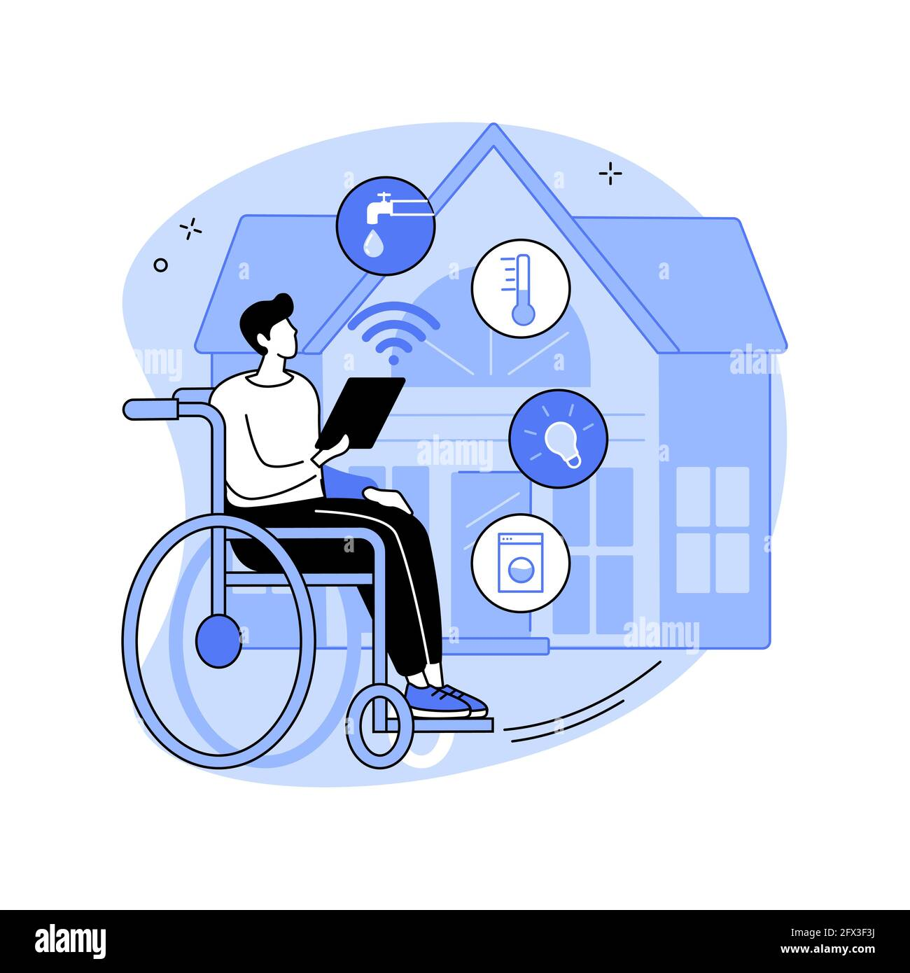

**FIG 7:- IoT for people with disabilities**

1. IoT and AT for the people with locomotor disabilities

The fundamental advantages of IoT sensors and technologies have influenced numerous areas of application. Implanted sensors on patients, acquire information remotely, assisting in anticipatory healthcare by foreseeing health risks through vital sign monitoring. Implantable sensors have a proven track record of efficacy, and they have a major impact on patients' long-term quality of life[20]. According to a survey, almost one-third of those who are paralysed are dissatisfied with the degree of rehabilitative technologies available on the market. IoT technology has the potential to improve this situation and boost the standard of living for people with impairments in general. According to World Health Organisation (WHO) estimates, over a billion people suffer from physical disability[21]. Another important innovation in e-healthcare is the movement of paralysed persons. Exoskeletons are the most often utilised assistance and rehabilitation approach for disabled persons today. Exoskeletons are available in a range of designs and serve a variety of applications, such as movement help, rehabilitation, and transportation assistance. These have major portability, flexibility, adaptation, and wearability issues. The Brain Energised Full Body Exoskeleton (BFBE) uses EEG sensors to record brain waves. When the user wishes to make a specific movement, such as sitting, standing, or sleeping, the sensors detect brain impulses. The Control Unit's microprocessor subsequently generates a signal for the necessary body portion[22]. Below are the examples of the IoT in the most commonly used mobility aids for people with locomotor disabilities :-

* 1. Smart crutch

A smart crutch is a more modern take on the classic crutch that includes a number of functions to improve its usability, comfort, and functionality. In order to give users further advantages, these crutches frequently incorporate sensors, microprocessors, and wireless communication[23]. Here are a few characteristics that a smart crutch could have:

1. Load sensors:- It monitors the force that the user applies to the crutch, which is crucial since it may give feedback on optimal weight distribution, assisting users in preventing overstretching or damage.
2. Height adjustment: - Automated height-adjustment devices may be included with smart crutches. With this function, users can quickly change the crutch's height with the push of a button or a simple motion.
3. Fall detection: - The smart crutch's integrated accelerometers and gyroscopes can detect rapid movements or changes in orientation, allowing it to identify and inform the user or caretakers in the event of a fall. This feature can give a greater sense of security, especially for people who have mobility challenges.
4. GPS tracking:- Smart crutches may contain GPS tracking capabilities, which can be useful for detecting missing crutches as well as a safety measure by allowing carers or emergency services to locate the user in the event of an emergency.
5. Anti slip feature:- To improve stability on varied surfaces, smart crutches can be constructed with anti-slip tips or feet. These characteristics serve to reduce

unintentional slips and falls, giving users more confidence and support when on the go.

1. Activity monitoring:- Smart crutches may monitor the user's daily activity levels, including the number of steps taken and the distance traveled. This information can be linked with a smartphone app or the system of a healthcare provider, allowing consumers to track their progress or exchange information with medical specialists.
2. Haptic feedback: Some smart crutches may have haptic feedback systems that offer users with vibrations or gentle reminders, assisting with gait training, posture correction, or reminding users to take breaks or conduct specified exercises.[24]

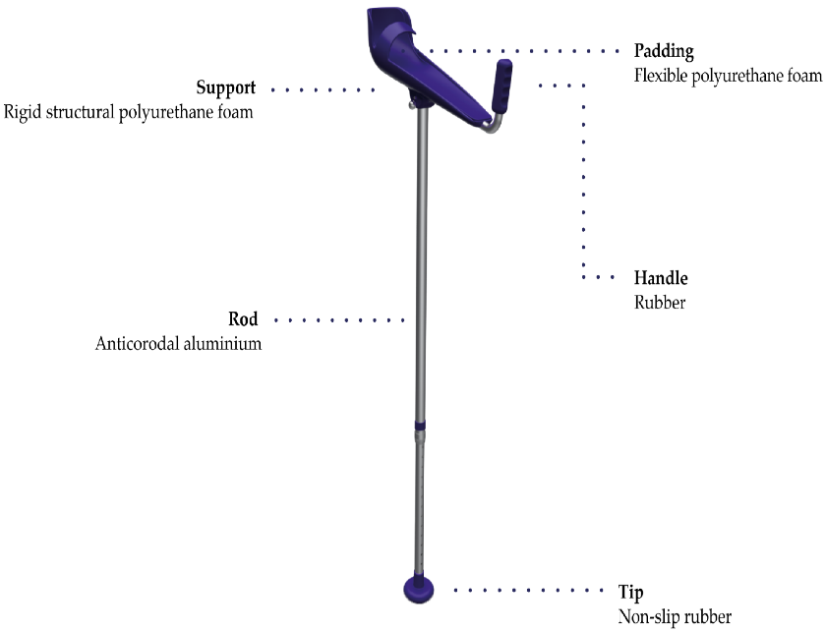

**FIG 8 Smart crutch[23]**

According to one study, the long-term, repeated research and survey at the Centre for the Rehabilitation of the Paralysed (CRP) resulted in the application of the developed Robotic Crutch. The smart crutch implementation is an actual time architectural system designed for paralyzed people as appliances to provide the necessary assistance so that they can move freely. The E-Care architecture is a newly added component of the robotic crutch that allows the user's family members to view their physical state correctly using IoT. In this case, the IoT module aids in the patient's actual tracking[25].



**Fig 9 smart crutch developed in a study[24]**

* 1. **Smart walker**

A smart walker, often called an intelligent walker or a high-tech walker, is a technologically enhanced variation on a regular walker that includes a number of capabilities to improve users' mobility, safety, and convenience. For added utility, these walkers frequently incorporate sensors, electronics, and networking[26], [27]. It has the following features:

1. Fall detection and prevention: -It has Sensors that detect rapid movements or changes in orientation allowing them to detect and stop falls. To enhance stability and prevent tipping, they have features like automated braking or stability control systems.
2. Navigation and obstacle detection: - Some smart walkers have sensors or cameras that can recognize obstacles in the user's route and send alerts or even perform automatic navigation to avoid them. People with limited mobility or visual impairments may find this function to be especially helpful.
3. Height adjustments: - Users of smart walkers may have access to automated height adjustment devices that make it simple to change the walker's height with the push of a button or a hand motion. This eliminates the requirement for manual adjustments and maintains the user's comfort and appropriate alignment.
4. Vital signs monitoring:- smart walkers have sensors which can monitor all the vital signs such as heart rate , blood pressure or oxygen saturation levels. These parameters can be easily transmitted wirelessly and information may reach to health care provider or care takers for easy monitoring and timely intervention.
5. Integrated seat and storage :- smart walkers can have incorporated seats or storage space , so that user can carry personal belongings with ease, this may improve users comfort and convenience during longer walks.
6. GPS tracking and location services: - Some smart walkers have GPS tracking facilities so that caretakers can locate the user and ensure the safety of the individual.

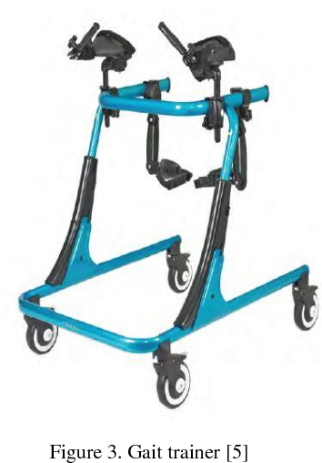

**Fig 10 smart walker developed in a study[26]**

* 1. Smart wheelchair

A smart wheelchair also known as an intelligent wheelchair is an advanced version of wheelchair that includes user independence, safety and convenience. It may have sensors electronics and connectivity to provide additional functions[28], [29]. Some features of the smart wheelchair are

1. Powered mobility: - It has powered mobility same as a motorized wheelchair functions which enables users to effortlessly maneuver the wheelchair without using their upper body strength. For people with more severe issues with mobility, motorized wheelchairs can be controlled via joystick interfaces or other input devices for more independent control
2. Obstacle detection: - It has sensors and cameras to detect obstacles in the user’s path .it help in preventing collisions and enhancing safety.
3. Navigation and mapping:- some wheelchair has incorporated GPS technology and mapping systems, which is useful for outdoor navigation
4. Seating and comfort adjustments: - It offers adjustable seating positions for more comfort, it may include features like adjustable backrests, seat tilt, and leg rest elevation for proper posture and pressure distributions[30]
5. User friendly controls :- it has additional features like touchscreens , voice commands or sip and puff systems , so that people with severe mobility issues can operate the wheelchair with ease
6. Remote monitoring and communication :- some smart wheelchair has a feature that it can be connected to caregiver’ smart phone for location tracking or communication or in case of any emergency
7. Power and battery management: - it has advanced battery management feature which optimizes battery usage and indicates when it is required to charge the wheelchair so that it can have sufficient power for the users need[31].

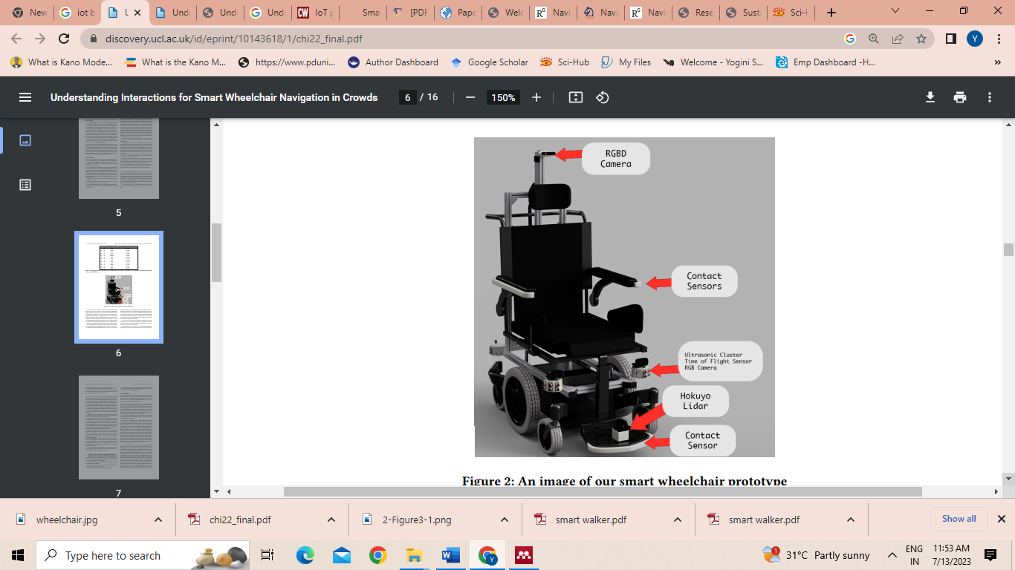

**Fig 11 smart wheelchair [28]**

6.4 IoT in prosthetics

The field of prosthetics deals with the development of artificial limbs to aid in the restoration of functionality to those who have lost or are missing one or more limbs. Early prosthetics were composed of wood, copper, iron, and steel, but their utility was restricted.

Prostheses have been used to restore the functions of the missing limb, e.g., cooking, feeding and dressing. Fully restoring the appearance and the function is challenging due to the large number of degrees of freedom involved. Nowadays advance prosthesis can be developed by using 3D printing and connected devices Patients with any type of amputation, whether upper or lower limb, can benefit from the use of connected devices in the field of healthcare equipment. These advantages may include doctors' capacity to remotely monitor patients with chronic and long-term illnesses, patients' ability to monitor their own data, and caretakers' ability to obtain essential data rapidly. With these objectives in mind, a prosthetic device and prototype based on the Internet of Things (IoT) and a mobile sensor platform were created. From years back IoT is playing an important role in prostheses it can be lower limb prostheses or upper limb prostheses[32]. While the concept of prostheses with IOT is still developing few are examples of prosthesis

1. Myoelectric prosthesis:- myoelectric prosthesis is the externally powered upper limb prosthesis, which uses IoT technology to achieve upper limb functions. it uses myoelectrodes which are placed over the muscle belly and it catches the signals from muscles as it contracts or expands and then amplifies the signals so the hand can function properly[33], [34]
2. Mind-controlled prostheses Researchers are researching combining IoT technologies with mind-controlled prostheses, which are prosthetic limbs that are controlled by neural signals from the user's brain. Brain-computer interfaces (BCIs) can be used in these prostheses to record the user's intention and transform it into precise motions of the prosthesis. IoT connectivity can be utilized to communicate and analyze brain data, allowing for real-time feedback and customization and modifications to improve control and functionality[35].
3. I-limb or microprocessor-controlled lower limb: - Though prosthetic legs improve movement for amputees, typical prostheses are passive, which means they cannot offer the necessary input to improve motor skills such as balance. Microprocessors paired with small motion control technology now enable dynamic prosthetic control, imitating the human reflex loop and improving the gait cycle of the wearer[32].
4. Sensor-Enabled Knee and Ankle Prostheses: Sensors that monitor movement patterns and joint angles can be included in IoT-enabled knee and ankle prostheses. This information can be wirelessly communicated to a smartphone or a central monitoring system, allowing physicians or users to track their stride and alter the prosthetic settings as needed[36].
5. Bionic hand:- Sensors in IoT-enabled bionic hands can capture data such as grip strength, finger position, and temperature. IoT technology can improve the functionality of bionic hands by including gesture recognition capabilities. This enables users to manage their prosthetic limbs more naturally, utilising sensors, cameras, or other IoT devices to precisely understand their motions. A user, for example, can contract their muscles in a precise way to initiate a specific movement in their bionic hand. IoT integration can allow bionic hands to communicate with smart home devices and virtual assistants. Users can use their bionic hand to control numerous IoT-enabled devices such as lights, thermostats, and appliances. This connection can considerably improve the user's convenience and freedom[37].

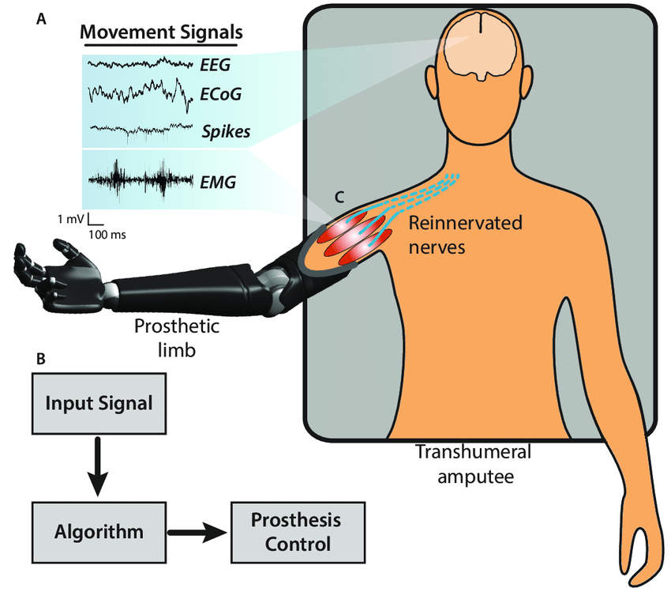

**Fig 12 -Working Of The Prosthetic Limb In Trans humeral Amputee[30]**

* 1. Orthotics

Orthotics is the external device worn by the patient with locomotor disabilities which improves their function , encourage proper alignment or protect existing limb , can be used by the patients in congenital abnormalities , paralysis , flat foot , osteoarthritis and other neuromuscular or musculoskeletal disorders. The utilization of IoT is still developing in this field to enhance functionality and user experience of orthotic devices . IoT enabled orthoses incorporate sensors to monitor various parameters like joint angle , pressure distribution or gait patterns. These sensors collect real time data about the user’s movement and biomechanics , so that any asymmetries , gait abnormality or pressure points can be detected, and this data can be transmitted wirelessely to healthcare professionals. Motion tracking sensors in IoT-enabled orthoses can give real-time feedback during rehabilitation exercises or functioning movements[38]. To encourage optimal movement patterns and adherence to recommended rehabilitation procedures, these gadgets can coach users through exercises, provide performance metrics, and provide visual or tactile feedback.

Some examples of orthosis with IoT are:-

1. Pressure sensing insoles :- Pressure sensors that can detect and track the distribution of pressure on the user's feet can be incorporated into IoT-enabled insoles. Real-time analysis of gait patterns, pressure points, and potential problem regions is possible thanks to the wireless transmission of this data to a mobile application or a healthcare professional. The data acquired can be used to make treatment decisions or improve the fit and design of orthotic devices[39].
2. Smart knee braces :- Knee braces with IoT technology can give real-time monitoring of joint movement and performance. During an activity, sensors can measure the range of motion, force, and knee angle. To gauge recovery progress or to offer advice on good biomechanics, the data gathered can be analysed. Medical practitioners can remotely monitor the data and modify the treatment plan as necessary[40].
3. Wearable back supports:- Back supports and braces with IoT capabilities can include sensors to monitor posture, movement, and spinal alignment. When users adopt improper postures or go above certain movement thresholds, these devices can give them immediate feedback and alerts, encouraging optimal ergonomics and lowering the risk of harm. Healthcare professionals can also receive the data for analysis and counselling[41].
4. Temperature and humidity monitoring IoT technology enables sensors to be incorporated into orthotic devices, which can then track the temperature and humidity levels at the point where the device and the user's body meet. This information can be helpful for evaluating comfort, locating potential skin irritation or moisture buildup, and refining the materials and design of orthoses[42].

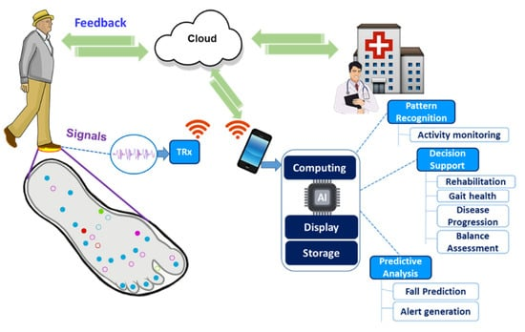

**Fig 13 Working of the pressure sensing insoles[34]**

**Table :1 – Some more evidences related to IoT in locomotor disability**

|  |  |  |  |
| --- | --- | --- | --- |
| S.no | Study title | Author’s and journal and year of publication | Finding |
|  | Iot based smart wheel-chair[29] | Dr. Pushpa D, Manasvi P Shetty Prakruthi M, Syed Haris, Vijayalakshmi  International Research Journal of Modernization in Engineering Technology and Science  2023 | In this study, authors worked on cost-effective IoT-based wheelchair that facilitate mobility and independence.It combines sensors, actuators, and communication modules with mobile app integration to enable obstacle detection and avoidance that provide users with enhanced mobility, safety, and freedom.. |
|  | A review of IoT systems to enable independence for the elderly and disabled individuals[43] | Perez, Alfredo J.  Siddiqui et.al  Internet of Things journal  2023 | In this study the author did a literature review on the rapid growth of IoT devices such as sensors and actuators has contributed to the development of smart homes, which include various types of IoT systems that provide enhanced convenience to persons with deteriorating physical and cognitive abilities. |
|  | Remote Monitoring of Physical Rehabilitation of  Stroke Patients Using IoT and Virtual Reality[44] | Octavian Postol ache  D. Jude Hemanth  Ricardo Alexandre et.al IEEE Journal on Selected Areas in Communications  2021 | This study uses physical rehabilitation monitoring that combines IoT, virtual reality games, and wearable sensor networks to boost patient engagement during physical therapy. It can be used in real-time circumstances for patients with stroke and other neurological disorders. |
|  | IOT-based Autonomous Wheelchair for Hospital  Environment[45] | Siddhant Pawar, Yogesh Kanade , Hemant Singh  International Journal for Research in Applied Science and Engineering Technology  2021 | The researchers of this study used IOT to control a wheelchair. The Wi-Fi module connects the wheelchair to the internet. The wheelchair's movement will be controlled by six Infrared sensors that will follow a map. An object-detecting system is also included in the automation. Obstacles can be detected using an ultrasonic sensor. Furthermore, the embedded system for fall detection in the event of an emergency, that will send an alert message via the IOT platform. |
|  | Smart Stair Lift for Disabled and Elderly[16] | Navya, K  Kumar, B Pavan  Mounika, G Hema  et.al ,  International Journal of Pure and Applied Mathematics  2018 | In this study author worked on stairlift, which is a mobile chair-like mobility device affixed to one side of stairways, improves access for the elderly between floors in homes and allows many people with mobility impairments to live independently with the help of the Internet of Things, this may also reduce the need of escalators or elevators. |
|  | Development of IoT based lower limb exoskeleton in rehabilitation[22] | Phong, Le Dinh  Long, Vu Ngoc  Hoang, et.al 2017 14th International Conference on Ubiquitous Robots and Ambient Intelligence, URAI 2017 | In this study author has developed the IoT based exoskeleton for the gait rehabilitation , which help the physical therapist to collect the data from the sensors for planning the further treatment. |

**Conclusion**

IoT has advanced significantly in recent years, and an extensive range of enabling technologies have been presented. The Internet of Things (IoT) has emerged as the next Internet trend. Every available thing is becoming intelligent. IoT research has a wide range of applications. Many new technologies will develop in the next years, propelling us to an entirely new degree of smartness. There are many problems in the assistive technologies which has been resolved by the IoT and all the application of IoT in various mobility aids are increasing day by day and enhancing the quality of life of people with locomotor disabilities.

**REFERENCES**

[1] P. Pant, V. B. Gupta, A. Khanna, and N. Saxena, “Technology foresight study on assistive technology for locomotor disability,” *Technol. Disabil.*, vol. 29, no. 4, pp. 163–171, 2018, doi: 10.3233/tad-170180.

[2] A. Khayatzadeh-Mahani, K. Wittevrongel, D. B. Nicholas, and J. D. Zwicker, “Prioritizing barriers and solutions to improve employment for persons with developmental disabilities,” *Disabil. Rehabil.*, vol. 42, no. 19, pp. 2696–2706, 2020, doi: 10.1080/09638288.2019.1570356.

[3] V. Tangcharoensathien, W. Witthayapipopsakul, S. Viriyathorn, and W. Patcharanarumol, “Improving access to assistive technologies: challenges and solutions in low- and middle-income countries,” *WHO South-East Asia J. public Heal.*, vol. 7, no. 2, pp. 84–89, 2018, doi: 10.4103/2224-3151.239419.

[4] B. E. Dicianno *et al.*, “The future of the provision process for mobility assistive technology: a survey of providers,” *Disabil. Rehabil. Assist. Technol.*, vol. 14, no. 4, pp. 338–345, 2019, doi: 10.1080/17483107.2018.1448470.

[5] A. V. F. Santos and Z. C. Silveira, “AT-d8sign: methodology to support development of assistive devices focused on user-centered design and 3D technologies,” *J. Brazilian Soc. Mech. Sci. Eng.*, vol. 42, no. 5, 2020, doi: 10.1007/s40430-020-02347-w.

[6] C. Widehammar, H. Lidström, and L. Hermansson, “Environmental barriers to participation and facilitators for use of three types of assistive technology devices,” *Assist. Technol.*, vol. 31, no. 2, pp. 68–76, 2019, doi: 10.1080/10400435.2017.1363828.

[7] S. Kadry, “Internet of things ( IoT ),” no. May, 2021, doi: 10.1088/978-0-7503-3663-5ch1.

[8] G. A. Francis, S. Lexmitha, N. A. Devi, and ..., “Embedded system based smart automation for elderly and disabled people,” *Ann. …*, vol. 25, no. 4, pp. 9909–9917, 2021, [Online]. Available: https://www.annalsofrscb.ro/index.php/journal/article/view/3738%0Ahttps://www.annalsofrscb.ro/index.php/journal/article/download/3738/3049

[9] M. Serror, S. Hack, M. Henze, M. Schuba, and K. Wehrle, “Challenges and Opportunities in Securing the Industrial Internet of Things,” no. May, pp. 1–12, 2021.

[10] R. A. J. M. Gining, S. S. M. Fauzi, A. F. A. Hadi, M. Z. A. Razak, and M. N. F. Jamaluddin, “Design and Development of Disabled Parking System for Smart City,” *J. Phys. Conf. Ser.*, vol. 1019, no. 1, 2018, doi: 10.1088/1742-6596/1019/1/012016.

[11] M. Km and D. Mk, “A Comprehensive Study on Human Interaction with IoT Systems,” no. May, pp. 8005–8014, 2020.

[12] W. Kim, “A Review of the Applications of the Internet of Things ( IoT ) for Agricultural A Review of the Applications of the Internet of Things ( IoT ) for Agricultural Automation,” no. December, 2020, doi: 10.1007/s42853-020-00078-3.

[13] N. M. Kumar and A. Dash, “The Internet of Things : An Opportunity for Transportation and Logistics,” no. June, 2018.

[14] M. Aboelmaged, Y. Abdelghani, M. A. Abd, and E. Ghany, “Wireless IoT based Metering System for Energy Efficient Smart Cites,” no. Icm, pp. 1–4, 2017.

[15] J. Suresh, “Inventory Management System Using IOT,” no. January, 2017, doi: 10.1007/978-981-10-2471-9.

[16] K. Navya, B. P. Kumar, G. H. Mounika, B. Vineeth, P. Rao, and P. Electronics, “Smart Stair Lift for Disabled and Elderly,” *Int. J. Pure Appl. Math.*, vol. 120, no. 6, pp. 4647–4660, 2018.

[17] W. Bengal, “Internet of Things : New Promises for Persons with Disabilities,” vol. I, no. I, p. 22, 2015, [Online]. Available: www.g3ict.org

[18] “A Case Study for Universal Design in the Internet of Things,” 2014, doi: 10.3233/978-1-61499-403-9-45.

[19] W. AL-mawee, “Privacy and Security Issues in IoT Healthcare Applications for the Disabled Users a Survey,” p. 50, 2012, [Online]. Available: https://scholarworks.wmich.edu/masters_theses%0Ahttps://scholarworks.wmich.edu/cgi/viewcontent.cgi?article=1661&context=masters_theses

[20] R. Das, A. Tuna, S. Demirel, and M. K. Yurdakul, “A Survey on the Internet of Things Solutions for the Elderly and Disabled: Applications, Prospects, and Challenges,” *Int. J. Comput. Networks Appl.*, vol. 4, no. 3, p. 1, 2017, doi: 10.22247/ijcna/2017/49023.

[21] M. J. Baucas, P. Spachos, and S. Gregori, “Internet-of-Things Devices and Assistive Technologies for Health Care: Applications, Challenges, and Opportunities,” *IEEE Signal Process. Mag.*, vol. 38, no. 4, pp. 65–77, 2021, doi: 10.1109/MSP.2021.3075929.

[22] L. D. Phong, V. N. Long, N. A. Hoang, and L. H. Quoc, “Development of IoT based lower limb exoskeleton in rehabilitation,” *2017 14th Int. Conf. Ubiquitous Robot. Ambient Intell. URAI 2017*, pp. 824–826, 2017, doi: 10.1109/URAI.2017.7992834.

[23] P. P. Sarkar, M. A. Tohin, M. A. Khaled, and M. S. Rahman, “Implementation of an Instrumented Crutch with Scalable E-Care Architecture Using IoT,” *2020 IEEE Reg. 10 Symp. TENSYMP 2020*, no. October 2022, pp. 242–245, 2020, doi: 10.1109/TENSYMP50017.2020.9230694.

[24] L. Frizziero, G. Donnici, A. Liverani, G. Alessandri, G. C. Menozzi, and E. Varotti, “applied sciences Developing Innovative Crutch Using IDeS ( Industrial Design Structure ) Methodology,” 2019.

[25] P. P. Sarkar, M. Asaduzzaman Tohin, M. Abdul Khaled, and M. Robiul Islam, “Design Process of an Affordable Smart Robotic Crutch for Paralyzed Patients,” *2019 IEEE Int. Conf. Robot. Autom. Artif. Internet-of-Things, RAAICON 2019*, no. October, pp. 112–115, 2019, doi: 10.1109/RAAICON48939.2019.6260845.

[26] M. M. Martins, C. P. Santos, A. Frizera-neto, and R. Ceres, “Assistive Mobility Devices focusing on Smart Walkers : Classification and Review”.

[27] A. Muammar, B. Yasin, L. W. Liong, P. S. K. Chua, and Z. Jianxin, “Smart Walker for Gait and Balance Rehabilitation,” vol. 138683, pp. 1–6.

[28] S. S. Nayak, P. Gupta, and P. A. B. Wani, “Wheel Chair with Health Monitoring System Using IoT,” *Int. Res. J. Eng. Technol.*, vol. 4, no. 5, pp. 1063–1067, 2017.

[29] D. Pushpa, M. P. Shetty, M. Prakruthi, S. Haris, and K. Vijayalakshmi, “IOT BASED SMART WHEEL-CHAIR,” no. 05, pp. 6023–6026, 2023.

[30] G. Barbareschi, T. Carlson, and C. Holloway, “Understanding Interactions for Smart Wheelchair Navigation in Crowds,” 2022.

[31] P.Manisha and M.Jagadheeshraja, “Smart Wheel Chair Using Iot,” *Int. J. Eng. Technol. Manag. Sci.*, no. 05, pp. 1–8, 2022, doi: 10.46647/ijetms.2022.v06i05.001.

[32] O. Fukuda, Y. Takahashi, N. Bu, H. Okumura, and K. Arai, “Development of an IoT-based prosthetic control system,” *J. Robot. Mechatronics*, vol. 29, no. 6, pp. 1049–1056, 2017, doi: 10.20965/jrm.2017.p1049.

[33] H. Wu, M. Dyson, and K. Nazarpour, “Internet of Things for beyond-The-laboratory prosthetics research,” *Philos. Trans. R. Soc. A Math. Phys. Eng. Sci.*, vol. 380, no. 2228, 2022, doi: 10.1098/rsta.2021.0005.

[34] L. Osborn, J. H. Medicine, and M. Iskarous, “Sensing and Control for Prosthetic Hands in Clinical and Research Applications,” no. January, pp. 0–26, 2020, doi: 10.1016/B978-0-12-814659-0.00022-9.

[35] T. Beyrouthy, S. Al Kork, J. A. Korbane, and M. Abouelela, “EEG Mind Controlled Smart Prosthetic Arm – A Comprehensive Study EEG Mind Controlled Smart Prosthetic Arm – A Comprehensive Study,” no. October, 2017, doi: 10.25046/aj0203111.

[36] H. Herr, “Innovation : Changing the Face of Disability”.

[37] T. Nadu, T. Nadu, T. Nadu, T. Nadu, and T. Nadu, “An Intelligent Bionic Person for Bomb Detection and Diffusion using Internet of Things ( IoT ) in Military Application,” vol. 6, no. 3, pp. 1029–1038, 2021.

[38] M. Hnatiuc, O. Geman, A. G. Avram, D. Gupta, and K. Shankar, “Human signature identification using iot technology and gait recognition,” *Electron.*, vol. 10, no. 7, 2021, doi: 10.3390/electronics10070852.

[39] “Insole-Based Systems for Health Monitoring : Current Solutions,” 2022.

[40] A. J. Turner *et al.*, “Closing the Wearable Gap — Part VIII : A Validation Study for a Smart Knee Brace to Capture Knee Joint Kinematics,” pp. 152–162, 2021.

[41] S. Toxiri *et al.*, “Back-Support Exoskeletons for Occupational Use : An Overview of Technological Advances and Trends,” *IISE Trans. Occup. Ergon. Hum. Factors*, vol. 7, no. 3–4, pp. 237–249, 2019, doi: 10.1080/24725838.2019.1626303.

[42] M. P. de Freitas, V. A. Piai, R. H. Farias, A. M. R. Fernandes, A. G. de Moraes Rossetto, and V. R. Q. Leithardt, “Artificial Intelligence of Things Applied to Assistive Technology: A Systematic Literature Review,” *Sensors*, vol. 22, no. 21, pp. 1–20, 2022, doi: 10.3390/s22218531.

[43] A. J. Perez, F. Siddiqui, S. Zeadally, and D. Lane, “A review of IoT systems to enable independence for the elderly and disabled individuals,” *Internet of Things (Netherlands)*, vol. 21, no. December 2022, p. 100653, 2023, doi: 10.1016/j.iot.2022.100653.

[44] O. Postolache, D. J. Hemanth, R. Alexandre, D. Gupta, O. Geman, and A. Khanna, “Remote Monitoring of Physical Rehabilitation of Stroke Patients Using IoT and Virtual Reality,” *IEEE J. Sel. Areas Commun.*, vol. 39, no. 2, pp. 562–573, 2021, doi: 10.1109/JSAC.2020.3020600.

[45] S. Pawar, “IOT based Autonomous Wheelchair for Hospital Environment,” *Int. J. Res. Appl. Sci. Eng. Technol.*, vol. 9, no. 5, pp. 715–724, 2021, doi: 10.22214/ijraset.2021.34293.