Biosecurity Practices for Health Management in Aquaculture

Yashwee Shrivastava

M.F.Sc. Scholar, Aquatic Animal Health Management ICAR-Central Institute of Fisheries Education, Mumbai Email- yashwee0307@gmail.com
Abstract

Global production of aquaculture has doubled over the past decade, making it one of the world's fastest-growing food production sectors. It is fulfilling the growing demand for seafood around the world, serving as a substantial source of protein and sustaining the livelihoods of millions of people. Fisheries heavily impact many countries’ Gross Domestic Product (GDP). Countries generate revenue through the sale of farmed fish and seafood products both domestically and internationally. The current trend in fish farming is intensification and commercialisation. However, as this industry is expanding and adapting intensive farming, concerns about disease occurrence are also growing. Over the years, many attempts have been made to avoid and control disease outbreaks in aquaculture. It has been observed that the best method to manage fish health is to adopt biosecurity practices. A biosecurity program is a set of procedures, protocols, and measures designed to prevent the entry and transmission of diseases and pathogens within the facility. This chapter describes the role of biosecurity and different health management measures to minimise disease risk in aquaculture.
Keywords: Disease risk, Biosecurity, Intensive farming, Pathogens, Health management

Introduction- Health management in aquaculture is now considered one of the most essential aspects of aquaculture development and management. Over the years, severe and significant damage to the sector in different parts of the world has caused considerable economic damage. In shrimps and fishes, numerous OIE-listed diseases, such as Epizootic Ulcerative Syndrome, Spring Viraemia of Carps, Koi Herpes Virus, White Spot Syndrome Virus, Taura Syndrome Virus, etc, inflict severe losses in this industry. Also, some newly emerging diseases, such as Tilapia Lake Virus, Viral Haemorrhagic Septicaemia Virus, etc., are severe risk to current practices. To stop the spread of diseases, importing nations may apply trade restrictions. Export restrictions or onerous testing requirements make it more difficult for impacted countries to access global markets, which causes a reduction in export earnings and leads to national

economic losses. Numerous reasons, such as the introduction of diseased or pathogen-carrying fishes into aquaculture facilities, unhygienic culture techniques, contaminated water supplies, contaminated feed, etc., might contribute to this condition. Biosecurity procedures are essential to prevent these disease outbreaks. A control and verification approach based on the hazard analysis and critical control points (HACCP) methodology must be applied to biosecurity measures (Zepeda et al., 2008).

What is Biosecurity:

The term "biosecurity" describes the precautions taken to prevent, control and minimise the spread of infectious diseases inside and between populations. It can be defined as "an essential group of tools for the prevention, control, and treatment of infectious diseases and the preservation of human, animal, and environmental health" (Lee & O'Bryen, 2003). According to FAO, 'biosecurity' is a strategic and integrated approach encompassing policy and regulatory frameworks aimed at analysing and managing risks relevant to human, animal and plant life and health, including those associated with the environment. It addresses zoonoses, transferring pests and pathogens to plants and animals, genetically modified organisms (GMOs), and invading alien species. The World Trade Organization's Agreement on Sanitary and Phytosanitary Measures (WTO's SPS Agreement), the primary regulatory framework controlling biosecurity, highlights the necessity to use risk assessments as a foundation for adopting any SPS measures (Subasinghe et al., 2006).

Objectives of Biosecurity:

- The primary goal of biosecurity practices is to prevent the entry of pathogens into aquaculture facilities.
- It seeks to reduce disease transmission inside a farm or from one farm to another. It is crucial to check on and test the farm's aquatic animals regularly.
- Early disease detection made possible by surveillance enables the implementation of quick and efficient management solutions.
- By implementing biosecurity procedures, farms can reduce the chances of disease outbreaks, improve the general health of aquatic populations, and guarantee sustainable and profitable production.
- It also provides security to human health from zoonoses and promotes one health concept.

Principles of Biosecurity:

The fundamental principles that protect fish health and restrict pathogen proliferation form the basis of aquaculture biosecurity. These principles demand strict sanitary practices to control the entry and transmission of disease. Understanding risk factors for disease outbreaks can help identify hazards. It also aims to take prophylactic measures against them and choose the appropriate biosecurity practices.

Risk factors:

In aquaculture farms, disease can be transmitted by various routes, including:

- Water- Many pathogens can enter aquaculture systems with water used for culture. Contamination risk can increase while using untreated water. These pathogens can flourish in an environment with poor water quality management, inadequate sanitary procedures, and overcrowding. Water discharge from one farm can also contaminate the water of other farms.
- Seed and broodstock- If the seed or broodstock is obtained from a hatchery or supplier with poor biosecurity measures, there is a higher risk of introducing pathogens. When infected broodstock is used for breeding, their offspring can inherit these diseases, perpetuating the infection cycle in subsequent generations.
- Feed- Commercially prepared feed is generally free of pathogens but, if stored improperly, can get spoiled or contaminated with pathogens. Some fungi like Aspergillus sp. can grow on feed that produces harmful mycotoxins that cause lethal hepatic carcinoma in fishes. At early life stages and in broodstock rearing, fishes are fed with live feed organisms like Artemia, rotifers, Tubifex, earthworms, etc. These live-feed organisms can act as vectors or carriers for many pathogens (e.g., Tubifex are paratenic hosts of Nematode parasites, and midge fly egg masses that develop into bloodworms harbour some Vibrio species).
- Workers and visitors- People, including workers, staff from other farms, visitors, contractors and other members, can present a significant risk of disease transmission onto the farm. Humans can carry pathogens on their bodies, clothing, and equipment, and poor hygiene practices among workers or the lack of biosecurity measures introduce these harmful microorganisms into the aquaculture setting.
- Pest and animals- Wild animals such as birds, monkeys, dogs and aquatic species can carry a variety of pathogens. When these animals enter aquaculture facilities, they can introduce disease-causing organisms into the farm environment. Wild animals can deposit

faeces and other organic matter into aquaculture ponds or tanks, causing faecal transmission of pathogenic microorganisms.
- Vehicle and equipment- Equipment used in aquaculture, such as nets, pumps, gears, etc, can become contaminated with pathogens from previous uses or contact with contaminated environments. Vehicles, such as trucks or boats, can carry pathogens from one location to another, spreading diseases between farms or aquatic ecosystems.
- Biosecurity protocols- Enforcing a robust biosecurity program is necessary to sustain aquatic animals' health and well-being. Here are the basic components of an effective biosecurity program in aquaculture.

Farm site selection and design:

To adhere to fundamental biosecurity protocols, choosing a suitable location for establishing an aquaculture facility is necessary. This decision should reflect factors such as water quality, distance from wild populations, and nearness to possible disease sources. The design of the facility should reduce the risk of pathogen entry by utilising physical barriers (fencing, cover net, lining, etc.) along with controlled access points. The location should permit the enforcement of stringent biosecurity measures and regulation of access of personnel, equipment, and visitors into the farm.
To maintain sanitation, facilities for farm workers, such as toilets, should be situated far from the culture units to prevent water contamination. A farm should have an isolated quarantine facility, water treatment unit, disinfection stations, etc. Furthermore, ensuring complete autonomy and segregation among production, processing, and recreational areas is crucial (Patra,2014).

Stocking:

Pathogens are always present in the pond environment. The main issue revolves around entering new disease organisms or inducing environmental deterioration, which can amplify the populations and virulence of existing pathogens. The disease outbreaks in wild stocks can result from pathogen spills from aquaculture farms or the entry of cultured animals into the wild (Pillay,2004). Buying seed or broodstock from a hatchery lacking proper biosecurity measures significantly increases the chances of introducing pathogens into the aquaculture system. Therefore, it is vital to stock ponds with certified, disease-free fish from reputable suppliers (Patra,2014). After harvest, many pathogenic spores, parasites and pests can survive

in pond bottom for many days. Pond drying and liming before stocking new fish is done to destroy all pathogenic organisms in the pond bottom (fig.1). Before releasing new seeds into pond water, seed disinfection is done by dipping the transportation bag in KMnO4 disinfectant (fig.2) to minimise the risk of entry of pathogen in the pond.
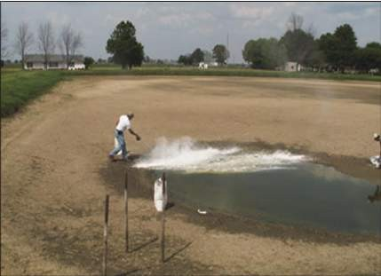
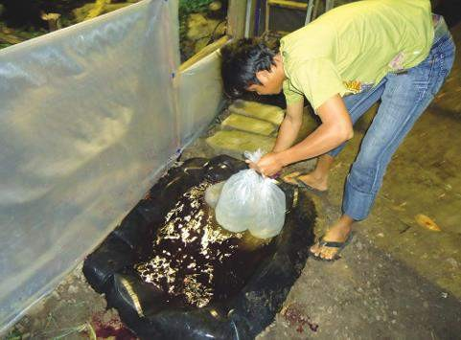
Fig.1 Disinfection of pond bottom by liming Fig.2 Dipping of seed bag in KMnO4 solution
(INFOFISH International, 2013)

Quarantine:

Quarantine, as defined by the World Organisation for Animal Health (OIE), involves isolating a group of aquatic animals with no direct or indirect contact with others. This isolation period allows for observation, testing, and appropriate treatment, including the proper management of effluent waters. In aquaculture health management, a quarantine facility plays a crucial role. It offers a controlled environment where new fish stocks, equipment, and materials can be isolated, monitored, and tested (Arthur et al.,2008). Quarantine not only prevents the introduction of diseases and pathogens into the culture facility but also gives new fishes time to acclimate in a new environment and to recover from handling and transport. Here are critical considerations for establishing a quarantine facility in fish farms:
- Location and Design: A quarantine unit in a farm must be situated in an isolated area, away from other fish hatcheries, farms, water bodies, or flood-prone areas. Facility design should incorporate multiple tanks or compartments to separate different groups of fish and equipment, ensuring no cross-contamination. The quarantine facility must be located within a separate operational unit, completely segregated from all other activities. This structural separation ensures that the facility is designated explicitly for holding new fish stocks and does not share a building with areas used for other purposes.

- Facility requirements: Tanks and holding areas must be constructed with designs that facilitate easy cleaning and disinfection. Water treatment, screening, aeration, and water quality testing arrangements are needed to sustain a safe environment for new stocks. Installing screens or barriers can effectively prevent contact with wild aquatic organisms. It must be well-equipped to sterilise all gears and tools that come in contact with fish or water or any potential source of contamination during the quarantine period. Developing and enforcing strict biosecurity protocols for personnel and visitors entering the quarantine facility is required. All individuals change into facility-specific clothing and footwear, practice thorough hand hygiene, and adhere to designated disinfection procedures.
- Stock isolation: This involves isolating all incoming fish stocks, tools, and materials in the quarantine unit for a specified number of days. During this time, regular monitoring and observation of animals for gross signs, stress, or behavioural change are conducted. Additionally, periodic health assessments, including rapid disease testing and molecular and protein-based diagnosis, are implemented to detect and confirm the absence of diseases.
- Disease management: If a disease is identified in a new shipment, affected fish must be immediately isolated, and suitable treatment protocols should be initiated.
- Documentation and records: Making comprehensive records of all activities during fish quarantine, including health assessments, treatments, and test results, is necessary. Complete documentation during the quarantine period is essential for health management, adhering to regulations, and assessing the efficiency of quarantine procedures.
- Water disinfection- Water utilised in an aquaculture facility must undergo rigorous testing to ensure its safety. Sources such as borewells and spring water are much less likely to harbour significant levels of pathogens. Before introducing new fishes, water should be adequately treated. Methods such as chlorination and exposure to UV light or ozone are effective. UV light with a wavelength of approximately 254 nm can penetrate cells and damage the genetic material and proteins of microorganisms present in water. Chlorine compounds like sodium hypochlorite or calcium hypochlorite are the most commonly used disinfectants for water supplies. The concentration of disinfectant depends on the water source, organic load, and specific pathogens targeted. Treated water should be dechlorinated (using sodium thiosulfate or another appropriate product) and then tested for residual chlorine. It is imperative that each fish holding facility has an independent water supply, and the flow from one tank or pond to another should be strictly avoided to maintain biosecurity (WOAH,2009).

Feed management:

Poorly stored feed may harbour pathogens; they should be tested before feeding them to fish. Strict quality control measures during feed production can ensure that feed is free from contaminants and pathogens. Adequate storage conditions, including temperature and humidity control, prevent feed spoilage and bacteria/fungi growth. Live foods may harbour pathogens. Live food culture vessels should be sanitised and disinfected regularly. Pathogen load in live food can be reduced by rinsing newly hatched live food organisms with sodium or calcium hypochlorite, or iodine. These live feeds should be tested before feeding them to fish.

Farm hygiene:

This includes critical practices in aquaculture farms to maintain a clean and pathogen-free environment, ensure the health of the aquatic animals, and promote efficient production. Staff should be trained in hygienic fish handling and management. There are several disinfection methods used in aquaculture. Physical methods of disinfecting equipment include heating and sun-drying. Chemical disinfectants are chosen based on their effectiveness against the target pathogens and compatibility with the aquaculture system. Common disinfectants include Quaternary Ammonium Compounds (QACs), chlorine-based compounds, and hydrogen peroxide. To help prevent the introduction of diseases, the use of disinfectant footbaths, hand- washing areas, net disinfection stations, showers, and vehicle disinfection stations is crucial. Hand sanitisation with 60 to 90% alcohol, either an alcohol (isopropyl) spray bottle or a gel product, destroys harmful pathogens. Nets should be disinfected after use to prevent the transmission of pathogens from one group of fish to another (fig.3). Disinfectants used in net dips include QACs that are benzalkonium chlorides and benzethonium chlorides, are cationic surfactant disinfectants. (WOAH,2009). In commercial footbaths, chlorine compounds (sodium or calcium hypochlorite) and Potassium permanganate are commonly used as disinfectants (fig.4). Vehicles that travel from one farm facility to another may carry pathogens on their wheels. Having drive-through disinfection stations at entrances and exits can help reduce this risk (fig.5).

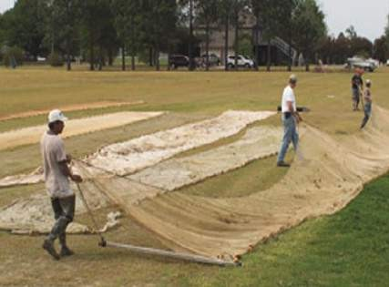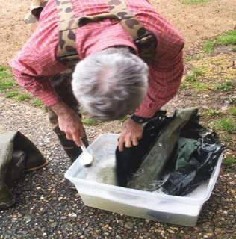
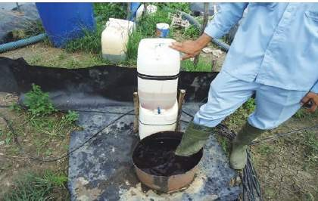
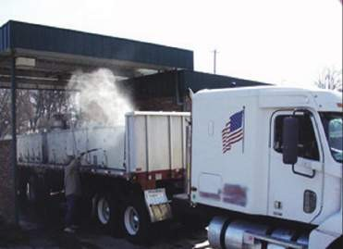
(Fig.3) Disinfection of nets and other equipment.
(Fig.4) Foot baths (Fig.5) Trucks and other vehicles disinfection Source- Sadler,2007

Pest and animal control:

This involves the use of fencing, bird nets, and other physical barriers. The net can cover the top of the pond to prevent birds, flying objects, etc. A brick wall or net fencing can control the movement of crabs, snakes, zooplankton, etc, from one pond to another pond. Installed cameras and other surveillance tools can detect and deter animals. Use of non-lethal scare tactics, sirens, scarecrows, bells, reflective tape, or visual deterrents to deter birds and other animals from approaching the farm. Birds can carry viruses, causing infectious pancreatic necrosis (IPN) and Viral nervous necrosis (VNN). The possibility exists of infection being transmitted through faecal matter (Pillay,2004). Regular pest management control must be applied to prevent disease spread by vermin or predators.

Immunisation:

A new technique of disease prevention is through immunisation with vaccines. These vaccines stimulate the immune system of the animals, preparing them to fight off infections more

effectively. Vaccines reduce the severity of disease losses, minimise the need for antibiotic use, do not leave residues in fish bodies and do not induce pathogen resistance. There are currently many commercially available vaccines for finfish diseases like the IHNV DNA vaccine, IPNV inactivated vaccine, etc. (Ma et al., 2019). Another approach to increase disease resistance is the use of probiotics and immunostimulants. These compounds boost or stimulate the innate immune system of farmed fish and shrimp.

Effluent discharge:

Appropriate processing of wastewater before discharge is crucial to prevent pathogen spills in the nearby farms and natural water bodies. Water used for culture, hatching, or quarantine should be treated before releasing into the environment. Disinfection of wastewater is done at three levels. Initially, it is released in a sedimentation tank where large debris and contaminants are eliminated. Then, the water is treated with chlorine compounds. Chlorination of effluents at 200mg/l total chlorine for 2 hours is recommended (Pillay, 1993). It is necessary to do dechlorination of treated water before discharge. It is done with vigorous aeration and neutralisation using sodium thiosulphate. Farmers are embracing the zero water exchange system to cut down costs associated with decontamination processes in the fill and exchange water systems (Lightner,2005). This approach provides an ecologically sustainable and economically feasible alternative to traditional fish and shrimp cultivation methods, where the water within the aquaculture facility is continuously recycled and reused.

Dead fish dumping:

Dumping carcasses of infected fish into natural waterways is another practice that contributes to increased populations of pathogens in the environment. Animals that die from infectious diseases are a significant source of pathogens. It is essential, therefore, to remove sick and dead individuals to minimise the presence of pathogens in the environment. Collection and destruction of dead fish in such a way as to prevent the dissemination of pathogens is, therefore, a legal requirement in fish farms in many areas.

Surveillance:

The primary purpose of aquatic animal disease surveillance is to provide scientifically accurate, cost-effective information to assess and manage risks of disease transfer in and out of the farm. Proper, regular veterinary checks should be undertaken for fish disease and health. This is an important step towards building essential information for instituting control and eradication

measures and supporting early warning, risk assessment, contingency plans and emergency preparedness programmes for aquatic animal diseases and epizootics.

Record keeping:

Detailed and regular documentation of several aspects of the aquaculture operation, such as water quality parameters, stock transportation, health assessments, treatment measures, disease incidents, staff training, workers and visitor’s logs, enables farm managers to track trends, identify patterns, and respond effectively to emerging threats. By maintaining comprehensive records, aquaculture operators can establish baseline data, monitor changes over time, and assess the effectiveness of biosecurity measures.

SPR, SPF, SPT:

Stocking ponds with seeds that are devoid of a specific disease or that show resistance towards particular disease-causing organisms or stocks tolerant of specific pathogens is the most crucial aspect of a biosecurity programme. One example of SPF stock is White-leg shrimp, which enabled aquaculturists to grow healthy shrimps devoid of disease-causing organisms (Lightner,2005).
An SPF animal undergoes rigorous tests for at least two years to ensure they are free from specific pathogens. They are raised in highly hygienic culture facilities, adhering to strict sanitary practices and grown in disease-free environments. Therefore, the SPF designation mainly refers to the sanitary status of the animal, determined by the culture conditions under which it has been raised and maintained. It only refers to its sanitary status, and this trait is not genetically inheritable. When these animals are exposed to potential pathogens and the sanitary standards are compromised, the animal loses its SPF designation. Such animals are called High Health (Sanz,2018). The first naturally derived SPF stock was P. vannamei in Hawaii (Wyban 2007; Lightner 2011). After this, Shrimp production was revolutionised with the replacement of P. monodon with P. vanammei. To ensure a shrimp stock is claimed to be Specific Pathogen Free (SPF), it must be verified that it is free from the pathogens listed in the OIE Code and Manual. These pathogens include Vibrio isolates causing Acute Hepatopancreatic Necrosis Disease (AHPND), infection with Hepatobacter Penaei causing Necrotising Hepatopancreatitis (NHP), infectious hypodermal and haematopoietic necrosis virus (IHHNV), infectious myonecrosis virus (IMNV), Taura syndrome virus (TSV), white spot syndrome virus (WSSV), and Yellow Head Virus (YHV- genotype 1). Any claim of

SPF status for shrimp stock must be supported by evidence confirming the absence of these pathogens as per the OIE standards and guidelines. (Sanz et al.,2018).
In contrast, Specific pathogen-resistant (SPR) shrimp production generally results from a selective breeding programme designed to enhance resistance to a particular disease. It denotes an animal's genetic trait that transfers from one generation to another.
Whereas, Specific pathogen tolerant (SPT) stocks are susceptible to infection by a particular pathogen but typically do not exhibit evident signs of disease. This tolerance to disease expression is quantitative and relies on the animal's genetic makeup, the pathogen's specific strain and environmental conditions influencing the disease. It is important to note that the term "Specific Pathogen Tolerant" does not indicate the overall health status of an animal stock; instead, it refers to the genetic traits of the stock.

Shrimp toilet:

The sludge deposition at the bottom of the pond is the main reason for the occurrence of several diseases in shrimp farms. The feed waste and the faecal matter released by shrimps deposit at the bottom of the pond where anaerobic conditions exist, which leads to the formation of ammonia and hydrogen sulphide that causes stress in aquatic animals. Stressed animals are more susceptible to infections by opportunistic pathogens. To avoid this kind of problem, farmers in Southeast Asian countries, Bangladesh and India are adopting the construction of shrimp toilets at the centre of the pond. About 5-7% area of the pond is needed to construct shrimp pits. Ideally, the size of the pond should be about 1000-5000 m2 for pit construction. Establishments include 7-10 feet of concrete cement with a smooth slope to the centre and a small well of about 2-3 feet depth. A slope of 25-30o at the centre allows the flow of waste toward the central pit (fig.6). Aeration also helps in continuous water movement, so the waste materials will be dragged into the well. The waste can be removed by siphoning or using a pump every week to enhance the water quality and provide a stress-free environment for shrimps (Kawahigashi,2018).

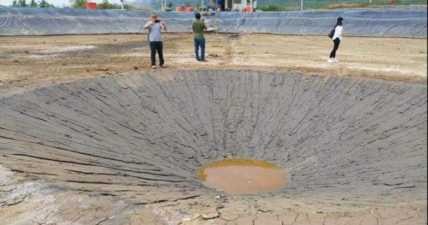
Fig. 6 Shrimp toilet (by Kawahigashi,2018)

Future perspective:

As we move towards the future, several trends and developments are expected in the field of aquaculture. The use of advanced genomic techniques for real-time detection of pathogens enables quicker response to disease occurrence. The continued vaccine developments and immunostimulant technologies can reduce the need for antibiotics and chemicals. Breeding disease-resistant strains of aquaculture species to enhance innate immunity is becoming popular. Development and implementation of international biosecurity standards and regulations, fostering collaboration among nations, and preventing the transfer of diseases across borders. Enhanced information-sharing among countries and regions can combat OIE- listed and emerging diseases collectively. The future of biosecurity practices in aquaculture relies heavily on technological innovation, international collaboration, sustainable practices, and education. By addressing these areas, the aquaculture industry can effectively mitigate disease risks, ensure environmental sustainability, and provide a safe and reliable source of seafood for the growing global population.

Conclusion:

Biosecurity practices are essential for the sustainable growth of the aquaculture industry. As global demand for seafood rises, implementing stringent biosecurity measures is vital in

preventing and controlling the spread of diseases in aquaculture facilities. This chapter has outlined biosecurity principles, emphasising the importance of early detection, proper quarantine protocols, water treatment, farm hygiene, and comprehensive record-keeping. Additionally, advancements in genetics, vaccine development, and international collaboration are shaping the future of aquaculture biosecurity. By embracing innovative technologies, adhering to international standards, and promoting cooperation, the aquaculture sector can effectively manage disease risks, ensure food safety, and contribute to the well-being of both aquatic populations and human consumers.

References:
- Arthur, J.R.; Bondad-Reantaso, M.G.; Subasinghe, R.P. Procedures for the quarantine of live aquatic animals: a manual. FAO Fisheries Technical Paper. No. 502. Rome, FAO. 2008. 74p.
- Kawahigashi, D. (2018). New Paradigm for Controlling EMS/APHNS in Intensive P. vannamei Boone 1931 Culture Ponds. Asian Fisheries Science 31S. pp. 182–193.
- Lee, C.-S. and O’Bryen, P.J. (2003). Biosecurity in aquaculture production systems: exclusion of pathogens and other undesirables. The World Aquaculture Society, Baton Rouge, Louisiana, USA. pp. 293.
- Lightner, D.V. (2005). Biosecurity in shrimp farming: Pathogen exclusion through use of SPF stock and routine surveillance. Journal of the World Aquaculture Society. 36. 229-248.
- Lightner, D.V. (2011) Status of shrimp diseases and advances in shrimp health management. In: Bondad-Reantaso MG, Jones JB, Corsin F, Aoki T (eds) Diseases in Asian Aquaculture VII, pp. 121–134. Fish Health Section, Asian Fisheries Society, Selangor, Malaysia.
- Ma, J., Bruce, T.J., Jones, E.M., and Cain, K.D. (2019). A Review of Fish Vaccine Development Strategies: Conventional Methods and Modern Biotechnological Approaches. Microorganisms. 7(11): 569.
- Patra, N.C. (2014). OIE and Healthcare and Management. Aquatic Animal Diseases and Management. pp. 135-139. Narendra Publishing House, Delhi.
- Pillay, T.V.R. (2004). Birds and Mammals in Aquaculture. Aquaculture and Environment. (2nd Ed). pp. 97-101. Blackwell Publishing, UK.
- Pillay, T.V.R. (2004). Pathogens in the Aquatic Environment. Aquaculture and Environment. (2nd Ed). pp. 92-96. Blackwell Publishing, UK.

- Pillay, T.V.R. and Kutty, M.N. (2005). Health and Diseases. Aquaculture Principles and Practices (2nd Ed). pp. 201-242. Blackwell Publishing, UK.
- Sadler, J. and Goodwin, A. (2007). Disease Prevention on Fish Farms. Southern Region Aquaculture Centre. 4703
- Sanz, V.A. (2018). Specific Pathogen Free (SPF), Specific Pathogen Resistant (SPR) and Specific Pathogen Tolerant (SPT) as Part of the Biosecurity Strategy for Whiteleg Shrimp (Penaeus vannamei Boone 1931). Asian Fisheries Science 31S (2018): 112–120
- Sanz, V.A., Brock, J., Flegel, T.W., McIntosh, R., Reantaso, M.R., Salazar, M., and Subasinghe, R. (2018). Facts, truths and myths about SPF shrimp in Aquaculture. Reviews in Aquaculture. pp. 1-9.
- Sivaramakrishnan, T., Renganathan, R., and Praveen, R.J. (2013). Culture practices in a bio-secure shrimp farm in Indonesia. INFOFISH International. pp. 26-32.
- Subasinghe, R.P. and Reantaso, M.B.G (2006). Biosecurity in Aquaculture: International Agreements and Instruments, their Compliance, Prospects, and Challenges for Developing Countries. Aquaculture Biosecurity Prevention, Control and Eradication of Aquatic Animal Disease. (Scarfe, A.D., Lee. C.S. and O’Bryen, P.J). pp. 9-15. Blackwell Publishing, UK.
- WOAH. (2009). Methods for disinfection of aquaculture establishments. Manual of Diagnostic Tests for Aquatic Animals, 2009. World Organisation of Animal Health. pp. 31- 42.
- Wyban J (2007) Thailand’s white shrimp revolution. Global Aquaculture Advocate May– June:56–58.
- Zepeda, C., Jones, J.B., & Zagmutt, F.J. (2008). Compartmentalisation in aquaculture production systems. Rev. sci. tech. Off. int. Epiz. 27. pp. 229-241.

