Hydrogeochemistry and Quality assessment of Groundwater in Coastal area of Mahabalipuram, Chennai, India

Ramachandran .A., Krishnamurthy. R.R., Gopal .V., and Nandhakumar .S
Department of Applied Geology, School of Earth and Atmospheric Sciences,
University of Madras, Guindy Campus, Chennai 600025, India
Corresponding author Email: ramugeo88@gmail.com

Abstract

The present study is to investigate the Groundwater quality along the coast in the parts of Kanchipuram district, east coast of Tamil Nadu. 72 Groundwater samples were collected during pre monsoon (PRM) and post monsoon (POM), and analyzed for pH, EC, Total dissolved solids (TDS), Bicarbonate, Chloride, Sulphate, Nitrate, Calcium, Magnesium, Sodium, Potassium and Total hardness. Spatial distribution maps were prepared for all the physicochemical parameters using GIS.
The results were evaluated and compared with WHO and BIS water quality standards.
The conventional techniques such as trilinear piper plot, Statistical techniques are widely accepted methods to determine the quality of water and nature of contaminants. The problems of ground water quality are more acute in areas that are coastal and have shallow groundwater tube wells.
Results revealed that the groundwater is fresh to brackish and moderately high to hard in nature. Na and Cl are dominant ions among Cations and Anions. Chloride, Calcium and Magnesium ions are within the allowable limit except few samples. According to Gibbs diagram, the predominant samples fall in the rock–water interaction dominance field. The Piper, Trilinear diagram shows that groundwater samples are Na–Cl and mixed Ca-Mg-Cl type. Based on the WQ results majority of the samples are falling under excellent to good category and suitable for drinking water purposes. The USSL graphical geochemical representation of groundwater quality suggests that majority of the water samples belongs to high and medium salinity with low alkali hazards. Correlation analyses and factor analyses were applied to classify the groundwater samples and to identify the nature and origin of contaminants in groundwater and leaching of secondary salts are the dominant factors controlling hydro geochemistry of groundwater in the study area. This study also illustrates the usefulness of statistical analysis to improve the understanding of groundwater systems. Results of the study indicate that all the groundwater samples are found to be suitable for irrigation purpose. .
Key words: Groundwater, Coastal, Spatial diagram, Piper diagram, SPSS

1. Introduction
Ground Water plays a vital role in the basic survival of living beings. The various factors such as industries, sewage disposal are influencing the groundwater quality and deteriorate its portability. Most of the people are using groundwater as the prime source for drinking in many rural and urban areas. Ramachandran and Sivakumar et al., (2020) investigated evaluation of potable groundwater zones identification based on WQI and GIS technique in Adyar river basin is categorized under very poor to unsuitable category. The region of Adyar river basin is recommended for implementation of artificial groundwater recharging to improve the groundwater quality and makes it suitable for drinking. Aishwarya (2021) investigated assessment of spatial distribution of physic-chemical parameters of groundwater around kodungaiyur dump yard highlighted the testing and spatial representation using GIS helps in monitoring and managing water contaminated in the study area. Annapoorani, et .al., (2013) has published a paper on the topic of groundwater analysis on the coastal area of Chennai city, Tamilnadu in which they have described that the effects of the intrusion of salt water into the groundwater basins in the coastal basins and the effects that has changes that have been caused in the geochemical properties such as the TDS, pH, EC, along with the cations the anions that are present in the groundwater surrounding the study area. Elango and Gnanasundar (1999) made an assessment of groundwater quality of a coastal aquifer, south of Chennai, using geo-electrical techniques. Coastal environment plays important role in resources, productive habits and rich biodiversity. In coastal areas, to meet the demands of domestic, agricultural and industrial needs, groundwater is the only source of water. Elango et al. (1992) examined groundwater quality in the coastal regions of South Madras. Results showed that Na⁺ and Cl⁻ were the dominant ions in the groundwater. Lakshmanan et al., (2003) reported the major ion chemistry of hydro-geochemical processes of groundwater in parts of Kancheepuram district, Sridhar et al. (2013) the chemical composition of groundwater is strongly influenced by rock-water interaction, dissolution and deposition of carbonate and silicate minerals, ion exchange and surface water interaction in Kanchipuram District, Tamil Nadu, India. Panigrah et al., 1996; Atwia et al., 1997; Ballukraya and Ravi, 1999; Ramappa and Suresh, 2000). Many studies have been carried out on contamination due to metal concentration in surface water and groundwater (Asubiojo et al., 1997; Klavins et al., 2000; Leung and Jiao, 2006; Kaushik et al., 2009; Mansouri et al., 2012). A few studies have been conducted in Chennai for assessing the metal contamination. Effect of anthropogenic activities and increased human population on groundwater quality and its variation were studied by hydro chemical analyses (Ramesh and Purvaja, 1995; Kumaresan and Riyazuddin, 2008; Jayaprakash et al., 2012). Majumdar and Gupta (2005) studied the chemical composition of groundwater and stated that it is controlled by several factors that include composition of precipitation, anthropogenic activities, geological structure and mineralogy of the watershed and aquifer within the aquifer medium. The District has a total coastline length of 87.2 Km, and is located 36 Meter above Mean Sea Level (MSL). The southeast coast of India is an important stretch of coastline, where many major rivers drain into the Bay of Bengal and they are also rich in marine fauna and flora (Rajkumar et al., 2011).The present study deals with the Ground water quality along Kanchipuram district, Coastal area between Kovalam and Mahabalipuram Tamil Nadu, India.
II. Study Area
The study area comprise Chennai coast covering a linear extent of 10 Km from Kovalam to Mamallapuram, Kanchipuram district. Geographically study area lies between 12⁰ 35’ to 12⁰ 50’ East Latitude and 80⁰ 12’ to 80⁰ 16’ North Longitude. The study area map is shown in Fig 1.The major water bearing formation being the coastal sands extending 30-40feet. Sand thickness is increasing towards coast. In many places the coastal water is brackish in nature due to the presence of Buckingham canal running parallel to the coast. The major zone of ground water occurrence is the Palar mouth where the Palar river bed acts as a potential formation. The important mineral found in this stretch is silica sands along the Mahabalipuram coast.

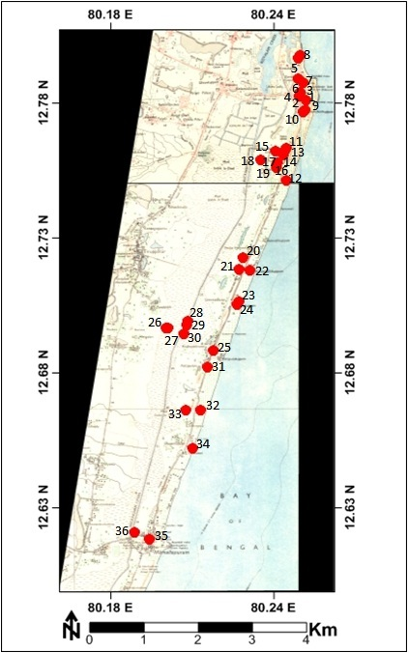
Fig 1: Location Map of the study area
III. Methodology
Thirty six groundwater samples were collected from Kovalam – Mahabalipuram, in kanchipuram District, Tamilnadu. The ground water samples were collected during (pre-monsoon) and (post-monsoon) from bore wells and dug wells. These samples were collected in 1.5 liter capacity polyethylene bottles. The pH, temperature, electrical conductance (EC), and total dissolved solids (TDS) were measured insitu using portable bore well logger (Multi probe system, YSI 556 MPS). The samples collected were analyzed in the laboratory for determining the concentration of major ions. The Ca²⁺, Mg²⁺, CO₃, HCO₃ were determined titrimetrically (APHA 1985). The Na⁺, K⁺ were estimated using Flame photometer. The anions Cl⁻, NO₃, SO₄ were determined using Ion Chromatography.
IV. Results and Discussion
Groundwater samples were collated in space and time and analyzed for major and minor dissolved ions using standard procedures. The results of the physical – chemical analysis of the ground waters of Kovalam - Mahabalipuram coastal areas for two seasons are given in Table 1.
Major ions | Pre monsoon |  | Post monsoon |  | WHO | BIS
EC µs/cm | 148 | 1689 | 217 | 1136 | 500-1000 | 500-1000
pH | 6.8 | 7.1 | 7 | 8.6 | 6.5-8.5 | 6.5-8.5
TDS mg/l | 147 | 1336 | 112 | 1324 | 500-1000 | 500-2000
Ca mg/l | 6 | 256 | 0 | 96 | 75 | 75-200
Mg mg/l | 4.8 | 79 | 0 | 42 | 50 | 30-100
Na mg/l | 2.4 | 432 | 2.5 | 244 | 200 | X
K mg/l | 2.3 | 178 | 0.1 | 166 | 20 | X
HCO₃ mg/l | 24.4 | 464 | 24.4 | 695 | 250 | 250-1000
SO₄ mg/l | 11.7 | 519 | 0 | 326 | X | X
Cl mg/l | 10 | 1892 | 15 | 860 | 50 | 45
NO₃ mg/l | 0 | 377 | 0 | 165 | 200 | 200-400

In general, pH of the waters is alkaline in nature. The pH is controlled by total alkalinity of the ground water and partially by sea water mixing. pH in the study area varies from 6.8 to 8.6 with an average of 7.4 in post monsoon and in pre monsoon it ranges from 6.8 to 7.1 with an average of 7.17. EC varies from 148 to 1689 us/cm with an average of 827 us/cm2 in post monsoon and 217 to 1136us/cm with an average of 827.32us/cm in pre monsoon. Total dissolved solids (TDS) ranges from 72 to 884 mg/l with an average of 579.41 mg/l in post monsoon and 112 to 870 mg/l with an average of 581.82 mg/l in pre monsoon. The water samples of the study area are classified as fresh to brackish in nature. Bicarbonate is the dominant anion followed by Chloride, Sulphate, Nitrate and Phosphate in post monsoon season and in pre monsoon Bicarbonate is the dominant anion followed by Chloride, Sulphate and Phosphate. The dominant cations are as follows: calcium followed by sodium, potassium and magnesium during post monsoon and calcium followed by Magnesium, Sodium and Potassium in pre monsoon. The spatial distribution of EC of samples was carried out for both seasons (Fig 2). In general, EC found to be high near the coastal areas. In order to understand the chemical characteristics of groundwater in the study region, groundwater samples were plotted in Piper trilinear diagram (Piper 1944) using AquaChem Software (Fig. 3). Displays the various types of classification of groundwater samples in the Piper diagram. The dominant water types are in the order of NaCl >CaMgCl >mixed CaNaHCO3 >CaHCO3. However, most of the samples are clustered in Na Cl and Ca-Mg-Cl segments. Water types (CaMgCl and NaCl) suggest the mixing of high-salinity water caused from surface contamination sources such as irrigation return flow, domestic wastewater, and effluents, with existing water followed by ion exchange reactions. In addition with Piper diagram, Gibbs plot (1970) demonstrated that if TDS is plotted against Na/ (Na + Ca), provides information on the mechanism controlling the chemistry of waters. Figure 2displays that most of the groundwater samples were plotted in the rock–water interaction zone and few samples in the evaporation zone. Both Piper and Gibbs plots suggest that water chemistry is regulated by mixing of salinity water, caused by surface contamination sources, with existing water, ion exchange reactions, mineral dissolution, and possibly evaporation.

A. Spatial Analysis of groundwater quality of Pre & Post-monsoon respectively
Representing the concentration of various ions on a map is the simplest way to presenting groundwater quality of the study area. In the present work, spatio-temporal variations of the physico-chemical parameters were carried out using GIS respectively.
Fig 2.Spatial Diagrams of major elements (Pre and Post monsoon)

A. Major Cations
The order of dominance of cations is found to be Na > Mg > Ca> K during pre and post-monsoon seasons. Sodium ion concentration in the pre-monsoon season varies from 2.4to 432 mg/l while it ranges between 2.5 and 244 mg/l during post-monsoon. Sodium concentration plays an important role in evaluating the groundwater quality for irrigation because sodium causes an increase in the hardness of soil as well as reduction in its permeability (Tijani, 1994). Calcium ion concentration in the pre-monsoon season varies from 6 to 256mg/l while it ranges between 0and 96 mg/l during post-monsoon samples. Magnesium ion concentration in the pre-monsoon season varies from 4.8 to 79mg/l while it ranges between 0 and 42 mg/l during post-monsoon samples. Potassium ion concentration in the pre-monsoon season varies from to 2.3 to 178 mg/l whereas it ranges between 0.1 and 166 mg/l during post-monsoon samples.
B. Major Anions
The order of dominance of anions is found to be Cl > HCO₃ > NO₃ >SO₄during post and pre-monsoon seasons. Chloride ion concentration in the pre-monsoon varies from 10 to 1892 mg/l while it ranges between 15 and 860 mg/l during post-monsoon. Cl⁻ is higher due to the impact of saline water and base–ion exchange reaction (Freeze and Cherry, 1979). Bicarbonate ion concentration in the pre-monsoon season varies from 24.4 to 464 mg/l while it ranges between 24.4and 695 mg/l during post-monsoon samples. Higher concentration of bicarbonate indicates the contribution by the country rock, typically charnokite. Sulphate ion concentration in the pre-monsoon season varies from 11.7 to 519 mg/l while it ranges between 0 to326 mg/l during post-monsoon samples. Nitrate ion concentration in the pre-monsoon season varies from 0 to 377 mg/l whereas; it ranges between 0 to165mg/l during post-monsoon samples.

D. Gibbs Plot
Reactions between groundwater and aquifer minerals have a significant role in water quality, which are also useful to understand the genesis of groundwater (Cederstorm, 1946). Groundwater chemistry in the study area is regulated by diverse processes and mechanisms. The chemical relationships of groundwater based on the lithology of aquifer have been studied following Gibb’s Plot (1970). Three kinds of fields are recognized in the Gibb’s diagram, namely, precipitation, evaporation/crystallization, and rock-water interaction. The weathering dominated water has high Ca and HCO₃⁻ concentration, and the evaporation/crystallization dominated water is characterized with high Na⁺ and Cl⁻ contents. In the cation plot, illustrated in Fig. 3 most of the water samples fall within the plot rock-water interaction and few of the water samples fall in the evaporation, for both the seasons of the study area. During summer the rate of evaporation is high which reflects on the water quality.

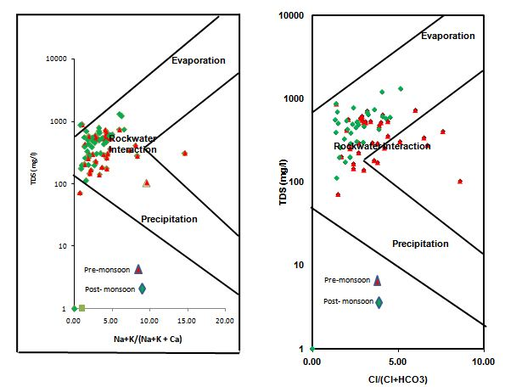

Fig 3: Gibbs plot

E. USSL Diagram
This diagram is used to evaluate the degree of suitability of groundwater to irrigation. Water can be grouped into 16 classes. The diagram is plotted using Sodium Absorption Ratio in vertical axis and conductance in horizontal axis as shown in Fig 4. All concentration values are expressed in equivalents per million. Salinity, sodicity and toxicity generally need to be considered for evaluation of the suitability of groundwater for irrigation. Sodium absorption ratio is also used to determine the suitability of groundwater for irrigation as it gives a measure of alkali/sodium hazard to crops. If Calcium and Magnesium are dominant, the hazard is low. In the USSL diagram, S1, S2, S3, S4 types indicate Sodium hazards and C1, C2, C3, C4 types indicate the salinity hazards. Based on this classification, majority of the samples belong to C3S1 (medium salinity, low sodium) and C3S1 (high salinity, low sodium) during pre and post monsoon season respectively.

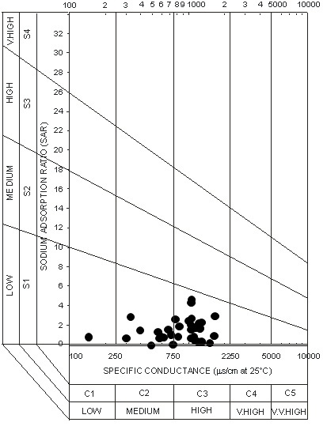
Fig 4. USSL Diagram

F. Wilcox diagram
The role of sodium in the classification of groundwater for irrigation was emphasized because of the fact that sodium reacts with the soil and as a result, clogging of particles takes place, thereby reducing the permeability (Todd, 1980; Domenico et al. 1990). Na is an important cation which in excess deteriorates the soil structure and reduces crop yield (Srinivasamoorthy, 2004). The concentrations of ions are expressed in milli equivalents per liter in Wilcox diagram (Wilcox, 1955). The water is classified based on the Na% with respect to other cations that are present in water. Values of Pre - and Post-monsoon groundwater samples of the area are plotted in the Wilcox diagram as shown in Fig. 5. In the study area, 54% and 57% of samples fall in good to permissible during Pre and Post-monsoon seasons, 37% of samples fall in very good type during both seasons, and few samples fall in permissible to doubtful and doubtful to unsuitable category during both seasons. Most of the samples in the study area fall in good/very good category.

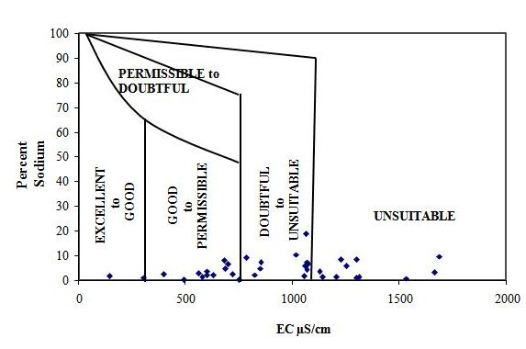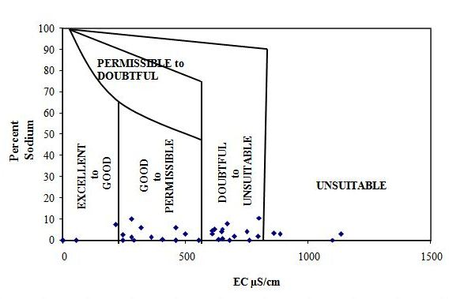
Fig. 5.Wilcox pre-monsoon Fig. 5.Wilcox Post-monsoon

G. Box whisker diagram
Box plots can be used to compare ground water quality data (generally for the same parameter) between wells. The plots are constructed using the median value and the interquartile range (25 and 75 cumulative frequencies are measured as central tendency and variability) (U.S. EPA, 1992). It is a quick and convenient way to visualize the spread of data. Complicated evaluations may dictate use of a series of box plots. The chemical composition of the groundwater samples is shown in Fig.6 as Box plot. The diagram reveals that the abundance of the major cations is in the order of Na>Ca>Mg for both seasons. The abundance of major anions is in the order of Cl>HCO3>SO4 during both seasons.

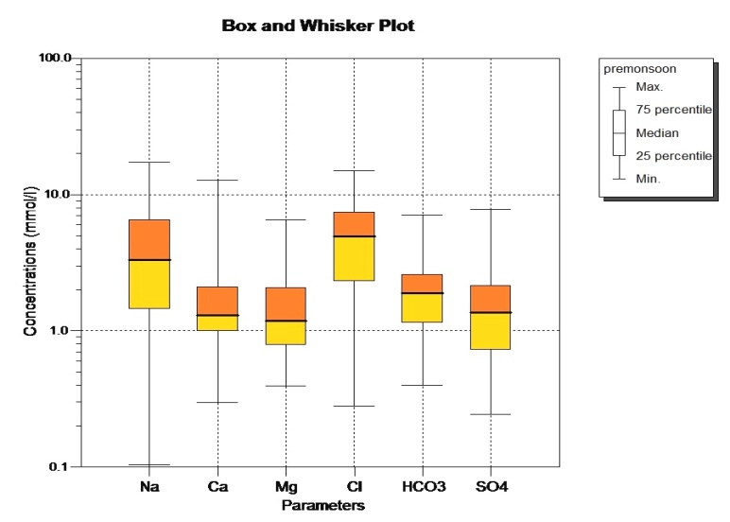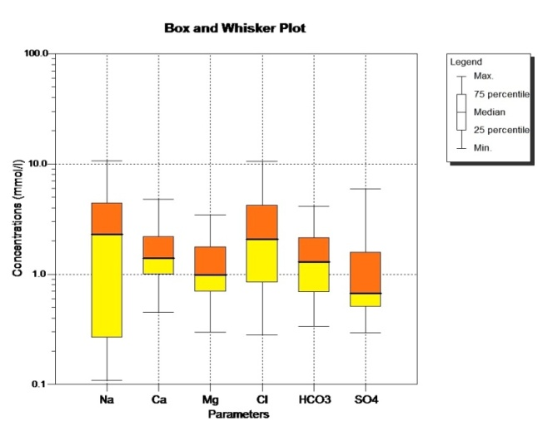
Fig.6. Pre-monsoon Box plot diagram Post-monsoon Box plot diagram

H. Chemical Relationship
One of the most useful graphs for representing and comparing geochemistry in water quality analysis is the Trilinear diagram of Piper (1953) and is shown in Fig. 7. The diagram is divided into three major divisions. The percentage of total cations is plotted on the left triangle; while the percentage of total anions is plotted on the right triangle. These two triangles are then projected into the central diamond shaped area parallel to the upper edges of the central area (Todd, 1980). During pre-monsoon, 90.9% of Strong acids (Cl) exceeds weak acids (HCO₃and SO₄), 78.8 % Alkaline earth (Ca+Mg) exceeds alkalies (Na+K) and 63.6% Mixed type (Ca-Na-HCO₃); during post-monsoon, 100% of Strong acids (Cl) exceeds weak acids (HCO₃ and SO₄), 66.6% Alkaline earth (Ca+Mg) exceeds alkalies (Na+K) and 63.6% Mixed type (Ca-Na-HCO₃). The reason is that the groundwater that pass through igneous rocks dissolves only small quantities of mineral matters because of the relative insolubility of the rock composition.

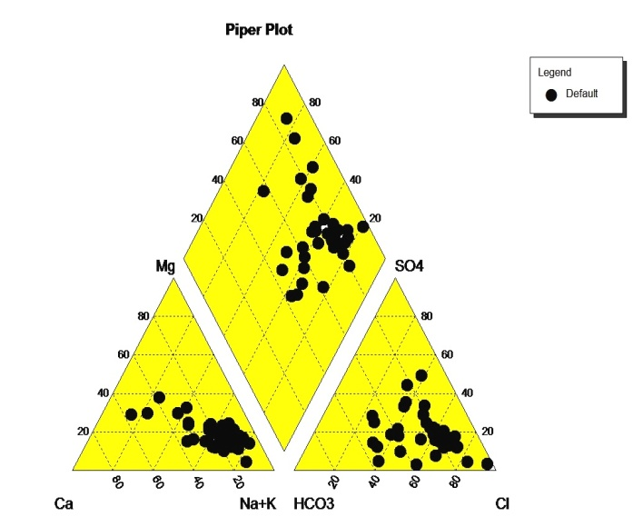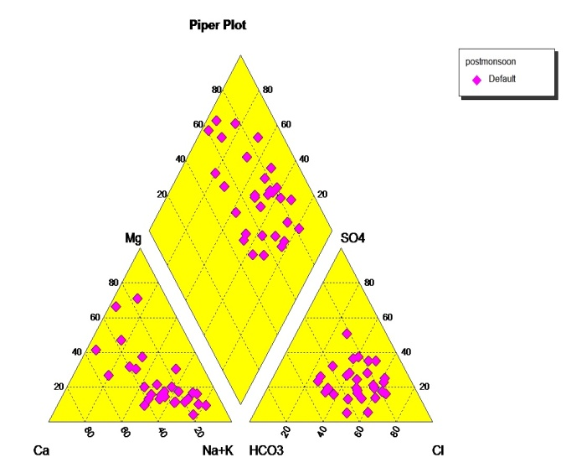
Fig. 7. Piper pre-monsoon Piper post-monsoon

I. Correlation Analysis of Groundwater Quality
In the present study, the correlation coefficients (r) among various water quality parameters have been calculated and the numerical values of correlation coefficients (r) are tabulated in Table-2 (pre-monsoon) and Table-3 (post-monsoon). Correlation coefficient (r) between any two parameters, x & y is calculated for parameter such as water pH, electrical conductivity, total alkalinity, total hardness, calcium hardness, magnesium hardness, chloride, nitrate, fluoride and total dissolved solids of the ground water samples. . The EC has been found to show positive correlation with total alkalinity and negative correlations with pH, total hardness, calcium hardness, magnesium hardness, chloride, nitrate, fluoride and total dissolved solids. EC has been found to show Positive correlations with total alkalinity and sulphate while all other parameters are positively correlated with EC.

Parameters | EC | PH | TDS | Ca | Mg | HCO₃ | Cl | Na | K | SO₄ | NO₃ | Fl
EC | 1.0
PH | -0.23 | 1.00
TDS | 0.57 | -0.17 | 1.00
Ca | -0.06 | -0.40 | -0.04 | 1.00
Mg | 0.21 | -0.34 | 0.08 | 0.81 | 1.00
HCO₃ | 0.31 | -0.24 | -0.08 | 0.34 | 0.49 | 1.00
Cl | 0.12 | -0.38 | 0.09 | 0.90 | 0.92 | 0.38 | 1.00
Na | 0.25 | 0.06 | -0.01 | -0.08 | 0.27 | 0.30 | 0.21 | 1.00
K | 0.29 | -0.38 | 0.28 | 0.36 | 0.50 | 0.59 | 0.45 | -0.09 | 1.00
SO₄ | 0.08 | -0.42 | 0.09 | 0.84 | 0.80 | 0.43 | 0.85 | 0.03 | 0.62 | 1.00
NO₃ | 0.57 | -0.07 | 0.49 | -0.05 | 0.19 | 0.25 | 0.04 | -0.09 | 0.57 | 0.23 | 1.00
Fl | -0.06 | -0.07 | -0.11 | -0.09 | -0.14 | 0.09 | -0.02 | 0.03 | 0.18 | 0.07 | -0.18 | 1.00

Parameters | EC | pH | TDS | Ca | Mg | Na | K | Cl | HCO3 | Fl | SO4 | NO3
EC | 1.0
PH | 0.52 | 1.00
TDS | 0.27 | 0.41 | 1.00
Ca | 0.34 | 0.40 | 0.69 | 1.00
Mg | 0.28 | 0.31 | 0.71 | 0.55 | 1.00
Na | 0.17 | 0.24 | 0.67 | 0.38 | 0.51 | 1.00
K | 0.04 | 0.21 | 0.77 | 0.59 | 0.56 | 0.49 | 1.00
Cl | 0.19 | 0.24 | 0.78 | 0.53 | 0.66 | 0.94 | 0.65 | 1.00
HCO₃ | 0.27 | 0.37 | 0.76 | 0.57 | 0.52 | 0.79 | 0.70 | 0.81 | 1.00
Fl | 0.22 | 0.73 | 0.27 | 0.34 | 0.16 | 0.17 | 0.05 | 0.09 | 0.30 | 1.00
SO₄ | -0.02 | 0.21 | 0.79 | 0.62 | 0.69 | 0.58 | 0.69 | 0.67 | 0.56 | 0.23 | 1.00
NO₃ | 0.17 | 0.27 | 0.55 | 0.54 | 0.51 | 0.61 | 0.53 | 0.60 | 0.42 | 0.22 | 0.49 | 1.00
V. Conclusion
The present study has been carried out to Monitor Groundwater quality along the Coastal area between Kovalam and Mahabalipuram Kanchipuram district, Tamilnadu. Results reveal that the dominance of the cations in the study area is found to be Na>Ca>Mg>K and anions in the order of HCO3>Cl>SO4>NO3.Spatial distribution of TDS shows that the concentration was more in the southern region of the study area compare to the other areas. Considering Calcium, the distribution is more in south and west of the study area. The magnesium map shows higher concentration in several parts of the study area, but it is high in south and north east. Spatial distribution map of sulphate demarcates that the southern area is having higher concentration compared to other areas. Sodium ions are also distributed similar to that of sulphate ions with high concentration of potassium (K) in most sample locations of the area, which is within the permissible limit. The high concentration might have due to fertilizer leaching. The bicarbonate distribution is dominant in areas along south, east, and northeast regions. The Box plot shows the abundance of the major cations in the order of Na> Ca>Mg during Pre-monsoon and Ca>Na>Mg in Post-monsoon. Based on USSL classification most of the groundwater samples fall in the field of C2S1, C2S2, C3S1 and C3S2 which indicates that the groundwater is good for irrigation in both the seasons. The dominant groundwater type was Ca-HCO3.Based on TDS, 75% of the groundwater was fresh and permissible for drinking. In Gibb’s diagram, most of the samples fall in the rock-water interaction field which indicates that the interaction between rock chemistry and the percolation of water under the subsurface is taking place predominantly. The suitability of groundwater for irrigation was assessed using Na%, EC, SAR classification. The groundwater in this area was seen to be good and suitable for drinking and domestic purposes. However, the groundwater was unsuitable for irrigation in few places. Based on Correlation matrix, for both seasons, good correlation exists with EC, TDS, Ca, and Mg. In general, most of the ions are positively correlated with EC. The overall groundwater quality in the Kovalam -Mahabalipuram area remains usable.

Acknowledgement
All the authors are thankful to Dept of Applied Geology, University of Madras, for the support and infrastructures provided for the study.
References
APHA., (1998). Standard methods for the examination of water and wastewater (19thed.).Washington, DC: American public Health Association.
Annapoorani.A, Murugesan.A, Ramu. A, Renganathan.N.G (2013). Hydrochemistry of groundwater in and around Chennai, India - A case study, Res. J. Chem. Sci. 4 (4) pp.99– 106.
Balakrishnan T. District groundwater brochure Chennai district Tamil Nadu. Government of India Ministry of Water Resources Central Ground Water Board South Eastern Coastal RegionChennaiNovember2008.
Ballukraya, P.N. (1997). Groundwater over-exploitation, A case study from Moje-Anepura, Kolar district, Karnataka. Jr. Geol. Soc. India. v.50, pp.277-282.
Ballukraya, PN and Ravi, R (1999). Characterization of groundwater in the unconfined aquifer of chennai city, India: Part 1- Hydro geochemistry, India v.54, pp.1-11.
Chidambaram, S., Ramanathan, A.L., Anandhan, P., Srinivasamoorthy, K., Prasanna, M.V., 2005. A comparative study on the coastal surface and ground water in and around Puduchattiram region, Tamilnadu. Special issue in International Journal of Ecology and Environment Sciences 31 (3), 299–306.

Chidambaram, S., Ramanathan, A.L., Srinivasamoorthy, K., Anandhan, P., 2003. WATCLAST-A Computer Program for Hydrogeochemical Studies. Recent Trends in Hydrogeochemistry (case studies from surface and subsurface waters of selected countries). Capital Publishing Company, New Delhi (pp. 203–207).

Elango.L and Manickam (1987). Hydrogeochemistry of the Madras aquifer, India:spatial and temporal variation in chemical quality of groundwater. The Role of Geology in urban development., Geological Society of Hong Kong Bulletin .No.3., pp-525-534.

Hussain, M., Ahmad, S.M. and Abderrahman, W. (2008) Cluster analysis and qualityassessment of logged water at an irrigation project, eastern Saudi Arabia. J. Environmental Management, 86: 297-307.
Jayakumar, R. and Siraz, L. (1997) Factor analysis. in Hydrogeochemistry of Coastal aquifer-a preliminary study. Environmental Geology, 31(3/4): 174-177.
Piper, A. M.: A graphic procedure I the geo-chemical interpretation of water analysis, USGS GroundwaterNote no, 1953, 12.

Ramachandran.A, Sivakumar.K, Shanmugasundharam.A, Sangunathan.U, Krishnamurthy.R.R (2021).Evaluation of potable groundwater zones identiﬁcation based on WQI and GIS techniques in Adyar River basin, Chennai, Tamilnadu, India Acta Ecol Sin (2021) Volume 41, Issue 4, pp. 285-295.

Sivakumar.K, Shanmugasundaram.A, Jayaprakash.M, Prabakaran.K Muthusamy.S, Ramachandran.A, Venkatramanan.S and Selvam.S (2021). Causes of heavy metal contamination in groundwater of Tuticorin industrial block, Tamil Nadu, India Environmental Science and Pollution Research (2021) 28:18651–18666 https://doi.org/10.1007/s11356-020-11704-0

Schoeller. H (1967) Qualitative evaluation of ground water resources.In: Methods and techniques of groundwater investigation anddevelopment. Water Research Series-33, UNESCO, pp 44–52.

Subramanian. Hydro geological studies of the coastal aquifers of Tiruchendur, Tamil nadu. PhD thesis, Manonmanian sundaranar University, Thiruneveli,1994, p-75.

Suk, H, Lee K. (1999) Characterization of a ground water hydrochemical system through multivariate analysis: Clustering into ground water zones. Ground Water, 37: 358-366.

Venkateswaran S, Vijay Prabhu M, Mohammed Rafi M, Vallel LK (2011) Assessment of groundwater quality for irrigational use inCumbum Valley, Madurai District, Tamil Nadu, India. Nat Environ Poll Tech 10:207–212.

Wicox, L. V.: Classification and use of irrigation waters, US Department of Agriculture, WashingtonDc, 1995, p-19

