Shade House: A Structure for Vegetable Production
Niraj Kumar Prajapati and Rajan Singh
Div. of Crop Improvement, ICAR - Indian Institute of Vegetable Research, Varanasi, (U.P.) – 221 305
nkp.ofcl@gmail.com, +91 8173905821
ABSTRACT
As a result of dramatic technological advancements, human activities pertaining to agricultural growth and productivity are reaching new heights every day. Along with technology, protected structures have entered the agricultural industry, and for forward-thinking growers and farmers around the world, shade net structures are a crucial component. This chapter explains in clear detail some of the technical requirements, planning, applications, material usefulness, and potential future research areas for the shade net structure. Future studies will take a closer look at the significance and range of protected cultivation.
Keywords: Vegetable, shade house, advances, protected cultivation, off-season etc.

INTRODUCTION
The largest contribution to a nation’s GDP growth is made by horticulture. Due to the importance of agriculture to the national economy, it is crucial that farmers take good care of their crops and put in a lot of effort in the field. Numerous methods exist for protecting crops. The use of technology in this industry has undergone remarkable progress during the last few decades. Insect and weed control for crops has a long history of success. With the use of these technologies, sowing, harvesting, storage, and distribution have improved. Presently, progressive farmers are adopting commercially protected cultivation of high-value vegetables (Maitra et al. 2020).
Fresh vegetable demand is constant throughout the year, while supply is only available during the growing season. The growth, physiological process, flowering, fruit setting, and ultimately yield and economic return of the various vegetable crops are all negatively impacted by changes in climatic vagaries like fluctuations in temperature, light, humidity, wind velocity, etc. The unfavourable weather significantly decreased yield or may have caused the entire harvest to fail. The urgent need is to encourage off-season production in order to boost the supply of fresh vegetables outside of the typical growing season.
Under open field conditions, it is impossible to cultivate winter-season vegetables in the summer because of the harmful effects of the hot sun and greater day and night temperatures on vegetative growth, which results in the loss of flowers and fruits. Again, low temperatures, cold waves, and freezing injuries affect summer crop cultivation throughout the winter months in open fields. Crops can be grown off-season by using the right protection technologies and creating a conducive environment. With the advent of shade net, which controls light and temperature to some extent and produces an environment that is beneficial for crop growth, it is possible to raise the crop during the hot summer months with the desired yield and quality.
"Protected cultivation" refers to a set of methods for modifying a plant’s natural habitat, which completely or partially modifies the microclimate conditions in order to increase their productivity. Wind breaks, mulches, low tunnels, direct coverings, high tunnels, and greenhouses are examples of protected cultivation systems. Another goal is to create a microclimate that will improve crops’ yield and quality while also promoting more efficient resource usage.
Why a shade house?
Offers a favourable environment for crops that can be maintained and regulated by the farmer, resulting in a healthy crop with superior quality, good light transmission, and UV protection. Shade houses are crucial for plant growth because they give plants time to "harden off" and become adapted to their environments. Protecting crops from adverse weather conditions such as wind, rain, hail, and snow as well as from pests, diseases, and predators is one of the main goals of protected cultivation. Increasing output per unit area Planting propagation material to increase germination rate and hardening to encourage the growing of high-quality vegetables beneath shade net houses. Year-round production of vegetables grown out of season. Continuous production of disease-free and genetically superior transplants is possible.
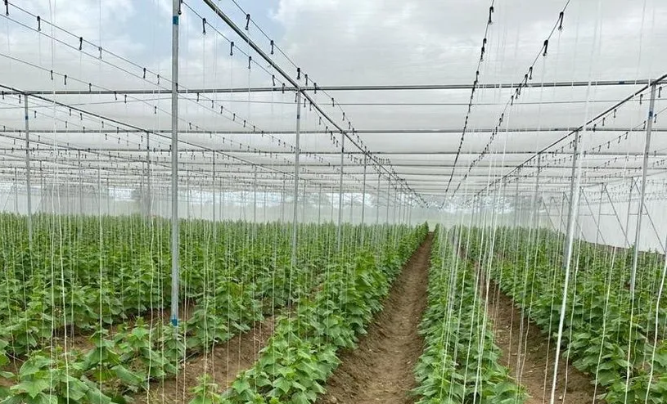
Fig: Shade net farming of Cucurbits
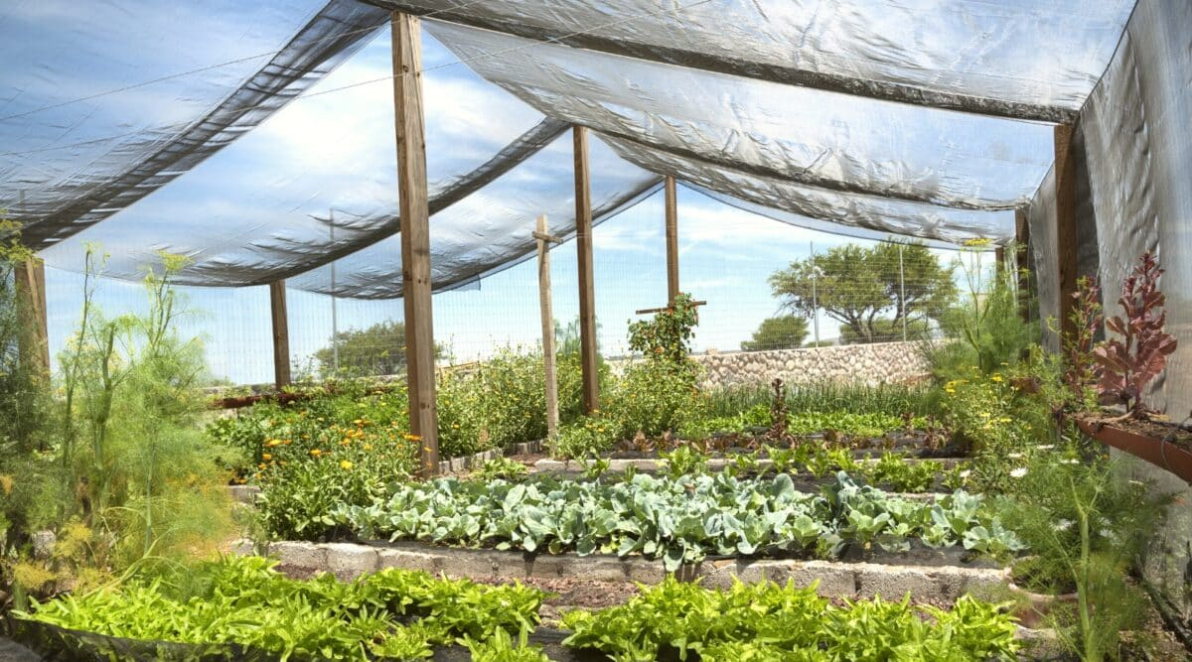
Fig: Shade net farming of Leafy vegetables

ROLE OF SHADE NET HOUSE
A straight-forward yet effective innovation that helps protect crops is the horticulture shade net. It shields the crops from the sun’s heat. Sunlight is a crop’s primary need for growth, yet too much of it can cause serious harm. Some crops are delicate, and particular regions are more susceptible to intense sunrays owing to geography and climatic conditions. Shade Net has a crucial role to perform in this situation.
According to Feijuan and Cheng (2012), the amount of light, the moisture in the soil, and the availability of nitrogen are crucial elements impacting the biomass of the crops. These elements also directly affect photosynthesis and growth. Different effects of varied light might be seen in the development of leaf area, growth, and yield.
Additionally, a lack of shade can reduce productivity by increasing the amount of light that hits the plant, which has a negative impact on the system’s metabolism. To increase agricultural output, it is vital to research the ideal lighting conditions. Differently coloured shade nets allow for the manipulation of both light amount and quality.
Shahak and Gussakovsky (2004) reported that colour nets are an innovative concept in agricultural technology that combines physical protection with selective solar radiation filtration in order to particularly promote desirable physiological reactions that are light-regulated. While light scattering enhances light penetration into the inner canopy, spectral modification especially aims to promote photo morphogenetic-physiological responses. When the diffuse component of the incident radiation is amplified under shade, radiation efficiency rises. The reactions that are intended to be addressed are those that affect each crop’s commercial value, such as yield, product quality, and rate of maturation.
APPLICATION OF SHADE NETS
Aids in the cultivation of vegetables, spices, medicinal plants, flowering plants, and foliage plants. Employed in nurseries for growing fruits and vegetables as well as producing forest species, etc. Promotes the quality drying of a variety of agricultural items. Used to ward off insect invasions. Tissue culture plants have secondary hardening nurseries. Aids in generating an environment that is favourable for the generation of vermicompost. Crops from natural weather disturbances such as wind, rain, hail, frost, snow, birds, and insects. Used in the creation of graft saplings and lowering their mortality during hot summer days.
How Does Shade Net Work?
Shade nets come in a variety of shades, or shade factors, including 15%, 35%, 40%, 50%, 75%, and 90%. For instance, a 35% shade factor means that the net will block 35% of the light intensity and only permit 65% of it to flow through. For a plant to grow at its best, the amount of sunlight and amount of shadow must be specific to each plant. The optimal shade factor selection is crucial to achieving the best possible climatic conditions and maximising plant productivity.
Qualities of an Ideal Shade Net
It must be extremely strong and long-lasting. This guarantees that it will persist for multiple crop lifetimes. UV Stabilization is the most crucial component that you must not overlook. A good shade net must provide the greatest amount of crop-protecting shadow. The shade needs to be technically constructed for greater yield. Large agricultural fields and even kitchen gardens can benefit from the use of shade netting. Crop microclimate and crop activity were both affected in different ways by the shading effect of crops. Shade nets are used to protect a variety of horticultural crops from various abiotic influences, such as intense sunlight, high wind speeds, and biotic damage from birds and rodents, and to improve the environment (Kittas et al. 2009).
COMPONENTS OF SHADE NET HOUSES
Depending on the shade net house, steel, bamboo, or GI pipes are used for the framework, and nuts and bolts are used to secure it at the joints. Special locking profiles made of aluminium secure covering materials to structures. UV-stabilized covering materials, such as insect net or shade net, bear hanging loads of 15 to 25 kg per square metre; vegetable trellising systems. Control System: Manual, Semi-Automatic, or Automatic if a high-priced shade net house is being installed. Planting Material: soilless media like coco peat.
Shade Net Installation
Allow 25% more shade fabric than you will need to completely cover the building. Staple the cloth to the structure every 12 inches, starting with the longest side you will be covering. As you move away from the house, start stapling on the closest short side, keeping the shade cloth uniformly aligned.
Structural materials
The frame and cladding material make up the two essential parts of a shade house structure. The frame of the shade house serves as support for the cladding material and is built to provide protection from wind, rain, and crop weight. Depending on the weather conditions of the shade house, the agro-shade net or horticulture shade net lasts for 3–5 years. In high-rainfall regions like Orissa, structural frames with modest modifications appropriate to local conditions are advised.
FEATURES AND SPECIFICATIONS
Yield increases five to seven times or higher. Uniform and of greater quality. Less fertilizer is needed, which results in a decrease in fertilizer cost. Low water usage results in water savings. Fewer possibilities of disease attack, which lowers the cost of disease control. Greater fertilizer and water efficiency, troublesome soil conditions, and problematic topography when cultivating. Cultivation under unfavourable weather conditions. Requires minimal space to achieve the greatest production and advantages. Simple to control, maintain, and operate.
In shade net houses, shade nets are frequently employed. These shade net dwellings come in three different price ranges depending on the building costs: low cost, medium cost, and high cost.
1. Low-cost shade net house
It has no climate control system and is built with a bamboo supporting frame and UV-stabilized shade net covering. The price per square metre for a low-cost shade net house with all of its components is about Rs 150.
2. Medium-cost shade net house
G.I. pipes, profile springs and wires, and a UV-stabilized shade net are the materials used to construct a medium-priced shade net house. Around Rs 180–250 per square metre is the price range for a medium-priced shade net house that includes all of its components.
3. High-cost shade net house
The lifespan of a high-priced shade net house is about 8 to 10 years. It is built of steel tubes and has numerous amenities, including an auto control mechanism, a heating, cooling, and humidification system, a drip irrigation system, etc. The price per square metre for a high-end shade net house with all of its components is approximately Rs 300.
TYPES OF SHADE HOUSES
1. Flat Roof Shade Net House
Shade Net for a Flat Roof House was built with the intention of overcoming the issues of intense summertime sunlight, catching CO₂ levels at night, and minimising insect infection. The plant house’s top is flat in the flat design, which is the simplest type of design. The net is secured to the framework via a spring. A plant house with a 1-acre lot size is optimal.
2. Dome-shaped shade net house
Dome-Shadow Net houses have a range of technical features. These are recognised for their alluring style, silky finish, and elegant design. They require little upkeep and are simple to install.
Choice of location
A shade house should be situated such that it has easy access to the market for the purchase of input materials and the sale of its products. There shouldn’t be any drainage issues at the site. Water of high quality and power should both be available. Wind breakers, however, might be 30 metres from the structure.
Creating a shadow structure
The sort of crop that will be cultivated, the materials that are readily available locally, and the local climate should all be taken into account while designing the shade house structure. There ought to be room for future growth.
Orientation
To get the best light possible, a single-span shade house should be located in the east-west or north-south direction, while a multi-span shade house should be located in the north-south direction.
Coloured netting
Crops can be protected from harmful environmental factors such as excessive sun radiation, heat and drought stress, wind and hail, birds, and flying pests using photo-selective, light-dispersive shade nets as an alternative, which would increase crop output, yield, and quality. The reviewed research also makes clear that light quality affects the production, accumulation, and preservation of vegetable phytochemicals as well as the development of degradation during storage. Farmers that grow vegetables should be informed of these new methods for adjusting light quality, which will enable them to meet year-round customer demand for vegetables with high nutritional value while preserving the freshness and post-harvest quality of their produce for a longer length of time. For open-field and greenhouse vegetable production to be sustainable and market-driven in the future, research on light modification in horticulture systems is required. Higher plants respond to changes in light intensity, colour, direction, and regularity. Plants have many photoreceptors, including those that respond to green light: cryptochromes, phototropins, cryptochromes, chlorophylls, and phtyochromes (Batschauer, 1999). Plants can adjust to ambient circumstances thanks to light and other environmental factors. The Colour Net approach was researched in various ornamentals (Nissim-Levi et al. 2008), vegetables (Falak et al. 2009; 2010), fruit trees (Shahak et al. 2004), and vineyards.
Radiation scattering
It has been demonstrated that diffuse light increases the effectiveness of radiation utilisation, yields (both at the plant and ecosystem level), and even influences plant flowering (timing and amounts). Any shade netting can reflect light, especially ultraviolet light since netting is frequently composed of UV-resistant plastic. Branching, plant compactness, and flower production per plant have all been found to increase with the use of shade netting that enhances light dispersion without altering the light spectrum (Nissim-Levi et al., 2008). In addition to increasing light scattering by 50% or more, coloured shade nets may also have an impact on the growth and development of plants.
Photo selectivity
The capacity of coloured shade nets to alter the spectrum of radiation reaching crops is the main reason they are being thoroughly tested. They can be used to alter the ratios of red to far-red light that phytochromes detect and the quantities of radiation that can activate the blue and ultraviolet photoreceptors, the blue light involved in phototropic responses mediated by phototropins, and radiation at other wavelengths that can affect plant growth and development. Based on the photosynthetic photon flux density (PPFD) and the a and b chlorophyll content of the leaves, light transmission through various cover materials encourages the differential stimulation of some physiological processes controlled by light, such as photosynthesis.
Using a ceptometer model Sun Scan SS1-UM-1.05 (Delta-T Devices Ltd., UK) with a 64-sensor photodiode linearly sorted in a 100 cm length sword, the effect of nets on the interception of light was assessed annually as a percentage of total photochemically active radiation (PAR) above canopy. Readings are expressed as PAR quantum flux (mol m-2 s-1) units. All measurements were made at noon on clear days. Three times throughout the day, measurements of global radiation were taken every other day.
The effect of colour on plant growth
Higher plants respond to the type, amount, direction, and regularity of light. Plants have a variety of photoreceptors, including those that respond to green light, cryptochromes, phototropism, and chlorophylls (Batschauer, 1999; Folta and Maruhnich, 2007). Plants can adjust to their surroundings using light and other environmental cues. For decades, researchers have worked to alter the morphology and physiology of plants using photo-selective filters, especially in greenhouse settings that have been widely available for this purpose. Both indoor and outdoor use of these nets is possible. They can guard against physical threats (birds, hail, insects, and extreme radiation), modify the environment (humidity, shadow, and temperature), raise the amount of diffuse (scattered) light, and absorb different spectral bands, all of which have an impact on the quality of the light. These effects can influence crops as well as the organisms associated with them.
Shade net colours
Presently, shade nets are available in different colours, i.e., white, black, red, blue, yellow, and green, and in combinations, including:
A. Green x Black: They cut off unwanted UV rays and give an aesthetic look.
B. Black x Black: It absorbs and radiates heat inside the shade net house. Used in nursery education.
C. White x Black: Diffuses the light inside the shade net house. Mainly used for flowers such as Gerbera, Anthurium, etc.
D. Green x Green: Enhance the process of photosynthesis in plants, resulting in better foliage in ornamental plants.
The Colour Nets are an innovative concept in agricultural technology that combines physical protection with varying sun radiation filters in order to particularly promote desirable physiological reactions that are light-regulated. Due to their capacity to alter the radiation spectrum that reaches crops, coloured shade nets are currently the subject of extensive testing. They can be used to alter the ratios of red to far-red light that phytochromes detect, the quantities of radiation that can activate the blue/ultraviolet-A photoreceptors, the blue light involved in phototropic responses mediated by phototropins, and radiation at other wavelengths that can affect plant growth and development. Coloured shade nets, which have been developed during the last decade to filter selected spectral regions of sunlight while simultaneously inducing light scattering, are designed to specifically modify plant behaviour.
What’s different about shade plants?
Typically, shade leaves are narrower than sun leaves but larger in area. On a weight basis, sun leaves get thicker than shade leaves, while shade leaves often have more chlorophyll. This is because the palisade cells or additional layer of palisade cells grow longer and have more grana leaves in the chloroplasts. The chloroplasts in shadow leaves move about inside the cells to occupy a position where they can absorb the maximum light without obstructing the light from chloroplasts below them. (In sun leaves, the chloroplasts alternate between absorbing bright light and hiding in the shade of others to use it; too much brilliant light would destroy the chloroplasts.) For the same amount of light, photosynthetic rates in leaves in the sun and the shade can vary by up to a factor of 5. The majority of these adaptations happen during leaf growth since a leaf (or a plant) cannot do much in low light.
Shade and the plant environment
Air and fruit surface temperatures additionally to incoming solar radiation are affected by shade fabric. Reduced levels of solar radiation will result in less sun damage. The overall crop production should stay high when the proper amount of shade is applied. Plant architecture is also changed by shading. Shade-grown plants are higher, more likely to have more nodes, and have larger leaves. Under the building, shading raises the relative humidity and lowers the wind.
Growing of Vegetables under Shade Net
Summertime average weekly temperatures were greater in an open field than they were in the shade net house. Shade netting promotes crop survival under high temperature and moisture stress conditions and increases the net energy available for crop growth.
Deciding what vegetables can be grown in the shade house
Consider which plant component is consumed when selecting the vegetable to grow in your shade house. The best growth conditions for crops like spinach and potatoes, which have edible leaves and roots, are usually partial shade or shadow structures. In contrast, vegetables that are cultivated for their edible fruits, such as tomatoes and cucumbers, do best in full sun, where they need a minimum of 6 hours of sunlight per day. Vegetables that are planted in the shadow typically yield a more succulent crop. Additionally, growing in the shade can reduce bolting in your veggies. Your companion to successfully growing veggies can be a high-quality shade house, which can also provide temporary protection for your plants. Your plants may benefit from a shade house in various ways, such as temporary relief from intense heat. You can effectively grow the proper veggies in the shade house with careful planning. Since you are growing your plant in a shadow house, its watering requirements may differ from those of plants grown in full daylight. Use good soil with nutrient-rich compost for growing your vegetables. So, you might not need to water your plants. Because moisture doesn’t evaporate as quickly in the shade house, vegetables are used more frequently.
Production plan for high-value vegetables in shade net houses
Plan | Suitable Vegetables
1. | Capsicum (July–March) and Cucumber (April–June)
2. | Cucumber (June-Sept) + Cucumber (Jan-Mar) + Coriander (April-May)
3. | Beans (May-Aug) + Tomato (Sept-Feb) + Cucumber or Summer Squash (Mar-May)
4. | Capsicum (July–Dec) + Tomato (Jan–April) + Leafy Vegetables (May–June)
5. | Cucumber (July–October) + Broccoli/Red Cabbage (Oct–Feb) + Leafy Vegetables/Summer Squash (Mar–June)
6. | Gerbera (July-March) + Leafy Vegetables (April-June)

LEVELS OF SHADE
Full sun vegetables
Full-sun vegetables refer to at least six hours (but generally at least eight) of direct sunlight per day. Nearly every day of the season should have at least six hours of direct sunlight hitting the plants. Naturally, days with bad weather and cloudy skies are not included. Nothing manmade (trees, structures, etc.) is obstructing the sunlight from reaching full-sun vegetables.
Partial-sun vegetables
Vegetables grown in partial sunlight need at least four hours of sunlight each day to grow, but they frequently do well with as few as six hours of direct sunlight. Beans, when grown as bushes, these require more sunlight (nearly 6 hours) than vine types, which, if grown on a trellis, can produce more with less. Beets will grow even in relatively dry weather if you keep them partially shaded.
Light-Shade Vegetables
The terms "light shade" or "shaded" plants are frequently used to describe plants that thrive in less sunshine (2 to 4 hours). Cauliflower and several spices are examples of "partial shade" plants that also grow in mild shade. Suitable vegetable crops under shade house conditions: Capsicum, Colour Capsicum, Tomato, Cucumber, beans, Red Cabbage and Broccoli etc.
CONCLUSION
Any agricultural technique must have a lower cost of cultivation and higher returns to be successful. The value of the crop at the point of consideration is the only factor that influences whether the initial cost of the shade net house is recovered to reach the breakeven point. The essential factors for the stakeholders of protected farming are a longer structure’s lifespan, a reduced initial cost for the structure, high-value crops with good storage quality, and measuring market demand. Scope of Future Research: Development of Low-Cost Shade Net Making Materials More climate-resilient and adverse weather-tolerant shade net houses are approaching. breeding aspect of specific cultivars suitable for shade net cultivation. Due attention should be paid to technology transfer activities in regions with limited natural resources. development of alternative growing mediums to the current ones to prevent the formation of nematodes and soil-borne infections The development of an all-in-one kind of instrument to measure various parameters at a stretch Portable shade net houses are being developed with a focus on unstable topographic settings and rapidly changing scenarios like the salinization of fields from seawater intrusion.
REFERENCES
Batschauer, A. Light perception in higher plants. CMLS, Cell. Mol. Life Sci. 55, 153–166 (1999).
Fallik, E., Alkalai-Tuvia, S., Parselan, Y., Aharon, Z., Elmann, A., Offir, Y., Matan, E., Yehezkel, H., Ratner, K., Zur, N. and Shahak, Y. 2009. Can coloured shade nets maintain sweet pepper quality during storage and marketing. Acta Hort., 830: 37-44.
Feijuan, W., Cheng, Z. Effect of nitrogen and light intensity on tomato (Lycopersicon esculentum M.) production under soil water control. African Journal of Agricultural Research, 2012; 7(31): 4408- 4415.
Folta, K.M. and Maruhnich, S.A., 2007. Green light: a signal to slow down or stop. Journal of experimental botany, 58(12), pp.3099-3111.
Kittas, C., Rigakis, N., Katsoulas, N. and Bartzanas, T. 2009. Influence of shading screens on micro climate, growth and productivity of tomato. Acta Hort., 807: 97-102.
Maitra, S., Shankar, T., Sairam, M. and Pine, S. 2020. Evaluation of gerbera (Gerbera jamesonii L.) cultivars for growth, yield and flower quality under protected cultivation. Indian Journal of Natural Sciences, 10(60): 20271-20276.
Nissim-Levi, A., Farkash, L., Hamburger, D., Ovadia, R., Forrer, I., Kagan, S. and Oren-Shamir, M. 2008. Light-scattering shade net increases branching and flowering in ornamental pot plants. Journal of Horticultural Science and Biotechnology, 83: 9-14.
Shahak, Y., Gussakovsky, E.E., Cohen, Y., Lurie, S., Stern, R., Kfir, S., Naor, A., Atzmon, I., Doron, I. and Green blat-Avron, Y. 2004. Color Nets: A new approach for light manipulation in fruit trees. Acta Hort., 636: 609-616
Raj Desh (Eds.) 2019. Floriculture at a glance. 4th Edition, Kalyani Publishers, Ludhiana, India, pp.136-141.

