Exploring The Culture Of Matua Community In Thakurnagar

Labani kirtania
Student, Department of Education
Harichand Guruchand University, W.B

INTRODUCTION
Thakurnagar is a village which is located in Bangaon subdivision of North 24 parganas district in the state of West Bengal. There is a police station at Gaighata. There is a railway station which named Thakurnagar, which is connected to city of Bangaon, Kolkata Barasat, and Ranaghat. Not only railway but also bus root is available in the village for communication places like Ranaghat, Nabadwip, Dakshineswar, Gaighata etc. Though it is a panchyat area, recently the state government have declared this village will be become municipality soon.
Location of the locality is essential for collecting data about Thakurnagar. At a glance the researcher picked up some valuable data from this area. The researcher surveyed and collected data of every area of Thakurnagar about the people, their God and their rituals and worship.
Thakurnagar is situated at on altitude of 9 meters above sea level. According to census of 2011 total population of this area 45000. Official language of Thakurnagar Bengali and English. In this paper we will discuss about the culture of Matua people.

Origin of Matua Community:
In present days, person who believes in Matua Philosophy, they are called Matua. They are spread in various part in our country but their influence is much greater in the Thakurnagar area. In present situation these philosophy is a matter of discussion among lot of people.
The great man shree shree Harichand Thakur is the propunder of Matua Philosophy. If we go back a few years from the present time, powerful rich person of our society like Brahmin , Khatriyo, Boissho, always deprived lower class people which was called ‘Sudro’. Without service of three upper class people they were not engaged in other work. Even , they were not allowed right to education like others.10 manas wood had to be cut to teach a letter. Other powerful and rich person of society cannot touch and trample the shadow of lower backward people . That time this lower people are called ‘chandal ‘or ‘charal’.
In these critical situation Harichand Thakur saw that lower class people have to get same opportunities like other classes and have to get right to education. These people were always neglected by powerful persons of society. These people did not have the right to praise God had not right go to temple so, Harichand Thakur indulged in ‘Harinam’ with this people and always told them no Brahmins are needed for their worship. One and only ‘Harinaam’ is adorable for them.
The meaning of ‘Matua’ word is ‘NAAME PREME MATOYARA’(Fall in Love with Name). Scilicet, they always enjoy to chant the name of ‘HARI’, devotion of Hari. So, other people of this society use to call them ‘Matua’ and Harichand Thakur welcomed this term Matua and said–
‘’ Vinno somproday mora matua Akkhayn’’.
( We are different cast/ religion ‘Matua’)

Thus, the path shown by Harichand Thakur , a different religion or different philosophy was born in the society called ‘Matua Darshan’. People who follow the path shown by Harichand Thakur and those who obey the twelveth commandment introduced by him are the people of the Matua religion or the people who believe in the Matua philosophy.
In this way he united the neglected people of the society in one version. And ordered his son, Guruchand Thakur, to show the nation the light of education. Guruchand Thakur accepted his father’s order and tried to fulfil the aim till death.

Culture of Matua People in Thakurnagar:
“Man eat – it is his nature.
It is his perversity that man robs.
People share food it is his CULTURE.”
In the current educational philosophy , the number of people who robbed the education sector is high but it does not mean that there are no good people. Good people’s words cannot be heard only by the screams of bad people.
Harichand Thakur wanted to inculcate the mantra of learning to eat and share, ignoring the bad, antisocial ,culture misfits etc. In other words , in his educational philosophy, he has made a face to face culture among the new generation . Culture always teaches people unity concentration friendship and love.
We know that every people or every human being has some basic needs and it is mandatory for every people or mankind. Man is the greatest creation by God so man will be valuable, kindful to others. Man eat it is his / her basic need so we can say that this eating is natural for every human being. As well as we lived in a society and we found that every people has many kinds of vision about society. It is true that food is basic need but it is also be truth some people don’t want to share his food to others.We can say that culture is the mirror of a society so culture baring the all good or bad effect of society, which is occurring in our day to day life so we can say that we are the (Human being) greatest creation by god so he made us to create or facilitate for the society so we can say that don’t look after yourself only, culture teach us every people is valuable and has specific role in our society.

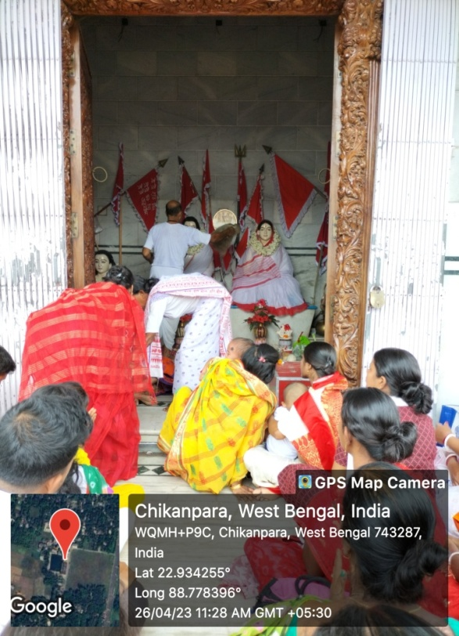
Matua People in the Temple

Religious Composition in Thakurnagar:
Almost 65% people belongs to the Matua religions. Also there are people who belongs to other religion like Muslim 5%, Christian 10% . Among this there are some people who belongs to different religion but believes in Matua philosophy. 10% people are totally believer of prabhu shree Krishna.
Main festival of Thakurnagar:
Here religion of Matua communities people main festival is ‘BARUNI UTSAV’ .This festival is organize At Thakurnagar place.People of this religion is believes monotheistic and also there are different style of worship. No priest is required for their worship. They are wear ‘Achar Mala’.They are uses ‘Danka’ , ‘ Kashor’ , ‘Nishan’,’Chota’ for equipments of worship. Beside this, women are wearing ‘red border white sharee’ and men also ‘Dhuti’ and ‘under vest’ as cloth of their worship. Both men and women have new towels (which is called ‘Gamchha’) around their neck. When Matua’s were asked about why the specific material used in their worship, they gave proper explanation. It is mentioned bellow –

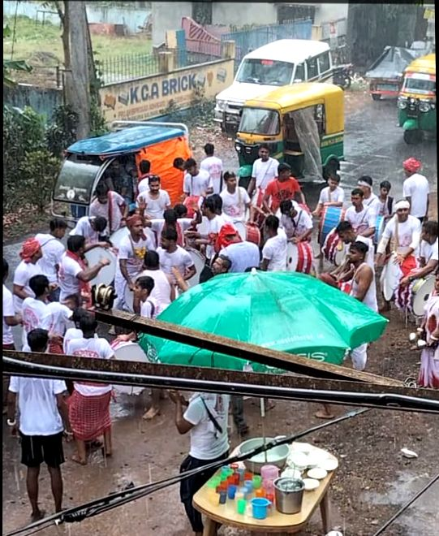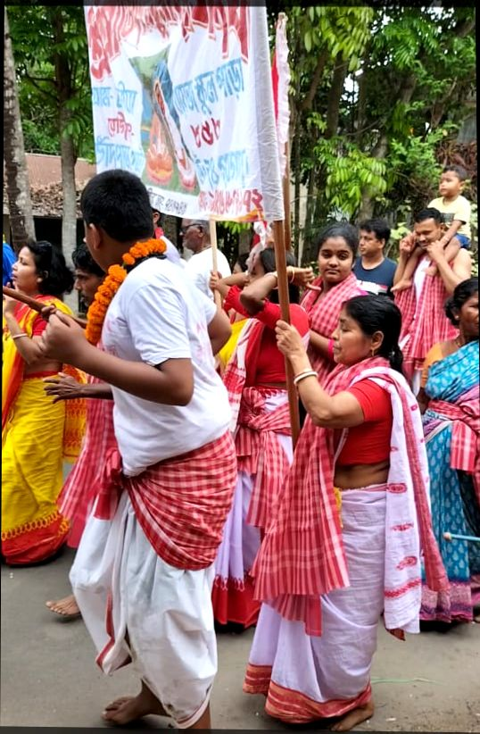
Devotees Celebrating Baruni Festival at Thakurnagar
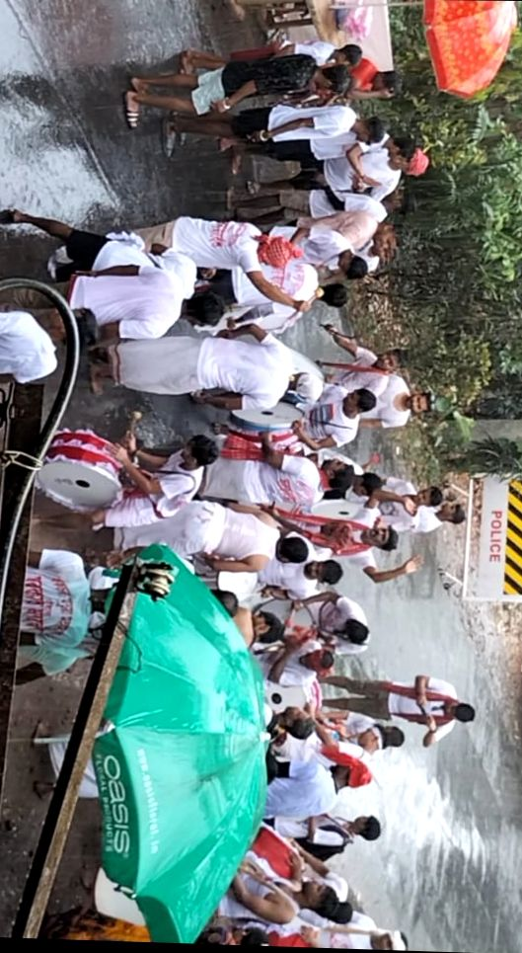
Importance of Baruni Festival:
Shree Shree Harichand Thakur was born in Ishan Kon on Madhukrishna Troyodoshi Tithi and the day was Wednesday. On the occasion of his birthday all Matua Religious people in India and other countries celebrate and organize great festival “BARUNI FESTIVAL”. All India matua people meet at Thakurnagar Dham for these festival. Hugging each other and they are also foot dust gets on the head. They are tumbled to the ground to love of Harichand Thakur , devotion of’ HARI’. Their devotion, love, faith, and purpose should all merge into one. The same sound repeated in everyone’s mouth is the Motto ‘HARIBAL’ Given by Harichand Thakur.May all people become united and chant the same motto and descend on the path of devotion for the same purpose. Their love for each other, fell in love for people ,their uniformity is not a message only to Matua but to entire humanity.

ACCHAR MALA and CHHOTA:
According to the information received from the devotees of Matua in Thakurnagar, Harichand and Guruchand Thakur is worshiped as GOD. Matua people has think their talk,word,advice is the best .Their opinion is Chaitanya Mahaprabhu relinquished his body and next time he appeared in the world as Harichand Thakur .When Chaitanya Mahaprabhu was leaving home , he was carry a STICK and AACHA.
Harichand Thakur’s wife who is worship as world mother of Matua religion people. During her lifetime she cut the stick into three pieces which served as a guiding force for the people which called “CHHOTA”and cut the Aacha many pieces and made a chain like garland which is called “ AACHAR MALA” to ordered own religion people for wearing this .
So that, all Matua community people has were this as blessing of mother and during of Baruni Festival they are go to God (Harichand Thakur and Guruchand Thakur) with ‘CHHOTA”in the hand and wear “AACHAR MALA”.
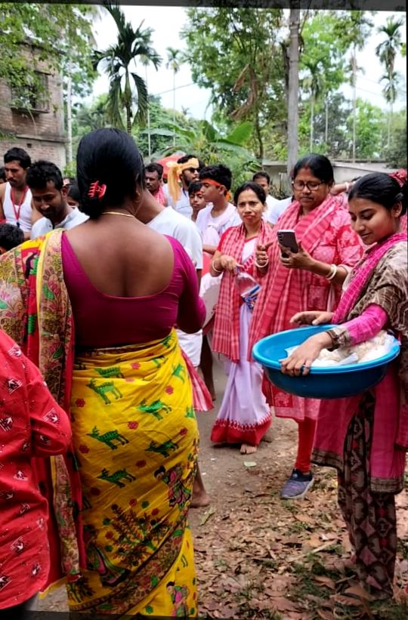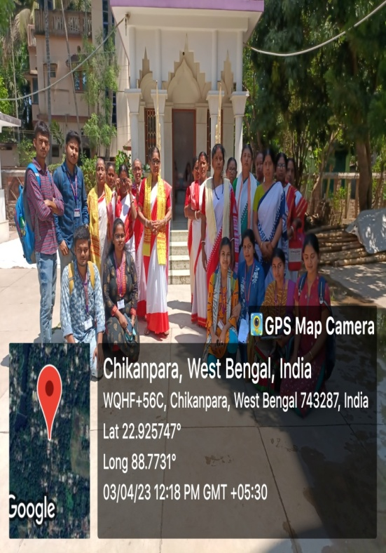

Importance of Nishan & Danka, Kashor :
‘Danka’, ‘Nishan’, ‘Kashor’ as a other equipment is very important for worship of Matua religion. They are worship to Harichand Thakur and his wife Santi Debi as a father and mother and consider them as one and the same. So they worship Nishan’s as a symbol of white cloth father and red cloth symbol of mother i.e. composite form.
Harichand Thakur, during his lifetime, was always enjoying’ Hari naam’ with his followers. He had create a devotional environment with sound of ‘DANKA’,’KASHOR’ so that everyone can forget all the sorrows and live in one Harinaam. For these cause Matua religion people always uses ‘DANKA’, ‘KASHOR’ as a part of worship to ‘LORD HARI’.

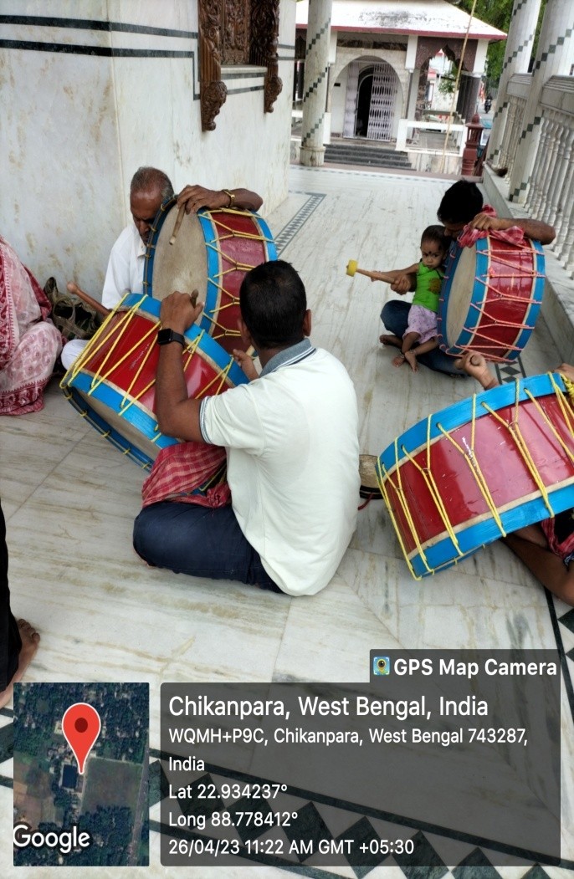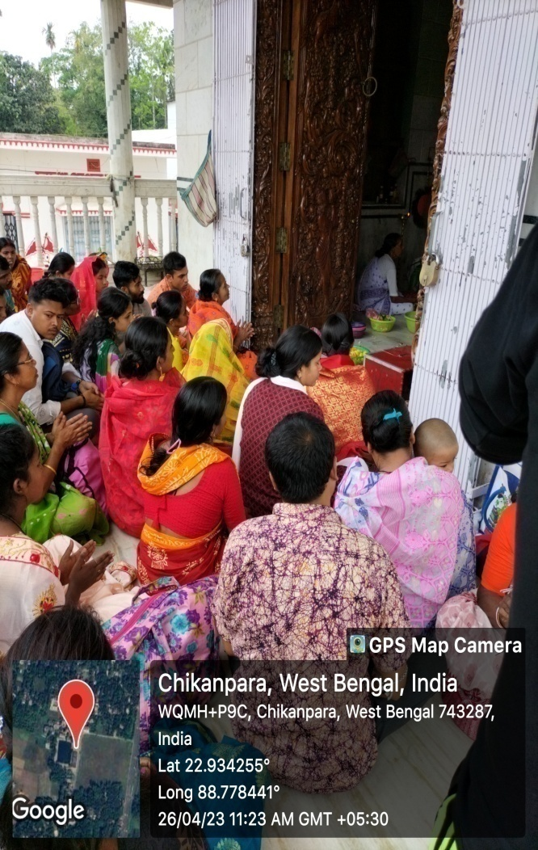

Rituals of worship:
The worship rituals of the devotees of the Matua sect are different from those of other sect .Here , when the group comes home for ‘NAMGAAN’, the feet of the leader are washed with water from the pot .The ‘Nissans’ are gathered and placed in a kasha dish and bathed in milk,ganga water and oil vermilion is applied. As well as they are started kirtan with Danka,Kashor.Various lilakothas composed by devotees of Harichand Thakur are recited through song .Everyone is hugged each other and mahaprasad dedicated to God is distributed among all. Finally the event is completed again ‘Danka Kirtan’.

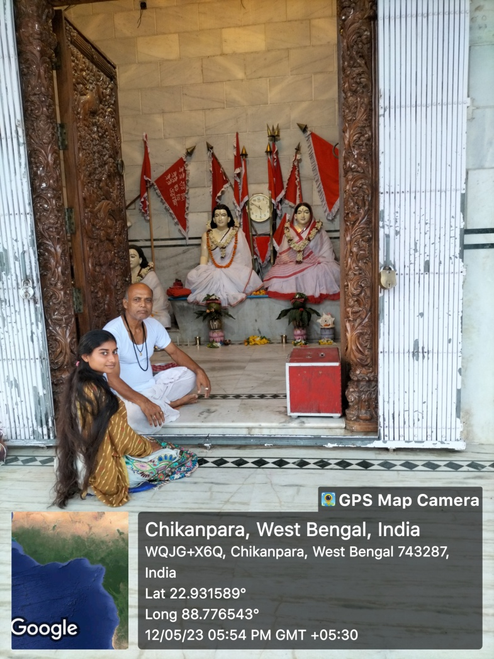

Specialities of Idols of adorable deities:
Harichand Thakur and Guruchand Thakur have rescued of lower class people of society. So that, backward class people always follow their speech and advice and do not follow other without them. So they are worship Harichand Thakur and Guruchand Thakur well as give equal respect to their wifes. This is the speciality of their IDOLS.
Importance of Santi shova:
People of Thakurnagar is say that , Harichand Thakur want to spread the peace , value, to every person and he always given people to peaceful life. Harichand Thakur’s wife name is Santi Devi. She is the mother of all Matua peoples. So they organised meeting of ‘Hari Naam ‘to every month in the name of her. They are forgotten every differences and chanted the God (Harichand Thakur , Guchand Thakur , and with their wife).They are spread peace to every body.This is the main aims of this “SANTI SHOVA” is spread happiness,peacefulness ,joyful ,cheerful to every person as well as society.

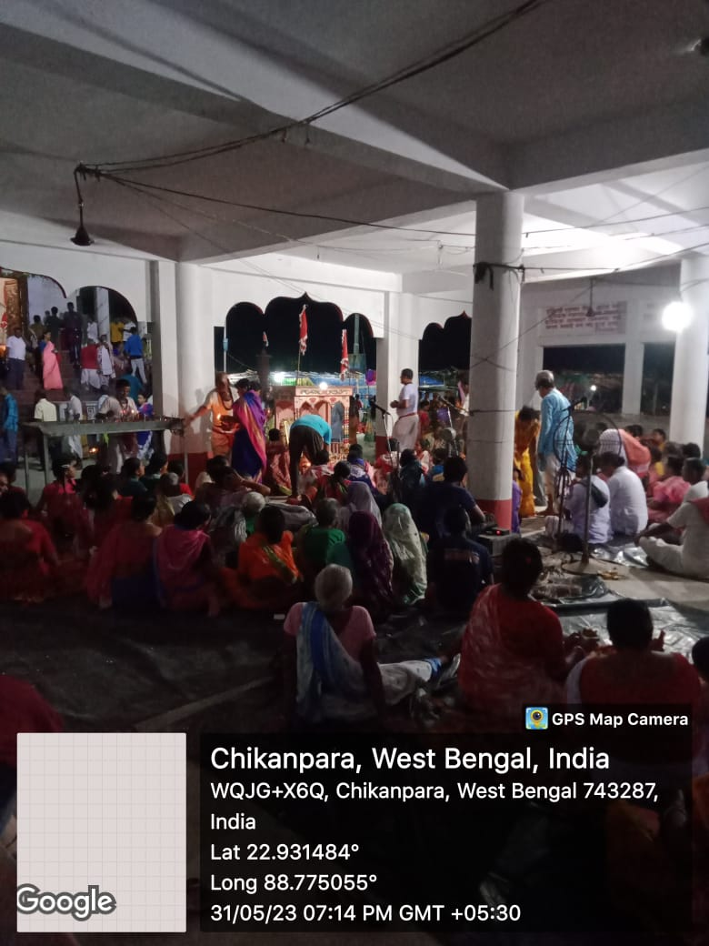

Importance of Kamana Sagar and Batasha:
Kamana Sagar is a pond which is situated Thakurbari adjacent to temple of Harichand Thakur. People of Matua religion is believed that if one dives into this pond and speaks his heart’s desire, it is fulfilled. The people who had come from many state, district , area they went to fullfill their desire pray to Harichand Thakur and take bath from Kamana Sagar.
When heart’s desire is fulfilled they again come and bath and after worship to the Harichand Thakur. This pond is being worshipped as a Kamana Sagar by Matua devotees for so many years.
When the Monks, Dalapati, Vaktas come to the Thakurnagar that time they spread every where ‘Batasha’. Because of that this Batasha is the main Prasad of Harichand Thakur. They spread Batasha towards vaktas who were come to Thakurbari and that is the way to pray to the God. As well as they pray for the God, they maintain some rituals like incense sticks, candles.
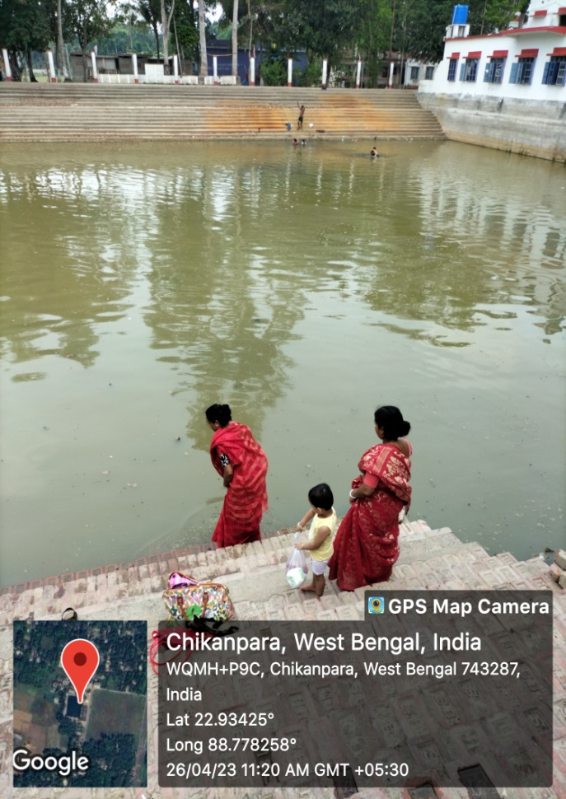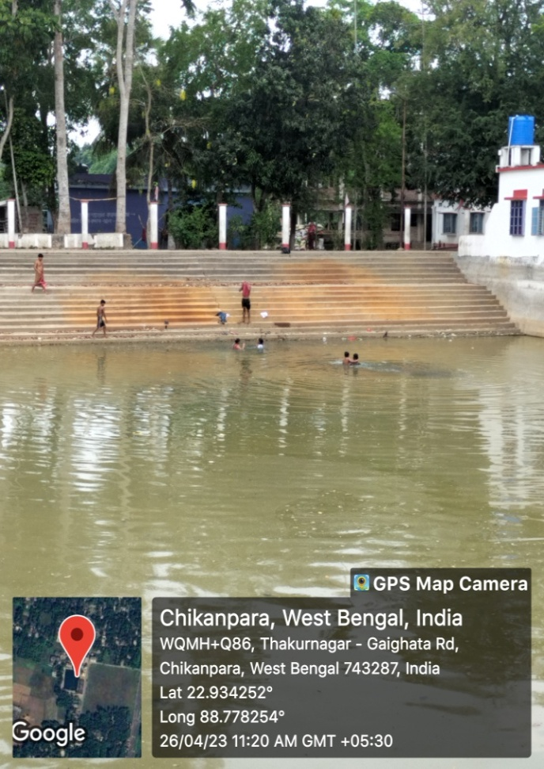
Kamana Sagar Pond

Others various festival of Thakurnagar:
Apart from Baruni Festival, various festival, cultural event is arrange in Thakurnagar villagers like –
Christian festival:
There are situated a Christian charch where organised event on 25 December. Here not only chrishtian but people of all religions come together and enjoy. Without 25 December, others day of the year these are closed for others people . only 25 December is open for all.
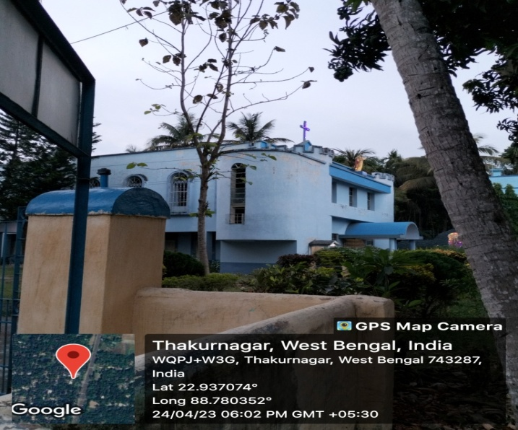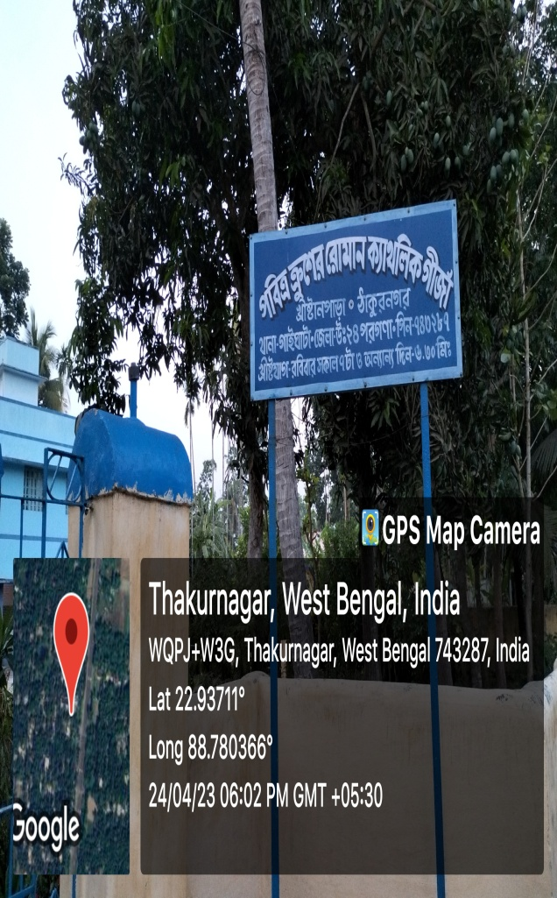

Rakhi Festival :
“Rakhi Bandhan” festival is celebrated at Thakurnagar railway station where everyone forgotten every differences and wear rakhi each other as brother.
Book fair,Shipo’ mela,krishi mela:
In specific time of the year there are many festival like Book fair,Shilpo festival , krishi festival has organised in the specific area adjacent to the station.
Others festival :
Durga festival :
Apart from these, a big festival of Bengal ‘DURGA PUJA,’is celebrated here. This puja is celebrated in different places of Thakurnagar. One Durga Temple is situated at Thakurnagar. hares people are enjoyed many days surrounding this festivals. That times the people of this locality wear new dress and going for many pandels to look after the idol. As well as these areas people go to Kolkata,kalyani and others places for see the great idol and pandels.
In these festivals the organiser arrange some functions like dancing, singing, quiz contest, distribution of cloth etc. in this time in this people spend lots of money for their cloth and food.
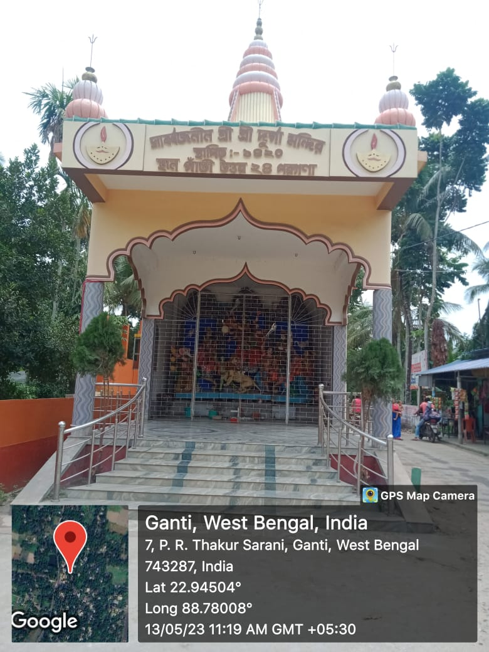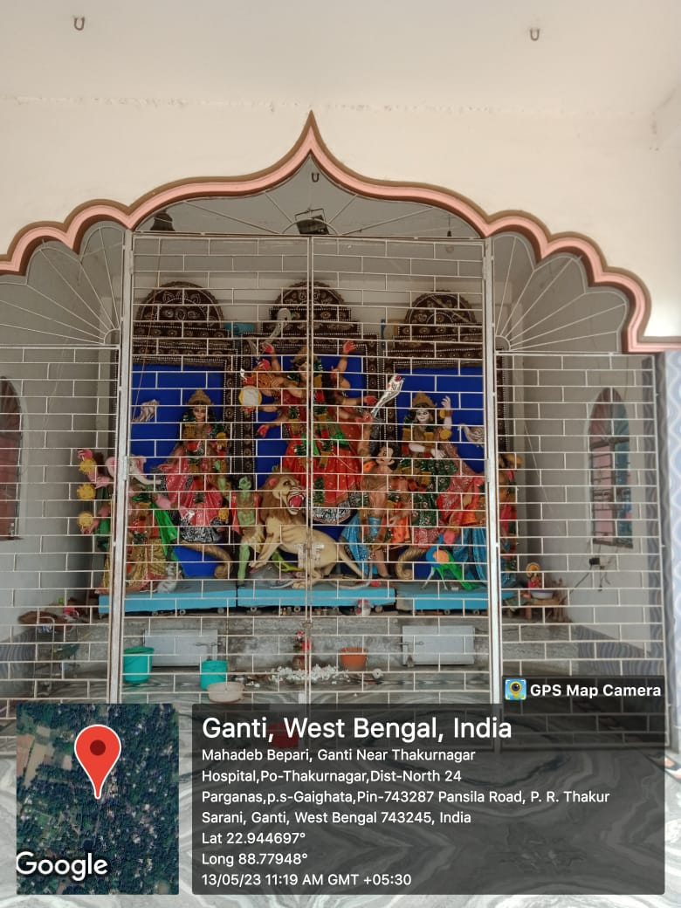

Kali Puja:
Samely Kali Puja is big festival of these area’s people like Durga puja.There are situated many Kali Temple.
That times the people of this locality and going for many pandels to look after the idol. As well as these areas people go to Kolkata ,Barasat,Chandannagar, and others places for see the great idol and pandels.
In these festivals the organiser arrange some functions like dancing, singing, quiz contest, distribution of cloth etc. in this time in this people spend lots of money for their cloth and food.
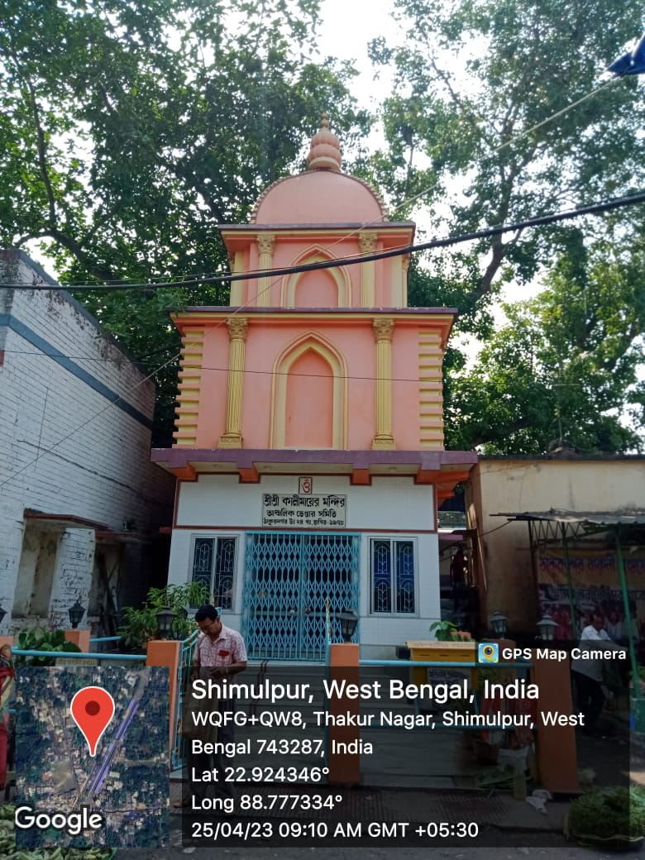
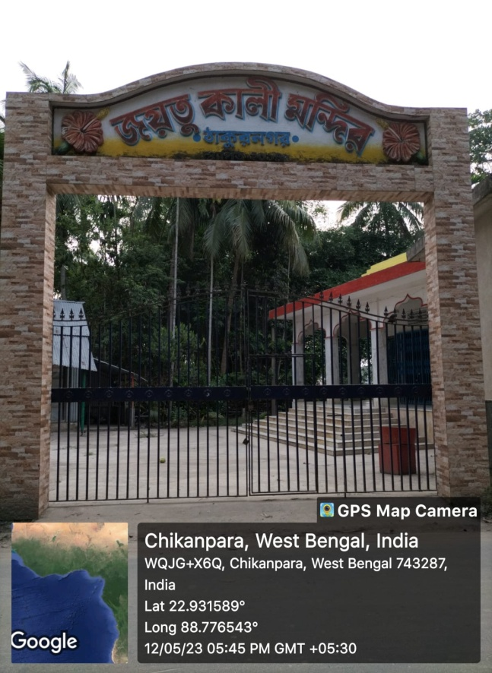
As well as various festivals is celebrated in the specific time of the year like Basanti Puja ,Ram Nabami,Jagadhatri Puja, etc. Are also organised and celebrated in the area Thakurnagar.

CONCLUSION:
After the collecting data from selective areas, the researcher concluded that the whole Thakurnagar areas basically worship and they obey the rituals of Harichand and Guruchand Thakur path.matua community people follow the path of Thakur family. As well as some people worships other idol. After the collecting information from Thakurnagar researcher can concluded that Thakurnagar areas is so much cultural and value oriented.

REFERENCE :
Thakurnagar" (May2018)news · newspapers · books · scholar · JSTOR Retrievedfrom https://en.wikipedia.org/wiki/Thakurnagar 6 june 2023.

