Why smaller size and amount of gold nanoparticles is more favourable to augment the electrical properties of discotic liquid crystals – treatise

Abstract: This article explains the mixing of discotic liquid crystals and nanoparticles. The conclusion as to what size and quantity of nanoparticle should be added to enhance the property is given here.
Key Words: Liquid crystals, liquid crystal nano composites, discotic liquid crystals, dielectric, thermodynaical studies
Discotic liquid crystals [1], or DLCs, are significant functional materials that are used in photovoltaic solar cells, light-emitting diodes, one-dimensional conductors, and photoconductors. Typically, they consist of aromatic core in the middle, surrounded by aliphatic chains. A variety of supramolecular interactions, including π-π ntacts, charge-transfer interactions, dipolar or quadrapolar interactions, metal coordination, hydrogen bonding, and others, cause appropriately substituted disc-shaped molecules to organize themselves in orderly columns. The molecules can stack on top of one another to create columns because of the strong π-π contact between the aromatic cores and the weak connection between the flexible aliphatic chains. Along the columns, there is quasi-one-dimensional electrical conductivity due to strong intracolumnar contact and weak intercolumnar interaction [2-6]. Numerous applications in the following domains have been suggested for these discotic systems' quasi-one-dimensional electrical conductivity. Liquid crystal-nano particle (LC-NP) composites have become a popular topic of study for scientists studying soft matter, drawing from a variety of disciplines. Liquid crystal characteristics can be effectively tuned with nanoparticles. There are several papers describing the distribution of NPs in DLCs, nematic LCs, and FLCs. But I am focusing only on discotic liquid crystal and naoparticle composites. During my research, I mixed various sizes of amounts/concentrations of gold nanoparticles and then studied it by using different techniques then that research was also published in many journals. Based on that I have come to a conclusion and able to write a treatise. I have mainly worked on hexabutoxytryphenylene (HAT4) and in this article I want to discuss the same. Gold nanoparticles (GNPs) of two sizes (5 nm and 2 nm) have been mixed in HAT4 with various low and high concentrations and discuss findings based on differential scanning calorimetry, polarized light microscopy, UV-Vis spectroscopy, X-ray diffraction (XRD) and dielectric spectroscopies. We have dispersed GNPs in four different concentrations 0.2, 0.6, 1.2 and 3 wt% in HAT4 i.e. both sizes of 0.2, 0.6, 1.2 and 3 wt%. of GNPs. Mainly columnar hexagonal to isotropic (Col_{hp}-Iso) transition temperature is listed in Table 1 for various concentrations with accuracy ±0.5°C. For detail analysis and thermo grams refer to the full manuscript.
Sr. No. | Transition Temperatures
 | Pure HAT4 | 0.2 wt% | 0.6 wt% | 1.2 wt% | 3.0 wt%
Phase | Col_{hp}-Iso | Col_{hp}-Iso | Col_{hp}-Iso | Col_{hp}-Iso | Col_{hp}-Iso
5 nm | 144.8 | 137.9 | 132.8 | 122.7 | 139.5
2 nm | 144.8 | 143.9 | 137.9 | 143.9 | 142.8

According to the results above, increasing the amount of GNPs of 5 nm in HAT4 decreases the Col_{hp}-Iso transition temperature up to 1.2 wt%. In contrast, the transition temperature begins to rise at 3 weight percent instead of decreasing. In a similar vein, the data for 2% weight shows that as GNP concentrations rise (below 1% weight), the Colhp-I transition temps drop sharply. This is conceivable since it is anticipated that GNPs will be placed in domain boundaries and columns, upsetting the cores—the Colhp–I transition being most negatively impacted. Based on the findings, I can deduce that the temperature of the Colhp-I transition, in particular, is either essentially constant or declines very slowly in the higher concentration zone for 2 nm. We can thus conclude that the transition temperature decreases very quickly with increasing GNP concentration in the first region, or low concentrations (<1 wt%), while it remains roughly constant or decreases very slowly with increasing GNP concentrations in HAT4 in the second region, or higher concentrations (>1 wt%). Several researchers have discovered that only a tiny quantity of NPs is needed to enhance the characteristics of liquid crystal hosts.
Doping with nanoparticles (NPs) generally results in increased conductivity in the isotropic and mesophases of discotic materials. Doping the GNPs in HAT4 produced similar results in our case as well, though there were some notable differences from earlier studies. Pure HAT4 has a conductivity of about 10⁻¹⁰ S-m-1, which is consistent with values found in published articles. In the case of the highest concentration (1.2 wt %) of GNPs, the conductivity in the col_{hp} has increased by approximately five orders of magnitude.
For both 0.6 and 0.2 weight percent of GNPs (5nm), the increase in ionic conductivity in col_{hp} is nearly identical. It is significant to note that, for composites containing 0.6 and 0.2 weight percent of GNPs, conductivity enhancement is nearly constant throughout the isotropic liquid and col_{hp} phases, with the exception of a slight decrease at the iso-col_{hp} transition, which is caused by an increase in viscosity at that point. On the other hand, when the composite with 1.2 weight percent of GNPs transitioned from the isotropic liquid phases to the col_{hp} phase, conductivity increased significantly (see Fig. 1). This demonstrates unequivocally that the molecules in the columns are highly aligned.
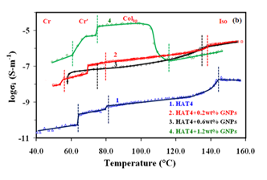
Fig.1 plot of Ionic conductivity vs tempertaure for pure and its nanocomposites (5 nm).
For 2 nm GNPs, It is also evident from Figure 2 that the enhancement of the dc conductivity is nearly uniform throughout the isotropic and Col_{hp} phase at lower concentrations (0.2 & 0.6 weight percent). On the other hand, conductivity has increased in the Col_{hp} phase from the isotropic phase in the case of higher concentrations (1.2 & 3.0 wt%). From an application perspective, this is significant evidence of good homeotropic alignment in the Col_{hp} phase during cooling from the isotropic phase.

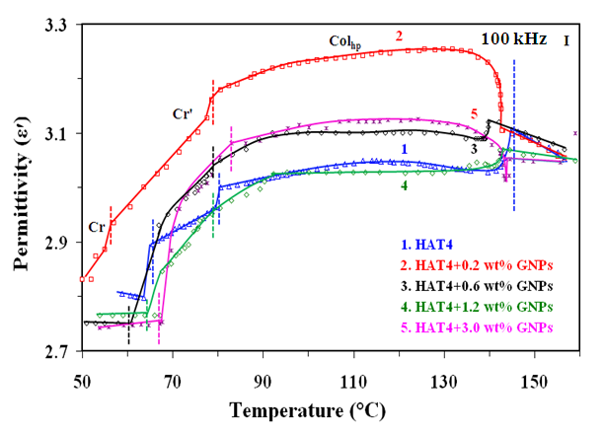
Fig.1 plot of Ionic conductivity vs tempertaure for pure and its nanocomposites (2nm)

Based on the aforementioned findings and discussions, it is determined that as GNP concentrations increase in DLC (HAT4), Col_{hp}–I phase transition temperatures decrease more slowly at higher concentrations. Even higher concentrations of GNPs (2nm) (1.2 wt %) dispersed in HAT4 have been shown to significantly increase (by roughly seven orders of magnitude) the value of dc conductivity when compared to lower concentrations. Conductivity is initially high at higher concentrations (3.0 wt%), but as temperature drops owing to GNP aggregation, alignment deteriorates and conductivity drops. At lower concentrations (0.2 & 0.6 wt%), these values decrease rapidly. Observed results strongly supports that plastic nature of the columnar mesophase of HAT4 shows better fluidity (mesophase behavior) in the presence of small concentration (<2%) of GNPs without losing its columnar structure (as confirmed by XRD). However, large concentration is expected to destroy its mesomorphic nature due to increase in disorder.

References:
- S. Kumar, Chemistry of discotic liquid crystals: From monomers to polymers, CRC Press, Boca Raton, USA, 2011.
- S. Chandrasekhar, B. K. Sadashiva, K. Suresh. Liquid crystals of disc- like molecules. Pramana. 9 (1977) 471-480.
- R. J. Bushby, K. Kawata. Liquid crystals that affected the world: discotic liquid crystals.
Liq. Cryst. 38 (2011) 1415-1426.
- S. Chandrasekhar, V. S. K. Balagurusamy. Discotic liquid crystals as quasi-one-dimensional electrical conductors. Proc. R. SOC. Lond. A. 458 (2002) 1783-1794.
- S. Kumar. Recent developments in the chemistry of triphenylene-based discotic liquid crystals. Liq. Cryst. 31 (2004) 1037–1059.
- S. Kumar. Triphenylene-based discotic liquid crystal dimmers, oligomers and polymer. Liq. Cryst. 32 (2005) 1089–1113.
- M.Mishra, R.Dhar, S. Kumar, Effect of the dispersed colloidal gold nano particles on the electrical properties of a columnar discotic liquid crystal. 4 (2014) 62404-62410.
- M.Mishra, R.Dhar, S. Kumar Gold nanoparticles in plastic columnar discotic liquid crystalline material. 631 (2016) 59-65.

