Agricultural Progress: Harnessing Quantum Dots for Crop Enhancement

Dr. A.Sharma, Dr.G.Pradhan, Mr.S.Deb, Dr.P.K.Shivam, Dr.D.Nath, Mr.Priyan.K.M.

Abstract

Quantum dots (QDs), with their unique optical and electronic properties, have garnered notable interest as potential agents for advancing crop enhancement strategies. This chapter explores the amazing realm of quantum dots in agriculture, aiming on their implementations in crop productivity by highlighting their applications in optimizing light absorption, nutrient uptake, and stress mitigation.

Introduction

The global demand for food is increasing, necessitating innovative approaches to enhance crop production while minimizing resource consumption and environmental impact. Quantum dots, nanometer-sized semiconductor particles, have recently emerged as novel tools in the agricultural sector due to their exceptional properties. This chapter explores the use of quantum dots in crop enhancement, highlighting their applications in optimizing light absorption, nutrient uptake, and stress mitigation.
Quantum Dots: Unveiling the Nano Wonders
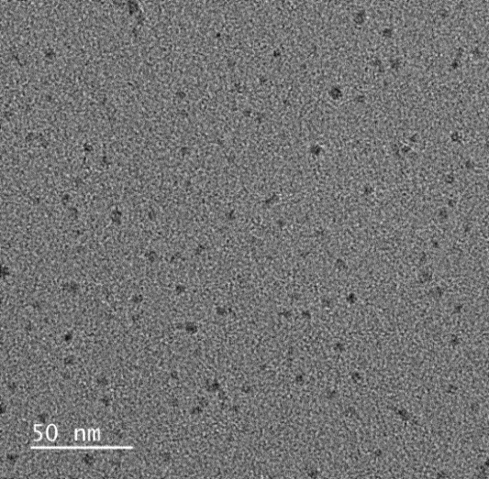
Quantum dots (QDs) are tiny semiconductor nanocrystal of a typical size of 0.5–9 nm that follows the rules of quantum chemistry and quantum mechanics. Typically, the size of the QDs of a material is within the Bohr radius of that material. The electrical, optical, and chemical properties of QDs can be tuned by changing their size. QDs are also called ‘zero-dimensional materials’ because of their very small size. At this size range, the energy levels of electrons are very high and discrete due to the quantum confinement effect.

Figure-1: Transmission electron microscope image of QDs

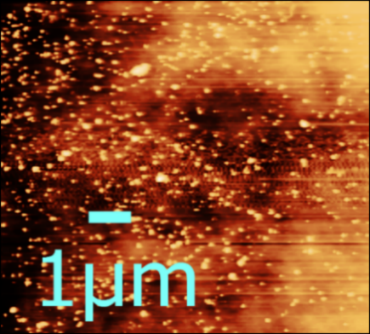

Figure-2: Atomic force microscope image of QDs
Quantum dots (QDs) are emerging nanomaterials that show potential applications in the fields of electronics, optics, medicine, agriculture, and many others. Highly luminescent, thermally and chemically stable QDs like CDSe, ZnS, InAs, InP, and PbS are useful for electronics and optical devices, while various biocompatible, photosensitive QDs like graphene QDs (GQDs) and carbon QDs (CQDs) are showing their effective applications in the fields of medicine and agriculture.
Table-1: The table shows the list of QDs materials use in various fields.
Fields of application | Name of QDs materials
Electronics & Optoelectronics | CDSe, ZnS, InAs, InP, PbS
Catalysis | MoS₂, WS₂
Photovoltaic | CdS, PbS
Medical | Graphene oxide, MoSe₂
Agriculture | graphene QDs, carbon QDs

Enhancing Photosynthesis through Quantum Dots

Quantum dots exhibit size-dependent optical properties, including tunable fluorescence and quantum confinement effects. These properties allow them to efficiently absorb and emit light at specific wavelengths, making them valuable for enhancing light absorption in crops.

Quantum dots offer a transformative approach to enhancing photosynthesis, the cornerstone of plant growth. These nano scale semiconductor particles can be tailored to selectively absorb specific wavelengths of light, enabling plants to tap into a broader spectrum of solar energy. By converting absorbed light energy into fluorescence, quantum dots can act as efficient energy donors, transferring this energy to photosynthetic pigments like chlorophyll. This process not only increases the activation of pigments but also amplifies the overall rate of photosynthesis. Quantum dots can also be strategically integrated into solar cells designed to capture sunlight and convert it into usable source of energy. This innovative approach has the potential to significantly enhance light absorption, energy conversion, and ultimately, crop productivity.

The application of quantum dots extends beyond traditional light conditions. In shaded or low-light environments, these dots can function as supplementary light sources, emitting fluorescence to compensate for insufficient natural light. Furthermore, quantum dots' ability to dissipate excess energy as heat can alleviate the detrimental effects of photo inhibition, a phenomenon where excess light damages plant cells. This unique characteristic ensures sustained photosynthetic efficiency even under challenging conditions. Quantum dots also hold promise in stress mitigation. By maintaining higher energy levels within plant cells, these nanoscale agents contribute to stress resilience, enabling plants to better endure adverse factors like heat, cold, and drought.

The implications of quantum dot-enabled photosynthesis enhancement are far-reaching. By maximizing light absorption, energy transfer, and stress resilience, quantum dots offer a sustainable avenue to increase crop yields without requiring additional land or resources. With this innovation, modern agriculture addresses the pressing need for food security and sustainable resource utilization, aligning with its goals. It is not only the potential of quantum dots to revolutionize agricultural practices in the quest for a more productive and resilient future that is demonstrated by their integration into plant physiology.
Quantum Dots for Nutrient Management

Quantum dots offer a revolutionary approach to nutrient management in agriculture, heralding a new era of precision and sustainability. Engineered with the capability to carry essential nutrients and trace elements, quantum dots provide a novel avenue for targeted nutrient delivery to plant roots. This tailored approach ensures that nutrients reach plants precisely where and when needed, maximizing uptake efficiency and minimizing environmental repercussions. Additionally, quantum dots serve as real-time nutrient monitors within the soil, offering insights into nutrient dynamics that empower farmers to implement timely and informed fertilization strategies.

A hallmark of quantum dot-based nutrient management is its potential to mitigate nutrient runoff and leaching, two significant contributors to water pollution. By optimizing nutrient uptake and assimilation, quantum dots help reduce the risk of nutrient loss from agricultural fields, promoting responsible and sustainable farming practices. Moreover, these nanoscale agents enable precision fertilization by mapping nutrient distribution within soil and plants. This approach not only minimizes the overuse of fertilizers but also optimizes resource allocation, aligning with the principles of precision agriculture and environmental stewardship.

The integration of quantum dots into nutrient management practices also addresses the intricate relationship between pH and nutrient availability. By designing quantum dots to respond to changes in soil pH, nutrient release can be fine-tuned, mitigating nutrient deficiencies resulting from imbalanced pH conditions. Furthermore, the convergence of quantum dots with remote sensing technologies and data integration offers real-time insights into nutrient levels, enabling data-driven decisions and fostering a holistic approach to nutrient optimization. As agriculture moves towards a more sustainable future, quantum dots emerge as a powerful tool to enhance nutrient use efficiency, support responsible resource management, and ensure bountiful and environmentally conscious yields.

Quantum Dots in Stress Mitigation

Quantum dots have shown potential in enhancing plant defense mechanisms against pests and pathogens. Functionalized quantum dots can stimulate the production of defense-related compounds, priming plants for faster and stronger responses to biotic stressors. Quantum dots have emerged as promising agents for mitigating stress in plants, particularly in the face of challenging abiotic and biotic conditions. These nanoscale semiconductor particles exhibit remarkable potential to enhance plant resilience by addressing various stressors. One key area of impact lies in abiotic stress response, where quantum dots demonstrate their ability to bolster plants against adversities such as drought, salinity, and extreme temperatures. By enhancing water-use efficiency and reducing oxidative stress, quantum dots offer a protective shield that enables plants to withstand and adapt to harsh environmental circumstances.

In the realm of temperature stress, quantum dots play a crucial role in alleviating both heat and cold challenges. Their capacity to dissipate excess energy as heat proves invaluable in preventing cellular damage caused by excessive heat. Moreover, quantum dots contribute to cold tolerance by stimulating metabolic processes and encouraging the synthesis of protective compounds. This dual functionality underlines their potential to maintain cellular integrity across a broad temperature spectrum, supporting plant survival and recovery in fluctuating climates.
Beyond abiotic stress, quantum dots extend their influence on biotic stress defence. Their ability to activate plant defense mechanisms against pests and pathogens enhances the plant's innate ability to fend off attacks. Additionally, quantum dots exhibit a profound impact on stress signaling pathways, enabling plants to trigger stress-responsive genes and optimize their responses to changing environmental conditions. In essence, quantum dots present a multifaceted approach to stress mitigation, fostering a comprehensive resilience strategy that empowers plants to thrive amidst adversity and contribute to sustainable agricultural practices.

Conclusion

The application of quantum dots in crop enhancement represents a promising frontier in agricultural engineering. Their unique optical properties, coupled with advances in nanotechnology, offer innovative solutions to address challenges in crop productivity, nutrient management, and stress resilience. This innovation aligns with the goals of modern agriculture, addressing the pressing need for food security and sustainable resource utilization. In addition to highlighting the potential for cutting-edge nanotechnology, quantum dots can revolutionize agriculture in order to make us more productive and resilient.

References

- Ditta, A., Mehmood, S., Imtiaz, M., Rizwan, M.S. and Islam, I., 2020. Soil fertility and nutrient management with the help of nanotechnology. In Nanomaterials for Agriculture and Forestry Applications (pp. 273-287). Elsevier.
- Dong, Z., Gong, Y. and Zhao, J., 2022. Cerium-doped carbon quantum dots trigger mung bean seeds to help mitigate salt stress by increasing the degree of stomata opening. Carbon Letters, 32(7), pp.1715-1727.
- Ghosh, S., Thongmee, S. and Kumar, A. eds., 2022. Agricultural nanobiotechnology: Biogenic nanoparticles, nanofertilizers and nanoscale biocontrol agents. Woodhead Publishing.
- Gong, Y. and Zhao, J., 2018. Small carbon quantum dots, large photosynthesis enhancement.
- Li, X.B., Tung, C.H. and Wu, L.Z., 2018. Semiconducting quantum dots for artificial photosynthesis. Nature Reviews Chemistry, 2(8), pp.160-173.
- Li, Y., Li, W., Yang, X., Kang, Y., Zhang, H., Liu, Y. and Lei, B., 2020. Salvia miltiorrhiza-derived carbon dots as scavengers of reactive oxygen species for reducing oxidative damage of plants. ACS Applied Nano Materials, 4(1), pp.113-120.
- Lin, S., Bhattacharya, P., Rajapakse, N.C., Brune, D.E. and Ke, P.C., 2009. Effects of quantum dots adsorption on algal photosynthesis. The Journal of Physical Chemistry C, 113(25), pp.10962-10966.
- Pradhan, G., Dey, P.P., Khare, A. and Sharma, A.K., 2021. Synthesis and size modulation of MoS2 quantum dots by pulsed laser ablation in liquid for viable hydrogen generation. Journal of Applied Physics, 129(2).
- Pradhan, G., Kesarwani, R., Khare, A. and Sharma, A.K., 2016, December. Thickness dependent optical properties of MoS2 thin films probed by spectroscopic ellipsometry. In International Conference on Fibre Optics and Photonics (pp. P1A-14). Optica Publishing Group.
Reference
- Ünlü, C., Budak, E., Kestir, S.M. and Zavafer, A., 2022. Altering natural photosynthesis through quantum dots: effect of quantum dots on viability, light harvesting capacity and growth of photosynthetic organisms. Functional Plant Biology.
- Whiteside, M.D., Treseder, K.K. and Atsatt, P.R., 2009. The brighter side of soils: quantum dots track organic nitrogen through fungi and plants. Ecology, 90(1), pp.100-108.
- Zhong, M., Yue, L., Chen, Q., Wang, H., Lei, B., Yang, X. and Kang, Y., 2023. Spermidine carbon dots enhance thermotolerance by modulating photosynthesis and cellular redox homeostasis in tomato. Environmental Science: Nano, 10(2), pp.595-610.

