Sustainable Agricultural Management
Dr. Sanjeeb Kumar Das
Department of Botany, Regional Institute of Education (NCERT), Bhubaneswar
Email: sanjeebdas75@yahoo.com/ dassanjeebbotany75@gmail.com

Introduction: Sustainable agriculture means the cultivation of all types of crops to meet all human needs without affecting our land, water and air. It aims that we must meet the needs of the present without affecting the needs of the future generation. It is the long lasting agriculture. It focuses on maintaining economic stability of farms and helping farmers improve their techniques and quality of life. It has three main goals. They are
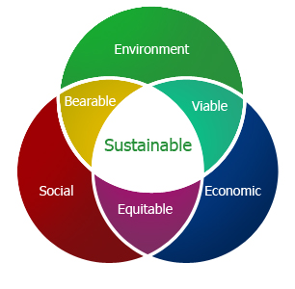

1. Environmental health
2. Economic Profitability
3. Economic Equity
Agriculture can be made sustainable by adopting suitable techniques that prevent the degradation of land and water resources. Sustainable agriculture is most likely to maintain ecosystem balance. It makes the soil more productive and at the same time, conserves the soil fertility.
Agriculture is of two types
- Conventional farming
- Organic farming
Conventional farming is the us e of chemical pesticides, herbecides, chemical fertilizers and genetically modified organisms for agriculture.
Organic farming rely on animal and plant manures, hand weeding, biological control, crop rotation, integrated pest management etc. It is also known as biodynamic agriculture.
Needs for Sustainable Agriculture:
- Nutrient depletion in the fields.
- Nutrient imbalance in the soil.
- Poor soil microflora.
- Chemical redidues in food grains.
- Pest resistance against pesticides.
- Ground water pollution due to agricultuaral chemicals.
- Depletion of biodiversity in crop lands.
If conventional agricultural is going on at this rate, our land and water will become unsuitable for human use. So it is necessary to follow sustainableagriculture to improve the soil fertility and natural ecosystems.
Objectives of Sustainable Agriculture:
- Long Lasting agriculture
- Maintaing environmental health
- Economic profitability
- Social and economic equity
- Maintaing balance of nature
- Maintaining biodivesity
- Agricultural pratices should not harm human health.
Elements of sustainable agricultural management:

Water management Soil management Waste management

Sustainable agriculture management

Crop management Pest /Disease management
Methods for Sustainable Agriculture:
- Cultivation of high yielding varieties.
- Food crops and cash crops should be cultivated in required proportions.
- Crop rotation.
- Fallowing-Land barren for one season.
- Ploughing.
- Algalization of soil before planting.
- Dual cropping.
- Use of Bio-fertilizer.
- Use of Bio-pesticides.
- Drip irrigation.
- Mechanized harvesting.
- Use of tractors for ploughing.
- Integrated Nutrient Management( INM)
- Use of pest Management( IPM)
- Cultivation of disease resistant crop varieties.
- Use of plant and animal manures.
- Use of farm –yard manure.
Methods of Sustainable Agriculture:
The following methods are important for sustainable agriculture.
- Growing balanced crops
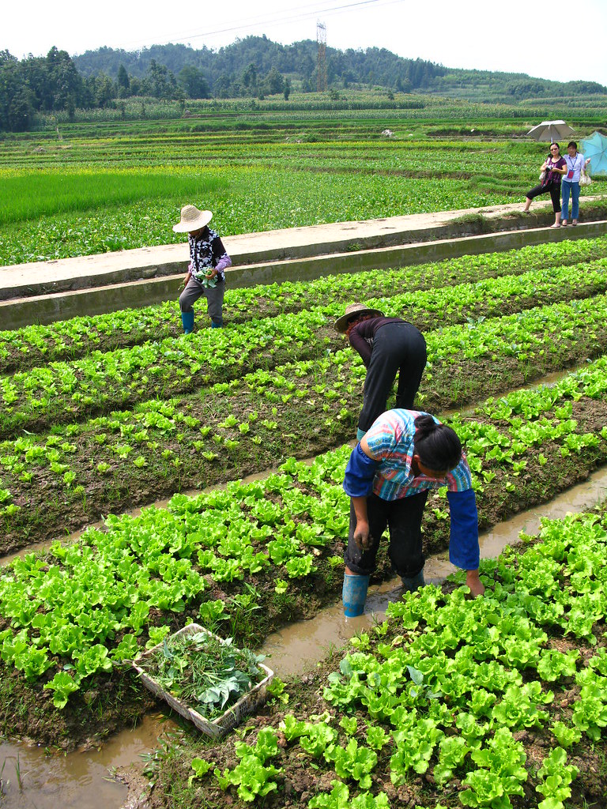
- Use of improved crop varieties
- Crop rotation
- Fallowing
- Cultivation methods
- Integrated nutrient management
- Integrated Pest management
- Integrated disease control.
1. Growing Balanced Crops:
- Growing all kinds of crops in required proportions to meet all needs of people is called balanced cropping.
- Food crops and commercial crops should be in appropriate proportions.
- Food crops include paddy, wheat, maize, millets, sorghum, pulses, vegetables fruits, potato etc. They required for food.
- The commercial crops include all crops which are grown for getting more income. Tea, coffee, rubber, oil seeds, cotton, jute, tobacco, spices etc. are commercial crops.
- If the production of food grains cannot meet the demand, they have to be imported in a country from other countries.
- So all crops grown in a country should meet the requirements of people. It will make the country self sustainable.
2. Use of Improved Crop Varieties:
- Many varieties of crops give relatively low yield and are sensitive to diseases, pests, and drought. If such varieties are grown in the field, more amounts of insecticides, fungicides and weedicides have to be applied to get high yield.
- It will lead to degradation of land and water resources.
- In order to avoid these problems, improved varieties to tolerant to diseases and drought are preferred to grow in the field.
- The improved varieties reduce the cost of production also.
3. Crop Rotation:
- Cultivation of cereals crops and legumes in alternate seasons is known as crop rotation.
- It maintains the fertility of soil. Continuation cultivation of cereals crops in a field for several years makes the soil less productive.
- This is mainly due to poor soil micro-flora and continuous removal of selected nutrients.
- If legumes are grown in alternate years, nitrogen is added to the soil. Hence crop rotation is necessary for sustainable agriculture.
4. Fallowing:
- Leaving the soil uncultivated for one year after five years of continuous cultivation is called fallowing.
- Just before fallowing, the land is ploughed and left barren for the development of grasses. Ploughing improves the aeration of soil.
- The grasses form food for grazing animals. Therefore, fallowing creates some balance in the natural ecosystem.
5. Integrated Nutrient Management:
- A system of crop manuring in which all kinds of manures and fertilizers are supplied to meet the nutrients needs of the crop is called integrated nutrient management.
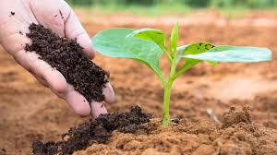
- The INM enriches the soil with all kinds of nutrients and organic substances which make the soil wealthy and healthy for the growth of plants.
- Physiological studies on crop plants have revealed that ten elements are essential for the growth and yield of plants. They are C, H, O, N,S,P,K,Fe,Mg,and Ca.
- In addition to these essential elements, some trace elements are also required for the growth of crop plants. They are B,Cl,Cu, I,Mn, Na and Zn.
- If these elements are depleted in the soil, the crop growth becomes low and yield is decreased to a considerable extent.
- Therefore, all kinds of manures are supplied to the crops to meet their nutrient requirements.
6. Organic manures:
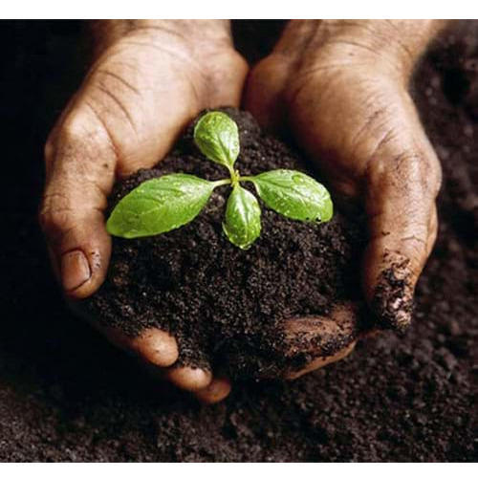
- Farm yard manure, night soil, poultry waste, oil cakes, leaf mould, wood ash and compost are important organic manures being used to manure crop plants.
- All these substances are of organic origin and have essential and trace elements in various proportions.
- Hence they are often known as relative manures.
- They provide essential and trace elements to the crops.
- They add organic matter, essential for good tilt of the soil.
7. Integrated Pest Management (IPM):
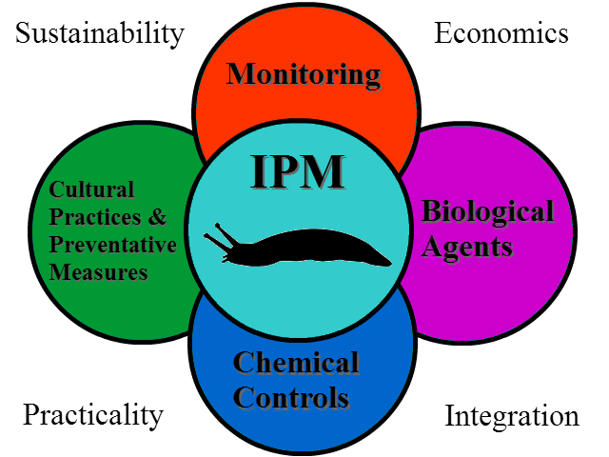
- Effective use of all methods available for pest control without affecting the ecological balance is called integrated pest management.
- It doesn’t destroy all pests from the crop field. But it keeps the pest population in control. So there is no crop loss due to pest attack.
- It involves Identification of target pest
  - Action threshold of the pest
  - Monitoring of pest population
  - Habitat manipulation
  - Prevention of pest attack by a combination of techniques
  - Modification of culture practices

Benefits of sustainable agriculture management:
- Contributes to environmental conservation: It helps to replenish land and other resources like soil, water, air to make them sufficiently available for the coming generations.
- Prevents pollution: Sustainable farming is carried in such manner that it cannot in any way cause pollution.
- Reduction of cost: Minimizes the use and cost of purchasing harmful fertilizers and transportation.
- Biodiversity: Plants are seasonally rotated about the fields, which results in enriched soil, prevention of disease and outbreaks of pest.
- Beneficial for animals: All animals in the farm are facilitated to exhibit their natural behaviors like grazing, pecking and rooting etc.
- Economically beneficial for farmers.
- Social Equality: When sustainable agriculture is practiced workers are offered competitive salaries and benefits.
Disadvantages:
- Limits the proper use of land.
- Also hinders the full exploitation of land, labour and capital since it advocates for the use of productive resources sparingly.
- It is normally difficult to be practiced in many countries.

Conclusion:
Agricultural technology investments including both “advanced” and “traditional” management practices are a game changer in terms of yield improvements and national and global food.
References:

Annadurai,K.,Palaniappan, SP.( 2018): Organic Farming : Theory And Practice, Scientific publisher, PP.1-257

Altieri,A.Miguel( 1995): Agroecology: The Science Of Sustainable Agriculture, Second Edition, CRC press, pp.1-310
Clements, D. & Shrestha, A. (2004): New dimensions in Agroecology. Binghampton, NY: Food Products Press.pp.1-278

Desai, B.K., Pujari, B.T. (2007): Sustainable Agriculture: A Vision for Future, New India Publishing Agency, pp.1-364

Jhariya, M.K., Banerjee, A., Meena, R.S., Yadav, D.K. (Eds.)(2019): Sustainable Agriculture, Forest and Environmental Management, Springer publication,pp:1-560
Kesavan, P. C. & Swaminathan, M. S. (2008): Strategies and models for agricultural sustainability in developing Asian countries. Phil. Trans. R. Soc. B 363, pp. 877–891.

