Self-micro emulsifying drug delivery system for a strategy for Therapeutic Enhancement
Satish Meshram¹, Prakash Itankar¹, Nikhil Amnerkar²
1. Department of Pharmaceutical Sciences, RTMNU Nagpur-441109
2. V.R. Manohar government college of Pharmacy, Wanadangari-441122
Satish.meshram@gmail.com

Abstract
The oral route of administration is the most popular since it is simple and painless. Due to dissolution rate-restricted absorption, many modern active compounds have poor oral bioavailability. Poorly water-soluble medicines' inability to have the desired therapeutic impact through this route is conducted to formulate an innovative delivery system that will meet therapeutic demands with the least amount of medication. Despite the existence of several formulation techniques such as pH manipulation, solid dispersions, complexation, and cocrystals, lipid-based systems are becoming more popular due to the apparent rise in drug absorption. The oral bioavailability of aquaphobic drugs is clearly bettered by self-micro emulsifying formulations containing droplet size (˂100 nm) among lipid-based formulations, primarily because of their effectiveness the hydrophobic medication is presented in a solubilized state, aiding solubilization and preventing dissolution. By encouraging lymphatic transport, various ingredients employed to create dosage forms, such as lipids and surfactants, help to increase oral bioavailability and overcome hepatic first-pass metabolism. In-depth information on formulation design, characterization, and probable methods by which SMEDDS could boost bioavailability is provided in the current study.

1.Introduction
An isotropic system containing lipids and cosurfactants that, with slight agitation, creates an emulsion in the aqueous fluid is known as a self-micro-emulsifying drug delivery system. The fact that almost half of the newly synthesized chemical compounds show lower solubility in the aqueous phase is the main barrier to the efficient delivery of therapeutic molecules and the subsequent decrease in the bioavailability of these entities. Additionally, lipid formulation is regarded as a key delivery method for improving oral hydrophobic medication bioavailability. (1) The increase of poorly water-soluble medications that exhibit oral bioavailability concerns is one of the formulation's key problems. As a solution to the issues of poor solubility and oral bioavailability of drugs, the development of lipid-based systems and self-emulsifying drug delivery systems has received more attention in recent years. SMEDDS features a higher concentration of hydrophilic surfactants and cosurfactants than lipids, in contrast. Following their dispersion in aqueous liquids, SMEDDS create homogeneous, transparent, isotropic, and thermodynamically stable microemulsions with droplet sizes of under 100 nm. (2) Oral delivery system depends upon lipids have a lot of potential to address the issues that more recent medications have, including low bioavailability, ineffective targeting to the intended location, quick clearance, and higher costs associated with innovative dosage forms. To better appreciate the possibilities of nanomaterial dosage forms in oral medications, a number of formulation factors will be addressed, including lipid-based, regulatory limitations, and absorption system. (3) It is challenging for a formulator to create oral dosage forms with a pharmaceutically satisfactory range of curative efficacy since some novel medicines have limited solubility in water. Solid SMEEDS are the most effective delivery systems utilized globally for hydrophobic medicines in such circumstances. SEDDS are also utilized, however because of its shortcomings, Solid SMEDDS are more commonly employed. The isotropic blends of surfactants, co-surfactants, and oils. Solid self-emulsifying dosage forms promote drug bioavailability by allowing for simple absorption of the medicine through the intestinal lymphatic channel and delivering the medication in the emulsion form into the gastrointestinal tract. They are also physically stable, simple to make, and simple to fill in capsule shells. (4)
These are isotropic blends of components (Surfactant, Cosolvent, and oil) that rapidly diffuse in GI fluid affording emulsions (nano/micro). Hepatic first-pass metabolism is reduced by these formulations that contain dispersed drugs that are absorbed via a lymphatic pathway. Compared to other drug delivery methods including microemulsion, nanoemulsion, and liposome, SEDDS is valued more highly for its stability. In reality, the self-emulsifying composition does not include any water, which improves their chemical and physical stability. (5)
2. Composition of Smeeds
Polyethylene glycol Based on the solubility research and their capacity to produce clear microemulsions upon dilution, oleic acid and tween-20 was selected as the oil, surfactant, and co-surfactant, respectively, to make liquid SMEDDS.(10) The ingredients utilized to create the SMEEDS were CaprylTM 90, Lauroglycol 90, Labrasol®, Transcutol®, Capmul®, Cremophor® EL (Kolliphor® EL), polyvinyl Tetraglycol, polyethylene glycol, polyethylene glycol 6000 (PEG 6000), maize oil, Tween® 20, Tween 80, and olive oil. (11)
The lipid-based formulation for oral administration
Table 1. Oral lipid formulations, their Characteristics, advantages & Limitations (12)
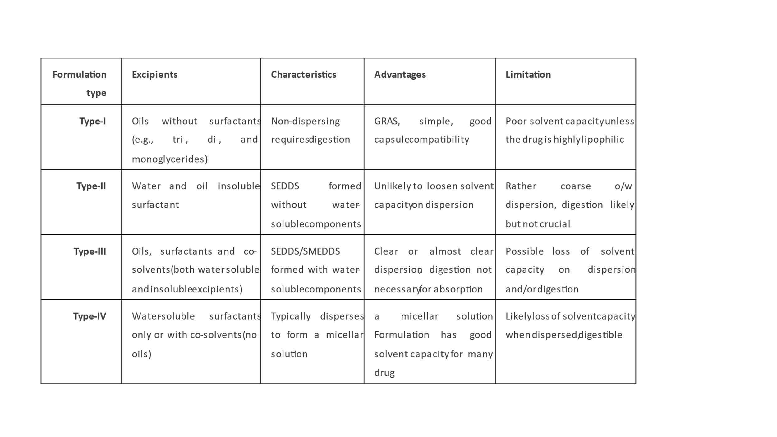
The quantity of triglycerides, hydrophilic and lipophilic surfactant, and co-surfactant phase all affect the classification of Lipid-based formulations. Table 1 lists the four main LFCS compositions and characteristics that may be utilized to mimic or analyze various lipid formulations in vivo. because the lipid concentration is lower. (8)
Long chain triglycerides
LC triglycerides are lipids with 14-20 carbons fatty acid chains, and fixed oils, or vegetable oils, contain a combination of esters of long-chain unsaturated fatty acids. These lipids are thought to be safe because they are frequently found in daily food and are simple to digest. (9)

Medium chain triglycerides and related esters:
Medium-chain triglycerides are a subtype of lipids that have fatty acid chains with 6–12 carbons. MCT is the most often used oil for self-micro emulsifying drug delivery systems because it has a larger solvent capacity than long chain triglycerides, a highly effective concentration of ester group, and resistance to oxidation. Medium chain compounds also known as glyceryl Tri caprylate, are created by distilling coconut oil and include liquid saturated C8 and C10 fatty acids. (9)
Table 2. Natural oil composition (Fatty acid chains) (12)
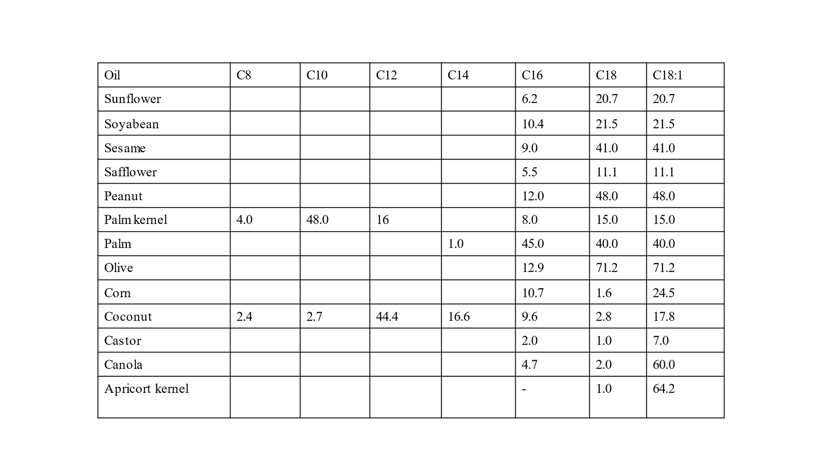
Surfactant
A surfactant (amphiphilic compound) has both hydrophilic and lipophilic linkages, as the name would imply. By selecting the right amphiphile, it is possible to meet the main criteria in achieving low interfacial tension at the water-oil interface. The main factors influencing the choice of surfactant are the efficiency and speed with which the selected oil can be microemulsion, the drug's solubilizing capacity, safety (depending on the route of administration), the type of emulsion to be created, the surfactant's cloud point, and its ability to inhibit. (9)

Table 3. Different commonly used surfactants (9)
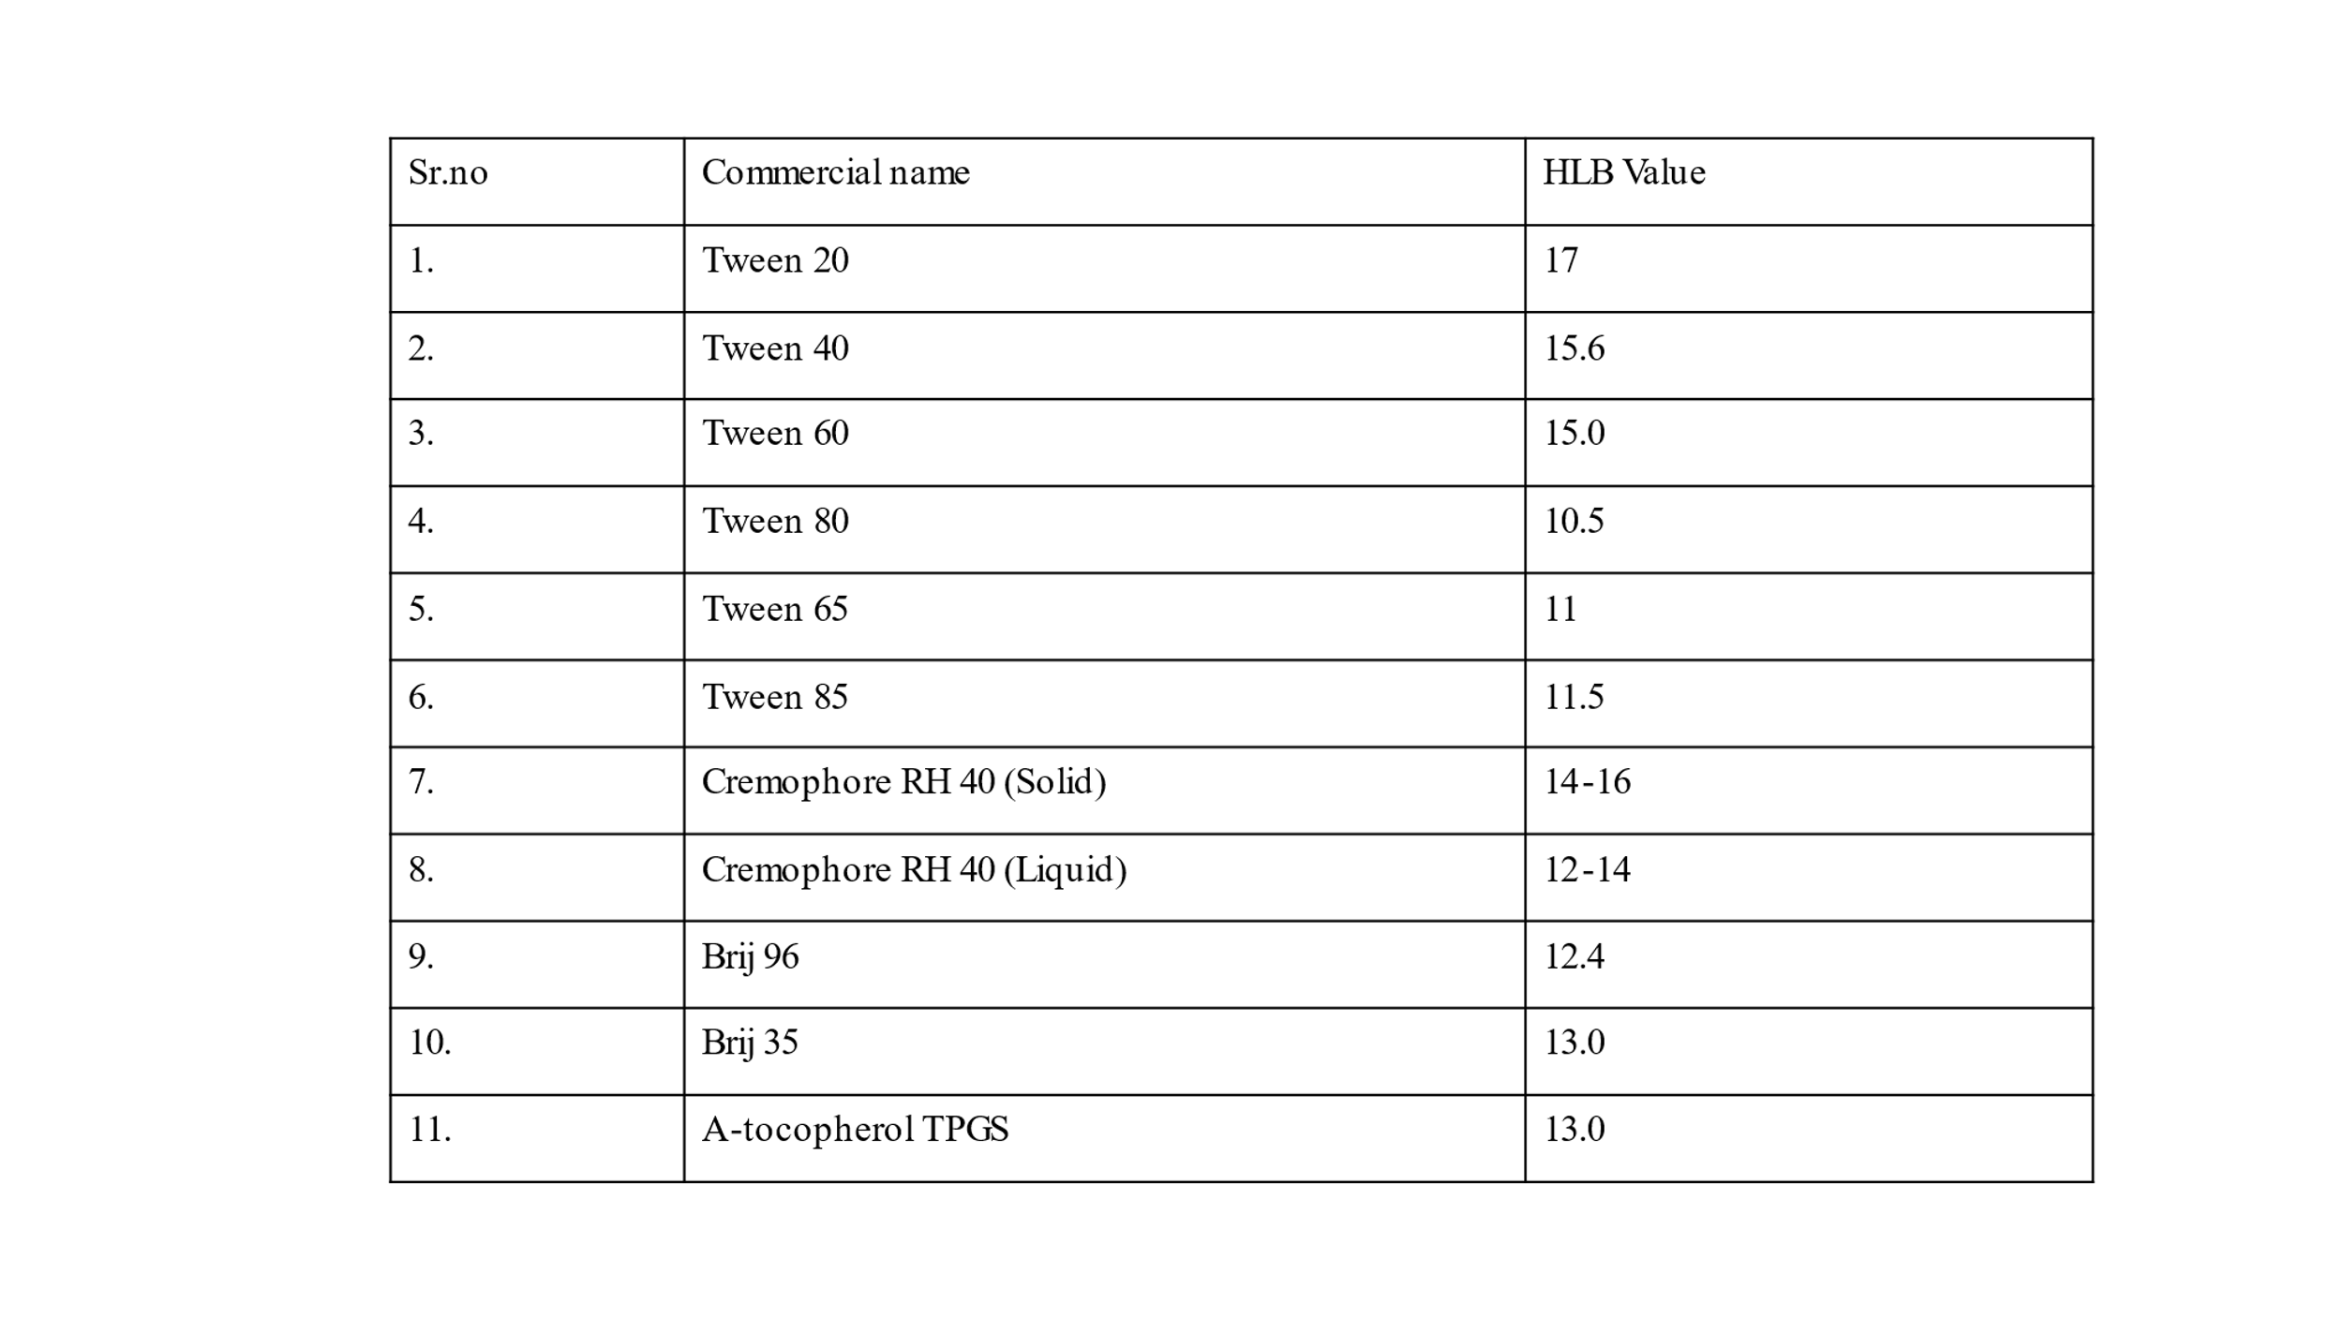
Co-surfactants/co-solvents:
A self-micro emulsifying drug delivery system's ability to create dynamic microemulsions and maintain equilibrium through constant chemical and molecular interaction across distributed phases. Examples of dynamic processes include the exchange of co-surfactant from the interfacial film to the continuous phase and dispersed phase, as well as the exchange of surfactant between water and the interfacial film. Microemulsions have a dynamic activity due to the interfacial surfacing flexibility, which is principally given by the presence of a co-surfactant. (9)
3.Different self-emulsifying drug delivery system
Self-emulsifying drug delivery system (SEEDS) falls under type 2 and type 3 of Pouton's categorization scheme for lipid formulations. Water-insoluble surfactants and oil make up type II, whereas water-soluble surfactants, oils, and cosolvents make up type III. Self-micro emulsifying drug delivery systems (SMEEDS) and Self nano emulsifying drug delivery systems (SNEEDS) are thought to be Type III, however, speculate that surfactant might not be well tolerated in prolonged usage. Since type III supersaturate formulations comprise the majority of SEDDS that have been recorded, less solubilizing excipients, including surfactants and/or co-solvents, are required, potentially lowering toxicity. From an industrial standpoint, the regulatory condition about the toxicity of excipients is essential for the successful development of the commercial final dosage form of SEEDS. (13)
Fig 1. Classification of different emulsifying drug delivery system (7)
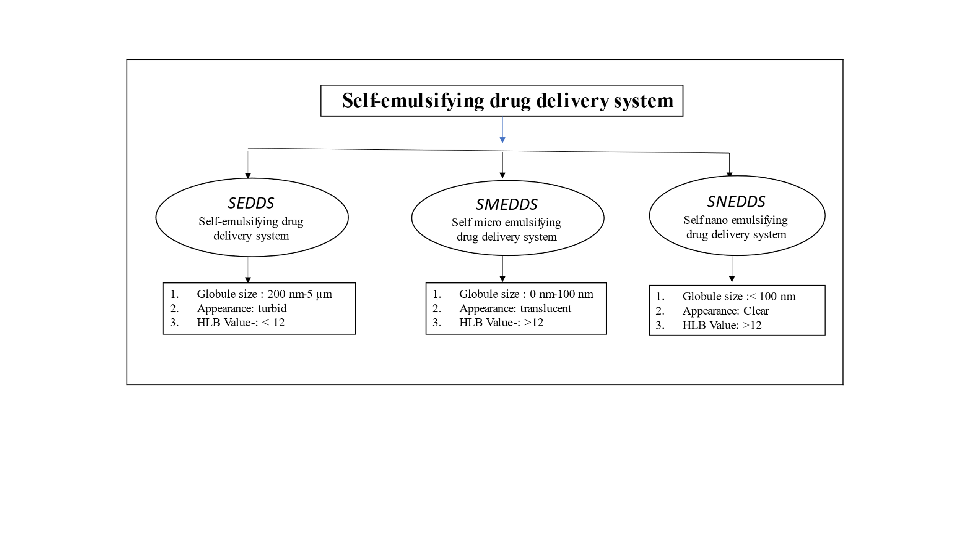
4. Advantages of Smeeds
- Storage: Self microemulsifying drug delivery system had similar advantages as emulsions in that it increases the solubility of hydrophobic medications and easily retained due to their thermodynamic stability, whereas macroemulsions progressively cream.
- Stability: Chemical and Physical more stable due to absence of water on long-term storage
- Patient compliance and Palatability: Formulation may be readily inserted into capsules, which eliminates the palatability problems that are related to lipid formulations.
- Food has no effect on the absorption of a medication made with SMEDDS. The lipophilic elements of fatty meals promote drug absorption from these systems. Rapid oral absorption of the medication, which leads to an early start of action, is made possible by SMEDDS.
- The ease of producing Large-scale production of self-micro emulsifying drug delivery systems is possible with the use of simple and inexpensive manufacturing equipment. (6)
- They lessen the chance that the SEDDS contents will interact with the capsule shell, improving stability because there is less chance of chemical deterioration and microbiological development, which implies a longer shelf life for the product.
- They can be given as immediate or controlled-release formulations, depending on the powder excipient used to make the SEDDS liquid.
- Due to the fact that the dosage form is solid, they can circumvent strict processing regulations.
- The dosage is supplied as an exact weight of S-SEDDS powder, granules, or pellets that have been processed into a tablet or filled into a capsule.
- They are simple to move about and store, which enhances patient compliance.
- Due to the exceptional flowability of self-emulsifying coarse powders, granules, and pellets, which enables quick and repeatable capsule or die-filling, manufacturing costs are much lower compared to liquid capsule filling.
- As multiple-unit dose forms, self-emulsifying granules, or pellets in particular offer therapeutic benefits that are unique to these dosage forms. They encourage less fluctuation in stomach emptying time, easy digestion, and reduced danger of dosage dumping. All this help to reduce the fluctuation in plasma levels.
- More significantly, research has revealed that giving dogs self-emulsifying pellets equalled administering the liquid microemulsion in terms of progesterone release. (13)
5. Mechanism of self-emulsification
Only a handful of these methods are known, but emulsification enables larger oil droplets to naturally split into smaller ones with more energy. They frequently include a phase upending, in which the interfacial surface-active agent layer's opted curve alterations its sign, or a temporary decrease in oil solubility in the continuous medium brought on by changing temperature or solvents. Here, we take use of narrow-range temperature cycling by taking advantage of periodic breaks in droplets to higher-energy states. Here, three drop breakup mechanisms that result in tens of thousands of smaller droplets exploding spontaneously are detailed. The method is suitable for a variety of oil-surfactant mixes and has several noteworthy advantages. It allows for minimum surfactant emulsion formulations with temperature-sensitive chemicals, is suitable for producing particulate drug carriers of the desired size and shape and is scaleable to industrial emulsification. (14)
The following equation may be used to describe the free energy of the emulsion:
∆G = ∑𝑁Π𝑟2𝜎. (1)
∆G represents the free energy, N the number of droplets, r the radius of the droplet, and E the energy at the interface. This equation clearly shows that the free energy falls down as the interfacial energy rises. Self-emulsification occurs when the energy required for droplet formation is greater than the energy required for dispersion. A typical emulsion has a very high free energy because it requires a lot of energy to form a new surface between two immiscible phases, such as oil and water. The emulsion might not be stable because to the high free energy and tendency for phase separation. However, because the system's free energy is so low, and occasionally even negative, due to the presence of a flexible interface in Self microemulsifying drug delivery system, emulsion formation begins straight away. When water, oil, and a surfactant/cosurfactant mixture are mixed, an interface between two phases is created. The aqueous phase solubilizes within the oil phase up to the solubilization limit after crossing the contact. As water penetration increases, dispersed liquid crystalline phases form. The amount of liquid crystalline phase depends on the surfactant concentration. Water quickly enters formulation when they are slightly shaken, shattering the interface and resulting in the formation of droplets. Because microemulsions are thermodynamically stable, equilibrium persists in the system even though there is a steady flow of materials between the different phases. The fission of larger droplets into smaller ones and the fusion of tiny droplets that subsequently coagulate with other droplets are the two primary methods by which matter is transferred. (6)
Self-emulsifying drug delivery systems (SEDDS) known as emulsion concentrates are made up of the drug, oils, surfactants, and occasionally co-solvents. They do not naturally form emulsions, but when they are somewhat stirred up in the watery environs of the stomach, they do so with ease and produce emulsions of a submicron size. SEDDS provide the opportunity to solubilize pharmaceuticals that are weakly water soluble. They prevent the dissolving stage of dispersed powder, which inhibits absorption, by being present in the stomach and becoming dissolved in tiny droplets. SEDDS are mostly used in this context, according to Amidon et al., to improve the bioavailability of drugs that are poorly soluble and fall into class II of the Biopharmaceutics Classification System (BCS) (low solubility, high permeability). The oil/surfactant mixture spontaneously reemulsifies when the dosage form enters the stomach and combines with the gastrointestinal (GI) fluids. it has been determined that the SEDDS composition is accurate. This mixing, which is made easier by the agitation the stomach motility provides, is crucial under fasting conditions. This is due to the fact that the oils and surfactants in the SEDDS are acting as emulsifiers and absorbents in the absence of intestinal content (bile salts and phospholipids). (13)
6. Effect on the addition of drug in Smeeds
Optimal drug integration can be achieved if there is good physical and chemical compatibility between the additional medicine and the system. By interfering with surfactant molecules on the interface surface or reacting with the formulation's components, the drug may change how the system behaves. This problem is especially serious with SMEDDS since its droplet size is much smaller than that of other self-emulsifying formulations. Preformulating studies can help with the problem of unanticipated effects of drug incorporation on ideal SMEDDS self-emulsifying powder by establishing a drug's solubility in various formulation components and creating a phase diagram to pinpoint the correct emulsification region. These findings provided a novel viewpoint and spurred interest in more studies. (15) Drug loading also has an impact on droplet size. the effect of drug addition on droplet size indicates that increasing the amount of drug addition causes an increase in particle size, which may be brought on by a shortage of surfactant available to reduce particle size. (16) The propensity of medication to form H-bonds with ethoxy chains of surfactant may affect the efficacy of SMEDDS. The addition of a chemical that is highly lipophilic and unable to establish H-bonds will not have any effect, not even at large doses. Phase diagrams created in the phase diagram software were used to assess the effect of medication addition on the existence of the microemulsion area. (17)

References
- Kuldeep Rajpoot, Muktika Tekade, Vikas Pandey, Sree Harsha Nagaraja, Susanne R. Youngren-Ortiz, Rakesh K. Tekade, Self-micro emulsifying drug-delivery system: ongoing challenges and future ahead, In Advances in Pharmaceutical Product Development and Research, Drug Delivery Systems, Academic Press, 2020, Pages 393-454,
- Marko Krstić, Đorđe Medarević, Jelena Đuriš, Svetlana Ibrić, Self-nanoemulsifying drug delivery systems (SNEDDS) and self-microemulsifying drug delivery systems (SMEDDS) as lipid nanocarriers for improving dissolution rate and bioavailability of poorly soluble drugs, Lipid Nanocarriers for Drug Targeting, William Andrew Publishing, 2018, Pages 473-508,
- Karthik Siram, S.M. Habibur Rahman, K. Balakumar, N. Duganath, R. Chandrasekar, R. Hariprasad, Pharmaceutical nanotechnology: Brief perspective on lipid drug delivery and its current scenario, Biomedical Applications of Nanoparticles, William Andrew Publishing, 2019, Pages 91-115
- Singh, N., Rai, S., & Bhattacharya, S. (2021). A Conceptual Analysis of Solid Self-emulsifying Drug Delivery System and its Associate Patents for the Treatment of Cancer. Recent patents on nanotechnology, 15(2), 92–104. https://doi.org/10.2174/1872210514666200909155516
- Midha, K., Nagpal, M., Singh, G., & Aggarwal, G. (2017). Prospectives of Solid Self-microemulsifying Systems in Novel Drug Delivery. Current drug delivery, 14(8), 1078–1096. https://doi.org/10.2174/1567201813666160824123504
- Shambhu Dokania & Amita K. Joshi (2015) Self-micro emulsifying drug delivery system (SMEDDS) – challenges and road ahead, Drug Delivery, 22:6, 675-690, DOI: 10.3109/10717544.2014.896058
- Vivek P. Chavda, Dhaval Shah, Self-emulsifying delivery systems: one step ahead in improving solubility of poorly soluble drugs, In Micro and Nano Technologies, Nanostructures for Cancer Therapy, Elsevier, 2017, Pages 653-718,
- Hsieh, C.-M.; Yang, T.-L.; Putri, A.D.; Chen, C.-T. Application of Design of Experiments in the Development of Self-Microemulsifying Drug Delivery Systems. Pharmaceuticals 2023, 16, 283. https://doi.org/10.3390/ph16020283
- Gurram, A. K., Deshpande, P. B., Kar, S. S., Nayak, U. Y., Udupa, N., & Reddy, M. S. (2015). Role of Components in the Formation of Self-microemulsifying Drug Delivery Systems. Indian journal of pharmaceutical sciences, 77(3), 249–257. https://doi.org/10.4103/0250-474x.159596
- Arpana Dholakiya, Kiran Dudhat, Jaydip Patel, Dhaval Mori, An integrated QbD based approach of SMEDDS and liquisolid compacts to simultaneously improve the solubility and processability of hydrochlorothiazide, Journal of Drug Delivery Science and Technology, Volume 61, 2021, 102162,
- Sijia Gao, Jingcai Chen, Wanqian Peng, Yang Yang, Yong Yang, Lei Hua, Yanlei Guo, Yunhong Wang, Xiaomei Zhang. (2023) The preparation and relative bioavailability of an artemisin in self-emulsifying drug delivery system. Drug Delivery 30:1.
- Md. Akhlaquer Rahman, Arshad Hussain, Md. Sarfaraj Hussain, Mohd. Aamir Mirza & Zeenat Iqbal (2013) Role of excipients in successful development of self-emulsifying/microemulsifying drug delivery system (SEDDS/SMEDDS), Drug Development and Industrial Pharmacy, 39:1, 1-19, DOI: 10.3109/03639045.2012.660949
- Nikolakakis, I.; Partheniadis, I. Self-Emulsifying Granules and Pellets: Composition and Formation Mechanisms for Instant or Controlled Release. Pharmaceutics 2017, 9, 50. https://doi.org/10.3390/pharmaceutics9040050
- Tcholakova, S., Valkova, Z., Cholakova, D. et al. Efficient self-emulsification via cooling-heating cycles. Nat Commun 8, 15012 (2017). https://doi.org/10.1038/ncomms15012
- R. N. Gursoy and S. Benita, “Self-emulsifying drug delivery systems (SEDDS) for improved oral delivery of lipophilic drugs,” Biomedicine and Pharmacotherapy, vol. 58, no. 3, pp. 173–182, 2004.
- M. M. Bandivadeka, S. S. Pancholi, R. Kaul-Ghanekar, A. Choudhari, and S. Koppikar, “Self-microemulsifying smaller molecular volume oil (Capmul MCM) using non-ionic surfactants: a delivery system for poorly water-soluble drug,” Drug Development and Industrial Pharmacy, vol. 38, no. 7, pp. 883– 892, 2012.
- C. W. Pouton and C. J. H. Porter, “Formulation of lipid-based delivery systems for oral administration: materials, methods and strategies,” Advanced Drug Delivery Reviews, vol. 60, no. 6, pp. 625–637, 2008.

