EXPERIMENTAL STUDY ON STRENGTH ANALYSIS OF FIBRE REINFORCED BUBBLE DECK SLABS WITH CONVENTIONAL SLABS

DR.S. BHAGAVATHIPERUMAL ¹, KEERTHANA B.², JESSICA JENNY JAMES³ &
A. RAJASHREE ⁴

1 Professor & Head, Department of Civil Engineering, Sri Sairam Engineering College, Chennai – 620 109, T.N., India
^{2,3,4} Research Scholars, Department of Civil Engineering, Sri Sairam Engineering College Correspondence should be addressed to Dr.S.Bhagavathi Perumal
ABSTRACT

This project introduces the Fibre Reinforced Bubble Deck Slab its uses and advantages, construction, which is economical and gives a light weight structure. To use this technique, we have reduced the total construction material and concrete by 35%. This project deals with reduction of dead load of slab by introduction of high-density polythene bubble in the middle of slab and fibres instead of steel reinforcements to increase the load bearing capacity of the slab. By introducing the gap, it leads to 30 to 50% lighter slab which reduces the loads on columns, walls and foundation, thus having various advantages over the traditional slab.
The aim of this project is to introduce about the various properties of Fibre reinforced bubble deck slab based on various studies done in the comparison with the conventional slab. Using bubble deck means floor cycle up to 20% faster than traditional construction method. By the Use of recycled material, lower energy consumption and reduced CO2 emissions, less transportation and crane lifts that make bubble deck more environmentally friendly than other concrete construction technique. Advantages of these project are material and weigh reduction, construction and time saving, cost saving, green design i.e. we used HDPE (High Density Poly ethene) recycled balls because to reduce wastage of plastics instead of burning the plastics. The Fibre Reinforced Bubble Deck slabs being entirely recyclable. Recycled balls can be recovered during the demolition of the building to meet the go all of sustainable construction).
KEY WORDS: hollow plastic bubbles, lathe scraps, HDPE.

INTRODUCTION

CEMENT:

Cement must develop the appropriate strength. It must represent the appropriate theological behavior. Generally same types of cements have quite different rheological and strength characteristics, particularly when used in combination with admixtures and supplementary cementing materials.Ordinary Portland Cement of 53 grade available in local market is used in the investigation. The cement used has been tested for various properties as per 15: 4031 and found to be confirming to various specifications of IS:12269.The specific gravity of cement was
3.15 and fineness was 3200 cm^2/gm.

COARSE AGGREGATE:

As coarse aggregates in concrete occupy 35 to 70% of the volume of the concrete. It may be proper to categories the properties into two groups: exterior features of maximum size, particle shape, textures) and interior quality (strength, density. porosity, hardness, elastic modulus, chemical mineral composition etc.) Smaller sized aggregates produce higher concrete strength:
Particle shape and texture affect the workability of fresh concrete. The transition zone between cement paste and course aggregates, rather than the properties of the course aggregates itself. Usually an aggregate with specific gravity more than 2.55 and absorption less than 1.5% (except for light weight aggregates) can be regarded as being of good quality. Where aggregates strength is higher, concrete strength is also higher.

FINE AGGREGATE:

Manufactured sand (M-Sand) is a substitute of river sand for concrete construction Manufactured sand is produced from hard granite stone by crushing Manufactured sand is an alternative for river sand. Due to fast growing construction industry, the demand for sand has increased tremendously, causing deficiency of suitable river sand in most part of the word.
Due to the depletion of good quality river sand for the use of construction, the me of manufactured sand has been increased. Another reason for use of M-Sand is its availability and transportation cost Since manufactured sand can be crushed from

hard granite rocks, it can be readily available at the nearby place, reducing the cost of transportation from far-off river sand bed.
MAX COARSE AGGREGATE SIZE: 20 MM, FINE AGGREGATE: M SAND.

PLASTIC BUBBLES:

The bubbles are made using high-density polyethylene materials. These are usually made with a non-porous material that does not react chemically with the concrete or reinforcement bars.
The bubbles have enough strength and stiffness to support between 180mm to 450mm. Depending on this, the slab depth is 230mm to 600mm. The distance between bubbles must be greater than 1/9th of bubble diameter. The nominal diameter of the gaps maybe 180, 225, 270, 315 or 360 mm. The bubbles may be of spherical or ellipsoidal in shape.

ADVANTAGES OF FIBRE REINFORCED BUBBLE DECK SLABS:
- Less weight than conventional slabs
- Superior statics.
- Production and carrying out is easy
- Production is of higher quality
- To carry it, light and cheap instruments are needed
- Less concrete is needed
- Carbon footprint is reduced.
- Earthquake & fire proof.
- Proper waste management ( 3-R principle)

APPLICATIONS OF BUBBLE DECK SLABS:

It is used as a flooring slab in residential living, offices, utility, and industrial buildings.
Used in offices, apartments, villas, hotels, schools, parking, hospitals, laboratories and factories.
It is less catastrophic than conventional slabs, so they can be used in high rise buildings in seismic zones.
In addition to being used as flooring slab, it can be used in partition walls too and can also be used as a roof slab
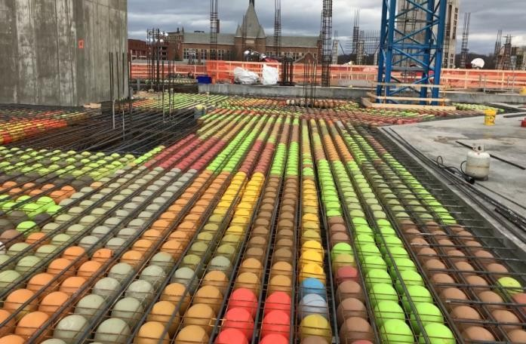

Fig. 1. Bubble Deck Slabs

METHODOLOGY

- Literature review

- Material testing

- Mix design

- Casting

- Curing

- Testing of specimen

- Result and discussion

- Conclusion

MATERIAL TESTING

The materials such as cement, fine aggregate, and coarse aggregate which is used in concrete mix is tested. The test taken for cement is consistency and setting time of cement, for fine aggregate is specific gravity and fineness modulus test.

MIX DESIGN

Mix design has been calculated by using the codal provisions is 10262-2019 and the result for the test is taken in the material testing such as water absorption, fineness modulus, specific gravity, setting time, consistency etc. The grade of concrete is M30. Steel fibres are incorporated into the concrete mixture.

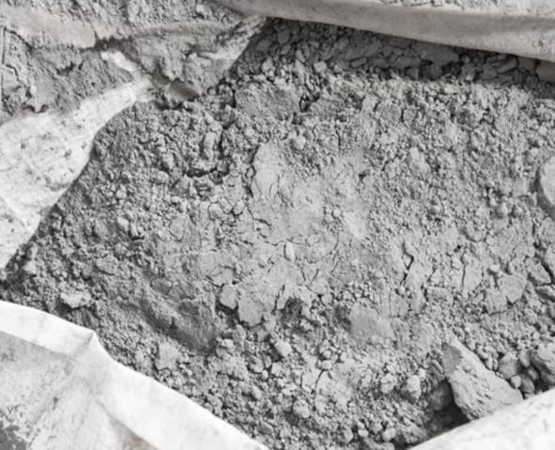
CASTING

After calculating the mix proportion, the concrete is prepared using the material cement, coarse aggregates and fine aggregate along with the required water content (determined from water cement ratio). The mould is prepared and properly fabricated. Then the concrete is casted in the prepared mould as layer by layer with compaction. Bubbles are incorporated into the slabs.
The Fibre Reinforced Bubble Deck slabs have been casted in moulds of dimension 1 ft X 1 ft.

CURING

After the final setting time of concrete is completed, then the mould which has been cast is demoulded. After the removal of slabs, the concrete specimen is immersed in the curing tank for attaining the optimum strength. The slabs are then tested on 7, 14 and 28th day of curing.

TESTING OF SPECIMENS

The test conducted on bubble deck slab is compressive strength test. This test shall be taken for 7 days, 14 days and 28 days curing respectively
PROPERTIES OF CEMENT

Cement is a fine powder used for bonding between components of concrete. In this project the cement would be Ordinary Portland cement (OPC) of 43 grade. Cement should be stored in proper place to avoid formation of floc.
The cement used was subjected to various field tests like:

- The cement used had no floc.
- After throwing in water, it floated on water for some time before sinking.
- After immersing our hand in cement, it gave us cool feeling.
- The cement was easily passing through 90-micron sieve.

Fig 2.Cement

MANUFACTURED SAND

Manufactured sand(M-Sand) is a substitute of river sand for concrete construction. Manufactured sand is produced from hard granite stone by crushing.
M-Sand is an alternative for river sand. Due to fast growing construction industry, the demand for sand has increased tremendously, causing deficiency of suitable river sand in most part of the world.
Due to the depletion of good quality river sand for the use of construction, the use of M-Sand has increased. Another reason for use of M-Sand is its availability and transportation cost.
Since manufactured sand can be crushed from hard granite rocks, it can be readily available at the nearby place, reducing the cost of transportation from far-off river sand bed.
PROPERTIES OF M-SAND

It is used as a filler material to fill the gap i.e., porosity of concrete is reduced. It also has high tensile strength that results from its fine-grained structure.
  - Specific gravity-2.5
  - Water absorption-0.6%

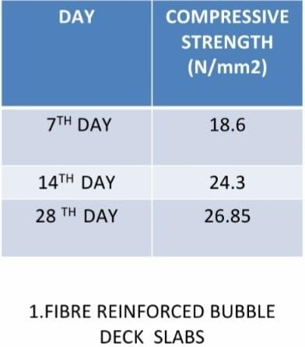
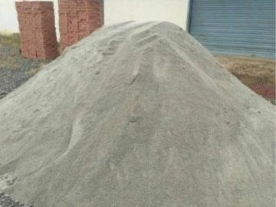

Fig.3. Manufactured Sand

LATHE SCRAPS (FIBRES)

Steel fibers has been increasingly used in civilian and military structures, because of its superior properties compared to normal concrete, such as its higher tensile strength, better strain capacity, improved energy absorption ability, and improved toughness. Additionally, it provides exceptional control of long-term drying shrinkage cracking and load stability at the floor joints, where it is most needed. We have used crushed mechanical lathe scraps and incorporated this into our concrete mixture. This has been used for promoting better waste management system and 3-R principle(Reduce-Reuse-Recycle)
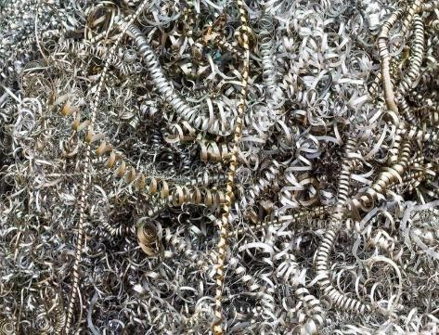

Fig 4. Lathe Scraps

RESULT OF THE EXPERIMENT COMPRESSIVE STRENGTH
Testing was done on the UTM after curing for 28 days. Dimensions of the block for testing was 0.5m×0.5m×0.1m. Its
weight when measured was 20.43 Kg. It can be noted that the weight of the bubble deck slab is lighter in weight than the conventional slab. Maximum load on the slab was observed as 655 KN.
Compressive strength of the block = Ultimate Load /Slab Area

Table 1- Compressive Strength Values of Fibre Reinforced Bubble Deck Slabs

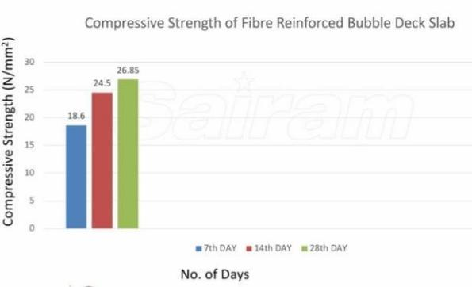

Graph-1 Fibre Reinforced Bubble Deck Slabs
FIBRE REINFORCED BDS
40
20
18.6
24.3
26.85
0
7th DAY 14th DAY 28th DAY
NO. OF DAYS

FIBRE REINFORCED BDS
COMPRESSIVE
STRENGTH(N/mm2)

Graph-2Fibre Reinforced Bubble Deck Slabs

RESULT ANALYSIS
35

30

25

20

15

10

5

0
7th DAY 14th DAY 28th DAY
NO. OF DAYS

CONVENTONAL SLABS BDS
FIBRE REINFORCED BDS
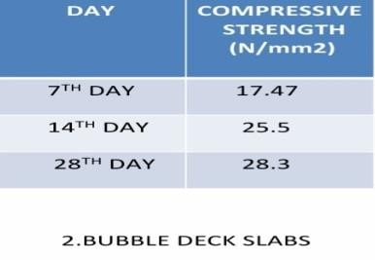

Table 2- Compressive Strength Values of Bubble Deck Slabs
BUBBLE DECK SLABS
30
25.5
28.3
20
10
0
17.47
7th DAY 14th DAY 28th DAY
NO. OF DAYS

BUBBLE DECK SLABS
COMPRESSIVE
STRENGTH(N/mm2)

Graph-3 Bubble Deck Slabs
COMPRESSIVE STRENGTH
OF BUBBLE DECK SLABS
30
25.5
28.3
20
17.47
10
0
NO. OF DAYS

7th DAY 14th DAY 28th DAY
COMPRESSIVE
STRENGTH(N/mm2)

Graph-4 Bubble Deck Slabs

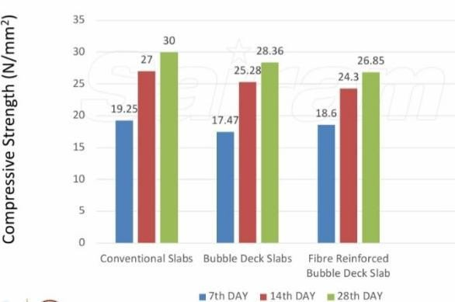
Graph-5 Compressive Strength of all 3 Slabs
(Comparison)

Graph-6 Comparison of Compressive Strength Values of all the 3 slabs
COMPRESSIVE STRENGTH(N/mm²)

RESULT & CONCLUSION:

This study was conducted with an aim to learn about Fibre Reinforced Bubble Deck Slabs and establish the comparative analysis between Bubble Deck Slab and conventional slabs.
From the result of the graph, it is found that Fibre Reinforced Bubble Deck Slabs have slightly less compressive strength when compared against Conventional & Normal Bubble Deck Slabs. The reason for weaker strength being corrosion inside the slabs due to the usage of metal lathe scrapes. This can be combated by using corrosion resistant admixtures and also using corrosion resistant coating namely, Polyfix (Anti Corrosive Rebar Coating Chemical) Polyfix is basically a polymer-based coating that is specially formulated to protect steel from corrosion.
The study recognized Bubble Deck Slab as a sustainable building material and emphasized on more research towards its performance parameters. The manufacturing. processing and construction techniques are still not developed enough to facilitate its use and this requires extensive amount of research.

Bubble deck slabs can be developed as a material which is suitable for low-cost housing and temporary shelters and offices and can help reduce carbon footprint. It is thus evident that it has a promising future, The study is to be looked upon as a sustainable building material and the study recognized bubble deck slabs as a sustainable building material and emphasized on more research towards its performance parameters.
As a result, Normal Bubble Deck Slabs are recommended over Fibre Reinforced Bubble Deck Slabs and Conventional Slabs.

REFERENCES

- Tina Lai-” Structural behavior of bubble deck slab and their applications to lightweight bridge decks” M.Tech thesis, MIT, 2009.
- P. Prabhu Teja, P. Vijay Kumar, S. Anusha, CH. Mounika- March-2012-“Structural behavior of bubble deck slab”, JISBN: IEEE, Vol: 81-pages: 383-388 ISBN: 978-81-909042-2-3.
- Sergiu Călin, Roxana Ginţu and Gabriela Dascălu,” Summary of tests and studies done abroad on the Bubble deck slab system”, The Buletinul Institute Polytechnic din Iaşi, t. LV (LIX), f. 3, 2009.

- Saifee Bhagat and Dr. K. B. Parikh Parametric Study of
R.C.C Voided and Solid Flat Plate Slab using SAP 2000, IOSR Journal of Mechanical and Civil Engineering (IOSR-JMCE), e- ISSN: 2278-1684, p- ISSN: 2320-334X, Volume 11, Issue 2 Ver. VI (Mar- Apr. 2014), PP 12- 16.
- Bubble deck design and detailing, Bubble Deck Voided Flat Slab Solutions- Technical Manual and Documents (2007).
- Bubble Deck Slab properties "Bubble Deck Voided Flat Slab Solutions- Technical Manual and Documents (2006).
- Bubble Deck-UK". "Lighter Flat Slab Structures with Bubble Deck." (2006).
- Bubble Deck Engineering Design & Properties" Overview." Bubble Deck Voided Flat Slab Solutions Technical Manual and Documents (2007).
- Bubble Deck International. "The Light weight Biaxial Slab." Bubble Deck (n.d):1-4.
- Bubble Deck Tests and Reports summary. "Bubble Deck Voided Flat Slab Solutions Technical Manual and Documents. (2006).
- https://publons.com/researcher/AAF-3416-2019/

- https://publons.com/researcher/32253383/bhagavathiperum al-s/

- https://www.scopus.com/authid/detail.uri?authorId=368067 10000

- https://scholar.google.com/citations?hl=en&amp;user=ATz EacAAAAJ

15. https://orchid.org/0000-0002-7868-7901

