Artificial Intelligence – Emerging Marketing in Economies, challenges, opportunities, with Integrated Development of SMEs in PMS
*M.Anitha¹, Research Scholar / CSE, Kingston Engineering College, Vellore, Tamilnadu
*Dr.S.Sakthivel², Professor / Dept. of CSE, Sona College of Technology, Salem, TamilNadu,
K.Thirunavukarasu³, Research Scholar / CSE, Thanthai Periyar Govt. Institute of Technology, Vellore, Tamilnadu
Dr.Leo Raju, Associate Professor, Sri Siva Subramanian Nadar, College of Engineering, Chennai, Tamilnadu
Dr.S.SathishBabu, Associate Professor, Thanthai Periyar Govt. Institute of Technology, Vellore, Tamilnadu
¹anitham.apcse@gmail.com, ²sakvel75@gmail.com, ³csetpgit005@gmail.com, ⁴leor@ssn.edu.in, ⁵sathishbabu3575@gmail.com

Abstract:
When it comes to connecting with clients at the BOP (Base of the Wealth Pyramid), technology has been identified as a crucial tool for achieving the Global Sustainable Development Goals for emerging economies. Provide a practical recommendation for practitioners, AI developers, and policymakers with regard to adopting and regulating AI usage in marketing, particularly in emerging economies, by concentrating on the ramifications and frequently disregarded negative elements. The current obstacle to AI application in India is PMS (Public Manufacturing Sector) and examines how they are related. The DEMATEL approach has been used in the study to identify the cause-and-effect group factors. Nonetheless, there are various examples of how AI is extending opportunities and assisting in the attainment of the Sustainable Development Goals in the most recent applications and trends in emerging economies. It also clarifies how investors, clients, and governments may maximise its benefits while avoiding its hazards. When handled well and with appropriate safety measures in place, AI can help private investment to alleviate poverty and enhance lives at a rate that was unthinkable just a decade ago. Explore the obstacles that SMEs (Small and Medium-Sized Entrepreneurs) experience in the AI transformation process in more detail and offer solutions. Lastly, we suggest a study programme based on environmental threats and technological obstacles faced by SMEs using PMS.
Keywords: BOP, Emerging Economics, AI, PMS, SME
1. INTRODUCTION:
Employers and economic growth are mostly driven by small and medium-sized businesses (SMEs) [1]. SME vulnerability has been increased by the COVID-19 outbreak in 2020 and related (regional) pandemic lockdown and control measures. SMEs face more difficulties and uncertainties than large firms, and these issues will probably persist into the post-pandemic age [2]. The financial struggles of SMEs have not greatly improved despite the quick response of governments to stop firm closures by offering mitigation measures such loans, wage support, and subsidies [3, 4]. Some mitigating methods to lessen this burden are not as effective as anticipated, thus it's critical to find quick solutions to SMEs' problems in order to support their ongoing development.
Numerous advances in algorithmic machine learning have been made in the burgeoning Artificial Intelligence (AI) era, and they may have a big impact on sectors including healthcare, agriculture, education, manufacturing, and retail, among others [5, 6]. However, obstacles like poor data quality, lack of privacy protections, and a skilled labour shortage restrict the application of AI in developing nations, notably in the Public Manufacturing Sector (PMS).
There is no denying that AI is influencing how businesses act and respond in the modern day and bringing improvements to established business structures. Implementing AI is thought to result in competitive advantage because it boosts productivity by innovating to some extent. Even though AI is becoming more and more popular, very few studies have examined AI in relation to PMS [7, 8]. Additionally, only a small number of studies have attempted to demonstrate how usage and impeding factors enable the implementation of AI for inter-organizational competitive advantage and value creation (Zhang, Chen, Chen, & Chong, 2021; Zuiderwijk, Chen, & Salem, 2021). However, it is still necessary to look at the implementing difficulties in relation to PMS [9, 10].
Examining the major obstacles to AI implementation in the context of a developing economy is the fundamental goal [11]. A vacuum in the literature regarding the difficult to apply AI aspects has been found after a thorough literature study. To fill this gap, the following objectives were set:
- To look into the difficulties the public manufacturing sector is having implementing AI in developing nations like India.
- To comprehend the causal connections between the difficult components and create a network relationship map with significant influence.
- In order to help managers plan and create AI-based systems in their organisation to improve efficiency outcomes, implications and advice for the successful application of AI in public manufacturing organisations are provided.

2. Methodology
The detailed search process used in this work is depicted in Figure and follows a realism systematic approach. In order to broaden the scope of the collection, we first defined the most fundamental search phrases by informal search and applied them to the Web of Science core collection [12, 13]. We specifically use the keywords small and medium-sized enterprises (SMEs), artificial intelligence (AI), and digitization (e.g., "artistic intelligence," "Ai," and "digital*"), as well as sustainable development (e.g., "sustaina*") under the TS column of Web of Science. The time period is restricted to "2019-2022," the literature type is restricted to "articles, Early access, or reviews," and the search yielded 62 items [14].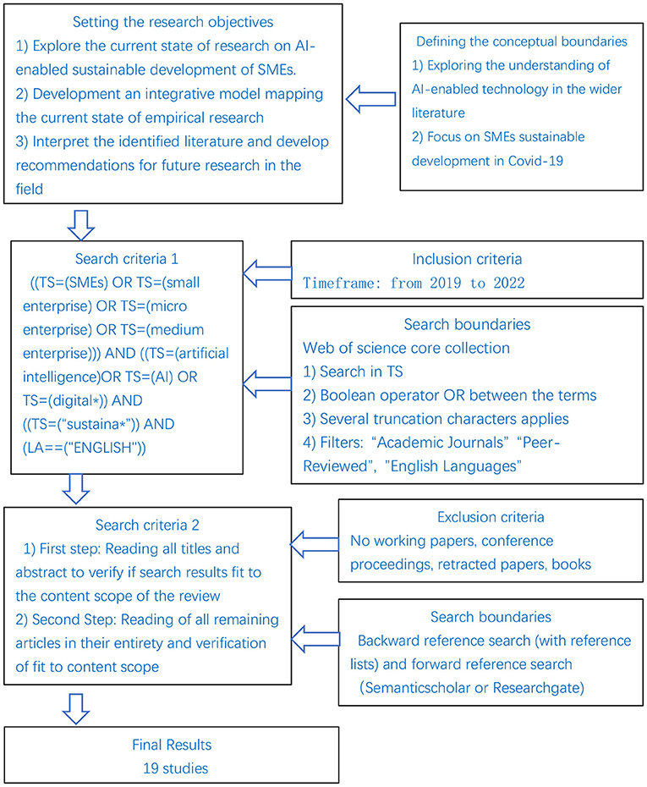

2.1 Data analysis and results

The purpose of this study was to assess and look into the difficulties in adopting AI in the PMS of India. In the second phase, DEMATEL was used to analyse the first phase's identified and validated issues [15,16]. DEMATEL was used in the study to create an understandable structural model that mapped the relationships between the highlighted issues. This approach works well for classifying cause-and-effect variables and is the best way to look at interdependency.

2.2 Findings
Our review's conclusions are arranged in a framework as shown in Figure. We first give a general summary of the difficult circumstances that SMEs had to deal with during the COVID-19 epidemic, then we talk about the benefits that AI technologies have to offer and the difficulties associated with its transformation [17].
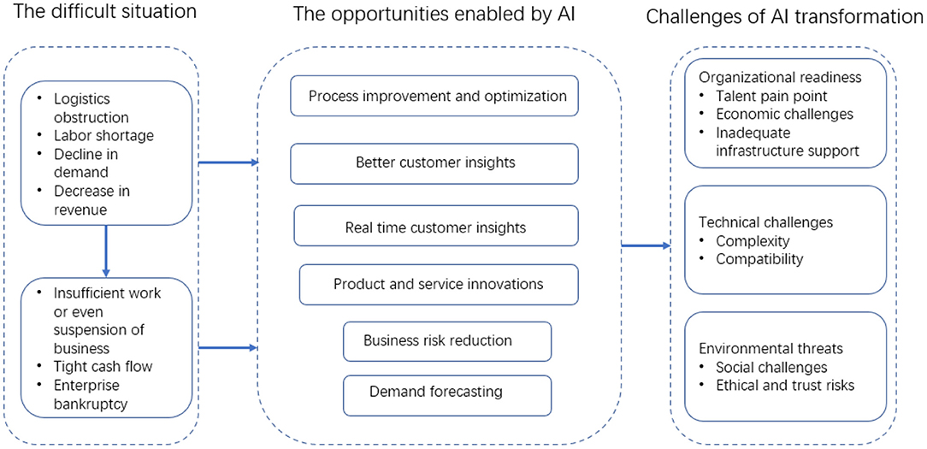
AI-enabled opportunities and transformation challenges for SMEs.

According to the studies, the biggest obstacles to implementing AI in PMS of India are poor data quality, managers' lack of awareness of cognitive technologies, data privacy, issues integrating cognitive initiatives, and expensive technologies [18, 19].

2.3 Opportunities Enabled by AI
In the areas of manufacturing, e-commerce, accounting, human resources, marketing, and customer relations, new technologies like AI can provide SMEs a competitive edge or ensure their survival [20]. The study of AI technology enabling SMEs during the pandemic primarily focuses on two aspects: the first is to improve the operation of SMEs through gradual process improvement and optimisation within the organisational boundary, and the second is the external AI-driven transformation to fundamentally promote SMEs to create business models, develop new organisational strategies and cultures, build business alliances, and other activities.
- Process Improvement and Optimization
- Real-Time Customer Insights
- Product and Service Innovations
- Business Risk Reduction
- Demand Forecasting
- Business Model Innovations

2.4 Challenges of AI Transformation
The COVID-19 pandemic has highlighted the need for organisations to go digital. In order to be competitive, SMEs must use new technology to improve, alter, or even destroy business models [22, 23]. However, SMEs might not have the plans, information, or materials needed to make use of AI technology. Many SMEs, particularly those in the manufacturing sector, are attempting to determine whether AI technology might provide them solutions. We examine the obstacles to the AI transformation of SMEs using the Technology, Organisation, and Environment (TOE) framework, as given in Table.

3. Conclusion
SMEs have boosted the economy and produced a number of new job prospects, whether in China, Europe, or the US. The continued growth of SMEs is essential for preserving a nation's economic stability. The pandemic and its containment efforts have posed a number of difficulties for the viability of SMEs globally, including logistical bottlenecks, supply chain disruptions, labour shortages, and a decline in demand. Unpredictability, forcing the most vulnerable SMEs to struggle for their survival and further growth, and highlighting the need for technological improvement as a potential solution. This study incorporates the most recent research on prospects for SMEs in the post-pandemic age that are enabled by AI as well as the difficulties of AI transformation [24, 25]. The different ways that AI can be used to enhance the ongoing development of SMEs are outlined, and the difficulties of transforming SMEs with AI are discussed. To assist SMEs in taking advantage of the prospects presented by AI technology for continual development, further research topics are suggested.
Industry sectors like healthcare, manufacturing, education, and agriculture might all benefit from AI's capacity to revolutionise organisational designs and processes. When planned and implemented properly, AI has the potential to transform how daily tasks are managed, establish new business models, and make significant societal benefits.
References:
[1] Rakshit S, Mondal S, Islam N, Jasimuddin S, Zhang Z. Social media and the new product development during COVID-19: An integrated model for SMEs. Technol Forecast Soc Change. (2021) 170:120869. doi: 10.1016/j.techfore.2021.120869
[2] Bai C, Quayson M, Sarkis J. COVID-19 pandemic digitization lessons for sustainable development of micro-and small- enterprises. Sustain Prod Consump. (2021) 27:1989–2001. doi: 10.1016/j.spc.2021.04.035
[3] S. Bag et al.Role of institutional pressures and resources in the adoption of big data analytics powered artificial intelligence, sustainable manufacturing practices and circular economy capabilities Technological Forecasting and Social Change (2021)
[4] S. Benzidia et al. The impact of big data analytics and artificial intelligence on green supply chain process integration and hospital environmental performance Technological Forecasting and Social Change (2021)
[5] I.F. Braga et al. A DEMATEL analysis of smart city determinants Technology in Society
(2021)
[6] T. Burström et al. AI-enabled business-model innovation and transformation in industrial ecosystems: A framework, model and outline for further research Journal of Business Research (2021)
[7] M. Cubric Drivers, barriers and social considerations for AI adoption in business and management: A tertiary study Technology in Society (2020)
[8] L. Cui et al. Exploring critical factors of green business failure based on Grey-decision making trial and evaluation laboratory (DEMATEL) Journal of Business Research (2019)
[9] K.C. Desouza et al. Designing, developing, and deploying artificial intelligence systems: Lessons from and for the public sector Business Horizons (2020)
[10] Papadopoulos T, Baltas KN, Balta ME. The use of digital technologies by small and medium enterprises during COVID-19: implications for theory and practice. Int J Inf Manage. (2020) 55:102192. doi: 10.1016/j.ijinfomgt.2020.102192
[11] Fletcher G, Griffiths M. Digital transformation during a lockdown. Int J Inf Manage. (2020) 55:102185. doi: 10.1016/j.ijinfomgt.2020.102185
[12] Priyono A, Moin A, Putri VN. Identifying digital transformation paths in the business model of SMEs during the COVID-19 pandemic. J Open Innovat Technol Market Complex. (2020) 6:104. doi: 10.3390/joitmc6040104
[13] Iansiti M, Lakhani KR. Competing in the age of AI: how machine intelligence changes the rules of business. Harv Bus Rev. (2020) 98:62–7.
[14] Sjödin D, Parida V, Kohtamäki M, Wincent J. An agile co-creation process for digital servitization: a micro-service innovation approach. J Bus Res. (2020) 112:478–91. doi: 10.1016/j.jbusres.2020.01.009
[15] Dwivedi YK, Hughes L, Ismagilova E, Aarts G, Coombs C, Crick T, et al. Artificial intelligence (AI): multidisciplinary perspectives on emerging challenges, opportunities, and agenda for research, practice and policy. Int J Inf Manage. (2021) 57:101994. doi: 10.1016/j.ijinfomgt.2019.08.002
[16] Hansen EB, Bøgh S. Artificial intelligence and internet of things in small and medium-sized enterprises: a survey. Journal of Manufacturing Systems. (2021) 58:362–72. doi: 10.1016/j.jmsy.2020.08.009
[17] Abed SS. A literature review exploring the role of technology in business survival during the Covid-19 lockdowns. Int J Org Anal. (2021). doi: 10.1108/IJOA-11-2020-2501.
[18] Patel PC, Rietveld CA. The impact of financial insecurity on the self-employed's short-term psychological distress: evidence from the COVID-19 pandemic. J Bus Venturing Insights. (2020) 14:e00206. doi: 10.1016/j.jbvi.2020.e00206
[19] Dai R, Feng H, Hu J, Jin Q, Li H, Wang R, et al. The impact of COVID-19 on small and medium-sized enterprises (SMEs): evidence from two-wave phone surveys in China. China Econ Rev. (2021) 67:101607. doi: 10.1016/j.chieco.2021.101607
[20] Akpan IJ, Soopramanien D, Kwak D-HA. Cutting-edge technologies for small business and innovation in the era of COVID-19 global health pandemic. J Small Bus Entrep. (2021) 33:607–17. doi: 10.1080/08276331.2020.1799294
[21] Johnson ME, Jain R, Brennan-Tonetta P, Swartz EASD, Paolini J, Mamonov S, et al. Impact of big data and artificial intelligence on industry: developing a workforce roadmap for a data driven economy. Glob J Flexible Syst Manage. (2021) 22:197–217. doi: 10.1007/s40171-021-00272-y
[22] Kumar A, Kalse A. Usage and adoption of artificial intelligence in SMEs. Mater Today. (2021). (in-press). doi: 10.1016/j.matpr.2021.01.595
[23] Wael B. Examining the impact of artificial intelligence (AI)-assisted social media marketing on the performance of small and medium enterprises: toward effective business management in the Saudi Arabian context. Int J Comput Intelligence Syst. (2020) 13:142–52. doi: 10.2991/ijcis.d.200127.002
[24] Chen J, Lim CP, Tan KH, Govindan K, Kumar A. Artificial intelligence-based human-centric decision support framework: an application to predictive maintenance in asset management under pandemic environments. Ann Operat Res. (2021). doi: 10.1007/s10479-021-04373-w.
[25] Y. Duan et al. Artificial intelligence for decision making in the era of big data–evolution, challenges and research agenda International Journal of Information Management (2019).

