**Research in The Biological Sciences Outlines a Novel Theory of Life Through Biological and Technological Perspective**

Diwakar Kumar Singh*, Assistant Professor, The Neotia University, West Bengal. *[diwakarcdri@gmail.com](mailto:diwakarcdri@gmail.com)

**Abstract:**

Research in biological sciences is fraught with opportunities and challenges. A few of the main challenges are the complexity of biological systems, the need for interdisciplinary collaboration, budgetary constraints, and moral dilemmas in the study of live organisms. But there are also a lot of opportunities in this field, such as using big data analytics for biological datasets of any size, new technologies like CRISPR-Cas9, and the potential for ground breaking discoveries that could revolutionise healthcare, agriculture, and environmental sustainability. Future biological research will be focused on resolving these problems and grasping the opportunity to inspire innovation and progress in our knowledge of life at the molecular level.

**Key words:** Research,Regeneration,Molecular Biology, Epidemiology, Immunology.

**Introduction:**

All the branches of natural sciences that study different facets of physiological processes are included in the biological sciences. The idea encompasses all living things, from microbes to plants and animals, and comprises anatomy, physiology, cell biology, biochemistry, and biophysics. Research on each of these topics can characterise what makes life new. Age can also have an impact on life force and the ability of cells to respond. Age is a common factor in the severity of infections including SARS-CoV-2(Poletti et al., 2020; Zimmermann and Curtis, 2022). Immunisation reduces morbidity and mortality, but because the immune system ages more slowly in elderly people, its benefits may be restricted. Most of the elderly people may have reduced cellular memory and humoral immunity. It becomes more and more difficult for elderly individuals to fight infection and recover from sickness due to their weakened immune systems and low antibody affinity. The complex dynamics of both the biological and technological worlds are supported by the varied motivations of those working in them. Therapeutics research asserts that medicine is essential to comprehending and negotiating life's intricacies, which include biological processes, philosophical questions, social dynamics, and technological developments(Horwitz et al., 2021). It challenges us to consider the significant effects that medical advancements will have on how we see life and the state of human health in the future.

**Development & Regeneration** **Perspective:**

The growing recognition of developmental biology's ability to provide light on the fundamental mechanisms behind a broad range of congenital and acquired illnesses including heart disease. This is due to the fact that several variables that are active during the organs and heart's morphogenesis in utero also affect their development and ability to adapt in the postnatal period. Furthermore, the developmental origins and lineages of many cells impact their behaviour into adulthood(Edgar et al., 2020; Elchaninov et al., 2021). Determining these characteristics presents promising opportunities for the development of innovative therapeutics.

The availability of sophisticated experimental approaches involving genetic, molecular, imaging, and engineering tools which can be used alone or in combination as well as a small number of visionary individuals worldwide who saw the potential of the subspecialty have been key drivers of the field's recent and sustained progress. Organ development and regeneration is a remarkable accomplishment that brings together experts in the field to clearly communicate the most recent research in a way that is understandable to a broad audience. The addition of many chapters on regeneration treatment, which is now the most talked-about medical issue, is a logical progression of the developmental biology themes(Weissman, 2000). The processes governing the growth, differentiation, organogenesis, and regeneration of tissues including blood, heart, retina, and kidney are investigated by the researchers because they are important to our comprehension of human development and illness. In addition, they may make use of cutting-edge molecular techniques to gain insight into the biology of stem cells. For example, they can identify the genetic pathways controlling induced pluripotent stem cells and the variables influencing the behaviour of tissue-specific stem cells inside the body.

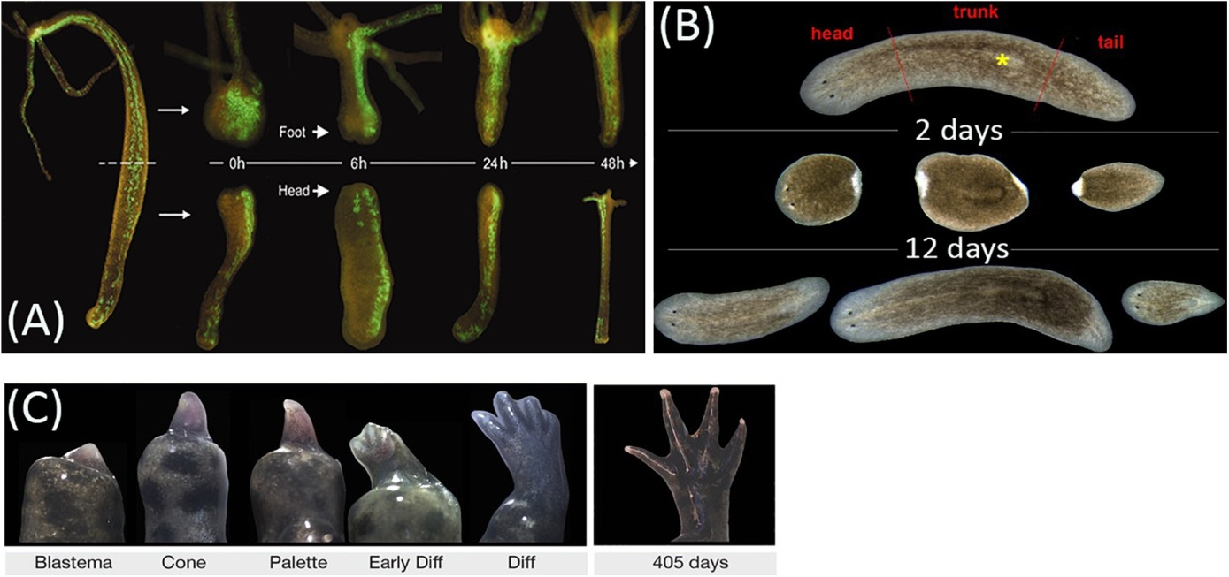

Figure 1: Animal regeneration model (A) Regeneration of head and foot in transgenic Hydra vulgaris. (B)Regeneration timing in planarian *Schmidtea mediterranea* (C) Epimorphic limb regeneration in axolotl (Elchaninov et al., 2021)

**Cellular & Molecular Biology:**

Cell biology is the study of cells, the basic structural unit of all living systems. The researchers seek to understand how cells work as individual units with a focus on membrane and cytoskeleton organization, how they organize into complex groups, how they coordinate their activities in organismal systems and how they respond to extracellular signals and infectious agents. Dissecting how cells function at the molecular level is becoming increasingly important for understanding the cellular basis of human disease(Li et al., 2021).

Research in cell and molecular biology has historically focused on understanding the role of a particular gene, gene family, or signal transduction pathway, frequently by disrupting or modifying individual genes. They employ molecular assays including PCR/qPCR, Sanger sequencing, and gene expression arrays in addition to signal-based techniques like microscopy, flow cytometry, and protein blotting to address the issues(Dwivedi et al., 2017; Kadam et al., 2013; Singh et al., 2014). This process may take a lot of time and doesn't always produce definitive results. Thus, the researchers seek to understand how cells work as individual units with a focus on membrane and cytoskeleton organization, how they organize into complex groups, how they coordinate their activities in organismal systems and how they respond to extracellular signals and infectious agents. Henceforth, dissecting how cells function at the molecular level is becoming increasingly important for understanding the cellular basis of human disease(Cornish et al., 2015; Singh, 2022).

The Illumina's array and next-generation sequencing (NGS) technologies have the potential to expand the scope of molecular biology and cell research beyond the traditional approaches of single-gene functional investigations and protein interaction analysis. It can be helpful in analysis across the genome, transcriptome, and epigenome and findings can guide future research and development in limited time (Kitsera et al., 2023).

**Epidemiology & Environmental Biology:**

The epidemiology highlights the dynamic and emerging nature of health and illness. Microorganisms are the source of human sickness in community outbreaks and others, including foodborne and waterborne intestinal infections like cholera, as shown by epidemiologic study(Elbehiry et al., 2023). This frame of view encourages a proactive and comprehensive approach to health by acknowledging the complexity and interconnectedness inherent in biological systems. In order to ensure the wellbeing of all living things worldwide, it highlights the need for global cooperation and a One Health approach. One of the mainstays of biology research has long been modelling of the various layers of information in biological systems. Epidemiological modelling of the essential characteristics of illness has become essential to the process of understanding and combating infectious diseases as the amount and quality of data increase dramatically. Furthermore, contemporary genomic techniques have enabled fine-resolution views of genome organisation and its implications for disease genetics, regional diversity, and pathogen dissemination, hence empowering mathematical representations of populations(Vashisht et al., 2023).

Understanding ecosystems and their function is critical to crafting a sustainable future for humans and the planet. The study the responses of organisms to the environment and the interactions among species in ecological communities is important to outlines a novelty of life(Wong and Candolin, 2015). Thus, a thorough foundation for comprehending life as a complex, linked system is provided by ecology and environmental biology. This new philosophy of life emphasises the significance of human effects, biogeochemical cycles, biodiversity, and evolutionary relations. It emphasises how important it is to preserve ecosystems' resilience and health in a comprehensive and sustainable way in order to ensure the continuous existence of life on Earth. The technological application in biology can be helpful in pollution management through identification of biomarkers that may indicate the uniqueness of life(Zaghloul et al., 2020).

**Microbiology & Immunology:**

Microbiology is the study of single-celled and multi-celled microscopic organisms. Many microorganisms can cause dangerous infectious diseases. Immunology is the study of the immune system of host against the diversity of organisms. Microbiology and Immunology go hand in hand, as microbes that cause disease trigger an immune response and manipulate the immune system during infection. Researchers deal with viruses, bacteria, and eukaryotic microorganisms that can cause a variety of illnesses, such as tuberculosis, leishmaniasis, malaria, and dengue fever. They are attempting to comprehend how infection is responded to by the immune system in host organisms. The evolution of microbiology and immunology, two fields whose histories are closely tied to the history of vaccines, is closely aligned with humanity's continuous pursuit of comprehending the basic principles of life. However, epidemic illness most likely has a minimal influence on the development of the rudimentary human immune system.

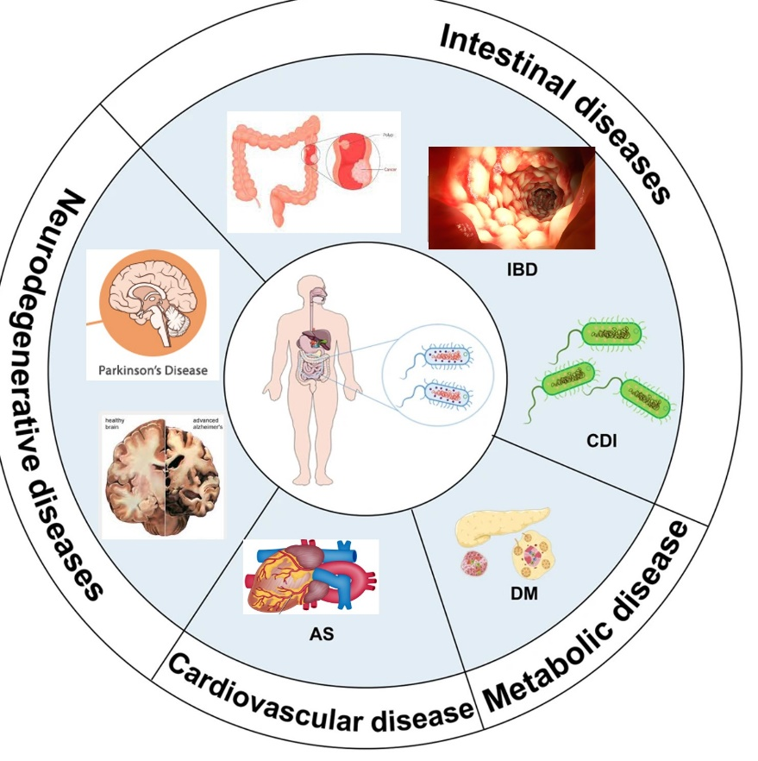

**Figure 1:** Neurodegenerative, Cardiovascular, Metabolic and Intestinal Disease are affective the huge population so these short of illness can be control by proper caring and drug therapy. AS- atherosclerosis, DM- Diabetes mellitus, IBD- Inflammatory bowel disease

Through the insertion of large retro-transposons into the genome, adaptive or acquired immunity developed relatively late in the evolution of vertebrates(Pourrajab and Hekmatimoghaddam, 2021; Savage et al., 2019). This allowed the organisms to become more complex and provided long-term immunologic memory against potential pathogens to which the host had previously experienced immunologic exposure. For many years, scientists have concentrated their study on the mechanisms that enable the host to coordinate a suitable immune response. The identification of the origins of B cells and T cells in the 1950s marked the beginning of a swift advancement in our understanding of the functioning features of the human immune system. By figuring out the essential elements of the parasite and host throughout the infection, new drugs can be produced. The essential elements may originate from the host or parasites, but they each have a distinct signature that changes as the illness does. The different disease types are shown in Figure 1 based on the site of infection.

**Conclusion:**

Historical advancements and current technological research advances have the potential to elevate humankind's status in life. Using an interdisciplinary approach, the hallmark molecules may be identified in both the parasite and the host. The biological system's wider spectrum of bioactivity is specified by the molecular process behind the activation, secretion, and signalling of important molecules. Molecular biology methods, host-parasite interactions, immune system regulation, and the biological system's regeneration process may all be used to represent all facets of biology and highlight its significance for scientific inquiry. Modern technology is useful to provide innovative and persuasive results in life.

**References:**

Cornish, A.J., Filippis, I., David, A., and Sternberg, M.J.E. (2015). Exploring the cellular basis of human disease through a large-scale mapping of deleterious genes to cell types. Genome medicine *7*, 1-18.

Dwivedi, S., Purohit, P., Misra, R., Pareek, P., Goel, A., Khattri, S., Pant, K.K., Misra, S., and Sharma, P. (2017). Diseases and molecular diagnostics: a step closer to precision medicine. Indian Journal of Clinical Biochemistry *32*, 374-398.

Edgar, L., Pu, T., Porter, B., Aziz, J.M., La Pointe, C., Asthana, A., and Orlando, G. (2020). Regenerative medicine, organ bioengineering and transplantation. Journal of British Surgery *107*, 793-800.

Elbehiry, A., Abalkhail, A., Marzouk, E., Elmanssury, A.E., Almuzaini, A.M., Alfheeaid, H., Alshahrani, M.T., Huraysh, N., Ibrahem, M., and Alzaben, F. (2023). An overview of the public health challenges in diagnosing and controlling human foodborne pathogens. Vaccines *11*, 725.

Elchaninov, A., Sukhikh, G., and Fatkhudinov, T. (2021). Evolution of regeneration in animals: A tangled story. Frontiers in Ecology and Evolution *9*, 621686.

Horwitz, R.I., Lobitz, G., Mawn, M., Conroy, A.H., Cullen, M.R., Sim, I., and Singer, B.H. (2021). Biosocial medicine: biology, biography, and the tailored care of the patient. SSM-Population Health *15*, 100863.

Kadam, U.S., Lossie, A.C., Schulz, B., and Irudayaraj, J. (2013). Gene expression analysis using conventional and imaging methods. DNA and RNA Nanobiotechnologies in Medicine: Diagnosis and treatment of diseases, 141-162.

Kitsera, M., Brunetti, J.s.E., and RodrÃguez, E. (2023). Recent developments in NSG and NRG humanized mouse models for their use in viral and immune research. Viruses *15*, 478.

Li, Y., Tang, W., and Guo, M. (2021). The cell as matter: Connecting molecular biology to cellular functions. Matter *4*, 1863-1891.

Poletti, P., Tirani, M., Cereda, D., Trentini, F., Guzzetta, G., Marziano, V., Buoro, S., Riboli, S., Crottogini, L., and Piccarreta, R. (2020). Age-specific SARS-CoV-2 infection fatality ratio and associated risk factors, Italy, February to April 2020. Eurosurveillance *25*, 2001383.

Pourrajab, F., and Hekmatimoghaddam, S. (2021). Transposable elements, contributors in the evolution of organisms (from an arms race to a source of raw materials). Heliyon *7*.

Savage, A.L., Schumann, G.G., Breen, G., Bubb, V.J., Al-Chalabi, A., and Quinn, J.P. (2019). Retrotransposons in the development and progression of amyotrophic lateral sclerosis. Journal of Neurology, Neurosurgery & Psychiatry *90*, 284-293.

Singh, D.K. (2022). The Role of Epigenetics Regulation in Development and Metastasis of Cancer. Research Reports.

Singh, D.K., Singh, P.K., Tiwari, S., Singh, S.K., Kumari, R., Tripathi, D.K., and Srivastava, K.K. (2014). Phosphorylation of pyruvate kinase A by protein kinase J leads to the altered growth and differential rate of intracellular survival of mycobacteria. Applied microbiology and biotechnology *98*, 10065-10076.

Vashisht, V., Vashisht, A., Mondal, A.K., Farmaha, J., Alptekin, A., Singh, H., Ahluwalia, P., Srinivas, A., and Kolhe, R. (2023). Genomics for emerging pathogen identification and monitoring: Prospects and obstacles. BioMedInformatics *3*, 1145-1177.

Weissman, I.L. (2000). Stem cells: units of development, units of regeneration, and units in evolution. cell *100*, 157-168.

Wong, B.B.M., and Candolin, U. (2015). Behavioral responses to changing environments. Behavioral Ecology *26*, 665-673.

Zaghloul, A., Saber, M., Gadow, S., and Awad, F. (2020). Biological indicators for pollution detection in terrestrial and aquatic ecosystems. Bulletin of the National Research Centre *44*, 1-11.

Zimmermann, P., and Curtis, N. (2022). Why does the severity of COVID-19 differ with age?: understanding the mechanisms underlying the age gradient in outcome following SARS-CoV-2 infection. The Pediatric Infectious Disease Journal *41*, e36-e45.