SUSTAINABLE RESOURCE MANAGEMENT

**Ms.K. Bindu Priya MBA 4th Semester, Department of Commerce and Business Management, University College for Women (Telangana Mahila Viswavidyalayam), Koti, Hyderabad, Telangana, India**

# **ABSTRACT**

Sustainable resource management in business is essential for addressing the increasing demand for raw materials and energy, as well as the escalating pollution of soil, air, and water resources. This approach focuses on the wise use and conservation of resources to meet current needs without compromising future generations' ability to meet their own. Key principles include reducing resource use, reusing materials, recycling waste, and prioritizing renewable resources. Examples of sustainable resources are solar, wind, and hydropower, which are renewable and managed responsibly.

The benefits of sustainable resource management for businesses include enhanced reputation, increased business opportunities, cost savings, and waste reduction. Implementing sustainable practices can lead to significant cost savings, improved brand image, compliance with regulations, resource security, and innovation. Key strategies for businesses include energy efficiency, water conservation, sustainable material sourcing, waste reduction, and sustainable supply chain management. Employee engagement and stakeholder transparency are also crucial.

Sustainable resource management involves integrating digital technologies and data analytics for real-time monitoring and optimization. Industry-specific applications vary, with manufacturing focusing on advanced robotics and AI, agriculture on IoT sensors, and energy and utilities on smart meters and renewable energy. This holistic approach not only ensures sustainability but also promotes cost savings and operational excellence.

By adopting these principles and strategies, businesses can minimize their environmental impact, enhance their reputation, reduce costs, and create long-term value for stakeholders.

**INTRODUCTION**

Sustainable resource management in business is all about using resources wisely and minimizing environmental impact. It's a win-win situation, benefiting both the company and the planet. Sustainable resource management involves using and managing natural resources in a way that meets current needs without compromising the ability of future generations to meet their own needs. It integrates economic, environmental, and social considerations to ensure resources are used efficiently and responsibly. The term sustainable resources management refers to developing and implementing methods and solutions for using and protecting resources such as water, energy and raw materials as well as treating waste-streams and -waters.

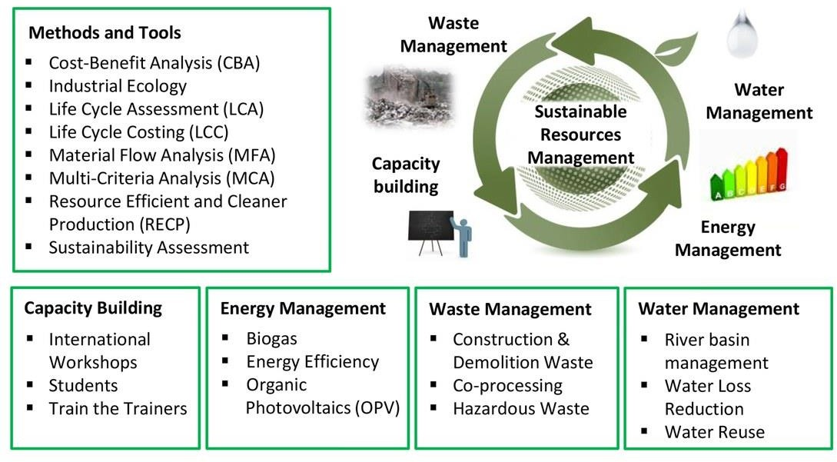

The demand for raw materials and energy is increasing worldwide causing scarcities and increases in the volatility of prices of raw materials since many resources remain insufficiently renewable. Additionally, the progressive pollution of soil, air and water resources with harmful emissions is threatening a sustainable development in many parts of the world.

The "Sustainable resources management" working group analyses and addresses such challenges. It helps develop environmentally and socially compatible resources and waste management methods, encourages the sustainable use of water resources through a comprehensive water and drainage basin management, and develops strategies to avoid waste

streams or to reuse/recycle material flows and energy using cleaner production (CP) and industrial symbiosis (IS) approaches. Our collaborative work with Swiss and foreign partners as part of national and international cooperations has proven to be instrumental to find regionally adapted and accepted solutions.

# **KEY PRINCIPLES OF SUSTAINABLE RESOURCE MANAGEMENT**

* **Reduce:** Minimize the number of resources you use. This can be done through efficiency measures, using less material in products, and adopting reusable items.
* **Reuse:** Find ways to use things again before throwing them away. This could involve repairing broken items, refilling containers, or donating unwanted goods.
* **Recycle:** Process used materials into new products. Recycling reduces the need to extract virgin resources and helps conserve the environment.
* **Renew:** Prioritize the use of renewable resources like solar, wind, and geothermal energy. These resources are naturally replenished and have a lower environmental impact compared to fossil fuels.

# **SUSTAINABLE RESOURCES EXAMPLES**

Sustainable resources are classified as natural resources that are renewable and can be replenished at the same rate, or faster than they are being consumed.

For a natural resource to be sustainable, it must be:

* Renewable
* Managed responsibly

Examples of sustainable resources include hydropower, solar power and wind power, to name a few.

Solar power, for example, is classed as a sustainable resource because the sun’s energy can be captured without the depletion of the sun itself. Similarly, wind power is another sustainable resource because it can’t be depleted and can be harnessed through the use of wind turbines. It’s important to note that not every renewable natural resource is always sustainable or better for the environment. For example, Biofuel is a unique form of renewable energy, as its consumption emits climate-affecting greenhouse gases, and growing the original plant product uses up other environmental resources therefore it is not better for the environment or fully sustainable in its current guise. That said, it remains a major part of the green revolution.

# **BENEFITS OF SUSTAINABLE RESOUCE MANAGEMENT**

Ensuring that the energy your organisation is consuming is renewable and managed responsibly, as well as making sure that it follows the correct environmental laws, offers many benefits for your business and beyond.

## Better reputation

Practising sustainable resource management lets your clients and consumers know that you are taking significant steps to make a positive environmental impact. It allows them to be confident that your organisation is putting the planet first, and is willing to invest time and resources into becoming sustainable.

Comparing your sustainable organisation to other organisations that have not yet made the investment to become more environmentally friendly allows you to have an edge over competitors. People can see your organisation has a clear understanding of how it affects the environment and is implementing ways to lessen its impact, which can make both old and new consumers want to follow and support you in your environmental journey.

## Acquire more business

It also allows consumers to have trust in your organisation to uphold environmental standards, for you and them. With the knowledge that you are considering your organisation’s impact on the environment, it can open up more opportunities for business for you.

It will allow your organisation to be more appealing to potential clientele, as it reassures them that they are supporting an organisation that is doing its part in keeping the future sustainable. Showing them that you have sustainability at the forefront of your business, it allows those with similar standards to work with you, rather than a competitor who may not hold the same environmentally friendly standards.

## Cost-effective

Using renewable resources can also help you to save money in the long run. By installing your own forms of renewable energy, like solar panels or wind turbines, on your organisation’s premises, it can then be used to power your own energy, directly contributing to reducing your energy output.

You are the one in control of how much you want to invest in renewable energy, and depending on the size of that investment depends on the energy return from it.

## Less waste

Sometimes, starting off small can help set the ball rolling when it comes to being sustainable. As your organisation begins to implement large-scale renewable energy, making smaller

changes like designated recycling bins, the cycle to work scheme and trying to make the most out of materials used can help to show that you are just as environmentally conscious on a smaller scale.

As mentioned above, being cost-effective, such as using energy-efficient light bulbs and turning off the lights when you leave a room can also make an impact on reducing your energy consumption.

It also means that you are considering your organisation’s impact on the environment outside of just renewable energy. By taking an active role towards recycling, reducing your own carbon footprint and being as environmentally friendly as you can, it reinforces the sustainability standards your organisation has set out to achieve.

## Here's a breakdown of why and how businesses can implement sustainable practices: Why go green?

* Cost savings: Reducing resource use through efficiency measures like switching to LED lights or using recycled materials can lead to significant cost savings on energy and raw materials.
* Enhanced reputation: Consumers are increasingly drawn to companies with strong environmental practices. Sustainable management can boost brand image and attract eco-conscious customers.
* Compliance with regulations: Environmental regulations are becoming stricter. Proactive businesses that adopt sustainable practices are better prepared to meet future regulations.
* Improved resource security: By reducing dependence on finite resources, companies are less vulnerable to price fluctuations and supply chain disruptions.
* Innovation: Sustainable practices often lead to new product development and innovative solutions, giving businesses a competitive edge.

# **IMPLEMENTATION OF SUSTAINABLE RESOURCE MANAGEMENT**

Here are some key strategies businesses can adopt:

* Energy efficiency: Invest in energy-efficient equipment, utilize renewable energy sources like solar or wind power, and implement practices like turning off lights and electronics when not in use.
* Water conservation: Fix leaks, install low-flow fixtures, and explore water recycling options.
* Material sourcing: Use recycled or sustainably sourced materials whenever possible.
* Waste reduction: Implement the "Reduce, Reuse, Recycle" hierarchy in your operations. Minimize waste generation, find ways to reuse materials, and establish a robust recycling program.
* Sustainable supply chain: Partner with suppliers who themselves have sustainable practices to ensure responsible sourcing throughout the entire chain.
* Employee engagement: Educate and empower employees on sustainable practices within the company. Encourage their participation in green initiatives.

## Examples of sustainable practices in business:

* A clothing company using organic cotton and recycled polyester.
* A restaurant composting food scraps and using energy-efficient appliances.
* An office implementing a paperless workflow and using recycled paper products.

Sustainable resource management is a continuous process. Businesses that make a commitment to it can create a positive impact on the environment, improve their bottom line, and build a strong reputation for the future.

Implementing sustainable practices in resource management is crucial for the long-term viability of businesses and the environment. By adopting tools and modules based on big data analytics, organizations can gain valuable insights into resource usage patterns, identify areas of inefficiency, and make informed decisions to improve resource management. Incorporating real-time analytics and IoT for monitoring and data collection, companies can further enhance resource management practices. This holistic approach to resource management not only ensures sustainability but also promotes cost savings and operational excellence.

## Some steps we can take to make resource management more sustainable include:

* Implementing energy-efficient technologies and practices, such as using renewable energy sources and optimizing energy consumption across operations.
* Adopting circular economy principles, such as reducing waste, reusing materials, and promoting recycling.
* Integrating smart meters and energy management systems to track and optimize energy usage.
* Promoting water conservation strategies, such as implementing smart irrigation systems and efficient water management practices.

Investing in research and development to find innovative solutions for resource management, such as developing new materials with reduced environmental impact or implementing advanced technologies for waste recycling and treatment.

In the pursuit of implementing sustainable practices for resource management, it is essential to delve deeper into the integration of these strategies within different industries. The application of digital transformation and data analytics in resource management varies across sectors and presents unique challenges and opportunities.



## Industry-specific Implementation of Sustainable Resource Management

* **Manufacturing Sector**

In the manufacturing sector, the integration of digital technologies such as Internet of Things and data analytics plays a crucial role in optimizing resource utilization. By implementing advanced robotics and artificial intelligence, organizations can automate production processes, leading to reduced energy consumption and minimized material waste. Moreover, the

utilization of IoT sensors in manufacturing facilities enables real-time monitoring of energy usage and production efficiency, facilitating proactive adjustments to resource allocation.

## Agriculture and Farming

In the agricultural domain, the incorporation of IoT sensors and data analytics tools revolutionizes resource management practices. Real-time monitoring of soil moisture levels, weather conditions, and crop health empowers farmers to make informed decisions regarding irrigation, fertilization, and pest control. This not only leads to efficient water usage and reduced chemical applications but also contributes to improved crop yields and sustainability in agricultural practices.

## Energy and Utilities

For energy and utility companies, the focus on sustainable resource management involves the deployment of smart meters and energy management systems. These technologies enable real- time tracking and optimization of energy usage, contributing to efficient operational practices and reduced environmental impact. Additionally, the integration of renewable energy sources and advanced energy-efficient technologies further reinforces the commitment to sustainable resource management.

Sustainable resource management in business involves the strategic use and conservation of resources to ensure long-term environmental, social, and economic sustainability. This approach integrates principles of sustainability into business operations, decision-making, and strategies to minimize environmental impact, promote social well-being, and ensure economic viability. Here are some key aspects of sustainable resource management in business:

## Resource Efficiency:

Energy Efficiency: Implementing measures to reduce energy consumption, such as using energy-efficient technologies and practices.

Water Conservation: Optimizing water use and recycling water to minimize waste.

Material Efficiency: Reducing material waste through recycling, reusing materials, and optimizing production processes.

## Renewable Resources:

Renewable Energy: Investing in renewable energy sources such as solar, wind, and hydro power to reduce reliance on fossil fuels.

Sustainable Sourcing: Using raw materials from sustainable sources, such as certified wood, organic cotton, or sustainably harvested seafood.

## Waste Management:

Reduce, Reuse, Recycle: Implementing the three R’s to minimize waste and promote circular economy practices.

Waste-to-Energy: Converting waste into energy through processes like incineration or anaerobic digestion.

## Sustainable Supply Chain:

Ethical Sourcing: Ensuring that suppliers adhere to ethical and sustainable practices.

Supply Chain Transparency: Monitoring and reporting on supply chain practices to ensure sustainability.

## Corporate Social Responsibility (CSR):

Community Engagement: Supporting local communities and contributing to social development.

Employee Well-being: Promoting fair labour practices, health, and safety in the workplace.

## Environmental Impact Assessment:

Life Cycle Assessment (LCA): Evaluating the environmental impacts of products or services throughout their life cycle.

Environmental Management Systems (EMS): Implementing systems like ISO 14001 to manage and reduce environmental impacts.

## Innovation and Technology:

Green Technologies: Investing in technologies that reduce environmental impact, such as electric vehicles and sustainable packaging.

Digitalization: Using digital tools to optimize resource use and improve efficiency.

## Policy and Regulation Compliance:

Adhering to Environmental Regulations: Ensuring compliance with local, national, and international environmental laws and regulations.

Voluntary Standards: Participating in voluntary sustainability standards and certifications, such as LEED, Fair Trade, or B Corp.

## Stakeholder Engagement:

Transparency and Reporting: Regularly reporting on sustainability performance and engaging with stakeholders, including customers, employees, investors, and communities.

Sustainability Goals: Setting and publicly committing to sustainability goals and targets.

By integrating these principles, businesses can not only reduce their environmental footprint but also enhance their reputation, reduce costs, and create long-term value for stakeholders.

**CONCLUSION**

Sustainable resource management is not just an environmental imperative but also a strategic business approach that promotes long-term economic and social benefits. Businesses that commit to these practices play a critical role in fostering a sustainable future, minimizing their environmental footprint, enhancing operational excellence, and creating lasting value for stakeholders. By embracing sustainability, businesses can secure their viability and contribute positively to the planet and society.

Sustainable resource management in business is indispensable for addressing the escalating global demand for raw materials and energy, while also mitigating environmental pollution. This practice is pivotal in ensuring that current needs are met without compromising the ability of future generations to meet their own, integrating economic, environmental, and social considerations to use resources efficiently and responsibly.