Indole (Synthetic/Natural) as antifungal agents
Divya Dhawal Bhandari¹, Gagandeep Kaur² and Suman Lata²*
¹University institute of Pharmaceutical Sciences, Panjab University, Chandigarh-160014
²Lyallpur Khalsa College of technical campus school of pharmacy jalandhar-144001
^{3*}Amar Shaheed Baba AjitSingh JujharSingh Memorial College of Pharmacy, Bela (Ropar)-140111
During the last decades, the frequency of fungal infections has increased due to more intensive and cytotoxic chemotherapies. A number of antifungal drugs are already available in the market but drug resistance has opened up new opportunities against fungal infections. The natural products are gaining considerable attention as potential leads for designing novel therapeutic agents. Indole alkaloids represent the most significant and emerging class of antifungals. Despite the decreasing interest of modern pharmaceuticals in pursuing natural products as leads for new medicine, indole alkaloids have gained considerable attention as potential leads for therapeutics. The isolation, characterization and identification of bioactive profile is complex due to their diversified sources such as plants, fungi, bacteria, sponges, tunicates and bryozoans.Among the synthetic compounds, azoles represent the major category of antifungal drugs being used but current research era is opening up newer insights towards hybrid compounds. Indole and its hybrids with pyrimidines, triazole, imidazole are gaining attention of researchers towards the synthesis of new indole containing antifungal agents. Understanding the pathway of development of resistant towards antifungals is an important aspect of designing newer antifungal agents. This chapter will focus on various underlying mechanisms involved in developing resistance towards antifungal drugs as well as on new emerging natural and synthetic indole containing drugs as antifungals.

Keywords: Indole, drug resistance, antifungal, synthetic, natural products.

- INTRODUCTION
Fungal infections pose a significant threat to human health, particularly in immunocompromised individuals, and there is an urgent need for the development of new and effective antifungal agents. A number of antifungal drugs are available in the market which majorly includes azoles, polyenes, allyl amines, echinocandins etc. The emerging issue of acquired resistance is lowering the susceptibility of fungus towards any given drug. The development of new antifungal is challenging as fungi share many basic cellular processes with us. The chemistry of indole and its derivatives came into light with the development of indigo dye. Indole, a heterocyclic aromatic organic compound, and its derivatives have gained considerable attention in recent years due to their diverse biological activities, including antifungal properties.
Indole is a ubiquitous structural motif found in various natural products and pharmaceuticals (Fig 1), and its unique chemical properties make it an attractive scaffold for the design and synthesis of novel antifungal agents. Indole is a privileged structure present in numerous natural products, including tryptophan, an essential amino acid, a biosynthetic precursor in the synthesis of 5-hydroxytryptophan, tryptamine, an immediate precursor of serotonin, melatonin and various alkaloids found in plants, fungi, and marine organisms. Its biological significance and synthetic versatility have made indole a valuable building block in medicinal chemistry, leading to the development of various therapeutic agents targeting different diseases [1][2]. Several studies have reported the antifungal activities of indole derivatives against a wide range of fungal pathogens. For instance, indole-containing compounds have shown promising activities against Candida species, which are responsible for various invasive fungal infections, particularly in immunocompromised individuals [3][4][5].
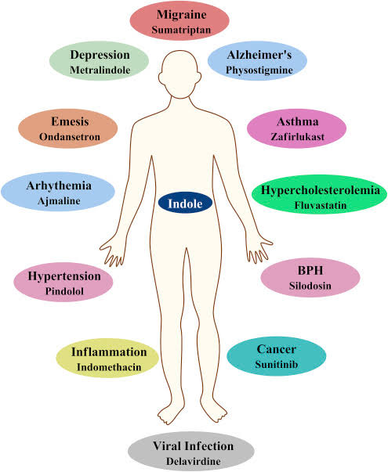
Fig. 1 Various Pharmacological Properties of Indole

Indole derivatives have also demonstrated antifungal activities against plant pathogenic fungi, such as Fusariumgraminearum, Alternariaalternata, and Helminthosporiumsorokinianum, among others [6]. These findings highlight the potential of indole-based compounds as lead structures for the development of new antifungal agents for agricultural and medical applications.

- STRUCTURE ACTIVITY RELATIONSHIP AND RELATED MECHANISM OF ACTION AS ANTIFUNGAL AGENTS
A number of modifications can be done to the chemical structure of indole to enhance its pharmacological properties. Various substitutions and addition of heterocyclic compounds affects the biological activity at different extent. Addition of an azole moiety such as imidazole, triazole, oxazole, pyrazole, thiazole at pyrrole ring of indole have proven to enhance the antifungal activity of indole moiety (Fig 2).
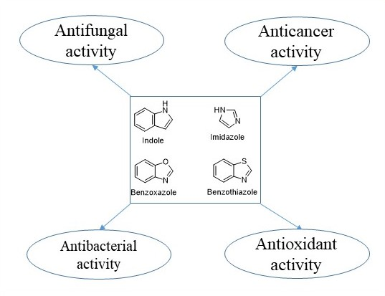
Fig. 2: Various activities of heterocyclic indoles
The antifungal mechanisms of action of indole derivatives are diverse and not fully understood. However, some proposed mechanisms include inhibition of ergosterol biosynthesis, disruption of cell membrane integrity, and interference with fungal virulence factors, such as phospholipase and protease activities (Fig 3) [7][8][9].
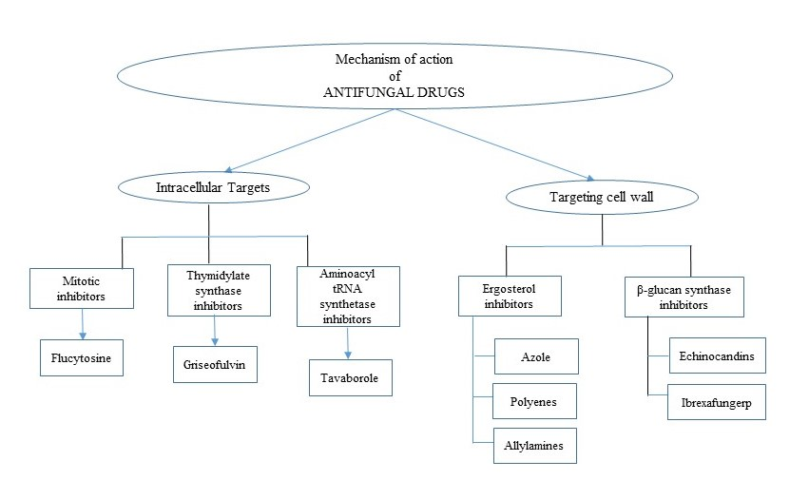
Fig. 3 Various mechanism of action of antifungal agents

- INDOLE DRUGS AS POTENT ANTIFUNFAL AGENTS
Though different categories of antifungals have been used against different species still the formerly available antifungals are unable to match the growing needs of managing infection. The call of time demands an urgent attention towards drug resistance, drug-induced toxicity and lack of drug potency which is further required to be explored leading to the development of novel antifungal agents. The following strategies may extend the scope of chemical scaffolds as antifungal agents:
- Developing new chemical entities (NCEs) for selective fungal target(s)
- Drug repurposing as antifungal agents
- Combination therapy
- Developing hybrid/chimeric antifungal agents hitting two or more fungal targets.
The fourth strategy aimed at developing hybrid/chimeric antifungal agents hitting more targets is acceptable as of now. The more careful insights into the literature exposes opportunities for a number of molecules as antifungals(Fig. 4) which belong to the five membered azole heterocycles. Triazoles, pyrazoles, imidazoles, tetrazolesand their bioisosteric compounds such as thiazole, isoxazole, oxadiazole and thiadiazoleare among them.
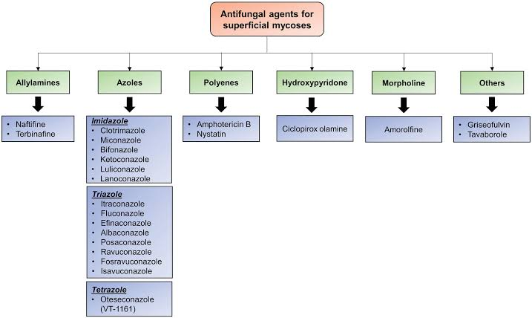
Fig. 4: Various reported antifungal agents

- CONCLUSION
The exploration of indole derivatives as antifungal agents holds great promise for addressing the growing challenge of fungal infections. By leveraging the structural diversity and biological activities of indole-based compounds, this research aims to contribute to the discovery and development of new antifungal agents, ultimately improving the treatment options and outcomes for patients suffering from fungal infections.This research is expected to contribute to the development of novel antifungal agents based on the indole scaffold. The synthesized compounds with potent antifungal activities could serve as lead structures for further optimization and development into potential therapeutic agents or agricultural fungicides.Additionally, the mechanistic studies will provide valuable insights into the modes of action of these compounds, which could facilitate the rational design of more potent and selective antifungal agents in the future.

- REFERENCES
[1] Barden, T. C. (2011). Indoles: Industrial, agricultural and over-the-counter uses. In Heterocyclic Scaffolds II: Reactions and Applications of Indoles (pp. 31-88). Springer, Berlin, Heidelberg. [https://doi.org/10.1007/7081_2011_57]

[2] Kaur, K., Kumar, V., Sharma, A. K., & Gupta, G. K. (2020). Isatin and its derivatives: a survey of recent progress in biology and medicine. Biomolecules, 10(7), 1025. [https://doi.org/10.3390/biom10071025]

[3] Xu, Z., & Fan, X. (2019). Synthesis and antifungal activity of novel indole [1, 2-c]-1, 2, 4-benzotriazine derivatives. Journal of Heterocyclic Chemistry, 56(2), 524-529. [https://doi.org/10.1002/jhet.3443]

[4] Zhang, Y., Xu, Z., & Fan, X. (2019). Synthesis and antifungal activity of novel indole derivatives containing 1, 3, 4-oxadiazole moiety. Journal of Heterocyclic Chemistry, 56(2), 530-535. [https://doi.org/10.1002/jhet.3444]

[5] Song, Y., Xu, Z., & Fan, X. (2019). Synthesis and antifungal activity of novel indole derivatives containing thiochroman moiety. Journal of Heterocyclic Chemistry, 56(2), 536-541. [https://doi.org/10.1002/jhet.3445]

[6] Xu, Z., Zhao, S. J., Lv, Z. S., Dai, H. F., Cao, X. P., & Shen, Y. M. (2010). Antifungal activities of some indole derivatives. European Journal of Medicinal Chemistry, 45(12), 5876-5885. [https://doi.org/10.1016/j.ejmech.2010.09.047]

[7] Xu, Z., Fan, X., & Zhang, Y. (2019). Design, synthesis and antifungal activity of novel indole compounds bridged with the 1, 2, 3-triazole motif. Journal of Heterocyclic Chemistry, 56(2), 542-547. [https://doi.org/10.1002/jhet.3446]

[8] Basha, U., Rao, V. M., Sunitha, M., Rao, G. K., & Rao, P. S. (2019). Synthesis and antifungal activity of novel 3-(1H-indole-3-carbonyl)-2H-chromen-2-one derivatives. Journal of Heterocyclic Chemistry, 56(2), 548-553. [https://doi.org/10.1002/jhet.3447]

[9] Na, M. (2009). Inhibition of farnesyl protein transferase by indole-based small molecules. Bioorganic & Medicinal Chemistry Letters, 19(18), 5527-5530. [https://doi.org/10.1016/j.bmcl.2009.07.101]

