Materials Redefined: Charting the Course for Future Developments: Fabrication and Testing of Flyash and Baggase mixed Aluminium Composite

Vipin Kumar Sharma
Department of Mechanical Engineering Maharaja Agrasen Institute of Technology Delhi-110086, India vipin.dtu@gmail.com

Chirag Gupta
Department of Mechanical Engineering Maharaja Agrasen Institute of Technology Delhi-110086, India vipin.dtu@gmail.com

Vansh Gulati
Department of Mechanical Engineering Maharaja Agrasen Institute of Technology Delhi-110086, India vipin.dtu@gmail.com

ABSTRACT
Metal matrix composites (MMC) prove to be stronger, lighter and durable materials in comparison to their constituent parent materials. The metal alloys and composite materials have a vast application in the automobile, aircraft and allied industries. The metal matrix selected for the investigation is Aluminium which has been reinforced with fly-ash (an industrial waste) and Bagasse (sugarcane agro-waste) to fabricate the required MMC. Therefore, base metal was selected in accordance to an automobile part like a Piston which experience high friction rate leading to high wear rate. Fly-ash composite is used in construction industry as they are light in weight. In this research three homogenous specimens (of varying compositions) of Aluminium with Fly-ash and Bagasse as reinforcement were fabricated. To maintain the homogeneity stir casting was used. The casted composite had rough surface therefore, finishing operation was performed. The problem of wear is likely to occur when there is relative motion between two mating surfaces resulting in failure. Although fly-ash and bagasse reduce the strength of the composite but during relative motion they prevent the wear of parent metal by wear before the parent metal. The pin on disc test is performed to analyse the effect of load, friction and velocity for wear characteristics. Coefficient of friction and frictional force were determined and appropriate graphs have been plotted.

Keywords—composite, aluminium, coefficient of friction, wear.

Introduction
Metal Matrix Composites (MMCs) represent a relatively new class of advanced materials in modern engineering. They have shown progress in terms of understanding, predictability in design, and performance characteristics, as well as improvements in affordability and availability, which are likely to lead to increased utilization in future designs. The scope of MMCs encompasses all commercially available MMC materials and those under advanced development, as well as those of future design interest. They differ from ordinary metals in the following ways:
a) The nature and type of constituents,
b) The consolidation and processing methods, and
c) The resulting engineering physical and mechanical properties, as well as liabilities.
MMC systems are typically identified by the metal alloy used as the matrix, along with details regarding the type, volume fraction, and form of the ceramic reinforcement. They are distinguished from other composite materials in several aspects:
1. The matrix phase of MMCs is either a pure metal or an alloy, unlike polymers or ceramics.
2. MMCs exhibit higher ductility and toughness compared to ceramics or Ceramic Matrix Composites (CMCs), although their ductility and toughness are lower than their respective unreinforced metal matrix alloys.
3. The primary role of reinforcement in MMCs is to enhance strength and modulus, similar to Polymer Matrix Composites (PMCs), whereas in CMCs, reinforcement is mainly for improved damage tolerance.
4. MMCs typically have a higher temperature capability than polymers and PMCs but lower than ceramics and CMCs.
5. Low to moderately reinforced MMCs can be formed using processes commonly associated with unreinforced metals.
Matrix materials play a crucial role in MMCs, with metals being highly versatile engineering materials. They can exhibit a wide range of properties through appropriate alloy composition and thermo-mechanical processing methods. The development of MMCs has aimed to achieve property combinations beyond those attainable with metals alone, resulting in tailored composites with enhanced specific stiffness, improved fatigue and wear resistance, and desired thermal characteristics. The choice of matrix alloy for an MMC depends on several factors, including whether the composite is continuously or discontinuously reinforced. Different forms of matrix materials, such as re-melting stock, wrought materials, and powders, are used in manufacturing MMCs. Various types of matrix materials, including aluminum, copper, iron, magnesium, nickel, and titanium, have been utilized in MMCs, each offering specific advantages based on the desired composite properties and applications. For instance, aluminum is widely used in MMCs due to its favorable properties such as low density, high thermal conductivity, ductility, and malleability. However, it can be susceptible to wear, which can be addressed by incorporating reinforcements like fly ash and sugarcane bagasse. Recent trends in MMCs are closely aligned with industries such as automotive and aerospace, aiming to improve efficiency by reducing weight while maintaining or enhancing mechanical properties and wear resistance. Techniques like stir casting and powder metallurgy are employed to create MMCs with customized properties for specific applications.
Juang et al. [8] developed a composite consisting of an aluminum alloy and 5% by weight of fly ash using the stir casting technique. They then applied multi-path friction stir processing (MP-FSP) to this composite. The study investigated the microstructure of the processed area and the fracture surfaces of a tensile test specimen to analyze the distribution of fly ash in the aluminum matrix, grain refinement, and failure mechanisms. The results of the experiments indicated significant grain refinement in the composite due to MP-FSP, reducing the original size of fly ash particles from 53–106 μm to 10 μm or less. In comparison to the ALFA composite without stir processing, the tensile strength and elongation along the direction of stirring increased from 143 MPa to 227 MPa and from 1.19% to 7.18%, respectively. Similarly, the properties perpendicular to the stirring direction increased from 143 MPa to 226 MPa for tensile strength and from 1.19% to 3.12% for elongation.

Prakash et al. [9] developed a cost-effective composite using Aluminum 6061 T6 reinforced with naturally occurring rock dust particles via the powder metallurgy method. They varied the reinforcement ratio from 0% to 50%, maintaining a constant particle size of 20 μm. The mixed powders were compressed at three different pressures ranging from 100 to 200 MPa. An Al2O3 ceramic coating was applied to the novel composite using the Type III Sulphuric acid hard coating method. The resulting composites underwent testing for microstructure, micro-hardness, and wear resistance. Analysis using SEM micrographs confirmed a uniform distribution of reinforcement within the matrix, while optical microscopic images revealed a fine ceramic hard coating. Micro-hardness increased with higher reinforcement levels, up to 10%. Wear properties were evaluated using a Pin on Disc setup without lubricant, with load, sliding velocity, and sliding distance kept constant. The study found that the composite with 10% rock dust exhibited superior wear resistance compared to other compositions. Additionally, an increase in hardness and subsequently improved wear resistance was noted with higher compacting pressures. The coated sample showed better performance than uncoated composite samples across all compositions and different compacting pressures.
Shin et al. [10] conducted a study on the microstructure and mechanical properties of aluminum alloy 2024 (Al2024) reinforced with few-layer graphene (FLG) composites. These composites were produced using ball milling and hot rolling techniques. The inclusion of dispersed FLGs with a high specific surface area significantly enhanced the strength of the composites. Specifically, the composite containing 0.7 vol.% FLGs demonstrated a tensile strength of 700 MPa, which is twice as high as that of pure Al2024, with an elongation to failure of approximately 4%. The strengthening mechanism in these Al2024/FLG composites during plastic deformation is attributed to restricted dislocation activities and the accumulation of dislocations between FLGs.
Alaneme et al. [11] conducted a study on the microstructural characteristics, mechanical properties, and wear behavior of aluminum matrix hybrid composites reinforced with alumina, rice husk ash (RHA), and graphite. Different weight ratios of alumina, RHA, and graphite were mixed and used to prepare 10 wt% hybrid-reinforced Al-Mg-Si alloy-based composites via a two-step stir casting process. The characterization of these composites included hardness testing, tensile testing, scanning electron microscopy (SEM), and wear tests. Their findings revealed that the hardness of the composites decreased with an increase in the weight ratio of RHA and graphite, with the effect of graphite on hardness becoming less significant when RHA content exceeded 50%. The tensile strength of composites containing 0.5 wt% graphite and up to 50% RHA was higher than that of composites without graphite. Moreover, the toughness values were consistently higher for composites containing 0.5 wt% graphite compared to those without graphite. The elongation percentage for all composites ranged from 10 to 13%, and this value remained consistent regardless of RHA and graphite content. SEM analysis showed a similar tensile fracture surface morphology across all composites, characterized by reinforcing particles within ductile dimples. Composites without graphite exhibited greater wear susceptibility compared to those with graphite, although wear resistance decreased as graphite content increased from 0.5 to 1.5 wt%.

Sharma et al. [12] conducted a study focusing on the impact of adding graphite particles on the microstructure of Al6082 metal matrix composites produced through the conventional stir casting process. They varied the reinforcement content from 0% to 12% in increments of 3%. The microstructures of the manufactured composites were examined using scanning electron microscopy (SEM), and elemental mapping was performed on the Al6082 + 12% Gr reinforced composite to identify the presence of different elements and their quantities. Additionally, X-ray diffraction (XRD) analysis was conducted to verify the elemental composition of the manufactured composites, supporting the findings from the elemental map analysis. The results of this microstructural investigation indicated a non-uniform distribution of graphite particles across all weight percentages of graphite reinforcement.
Kumar et al. [13] conducted a study to create composites with high strength and good ductility by optimizing a uniform and smooth interface to efficiently transfer loads and reduce issues like reinforcement agglomerations, cracking, and pullouts. They used a high-strength, high-entropy alloy (ternary) in particulate (HEAp) form as reinforcement in 2024 aluminum. The AA 2024-HEAp composite was prepared via the stir casting method by dispersing reinforcement particles with an average size of 125 μm at various weight fractions ranging from 5 to 15%. Subsequently, the billets were hot extruded into 14 mm diameter rods. All experiments were homogenized in an industrial furnace at 100°C for 24 hours. The mechanical behavior of the alloy and composites was evaluated in terms of resistivity, hardness, and tensile properties. They observed a 62% increase in hardness, and higher reinforcement contents improved mechanical properties such as yield strength, tensile strength, and Young’s modulus.

Claunch et al. [15] hydrolyzed gluten into low molecular weight proteins, where some of these proteins self-assembled into high modulus fibers, while the rest arranged around the fibers to form a polymer matrix, resulting in a fiber-reinforced polymer matrix composite. Self-assembly at 37°C produced fiber composites with a modulus of 266 MPa. However, self-assembly at 22°C suppressed fiber formation, leading to polymer materials with a much lower modulus of 20 MPa. Fourier transform infrared (FTIR) spectroscopy results revealed that both materials had a similar beta-sheet content of about 50%, but the composites formed at 37°C showed increased hydrogen bonding. Hydrophobic interactions also differed in the 37°C composite, as it was these interactions that drove self-assembly into large amyloid fibers. Scanning electron microscopy (SEM) analysis indicated good interaction between the fiber and matrix, as the protein completely coated the fibers, and no voids were observed at the fiber/polymer interface. Thermogravimetric analysis (TGA) demonstrated that the 37°C composite exhibited greater thermal stability at higher temperatures due to increased intermolecular interactions and the presence of fibers.

Xiong et al. [16] developed granular composites comprising aluminum (Al) and nickel (Ni), which are typical structural energetic materials known for their ideal combination of mechanical properties and energy release capability. They investigated the influence of two additives, namely Teflon (PTFE) and copper (Cu), on the mechanical properties and shock-induced chemical reaction (SICR) characteristics of the Al/Ni material system. Three composites—Al/Ni, Al/Ni/PTFE, and Al/Ni/Cu—with the same volumetric ratio of Al powder to Ni powder were processed using static pressing. Scanning electron microscopy (SEM) was used to analyze the microstructure of these composites, and quasi-static compression tests were conducted to determine their mechanical properties and fracture behavior. The study revealed that the additives influenced both the compressive strength and fracture mode of the composites. Impact initiation experiments were also performed to assess shock-induced chemical reaction characteristics, considering pressure histories measured in the test chamber. The experimental results demonstrated significant effects of the additives on critical initiation velocity, reaction rate, reaction efficiency, and post-reaction behavior.

Li et al. [17] investigated the compressive behavior of an aluminum composite. Their results showed that the quasi-static stress–strain (σ–ε) curves of the Al composite were similar to those of Al foams. However, within two strain ranges (ε<0.03 and ε>0.2), the ideal energy absorption efficiency (I) of the composites was higher than that of Al foams. Conversely, when ε ranged from 0.03 to 0.2, the I value of the composite was lower than that of Al foams.

Shen et al. [18] conducted research on the fabrication of superhydrophobic conductive graphite nanoplatelet (GNP)/vapour-grown carbon fibre (VGCF)/polypropylene (PP) composite coatings. They addressed the challenge of achieving superhydrophobic surfaces with mechanical durability, as surface microstructure is prone to damage. Their report focused on creating superhydrophobic conductive composite coatings with mechanical durability using a hot-pressing method.
Zhang et al. [19] developed two types of Cr3C2–Cu composites with distinct characteristics. Bi-continuous Cr3C2–Cu composites featuring interpenetrating structures were created through metal infiltration of porous Cr3C2 networks. On the other hand, particle-reinforced Cr3C2–Cu metal matrix composites (MMCs) were produced using a powder metallurgy process. The microstructure, electrical conductivity, and wear resistance of these composites were studied. While both types of composites exhibited excellent electrical conductivity and wear resistance, the bi-continuous composites generally showed superior performance compared to MMCs with the same chemical composition.

Dobrzyn et al. [20] consolidated aluminum metal composites using elemental Al powder and atomized Al65Cu20Fe15 particles via vacuum hot pressing. The spherical Al65Cu20Fe15 particles comprised icosahedral quasi-crystalline dendrites or cells and cubic s-Al Cu(Fe) phase located in inter-dendritic areas. Composites with varying content of reinforcement particles (20, 40, and 60 wt%) were prepared, all exhibiting about 99% density and good bonding between the Al65Cu20Fe15 particles and the matrix. The phase composition of the atomized particles remained unchanged after consolidation in composites with 20% and 40% added particles, while Al2Cu precipitates formed at the Al/Al65Cu20Fe15 interfaces and within the matrix in the composite with 60% of Al65Cu20Fe15 particles. As the volume fraction of reinforcement increased, the hardness and compressive strength of the composite also increased, reaching 173 HV0.5 and 370 MPa, respectively, for 60% of Al65Cu20Fe15 particles. The friction coefficient slightly varied in the range of 0.5–0.7 depending on the composition.
Sharma et al.[21] focused on producing aluminum (AA6082-T6) matrix composites reinforced with varying weight percentages of silicon nitride particles through conventional stir casting. The reinforcement percentage ranged from 0 wt.% to 12 wt.% in increments of 3%. They investigated the microstructures and mechanical properties of these fabricated aluminum matrix composites, identifying the presence and distribution of Si3N4 particles using scanning electron microstructure images and X-ray diffraction techniques.
Kumar et al. [14] developed an AA5052/ZrB2 composite with varying volume percentages (0%, 3%, 6%, 9%, and 10%) of ZrB2 particles through an in-situ reaction of molten AA5052 alloy with two inorganic salts, K2ZrF6, and KBF4, at a temperature of 860°C. They characterized the in-situ composites using Differential Thermal Analysis (DTA), X-ray Diffraction (XRD), Scanning Electron Microscopy (SEM), and Transmission Elec;ile properties were evaluated using standard methods. The morphology studies indicated a reduction in grain size of the Al-rich phase due to the presence of ZrB2 particles. Microstructural analysis revealed a uniform distribution of second-phase particles, clear interfaces, good bonding, dislocations, and the morphology of ZrB2 particles. The ZrB2 particles were predominantly in nano size with hexagonal or rectangular shapes, although some particles in micron size were also observed. The density and hardness of the composites increased with a higher amount of reinforcement. The ultimate tensile strength and 0.2% yield strength improved continuously with an increase in the volume fraction of ZrB2 particles up to 9 vol.%, but beyond this composition, the strength decreased.

Manufacturing of Composite
1) Manufacturing via Stir Casting: The MMC was produced using the Stir Casting Method, ensuring a uniform composition. This process involves a diagram illustrating the setup with a furnace, crucible, and a motor-driven rotor. The molten matrix metal is contained in the crucible, while reinforcement material is added externally. The rotor stirs the materials vigorously to achieve thorough mixing. Stir casting is crucial for eliminating agglomerates and ensuring a homogeneous mixture.

2) Machining for Shape and Size:After manufacturing, various machining processes were employed to shape and size the workpiece according to desired specifications.

3) Mechanical Testing:The fabricated MMC underwent rigorous mechanical testing, including Spectroscopy, Hardness testing, Pin-on-disc analysis, and Universal Testing Machine (UTM) tests. These tests provide insights into the material's properties, such as its composition, hardness, wear resistance, and mechanical strength.
The experimental procedure for creating the aluminum-based metal matrix composite (MMC) involved several steps:

1. Preparation of Aluminum and Silicon (Si) Powder:
- Aluminum was preheated at 450°C for 3 to 4 hours.
- Silicon powder was heated separately at 900°C.
- Both preheated mixtures were mechanically mixed below their respective melting points.

2. Mixing and Heating in Crucible:
- The metal-matrix Al-Si mixture was poured into a graphite crucible.
- The crucible was placed in a coal-fired furnace at 760°C.
- Finely ground fly ash and sugarcane bagasse were added to the mixture.

3. Melting and Semi-Solid State:
- The furnace temperature was raised to fully melt the aluminum scraps and composite materials.
- The mixture was then cooled slightly to maintain a semi-solid state.

4. Manual Mixing of Silicon Powder:
- Preheated silicon powder was added to the semi-solid mixture.
- Manual mixing was performed as machine or stirrer mixing was challenging in the semi-molten state.

5. Automatic Stirring:
- After manual mixing, automatic stirring was conducted for ten minutes at a normal rate of 400 rpm.

6. Controlled Temperature and Final Mixing:
- The furnace temperature was controlled at 760 ± 10°C during the final mixing process.

7. Casting into Sand Mould:
- Once mixing was complete, the slurry was swiftly poured into a sand mold within thirty seconds.
- The composite was allowed to solidify in the mold.
This detailed procedure ensured the proper preparation, mixing, and casting of the metal matrix composite while maintaining control over temperature and mixing conditions for optimal results.
Experimentation
The Pin-On-Disc method is employed to assess the friction and wear properties of various materials under dry or lubricated sliding conditions. It involves rotating a test disc against a stationary pin specimen. Here's an overview of the method and its experimental procedure:

Method Overview:
- Pin-On-Disc evaluates friction and wear characteristics in materials like metals, polymers, composites, ceramics, lubricants, coatings, etc.
- It provides insights into material wear and lifetime, crucial for applications where wear resistance is critical.
- The test uses a spherical-ended pin to maintain controlled contact conditions, irrespective of any misalignment between the pin and disc axes.
- Pin-on-disc tests are versatile and applicable to various coatings, materials, and thicknesses.

Experimental Procedure:
1. Preparation:
- Two specimens are needed: a cylindrical pin and a flat circular disc.
- The pin is positioned perpendicular to the disc, with the test machine causing either the disc or the pin to revolve around the disc center.
- The sliding path forms a circular pattern on the disc's surface, which can be oriented horizontally or vertically.

2. Loading and Testing:
- The pin specimen is pressed against the disc at a specified load using a lever with attached weights.
- Wear is measured either by assessing linear dimensions (length change, shape change) of both specimens before and after the test, or by weighing them.
- Linear wear measures are converted to wear volume using geometric relations, while mass loss is converted to volume loss based on specimen density.

3. Data Collection:
- Wear tests are conducted for selected sliding distances, loads, and speeds.
- Wear results are obtained by analyzing the changes in specimen dimensions or mass loss, providing insights into the material's wear resistance under specific conditions.

Overall, the Pin-On-Disc method offers a reliable way to evaluate friction and wear behaviors, making it valuable for material characterization and performance assessment in various industries.
Tensile Testing
The tensile strength test involves using a Universal Testing Machine (UTM) to assess the behavior of a material under tensile stress. Here's how the test generally works:

1. Setup: The test sample, often in the form of a standardized specimen such as a dogbone shape, is securely mounted onto the UTM. The machine is capable of applying controlled tensile loads to the specimen.

2. Loading: The UTM applies an ever-increasing tensile force to the specimen, typically at a constant rate, until the material reaches its breaking point. The force applied and the corresponding deformation (strain) are measured throughout the test.

3. Data Collection: As the test progresses, the UTM records the applied force and the resulting elongation or deformation of the specimen. This data is used to plot a stress-strain curve, which shows how the material responds to increasing tensile stress.

4. Analysis: The stress-strain curve provides valuable information about the material's mechanical properties. Key parameters include:
- Tensile Strength: The maximum stress the material can withstand before fracturing.
- Elongation at Break: The amount of deformation the material undergoes before breaking.
- Modulus of Elasticity (Young's Modulus): The material's stiffness or resistance to deformation under tensile stress, measured in the initial linear portion of the stress-strain curve.
- Yield Strength: The stress at which the material begins to deform plastically, usually identified by a deviation from the linear elastic behavior on the stress-strain curve.

By analyzing the stress-strain curve and extracting these parameters, engineers and researchers can understand how a material behaves under tensile loading, which is crucial for designing and evaluating structural components in various industries.
Hardness Testing
The hardness test is a common method used to assess the resistance of a material to deformation, particularly localized deformation such as indentation or scratching. Here's an overview of how the hardness test is typically conducted:

1. Types of Hardness Tests:There are various methods to measure hardness, each suited for different materials and applications. Some common hardness tests include:
- Rockwell Hardness Test: Measures the depth of penetration of an indenter under a large load (major load) and a subsequent smaller load (minor load).
- Brinell Hardness Test: Measures the diameter of an impression made by a hardened steel ball under a specified load.
- Vickers Hardness Test: Measures the size of the indentation created by a diamond-shaped indenter under a specified load.

2. Preparation: Before conducting the hardness test, the test surface of the material is typically prepared by grinding or polishing to ensure a smooth and flat surface.

3. Indentation: The test is performed by applying a known force or load to an indenter (which can vary based on the type of hardness test) and pressing it into the material's surface for a specified duration.

4. Measurement: After the indentation is made, the size or depth of the indentation is measured using specialized equipment such as a microscope or optical measuring device.

5. Calculating Hardness: Depending on the hardness test method used, the hardness value is calculated based on the applied load, the area or diameter of the indentation, and other relevant factors specified by the test method.

6. Interpretation: The hardness value obtained from the test provides information about the material's resistance to plastic deformation. Higher hardness values typically indicate greater resistance to deformation and are often correlated with material strength.

Results and Discussion

Spectroscopy :

The spectroscopy was required to know the silicon content in the specimens. The specimens were compared with the original specimen of piston composition. The silicon content was found out to be nearly as same as that of the original specimen(by adding flyash and baggase).The data is as follows:

Table No.2 : Silicon percentage in various specimens.

Material | Original | High | Medium | Low
Silicon percentage(w/w) | 10 | 10.31 | 10.2 | 9.9
The exact composition of the specimens is in appendix xx.

Pin on disc
Pin-on-Disk wear testing is a method of characterizing the coefficient of friction, frictional force, and rate of wear between two materials. During this tribological test, a stationary disk was articulated against a rotating pin while under a constant applied load.
Pin-on-disk wear testing can simulate multiple modes of wear. The computer software WINDUCOM was used to generate values of frictional force and wear. The specifications of the various controlling factors (RPM , time , track distance , sliding velocity, mass before and after wear,load) has been tabulated.

Table No. 3: Parameters on pin on disc machine.
Material | RPM | Track Distance(mm) | Time(sec) | Mass before wear(gm) | Mass after wear(gm) | Load(kg) | Loss in mass
Low | 780 | 100 | 245 | 6.636 | 6.6317 | 2 | 0.0043
Medium | 600 | 130 | 245 | 24.6177 | 24.6139 | 2 | 0.0038
High | 1115 | 70 | 245 | 24.396 | 24.3916 | 2 | 0.0044

Data was accumulated for a set of nearly 2500 points and the following graphs and relations were obtained.
Result 1
COMPARISON OF FRICTIONAL FORCE AMONG SPECIMENS

Frictional force vs Data points(low)
6
5
4
3
2
1
0
0
500
1000
1500
2000
2500
3000
a)
Frictional force vs Data points(Med)
6
5
4
3
2
1
0
0
500
1000
1500
2000
2500
3000

b)
Frictional force vs Data points(high)
6
5
4
3
2
1
0
0
500
1000
1500
2000
2500
3000
-1
c)

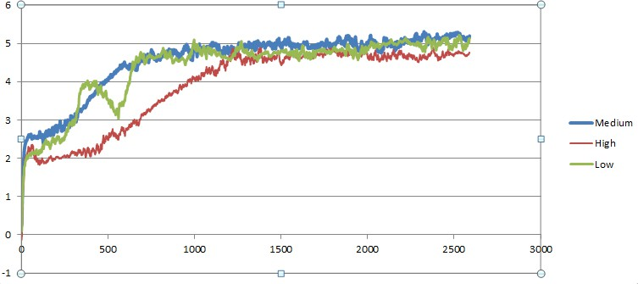
d)
Figure 19 :a)Low , b) Medium , c) High , d) Combined. Frictional force variation with data points.
As the silicon percentage increased the frictional force kept on decreasing between the pin and the cast iron disc.
This again showed a favourable inverse relationship between silicon and frictional force.

Result 2
COMPARISON OF WEAR RATE AMONG SPECIMENS
Wear Rate vs Data Points(Low)
250

200

150

100

50

0
0
500
1000
1500
2000
2500
3000
-50
a)

Wear Rate vs Data Points(Med)
15
10
5
0
-5 0
-10
-15
-20
-25
-30
500
1000
1500
2000
2500
3000
b)
Wear Rate vs Data Points(High)
15
10
5
0
-5 0
-10
-15
-20
-25
-30
500
1000
1500
2000
2500
3000

c)
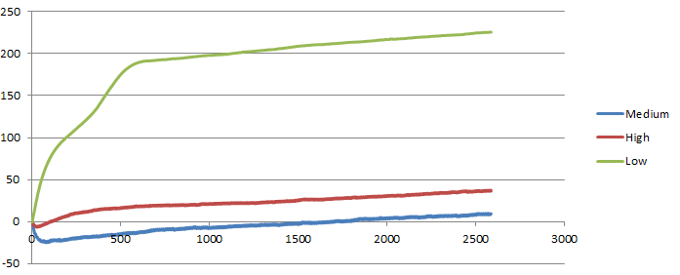
d)
Figure 20 :a)Low , b) Medium , c) High , d) Combined. Wear rate variation with data points.

As the Silicon percentage increased in the specimens the wear rate of the pins reduced. The silicon levels are inversely proportional to the wear rate.
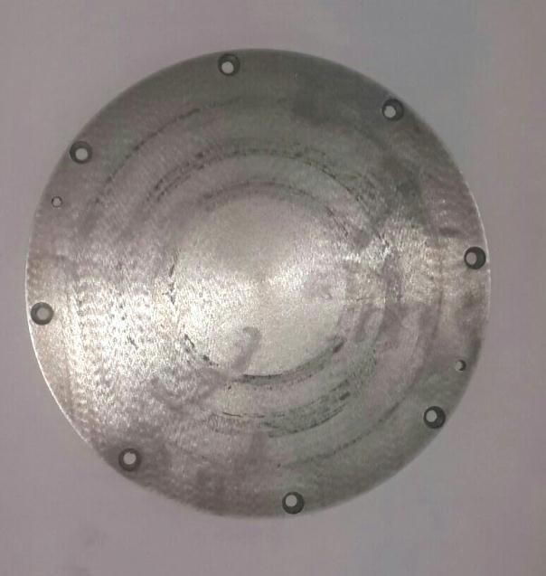
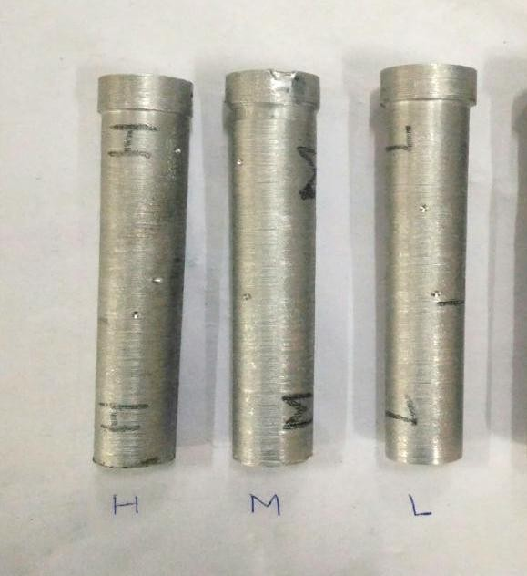

Figure 21 : Wear on disc after test Figure 22 : Test Specimens (Showing Track Distance of all 3 specimens)
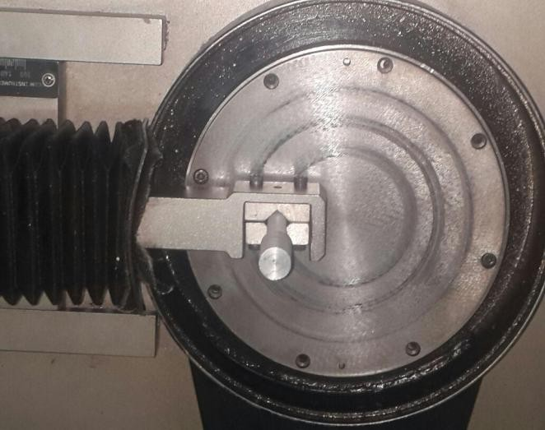
Figure 23 : Pin-on-Disc setup with specimen
sliding on revolving disc

Hardness
The Rockwell hardness test measured the depth of indentation produced by an indentor. Two values were taken which are tabulated below along with their average.

Table No.4 : Rockwell hardness for different compositions.
Material | Reading 1 | Reading 2 | Average
Low Grade | 37.5 | 39 | 38.25
Medium Grade | 49 | 49.2 | 49.1
High Grade | 57.8 | 54 | 55.9

Pure Grade^{[22]} | 54.9 | 57 | 55.95
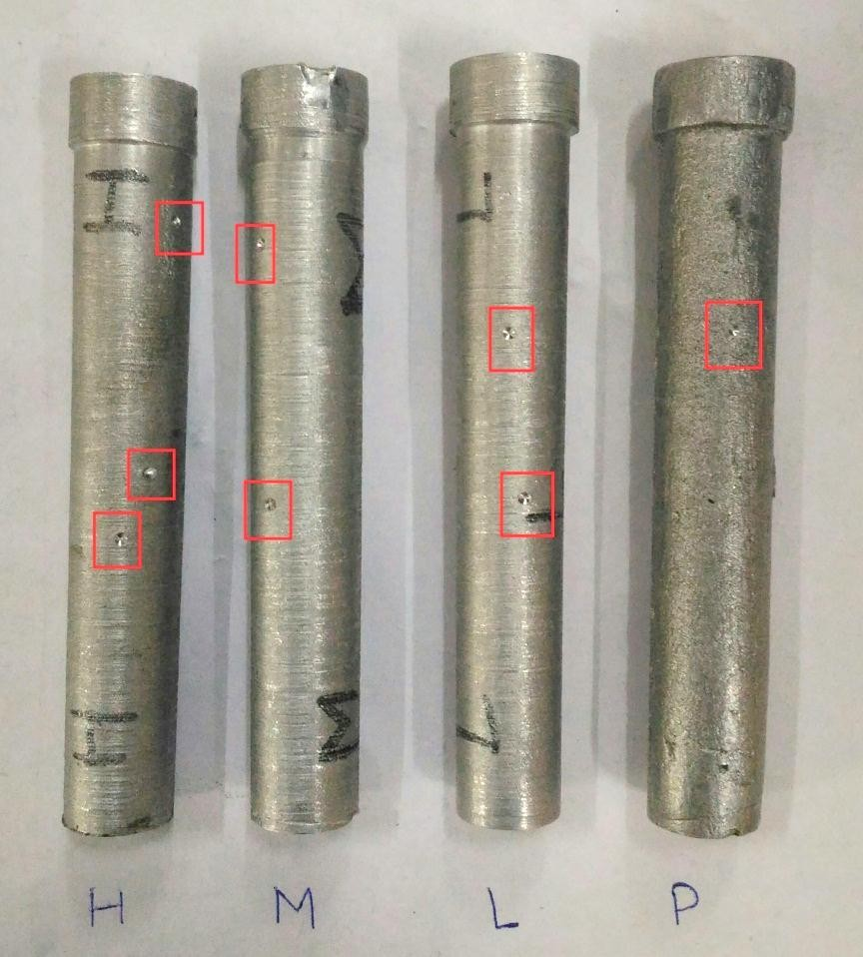

Figure 24 : Specimen showing indentations.
3.4 Tensile Test
The tensile test was performed to test nature of fabricated specimens by observing their surface after fracture by using UTM. It was observed that the surface was perpendicular to the axis of applied tensile force, thus concluding that the material has adopted brittle nature.

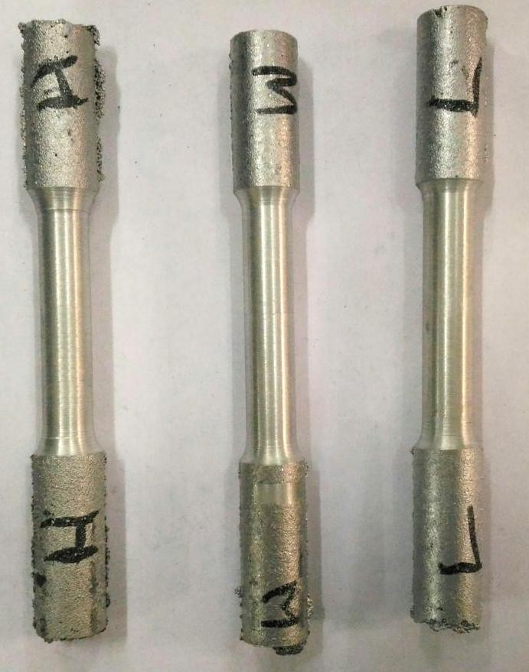
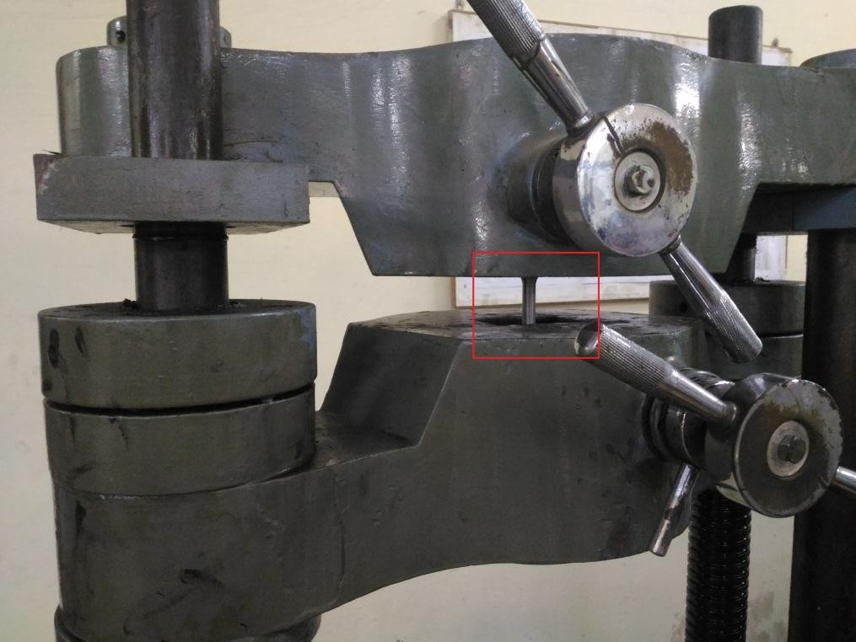
Figure 25 : The specimens prior tensile test.
Figure 26 : Specimen under tensile test.

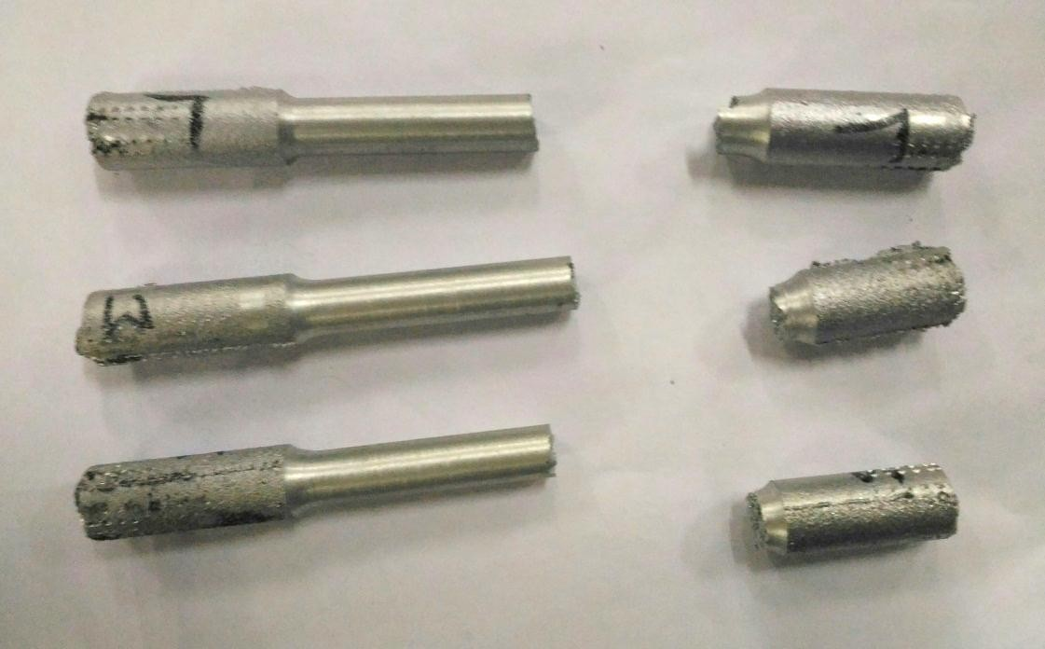
Figure 27 : Fractured specimen after tensile test.

DISCUSSION
In this research work, a new aluminium based metal matrix composite with fly ash and sugarcane baggase as the reinforcing materials has been successfully fabricated.
Three different samples were fabricated by varying the composition of fly ash while that of sugarcane baggase remained fixed in each sample. For fabrication of samples, Stir-Casting process has been used. These samples were used for the study of variation in the microstructure and mechanical properties with the variation of flyash. For analysing the variation in the mechanical properties, the samples were tested on-
- Universal Testing Machine

- Rockwell Hardness Testing Machine

- Pin on Disc machine.

While for analysing the change in microstructure, Spectroscopy was used.
On comparing the results obtained from the microstructure analysis of the samples, following results have been obtained-
Spectroscopy of the samples reveals that the content of silicon increased with increase in the composition of fly ash, although it is comparable to the silicon content of the parent material. Similarly, on comparing the results obtained from the mechanical testing of the samples, following results have been obtained-

- Pin On Disc wear Test

As the fly ash content increases

  - Wear resistance increases.
  - Frictional force reduces.
- Universal Testing Machine

By observing the nature of fracture of the specimens, it was found that ductility was compromised as compared to parent material i.e. pure aluminium[22].
- Rockwell Hardness Test

It has been observed that the hardness of the specimen with highest fly ash content is comparable to the parent material. While for the other specimen, the hardness was found to be reduced.

References

- K. Kato, Wear in relation to friction - a review, Wear, vol. 241, pp. 151-157, 2000.
- A.P. Sannino, H.J. Rack, Dry sliding wear of discontinuously reinforced aluminum composites review and discussion, Wear, vol. 189, pp. 1-19, 1995.
- M. Singh, D.P. Mondal, Q.P. Modi, A.K. Jha, Two-body abrasive wear behavior of aluminum alloy-sillimanite particle reinforced composite, Wear, vol. 253, pp. 357-368, 2002.
- N. Kahramana, B. Gulenc, Abrasive wear behavior of powder flame sprayed coatings on steel Substrates, Materials and Design, vol. 23, pp. 721-725, 2002.
- T. Satoh , N. Koreeda , T. Hayashi , M. Nagai, Fretting fatigue properties of turbine blade/disk joints, Technical Research and Development Institute, Japan Defense Agency Technical Report No. 6687, 1999.
- Y. Torres, S. Rodriguez, A. Mateo, M. Anglada, and L. Lianes, Fatigue behavior of powder metallurgy high-speed steels, fatigue limits prediction using a crack growth threshold- based approach, Mater. Sci. Engg. a Structure Mater, pp. 387-389, 501-4,2004.

- J. Takeda, M. Niinomi, T. Akahori, Gunawarman, Effect of microstructure on fretting fatigue and sliding wear of highly workable titanium alloy (Ti-4.5AI-3V-2Mo-2Fe),Toyohashi, Japan 19 December, 2003.
- Shueiwan H. Juang and Cheng-Shuo Xue, Investigation of mechanical properties and microstructures of aluminium-fly ash composite processed by friction stirring, Materials Science&Engineering A640(2015)314–319.
- K. Soorya Prakash, R. Sathiya Moorthy, P.M. Gopal and V. Kavimani, Effect of Reinforcement, Compact Pressure and Hard Ceramic Coating on Aluminium Rock Dust Composite Performance, RMHM 4137 S0263-4368(15)30108-6.
- S.E. Shin and D.H. Bae, Deformation behavior of aluminium alloy matrix composites reinforced with few-layer grapheme, JCOMA 4008 S1359-835X(15)00256-0.
- Kenneth Kanayo Alaneme and Kazeem Oladiti Sanusi, Microstructural characteristics, mechanical and wear behaviour of aluminium matrix hybrid composites reinforced with alumina, rice husk ash and graphite, Engineering Science and Technology International Journal xxx (2015) 1-7.
- Pardeep Sharma, Satpal Sharma, and Dinesh Khanduja, A study on microstructure of aluminium matrix composites, Journal of Asian Ceramic Societies xxx (2015) xxx–xxx.
- K. Praveen Kumar, M. Gopi Krishna, J. Babu Rao and N.R.M.R. Bhargava, Fabrication and characterization of 2024 aluminium - high entropy alloy composites, JALCOM 33704 S0925-8388(15)00806-3.
- Narendra Kumar, Rakesh Kumar Gautam and Sunil Mohan, In-situ Development of ZrB2 Particles and Their Effect on Microstructure and Mechanical Properties of AA5052 Metal-Matrix Composites, JMAD 7251 S0261-3069(15)00258-7.
- Elizabeth C. Claunch, Devin M. Ridgley and Justin R. Barone, Completely self- assembled fiber composites, Composites Science and Technology 117 (2015) 1-8.
- Wei Xiong, Xianfeng Zhang, Yang Wu, Yong He, Chuanting Wang and Lei Guo, Influence of additives on microstructures, mechanical properties and shock-induced reaction characteristics of Al/Ni composites, Journal of Alloys and Compounds 648 (2015) 540e549.

- Yong-gang Li, Ying-hui Wei, Li-feng Hou, Chun-li Guo and Sheng-qiang Yang, Fabrication and compressive behaviour of an aluminium foam composite, JALCOM 34738 S0925-8388(15)30446-1.
- Lie Shen, Wenlian Qiu , Wen Wang , Guohua Xiao and Qipeng Guo, Facile fabrication of super hydrophobic conductive graphite nano-platelet/vapor-grown carbon fiber/polypropylene composite coatings, Composites Science and Technology 117 (2015) 39e45.
- Lei Zhang, AnastasiaEliasb, WeixingChen and KeweiGao for Electrical conductivity and wear behaviour of bi-continuous Cr3C2–Cu composites.
- L.Lityn´ska-Dobrzyn´ska , J. Dutkiewicz , K. Stan-Głowin´ska, W. Wajda, L. Dembinski, C. Langlade and C. Coddet, Characterization of aluminium matrix composites reinforced by Al–Cu–Fe quasicrystalline particles, Journal of Alloys and Compounds (2014).
- Pradeep Sharma, Satpal Sharma, Dinesh Khanduja, Production and some properties of Si3N4 reinforced aluminium alloy composites, Journal of Asian Ceramic Societies (2015)
- Study, preparation and wear testing of Al-Si(10%w/w) alloy, B.tech thesis, MAIT, 2013.
- Muhammad Hayat Jokhio, Muhammad Ibrahim Panhwar, Mukhtiar Ali Unar, “Manufacturing of Aluminium Composite Material Using Stir Casting Process”, Mehran University Research Journal of Engineering & Technology, Volume 30, No. 1, January, 2011,
ISSN 0254-7821

- Neelima Devi. C, Mahesh.V, Selvaraj. N, “Mechanical characterization of Aluminium silicon carbide composite”, International journal of applied engineering research, dindigul,
Volume 1, No 4, 2011, ISSN 09764259

- J.U. Ejiofor, R.G. Reddy, “Developments in the Processing and Properties of Particulate Al-Si Composites”, JOM publication, of The Minerals, Metals & Materials Society (1997)
- Karl Ulrich Kainer, “BASICS OF METAL MATRIX COMPOSITES”, WILEY-VCH
Verlag GmbH & Co. KGaA, Weinheim, (2006).

- Jain & Jain, “ENGINEERING CHEMISTRY”, 15th Edition, Dhanpat Rai Publishing Company, New Delhi (2006).
- R.K. Jain, “PRODUCTION TECHNOLOGY”, 16th Edition, Khanna Publishers, New Delhi (2006).
- “Development of Aluminium Based Silicon Carbide Particulate Metal Matrix Composite”, Journal of Minerals & Materials Characterization & Engineering, Vol. 8, No.6, Printed in the USA, (2009) , pp 455-467.
- “Development of Particulate Reinforced Aluminium Metal Matrix Composite”, 2nd International Conference on Engineering Research & Development: Innovations, Benin City, Nigeria, (2008).
- “Metal matrix composites: production by the stir casting method”, Journal of Materials Processing Technology
- http://www.substech.com

- http://www.ipublishing.co.in

- http://www.ethesis.nitrkl.ac.in/1845/1/nigam%26di

