**Prostatitis, A Neuromuscular Disorder: its Causes, Symptoms, Diagnosis, and Management**

**Koyel Bannerjee**1**#, Sangita Das**1**#, Sashikanta Dey**1**, Somshree Pramanik**1**, Abirbhab Deshmukh**1**, Dr. Riya Sarkar\***

1Department of Medical Laboratory Technology,

Dr. B. C. Roy Academy of professional courses,

Formally known as Dr. B. C. Roy Engineering College

Durgapur,

West Bengal, Pin-713206.

India

**#Authors equally contributed as joint first author**

**\*Corresponding author:**

**Dr. Riya Sarkar**

Assistant Professor

1Department of Medical Laboratory Technology,

Dr. B. C. Roy Academy of professional courses,

Formally known as Dr. B. C. Roy Engineering College

Durgapur, India, West Bengal, Pin-713206

Email: [rsriyasarkar01@gmail.com/](mailto:rsriyasarkar01@gmail.com/) [riya.sarkar@bcrec.ac.in](mailto:riya.sarkar@bcrec.ac.in)

Phone: +91 8250467900

**Abstract:** Prostatitis is a prevalent clinical condition that affects a significant portion of the male population, particularly those aged 30 to 50 years. It can arise from acute or chronic infectious diseases, chronic pelvic pain syndrome, or asymptomatic infections of the prostate gland. Inflammation of the prostate gland disrupts its normal growth, potentially leading to symptoms of benign prostatic hyperplasia and prostatitis. The causes of prostatitis vary depending on its type; acute bacterial prostatitis is typically caused by bacterial infections, often stemming from urinary tract infections (UTIs) involving bacteria such as *E. coli* and Pseudomonas. These same bacteria often underlie chronic cases as well. Chronic prostatitis/chronic pelvic pain syndrome (CP/CPPS) can be inflammatory or non-inflammatory and is characterized by pelvic pain syndromes. Asymptomatic prostatitis occurs without noticeable symptoms. Diagnosing bacterial prostatitis is generally straightforward compared to CP/CPPS. Treatment for prostatitis is tailored to the specific type a patient has. It typically involves antibiotic therapy, lifestyle modifications such as incorporating more vegetables and fruits into the daily diet, and in severe cases, hospitalization and physical therapy may be necessary.

**Keywords:** Prostatitis, Prostate cancer, Bacterial infections, Prostatic hyperplasia

**Introduction:** The prostate gland is the largest accessory sex gland in males, surrounding the urethra at the base of the urinary bladder **(figure 1)**. It is approximately 3x3x5 cm in size, with a volume of about 25 mL. The weight of the prostate gland varies with age, typically around 20g between 20 and 50 years and 30g between 60 and 80 years. Prostatitis, an infection or inflammation of the prostate gland, is a common urological disorder affecting men of all ages. Prostatic inflammation can influence prostate gland growth and lead to symptoms of benign prostatic hyperplasia.

Prostatitis manifests with genitourinary or ejaculatory symptoms without clear underlying causes. Diagnostic findings for prostatitis are often nonspecific, occurring in healthy adult men globally **(Thomas and Staemy, 1981)**. The term "prostatitis" accurately describes inflammation of the prostate gland and encompasses various clinical conditions with uncertain origins, not always linked to identifiable inflammatory processes. Symptoms can include painful pelvic symptoms, lower urinary tract symptoms, and sexual disorders, necessitating diverse treatment approaches **(Kasongo et al., 2024)**.

There are four recognized types of prostatitis: Chronic Bacterial Prostatitis (CBP), Acute Bacterial Prostatitis (ABP), Chronic Prostatitis/Chronic Pelvic Pain Syndrome (CP/CPPS), and Asymptomatic Inflammatory Prostatitis. Bacterial prostatitis can be diagnosed and treated more straightforwardly, whereas abacterial prostatitis is more common, less understood, and poses challenges for evaluation and treatment **(Richard and Payne, 2007).**

The differential diagnosis of prostatitis includes acute cystitis, benign prostatic hyperplasia, urinary tract stones, bladder cancer, enterovesical fistula, and foreign bodies within the urinary tract **(Victoria et al., 2010)**.

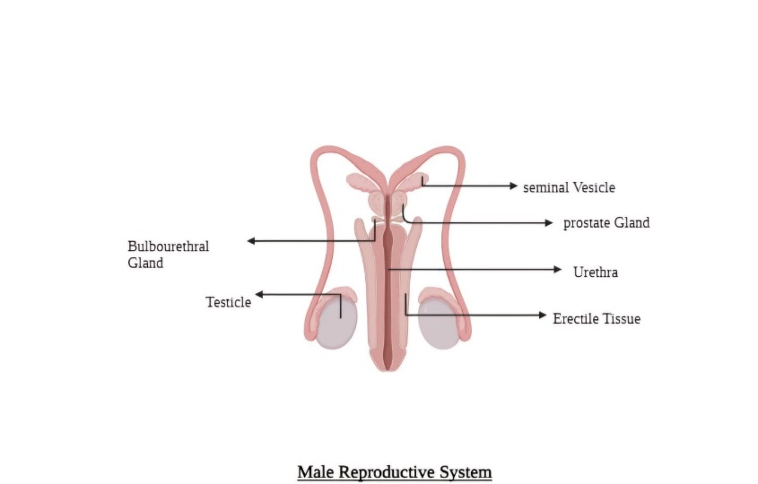

**Top of Form**

**Figure 1: Male Reproductive system**

**Bottom of Form**

**Prevalence:** Prostatitis is a common condition that impacts the prostate gland in the male reproductive system, and its prevalence estimates exhibit considerable variation. The condition arises from diverse causes, encompassing both infectious and non-infectious origins. Approximately fifty percent of men encounter prostatitis at some stage in their lives. Its incidence spans about 10-14% of males across all demographics, including those from tribal and folk backgrounds. The most prevalent type among the four forms of prostatitis is chronic prostatitis (CP) or chronic pelvic pain syndrome (CPPS), which constitutes 90-95% of reported cases.

African American males experience disproportionately higher rates of prostate disease. For instance, the occurrence of prostate cancer, a potential cause of prostatitis, is reported at 274.3 per 100,000 men among African Americans, whereas white men have an occurrence rate of 171.2 per 100,000. This indicates that prostate cancer is more prevalent among African American males compared to their white counterparts **(Maitre, 2006).**

Other studies have found that symptomatic prostatitis affects approximately 11% of Europeans. In Canada, where the average age is 50 years, 2.7% of individuals have been diagnosed with prostatitis.

In India, Benign Prostatic Hyperplasia affects about 25% of men aged between 40-49, increases to 37% among those aged 50-59, and remains consistent at 37% for men aged 60-69. More than half of men in these age groups experience symptoms related to BPH. The highest incidence of prostate cancer in India is found in Delhi, where it is reported at 10.2% **(Suresh, 2022)**.

Top of Form

**Classification of prostatitis:** Prostatitis is an inflammation of the prostate gland, that are classified into four main categories **(Krieger et al., 1999)**.

They are:

**Acute Bacterial Prostatitis Known as Category I:**

Acute bacterial prostatitis, caused by specific pathogens, manifests with pelvic and genitourinary pain alongside symptoms affecting the lower urinary tract. These include dysuria, increased urinary frequency, and urinary retention. Additionally, systemic symptoms such as fever, chills, nausea, and malaise may also be present. Although rare, acute bacterial prostatitis typically presents abruptly with signs and symptoms of infection. The likelihood of acute bacterial prostatitis depends significantly on individual patient characteristics and suspicion of complications. Management of acute bacterial prostatitis involves selecting appropriate broad-spectrum antibiotics with good penetration into prostate tissue, as well as addressing any complications or sequelae that may arise from the disease. In cases of urinary retention associated with acute bacterial prostatitis, consideration should be given to urology consultation for potential placement of a suprapubic catheter **(Wolfe et al., 2018)**

**Chronic Bacterial Prostatis Known as category II:**

Chronic bacterial prostatitis involves persistent or recurrent infections of the prostate, leading to genitourinary pain and lower urinary tract symptoms. This condition lasts for three months or more and is generally more severe and damaging compared to acute bacterial prostatitis. Infections can occur via ascending routes from the urethra to the prostate, or through hematogenous or lymphogenous spread from other parts of the body**.** Chronic bacterial prostatitis often goes unrecognized until a man experiences recurrent urinary tract infections. Risk factors are similar to those for acute bacterial prostatitis. Factors such as instrumentation of the lower urinary tract, like catheterization or endoscopy, can facilitate bacterial growth or lead to urethral strictures, allowing bacteria-laden urine to enter the prostatic ducts from the urethra. Continuous isolation of the same bacterial species with identical sensitivity patterns in urine cultures is considered diagnostic for chronic bacterial prostatitis **(Davis and Silberman, 2019)**

**Chronic Prostatitis / Chronic Pelvic Pain Symdroms Known as Category III :**

Chronic Prostatitis/Chronic Pelvic Pain Syndromes (CP/CPPS), formerly known as chronic non-bacterial prostatitis, is characterized by persistent pelvic pain and lower urinary tract symptoms (LUTS) in the absence of confirmed bacterial infection.

CP/CPPS is classified into two categories based on the presence of inflammatory cells in expressed prostatic secretion (EPS): category IIIA (inflammatory) and category IIIB (noninflammatory). However, this distinction is purely descriptive, as white blood cell (WBC) counts do not consistently correlate with symptoms or the presence or absence of infection.

Patients with chronic prostatitis commonly report associated LUTS. One study have highlighted that voiding dysfunction confirmed by urodynamic studies is often misattributed to prostatitis. Therefore, clinicians now consider these urodynamic abnormalities as integral components of the more comprehensive and refined diagnosis of CPPS **(Maitre, 2006).**

**Asymptomatic Inflammatory Prostatitis Known as Category IV:**

Asymptomatic Inflammatory Prostatitis involves painless inflammation of the prostate gland without any signs of infection, distinguishing it from other forms of prostatitis like chronic bacterial prostatitis, acute bacterial prostatitis, and chronic pelvic pain syndrome (CPPS), which typically manifest with pelvic pain or clear evidence of infection **(Holt et al., 2016)**.

This condition is frequently identified in adult men with benign prostatic hyperplasia. Diagnosis of asymptomatic prostatitis, categorized as NIH type IV, is confirmed when inflammatory cells are detected on prostate biopsy or when leukocytes are found in semen analysis conducted during urological evaluations for unrelated reasons **(Nickel et al., 1999)**. The clinical significance of asymptomatic inflammatory prostatitis remains uncertain, and treatment approaches generally focus on managing the primary indication for the urological assessment.

**Aetiology:** The causes of prostatitis vary depending on the type of condition.

Acute bacterial prostatitis typically results from bacterial infection entering the prostate gland through the urethra or via vesicoureteral reflux, where urine flows backward from the bladder. Approximately 80% of cases involve gram-negative organisms such as Escherichia coli, Enterobacter, Serratia, and Pseudomonas **(Robert et al., 1998)**. Factors contributing to acute bacterial prostatitis include bladder infections, bladder stones, sexually transmitted infections (STIs), urinary catheter use, urinary retention, and urinary tract infections (UTIs) **(Davis and Silberman, 2023)**.

Chronic pelvic pain syndromes (CPPS) and non-bacterial prostatitis may be linked to autoimmune diseases, pelvic floor muscle damage, pelvic nerve irritation or inflammation, and stress **(Davis and Silberman, 2023)**. The precise etiology of these conditions remains unclear but may involve infectious or inflammatory triggers that lead to neurological dysfunction and pelvic floor disturbances **(Robert et al., 1998)**.

**Pathogenesis: Acute Bacterial Prostatitis:** Acute bacterial prostatitis is inflammation of the prostate gland resulting from bacterial infection. Gram-negative bacteria like Escherichia coli, Proteus spp., and Klebsiella spp. are common pathogens associated with this condition. Infections can originate from urethritis, urinary tract infections, or more profound genital infections. Bacteria typically enter the prostate gland via the urethra or through the reflux of infected urine into the prostate ducts. Invasive procedures such as catheterization, cystoscopy, or prostate biopsy can also serve as routes for introducing infections. Furthermore, bacteria may reach the prostate gland through the bladder, bloodstream, or lymphatic system **(Stevermer and Easley, 2020).**

**Chronic Bacterial Prostatitis:** Chronic bacterial prostatitis is a prolonged bacterial infection affecting the prostate gland. Bacteria typically enter through the urethra, although they can also migrate from the bladder through the prostatic ducts. Common pathogens include *E. coli* and gram-positive bacteria like *Staphylococcus aureus* and *Enterococcus faecalis* **(Krieger et al., 1999)**. In certain instances, bacteria may access the prostate gland via hematogenous or lymphatic rout **(Terai et a., 2020**)**. Top of Form**

Bottom of Form**Chronic Pelvic Pain Syndrome / Chronic Prostatitis:** Chronic prostatitis/chronic pelvic pain syndrome (CP/CPPS) manifests with symptoms possibly stemming from immune, neurological, and endocrine system dysfunctions. This syndrome is linked to issues such as hypothalamic-pituitary-adrenal axis dysfunction, neurogenic inflammation, and myofascial pain syndromes. Theories regarding non-bacterial prostatitis propose that the reflux of substances like creatinine, urate, and white blood cells into the prostatic ducts might provoke an inflammatory reaction **(Benson and Smith, 1992).**

**Asymptomatic Prostatitis:** Asymptomatic prostatitis is defined by inflammation in the prostate gland without apparent symptoms. It is often detected during evaluations such as elevated levels of prostate-specific antigen (PSA). The pathogenesis of asymptomatic prostatitis is discerned by the presence of leukocytes in prostatic fluid or tissue **(Sharp et al., 2010)**.

**Symptoms of Different Types of Prostatitis**:

1. **Acute Bacterial Prostatitis:** Acute bacterial prostatitis is a sudden bacterial infection of the prostate gland characterized by **(Coker and Dierfeldt, 2016)**:

* **Irritative Symptoms:** Pain or burning during urination (dysuria), urgent need to urinate, and frequent urination.
* **Obstructive Symptoms:** Weak urine stream, difficulty starting or maintaining urination (hesitancy), and urinary retention.
* Other symptoms may include pain during ejaculation, discomfort in the rectal or perineum area (between scrotum and anus), lower back pain, and sometimes blood in semen (hematospermia).
* Systemic symptoms such as fever (>38°C), chills, malaise, and nausea may also occur.
* Early diagnosis and prompt treatment are crucial for managing acute bacterial prostatitis.

1. **Chronic Bacterial Prostatitis:** Chronic bacterial prostatitis involves recurrent infections of the prostate gland, typically seen in older individuals. Symptoms include **(Majeed and Mustafa, 2023)**:

* Pain or discomfort in the lower abdomen, perineum, and lower back.
* Pain during bowel movements and after ejaculation.
* Presence of blood in urine (hematuria) and a foul smell to the urine.
* Pain or burning sensation during urination, discomfort in the prostate region, testicles, and penis.
* Weak urine stream, urgent need to urinate, and discomfort or pain in the prostate area.
* Medical diagnosis and ongoing treatment are necessary to manage chronic bacterial prostatitis symptoms.

1. **Chronic Pelvic Pain Syndrome or Chronic Prostatitis :** CPPS, also known as chronic non-bacterial prostatitis, is the most common form of prostatitis. Symptoms include **(Rees et al., 2015)** :

* Chronic pelvic pain lasting three months or longer, not attributable to bacterial infection.
* Pain in the lower abdomen, perineum, and lower back.
* Pain in the penis, testicles, and rectum, exacerbated during ejaculation and sitting.
* Frequent urination, erectile dysfunction, pain or burning sensation during urination (dysuria), and urgent need to urinate.
* Hesitancy in urination and presence of blood in semen.
* Psychological effects such as depression, anxiety, fatigue, and lack of energy are common.
* Proper diagnosis and management by healthcare providers are essential due to the impact on quality of life.

1. **Asymptomatic Prostatitis:** Asymptomatic prostatitis refers to inflammation of the prostate gland without noticeable symptoms, often discovered incidentally during evaluation for other medical issues **(figure 2)**. Key points include **(Engelhardt et al., 2015)**:

* No pain or discomfort in the pelvic, lower abdomen, or genital areas.
* Absence of urinary symptoms such as frequent urination or urgency.
* Presence of white blood cells in prostate fluid, urine, or semen samples obtained for other medical tests.
* Elevated prostate-specific antigen (PSA) levels found during routine blood tests or detected during prostate biopsy.

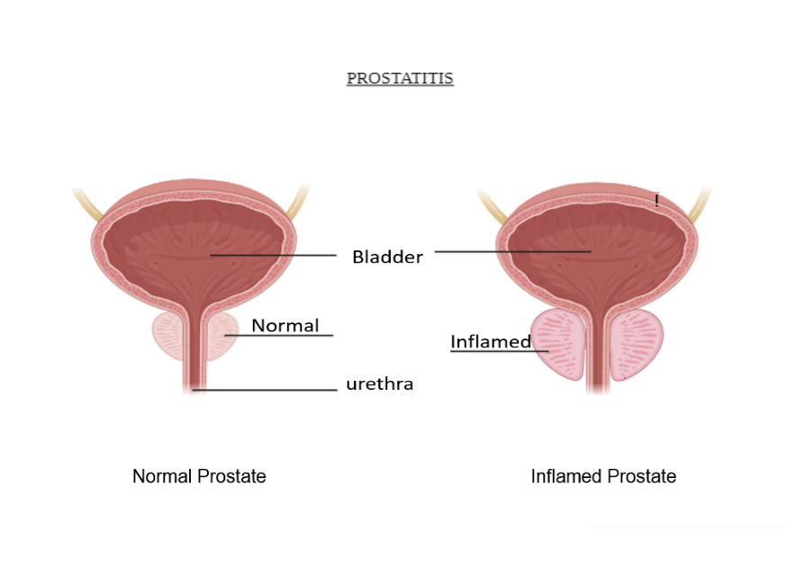

**Figure 2: Inflammation of prostate gland**

**Health Impact:** Prostatitis significantly affects a patient's daily life, akin to the impact experienced by patients with acute myocardial infarction or unstable angina. As part of assessing the condition, patients are asked questions such as, "If you were to live with your current genitourinary condition for the rest of your life, how would you feel about that?" This query, adapted from the American Urological Association's BPH symptom index, prompts patients to rate their response on a scale from "terrible" to "delighted," providing insight into their condition and its effects **(Bajpayee et al., 2012)**

Prostatitis, while non-cancerous, can lead to elevated levels of Prostate Specific Antigens (PSA) in the bloodstream, similar to the effect seen in prostate cancer. In cases of acute bacterial prostatitis, patients may develop sepsis, a severe and potentially fatal condition characterized by widespread infection throughout the body **(Magri et al., 2018)**.

Prostatitis can lead to various health impacts, including:

* Sexual dysfunction of men
* Urinary problems
* Inflammation in nearby organs of the prostate
* Infertility
* Chronic pain in the pelvic area and genitalia
* Mental health challenges due to discomfort and pain
* Sleeping problems
* Decreased activity levels

**Diagnosis:** Diagnosing prostatitis involves a physical examination, review of medical history, and laboratory tests. Initial steps typically include urinalysis and targeted cultures to rule out infection **(Zabihi et al., 2008).**

Common methods which are used to diagnose prostatitis are –

* **Digital Rectal Exam (DRE):** During this procedure, a doctor inserts a gloved finger into the rectum to assess the prostate gland for any abnormalities.
* **Urinalysis:** This test examines urine for signs of infection, blood, or white blood cells (WBCs).
* **Prostate Specific Antigen (PSA) Test:** This measures the levels of a protein produced by the prostate gland, which can be elevated in cases of prostatitis.
* **Urine Culture:** Conducted to identify bacterial infections present in the urine.
* **Imaging Tests:** Techniques such as ultrasound, CT scan, and MRI scan are utilized to visualize the prostate gland and surrounding tissues.
* **Symptom Assessment**: Doctors inquire about symptoms such as pain, urinary frequency, and discomfort during urination.
* **Physical Examination:** A thorough examination of the genital and rectal areas is performed to evaluate the prostate gland and surrounding structures

The other specific diagnosis tests for prostatitis are:

* **UTI (Urinary Tract Infection):** Urinalysis, urine culture.
* **Benign Prostatic Hyperplasia (BPH):** Digital Rectal Exam (DRE), Prostate Specific Antigen (PSA) test, ultrasound.
* **Prostate Cancer:** PSA test, DRE, Prostate biopsy.
* **Interstitial Cystitis / Bladder Pain Syndrome:** Cystoscopy, Urine culture.
* **Bladder Stones:** Imaging (ultrasound, CT scan)
* **Urethritis:** Urethral swab, Urine Culture.

Diagnosing different types of prostatitis can be challenging for both patients and physicians. Symptoms vary from person to person, and there is significant overlap among the symptoms of various prostatitis types. Treating patients with antibiotics can make it difficult to distinguish between bacterial prostatitis and chronic pelvic pain syndrome (CPPS).

**Treatment for prostatitis:** Treatment for prostatitis depends on its cause and type. Non-bacterial prostatitis may not require specific treatment **(Dickson, 2013)**.

* **Antibiotics**: If prostatitis is caused by a bacterial infection, antibiotics are prescribed to target the specific bacteria. The choice of antibiotic and duration of treatment depend on the severity of symptoms and the results of urine or prostate fluid cultures.
* **Alpha-blockers:** These are prescribed to alleviate obstruction caused by an enlarged prostate, which can contribute to urinary tract infections and prostatitis**.**
* **Nonsteroidal anti-inflammatory drugs (NSAIDs):** NSAIDs are used to reduce pain, inflammation, and fever associated with prostatitis.

Additional treatments may include:

* **Urinary catheterization:** In cases of urinary retention, a flexible tube is inserted into the urethra to facilitate bladder drainage.
* **Prostate massage:** This technique helps in releasing fluid from the prostate ducts.
* **Physical therapy:** Pelvic floor muscle problems can contribute to prostatitis; physical therapy helps in addressing these issues, supporting bladder, bowel, and sexual function.

Other treatment options available include analgesics (pain-relieving medications), anti-infective agents (to prevent infections), anti-inflammatory agents (to reduce inflammation), 5-alpha-reductase inhibitors (used for benign prostatic hyperplasia and male pattern hair loss), and pentosan polysulfate (used for interstitial cystitis symptoms) **(Stamey, 2018).**

**Conclusion:** In conclusion, prostatitis is a complex syndrome that spans from straightforward presentations of acute prostatitis to the intricate array of symptoms in CP-CPPS. Chronic prostatitis is a common condition primarily affecting younger men, characterized by a diverse combination of pain, urinary, and ejaculatory symptoms. Treatment approaches vary depending on the type and severity of the condition and should be tailored to each individual case for effective management and resolution. This disease is linked to various factors including diet, lifestyle, and gastrointestinal or anorectal tract disorders.

**References:**

Bajpayee, P., Kumar, K., Sharma, S., Maurya, N., Kumar, P., Singh, R., & Lal, C. (2012). Prostatitis: prevalence, health impact and quality improvement strategies. *Acta Pol Pharm*, *69*(4), 571-9.

Benson, P. J., & Smith, C. S. (1992). Cytomegalovirus prostatitis. *Urology*, *40*(2), 165-167.

Coker, T. J., & Dierfeldt, D. M. (2016). Acute bacterial prostatitis: diagnosis and management. *American family physician*, *93*(2), 114-120.

Davis, N. G., & Silberman, M. (2019). Bacterial acute prostatitis. *StatPearls [Internet]. Treasure Island (FL): StatPearls Publishing*.

Davis, N. G., & Silberman, M. (2019). Bacterial acute prostatitis. *StatPearls [Internet]. Treasure Island (FL): StatPearls Publishing*.

Dickson, G. (2013). Prostatitis: diagnosis and treatment. *Australian family physician*, *42*(4), 216-219.

Engelhardt, P. F., Seklehner, S., Brustmann, H., Riedl, C., & Lusuardi, L. (2015). Tumor necrosis factor-α expression in patients with obstructive benign prostatic hyperplasia is associated with a higher incidence of asymptomatic inflammatory prostatitis NIH category IV and prostatic calcification. *Scandinavian journal of urology*, *49*(6), 472-478.

Holt, J. D., Garrett, W. A., McCurry, T. K., & Teichman, J. M. (2016). Common questions about chronic prostatitis. *American family physician*, *93*(4), 290-296.

Kasongo Potts, J., & Payne, R. E. (2007). Prostatitis: Infection, neuromuscular disorder, or pain syndrome? Proper patient classification is key. *Cleveland Clinic journal of medicine*, *74*(3), S63.

Krieger, J. N., Nyberg Jr, L., & Nickel, J. C. (1999). NIH consensus definition and classification of prostatitis. *Jama*, *282*(3), 236-237.Thomas A Stamey MD Prostatitis The royal society of medicine January 1981, volume 74

Magri, V., Boltri, M., Cai, T., Colombo, R., Cuzzocrea, S., De Visschere, P., ... & Wagenlehner, F. M. (2018). Multidisciplinary approach to prostatitis. *Archivio Italiano di Urologia e Andrologia*, *90*(4), 227-248.

Maitre, S. (2006). Prostatitis: prevalence, Classification and Treatment. *AMA Journal of Ethics*, *8*(11), 748-751.

Majeed, A. S., & Mustafa, L. A. (2023). Estimated The Level Of Apelin As An Innovative Early Indicator Of Acute Kidney Injury And Its Linear Relationship With B₂-MG, FGF 23, And Egfr In Both Control Groups And Acute Kidney Injury Patients.

Nickel, Downey, & Boag. (1999). Asymptomatic inflammation and/or infection in benign prostatic hyperplasia. *BJU international*, *84*(9), 976-981.

Rees, J., Abrahams, M., Doble, A., Cooper, A., & Prostatitis Expert Reference Group (PERG). (2015). Diagnosis and treatment of chronic bacterial prostatitis and chronic prostatitis/chronic pelvic pain syndrome: a consensus guideline. *BJU international*, *116*(4), 509-525.

Roberts, R. O., Lieber, M. M., Rhodes, T., Girman, C. J., Bostwick, D. G., & Jacobsen, S. J. (1998). Prevalence of a physician-assigned diagnosis of prostatitis: the Olmsted County Study of Urinary Symptoms and Health Status Among Men. *Urology*, *51*(4), 578-584.

Sharp, V. J., Takacs, E. B., & Powell, C. R. (2010). Prostatitis: diagnosis and treatment. *American family physician*, *82*(4), 397-406.

Stamey, T. A. (1980). Pathogenesis and treatment of urinary tract infections. *(No Title)*.

Stevermer, J. J., & Easley, S. K. (2000). Treatment of prostatitis. *American Family Physician*, *61*(10), 3015-3022.

Suresh, K. (2022). Prostate health in India (BPH &Prostate Cancer). *Archives of Cancer Science and Therapy*, *6*(1), 009-017.

Terai, A., Ishitoya, S., Mitsumori, K., & Ogawa, O. (2000). Molecular epidemiological evidence for ascending urethral infection in acute bacterial prostatitis. *The Journal of urology*, *164*(6), 1945-1947.

Victoria J.Sharp MD, Elizabetg B.Takacs MD, Charles R.Powell MD, Prostatitis: Diagnosis and Treatment American family Physician ,Volume 82 August 15,2010

Wolfe, T., Smith, C., & Jacob, R. (2018, January). Acute bacterial prostatitis in an adolescent patient following blunt trauma. In *Baylor University Medical Center Proceedings* (Vol. 31, No. 1, pp. 107-108). Taylor & Francis.

Zabihi, N., Mourtzinos, A., Maher, M. G., Raz, S., & Rodríguez, L. V. (2008). Short-term results of bilateral S2–S4 sacral neuromodulation for the treatment of refractory interstitial cystitis, painful baldder syndrome, and chronic pelvic pain. *International Urogynecology Journal*, *19*, 553-557.