Review of Artificial Intelligence based concept of Automated planning

Prof. Daljeet Kaur

Department of Computer Science & Engineering

Gyan Ganga College of Technology

Jabalpur (MP), India

daljeetkaur@ggct.co.in

ABSTRACT

New advances in computerized planning are enabling planners to solve real-world challenges in addition to toy ones. It is far from easy to apply automated planners to real-world issues, nevertheless. One the one hand, there is still a barrier in the definition of precise action models for planning. Conversely, off-the-shelf planners fall short in many sectors in terms of scaling up and producing good solutions. Planners can use domain-specific control knowledge in these troublesome domains to increase the pace and quality of their solutions. On the other hand, control knowledge definition by hand is highly challenging. This research examines state-of-the-art machine learning methods for automatically defining planning knowledge. It is arranged in accordance with the learning process's objective: automated planning definition

Keywords— Information, Data Science, Data Analytics.

# INTRODUCTION

Artificial intelligence (AI) has emerged to relieve humans of repetitive duties at work that necessitate human competencies for successful completion. Scientists are no different; in order to expedite their discoveries, they too require strong computational approaches. In this regard, launching a new study frequently entails a thorough examination of pertinent scientific literature in order to comprehend the background and identify pertinent studies dealing with the same or a related issue. In addition, it takes time to search through, filter through, and extract relevant material from a large collection of articles. If this is done without guidance or experience, it is possible to overlook significant contributions. Finding a series of steps to achieve one or more objectives is the process of planning. Computation is used in automated planning to help human operators make decisions or to control automated systems. When it comes to handling the intricacy of managing resource-intensive systems, automated planning exhibits considerable promise. In the area of automated planning, various techniques have been developed that can be applied to determine the best course of action given objectives and a set of circumstances. But on their own, planning algorithms are fragile since circumstances can alter after a plan is created. The majority were created with the assumption of a controlled and predictable environment [1]. Domains that engage with the outside world are even more complex because of this

We now live in a technological age marked by the Fourth Industrial Revolution, or 4IR for short. This revolution is expected to bring about rapid changes in industries, technology, societal norms, and procedures as a result of increased interconnectedness and intelligent automation. This revolution has ramifications for all disciplines, industries, and economies, affecting nearly every industry in every nation and bringing about a significant amount of change at a non-linear rate that has never been seen before. Three essential terms Since the modern world is more dependent on technology than ever before, automation—the reduction of human interaction in operations—intelligent—the capacity to draw conclusions or useful knowledge from data—and smart computing—the ability to monitor, analyze, and report—also known as self-awareness—have emerged as key design principles.

The goal of the large discipline of computer science known as artificial intelligence (AI) is to create intelligent machines that are able to carry out tasks that traditionally require human intelligence. Or, to put it another way, its goal is to imbue computers with human-like intelligence by enabling them to study and reason like computers do through computer programs or machine learning. Philosophically speaking, artificial intelligence (AI) has the promise of managing the vast network of interconnected people, companies, states, and nations in a way that is advantageous to all, as well as helping people live more fulfilling lives with less effort. Therefore, the main objective of AI is to make computers and other devices capable of cognitive tasks like

In AI, planning is the process of devising a set of steps or protocols to achieve a specific objective. It comprises evaluating the current state of affairs, determining the desired result, and formulating a plan that outlines the necessary actions to reach that goal. It can be utilized in robots, video games, logistics, and the medical field, among other industries.

As figure 1 illustrates, there are various forms of AI planning, each appropriate for a certain circumstance. Popular varieties of AI planning include:

• Classical Planning: In this kind of planning, a sequence of steps is designed to achieve a goal in a prearranged environment. Everything is taken to be unchanging and predictable.

• Hierarchical planning: Planning becomes more efficient when big challenges are broken down into smaller ones using hierarchical planning. It is necessary to create a hierarchy of plans, where higher-level plans oversee the implementation of lower-level plans.

• Temporal Planning: Future planning takes into account time constraints and the interdependencies between tasks. It does this by accounting for job length, which guarantees that the plan may be implemented within a given time frame.

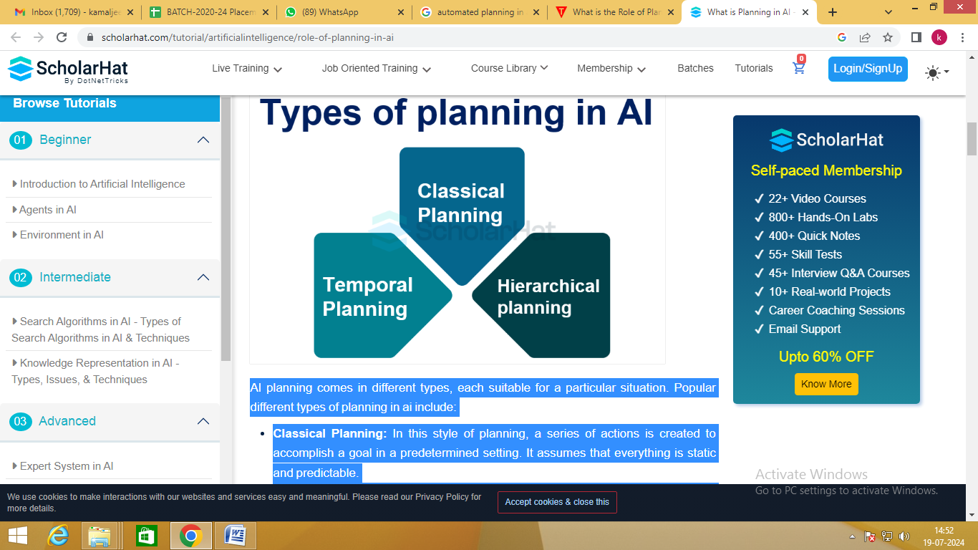

Fig.1 Types of planning

**Components of planning system in AI**

AI planning systems are composed of numerous essential components that work together to create effective plans. These AI planning system components are as follows:

• Representation: Representation is the term used to describe the way the planning problem is represented. It is necessary to specify the state space, actions, goals, and constraints.

• Search: The search component looks throughout the state space for a set of instructions that will lead you to your destination. Many search strategies, such as depth-first search and A* search, can be employed to find the best plans.

• Heuristics: Heuristics help focus search efforts and determine the cost and value of different courses of action. They facilitate the identification of potential routes and improve the efficiency of the planning procedure.

**Benefits of AI Planning**

Artificial intelligence planning has many benefits that increase the effectiveness and efficiency of AI systems. Among the principal advantages are:

• Allocation of Resources: AI planning enables the optimal distribution of resources, guaranteeing their efficient utilization in achieving the intended goals.

• Better Decision-Making: AI planning helps with educated decision-making by accounting for a range of factors and constraints. It aids AI systems in weighing multiple options and selecting the optimal course of action.   
  
• Automation of Complex Tasks: Complex tasks that would need a lot of human labor are automated by AI planning. It enables AI systems to oversee intricate processes and enhance them for superior outcomes.

**Applications of AI Planning**

AI planning's versatility and effectiveness are demonstrated by the wide range of fields in which it is applied. Among the noteworthy applications are:   
• Robotics: Planning is essential for autonomous robots to be able to operate, traverse their environment, and accomplish tasks.  
• Gaming: Because AI planning empowers virtual characters to make deliberate decisions and create challenging and captivating gameplay settings, it is crucial to the gaming industry.   
  
• Logistics: AI planning is frequently used in logistics to optimize schedules, routes, and resource allocation to accomplish successful supply chain management.   
• Healthcare: By scheduling patients, assigning resources, and organizing treatments, AI planning helps the

sector improve the efficacy and quality of healthcare services.

**Challenges in AI Planning**

Despite all of AI planning's benefits, there are still a lot of problems to be fixed. Common difficulties consist of:   
• Complexity: Planning can be challenging in complex domains because of the large state space, numerous potential actions, and interdependencies between them.  
• Uncertainty: Overcoming uncertainty is one of the main obstacles in AI planning. The outcomes of actions may not always be known in advance, so the planning system must be prepared to handle these unclear circumstances.   
• Scalability: As planning issues get larger and more complicated, scalability becomes a major obstacle. Planning systems are necessary for the efficient handling of large-scale concerns.

**Strategies for Mastering AI Planning**

To become an expert at AI planning, you must implement techniques that enhance your planning skills. Here are some tactics to consider:

• Domain Knowledge: Acquire as much knowledge as possible regarding the planning domain. Knowing the intricacies and constraints of the field can help you formulate more effective solutions.

• Algorithm Selection: The appropriate planning algorithm must be selected for the specific problem at hand. Because different algorithms have different advantages and disadvantages, selecting the optimal algorithm can significantly affect the planning process.   
  
• Iterative improvement: Planning is an iterative process, and progress is necessary. Evaluate the success of plans, identify areas for development, and make any required adjustments to the planning system.

**Tools and Techniques for AI Planning**

AI planning can be aided by a variety of planning-supportive techniques and tools. Commonly employed methods and resources include:

• Automatic planners: STRIPS and PDDL are two programs that provide a framework for defining planning problems. They are examples of programs that automatically generate plans.  
• Constraint Programming: Complex planning problems with a range of restrictions can be modeled and resolved with the powerful technique of constraint programming.

• Machine Learning: By learning from past experiences and improving plans in response to feedback, reinforcement learning is a machine learning technology that may be used to improve planning.

**Best Practices of AI Planning**

The following significant elements are included in best practices for AI planning:   
• A clear formulation of the problem: Indicate your objectives, limitations, and intended outcomes clearly.  
• The best possible portrayal Provide a suitable illustration of the planning realm.   
• Algorithm selection: Select planning algorithms that balance optimality and complexity.   
• Iterative improvement: Review and enhance the planning process on a regular basis.   
• Uncertainty management: Use techniques to address uncertainty, such as probabilistic modeling.   
• Making use of human expertise: Get input from others and use it to ensure that your goals align with theirs.

• Benchmarking and evaluation: Monitor performance over time and compare it to relevant metrics.   
• Cooperation: Promote collaborative planning by including relevant partners.   
• Scalability: To successfully address large challenges, design planning systems with scalability in mind.

• Quick response time:

The corporate community has quickly realized AI's promise. Its acceptance has grown quickly and yearly. AI has the ability to bring about revolutionary change as its capabilities grow at an unparalleled rate. Artificial intelligence (AI) technology are being used to automate jobs, analyze massive amounts of data, improve consumer experiences, refine decision-making processes, and open up new avenues for efficiency and growth..

Companies that have already made investments in AI technology typically plan to spend more in the ensuing years. By 2022, 52% of respondents who were currently employing AI reported that the technology accounted for more than 5% of their digital expenditure, up from 40% in 2018. It appears that those who employ AI in some way find it valuable enough to keep investing in it and even raise the percentage of their budget that goes toward it. This seems to be solid evidence in favor of the claim that AI has enormous financial benefits. Artificial Intelligence (AI) has numerous applications, including virtual assistants, computer vision, machine learning (ML), natural language processing (NLP), and data analysis and insights.

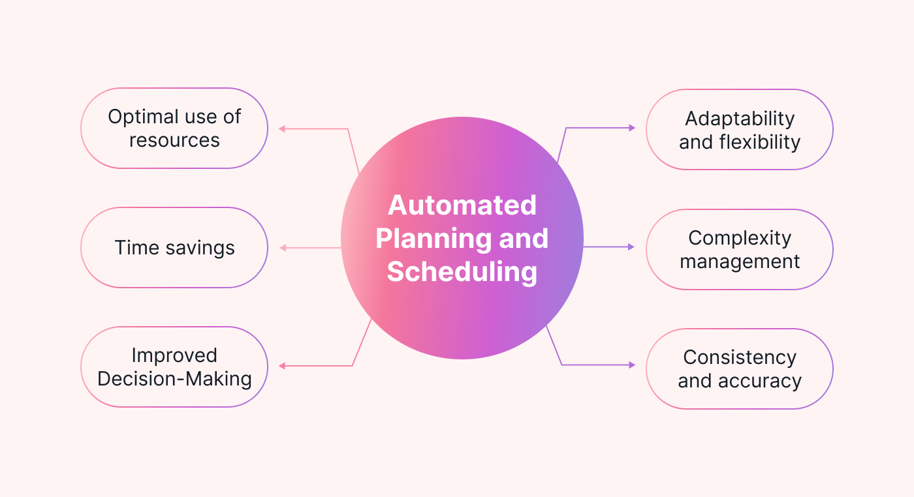

**Figure-2** Automated Planning and Scheduling

# RELATED WORK

The goal of Srihari Maruthi et al. [1] is to outline potential research avenues and offer insights into the level of automated planning and scheduling in AI today. Recent machine learning strategies for the automatic definition of planning knowledge are reviewed by Sergio Jimenez et al. [2]. It has been arranged in accordance with the learning process's objectives, which are the automatic definition of planning control knowledge and planning action models. The goal of Tan Yigitcanlar et al.,[3] is to increase our knowledge of the connections between the major artificial intelligence (AI) technologies (n = 15) and their major urban planning and development application sectors (n = 16). In order to achieve this, this study looks at how the general public views artificial intelligence (AI) technologies and the ways in which they are applied in urban planning and development. The goal of Fouad Amer, S.M.ASCE et al. [6] is to investigate the main problems that have so far prevented automated planning systems and methodologies from being widely used and scaled up. The following knowledge gaps were found after a thorough analysis of the formalization of knowledge, scope quantification and project definition procedures, and planning, scheduling, and schedule optimization techniques. A generic formal framework for automated planning that can model domains, plans, and goals is presented by Alessandro Cimatti et al. [7]. The chapter also covers potential upcoming research problems and the most recent methods in the field. The primary goal of Ilche Georgievski et al.'s [8] classification of the literature is to make those features easier to understand. After that, we conduct a comprehensive analysis of the literature to pinpoint upcoming obstacles in the planning of ubiquitous computing. There are two ways that Matias Rojas et al.[9] add to the body of literature. Firstly, we suggest a new monitoring approach for partial-order plans that is more appropriate for use in learning environments. Secondly, we demonstrate how plan-derived feedback might encourage introspection regarding cooperative problem-solving during a multi-agent exercise. Javier Martinez Silva et al.[10] aims new hierarchical approach to requirement analysis of problems in automated planning

# CASE STUDY OF ARTIFICAL INTELLIGENCE

The field of artificial intelligence that deals with the realization of strategies or action sequences, usually for execution by intelligent agents, autonomous robots, and unmanned vehicles, is known as automated planning and scheduling, or simply AI planning. In contrast to traditional control and classification issues, these challenges have complicated solutions that need to be found and improved in multiple dimensions. Decision theory is also connected to planning. Offline planning is possible in environments that are well-known and have models available. Alternatives can be identified and assessed before implementing. Online strategy revision is frequently necessary in contexts that are dynamic and uncertain. Policies and models need to be modified. Typically, solutions rely on the iterative trial-and-error procedures seen in artificial intelligence. Among these are combinatorial optimization, reinforcement learning, and dynamic programming. languages employed

Self-driving automobile technology is one of the most interesting uses of AI's automated planning and scheduling capabilities. Automated planning and scheduling is a crucial piece of technology that will allow self-driving cars to function safely and effectively. These vehicles have the potential to completely transform transportation. Additional possible uses for AI's automatic scheduling and planning include: Package delivery drones that operate on their own; hospital and assisted living robots; intelligent traffic control systems There are many advantages to automated scheduling and planning. We can free up human time and resources for other duties and even improve our lives by automating the planning and scheduling process.

Artificial intelligence (AI) planning and forecasting is the application of AI to create independent, scientific predictions about the future. AI planning systems forecast future developments for a wide range of industries, including manufacturing, sales, healthcare, and financial services, using time series data. A burgeoning field of study and application in computer science and artificial intelligence (AI) is automated planning. The following are some relevant publications and noteworthy advancements in automated planning: as depicted in picture 3.

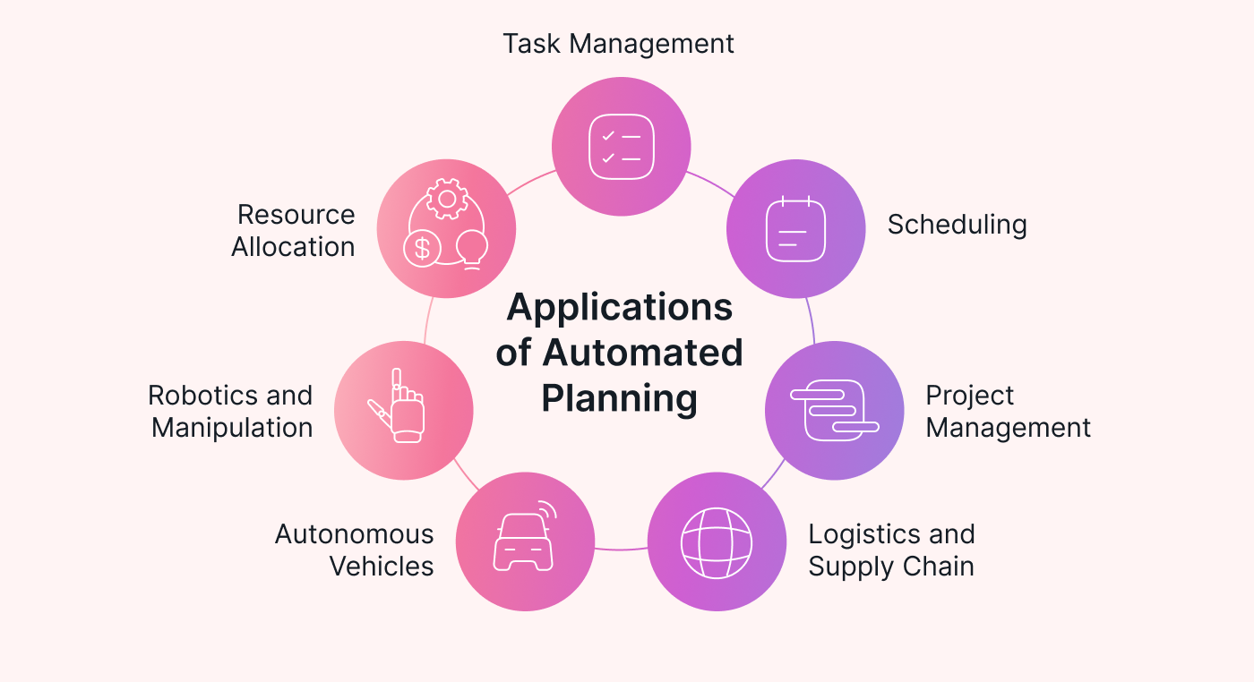

**Figure-3** Application of Automated Planning

1. STRIPS (the problem solver from Stanford Research Institute): STRIPS, a formalism for modeling planning problems using states, actions, and goals, was developed in the late 1960s. It established the groundwork for further automated planning research.

2. Planning domains and challenges can be described using PDDL (Planning Domain Definition Language), which is a standard language that enables practitioners and scholars to communicate and codify planning activities. It is now a commonly accepted benchmark in the planning industry.

3. Classical Planning: This method of planning is based on deterministic settings with predictable results for activities. Various algorithms, such as heuristic search, graph-based planners (like Graphplan), and A* search, have been created to identify the best or almost best plans.

4. Temporal Planning: Adding time limits and temporal linkages between actions, temporal planning goes beyond classical planning. Plans that adhere to temporal constraints are created using strategies like constraint-based reasoning and temporal logic.

5. Hierarchical Planning: By breaking down high-level objectives into smaller, more manageable subgoals, hierarchical planning enables the organization of actions into hierarchical structures for more effective planning.   
  
6. Planning under Uncertainty: Planning under uncertainty refers to situations in which decisions may be made based on probabilities or in which only a portion of the world's state is known. In these situations, methods like partially observable Markov decision processes (POMDPs) and Markov decision processes (MDPs) are employed.  
  
7. Robotics Applications: Autonomous robots need automated planning to carry out activities including navigation, manipulation, and work scheduling. It lets robots to program actions to accomplish objectives in unpredictable and changing surroundings.

8. Real-time Planning: This refers to situations in which plans must be made and promptly modified in response to fresh information or conditions that change. In these situations, strategies like preplanning and online planning are used.

9. Integrated Task and Motion Planning: In order to empower robots to carry out intricate activities involving both symbolic reasoning and actual physical contact with the environment, this field focuses on fusing high-level task planning with low-level motion planning.   
  
10. Multi-Agent Planning: This technique involves arranging the activities of several independent agents in order to maximize group performance or accomplish shared objectives. It entails dealing with issues including agent coordination, bargaining, and communication.  
  
  
These fields reflect current research initiatives aiming at improving automated planning systems' capacities and making them more reliable, flexible, and effective in resolving real-world issues in a variety of fields.

### **Understanding Various Types of Artificial Intelligence**

The main goals of artificial intelligence (AI) are to understand and do intelligent tasks including thinking, learning new skills, and adjusting to novel situations and difficulties. Thus, artificial intelligence (AI) is regarded as a discipline of study and engineering that focuses on modeling a variety of problems and tasks related to human intellect. However, creating a useful AI model is a difficult endeavor because of the dynamic nature and diversity of real-world scenarios and data. Thus, in order to comprehend the concept of the power of AI, as illustrated in Fig. 1, we investigate several forms of AI, such as analytical, functional, interactive, textual, and visual, to tackle various problems in today's Fourth Industrial Revolution. We provide a definition of each category's parameters in the following terms.

• **Analytical AI**: Analytics is the general term for the process of finding, deciphering, and conveying significant data patterns. Analytical AI thus seeks to support data-driven decision-making by identifying novel insights, patterns, correlations, or dependencies in data. As a result, it becomes a fundamental component of AI in the context of modern business intelligence, capable of offering insights to an organization and producing ideas or recommendations via its analytical processing power. An analytical AI model can be created using a variety of machine learning and deep learning techniques to address a specific real-world issue. For example, a data-driven analytical model can be used to evaluate business risk.

• **Functional AI**: Because it examines vast amounts of data for patterns and dependencies, functional AI functions similarly to analytical AI. Conversely, functional AI does not provide recommendations; instead, it does tasks. For example, robotics and Internet of Things applications could benefit from a functioning AI model to make quick decisions.

• **Interactive AI:** This type of AI usually makes it possible to automate effective and interactive communication, which is widely used in many facets of daily life, especially in the business world. An interactive AI model, for example, might be helpful in the development of chatbots and intelligent personal assistants. A range of methods, including machine learning, frequent pattern mining, reasoning, and AI heuristic search, can be used to create an interactive AI model.

• **Textual AI**: This refers to text analytics or natural language processing, which gives organizations access to features like machine translation, speech-to-text conversion, text recognition, and content creation. An organization might, for example, utilize textual AI to support an internal corporate knowledge repository and offer pertinent services, such responding to customer inquiries.

• **Visual AI**: This type of AI can usually identify, categorize, and arrange objects in addition to providing insights from photos and videos. As a result, visual AI is a field of computer science that teaches robots to comprehend visual information and images in the same way that people do. In industries like computer vision and augmented reality, this kind of AI is frequently employed.

Every kind of AI, as was previously said, has the ability to offer answers for a range of issues in the actual world. However, a variety of AI techniques and their combinations—discussed briefly in "Potential AI techniques"—such as machine learning, deep learning, advanced analytics, knowledge discovery, reasoning, searching, and pertinent others—can be used to provide solutions while taking into account the target applications. In the realm of AI-powered computing and systems, analytical AI that makes use of machine learning (ML) and deep learning (DL) approaches can be crucial since the majority of real-world problems require advanced analytics to deliver an intelligent and clever solution in accordance with today's needs.

### **The Relation of AI with ML and DL**

These days, intelligent systems or software are commonly referred to by three well-known terms: artificial intelligence (AI), machine learning (ML), and deep learning (DL). Fig. 2 shows where machine learning and deep learning fit within the artificial intelligence space. Fig. 2 shows that DL is a subset of ML, which is a subset of AI. Artificial intellect (AI) generally integrates intellect and human behavior into computers or systems, whereas machine learning (ML) automates the process of developing analytical models by learning from data or experience. Data-driven learning techniques that compute using multi-layer neural networks and processing are also referred to as deep learning. The word "Deep" in the deep learning approach alludes to the idea of multiple levels or stages that data is processed through.

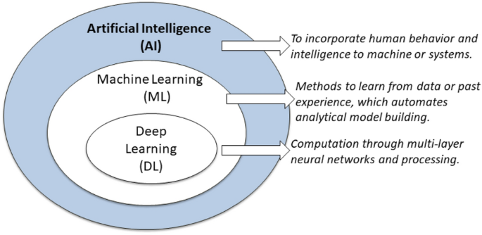

Artificial intelligence and machine learning, which are already the center of our life, will definitely continue to be important in the near future. They enhance everyday technologies, transform entire industries, inspire innovation, find solutions to difficult problems, and allow customization. As AI and ML advance, our world will transform, opening up new possibilities and fundamentally changing how we interact, work, and live. It will be crucial to accept current technology and understand their potential if we are to stay ahead in a world that is changing swiftly and to take use of all the numerous benefits they have to offer.   
Finding a series of steps to achieve one or more objectives is the process of planning. Computational tasks are carried out in automated planning to assist human operators or control automated systems.

# ARTIFICAL INTELLIGENCE APPROACHES

AI's automated planning component is crucial. Using automated planning, a collection of methods that, from a given starting point, will result in a given outcome are created. This branch of AI is essential for problems related to manufacturing, logistics, robotics, gaming, and self-controlled systems.

By accomplishing the objective of a decision-processing technique that can function in a world that is continuously changing, automated planning is a means of generating effective and efficient judgments in complex systems. The essay explores the fundamentals of automated planning as well as its workings, uses, and obstacles.

## **The Essence of Automated Planning**

Automated planning, sometimes known as AI planning or just planning, is based on traditional control and decision-making theories. Fundamentally, it represents the act of identifying an objective and methodically arranging the actions necessary to reach it within specific limitations.

## **Techniques in Automated Planning**

**Important Elements of Automated Planning:**

• Domain Model: Specifies the regulations of the environment and the consequences of activities in that regard. This model is essential to comprehending how deeds alter the state of the universe.   
  
 • Planner: The algorithmic core that generates a plan—a series of steps leading to the objective—after processing input data (the goal and the present state).   
• Executor: carries out the plan, frequently with the ability to adapt instantly to unanticipated changes in the surroundings.   
• Monitor: Keeps an eye on the environment and execution to give the planner feedback and enable dynamic re-planning as needed.

Automated planning techniques can be broadly classified into two categories: deterministic and non-deterministic.

1. ***Deterministic planning*** assumes a predictable environment where every action has a guaranteed outcome, suitable for static or highly controlled environments.
2. ***Non-deterministic (or probabilistic) planning***, on the other hand, deals with uncertainty in action outcomes, requiring more complex algorithms like[Markov decision processes (MDP)](https://www.geeksforgeeks.org/markov-decision-process/) or [Partially Observable Markov Decision Processes (POMDP)](https://www.geeksforgeeks.org/Partially-Observable-Markov-Decision-Process-(POMDP)-in-AI/).

## Automated Planning in AI

Automated planning in AI constitutes a range of constituents and strategies. It involves identifying the problem, constructing the domain model, designing the algorithms to create plans, and implementing these planning systems optimally. Now let us discuss each of these steps in detail.

### **Domain Independent Planning**

Domain independence focuses on development of planning algorithms can be applied to any specific problem domain without a lot of modification. These algorithms build upon a generalized concept that can interpret and analyze various inputs so that it can create efficient plans. This is different from general planning where algorithms are designed for general problems or problems solving spaces.

Domain-independent planning is intended to address the issue of generating a general planning scheme. It includes:

1. **Classical Planning:**Assumes that the environment is determined and the actions that are being taken will yield determined results.
2. **Probabilistic Planning:** Covers the area of managing risks in an environment which may yield multiple outcomes based on the action taken.
3. **Temporal Planning:**Includes the time factors, or where actions are quantified for their duration and various other conditions associated with time.
4. **Hierarchical Planning:** It divides the work into smaller knowable parts that are arranged in a hierarchy.

### **Planning Domain Modeling Languages**

Planning domain modelling languages are formal languages used to describe the components of a planning problem, including actions, states, and goals. These languages provide a structured way to define the parameters and constraints of the planning domain.

Some prominent planning domain modelling languages include:

1. **PDDL (Planning Domain Definition Language):** The most widely used language for describing planning problems. PDDL allows the specification of the initial state, goal state, and actions, including their preconditions and effects.
2. **PPDDL (Probabilistic PDDL):** An extension of PDDL for probabilistic planning. It incorporates probabilities to handle uncertain outcomes of actions.
3. [**HTN (Hierarchical Task Network)**](https://www.geeksforgeeks.org/hierarchical-planning-in-ai/)**:** A planning formalism that breaks down complex tasks into simpler subtasks. HTN is appropriate for hierarchical planning methods.

### **Algorithms for Planning**

Automated planning is centered around the management and creation of algorithms to generate plans. Depending on the kind of planning problem and some other features of the solution these algorithms are different. Key planning algorithms include:

1. **State-Space Search Algorithms:** Some of the considerations made while navigating is the distance from the starting point to a particular position, distance from the goal position to a particular position as well as the movements from the starting position to the goal position. Some of the well-known search algorithms include: the Breadth – First Search (BFS), Depth – First Search (DFS) and the A* search algorithms.
2. **Graph-Based Algorithms:** Model the planning problem on the graph so the vertices stand for the states and the arcs represent the actions. Two highly powerful methods that have been developed are called Planning Graphs and Graph Plan.
3. **SAT-Based Planning:** Transforms the planning problem into the Boolean Satisfiability Problem (also known as the NP complete problem) and then applies SAT solvers to get an answer. This approach takes advantage of current SAT solvers. This approach builds upon some of the efficient current SAT solvers.
4. **Heuristic Search Algorithms: Heuristic** functions should be applied to make the search process easier and to guide if towards the goal. Some examples of the AS code include the GBFS (Greedy Best-First Search) and the FF (Fast Forward) planner.

These algorithms have their own advantage and disadvantage, which determine the appropriateness of utilization of these algorithms, depending on the nature of the planning problem at hand.

### **Deployment of Planning Systems**

Deploying planning systems involves integrating them into real-world applications. This process includes several steps:

1. **Problem Formulation:** Accurately define the planning problem which includes initial states, goal states, and actions to be taken.
2. **Modeling:** Use a suitable planning domain modeling language to represent the problem.
3. **Algorithm Selection:** Based on the characteristics of the problem, choose an appropriate planning algorithm.
4. **Implementation:**Develop the planning system and integrate it into the application environment.
5. **Evaluation and Optimization:** Test the system’s performance, optimize the algorithm, and if necessary, refine the model.

## Example of Automated Planning in Robotics

**In this section, we have demonstrated automated planning in robotics, where a robot navigates through a dynamic environment.**

Automated planning, in this case, involves the following key steps:

1. **Environment Representation**: The grid and obstacles are defined. The `environment` matrix represents the grid as a 10×10 array, with obstacles marked by setting specific cells to 1. This setup gives the planning algorithm information about which areas of the grid are impassable.
2. **Path Planning**: The robot’s path is defined as a series of coordinates. This sequence represents the path that the planning algorithm has determined to be optimal for reaching the goal from the starting point. Each step in the path avoids the obstacles, demonstrating that the planning process considers these barriers when devising the route.
3. **Visualization of the Route**: The path is visually plotted on the grid, showing the trajectory the robot would follow. This not only helps in debugging and optimizing the path but also provides a clear visual representation of the planning outcome.

## **Application of Automated Planning in AI**

Real-world applications of planning systems span various domains:

* **Robotics:**These algorithms help self-driven machines move around while carrying out tasks in changing surroundings.
* **Logistics:** Planning is essential for automated systems to come up with the best routes as well as schedules for transport and delivery.
* **Manufacturing:** They can also be applied in industries where they are used to make production processes more efficient thus minimizing on time wastage.
* **Game AI:**In the world of gaming, non-player characters (NPCs) tend to be more intelligent and active due to enhanced behavior brought about by planning software.

# CONCLUSION

##### One of the key facets of AI's knowledge representation and reasoning is automated planning, which enables machines to handle a variety of challenging problems on their own and make sufficient judgments. Specifically, when used properly, AI systems can attempt to handle a variety of problems by utilizing the fundamentals of domain-independent planning, modeling languages, powerful algorithms, and optimal deployment techniques. Furthermore, we can see that research and development in this area is continually advancing, which means that automated planning's capabilities and possible applications will only expand and advance, spurring innovation across a range of industries. One of the key facets of AI's knowledge representation and reasoning is automated planning, which enables machines to handle a variety of challenging problems on their own and make sufficient judgments. Specifically, when used properly, AI systems can attempt to handle a variety of problems by utilizing the fundamentals of domain-independent planning, modeling languages, powerful algorithms, and optimal deployment techniques. Furthermore, we can see that research and development in this area is continually advancing, which means that automated planning's capabilities and possible applications will only expand and advance, spurring innovation across a range of industries. Manufacturing automation serves as an example of how AI-driven methods can completely transform conventional production planning procedures. Manufacturing organizations can boost their competitiveness, create notable operational gains, and

##### REFERENCES

[1]. Srihari Maruthi et al. " Automated Planning and Scheduling in AI: Studying automated planning and scheduling techniques for efficient decision-making in artificial intelligence", [Vol. 2 No. 2 (2022): African Journal of Artificial Intelligence and Sustainable Development](https://africansciencegroup.com/index.php/AJAISD/issue/view/4).

[2]. [Sergio Jimenez](https://www.researchgate.net/scientific-contributions/Sergio-Jimenez-71057107?_tp=eyJjb250ZXh0Ijp7ImZpcnN0UGFnZSI6InB1YmxpY2F0aW9uIiwicGFnZSI6InB1YmxpY2F0aW9uIn19) et al. "A review of machine learning for automated planning", DOI:[10.1017/S026988891200001X](http://dx.doi.org/10.1017/S026988891200001X), December 2012 The Knowledge Engineering Review 27(04)

[3]  Tan Yigitcanlar et al.,"Artificial Intelligence Technologies and Related Urban Planning and Development Concepts: How Are They Perceived and Utilized in Australia?", *J. Open Innov. Technol. Mark. Complex.* 2020, *6*(4), 187; <https://doi.org/10.3390/joitmc6040187>

[4] [Erez Karpas](https://www.annualreviews.org/search?value1=Erez+Karpas&option1=author&noRedirect=true) et al. "Automated Planning for Robotics", Vol. 3:417-439 (Volume publication date May 2020) <https://doi.org/10.1146/annurev-control-082619-100135>

[5] [Andrea Marrella](https://link.springer.com/article/10.1007/s13740-018-0096-0#auth-Andrea-Marrella-Aff1), "Automated Planning for Business Process Management",  [Journal on Data Semantics](https://link.springer.com/journal/13740), Volume 8, pages 79–98, (2019).

[6]  [Fouad Amer, S.M.ASCE](https://ascelibrary.org/doi/abs/10.1061/%28ASCE%29CO.1943-7862.0002093#con1) et al. "Automated Methods and Systems for Construction Planning and Scheduling: Critical Review of Three Decades of Research", Journal of Construction Engineering and Management, Volume 147, Issue <https://doi.org/10.1061/(ASCE)CO.1943-7862.0002093>.

**[**7] Alessandro Cimatti, et al. "Automated Planning",[Foundations of Artificial Intelligence](https://www.sciencedirect.com/bookseries/foundations-of-artificial-intelligence), [Volume 3](https://www.sciencedirect.com/bookseries/foundations-of-artificial-intelligence/vol/3/suppl/C), 2008, Pages 841-867, <https://doi.org/10.1016/S1574-6526(07)03022-2>.

[8] [Ilche Georgievski](https://dl.acm.org/doi/abs/10.1145/3004294), et al.," Automated Planning for Ubiquitous Computing", [ACM Computing Surveys (CSUR), Volume 49, Issue 4](https://dl.acm.org/toc/csur/2017/49/4), Article No.: 63, Pages 1 - 46, <https://doi.org/10.1145/3004294>

[9] [Matias Rojas](https://link.springer.com/article/10.1007/s40593-022-00321-2#auth-Matias-Rojas-Aff1-Aff2) et al. , "Using Automated Planning to Provide Feedback during Collaborative Problem-Solving", Volume 33, pages 1057–1091, (2023), Published: 01 December 2022.

[10] Javier Martinez Silva et al., "A new hierarchical approach to requirement analysis of problems in automated planning",Engineering Application of AI, [Volume 81](https://www.sciencedirect.com/journal/engineering-applications-of-artificial-intelligence/vol/81/suppl/C), May 2019, Pages 373-386, <https://doi.org/10.1016/j.engappai.2019.02.019>