Essentials of Dielectric Materials and their Applications

C. Thirmal^{a*}, L. Srinivasa Rao^{a,}, N. Suresh Kumarª, M. Sumithraª
ªCentre for Nanoscience and Technology,
Humanities and Sciences Department (Physics),
VNR Vignana Jyothi Institute of Engineering and Technology,
Hyderabad-500090, India.
*Corresponding author:
thiruphysics03@gmail.com thirmal_ch@vnrvjiet.in

Giriprasad Ambati^{b,}
Department of Electrical and Electronics Engineering,
VNR Vignana Jyothi Institute of Engineering and Technology,
Hyderabad-500090, India.

ABSTRACT
The properties of dielectric materials with their origin were explained. The various types of polarization mechanisms with their frequency dependance were also described. The dielectric measurement principles, the data representation and basics of equivalent circuit analysis was elaborated. Finally, the various functional dielectric materials such as piezoelectric, pyroelectrics and ferroelectrics were briefly discussed along with their appropriate applications. Overall, the present chapter on dielectrics gives the reader a basic understanding of dielectrics, related measurements and their applications.

Keywords: Dielectrics, impedance, piezoelectric, pyroelectrics, ferroelectrics.

- INTRODUCTION

The materials which oppose the flow of charge through them are known as electrical insulators. Some of the insulators show an extra and important property known as polarization. The insulating materials which can be polarized as a result of applied electric fields are known as dielectric materials. The charges present in the dielectric materials get separated and produce dipole moments. The net dipole moment measured for per unit volume of the material is known as polarization. The dielectric materials show different types of polarizations based on their constituent atoms/ions/molecules and their crystal structure.

- TYPES OF POLARIZATION

i. Electronic Polarization: The electronic cloud of an atom gets displaced relative to the nucleus due to applied electric field. This results in the formation of the electric dipoles in the atom. These electronic dipoles will be aligned in the direction of the applied field. The net electronic dipole moment per unit volume is referred as electronic polarization.
ii. Ionic Polarization: The ionic solids exhibit the relative displacement of the positively and negatively charged ions. The net dipole moment obtained per unit volume in the ionic solids is known as ionic polarization.
iii. Dipolar or orientational polarization: The materials with permanent molecular dipoles or complex ions with permanent dipoles exhibit the dipolar polarization. Absence of the electric field results the dipoles orient randomly, whereas they can be oriented in a particular direction by applying electric field. However, the thermal energy randomizes these dipoles. Hence, dipolar polarization is observed to be temperature dependent.
iv. Space charge polarization: At the time of the materials synthesis, they may contain additional charges formed due to various reasons such as dangling bonds or impurities or defects in the solids. These charges can accumulate at the electrode interface or across the grain boundary within the crystalline materials and produce a net dipole moment per unit volume in an electric field. The resulting polarization is known as space charge polarization.
The materials which have only electronic polarization are known as non-polar dielectrics, whereas if the material has electronic and ionic polarization they are called as polar dielectrics and if the material has electronic, ionic, and orientational polarization are known as dipolar dielectric materials. In general, dielectric materials are amorphous or polycrystalline solids, hence they always possess the space charge polarization.
The polarization is responsible for the dielectric behavior of the material. The dielectric materials are characterized by the dielectric function $ɛ(ω)$ and it is complex in nature. The dielectric function can be written as $ɛ\left(ω\right)=ɛ'\left(ω\right)-ɛ''(ω)$. The respective contributions to the polarization can be understood from its frequency dependance [1-3]. The polarization contribution decreases as the frequency increases as the dipoles do not follow the frequency as it increases. Hence, the same trend is seen in the dielectric properties. The dielectric constant or relative permittivity $ɛ'(ω)$ can be obtained from real part whereas dielectric loss $ɛ''(ω)$ can be understood from the imaginary part of the dielectric function. The frequency response of the real and imaginary parts of a given dielectric material shown in Fig. 1. It is observed that the contribution from space charge polarization decreases initially, then dipolar, followed by ionic polarization as we increase the frequency to 10¹⁵ Hz.
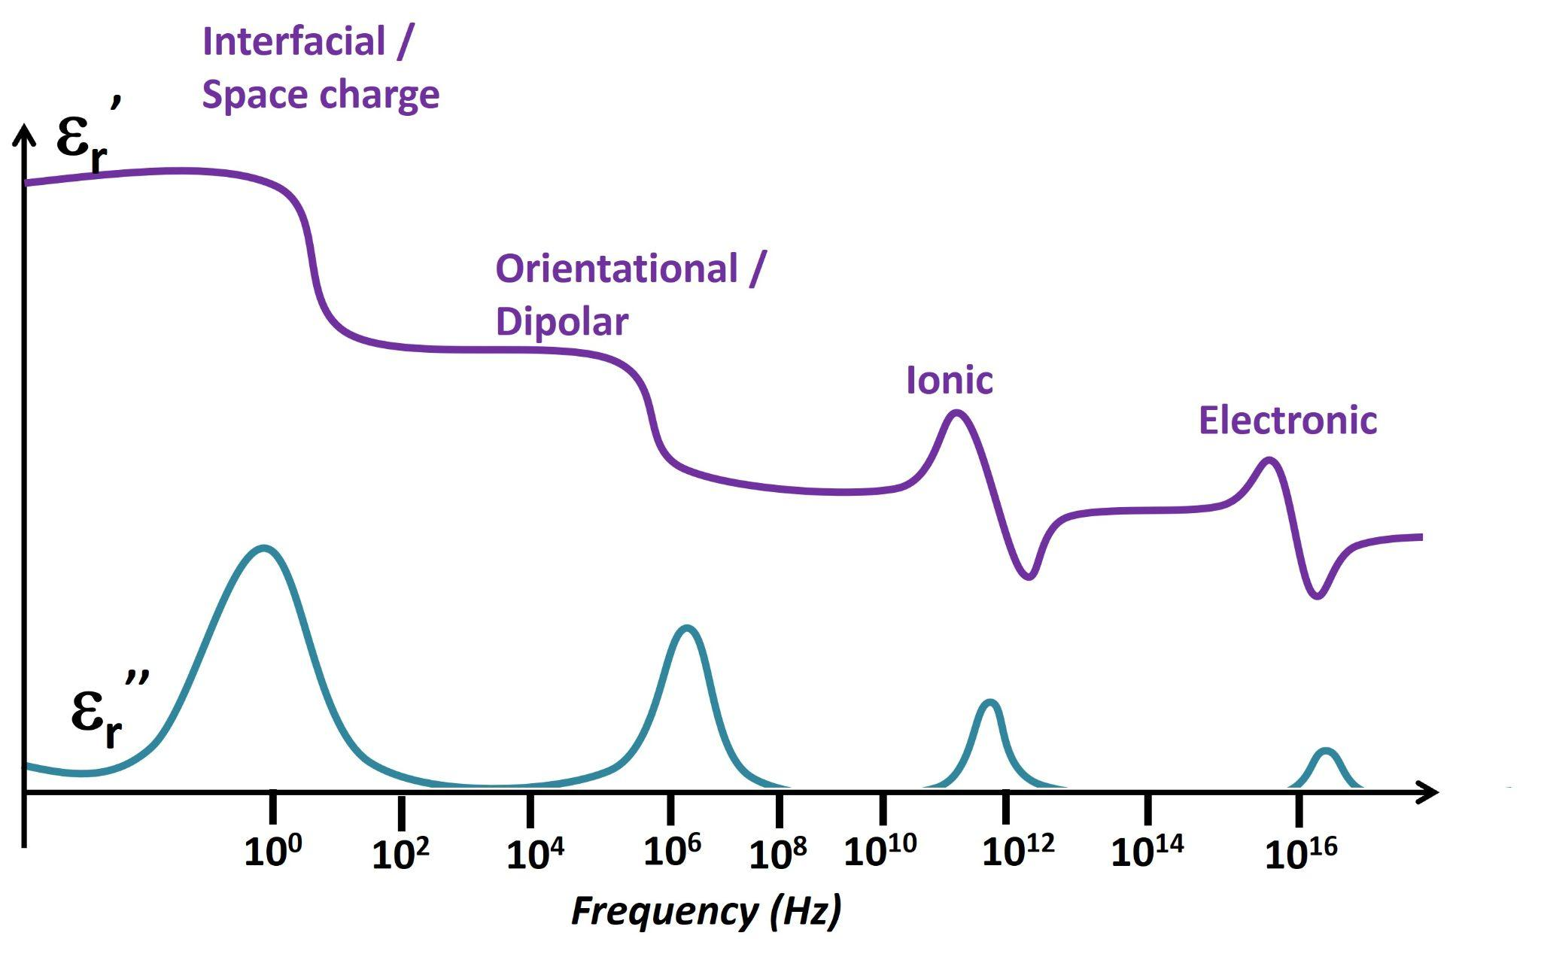
Fig.1. Frequency dependance of dielectric properties.

- CHARACTERIZATION OF DIELECTRIC MATERIALS

The measurement of dielectric constant of polycrystalline solids in the frequency region of 1 Hz to 1 MHz uses a capacitor structure. In general, polycrystalline materials are pressed into pellets and sintered to get the maximum density. Then, for better contact between the sample and electrodes, the pellet is coated with metals like Au, Ag on both sides. A sinusoidal voltage is applied across the sample and the resulting sinusoidal current through the sample is measured [4-6]. It is expected that the applied voltage and measured currents are not in phase, hence the respective phase difference is also measured. Generally, LCR meters or impedance analyzers are built for the measurement of dielectric properties.
Consider the applied voltage is $V=V_{0} \sin{(ωt)}$ and the measured current is $I=I_{0} \sin{(ωt+θ)}$. By these input and response functions, the resulted impedance can be derived as $Z(ω)=\frac{V(ω)}{I(ω)}$, and the same for capacitance $Z(ω)=\frac{1}{jωc}$ and for inductance $Z\left(ω\right)=jωL$. Here, the impedance $Z(ω$) is the complex function and is given by $Z(ω$)= $Z^{'}+jZ^{''},$ where $Z^{'}=\left|z\right|\cos{θ}$ and $Z^{''}=\left|z\right|\sin{θ}$. The impedance data can be represented in various functions such as Admittance (Y), impedance (Z), Modulus (M) and dielectric function $(ɛ)$ [7].
Impedance Spectroscopy: The interpretation of the interfacial or space charge polarization, electrode effects, grain boundary and grain contributions to the impedance requires representation of data in terms of impedance and admittance as
$${Z=Z}^{'}+jZ^{''}$$
and
${{Y=Z}^{-1}=Y}^{'}+jY^{''}$
Dielectric spectroscopy: Dielectric materials show different relaxation mechanisms (Debye or non-Debye or Maxwell-Wagner relaxation), and their understanding requires to represent the data in terms of dielectric constant and electric modulus as
$$M=jωC_{0}Z=M'+jM^{''}$$
and
${{ɛ=M}^{-1}=\frac{Y}{jωC_{0}}=ɛ}^{'}-jɛ^{''}$ [8].
However, for the complete understanding of the dielectric materials, it is important to introduce an equivalent circuit analysis along with impedance and dielectric spectroscopies. The equivalent circuit model helps in the deconvolution of the dielectric properties with respect to the various contributions such as interface, grain and grain boundary related responses. It also helps to understand the relaxation mechanisms related to each contribution individually. The deconvolution of the data can be understood by assigning each contribution to its respective equivalent electrical element. In general, the polycrystalline material is considered by brick layer model as shown in Fig.2, and the respective equivalent circuit is also shown in Fig.3.

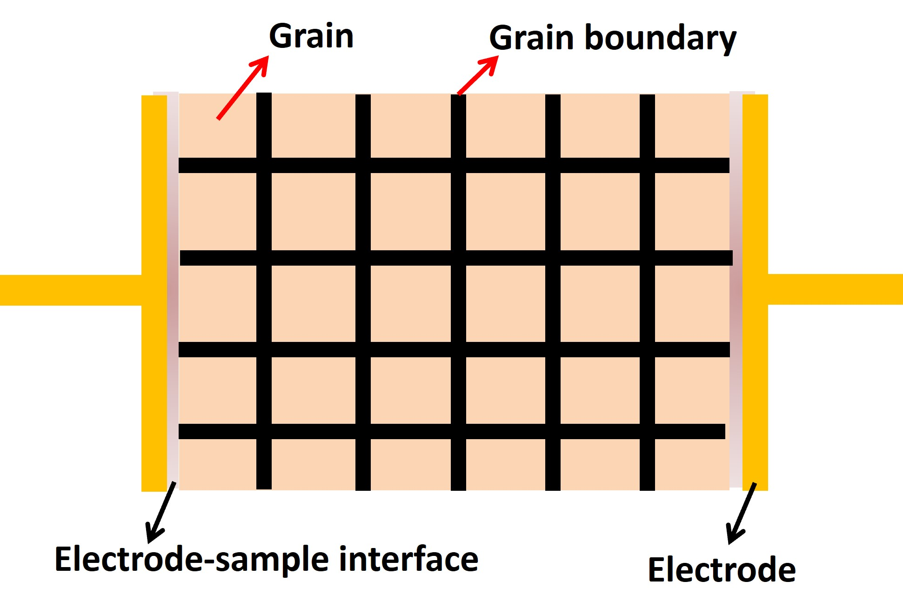
Fig.2. Brick layer model of polycrystalline sample
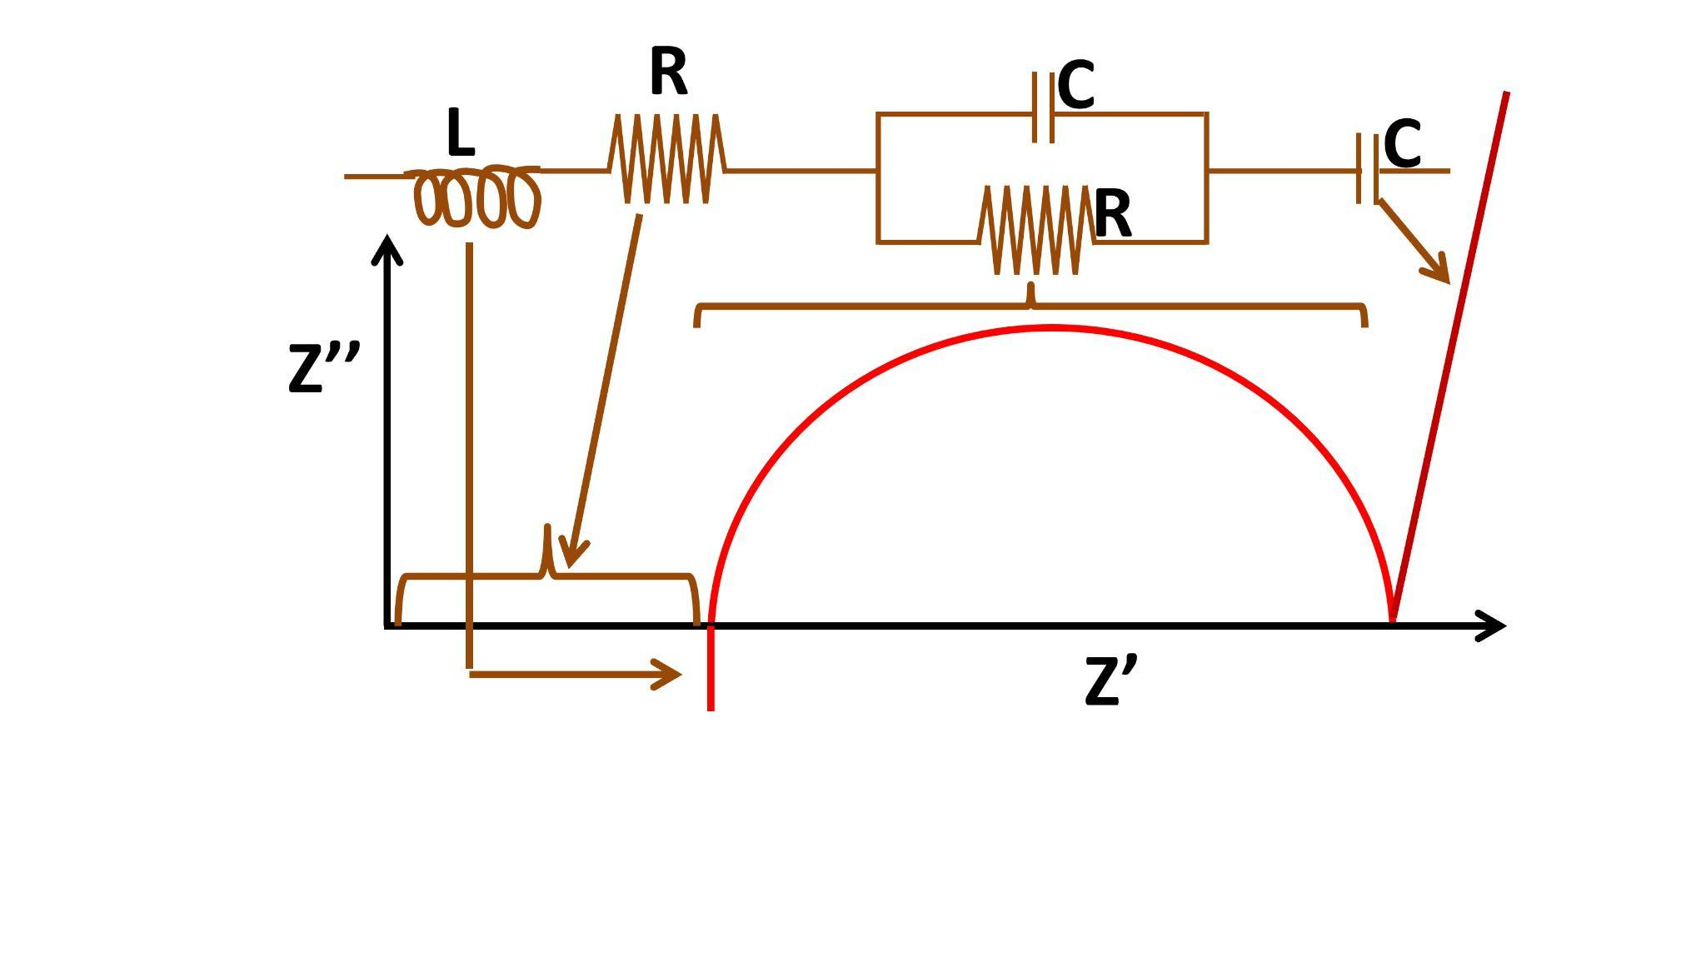
Fig.3. An equivalent circuit showing different electrical elements.

In the circuit, the capacitor (C) represents the sample-electrode interface, the resistor (R) represents the electrode resistance, the inductor (L) represents the inductance of the wires. The grain and grain boundary contributions can be modeled with a parallel RC circuit or parallel R-CPE (constant phase element) to represent a distribution of the relaxation times [9].

- FUNCTIONAL DIELECTRIC MATERIALS

The dielectric solids may be amorphous or crystalline in nature. Among the available 32-point groups of crystalline solids, only 21-point groups show non-centro symmetry and 11 show centro-symmetry. Among these non-centro symmetric crystalline structures, 20-point groups show piezoelectric property. Out of 20 piezoelectric crystalline point groups, 10-point groups show pyroelectric property (spontaneously polarized) and even some of these 10 pyroelectric point groups also exhibit ferroelectric property (reversible polarization) [10]. Hence, the dielectric materials are classified as piezoelectrics, pyroelectrics and ferroelectrics, which are important classes of functional materials. The piezoelectric, pyroelectric and ferroelectric materials respond to external stimuli such as mechanical stress, temperature and electric field respectively. The example materials for each class of functional dielectric materials along with the external stimuli are listed in Table.1.

Functional dielectric material | Examples | External stimuli
- Piezoelectric Materials | Quartz, BaTiO₃, PbZr_{1-x}Ti_{x}O₃, PVDF, LiNbO₃, etc. | Mechanical stress
- Pyroelectric Materials | Triglycine sulfate (TGS), LiTaO₃, PbZr_{1-x}Ti_{x}O₃, PVDF, etc. | Temperature, mechanical stress
- Ferroelectric Materials | BaTiO₃, PbZr_{1-x}Ti_{x}O₃, PVDF, etc. | Electric field, Temperature, mechanical stress

Table:1. The classification of functional dielectrics with examples and respective external stimuli.

Ferroelectric materials also show piezoelectric and pyroelectric properties whereas all pyroelectric materials show piezoelectric properties, but all piezoelectric materials do not show pyro and ferroelectric properties and the same is shown in the Fig.4.
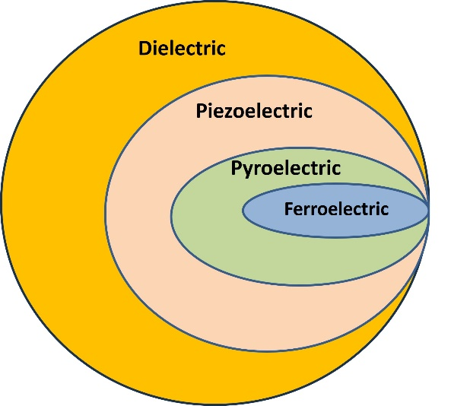

Fig.4. Schematic representation of dielectric, piezoelectric, pyroelectric and ferroelectric materials

- Piezoelectric materials: In direct piezoelectric effect, the non-centrosymmetric crystalline solids produce an overall polarization and hence the voltage upon application of mechanical stress. The converse of the piezoelectric effect is also possible, i.e., application of an appropriate electric field across the piezoelectric crystal will produce a mechanical strain. The strain measured as function of electric field in a piezoelectric material shows a butterfly loop as shown in Fig.5.
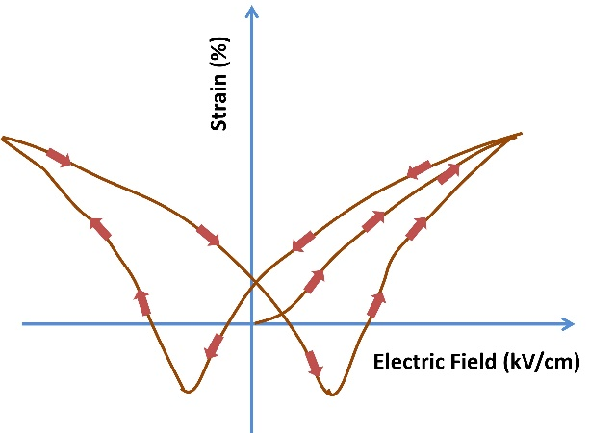
Fig.5. Schematic representation of strain versus electric field (butterfly loop) of a piezoelectric material

- Pyroelectric Materials:
The dielectric materials which have spontaneous polarization show the pyroelectric effect. The change in temperature results in the alteration in the spontaneous polarization. The polarization decreases with increase in temperature in pyroelectric materials. The change polarization results in an internal field which drives pyroelectric current in the material.
- Ferroelectric Materials:
The class of non-centrosymmetric polar dielectric materials, with their spontaneous polarization can be switched reversely by application of the appropriate electric field. The polarization (P) versus electric field (E) shows a hysteresis loop as shown in Fig.6. The spontaneous polarization vanishes above a certain temperature which is known as Curie temperature (T_{C}). Hence, the dielectric constant (ε_{r}) versus temperature curve exhibits an anomaly at T_{c} and it is described by the Curie-Weiss law as,$_{r}=\frac{C}{T-T_{c}}$ , where C is the Curie constant and T_{c} is the Curie–Weiss temperature.
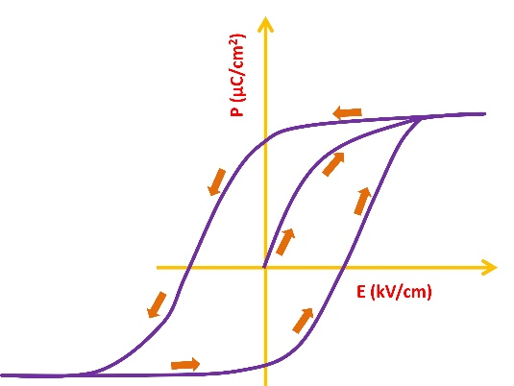
Fig.6. Schematic representation of polarization versus electric field (hysteresis loop) of a ferroelectric material.

- APPLICATIONS OF FUNCTIONAL DIELECTRIC MATERIALS

- The direct piezoelectric effect is used in mechanical sensor and energy harvesting devices whereas, the converse piezoelectric effect is used in actuators and ultrasonicate transducers etc. [11].
- Due to the induced current with change in temperature, the pyroelectric materials are used in IR sensing, IR imaging, power generation etc. [12].
- The switchable polarization and its remanence of ferroelectric materials used in non-volatile memory device applications [13]. The ferroelectric material with suitable composition shows high dielectric constant with high break down voltage and hence they are also used capacitor applications [14]. Some of the transparent ferroelectric materials also realized their applications in electro-optic devices [15].
- The dielectric ceramic materials are also used in multi-layer ceramic capacitors where thin layers of ceramic dielectric materials are stacked to produce high values of capacitance [16]
- Dielectric materials with large dielectric constant, minimal dielectric loss and low temperature dependance are extensively used in microwave wireless communication systems [17].
The schematic representation of applications of dielectric materials are shown in Fig.7.

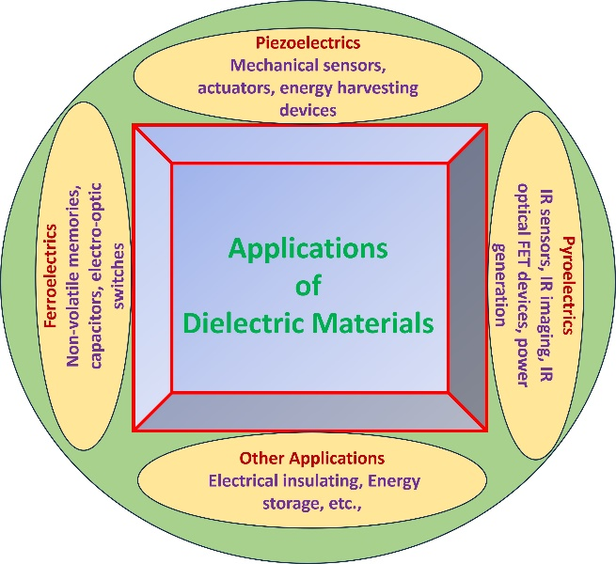
Fig.7. Applications of dielectric materials

- CONCLUSIONS
The present chapter discusses the basic principles of dielectric materials such as origin of polarization and their types. The frequency dependance of the dielectric constant is discussed with respect to the polarization mechanisms. The dielectric measurement principles were discussed for the frequency range of 1 Hz to 1 MHz. The various representations of the dielectric data and their importance were also introduced. The basic principles of equivalent circuit model are given with appropriate schematic diagrams. Finally, the various functional dielectric materials such as piezoelectric, pyroelectric and ferroelectric materials along with their appropriate applications were also discussed.

REFERENCES

- F. kremer, A. Schonhals, Broadband dielectric spectroscopy, Springer Publishers, 2003, P-1-96.
- Y. M. Poplavko, Electronic materials, Ch-7, Elsevier Publishers, 2019, P-287-408.
- A. K. Basin, P. Chand, Pyroelectric materials: Physics and applications, Ch-1, Wiley publishers, 2023, P-1-17.
- K.C. Kao, Dielectric phenomena in solids, Elsevier academic press, 2004, P1-112.
- C. Thirmal, P. Murugavel, V. Subramanian, Impedance spectroscopic analysis of the organic ferroelectric e Diisopropylammonium bromide (DIPAB), Cur. Appl. Phys, 2014, 14, 688-690.
- C. Thirmal, S.D. Ramarao, L. Srinivasa Rao, V. R. K. Murthy, Study of structural, dielectric and AC conductivity properties of SrMoO₄, Mater. Res. Bull. 2022, 146, 111618.
- E. Barsoukov, J. R. Macdonald, Impedance spectroscopy-theory, experiment and applications, A John Wiley and sons,Inc, Publication, 2005, P-1-20.
- M. Hodge, M.D. Ingram and A. R. West, A new method for analyzing the a.c. behavior of polycrystalline solid electrolytes, J. Electroanal. Chem, 1975, 58, 429-432.
- R. Schmidt, ceramic materials research trends, Nova Science Publishers, 2007, P-325-355.
- J. F. Nye, Physical properties of crystals, Oxford university press, 1957, P-123.
- S. D. Mahapatra, P. C. Mohapatra, A. I. Aria, G. Christie, Y. K. Mishra, S. Hofmann, and V. K. Thakur, Adv. Sci. 2021, 8, 2100864.
- D. Zhang, H. Wu, C. R. Bowen, and Y. Yang, Recent Advances in Pyroelectric Materials and Applications, Small 2021, 2103960.
- J. F. Scott, Ferroelectric memories today, Ferroelectrics, 2000, 236(1), 247-258.
- H. Zhu, T. Miyashita, M. Mitsuish, Energy storage behaviors in ferroelectric capacitors fabricated with sub-50 nm poly(vinylidene fluoride) Langmuir–Blodgett nanofilms, Polymer Journal 2019, 51, 795–801.
- A. Hideaki, Mitsuya Tsuneo, Yamazaki Osamu Ferroelectric (Pb,La)(Zr,Ti)O3 epitaxial thin films on sapphire grown by rf-planar magnetron sputtering. J Appl Phys. 1986, 60, 736–741.
- K. Laadjal and A. J. M. Cardoso, Multilayer Ceramic Capacitors: An Overview of Failure Mechanisms, Perspectives, and Challenges, Electronics 2023, 12, 1297.
- R. J. cava, dielectric materials for applications in microwave communications, J. Mater. Chem, 2001, 11,54-62.

