CHAPTER TITLE

Introduction to Cardiovascular System
Ms. Sejal M. Khuman¹, Ms. Jeshika B. Patel² Ms. Morvi M. Raval³, Ms. Saloni S. Desai⁴

Ms. Sejal M. Khuman¹
M.Pharm,
Assistant Professor
Rofel Shri G. Bilakhia College of Pharmacy,
Rajju Shroff Rofel University, Vapi

Ms. Jeshika B. Patel²
M.Pharm,
Assistant Professor
Rofel Shri G. Bilakhia College of Pharmacy,
Rajju Shroff Rofel University, Vapi

Ms. Morvi M. Raval³
M.Pharm, Ph.D*
Assistant Professor
School of Pharmacy
Dr. Subhash University, Junagadh

MS. Saloni S. Desai⁴
M.Pharm, , Ph.D*
Assistant Professor
Rofel Shri G. Bilakhia College of Pharmacy,
Rajju Shroff Rofel University, Vapi

Topic covered

- Introduction
- Anatomy of heart
  - Heart structure and function
    - General introduction
    - Layers of heart
    - Chambers of heart
    - Valves of heart
    - Function of heart
- Cardiac circulation vessels
- Circulation of blood
- Conduction system of heart
- Cardiac Cycle
- Conclusion

ABSTRACT

The cardiovascular system is responsible for supplying and draining blood to all parts of the body. Broadly speaking, the cardiovascular system includes the heart, arterial system, venous system, and an extensive network of microscopic capillaries. The heart is a hollow muscular pump responsible for transporting blood through a network of blood vessels. Arteries carry blood from the heart to the body's tissues. Veins drain blood from the body's tissues and return it to the heart. Capillaries are the smallest blood vessels and serve as connections between the arterial and venous systems. Additionally, blood vessels can be divided based on the area of ​​the body that they supply (or drain) blood. Pulmonary circulation refers to blood vessels that connect to the lungs, and coronary circulation refers to blood vessels that supply blood to the heart muscle itself.This chapter give information about hearts anatomy and physiology.

INTRODUCTION ^{[1,2]}

The human circulatory system is an organ system that transports blood via vessels to and from every area of the body, supplying tissues with nutrients and oxygen while expelling waste products like carbon dioxide. It is a closed tubular system in which the heart muscle pumps blood. Venous, capillary, and arterial components make up the pulmonary and systemic circuits.
The main job of the heart is to pump blood into and out of vessels in all areas of the body like a muscle pump. The thick walls of the arteries, which carry this blood throughout the body at great pressure and velocity, are made of both muscle cells and elastic fibrous tissue.

Anatomy of the Heart

The cardiovascular system can be compared to a muscular pump equipped with one-way valves and a system of large and small plumbing tubes within which the blood travels.

Heart Structure and Functions
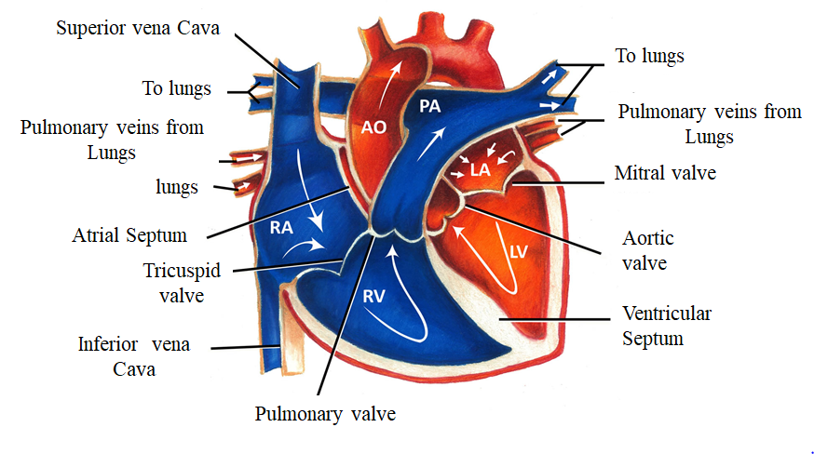
Structure of heart^{[3]}
- The adult human heart is normally slightly larger than a clenched fist.
- With an average mass of 250g for adult females and 300g for adult males, it measures roughly 12 cm (5 in.) long, 9 cm (3.5 in.) wide at its broadest point, and 6 cm (2.5 in.) thick.
- It is located in the mediastinum, an anatomical area that connects the lungs, the first rib to the diaphragm, and the sternum to the vertebral column. The heart's mass is located around two thirds to the left of the body's midline. Four chambers make up the heart. The two inferior pumping chambers are called ventricles, while the two superior receiving chambers are called atria (entrance halls or chambers).

- The pericardium^{[3,4]}

  - The pericardium is the membrane that envelops and shields the heart.
  - The heart is restricted to its location in the mediastinum, yet it still has adequate space to move around to contract rapidly and forcibly.
  - The fibrous pericardium and the serous pericardium are the two primary components of the pericardium. Tough, elastic, thick, uneven connective tissue makes consists the superficial fibrous pericardium.
  - The fibrous pericardium provides protection and keeps the heart from overstretching. A thinner, more sensitive membrane known as the deeper serous pericardium surrounds the heart in a double layer. The outer parietal layer of the serous pericardium is fused to the fibrous pericardium. One of the layers of the heart wall is the epicardium, or inner visceral layer of the serous pericardium, which firmly attaches to the surface of the heart.
  - There is a small layer of lubricating serous fluid between the parietal and visceral layers of the serous pericardium. As the heart beats, a substance known as pericardial fluid reduces friction between the serous pericardium's layers. The pericardial cavity is the area that holds the few milliliters of pericardial fluid.

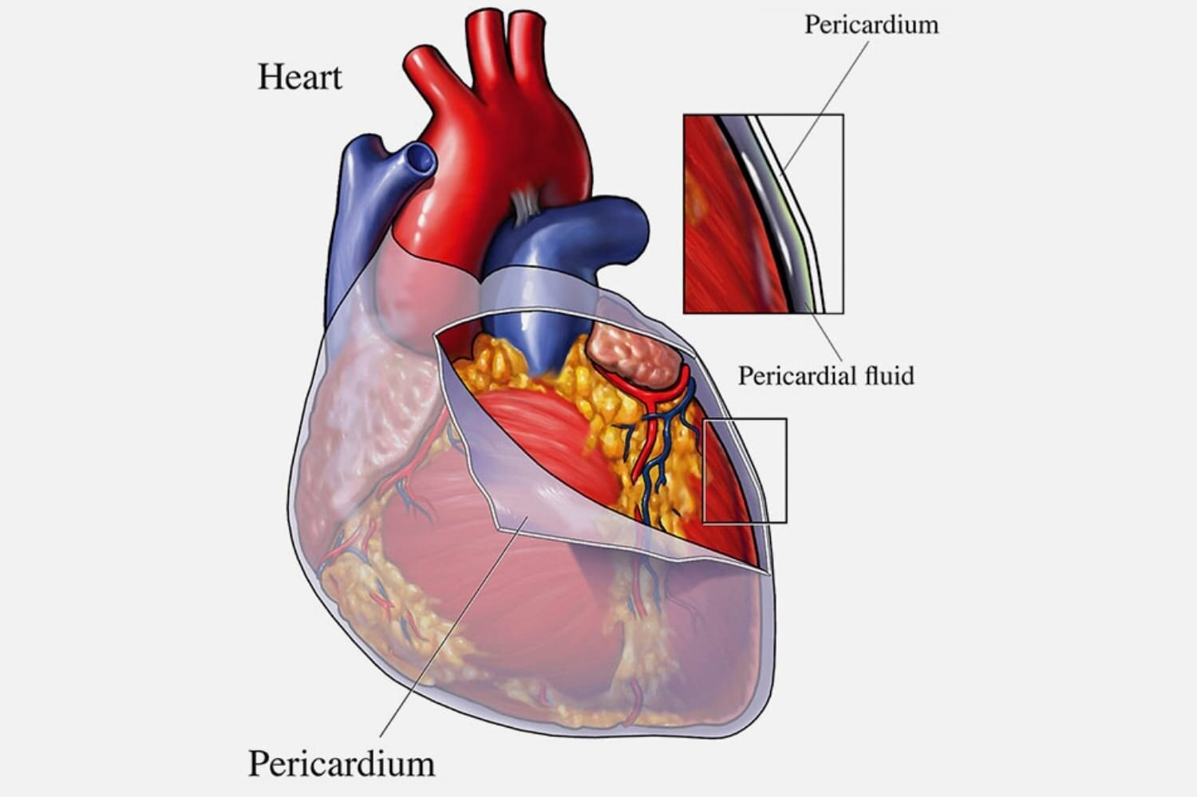

Heart’s pericardium^{[5]}
Layers of the Heart^{[3,4]}

The heart muscle has three layers and they are as follows:
- The epicardium (external layer)
- The myocardium (middle layer), and
- The endocardium (inner layer)

  - The epicardium (external layer)
- The outermost epicardium, the thin, transparent outer layer of the heart wall, is also called the visceral layer of the serous pericardium.
- It gives the external surface of the heart a smooth, sticky texture and is made up of mesothelium and delicate connective tissue.

  - The myocardium (center layer)
- The center myocardium, which is cardiovascular muscle tissue, makes
up around 95% of the heart and is liable for its pumping activity. The cardiac muscle fibers swirl diagonally around the heart in bundles

  - The endocardium (inner layer)
- Consists of a thin layer of endothelium and a thin layer of connective tissue.
- Its primary function is to provide a smooth lining for the heart chambers and to cover the heart valves.
- Additionally, the endocardium is seamlessly connected to the endothelial lining of the major blood vessels connected to the heart, ensuring minimal surface friction.

Chambers of the Heart^{[3,4]}

The heart is partitioned by septa into two halves, namely the right and left halves. Each half is further divided into two chambers. The upper chambers, called atria, are separated by the interatrial septum, while the lower chambers, known as ventricles, are separated by the interventricular septum. The atria receive blood from different parts (receiving chambers) of the body and transfer it to the ventricles. Subsequently, the ventricles pump blood to both the lungs and the rest of the bod (Discharging chambers).

The right atrium, also known as the right superior part of the heart, is a chamber with thin walls that receives blood from all tissues except the lungs. Three veins, namely the superior and inferior vena cavae, as well as the coronary sinus, empty into the right atrium, bringing blood from the upper and lower parts of the body and draining blood from the heart itself. Blood then flows from the right atrium to the right ventricle. The right ventricle, located in the right inferior part of the heart, is responsible for pumping blood to the lungs through the pulmonary artery.

On the other hand, the left atrium, situated in the left superior part of the heart, is slightly smaller than the right atrium and has a thicker wall. It receives oxygenated blood from the lungs through the four pulmonary veins. From the left atrium, blood flows into the left ventricle. The left ventricle, found in the left inferior part of the heart, has walls that are three times thicker than those of the right ventricle. Blood is forcefully pumped from this chamber through the aorta, supplying all parts of the body except the lungs.

Valves of heart^{[4]}
The valves of the heart respond to changes in pressure by opening and closing. As the heart contracts and relaxes, these valves play a crucial role in maintaining the unidirectional flow of blood. They open to allow blood to pass through and then close to prevent any backward flow.

Atrioventricular Valves (AV)

AV valves, namely the tricuspid and bicuspid valves, are referred to as atrioventricular valves due to their positioning between an atrium and a ventricle. During the relaxation of the ventricles, the papillary muscles and chordae tendineae also relax, allowing blood to flow from the higher pressure in the atria to the lower pressure in the ventricles via the open AV valves.

Semilunar Valves

The semilunar valves, namely the aortic and pulmonary valves, derive their name from their structure, which consists of three crescent moon-shaped cusps. These valves play a crucial role in facilitating the ejection of blood from the heart into the arteries while preventing any backflow into the ventricles. As the ventricles contract, pressure gradually increases within the chambers. Subsequently, the semilunar valves open when the pressure in the ventricles surpasses the pressure in the arteries, enabling the blood to be expelled from the ventricles into the pulmonary trunk and aorta.

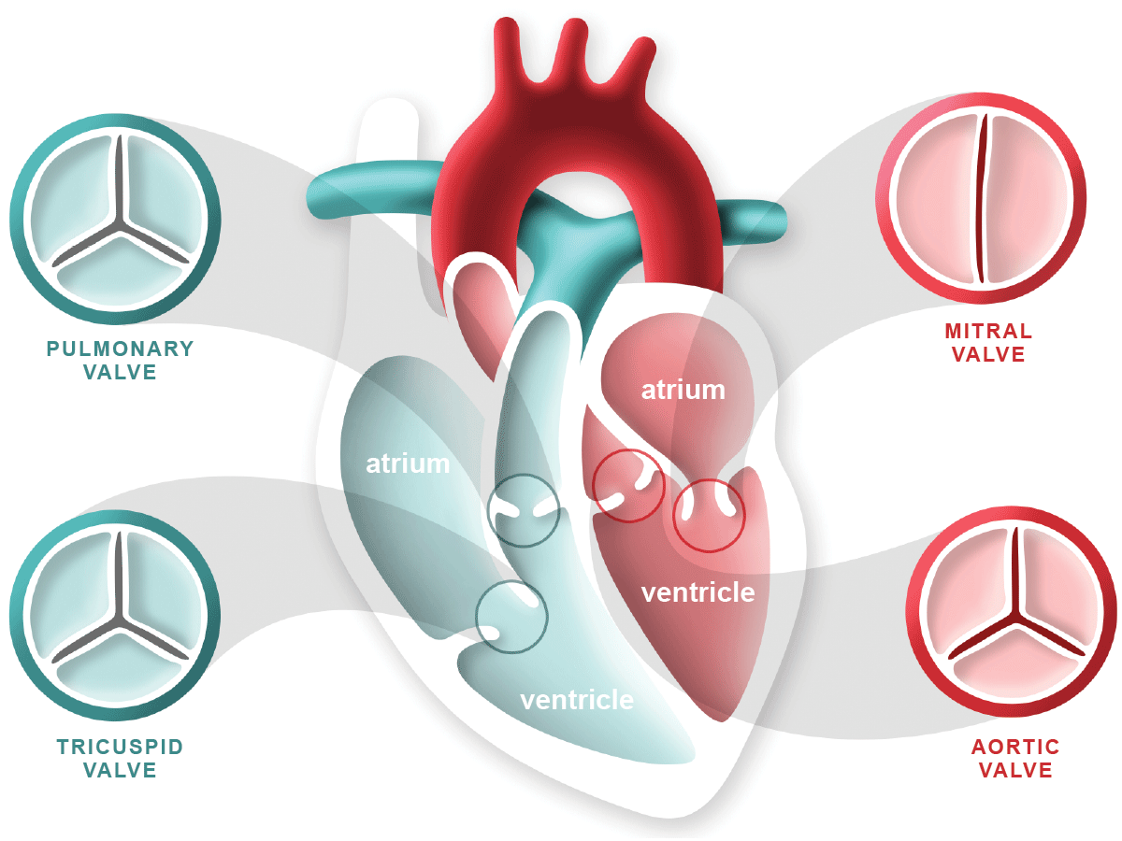

Valves of heart^{[6]}

Associated Great Vessels^{[7]}
The great blood vessels provide a pathway for the entire cardiac circulation to proceed.
- The heart receives deoxygenated blood from the veins of the body through the superior and inferior vena cava. This blood is then pumped through the pulmonary trunk. The pulmonary trunk divides into the right and left pulmonary arteries, which transport the blood to the lungs. In the lungs, oxygen is taken up and carbon dioxide is released. The oxygenated blood then flows back to the left side of the heart through the four pulmonary veins. From there, it is pumped out of the heart into the aorta. The aorta gives rise to systemic arteries that supply oxygenated blood to all body tissues.

Functions of the Heart
The functions of the heart are as follows:
- Managing blood supply. Variations in the rate and force of heart contraction match blood flow to the changing metabolic needs of the tissues during rest, exercise, and changes in body position.

- Producing blood pressure. Contractions of the heart produce blood pressure, which is needed for blood flow through the blood vessels.

- Securing one-way blood flow. The valves of the heart secure a one-way blood flow through the heart and blood vessels.

- Transmitting blood. The heart separates the pulmonary and systemic circulations, which ensures the flow of oxygenated blood to tissues.

Cardiac Circulation Vessels^{[7]}
Although the heart chambers are bathed with blood almost continuously, the blood contained in the heart does not nourish the myocardium.
- Coronary arteries. The coronary arteries branch from the base of the aorta and encircle the heart in the coronary sulcus (atrioventricular groove) at the junction of the atria and ventricles, and these arteries are compressed when the ventricles are contract and fill when the heart is relaxed.
- Cardiac veins. The myocardium is drained by several cardiac veins, which empty into an enlarged vessel on the posterior of the heart called the coronary sinus.

Blood Vessels
Blood circulates inside the blood vessels, which form a closed transport system, the so-called vascular system.
- Arteries. As the heart beats, blood is propelled into large arteries leaving the heart.

- Arterioles. It then moves into successively smaller and smaller arteries and then into arterioles, which feed the capillary beds in the tissues.

- Veins. Capillary beds are drained by venules, which in turn empty into veins that finally empty into the great veins entering the heart.

- Tunics- Except for the microscopic capillaries, the walls of the blood vessels have three coats or tunics.

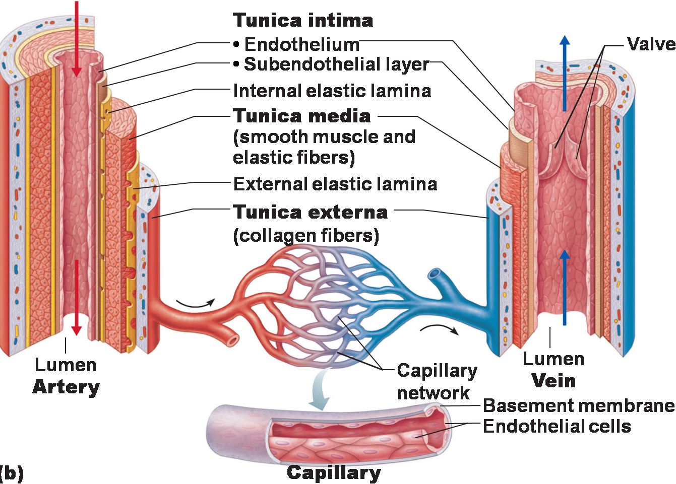

Artery, vein and capillary ^{[8]}
- Tunica intima. The tunica intima, which lines the lumen, or interior, of the vessels, is a thin layer of endothelium resting on a basement membrane and decreases friction as blood flows through the vessel lumen.

- Tunica media. The tunica media is the bulky middle coat which mostly consists of smooth muscle and elastic fibers that constrict or dilate, making the blood pressure increase or decrease

- Tunica externa. The tunica externa is the outermost tunic composed largely of fibrous connective tissue, and its function is basically to support and protect the vessels.

Circulation of blood ^{[4]}

- In the circulation that occurs after birth, the heart functions by pumping blood into two distinct closed circuits known as systemic circulation and pulmonary circulation.

- Arteries in systemic tissues give rise to arterioles with smaller diameters, which eventually lead to extensive networks of systemic capillaries.

- The exchange of nutrients and gases takes place across the thin walls of these capillaries. During this process, blood unloads oxygen (O2) and picks up carbon dioxide (CO2). Typically, blood flows through a single capillary before entering a systemic venules.

- These venules carry deoxygenated (oxygen-poor) blood away from the tissues and merge to form larger systemic veins. Ultimately, the blood returns to the right atrium.

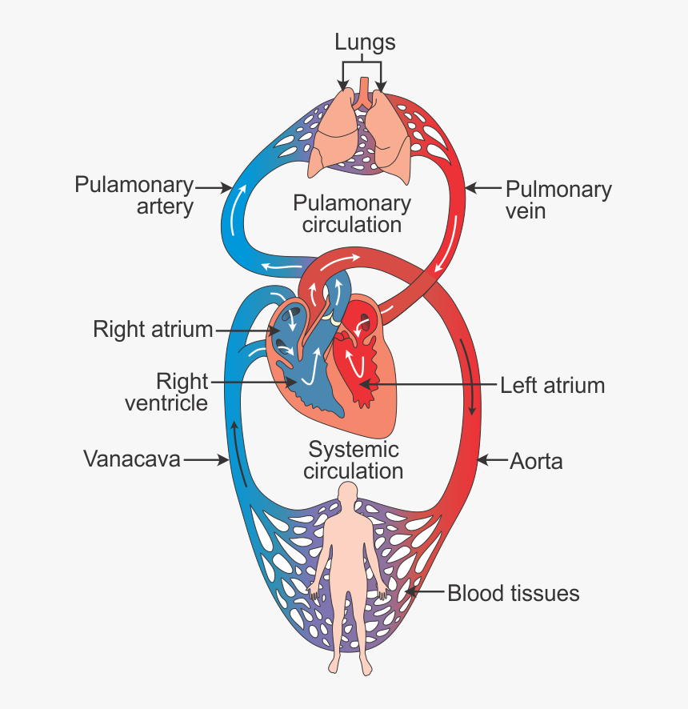
Blood circulation pathway ^{[9]}

The heart's myocardium is supplied with nutrients through its own intricate network of blood vessels known as the coronary or cardiac circulation. These coronary arteries originate from the ascending aorta and form a circular pattern around the heart, resembling a crown encircling the head
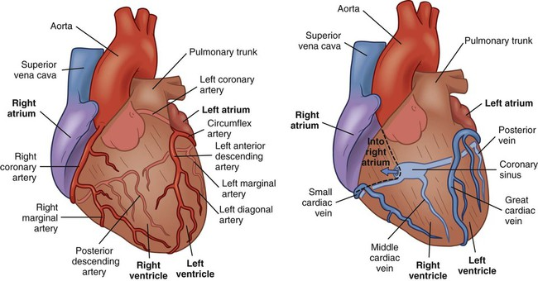
Coronary artery and coronary vein^{[11]}

Conduction system of the heart^{[10]}

- The heart's conducting system is comprised of cardiac muscle cells and conducting fibers—not nerve tissue—that are designed to rapidly initiate impulses and carry them throughout the heart.
- They start the typical cardiovascular cycle and direction the constrictions of heart chambers.
- The two atria contract together, as do the ventricles, however atrial compression happens first. The directing framework gives the heart its programmed musical thump. For the heart to siphon proficiently and the foundational and aspiratory courses to work in synchrony, the occasions in the cardiovascular cycle should be composed.
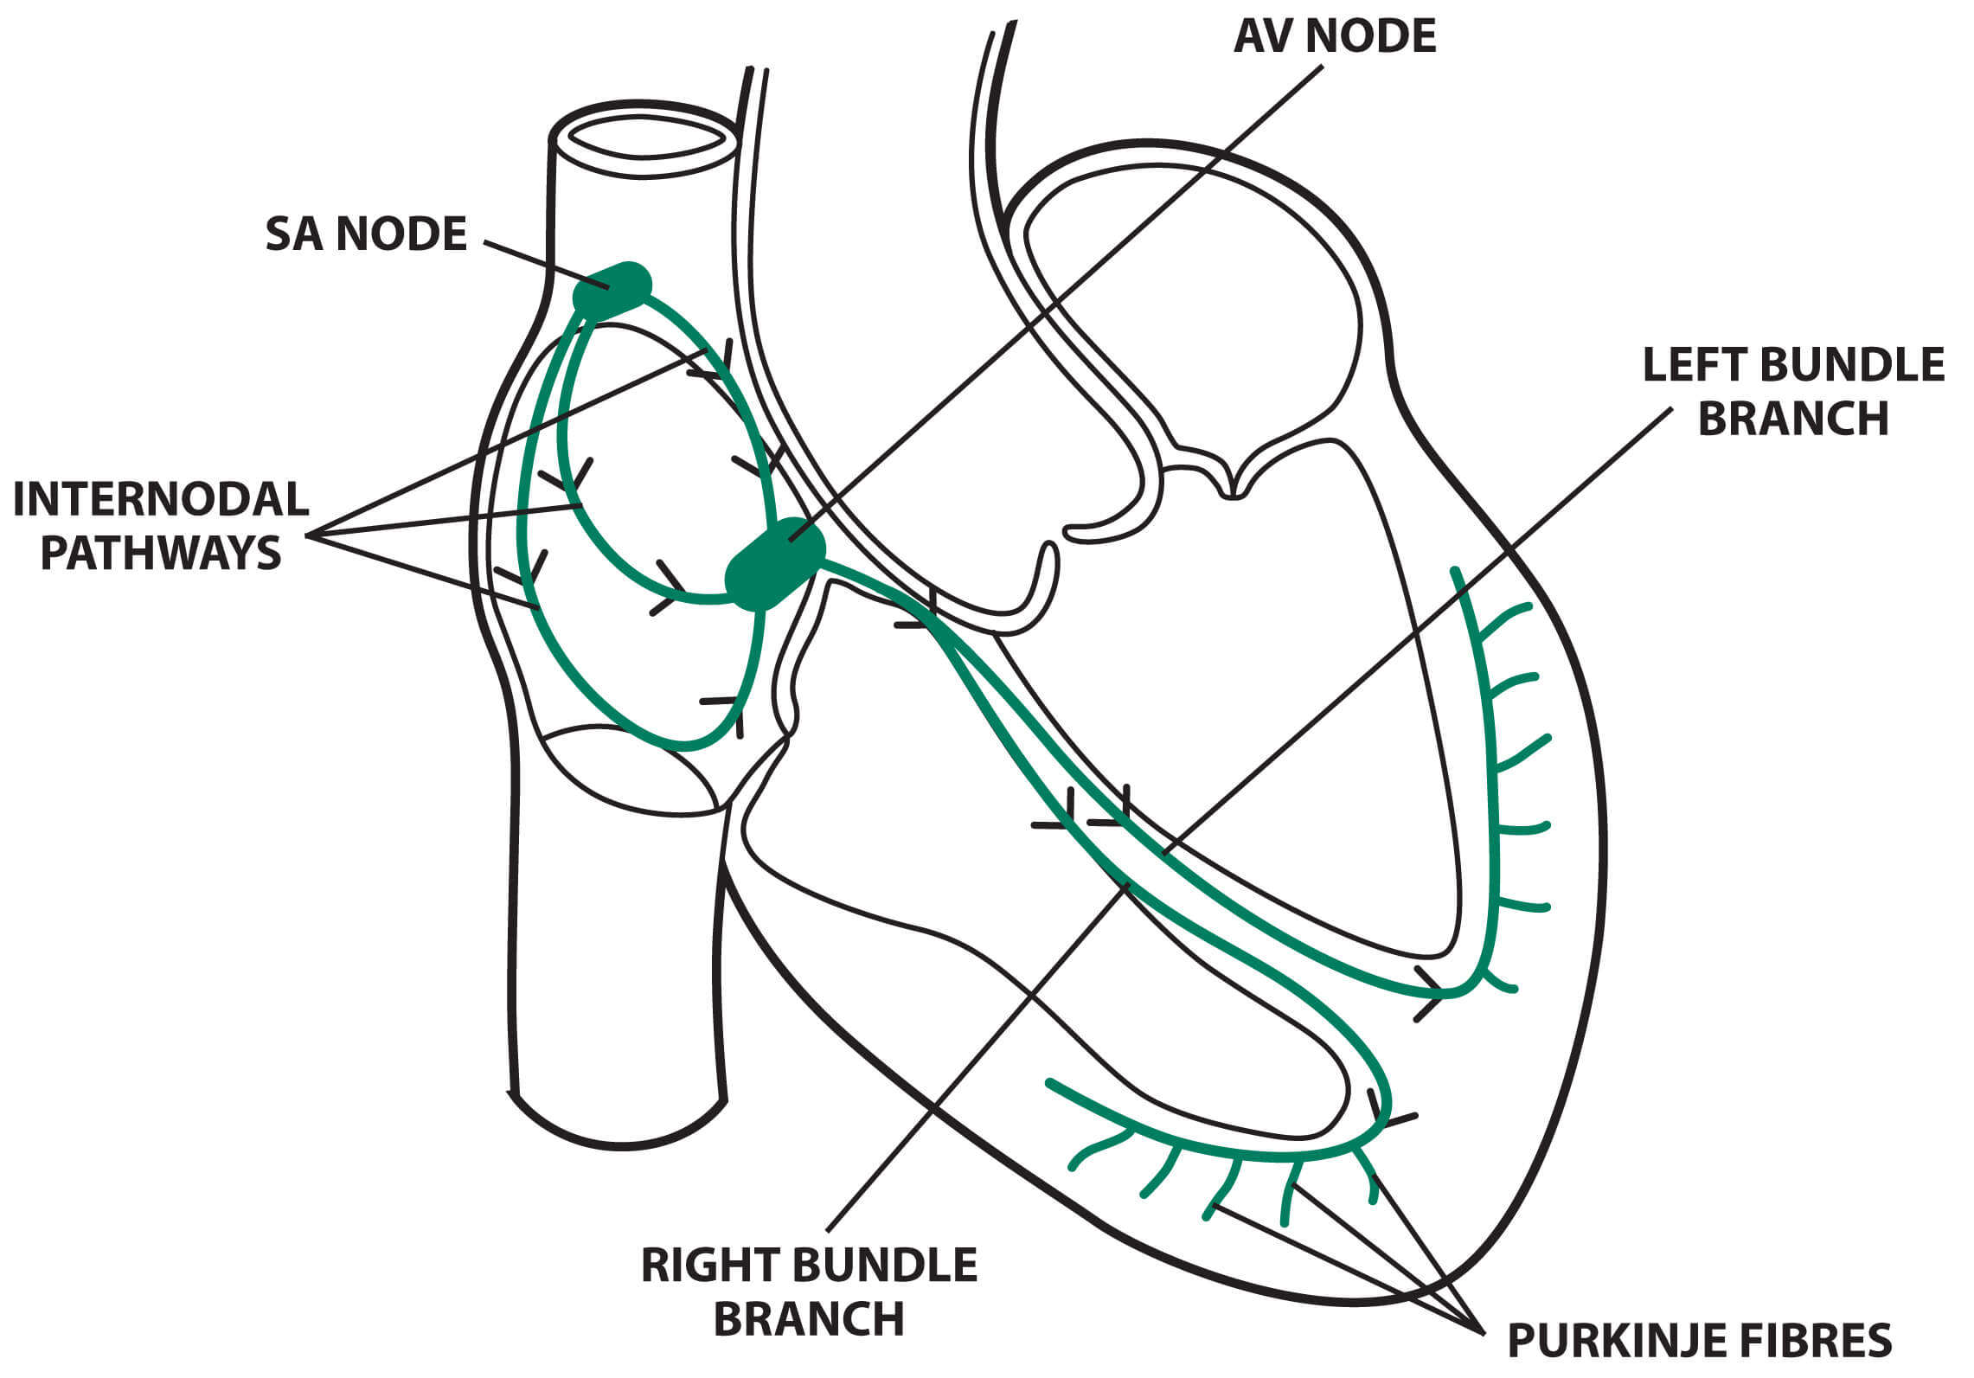

Conduction system of heart^{[13]}

Sinoatrial node

The Sinoatrial (SA) node is a structure in the shape of a spindle made of tightly packed cells in a fibrous tissue matrix. It is 10-20 mm long, 2-3 mm wide, and thick, having a tendency to limit caudally toward the inferior vena cava (IVC).

The SA node is found less than 1 mm from the epicardial surface, along the side in the right atrial sulcus terminals at the intersection of the anteromedial part of the superior vena cava (SVC) and the right atrium (RA).

The vein providing the sinus node branches from the right coronary artery in 55-60% of hearts or the left anterior descending artery in 40-45% of hearts. Around the SVC–RA junction, the artery approaches the node in either a clockwise or counterclockwise direction.

The SA node is thickly innervated with postganglionic adrenergic and cholinergic nerve terminals.

Through stimulation of beta-adrenergic and muscarinic receptors, neurotransmitters alter the rate of discharge from the SA node. Both beta1 and beta2 adrenoceptors subtypes are available in the SA node. The human SA node contains a more than 3-overlay more noteworthy thickness of beta-adrenergic and muscarinic cholinergic receptors than the nearby atrial tissue

Internodal and intra-atrial conduction

Anatomic evidence recommends the presence of 3 intra-atrial pathways: (1) anterior internodal pathway, (2) center internodal tract and (3) posterior internodal tract .

The anterior internodal pathway starts at the foremost edge of the SA node and bends anteriorly around the SVC to enter the front interatrial band, called the Bachmann group. This band proceeds to the left artery (LA), with the front internodal pathway entering the predominant edge of the AV node. The Bachmann bundle is a huge muscle group that seems to lead the cardiovascular drive especially from the RA to the LA.

The center internodal pathway starts at the prevalent and back edges of the sinus node, makes a trip behind the SVC to the peak of the interatrial septum, and plummets in the interatrial septum to the predominant edge of the AV node.

The back internodal parcel begins at the back edge of the sinus node and voyages posteriorly around the SVC and along the crista terminalis to the eustachian edge and afterward into the interatrial septum over the coronary sinus, where it joins the back piece of the AV node.

These gatherings of internodal tissue are best alluded to as internodal atrial myocardium, not lots, as they don't seem, by all accounts, to be histologically discrete specific tracts.

Atrioventricular node

The smaller piece of the atrioventricular (AV) node is a shallow design found just underneath the RA endocardium, foremost to the ostium of the coronary sinus, and straight over the inclusion of the septal handout of the tricuspid valve. The tricuspid valve and the Todaro tendon, which originates in the central fibrous body and travels posteriorly through the atrial septum to continue with the eustachian valve, form a triangle at its apex.

In 85-90% of human hearts, the blood vessel supply to the AV node is a branch from the right coronary artery that begins at the posterior crossing point of the AV and interventricular grooves (core). In the excess 10-15% of the hearts, a part of the left branch of coronary artery gives the AV nodal supply route. Strands in the lower part of the AV node may exhibit automatic impulse formation. The primary capability of the AV node is modulation of the atrial impulse transmission to the ventricles to arrange atrial and ventricular contraction.

The Pathway of the Conduction System
The conduction system occurs systematically through:
- SA node. The depolarization wave is initiated by the sinoatrial node.

- Atrial myocardium. The wave then successively passes through the atrial myocardium.

- Atrioventricular node. The depolarization wave then spreads to the AV node, and then the atria contract.

- AV bundle. It then passes rapidly through the AV bundle.

- Bundle branches and Purkinje fibers. The wave then continues on through the right and left bundle branches, and then to the Purkinje fibers in the ventricular walls, resulting in a contraction that ejects blood, leaving the heart.

Cardiac Cycle ^{[12,14]}

The cardiac cycle refers to the series of events that occur from the beginning of one heartbeat to the beginning of the next. The heart is composed of two pumps that work in sequence.

The first pump consists of the right atrium and right ventricle, which supply blood to the lungs for gas exchange (removing carbon dioxide and obtaining oxygen). The second pump consists of the left atrium and left ventricle, which propel blood to all other tissues in the body (known as systemic circulation). The flow of blood is unidirectional, thanks to the presence of valves within the cardiac chambers. These valves include the tricuspid valve, located between the atrium and right ventricle; the mitral valve, located between the atrium and left ventricle; the pulmonary valve, located between the right ventricle and the pulmonary artery (which carries blood to the lungs for oxygenation); and the aortic valve, located between the left ventricle and the aortic artery (which carries oxygenated blood to the rest of the body). The opening and closing of these valves are regulated by pressure differences.

The heart operates in two phases, systole and diastole, similar to a pump. During systole, the right ventricle contracts to pump deoxygenated blood into the lungs for oxygenation, while the left ventricle contracts to pump oxygenated blood into the entire systemic circulation. This process involves the closure of the atrioventricular valves (mitral and tricuspid) and the opening of the pulmonary and aortic valves. The contraction of the right ventricle increases the pressure, causing the pulmonary valve to open and allowing blood to flow into the pulmonary artery. Simultaneously, the left ventricle contracts, increasing pressure and opening the aortic valve to propel blood into the circulation. During diastole, the ventricles relax, resulting in a decrease in pressure. This relaxation allows the tricuspid and mitral valves to open, enabling the ventricles to fill with blood from the atria.

The systole is comprised of three distinct phases. The first phase, known as isovolumetric contraction, is characterized by the closure of all valves. During this phase, the ventricles contract, resulting in an increase in pressure. The right ventricle experiences a pressure increase of 8mmHg, while the left ventricle experiences a pressure increase of 80mmHg. This leads to the opening of the pulmonary and aortic valves, respectively. The second phase, referred to as maximum ventricular ejection fraction, is characterized by the ejection of blood volume at a high pressure. The pressure can reach up to 120mmHg, and the blood is ejected into both the pulmonary circulation and the systemic circulation. The third and final phase is known as reduced ventricular ejection rate. During this phase, the ejection occurs at a lower velocity and pressure. The velocity and pressure gradually decrease until the aortic and pulmonary valves close.

Diastole is divided into four distinct phases. The first phase, known as isovolumetric relaxation, is characterized by the relaxation of the ventricles without any change in the blood volume inside. This phase lasts for a period of 0.03 to 0.06 seconds, during which all valves are closed. The second phase, called rapid diastolic filling, occurs when the tricuspid and mitral valves open, allowing the ventricles to fill with blood. This filling process is accompanied by a slight increase in pressure, approximately 5 mmHg. The third phase, known as slow diastolic filling, is characterized by a slower flow of blood from the atria to the ventricles. This is due to a slight increase in pressure within the ventricles. The final phase, atrial contraction, involves the contraction of the atria, which increases the pressure within the ventricles. This prepares the ventricles for the onset of systole.

The pressure increase during atrial contraction is around 4-6 mmHg in the right atrium and 7-8 mmHg in the left atrium. It is important to note that approximately 70% of the blood volume flows directly from the atria to the ventricles without the need for atrial contraction. The contraction of the atria only contributes to a 25% increase in ventricular volume. This is why the atria are often referred to as a priming pump. However, the heart is capable of functioning without this additional 25% because it pumps a significantly larger amount of blood than the body requires, approximately 300 to 400% more.

During the relaxation phase of the cardiac cycle, known as diastole, the ventricles fill up with approximately 110 to 120 ml of blood. This specific volume is referred to as the final diastolic volume. On the other hand, during the contraction phase of the cardiac cycle, known as systole, this volume decreases by around 70 ml, which is known as systolic output. The remaining volume in each ventricle, ranging from 40 to 50 ml, is called the final systolic volume. The proportion of the diastolic volume that is expelled is termed the ejection fraction, typically amounting to 60%. Consequently, the increase in final diastolic volume and the decrease in final systolic volume contribute to an elevation in systolic output. The quantity of blood pumped by the heart per minute is referred to as cardiac output.

CONCLUSION

Every part of our body receives life-sustaining blood pumping from the heart, a function made possible by the sophisticated and complex circulatory system. This system is a network of fluids, organs, and vessels that work together to carry nutrition and oxygen throughout our bodies. This guide covers the interesting anatomy and physiology of the circulatory system, covering everything from the four chambers of the heart to the complex sequence of events that make up the cardiac cycle.The blood carries waste materials out of the body and carries nutrients and oxygen to the cells. For cells to continuously obtain oxygen and nutrients, the heart cycle and cardiovascular system must function harmoniously. Blood pressure is a crucial indicator of cardiovascular health that is regulated by a number of factors, including blood volume, peripheral resistance, and cardiac output. Comprehending these crucial elements can aid medical practitioners in accurately diagnosing and treating cardiovascular disorders.

REFERENCE
  - Melanie A. Greeley and Stephanie J. White-Hunt, “Cardiovascular System.” Elsevier Inc. 2016, PP-423-437.
  - J.D. Humphrey and A.D. McCulloch, “The Cardiovascular System - Anatomy, Physiology and Cell Biology.” Springer-Verlag Wien, 2003, PP-.1-2.
  - Anatomy Of Heart, December 2023, https://healthjade.com/purpose-heart-valves
  - Human cardiovascular system -- Britannica Online Encyclopedia
  - Pericardium Of Heart, December 2023, https://heartvein.com/heart-disease/conditions/pericarditis
  - HEART VALVES, DECEMBER 2023, https://www.heartfoundation.org.nz/your-heart/heart-conditions/heart-valve-disease
  - Jan Hendrik van Weerd and Vincent M. Christoffels, “The formation and function of the cardiac conduction system.” The Company of Biologists Ltd ,Development, 2016, 143, 197-210.
  - Artery, Vein And Capilary,December 2023, https://www.pinterest.ca/pin/168885054751453242/
  - Blood Circulation Pathway,December 2023, https://www.toppr.com/ask/question/explain-double-circulation-in-human/
  - Conduction system of heart,january 2023, https://emedicine.medscape.com/article/1922987-overview?form=fpf
  - Coronary Artery And Veins, December 2023, https://nursekey.com/nursing-assessment-cardiovascular-system/
  - Vanessa Novaes Barros, “The heart cycle: review.” MOJ Womens Health. 2019, 8(1):66‒69.
  - Conduction System Of Heart, January 2024, https://www.medicalexamprep.co.uk/the-basics-of-ecg-interpretation-part-2-rate-rhythm-and-axis/cardiac-conduction-system-5/

