**Electromagnetic Radiation and Human Health**

Sandeep Kumar

Department of Physics, Dhanauri P.G. College, Dhanauri, Haridwar, Uttrakhand, 247667

**ABSTRACT:**

In this paper author try to raise the awareness for the general public or society regarding health issues due to electromagnetic radiation (Non-ionizing radiation) especially those people are living nearby mobile phones towers. Author’s also evaluate specific absorption rate (SAR) inside human body tissues with the help of mathematical modeling and compare it with standard permitted values of SAR given by many national and international agencies like International Commission non- ionizing radiation Committee (IRIRC), World Health Organization (WHO), National Council on Radiation Protection and Measurement (NCRP) and Federal Communication Commission (FCC), Department of telecommunications (DOT) etc.

**KEYWORDS:**  Electromagnetic Radiation (EMR), Specific Absorption Rate (SAR), Radio frequency (RF), Electromagnetic field (EMF) etc.

**1. INTRODUCTION:**

The use of EMR is rapidly increasing and we are living in the sea of invisible radiation comes from natural and manmade sources of EMR; there are growing concerns about human health hazards. Thus, there is a need to studies the interaction of microwave radiation with living organisms. These tissues of human body is complex functions of numerous parameters like conductivity, permittivity and density. The dissymmetric studies attempt to quantify the interaction of EMF with human being. Adey (1990) delivered a plenary lecture on “Electromagnetic Fields and Essence of Living Systems” at Prague (URSI). Radio waves in free space are characterized by the frequency, intensity of the electric field (E) and magnetic field (H), direction, and polarization.

When human bodies exposed to known electromagnetic fields (non-ionizing) then the induced electric field inside the biological body can be calculated by solving Maxwell’s equation subject to given boundary conditions. A biological body is described by the complex permittivity; conductivity and mass density, etc.The inhomogeneity of the dielectric properties and the complexity of the shape make a solution, or sometimes even a full formulation of the problem.

The intensity of the electromagnetic field depend on the parameters of the external field, viz., the frequency, intensity, density, resistivity , conductivity, polarization and on the size, shape and dielectric properties of the exposed body, spatial configuration between the exposure source and the exposed body, and the presence of other objects in the vicinity with a complex dependence on so many parameters, it is apparent that the internal fields in a mouse and a man exposed to the same external field can be dramatically different, and so will be their biological response, regardless of physiological differences. Conversely, different exposure conditions, e.g., different frequencies, may induce similar fields inside such diverse shapes as a mouse and a man.The development and application of devices that emit RF radiation have significantly increased the quality of life through the world. Yet the beneficial aspects of RF/MW technology have been somewhat overshadowed in recent years by the public’s fear of potential adverse effects. This fear, in turn, has led to increased radio frequency radiation (RFR) research and to new RFR safety guidelines. The new exposure standards are based on what is known about any biological effect. In general, the new guidelines provide an added margin of safety over those previously used. In 2000, the U.K. National Radiation Protection Board measured RF radiation level at 118 publicly accessible sites around 17 mobile phone base stations. The maximum exposure was 0.00083 mW/cm2 on a playing field 60 m from a school building with an antenna on its roof. Typically, power densities were less than 0.01 % of the ICNIRP public exposure guidelines. The power densities indoors were substantially less than power densities outdoors. When RF radiation from all sources (the mobile phone, FM, T.V., and their transmitters, etc.) was taken into account, the maximum power density at any site was less than 0.2 % of the ICNIRP public exposure guidelines.

The National and International safety guidelines for exposure of the public to the RF radiation are most widely accepted standards which is developed by the Institute of Electrical and Electronics Engineers and American National Standards Institute (ANSI/IEEE). The International Commission on Non-Ionizing Radiation Protection (ICNIRP 1998) and the National Council on Radiation Protection and Measurement (NCRP, 1986). In 2001, the IEEE published a statement on mobile phone base station (IEEE, 2001). This report concluded that in nearly all circumstances, public exposure to RF field near wireless base stations is far below the recommended safety limits. Consequently, wireless base stations are not considered to present a risk to the general population including aged people, pregnant women and children.

Inherent health risk from microwave radiation exposure are directly depends on the rate of energy absorption (Osephuk and Peterson, 2003) and distribution of Radiation energy in the body. The absorption and distribution are strongly dependent on body size, orientation, frequency and polarization of the incident radiation. Both theoretical and experimental dissymmetric data shows that microwave Radiation absorption approaches maximum when the long axis of the body is both parallel to the E-field vector and equal to the four-tenths of the wavelength of the incident microwave Radiation field.

**2. INTERACTION OF EMR WITH HUMAN HEALTH AND METHODOLOGY:**

The interaction of microwave radiation with living organism, including human being is a complex function of many parameters. The Biological responses are due to the EMF inside the biological body tissues. The amount of radiation reflected, transmitted and absorbed for a given exposure field, is determined with the help of electrical properties of living organism systems. The exposure field is characterized by the frequency, intensity, density, conductivity, resistivity, polarization and near-field of a radiator. The interaction of biological material with an electromagnetic source depends on the frequency of the source (Moulder and Foster, 1995). It can be considered on a macroscopic or microscopic (molecular, cellular) level, on the molecular level, two basic mechanisms govern the interactions, viz., space charge polarization at lower RF and field-induced rotations of polar molecules at higher RF and microwave frequencies (Health Aspects, Part I and II, 1977, 1978). The space charge polarization is due to travelling charge carriers, i.e., ions and the applied field affects the whole movement of the ions. Polar molecules, i.e., molecules having an uneven spatial distribution of charges, such as water and proteins, experience a torque when placed in an electric field; both of these mechanisms are of a relaxation character. In moderate fields, only a relatively small number of charges or molecules are actually affected by the field. The thermal motion of molecules and charges hinders the movements, and the kinetic energy undergoes a conversion into the thermal energy. In these interactions, the electromagnetic energy is converted into kinetic energy of molecules, and subsequently converted into thermal energy which produce heating or raise the body temperature (Mclntosh et al., 2005).]

When EMR from transmission towers falls on the human body, then it penetrates into it and affecting the biological tissues of human body. The electric field is propagated from the tower in all directions and thus the value of electric field depends upon the distance  from the tower and its transmission power  is given by Polk (1996)



Where  is speed of light and  the permittivity of free space.





Thus the electric field around the transmission tower is inversely proportional to the distance from the towers. The electric field at depth  inside human body due to incident electric field  on the surface of body is given by Polk (1996)



Where  is the skin depth (The distance at which the field is reduced to  of its original value at the boundary). It depends upon the frequency of radiation for biological body is given by







Where

 is radian frequency of radiations

 is Permittivity of tissue material

 is Permeability of tissue material

 is Conductivity of tissue material.

The above mathematical formulation can be used to evaluate the electric field inside the human body tissues at different depths.

**2.1 SPECIFIC ABSORPTION RATE** **(SAR):**

SAR is defined as the time derivative of the incremental energy (dw) absorbed or dissipated is an incremental mass (dm) contained in a volume element (dv) of a given density (ρ)

SAR = d/dt (dw/dm) = d/dt (dw/ ρdv)

For sinusoidal electro-magnetic fields

SAR = σ E2i/ρ

σ is conductivity of the tissues

Ei is induced electric field inside human body tissues

ρ is the density of tissues materials

**2.2 SAR FOR SKELETAL MUSCLES at 935 and 960 MHz**

The values of SAR in skeletal muscles at different distances from tower of transmitted tower of 2 W have been calculated by Pathak et al. (2008). In this paper author is calculated the values of SAR for skeletal muscles at transmitted power 20 W, 50 W and 1000 W, values are given in Tables 1 and 2 for 20 W transmitted power at frequencies 935 Mhz and 960 Mhz., and Tables 3 and 4 for 50 W and 1000 W at frequency 935 Mhz.. The variation of SAR inside skeletal muscles at 935 MHz is shown in Figure 1 & 2 at 20 W and Figures 3 & 4 at 50 W & 1000 W respectively. The variation of SAR at 960 MHz has been found to be similar as that at 935 MHz frequency.

**Table 1. SAR for skeletal muscles of human body at 935 MHz (20 W)**

|  |  |  |  |  |
| --- | --- | --- | --- | --- |
| Distance from the base station  (m) | Incident Electric Field  (V/m) | SAR x 10-3 (W/kg) | | |
| 1 mm | 2 mm | 3 mm |
| 10  20  30  40  50  60  70  80  90  100 | 3.464  1.732  1.154  0.866  0.693  0.577  0.495  0.433  0.385  0.346 | **156.03**  39.00  17.31  9.75  6.24  4.33  3.18  2.43  2.02  1.64 | **148.73**  37.18  16.50  9.29  5.94  4.13  3.03  2.32  1.83  1.48 | **141.79**  35.44  15.73  8.86  5.67  3.94  2.89  2.21  1.75  1.42 |

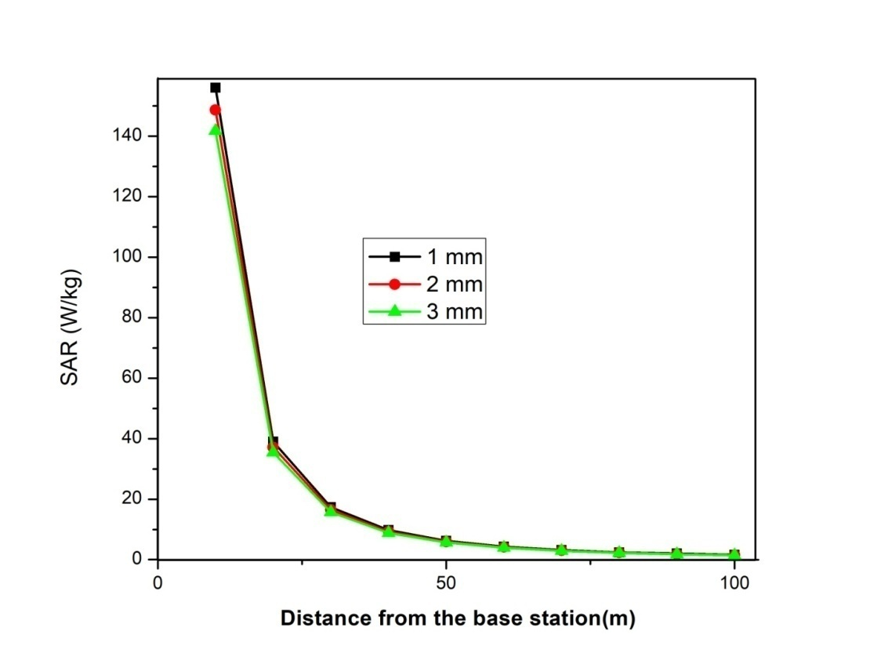

**Fig. 1: SAR inside skeletal muscles of human body at 935 MHz (20 W)**

**Table2: SAR for skeletal muscles of human body at 960 MHz (20 W)**

|  |  |  |  |  |
| --- | --- | --- | --- | --- |
| Distance from the base station  (m) | Incident Electric Field  (V/m) | SAR x 10-3 (W/kg) | | |
| 1 mm | 2 mm | 3 mm |
| 10  20  30  40  50  60  70  80  90  100 | 3.464  1.732  1.154  0.866  0.693  0.577  0.495  0.433  0.385  0.346 | **157.44**  39.36  17.47  9.84  6.30  4.37  3.21  2.45  1.94  1.57 | **149.98**  37.49  16.63  9.37  6.00  4.16  3.06  2.34  1.85  1.49 | **151.93**  35.72  15.86  8.93  5.72  3.97  2.92  2.23  1.76  1.42 |

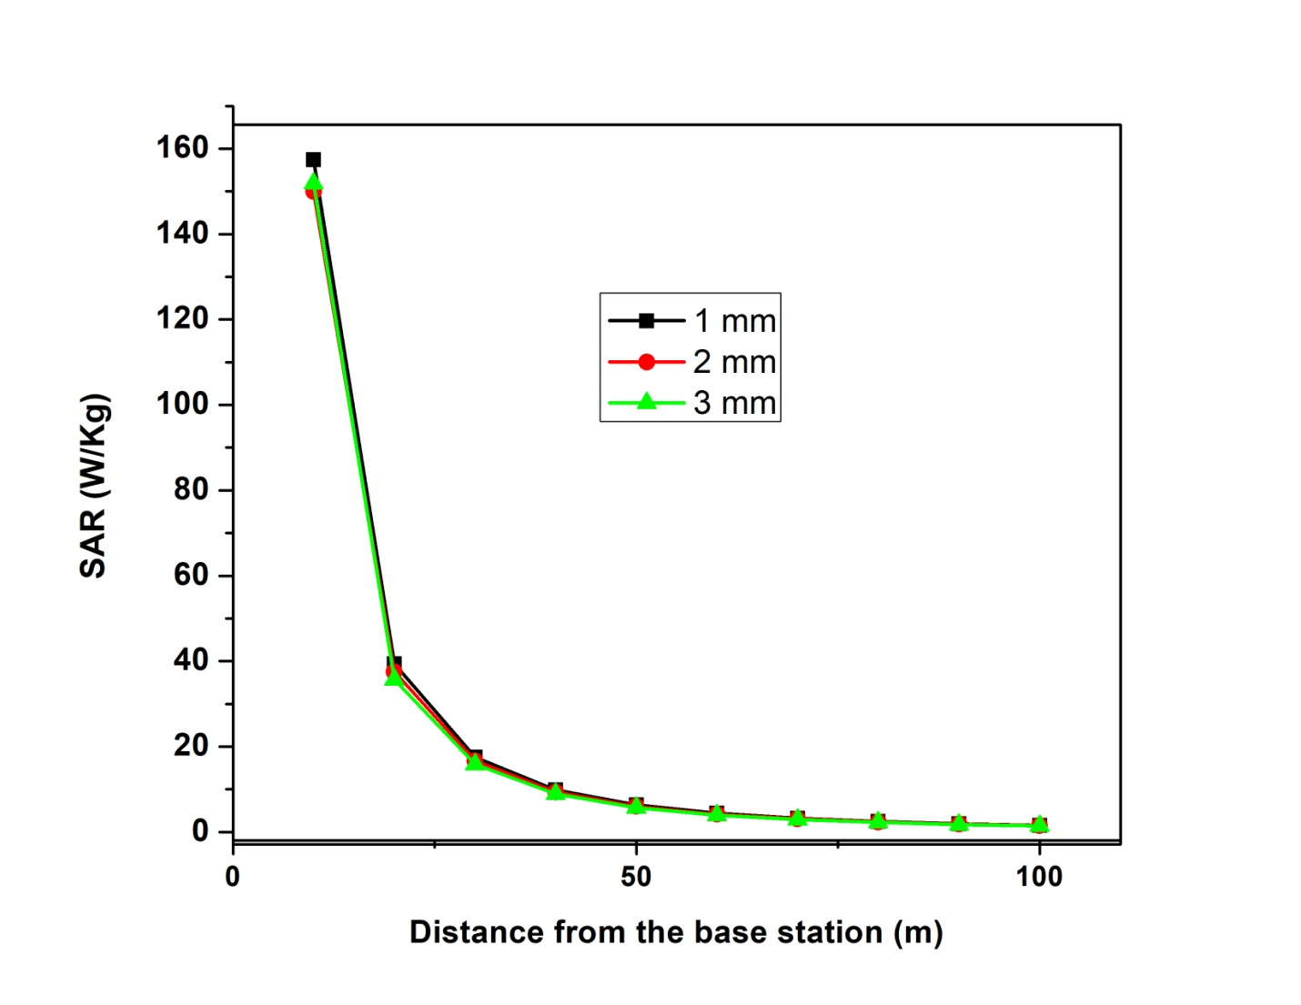

**Fig 2: variation of SAR for skeletal muscles of human body at 960 MHz (20 W)**

**Table 3: SAR for skeletal muscles of human body at 935 MHz (50 W)**

|  |  |  |  |  |
| --- | --- | --- | --- | --- |
| Distance from the base station  (m) | Incident Electric Field  (V/m) | SAR x 10-3 (W/kg) | | |
| 1 mm | 2 mm | 3 mm |
| 10  20  30  40  50  60  70  80  90  100 | 5.477  2.74  2.825  1.369  1.095  0.913  0.782  0.685  0.608  0.547 | **390.0**  **97.6**  43.3  24.4  15.5  10.8  7.9  6.6  4.8  3.8 | **371.2**  **93.05**  41.28  23.23  14.86  10.33  7.58  5.81  4.58  3.21 | **354.4**  **88.71**  39.33  22.14  14.16  9.85  7.23  5.54  4.36  3.53 |

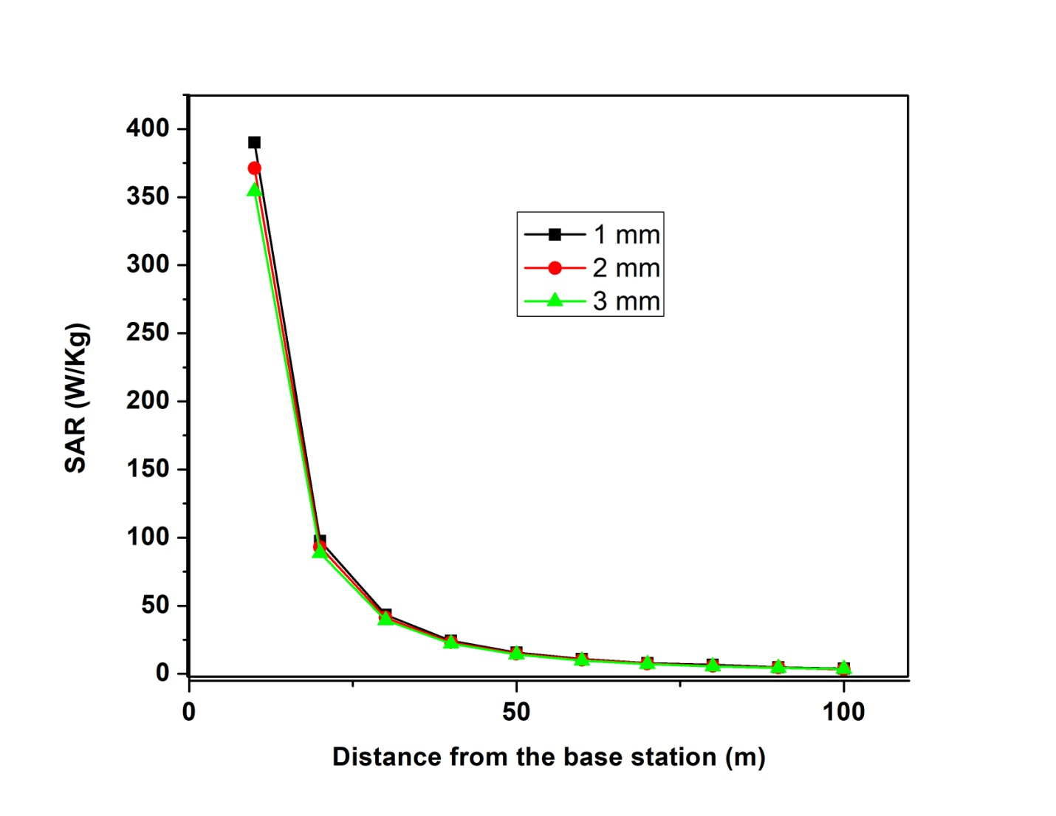

**Fig. 3: Variation of SAR for skeletal muscles of human body at 935 MHz (50 W)**

**Table 4: SAR for skeletal muscles of human body at 935 MHz (1000 W)**

|  |  |  |  |  |
| --- | --- | --- | --- | --- |
| Distance from the base station  (m) | Incident Electric Field  (V/m) | SAR x 10-3 (W/kg) | | |
| 1 mm | 2 mm | 3 mm |
| 10  20  30  40  50  60  70  80  90  100 | 24.495  12.247  8.165  6.112  4.898  4.081  3.498  3.061  2.721  2.449 | **7799**  **1948**  **866.8**  **485.7**  **311.9**  **216.5**  **159.1**  **121.8**  **96.24**  77.5 | **7437**  **1858**  **826.9**  **463.1**  **297.3**  **206.4**  **151.6**  **116.1**  **91.72**  74.32 | **7085**  **1772**  **785.9**  **441.4**  **283.4**  **196.7**  **144.5**  **110.6**  **87.4**  70.8 |

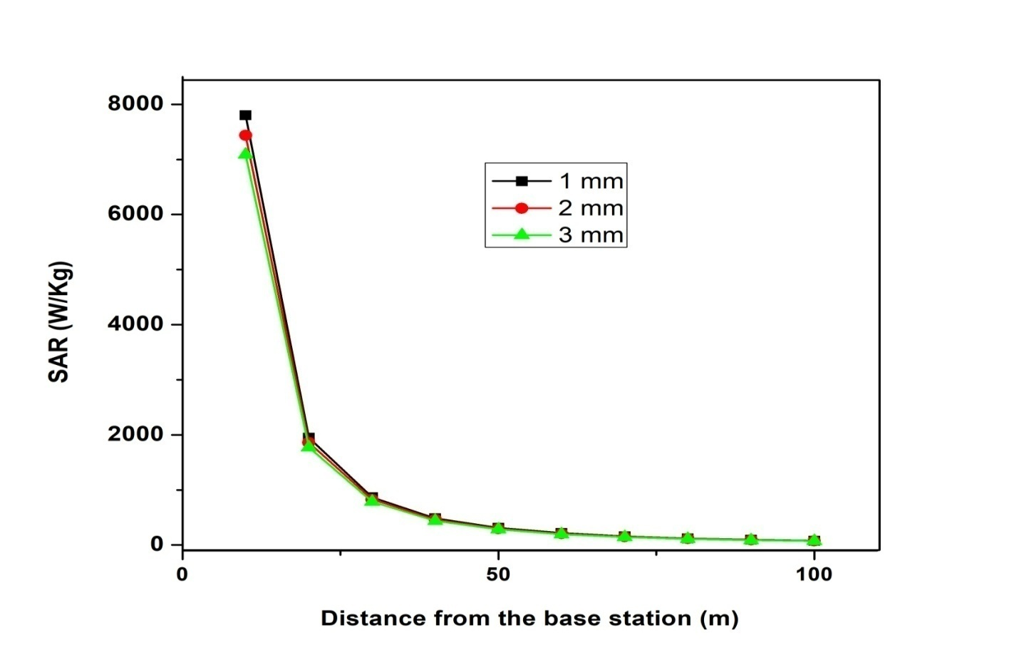

**Fig. 4: variation of SAR for skeletal muscles of human body at 935 MHz (1000 W)**

**3. RESULTS AND DISCUSSIONS:**

From above tables the harmful values of SAR are shown in bold digits and these values above 0.08 w/kg. The Induced electric field and SAR at Effective radiated power 20W, 50W, and 1000 Watt are calculated. The distances from towers 10 meter to 100 meters is to be used for calculation of SAR. For above stated tissues of human body is observed that the SAR values across the standard limit given by many national and international agencies like NCRP,WHO,DOT,NICRP & IEEE etc. Tables and graphical representation of specific absorption rate shows that up to 90 meters distances from mobile phone towers are in critical zone and harmful for human being. The Authors are advised to the people that do not reside near the towers of mobile phone up to 90 meters distances and also suggest the set up guidelines of the transmission towers for the authorities that towers does not setup near the schools and colleges, railway stations, bus stands, and in dense populated areas up to specified distances.

**References:**

1. Adey W. R., Electromagnetic fields and the essence of living systems, Plenary Lecture, 23rd General Assembly, International Union of Radio Sciences (URSI), Prague, in J. Bach, Andersen, ed., Modern Radio Science, Oxford University Press, pp. 1-36, 1990.
2. Moulder J. E. and Foster K. R., Biological effects of power-frequency fields as they relate to carcinogenesis, Proc. Soc. Exper. Biol. Med. 209, 309-324, 1995.
3. Mclntosh, R. L., Anderson, V. and Mckenzie, R. J., A numerical evaluation of SAR distribution and temperature changes around a metallic plate in the head of a RF exposed worker, Bioelectromagnetics, 23, 377-388, 2005.
4. National Council on Radiation Protection and Measurements : Biological effects and exposure criteria for radiofrequency electromagnetic fields, NCRP Report No. 86, 1986.
5. NCRP, Biological effect of modulated radiofrequency fields (NCRP Commentary No 18), National Council on Radiation Protection and Measurements, Bethesda, M. D., 2003.
6. Pathak P. P., Kumar S. and Kumar V., Harmfulness of mobile phones tower, Communicated to XXIX General Assembly of the International Union of Radio Science (URSI 08), Paper No. 2395, Commission K, to be held at Chicago IL, U.S.A., 9-16 August 2008.
7. Pathak P. P. Vijay Kumar and Vats R. P. Harmful Electromagnetic Environment near transmission towers, Indian Journal of Radio and Space Physics, 32, 238-241, 2003.
8. Polk C., Dissymmetric extrapolations across biological systems: Dosimetry of ELF magnetic fields, Bioelectromagnetics, 13-S1, 1992.
9. Polk C., “Introduction”, In Handbook of Biological Effects of Electromagnetic Fields, C. Polk and E. Postow (eds.), Boca Raton, CRC Press, USA, 1-23, 1996.
10. Kumar V., Vats R. P., Goel S., Kumar S., Pathak P. P., Interaction of electromagnetic field with human health, Indian Journal of Radio and Space Physics, 37, 131-134, 2008.
11. Kumar S., Pathak P. P., Induced electric field inside and surface of human brain due to mobile phone radiation, National Journal of Natural and Physical Science, 20 : pp 35-39, 2006a.
12. Foster K. R., Moulder J. E., Are mobile phones safe? IEEE Spectrum, pp. 23-28, Aug. 2000.