Presented by - Swaleha Saiyed
Corresponding author – swalehasaiyed84@gmail.com
UG Student , Department of Biotechnology , GD Rungta College of Science and Technology
ADVANCEMENT IN MEDICAL SCIENCES THROUGH TECHNOLOGICAL INTEGRATION

INTRODUCTION
Medical science includes subjects like anatomy , physiology , biotechnology , biochemistry , microbiology , molecular biology and genetics. The maintenance of health , prevention and treatment of diseases are dealt with the help of medical sciences. In this contemporary world , rapid technological progresses is vital in the field of medicine, significantly influencing diagnostic processes . With constant advancement in medical technology healthcare professionals have powerful role and techniques that help in diagnosis and treatment. This article emphasises the latest advancement in medical diagnostic technology , delving into the advantages of breakthroughs in MedTech and their profound impact on diagnostic , patient care and the evolution of healthcare.
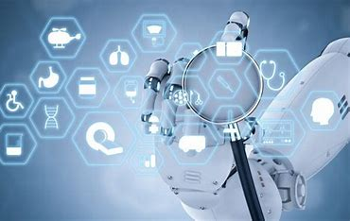

UPGRADES IN MEDICAL TECHNOLOGY TILL The 21st CENTURY
The history of medical technology until 21st century is a fascinating journey marked but significant discoveries and advancement . Early civilizations practised basic surgery and herbal medicines . the renaissance brought a deeper understanding of anatomy , and the 19 century saw breakthroughs like anaesthesia and microscope.

The 20th century was a pivotal era with discoveries of antibiotics , vaccines and the structure of DNA . Medical imaging technologies like X-Rays , MRI and CT Scan revolutionized diagnostics . The latter part of the century witnesses the rise of computers leading to digital advancements in medical devices and recording keeping.

In the 21st century , genomics and personalised medicines became prominent , allowing various treatments based on individual genetic profiles . Robotic surgery , telemedicines and wearable devices transformed patient care . Artificial intelligence and machine learning advanced diagnostic , drug discovery and treatment planning .

The constant evolution and integration of technologies continue to shape the future of medical science , with ongoing developments in area like CRISPER gene editing , nanomedicine and bioinformatics paving the way for even more personalised an precise healthcare solutions .

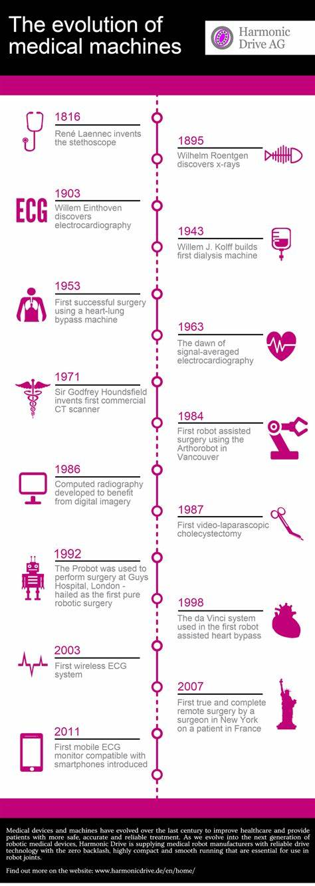
INTEGRATION CURRENTLY IMPLEMENTED TECHNOLOGICAL

- Telemedicine and Remote monitoring:
Telemedicine encompasses delivering medical service from a distance , utilizing telecommunications technology . this include virtual consultations , diagnostic evaluations and treatment suggestions through video calls , phone calls, or online platform. Remote monitoring complements telemedicine by using devices to track patients’ health data , like vital signs or chronic condition metrics , enabling healthcare professionals to oversee and handle patient’s health remotely. This innovative approach improves healthcare accessibility facilitates proactive healthcare management.

- Synchronus Telemedicine
Realtime interaction between healthcare providers and patients. Examples : Live video consultations or phone calls where immediate communications occurs.

- Asynchronous Telemedicine
Non real time exchange of medical information.
Examples : Email consultations , where patients send
information and healthcare providers respond later.

- Remote Monitoring
Continuous tracking of patients’ health data remotely. Examples : Wearable devices measuring heartrate , blood pressure , or glucose levels , transmitting data to healthcare providers.
- Store and forward :
Capturing and storing patient data for later review by healthcare professionals . Examples: Uploading diagnostic images or test results for a specialist’s evaluation.

- Electronic Health Records (EHRs) :
Electronic Health Records are like digital archives of your medical history. Instead of paper charts , all your health information , from diagnoses to test results, is stored digitally. They make it easy for doctors and healthcare providers to access and share your health details , ensuring better coordinated and efficient care.

TYPES OF EHRs :

- Basic EHR : A straight forward digital record keeping track of the basics . It is used in small clinics or private practises implementing digital records for basic patient data.

- Comprehensive EHR : In- depth digital records including lab results , imaging reports and progress notes . Hospitals and larger healthcare facilities using comprehensive EHR systems for extensive patient care.

- Specialized EHR : Tailored for specific medical specialties , focusing on unique data. Cardiology clinics using specializes EHRs designed to handle cardiac-related data efficiently.

- Open EHR : Allows interoperability , enabling data exchange between different EHR systems. Health information exchanges patient data seamlessly moves between hospitals , clinics and other healthcare entities .

- Cloud – Based EHR : Hosted on cloud servers , providing flexibility and accessibility . Multi- location health care systems utilizing cloud – based EHRs for centralizes and easily accessible patient records .

- Patient – Managed EHR : Patients actively contribute and manage their health information . Personal health apps or platform allowing individuals to input daily health data into their HER .

- Advanced Imaging Techniques :
These techniques encompass a range of modalities , each offering unique insights into different aspects of the human anatomy and physiology. As technology continues to evolve , the synergy between medicine and imaging promises to push the boundaries of what is possible in understanding , managing and treating various medical conditions .

- Magnetic Resonance Imaging : Uses strong magnetic fields and radio waves to generate detailed images of internal structures. It used to detect abnormalities
and injuries in brain .

- Computed Tomography (CT or CAT SCAN ) : Combines X- RAYS from different angles to create cross-sectional images of the body and to diagnosis conditions like fractures or tumors .
- Positron Emission Tomography ( PET ) : Injects radioactive tracers to visualize metabolic activity in tissues . It used to detect cancer and assessment of brain function .

- Single – Photon Emission Computed Tomography (SPECT) : It is similar to PET but uses different tracers to examine blood flow and tissue function and also accessing cardiac perfusion in heart studies .

- Ultrasound Imaging : Uses sound waves to create images of internal structures . It is used in prenatal imaging to monitor fetal development .

- Functional Magnetic Resonance Imaging ( fMRI ) : It helps in studying brain function during specific tasks by detecting changes in blood flow.

- Diffusion Tensor Imaging ( DTI ) : Maps the diffusion of water molecules in tissues , useful for studying nerve fiber pathways and helps in investigating neurological disorders and brain connectivity .

- C-Arm Fluoroscopy : It helps in guiding orthopedic surgeries or vascular interventions and provide real time X- rays images during procedures, commonly used in surgeries .

- Robotics in Surgery :
Robotics is changing the game by bringing advanced technology into the operating room . Pictures specialized robotics systems working alongside surgeons , offering a level of precision and control that goes beyond what traditional methods can achieve . This fusion of making robotics and surgery is making procedures less invasive , with smaller incisions , quicker recovery times and ultimately better results for patients .

FEATURES OF ROBOTICS SURGERY :
- Robotic Surgical Systems : Robotic arms and instruments controlled by surgeons . THE DA VINCI SURGICAL SYSTEM is a well known robotic assistant in various surgeries .

- Telepresence Surgery : It enables expert collaboration , especially in far – off or underserved areas where surgeons can perform surgeries remotely using robotic systems.

- Enhances Visualization : High quality cameras and 3D imaging for surgeons to see everything in detail which helps surgeons do their job with more accuracy.

- Gynecological and Urological : Common use of robotics in surgeries like hysterectomies and prostatectomies and it allows for detailed and less invasive procedures.

CONCLUSION :
The future of medical sciences holds exciting possibilities. The seamless integration of telemedicine and remote monitoring , EHRs , advanced imaging techniques and robotics surgery has elevates the precision and personalization of medical interventions . The shift towards minimally invasive procedures, facilitated by robotics and state of the art imaging techniques, not only reduces patient trauma but also accelerates recovery times. The trajectory of medical sciences paints an inspiring vision of future where healthcare transcends mere reactivity, embracing anticipation, prevention and tailored care for each individual . The ongoing convergence of technology and medicine not only signifies innovation but also holds the promise of healthcare landscape that is more effective , universally accessible and inherently centered around the unique needs of each patient on a global scale . Looking forward , the next two decades promise a remarkable transformation in medical sciences through the continued integration of cutting-edge technologies.

REFERENCES :
- Ministry of Health and Family Welfare , Government of India . (2019) “National Digital Health Blueprint”.
- Topol, E.(2019).“Deep medicine :How Artificial intelligence can make healthcare human again”
- Densen, P. (2010). "Challenges and Opportunities Facing Medical Education."
- Brennan, T., & Bakken, S. (2015). "Is Health Information Technology Associated with Patient Safety?"
- PwC India. (2018). "Next in Healthcare: Augmented Reality."
- Sharma, R., & Webster, P. (2018).”Telemedicine Primer for Primary Care: The Present and Future."
- The Lancet India Commission. (2019). "Healthcare and Sustainable Development in India."
- Kvedar, J., Coye, M. J., & Everett, W. (2014). "Connected Health: A Review of Technologies and Strategies to Improve Patient Care with Telemedicine and Telehealth."
- Bates, D. W., & Gawande, A. A. (2003). "Improving Safety with Information Technology.
10.Wachter, R. M. (2015). "The Digital Doctor: Hope, Hype, and Harm at the Dawn of Medicine's Computer Age."
11. Silver, J. K., & Binder, D. S. (2020). "Innovation in Medicine and Healthcare 2020."
12.Halamka, J. D., & Tripathi, M. (2012). "The HITECH Era in Retrospect."
13.Coiera, E.(2003).‘‘Information Epidemics,Economics and Immunity on the Internet.”
14.Groves, P.,Kayyali, B.,Knott, D., & Van Kuiken, S.(2016).‘‘The
‘big data’ revolution in healthcare.”
15.Reddy, K.S.(2011).‘‘India’s Aspirations for Universal Health Coverage.”

