SUATAINABLE RESOURCE MANAGEMENT

# ABSTRACT

Sustainable resource management in business is essential for addressing the increasing demand for raw materials and energy, as well as the escalating pollution of soil, air, and water resources. This approach focuses on the wise use and conservation of resources to meet current needs without compromising future generations' ability to meet their own. Key principles include reducing resource use, reusing materials, recycling waste, and prioritizing renewable resources. Examples of sustainable resources are solar, wind, and hydropower, which are renewable and managed responsibly.

The benefits of sustainable resource management for businesses include enhanced reputation, increased business opportunities, cost savings, and waste reduction. Implementing sustainable practices can lead to significant cost savings, improved brand image, compliance with regulations, resource security, and innovation. Key strategies for businesses include energy efficiency, water conservation, sustainable material sourcing, waste reduction, and sustainable supply chain management. Employee engagement and stakeholder transparency are also crucial.

Sustainable resource management involves integrating digital technologies and data analytics for real-time monitoring and optimization. Industry-specific applications vary, with manufacturing focusing on advanced robotics and AI, agriculture on IoT sensors, and energy and utilities on smart meters and renewable energy. This holistic approach not only ensures sustainability but also promotes cost savings and operational excellence.

By adopting these principles and strategies, businesses can minimize their environmental impact, enhance their reputation, reduce costs, and create long-term value for stakeholders.

# INTRODUCTION

Sustainable resource management in business is all about using resources wisely and minimizing environmental impact. It's a win-win situation, benefiting both the company and the planet. Sustainable resource management involves using and managing natural resources in a way that meets current needs without compromising the ability of future generations to meet their own needs. It integrates economic, environmental, and social considerations to ensure resources are used efficiently and responsibly. The term sustainable resources management refers to developing and implementing methods and solutions for using and protecting resources such as water, energy and raw materials as well as treating waste-streams and -waters.

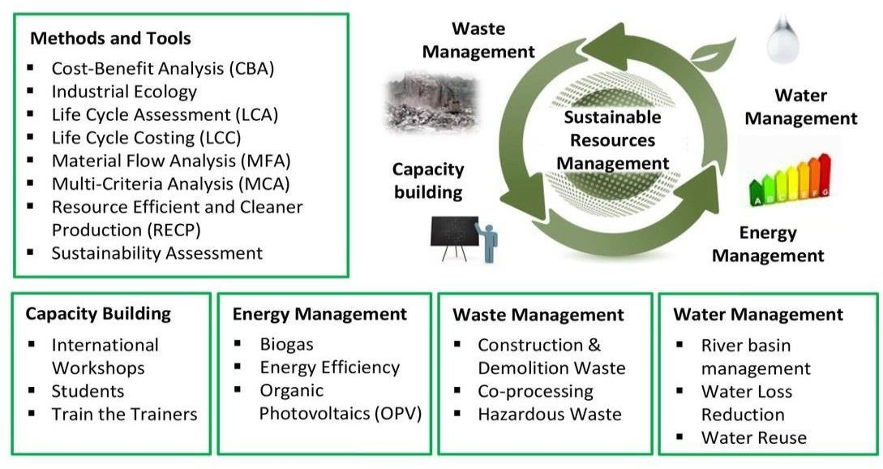

The demand for raw materials and energy is increasing worldwide causing scarcities and increases in the volatility of prices of raw materials since many resources remain insufficiently renewable. Additionally, the progressive pollution of soil, air and water resources with harmful emissions is threatening a sustainable development in many parts of the world.

The "Sustainable resources management" working group analyses and addresses such challenges. It helps develop environmentally and socially compatible resources and waste management methods, encourages the sustainable use of water resources through a comprehensive water and drainage basin management, and develops strategies to avoid waste streams or to reuse/recycle material flows and energy using cleaner production (CP) and industrial symbiosis (IS) approaches. Our collaborative work with Swiss and foreign partners

as part of national and international cooperations has proven to be instrumental to find regionally adapted and accepted solutions.

# KEY PRINCIPLES OF SUSTAINABLE RESOURCE MANAGEMENT

* **Reduce:** Minimize the number of resources you use. This can be done through efficiency measures, using less material in products, and adopting reusable items.
* **Reuse:** Find ways to use things again before throwing them away. This could involve repairing broken items, refilling containers, or donating unwanted goods.
* **Recycle:** Process used materials into new products. Recycling reduces the need to extract virgin resources and helps conserve the environment.
* **Renew:** Prioritize the use of renewable resources like solar, wind, and geothermal energy. These resources are naturally replenished and have a lower environmental impact compared to fossil fuels.

# SUSTAIANBLE RESOURCES EXAMPLES

Sustainable resources are natural resources that can be replenished or maintained over time without depleting them or causing long-term environmental damage. Here are some examples:

1. **Solar Energy:** Solar power is harnessed from the sun, a virtually inexhaustible resource. It can be used for electricity generation, heating, and various other applications without depleting the sun’s energy.
2. **Wind Energy:** Wind turbines capture the kinetic energy of wind and convert it into electricity. Wind is a renewable resource that is naturally replenished as long as the sun heats the Earth.
3. **Hydro Energy:** This involves generating electricity from flowing water, usually through dams on rivers. While water cycles naturally, the sustainability of hydropower depends on managing ecosystems and water use carefully.
4. **Biomass:** Biomass energy comes from organic materials such as wood, agricultural crops, and waste. When managed sustainably, biomass can be replenished through replanting and recycling organic materials.
5. **Geothermal Energy:** This is heat energy generated and stored in the Earth. It can be used for electricity generation and direct heating applications, and it is a consistent and reliable source of renewable energy.
6. **Sustainable forestry:** Forests can be managed sustainably by harvesting trees in ways that allow for natural regeneration and maintaining biodiversity. This includes practices like selective logging and reforestation.
7. **Sustainable Agriculture:** This involves farming practices that maintain soil health, reduce the need for chemical inputs, and conserve water. Techniques like crop rotation, organic farming, and agroforestry contribute to sustainable agriculture.
8. **Aquaculture:** Sustainable aquaculture involves farming fish and other aquatic species in ways that do not deplete natural populations or harm ecosystems, such as using responsible feeding practices and avoiding overfishing.
9. **Recycled Materials:** Recycling materials like metals, paper, and plastics reduces the need for raw resource extraction, conserving natural resources and reducing environmental impact.
10. **Water:** When managed sustainably, freshwater resources can be used without depleting aquifers or damaging ecosystems. This involves practices like efficient irrigation, rainwater harvesting, and protecting watersheds.

# BENEFITS OF SUSTAINABLE RESOUCE MANAGEMENT

Sustainable resource management offers a range of benefits across environmental, economic, and social dimensions. Here are some key advantages:

* + **Environmental Protection:** Sustainable management ensures that natural resources, such as water, forests, and minerals are used in a way that maintains their availability for future generations. It helps reduce pollution, conserve biodiversity, and mitigate the effects of climate change.
  + **Economic efficiency:** By promoting the efficient use of resources, sustainable management can lead to cost savings for businesses and governments. It ensures the development of innovative technologies and processed that reduce waste and increase productivity.
  + **Long-term viability:** Sustainable practices ensures that resources are available over the long-term, supporting continuous economic activity. This reduces the risk of resource depletion, which can lead to economic instability.
  + **Social Equity:** Sustainable resource management promotes fair access to resources, ensuring that all communities, including vulnerable and marginalized groups, have the

resources they need to thrive. It also supports the creation of sustainable jobs and livelihoods.

* + **Resilience to Crises:** By maintaining the health of ecosystems, sustainable management helps build resilience against natural disasters and environmental crises. Healthy ecosystems are better able to withstand and recover from shocks such as droughts, floods, and wildfires.
  + **Improved Quality of life:** Sustainable resource management contributes to cleaner air, water, and soil, leading to improved public health and overall quality of life.. It also helps preserve natural landscapes, which are vital for recreation and cultural identity.
  + **Global Responsibility:** Sustainable practices align with global goals, such the United Nation’s Sustainable Development Goals(SDGs), promoting international cooperation and responsible resource use to tackle global challenges like climate change and poverty.

## Here's a breakdown of why and how businesses can implement sustainable practices: Why go green?

* Cost savings: Reducing resource use through efficiency measures like switching to LED lights or using recycled materials can lead to significant cost savings on energy and raw materials.
* Enhanced reputation: Consumers are increasingly drawn to companies with strong environmental practices. Sustainable management can boost brand image and attract eco-conscious customers.
* Compliance with regulations: Environmental regulations are becoming stricter. Proactive businesses that adopt sustainable practices are better prepared to meet future regulations.
* Improved resource security: By reducing dependence on finite resources, companies are less vulnerable to price fluctuations and supply chain disruptions.
* Innovation: Sustainable practices often lead to new product development and innovative solutions, giving businesses a competitive edge.

# IMPLEMENTATION OF SUSTAINABLE RESOURCE MANAGEMENT

Here are some key strategies businesses can adopt:

* Energy efficiency: Invest in energy-efficient equipment, utilize renewable energy sources like solar or wind power, and implement practices like turning off lights and electronics when not in use.
* Water conservation: Fix leaks, install low-flow fixtures, and explore water recycling options.
* Material sourcing: Use recycled or sustainably sourced materials whenever possible.
* Waste reduction: Implement the "Reduce, Reuse, Recycle" hierarchy in your operations. Minimize waste generation, find ways to reuse materials, and establish a robust recycling program.
* Sustainable supply chain: Partner with suppliers who themselves have sustainable practices to ensure responsible sourcing throughout the entire chain.
* Employee engagement: Educate and empower employees on sustainable practices within the company. Encourage their participation in green initiatives.

## Examples of sustainable practices in business:

Sustainable resource management is an ongoing journey for businesses committed to making a positive environmental impact.

* + A clothing company using organic cotton and recycled polyester.
  + A restaurant composting food scraps and using energy-efficient appliances.
  + An office implementing a paperless workflow and using recycled paper products.

Implementing sustainable practices is essential for the long-term success of both businesses and the environment. By leveraging big data analytics tools and modules, organizations can uncover valuable insights into their resource usage, pinpoint inefficiencies, and make informed decisions to enhance their resource management strategies. The integration of real-time analytics and IoT for monitoring and data collection can further optimize these practices. This

comprehensive approach to resource management not only supports sustainability but also helps businesses improve their bottom line and strengthen their reputation for the future.

## Some steps we can take to make resource management more sustainable include:

* Implementing energy-efficient technologies and practices, such as using renewable energy sources and optimizing energy consumption across operations.
* Adopting circular economy principles, such as reducing waste, reusing materials, and promoting recycling.
* Integrating smart meters and energy management systems to track and optimize energy usage.
* Promoting water conservation strategies, such as implementing smart irrigation systems and efficient water management practices.

Investing in research and development to find innovative solutions for resource management, such as developing new materials with reduced environmental impact or implementing advanced technologies for waste recycling and treatment.

In the pursuit of implementing sustainable practices for resource management, it is essential to delve deeper into the integration of these strategies within different industries. The application of digital transformation and data analytics in resource management varies across sectors and presents unique challenges and opportunities.



## Industry-specific Implementation of Sustainable Resource Management

* **Manufacturing Sector**

In the manufacturing sector, the integration of digital technologies such as Internet of Things and data analytics plays a crucial role in optimizing resource utilization. By implementing advanced robotics and artificial intelligence, organizations can automate production processes, leading to reduced energy consumption and minimized material waste. Moreover, the utilization of IOT sensors in manufacturing facilities enables real-time monitoring of energy usage and production efficiency, facilitating proactive adjustments to resource allocation.

## Agriculture and Farming

In the agricultural domain, the incorporation of IOT sensors and data analytics tools revolutionizes resource management practices. Real-time monitoring of soil moisture levels, weather conditions, and crop health empowers farmers to make informed decisions regarding irrigation, fertilization, and pest control. This not only leads to efficient water usage and reduced chemical applications but also contributes to improved crop yields and sustainability in agricultural practices.

## Energy and Utilities

For energy and utility companies, the focus on sustainable resource management involves the deployment of smart meters and energy management systems. These technologies enable real- time tracking and optimization of energy usage, contributing to efficient operational practices and reduced environmental impact. Additionally, the integration of renewable energy sources and advanced energy-efficient technologies further reinforces the commitment to sustainable resource management.

Sustainable resource management in business involves the strategic use and conservation of resources to ensure long-term environmental, social, and economic sustainability. This approach integrates principles of sustainability into business operations, decision-making, and strategies to minimize environmental impact, promote social well-being, and ensure economic viability. Here are some key aspects of sustainable resource management in business:

## Resource Efficiency:

Energy Efficiency: Implementing measures to reduce energy consumption, such as using energy-efficient technologies and practices.

Water Conservation: Optimizing water use and recycling water to minimize waste.

Material Efficiency: Reducing material waste through recycling, reusing materials, and optimizing production processes.

## Renewable Resources:

Renewable Energy: Investing in renewable energy sources such as solar, wind, and hydro power to reduce reliance on fossil fuels.

Sustainable Sourcing: Using raw materials from sustainable sources, such as certified wood, organic cotton, or sustainably harvested seafood.

## Waste Management:

Reduce, Reuse, Recycle: Implementing the three R’s to minimize waste and promote circular economy practices.

Waste-to-Energy: Converting waste into energy through processes like incineration or anaerobic digestion.

## Sustainable Supply Chain:

Ethical Sourcing: Ensuring that suppliers adhere to ethical and sustainable practices.

Supply Chain Transparency: Monitoring and reporting on supply chain practices to ensure sustainability.

## Corporate Social Responsibility (CSR):

Community Engagement: Supporting local communities and contributing to social development.

Employee Well-being: Promoting fair labour practices, health, and safety in the workplace.

## Environmental Impact Assessment:

Life Cycle Assessment (LCA): Evaluating the environmental impacts of products or services throughout their life cycle.

Environmental Management Systems (EMS): Implementing systems like ISO 14001 to manage and reduce environmental impacts.

## Innovation and Technology:

Green Technologies: Investing in technologies that reduce environmental impact, such as electric vehicles and sustainable packaging.

Digitalization: Using digital tools to optimize resource use and improve efficiency.

## Policy and Regulation Compliance:

Adhering to Environmental Regulations: Ensuring compliance with local, national, and international environmental laws and regulations.

Voluntary Standards: Participating in voluntary sustainability standards and certifications, such as LEED, Fair Trade, or B Corp.

## Stakeholder Engagement:

Transparency and Reporting: Regularly reporting on sustainability performance and engaging with stakeholders, including customers, employees, investors, and communities.

Sustainability Goals: Setting and publicly committing to sustainability goals and targets.

By integrating these principles, businesses can not only reduce their environmental footprint but also enhance their reputation, reduce costs, and create long-term value for stakeholders.

# CONCLUSION

Sustainable resource management is not just an environmental imperative but also a strategic business approach that promotes long-term economic and social benefits. Businesses that commit to these practices play a critical role in fostering a sustainable future, minimizing their environmental footprint, enhancing operational excellence, and creating lasting value for stakeholders. By embracing sustainability, businesses can secure their viability and contribute positively to the planet and society.

Sustainable resource management in business is indispensable for addressing the escalating global demand for raw materials and energy, while also mitigating environmental pollution. This practice is pivotal in ensuring that current needs are met without compromising the ability of future generations to meet their own, integrating economic, environmental, and social considerations to use resources efficiently and responsibly.