**Spectrophotometric and physicochemical investigations of congo, alizarin** **red dyes and BSA interactions with Au, Ag and Au/Ag mix nanoparticles, and their antimicrobial activities**

Ankita Chaudharya, Chetan B. Sangania*, R. K. Ametaa*

bShri Maneklal M. Patel Institute of Sciences & Research, Kadi Sarva Vishwavidyalaya, Gandhinagar, Gujarat, India

**Corresponding author**

**Email: ametarakesh40@gmail.com**

**Abstract**

Individual and mix metal nanoparticles of Ag and Au have been prepared by the reducing method where citrate was used as reducing/ stabilizing agent. The prepared NPs were characterized with UV/ Visible and transmission electron microscopic (TEM) tools. The characteristic peak in UV/ Visible at 525, 444 and 531 nm for Au, Ag and Ag/Au mix NPs respectively, gave primary confirmation of prepared NPs. TEM analysis showed the size of nanoparticles as 44.04, 19.78 and 30.93nm for Ag, Au and Ag/Au mix NPs respectively. Congo and alizarin red dye interactions studies have been performed with prepared NPs to see the removal of the pollutants from water. Congo dye has shown weaker interaction as compared to alizarin due to structural symmetry. Amongst all, the AgNPs have shown maximum 67% and 75% interactions with Congo red and alizarin respectively due to high negative charges on the surface. The Au, Ag and Au/Ag mix NPs have shown stronger interaction with bovine serum albumin (BSA) protein up to 51, 59, 55% respectively, estimated through UV/Vis and physicochemical analysis. The biological evaluations of the prepared NPs have shown their antibacterial activity against Gram +ve and –ve species showing up to 9cm zone of inhibition. The BSA interaction and antibacterial activity of NPs reveal the importance of NPs in medicinal field.

**Key worlds**: Ag/Au mix nanoparticles, TEM, Dye interactions, Gram +ve/–ve bacteria

1. **Introduction**

Metal nanoparticles have attracted great attention of researchers and scientist due to their outstanding physicochemical properties. Among metals, the Ag and Au are more fascinating because of their high optical, electrical, and thermal, high electrical conductivity, and biological properties. [1-4] The nano size of metal NPs results surface plasmon resonance (SPR) property which varies with the size of NPs, and accountable for many characteristic properties of the NPs [5-6]. This SPR phenomenon is correlated to the colour and characteristic UV/ Vis wavelength of colloidal metal NPs. Such thing is observed in case of AuNPs due to interaction of oscillating free electrons in the conduction band with the incoming light radiation of appropriate wavelength in plasmon band [7]. Apart from this, the Ag and AuNPs are being widely used in medical, food, health care, consumer, and industrial purposes, due to their unique physicochemical properties. Currently, due to increase in populations, the demands of daily usable goods has been increased. For their production, many toxic chemicals are being used by the chemical industries, and their discharges contaminate the drinking water. Among all pollutants, the Congo red (CR) and Alizarin Red S (ARS), shown in Figure 1, are very toxic and attracted the attention of the researchers due to their limited studies and high toxicity. These are anionic dyes being widely used in textiles, paper, rubber, and plastic industries, and accountable for polluting the water at a major extent [8]. Therefore, there is an urgent need to remove these pollutants from water. In this regard the Ag and Au NPs have been found much effective due to their strong interaction ability with such chemicals due to larger surface area [9-11]. Apart from this, the binding of nanoparticles with peptides, proteins and other complex molecules are introducing affinity of interactions between the bio molecules and antibodies or cell receptors [12]. This advantage has been widely used in different applications to design nanoparticle conjugates. Surface free energy of Au, Ag and Mix NPs reduces due to the formation of protein corona around Au, Ag & Au/Ag NPs when bio molecules are easily adsorbed onto the surface of NPs [13]. BSA is one of more used protein, contains disulfide bonds those interact with NPs surface. BSA is used as a carrier for intracellular transportation and abundantly present in blood plasma, and have a great importance in pharmacology as the to decrease the toxicity of drugs. Studies of the binding of BSA to NPs surface reveals that nonspecific binding to self-assembled monolayers is favoured as hydrophobic > COO- > NH3 > OH > ethylene glycol [14-16]. In this context, in present study, we report the preparation of citrate capped AgNPs, AuNPs and Ag/Au mix NPs and their interactions with organic pollutants such as dyes and BSA, and their antibacterial activity showing their multipurpose applications.

1. **Experimental section**
   1. **Materials**

Chloroauric acid (HAuCl4) (99%), trisodium citrate, silver nitrate, congo red and alizarin red were purchased from Sigma-Aldrich, and used as received. Sample solutions were prepared using double distilled water.

* 1. **Preparation of Au, Ag and Mix Ag/AuNPs**

The citrate-stabilized AuNPs were prepared through chemical reduction method [17]in which 0.1mM HAuCl4 was taken as precursor of Au as Au3+ that become reduced by 0.5% trisodium citrate. The colour of AuNPs solution is observed from yellow to red or yellow to blue (Figure 2) where the carboxylic (-COOH) groups of citrate provided negative charge to the AuNPs surface [17]. Similarly, Citrate capped AgNPs were prepared by the same reduction method in which 1mM silver nitrate as silver precursor was reduced by 0.5% trisodium citrate. The colour of AgNPs solution is observed from colourless to yellow. Mix (Au + Ag) NPs were prepared by the same reduction method in which 0.1mM HAuCl4 and silver nitrate mixed in same proportion and reduced by 0.5% trisodium citrate. The colour of (Au+Ag) NPs solution was noted as red. Prepared AuNPs, AgNPs and Mix NPs were characterized using UV-vis spectroscopy (Shimadzu UV1800) and transmission electron microscopy (TEM) (200 KV Technai-20, Phillips, Holland). In UV/ Vis, first aqueous citrate solution was used as blank and then dispersed NPs solution were taken for analysis. The size and morphology of NPs were investigated by HRTEM (JEOL JEM 2100F) at an accelerating voltage of 120 kV. Samples for TEM analysis were prepared by dropping the dispersed NPs in AUA onto a 3 mm copper grid coated with carbon film. This was followed by staining the grid with negative stain of ammonium molybdate (7.5 pH) which was previously filtered by 0.45 μm filter. The stain on edges of the grid was drained out using filter paper, and allowed to dry at room temperature.

* 1. **Interaction of dyes with Au, Ag and Mix NPs**

For the interaction analysis between AuNPs, AgNPs and Mix NPs with CR and ARS, the initial concentration of CR and ARS dyes as 100µM and 500µM respectively, were mixed individually with prepared AuNPs, AgNPs and MixNPs in separate vials at room temperature. Samples were prepared by mixing of different ratio of dye and NPs where the volumetric ratios of NPs:dye was 6:6, 6:5.5, 6:4.5, 6:3.5, 6:2.5, 6:1.5, and 6:0.5 respectively. After mixing of NPs with dyes, change in colour was observed and analysed with and UV-Visible spectroscopy. For this, initially aqueous citrate was taken as blank and then samples were analysed in UV/ Vis.

* 1. **Physicochemical analysis of** **dyes with synthesised Au, Ag and Mix NPs**

The density, pH, conductance, viscosity and potential of pure dye, pure NPs and dye + NPs solutions were investigated for comparative interaction analysis. Solutions (w/w) were prepared using Mettler Toledo New Classic MS with an inbuilt self-calibrator of ±1 × 10−4g accuracy. pH was measured by pH meter model EQ-615 which was calibrated by buffer solution of 4, 7 and 9.2 pH. The potential was measured by Potentiometer model no. EQ-601 which was calibrated by adjusting the potential value 1.018 V of calomel electrode in saturated KCl solution. Two electrodes calomel (as a reference) and platinum electrodes were used to measuring the potential. The conductivity was measured by Conductivity meter model no. EQ-667 that was calibrated by 0.1, 0.01 and 0.001 molal KCl solutions. Densities (ρ) were measured using an Anton Paar Density meter, DSA 5000 M, having ±1 × 10−3 K temperature controlled via built-in-Peltier device and ±5 × 10−6g·cm−3 accuracy. The Anton Paar measures oscillation periods of quartz U tube with air, solvent and solutions [18-19]. For each measurement the sample holding tube was cleaned with acetone and dry air using an air pump. Viscosity was measured by Ostwald viscometer where measuring the time for a known volume of the liquid (the volume contained between the marks A and B) to flow through the capillary under an influence of gravity. The instrument was calibrated with materials of known viscosity such as pure (deionized) water, and viscosity was calculated as follows.

Here η1 and η2 are viscosity coefficients of the sample and water, and ρ1 and ρ2 are the densities of sample and water, respectively. A literature comparison of instrumental data is reported in the Table 1 [20] showing the instrument validity.

* 1. **Interaction of BSA with Au, Ag and Mix NPs**

To study the interaction between citrate capped AuNPs, AgNPs and Mix NPs with BSA, initial concentration 38.8µM BSA mixed individually with AuNPs, AgNPs and MixNPs in separate vials at room temperature. Five samples of 5 ml each were prepared by mixing different concentration of BSA with different volumetric ratios of Au: BSA -5:5, 5:4.5, 5:3.5, 5:2.5 and 5:1.5 respectively. For Ag: BSA, and Mix: BSA same ratio was taken. After mixing of NPs with different concentration of BSA, colour change was observed and examined with and UV-Visible spectroscopy. For the same solution the physicochemical data such as pH, potential, conductivity, density and viscosity were also investigated for better understanding of interaction.

* 1. **Antimicrobial activity**

The prepared NPs were assessed for their antibacterial activities against human pathogenic bacteria, viz. gram +ve B. subtilis (ATCC6633), S. aureus (ATCC6538) and and gram -ve E.coli (ATCC35218), P. aeruginosa (ATCC13525) by Kirby Beurs Disc Diffusion Method using ethanol as solvent at 20 *μg*mL−1 with Mueller Hinton Agar media [21]. The zone of inhibition was measured in millimetre (mm) after 24 h incubation at 37 °C and pH 7.4. The zones of inhibition were compared with the standard drugs Kanamycin B and Penicillin G (20 μg) which had resistant and sensitive. Discs with only ethanol were used as positive control.

1. **Results and discussion**
   1. **Preparation and characterization of prepared NPs**

Au**,** Ag and MixNPs were prepared using literature method with slight modification where citrate which functioned as reducing and stabilizing agents. In case of citrate-capped Au and Ag NPs, the addition of citrate solution to HAuCl4 and in AgNO3 led to the formation of Au from Au (III) and Ag from Ag (I) through redox reaction respectively. Then, the Au and Ag worked as seed particles for the growth of AuNPs and AgNPs respectively. On the surface of Au and Ag NPs one of -COOH groups of citrate molecule is bound to provide stability while the negative charge on Au & AgNPs comes due to free -COOH group. It provides electrostatic repulsion and stability to the Au & AgNPs [22, 23]. The characteristic UV–visible spectrum of prepared NPs is shown in Figure 3 where AuNPs showed single peak at 523 nm (3a), a strong absorption, with the red colour which is clear evidence for the formation of AuNPs [24, 25]. AgNPs showed the sharp peak at 444 nm with yellow colour providing evidence for the formation of AgNPs. The Mix NPs gave a single peak at 531 nm with strong absorption with reddish pink in colour. The UV–visible spectra of the prepared AuNPs and AgNPs show a single surface plasmon band, which means NPs was small in size and spherical in shape. For more confirmation of prepared NPs, the TEM analysis was performed to characterize size and morphology, illustrated in Figure 4,where spherical nanoparticles were noted with average size of 19.78, 44.04, and 30.93 nm for AuNPs, AgNPs, and MixNPs respectively. Among the prepared NPs, the AuNPs exhibited smaller size, while Mix NPS led to the formation of medium size. The type of functionality on AuNPs is majorly suspected for variations in the size of AuNPs [26]. Moreover, a variety of other factors including experimental conditions are also considered for the variations in the size of AuNPs [27]. Prepared NPs were found to be stable for many days and it was checked for fifteen days with their characteristic peaks in UV/ Visible region (Figure 5).

* 1. **Interactions of NPs with dyes: (Spectrophotometric analysis)**

The interaction of dyes and NPs have been evaluated on the basis of decrease in absorbance or shifting in wavelength of dye. The interactions of analytes with AuNPs, AgNPs & MixNPs induced the aggregation of NPs, which caused change of the colour of colloidal solution of AuNPs, AgNPs & MixNPs. In case of selectivity in AuNPs for particular dye, it is intensely dependent on the charge availability and functionality of NPs or molecule/s attached to the surface of AuNPs [28]. Notably, the interaction of dye molecule with the prepared Au, Ag, & Mix NPs led to the aggregation and change in its UV-Visible spectra and physical parameters. All prepared NPs were studied in term of interaction with CR and ARS dyes. CR (100μM- 6ml) added in 6ml Au, Ag and Mix NPs solution separately. In this experiment only volume of CR dye was change but volume of NPs kept constant in each addition, and total volume of solution was constant, 12ml. That mean concentration of CR dye was change by dilution, and the same is done for all dyes. In case of AuNPs and AgNPs, the maximum absorbance were found 2.91 and 1.21 at 523 and 444nm respectively while on interaction with dyes at different ration, the absorbance was found to be decreased (Figure 6). The % decrease in absorbance was calculated as under which was considered in terms of interaction.



Figure 7 depicts the % interaction of Au and Ag NPs with the CR and MixNPs with ARS where the it was found greater for AuNPs with CR as compared to ARS dyes, for example, the AuNPs74%CR > AuNPs45%ARS for the 6:6 raito of AuNPs and dyes respectively. Because, the CR dye has two –ve poles where the interaction can be occurred, but in the case of ARS, only one –ve pole, so it creates less possibility of interaction as compared to CR. In comparison of NPs the AuNPs has more interaction than AgNPs (AuNPs74%CR > AgNPs10%CR) which may be due to the AgNPs has more –ve chare on their surface as compared to AuNPs, so the interaction with –ve pole of dyes decreases due to repulsion, as illustrated in Figure 8. In case of AgNPs interacted ARS dye, a hyper chromic effect was noted which may be due to agglomeration or instability of NPs (Figure 9). For instance, the absorbance of AgNPs without dye was 1.21 at 444nm whereas with ARS dye the absorbance were 2.195, 2.11, 1.945 for 6:6, 6:5.5 and 6:5 ration respectively. Similarly, with mix NPs the hyper chromic effect was noted for both the dyes, may be because, here the effect of AgNPs dominates over the effect of AuNPs. Therefore, we can say that the CR and ARS dyes are strongly interacted with AuNPs than Ag and Ag/Au mix NPs. Apart from this, chosen dyes have characteristic spectra and absorb light in visible region. The changes of spectra, hypochromic shift, occur when dye gets adsorbed on to the surface of NPs while the pattern of dye adsorption spectrum is not changed when there is no interaction between dye and NPs. In context of dyes, here the absorbance of pure CR dye was found maximum 1.850 at 492 nm. Upon interaction, the decrease in maximum absorbance of dye was found. After addition of volume 5.5ml, 4.5ml, 3.5 ml and 2.5 ml of CR dye the absorbance is increased while upon addition of 1.5ml and 0.5 ml of CR dye, the absorbance is decreased (Figure 6 A). Similarly, the interaction of AgNPs and mixNPs affected the maximum absorbance of dye, for instance, on addition of volume 5.5ml of CR dye the absorbance is increased while addition of 4.5ml, 3.5 ml, 2.5 ml, 1.5ml and 0.5 ml of CR dye, decreased the absorbance **(**Figure 6 B**)**. Similarly, with respect to ARS dye, the interaction of NPs showed different SPR absorbance (Figure 9) with different concentrations and ration of ARS where the colour of solution became darker to lighter. The similar observation were noted for ARS as noted for CR where ARS dye (500μM – 6ml) mixed with 6 ml AuNPs, and the decrease in maximum absorbance of dye was found. Upon addition of 5.5ml and 4.5ml of ARS to the AuNPs solution, the absorbance of reaction mixture found to be increased while addition of 3.5, 2.5, 1.5 and 0.5 ml of ARS dye, the absorbance decreased (Figure 9 A), and similar trends were obtained for AgNPs and mix NPs.

* 1. **Interactions of NPs with dyes: Physicochemical analysis**

The interaction of CR and ARS has also been investigated with physicochemical parameters where the change in such parameters was considered. The different concentrations of CR and ARS dye at different ratio with NPs have been taken for the same analysis. pH of pure CR (100 μM) and ARS (500 μM) was found 7.89 and 5.35 (Suppl. Table T1 and T2) due to presence of basic and acidic groups respectively. Interaction with AuNPs led the decrease in pH of CR at small extent only because they did not disturb the H+ activity or not interacted with H+ that may be due to they have very low -ve charge on the surface. But the AgNPs have greater decreased the pH than AuNPs because they have higher –ve charge on the surface as compared to AuNPs, as shown in Figure 10. The mix NPs have changed the pH values in between AuNPs and AgNPs. Therefore, the pH analysis shows the extent of –ve charge on the surface of NPs as AgNPs > Ag/AuNPs > AuNPs, Similarly, in case of ARS the AgNPs have affected the pH greater than other NPs. The changes in potential of CR and ARS with different NPs was found as a function of concentration where pure CR showed less potential as compare to pure ARS (Suppl. Table T3 and T4). It may be due to the higher amount of charge in reaction mixture available with ARS. On interaction with NPs the potential was increased because the number of charges increased. This potential varied with type of NPs such as in case of AgNPs the potential was increased higher as compared to others. For example, the potential of CR with AgNPs was 0.265V wile with AuNPs and mix NPs the same was 0.036 and 0.047V. It indicates that with AgNPs the charge availability became increased in the interacting system. As pH analysis showed that the AgNPs have more –ve charges on the surface than mix NPs and then AuNPs, so, the potential increased as AgNPs > Mix NPs > AuNPs as compared to potential of pure CR (0.007V). The same trend was noted for the ARS and NPs. Interestingly, the conductivity analysis has proven the pH and potential analysis of interaction of dyes and NPs. The conductivity depends upon the movement ions, therefore, the interaction of NPs with the dyes has decreased the conductivity and varied with types of NPs. The interaction created the restriction for the movement of ions, and this restriction increases with the stronger interaction. For instance, the conductivities (m*S*) of pure CR (100μM) and ARS (500μM) dyes were 123.3 and 81.9 m*S,* a maximum (Suppl. Table T5 and T6). Upon interaction with NPs, the conductivity decreased, and varied as AuNPs > Mix NPs > AgNPs which is the inverse of pH and potential. It inferred that the higher charges on the surface of NPs interacts more with the dye which leads the less movement of ions or less number of free ions available in the system for movement. The AgNPs has greater interaction with dyes while AuNPs has minimum interaction with dyes that’s why the larger decreased in conductivity found with the AgNPs than mix NPs and then AuNPs. For example, the conductivity with AgNPs, mix NPs and AuNPs was 0.666, 0.566 and 2.43 m*S* respectively, as compared to pure CR (123.3 m*S*). Similarly, 0.816, 0.38 and 0.534 m*S* were found for AuNPs, Mix NPs and AgNPs respectively as compared to ARS (81.9 m*S*). The density reflects the compactness of the interacting system when two or more components interact to each other. The decrease and increase in density of NPs-CR/ ARS system from density of pure CR solution show the weaker and stronger interaction respectively. With 100µM CR has density 0.9845 kg/m3 but in 1:1 ratio with NPs the same has been noted as MixNPs-CR (1.0053kg/m3) > AgNPs-CR (0.9943kg/m3) > AuNPs(0.9825kg/m3) (Suppl. Figure S1 and Table T7). It inferred that with AuNPs the interaction of CR is less than Mix and AgNPs which may be due to more inertness of AuNPs. It shows that the interaction of AuNPs have disturbed or decreased the compactness of pure CR solution. It means, the interaction of AuNPs with CR is lesser than interaction of CR and water molecules. But, the interaction of AgNPs with CR is stronger than the water-CR interaction that’s why the density values found greater for AgNPs-CR system than AuNPs-CR as compared to pure water-CR system (Figure 11.). As increase in ration of NPs and CR, the densities have also varied from the density of pure CR. Similarly, the interaction of prepared NPs with ARS dye shows that the AgNPs have strongly interacted with the same dye estimated on the basis of density data of pure ARS dye solution. Here the pure (without NPs) ARS has 0.9981 kg/m3 density while with NPs the density became changed as ARS > AuNPs-ARS > AgNPs-ARS > MixNPs-ARS (Suppl. Table T8). In case ARS dye the compactness was found greater for AuNPs-ARS interaction as compared to ARS-water which is opposite to AuNPs-CR interaction where the water has more interacted CR than AuNPs (Figure 11). The density data show that CR has less density than ARS which may be due to their structures where CR is more symmetrical than ARS (Figure 1). Due to this symmetry, the CR has shown less density despite it has more interacting sites as compared to ARS. The viscosity analysis is presented in Suppl. Table T9 and Figure S2, where the same of pure CR at different concentration found lower than pure AR (Suppl. Table T10 and Figure S3). The viscosity revels the frictions or intermolecular forces (IMF) between the layers when liquid flows and depends upon the concentrations. So, upon interaction with NPs, the viscosity of dyes has been found to be changed and varied with different NPs. The viscosity of pure CR having concentration 100uM is 0.3816 cps but upon interaction with AgNPs, AuNPs and MixNPs, the same was found as 0.3913, 0.3987 and 0.3462 cps respectively at 1:1 ratio. It infers that CR molecules interacted NPs with different strength where AgNPs have shown stronger interaction as compared to other. As discussed above where pH, conductivity and density data revealing the stronger interaction for the same. Similar trend was noticed for the ARS dye where pure ARS showed 0.3969 cps whereas upon interaction with AgNPs, AuNPs and MixNPs, the same was found as 0.4121, 0.4125 and 0.3783 cps respectively at 1:1 ratio.

* 1. **Interactions of NPs with BSA: Spectrophotometric analysis**

The interaction of BSA with prepared NPs have been analysed in terms of decrease in absorbance of NPs from their pure form (without BSA) [29, 30]. The changes of spectra occur when BSA interacted to the NPs and decreased absorbance of NPs due to electrostatic attraction between the positive surface residues of BSA and the negatively charged NPs (Figure 12). AuNPs, AgNPs and MixNPs induced the aggregation with BSA interactions which caused change of the colour of AuNPs, AgNPs & MixNPs colloidal solution. Notably, the interaction of BSA with the Au, Ag, & Mix NPs led to the aggregation of these three NPs and change in its UV-Visible spectra and physical parameters. BSA protein (38.8μM- 5ml) added in 5ml Au. The absorbance of pure AuNPs found maximum 2.930 at 523 nm while upon interaction, the decrease in maximum absorbance of AuNPs was found. After addition of volume 4.5ml the absorbance is decrease when addition of 3.5 ml, 2.5 ml and 1.5 ml of BSA the absorbance is increases (Figure 12). The absorbance of pure AgNPs is maximum 1.210 at 444 respectively where the interaction with BSA decreased the maximum absorbance of AgNPs. After addition of volume 4.5, 3.5, 2.5 and 1.5 ml of BSA the absorbance is increased (Figure 12). Similarly, the absorbance of pure MixNPs (Ag+AuNPs) was noted maximum 0.427 at 531 nm while upon interaction the decrease in maximum absorbance of MixNPs was found.

* 1. **Interactions of NPs with BSA: Physicochemical analysis**

pH of pure BSA (38.8 μM) was found 7.44 whereas interaction with NPs led the increase in pH of AuNPs-BSA and MixNPs-BSA where AgNPs-BSA decreases as shown in Suppl. Table T11 where pH of AgNPs-BSA is lower than AuNPs-BSA and Mix-BSA. Here pH of pure BSA is more than 7 inferring the more positively charged surface of BSA. Thus the negatively charged NPs have good interaction with BSA. The change in potential (E.M.F) of BSA with different NPs as a function of concentrationshown inSuppl. Table T12 where changes in EMF values of BSA with NPs are due to higher or lower amount of charge in interacting mixture. When current flows, the point become more negative and higher potential has more number of electrons and have negative charge potential. Suppl. Table T13shows the conductivity (m*S*) of BSA with different NPs where conductivity of pure BSA (μ*S*) and NPs at different concentration is randomly increase and decrease. Conductivity of AgNPs-BSA is higher than AuNPs-BSA and Mix-BSA. There is decrease in mobility of electrons, conductivity also decreases. Conductivity has linear relation with the number of ions and concentration also. Suppl. Table T14 show the densities of pure BSA and BSA with NPs where the density of pure BSA with concentration 10.36 µM has been found more than the densities of NPs-BSA and also not much changes in density of NPs-BSA means less compactness. Density is directly proportional to the weight of solution and more density contains more particles and closely arranged.Suppl. Table T15show the viscosity (cps) data of pure BSA with NPs where viscosity has linear relation with time. The viscosity of pure BSA with concentration 10.36 µM has been found more than the viscosity of NPs-BSA. Viscosity increase when BSA (38.8 µM) interact with NPs, AgNPs-BSA show lower than AuNPs-BSA and MixNPs-BSA. At concentration 31.06 µM viscosity of NPs-BSA decrease, at concentration 21.27 µM viscosity of NPs-BSA increase, at 10.36 µM viscosity of NPs-BSA decrease and at 5.27 µM viscosity of NPs-BSA decrease as compared with pure BSA. Thus the changes in viscosity infers the interaction between BSA and NPs.

* 1. **Antibacterial activity**

The zone of inhibitions was the measure for antibacterial activity [31] where the effect of NPs was compared with standard drug. The zone of inhibition was found high for AgNPs than AuNPs and MixNPs against B. subtilis (ATCC6633), S. aureus (ATCC6538) and E. coli (ATCC35218), P. aeruginosa (ATCC13525) as shown in Figure 13. As compared to standard drug the NPs showed higher activity. The higher surface area and charge on the surface of prepared NPs interact with bacterial cell wall which restricts the growth of cell. This antibacterial activity of NPs may also be due to blocking the production of peptidoglycan which is responsible for the growth of bacterial cell wall. Therefore, prepared NPs are of medicinal uses.

1. **Conclusion**

The interaction study of freshly prepared citrate capped AuNPs, AgNPs and MixNPs with Congo Red & Alizarin Red S dyes estimated through UV-Visible and physicochemical parameters revealed the binding with dyes. AgNPs have strongly interacted with dyes as compared to AuNPs and Au/AgNPs due to their higher surface charge. Similarly, BSA protein interaction and antimicrobial activity of prepared NPs show their importance in medicinal field.

**Acknowledgement**

Authors are very thankful to Shri Maneklal M. Patel institute of sciences and Research, Kadi Sarva Vishwavidhyalaya for giving infrastructure and laboratory facility.

**References**

[1]. S. Gurunathan, J.H. Park, J.W. Han, J.H. Kim, Int. J. Nanomed. (2015) 10 4203–4222.

[2]. W.R. Li, X.B. Xie, Q.S. Shi, H.Y. Zeng, Y.S. Ouyang, Y.B. Chen, Appl. Microbiol. Biotechnol. 85 (2010) 1115–1122

[3]. P. Mukherjee, A. Ahmad, D. Mandal, S. Senapati, S.R. Sainkar, M.I. Khan, P. Renu, P.V. Ajaykuma, M. Alam, R.Kumar, Nano Lett. 1 (2001) 515–519.

[4]. Rakesh Kumar Ameta, K. Ravi Shankar and Singh Man, SF Journal of Nanochemistry and Nanotechnology. 1 (2018) 1008.

[5]. K. Kim, K.L. Kim, S.J. Lee, Chem. Phys. Lett. 403 (2005) 77.

[6]. J. Yin, Z. Yu, F. Gao, J. Wang, H. Pang, Q. Lu, Angew. Chem. 122 (2010) 6472.

[7]. T. Lan, C. Q. Dong, X. Y. Huang, and J. C. Ren. Analyst, 2011, 136, 4247−4253

[8]. T. Moriguchi, K. Yano, S. Nakagawa, Kaji, J. Colloid Interf. Sci. 260 (2003) 19-25.

[9]. J. Hu, J. Zhang, F. Liu, K. Kittredge, J.K. Whitesell, M.A. Fox, J. Am. Chem. Soc. 123 (2001) 1464-1470.

[10]. B.I. Ipe, K. George Thomas, S. Barazzouk, S. Hotchandani, P.V. Kamat, J. Phys. Chem. B 106 (2002) 18-21.

[11]. P.K. Sudeep, B.I. Ipe, K. George Thomas, M.V. George, S. Barazzouk, S. Hotchandani, P.V. Kamat, J. Phys. Chem. B 108 (2004) 13066-13068.

[12]. Parth Malik, Rakesh Kumar Ameta, Recent Advances in the Au NP Treatment strategies of Lung Cancers, Springer Nature. (2019), http://doi.org/10.1007/978-981-13-3705-5

[13]. X. Bai, J. Wang, Q. Mu, G. Su, Bioeng. Biotechnol. 9 (2021) 646708. doi: 10.3389/fbioe.2021.646708

[14]. S Nakata, N Kido, M Hayashi, M Hara, H Sasabe, T Sugawara, T Matsuda, Biophys. Chem. 62 (1996) 63-72.

[15]. V Silin, H Weetall, DJ Vanderah, J. Colloid Interface Sci. 185 (1997) 94-103.

[16]. AM Moulin, S.J O’Shea, R.A Badley, P Doyle, ME Welland, Langmuir 15 (1999) 8776-8779.

[17]. J. Turkevich, PC Stevenson, J. Hillier, J. Faraday Soc.11 (1951) 55-75.

[18]. R.K. Ameta, M. Singh, Journal of Molecular Liquids, 195 (2014) 40–46.

[19]. R.K. Ameta, M. Singh, R.K. Kale, J. Chem.Thermodyn. 60 (2013) 159–168.

[20]. R.K. Ameta, M. Singh, Journal of Molecular Liquids, 203 (2015) 29–38.

[21]. Y. Duan, R. R. Koshti, A. Vyas, N. S. Trivedi, A. S. Patel, M. Muddassir, R. K. Ameta, Journal of Molecular Liquids 325 (2021) 115154.

[22]. J.-W.Park, J. S. Shumaker-Parry, J. Am. Chem. Soc. 136 (2014) 1907-1921.

[23]. H. Al-Johani, E .Abou-Hamad, A. Jedidi, C. M. Widdifield, J. Viger-Gravel, S. S. Sangaru, D. Gajan, D. H. Anjum, S .Ould-Chikh, Hedhili, Nat. Chem. 9 (2017) 890-895.

[24]. J .Pal, M.K. Deb, Indian J. Chem. Sec. A51 (2012) 821–824

[25]. J .Pal, M.K Deb, D.K. Deshmukh, D. Verma, Applied Water Sc. 3 (2013) 367–374.

[26]. P. U. Londhe, M. More, N. Chaure, IEEE (2013) 17-319.

[27]. P. Abdulkin, T. L. Precht, B. R. Knappett, H. E. Skelton, D. A. Jefferson, Part. Syst. Charact. 31 (2014) 571-579.

[28]. E. Priyadarshini, N. Pradhan, Sci. Rep. 7 (2017) 1-8.

[29]. R. K. Ameta, M. Singh, Heliyon, 5 (4) (2019) e01568.

[30]. R. K. Ameta, M. Singh, Chemistry select, 4 (2019) 1922–1929.

[31]. R.K. Ameta, Man Singh, R.K. Kale, Journal of Coordination Chemistry, 66(4) (2013) 551–567.

**Table 1.** Properties of water; density, ρ, and viscosity, η, for literature comparisons, and standard deviation, σ, with their values at T = 298.15 K.

|  |  |  |  |  |  |
| --- | --- | --- | --- | --- | --- |
| **ρ ±103 kg m−3** | |  | **η±10−4 mPas** | |  |
| **Literature** | **Exp.** | **σ** | **Literature** | **Exp.** | **σ** |
| 0.997044 | 0.997042 | 8.35 x 10-7 | 0.8937 | 0.8941 | 8.33 x 10-5 |
|  | 0.997041 |  |  | 0.894 |  |
|  | 0.997044 |  |  | 0.8941 |  |
|  | 0.997043 |  |  | 0.8942 |  |
|  | 0.997041 |  |  | 0.8941 |  |

Estimated uncertainties in density, and viscosity measurements are less than ±1 × 10−6 g·cm−3, and ±10−4 mPa·s respectively. The uncertainties in temperature are ±0.01 °C.

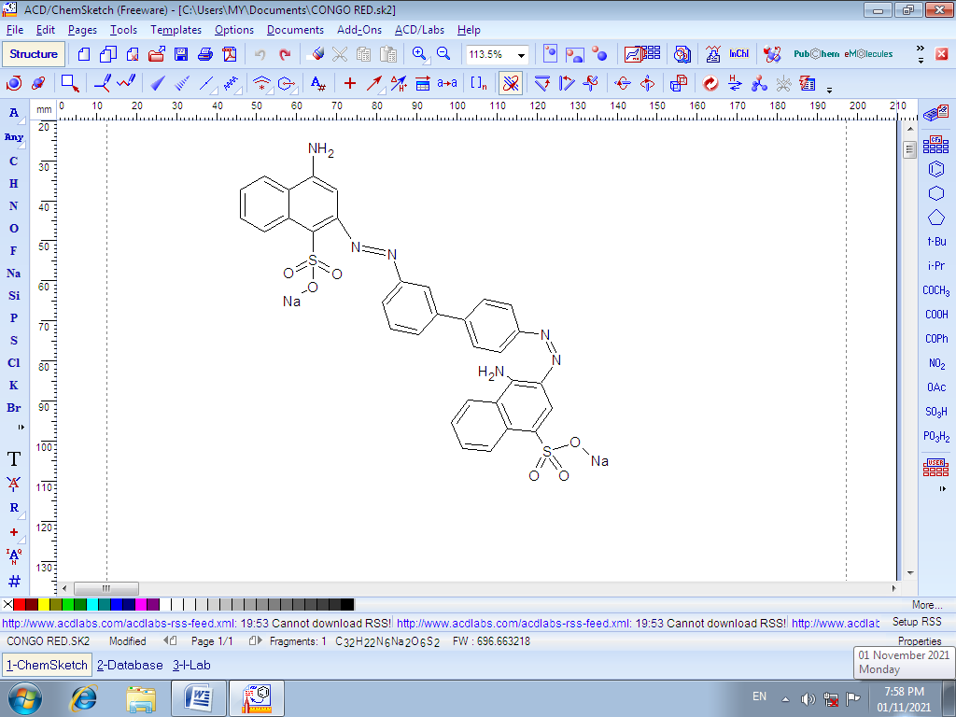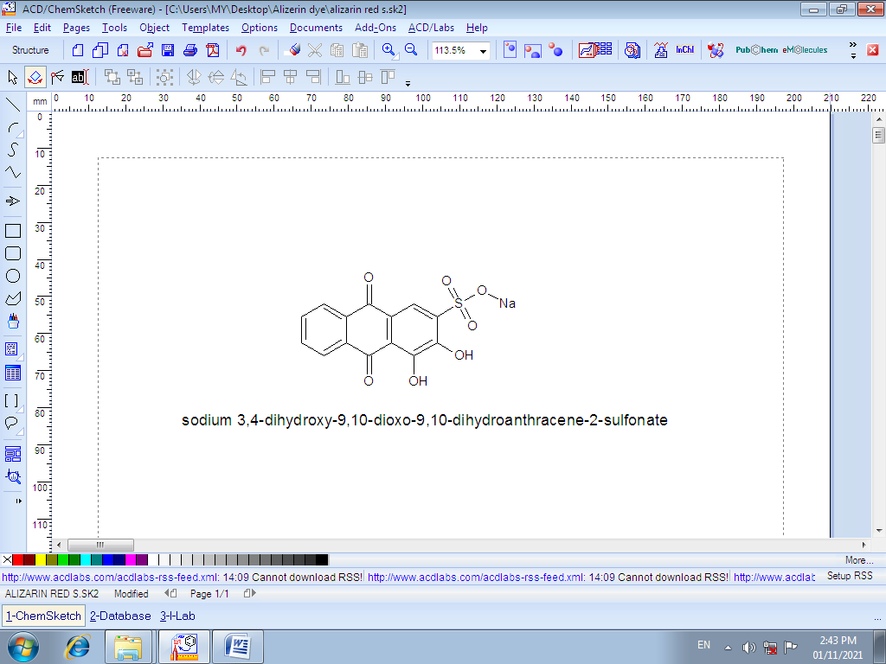

**Figure 1. Structure of Congo Red (left) and Alizarin Red S (right)**

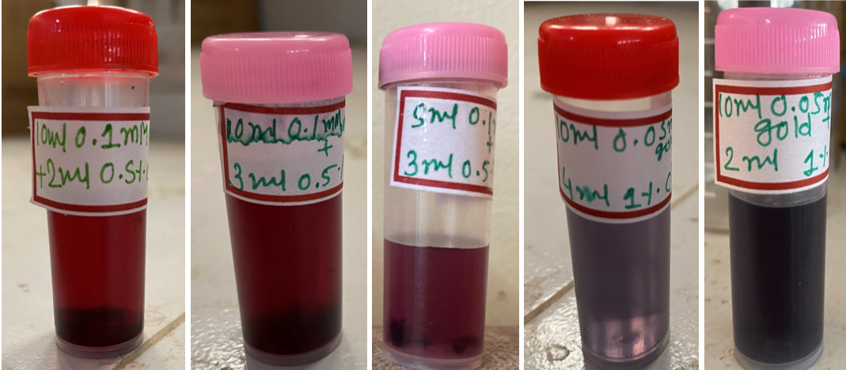

Figure 2. Different colors of AuNPs according to their different sizes.

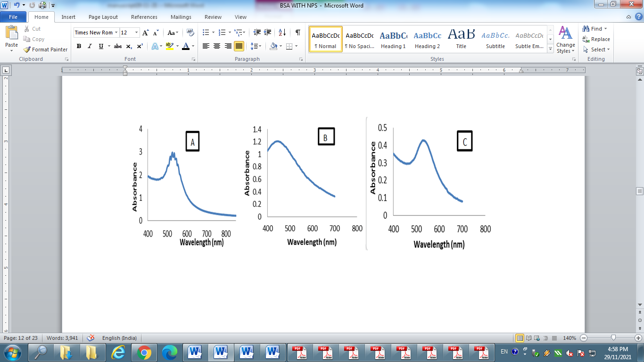

Figure 3. UV–visible spectrum of the prepared (A) AuNPs (B) AgNPs (C) Mix NPs

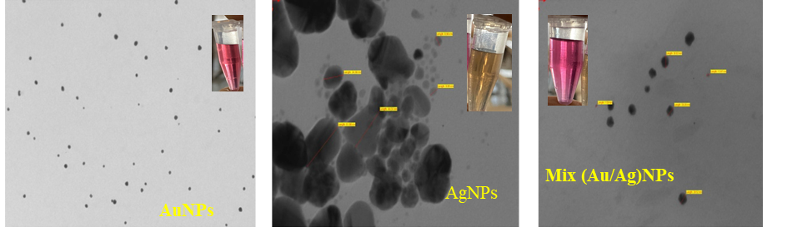

Figure 4. TEM images of synthesized citrate capped spherical AuNPs, AgNPs and Mix NPs

**Figure 5.** Stability of prepared nanoparticles till 15 days.

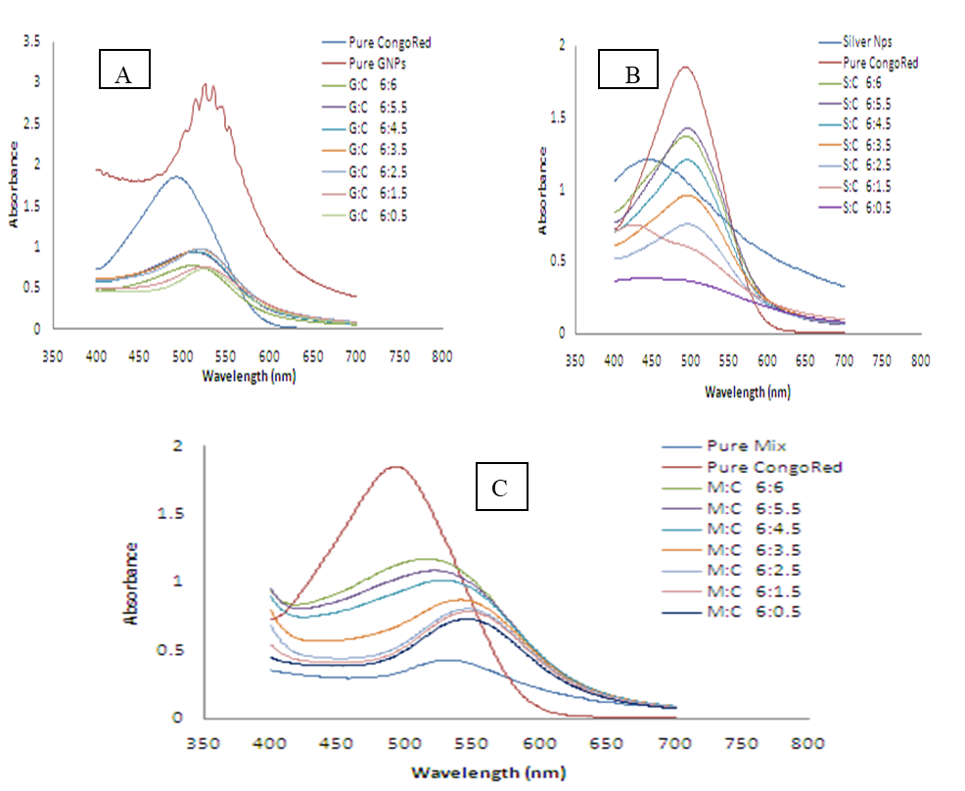

A

**Figure 6**. UV-visible spectra of CR dye at different concentration with (A) AuNPs (G:C) (B) AgNPs (S:C) & (C) Mix NPs (M:C) at different ratio of dye.

**Figure 7**. % Interaction of dye with AuNPs+ CR, AgNPs+ CR and Mix NPs+ARS estimated through UV-visible spectra.



**Figure 8**. Explanation of higher interaction of AuNPs than AgNPs where less –ve charged sphere shows AuNPs and high –ve charged sphere represents AgNPs.

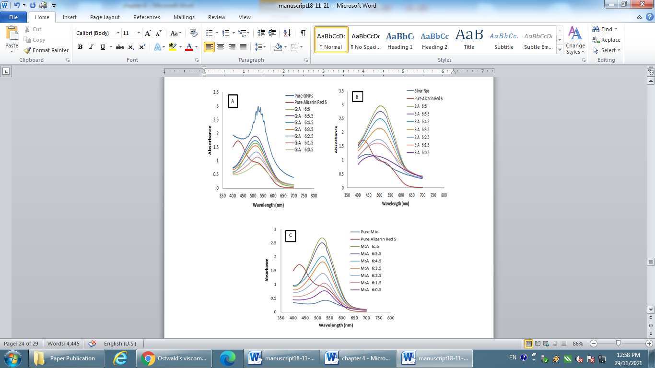

**Figure 9.** UV-visible spectra of ARS dye with (A) AuNPs (G:A) (B) AgNPs (S:A) & (C) Mix NPs (M:A).



**Figure 10.** pH analysis of interaction system (NPs + Dyes)



**Figure 11.** Increasing the compactness upon interaction.

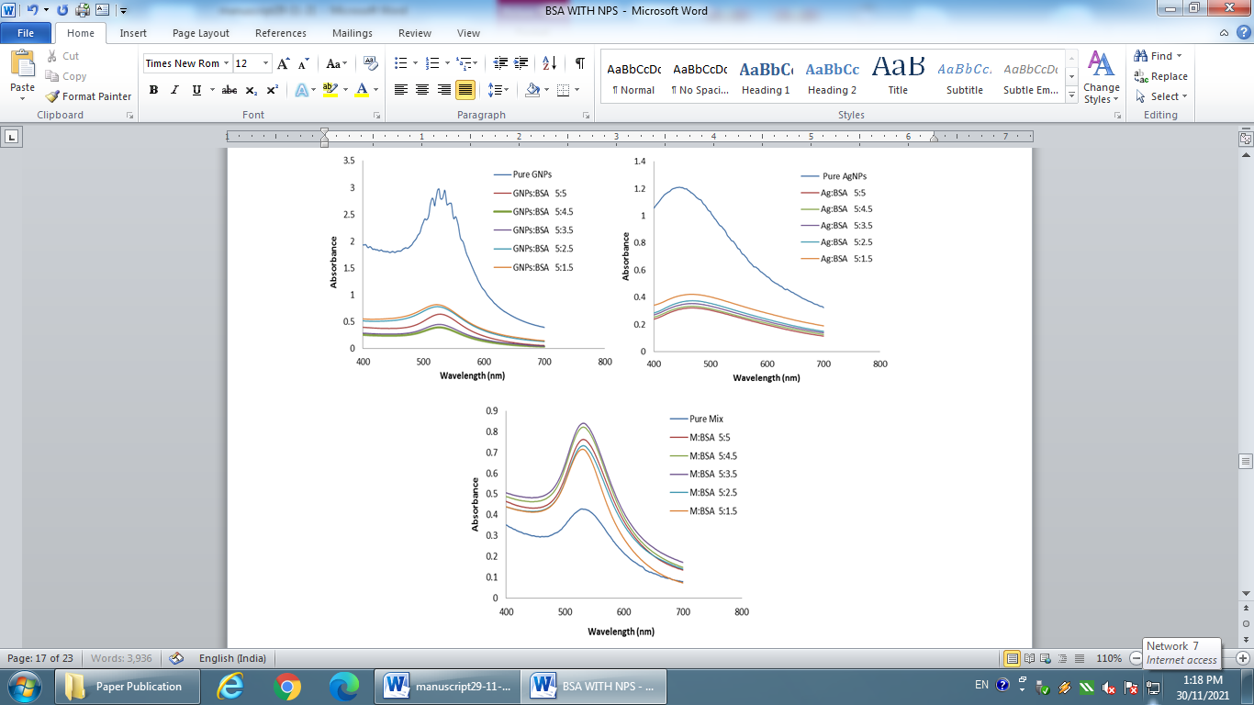

**Figure 12** UV-visible spectra of AuNPs, AgNPs & Mix NPs with BSA (A) GNPs:BSA (B) Ag:BSA & (C) M:BSA at different ratio of BSA.

**Figure 13.** Zone of inhibition shown by NPs with respective microorganism.