**Innovative Collaborations and Strategic Partnerships for Sustainable Business Practices**

**Ms. A. Latha, MBA 4th Semester, Department of Commerce and Business Management, University College for Women (Telangana Mahila Viswavidyalayam), Koti, Hyderabad**

**Abstract**

This chapter explores the strategic significance of collaboration and partnerships for achieving business sustainability. Recognizing the limitations of individual action, businesses are increasingly turning to collaborative approaches to address complex environmental and social challenges. The chapter examines various types of collaborations, key components for success, and real-world examples across industries. It highlights how collaborative initiatives can drive innovation, reduce costs, enhance brand reputation, and create shared value, underscoring their imperative for businesses in the 21st century

**Introduction**

Business sustainability encompasses a holistic approach to managing a company’s operations in a manner that balances environmental, social, and economic considerations, ensuring the well-being of both present and future generations. While individual companies have made strides in adopting sustainable practices, the escalating complexity of global challenges necessitates a shift towards collaborative solutions.

In this context, **collaboration** refers to the strategic alignment of two or more organizations to achieve shared sustainability goals. It involves the pooling of resources, expertise, and knowledge, often taking the form of joint ventures, consortia, networks, or coalitions. Collaboration enables businesses to leverage collective strengths, share risks, and co-create innovative solutions that surpass the capabilities of individual action.

**Partnerships**, a specific form of collaboration, entail more formalized agreements with clearly defined roles, responsibilities, and governance structures. These strategic alliances can be particularly effective in driving large-scale sustainability initiatives that require sustained commitment and coordinated action.

Both collaboration and partnerships are instrumental in addressing complex sustainability challenges that transcend organizational boundaries. By working together, businesses can share best practices, access new markets and technologies, and mitigate risks, ultimately enhancing their competitive advantage and contributing to a more sustainable future. This chapter delves into the various types of collaborations and partnerships available to businesses, the key components that contribute to their success, and real-world examples demonstrating their transformative power in achieving business sustainability goals.

**Types of Collaboration and Partnership in Business**

1. **Internal Collaboration**

Definition: Cooperation within an organization across different departments or teams to achieve common goals.

Example: Google’s ‘20% Time’ Policy encourages employees to spend one-fifth of their work hours on projects of personal interest, fostering innovation and collaboration across departments.

1. **Cross-Sector Collaboration**

Definition: Collaboration between organizations from different sectors (e.g., public, private, non-profit) to address common challenges or opportunities.

Example: The Partnership for New York City brings together business leaders, government officials, and non-profit organizations to promote economic growth and job creation in New York City.

1. **Industry Collaboration**

Definition: Collaboration among companies within the same industry to achieve shared objectives, such as industry standards or technological advancements.

Example: The Sustainable Apparel Coalition (SAC) includes leading apparel brands, retailers, and suppliers working together to reduce the environmental and social impacts of apparel and footwear production.

1. **Academic Collaboration**

Definition: Collaboration between businesses and academic institutions to foster innovation, research, and development.

Example: The MIT Energy Initiative partners with industry leaders and government agencies to advance research in energy technology and policy, aiming to address global energy challenges.

1. **Strategic Alliances**

Definition: Formal agreements between two or more organizations to pursue mutually beneficial objectives while remaining independent entities.

Example: The Star Alliance in the airline industry, where member airlines collaborate on marketing, route planning, and shared airport facilities to enhance passenger benefits and operational efficiency.

1. **Joint Ventures**

Definition: Business partnerships where two or more parties pool their resources and expertise to create a new entity or undertake a specific project.

Example: Sony Ericsson, a joint venture between Sony and Ericsson, collaborated to produce mobile phones and leverage each company’s strengths in consumer electronics and telecommunications.

1. **Public-Private Partnerships (PPPs)**

Definition: Collaborations between government entities and private sector organizations to finance, build, and operate public infrastructure or services.

Example: The London Underground PPP, where private sector companies were contracted to upgrade and maintain London’s underground railway system, improving efficiency and service delivery.

1. **Supplier Collaboration**

Definition: Collaboration between a company and its suppliers to improve supply chain efficiency, quality, and sustainability.

Example: Toyota’s Supplier Support Center works closely with its suppliers to implement lean manufacturing principles, reduce waste, and improve product quality across its global supply chain.

1. **Community Collaboration**

Definition: Collaboration between businesses and local communities to address social, environmental, or economic challenges.

Example: Patagonia’s Community Grants Program supports grassroots environmental organizations worldwide, fostering collaboration with local communities to protect and preserve natural resources.

1. **Technology Collaboration**

Definition: Collaboration between technology companies to develop new products, services, or technological solutions.

Example: The Open Automotive Alliance, where automakers and technology companies collaborate to integrate Android technology into vehicles, enhancing connectivity and user experience.

**Components of Successful Collaboration for Sustainability**

Successful collaboration for sustainability requires a number of key components:

**Shared Vision and Goals:** Partners must have a clear and shared understanding of what they want to achieve through collaboration. This includes defining common goals, establishing metrics for success, and aligning on values and principles.

**Trust and Transparency:** Trust is essential for any successful partnership. Partners must be willing to share information openly, communicate honestly, and address conflicts constructively. Transparency about motivations, processes, and outcomes is also crucial.

**Resource Sharing**: Collaboration allows partners to pool their resources, including financial, technological, human, and intellectual capital. This can significantly enhance the scale and impact of sustainability initiatives.

**Co-creation and Innovation:** Collaboration often leads to the co-creation of new products, services, and processes that are more sustainable than what could be achieved individually. Partners can leverage their diverse expertise and perspectives to generate innovative solutions.

**Governance and Leadership:** Effective governance structures are needed to ensure that collaborative initiatives are well-managed and achieve their goals. Strong leadership is also essential to inspire and motivate partners, resolve conflicts, and maintain momentum.

**Measurement and Evaluation:** It is important to establish clear metrics and mechanisms for measuring and evaluating the impact of collaboration. This allows partners to track progress, identify areas for improvement, and demonstrate accountability.

**Adaptability and Flexibility**: The dynamic nature of sustainability challenges requires collaboration to be adaptable and flexible. Partners must be willing to adjust their strategies and approaches as circumstances evolve.

**Innovative Partnerships Driving Sustainable Business Practices**

* From Food Waste to Craft Beer: Kellogg’s and Hallertau’s Upcycled Brew

Kellogg’s, in a bid to reduce food waste, partnered with New Zealand brewery Hallertau to create a limited-edition beer from Crunchy Nut cereal. This innovative approach repurposes cereal that doesn’t meet quality standards due to size or overcooking. In a similar move, Kellogg’s UK collaborated with Seven Bro7hers Brewery to launch “Throw Away IPA,” a beer made from discarded Cornflakes.



* Casetify’s Compostable Phone Case Collaboration with The Earth Day Network

Tech company Casetify joined forces with The Earth Day Network to introduce the world’s first 100% compostable and biodegradable phone case. The Earth Day Collection, made from discarded phone cases with nature-inspired designs, aligns with Casetify’s mission to reduce virgin plastic usage. This collaboration also amplified The Earth Day Network’s message through Casetify’s vast online community. Casetify also pledged to plant 7.8 billion trees, with one tree planted for every compostable case, biodegradable case, or reusable water bottle sold.

* Bright Brewery and POW Australia’s Sustainable Suds

Bright Brewery, situated near the Victorian Alps, partnered with Protect Our Winters (POW) Australia to create the POW Pale Ale. Part of the proceeds from each sale directly supports POW Australia’s efforts to combat climate change. The collaboration has expanded to include an exclusive clothing line and special events centered around outdoor recreation, environmental awareness, and community action

* Patagonia Provisions and Craft Breweries Raise a Glass to Regeneration

Patagonia, a pioneer in sustainability, launched a program with 11 craft breweries across the United States to produce lager-style beers using organic ingredients and regenerative Kernza®. Kernza®, a perennial grain, offers environmental benefits like improved soil health and ecosystem restoration. This initiative reflects Patagonia’s dedication to scaling regenerative agriculture practices.

* Adidas and Allbirds: Rivals Turned Collaborators in the Race for Zero Carbon

Adidas and Allbirds, once competitors, united to create the Adizero X Allbirds 2.94 KG CO2e running shoe, boasting a carbon footprint of just 2.94 kg CO2e. While not yet at zero, this collaboration demonstrates the potential of brands working together to achieve greater sustainability goals. Both companies were already focused on reducing their environmental impact, with Adidas utilizing recycled plastic and Allbirds incorporating natural resources like wool and sugarcane. This collaboration serves as a model for other brands in the industry.

**Industry Examples**

**Fashion Industry:**

H&M and WWF (World Wide Fund for Nature):

H&M has partnered with WWF to improve water stewardship throughout its supply chain. This collaboration focuses on water efficiency, wastewater treatment, and promoting sustainable water use in the regions where H&M operates.



2. **Technology Industry:**

Apple and Conservation International:

Apple collaborates with Conservation International to protect and restore critical forests and ecosystems. This partnership aims to remove carbon dioxide from the atmosphere through nature-based solutions, contributing to Apple’s goal of becoming carbon neutral by 2030.

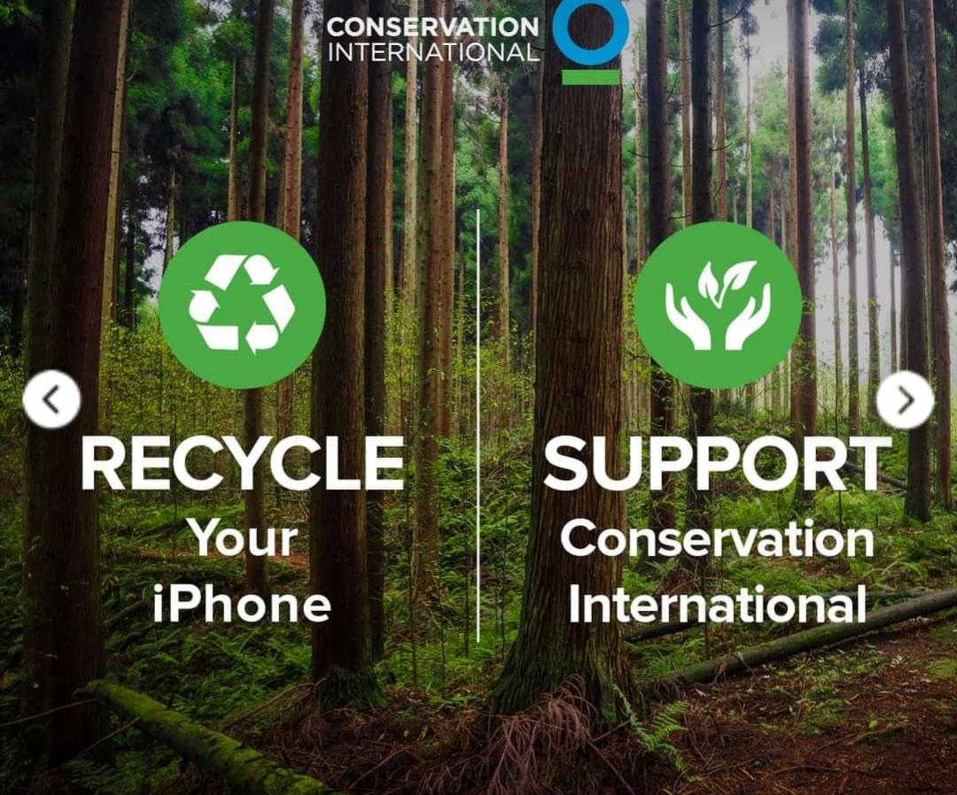

3. **Food and Beverage Industry:**

Unilever and the Rainforest Alliance:

Unilever partners with the Rainforest Alliance to source sustainable tea for its brands like Lipton and PG Tips. This collaboration ensures that the tea is grown using methods that protect the environment and promote social and economic well-being for farmers and workers.

4. **Automotive Industry:**

Toyota and Panasonic:

Toyota has partnered with Panasonic to develop and manufacture electric vehicle batteries. This collaboration aims to enhance the efficiency and sustainability of battery production, supporting the transition to electric vehicles and reducing carbon emissions.



5. **Retail Industry:**

Walmart and Environmental Defense Fund (EDF):

Walmart works with EDF to reduce the environmental impact of its operations and supply chain. This partnership focuses on energy efficiency, waste reduction, and sustainable sourcing practices to lower Walmart’s overall carbon footprint.

6. **Energy Industry:**

BP and Lightsource BP:

BP has a partnership with Lightsource BP, a global leader in solar energy development. This collaboration aims to expand solar energy projects worldwide, supporting the transition to renewable energy sources and reducing reliance on fossil fuels.

7. **Consumer Goods Industry:**

Procter & Gamble (P&G) and TerraCycle:

P&G collaborates with TerraCycle on the Loop initiative, which provides a zero-waste platform for consumers to buy products in reusable packaging. This partnership aims to reduce single-use plastic waste and promote a circular economy.

8. **Banking Industry:**

HSBC and the World Resources Institute (WRI):

HSBC partners with WRI to support sustainable finance initiatives. This collaboration focuses on developing financial products and services that promote environmental sustainability and help clients transition to low-carbon economies

**CONCLUSION**

Collaboration and partnerships are not merely optional add-ons for businesses; they are strategic imperatives in the pursuit of sustainability. By embracing collaboration, businesses can unlock a wealth of opportunities for innovation, risk mitigation, and value creation. As the world grapples with the urgent need for sustainable solutions, collaboration will play an increasingly pivotal role in shaping the future of business and society.

**REFERENCES**

www.studysmarter.co.uk

www.forbes.com

www.matthews.com

www.ideascale.com