Object Detection and Localization

Vikas Kumar
Department of Computer Science and Engineering
Dev Bhoomi Uttarakhand University, DBUU
Dehradun, India
socse.vikaskumar@dbuu.ac.in

Sukesh Kumar Bhagat
Department of Computer Science and Engineering
Dev Bhoomi Uttarakhand University, DBUU
Dehradun, India
Socse.sukesh@dbuu.ac.in

ABSTRACT

Basic tasks in computer vision, object detection and localization have many applications in autonomous driving, robotics, surveillance, and healthcare [1]. Deep learning has enabled previously unheard-of levels of accuracy and robustness in object detection and localization tasks, revolutionizing the area in recent years. This paper provides a thorough overview of the most recent developments and approaches in the application of deep learning algorithms for localization and object detection. First, we go over the basic ideas behind object identification and localization, emphasizing the difficulties caused by different item sizes, occlusions, and cluttered backgrounds. We then explore the nuances of deep learning architectures designed specifically for these kinds of tasks: anchor-free approaches like Center Net, single-shot detectors like YOLO, and region-based detectors like Faster R-CNN. We investigate feature extraction networks, object detecting heads, and training procedures for best performance as we investigate the underlying mechanics of these architectures. We also go over important assessment measures and datasets that are necessary for benchmarking and training object detection algorithms. We stress the significance of using strong evaluation techniques to guarantee the dependability and capacity for generalization of the suggested algorithms. Apart from technical concerns, we investigate practical uses cases where object detection and localization are essential, like autonomous vehicle pedestrian identification, surveillance system object tracking, and medical imaging anomaly detection.
Lastly, we examine new developments and directions for the discipline, such as integrating multimodal data, handling domain shifts, and improving object detection algorithms' interpretability and fairness. Our goal is to stimulate further developments in computer vision systems by offering scholars, professionals, and hobbyists insightful knowledge about the problems and cutting-edge methods of object recognition and localization through this thorough review. The content of the paper is succinctly summarized in this abstract, which also highlights the significance of deep learning, object detection and localization, important methodology, datasets, applications, and future developments in the field.

Keywords— enormous; contemporary; knowledge; significant; preferences

- Introduction to Computer Vision

Through the multidisciplinary field of computer vision, robots can comprehend and interpret visual data from their surroundings in a similar way to how people do with their eyes and brains. It includes a variety of activities, ranging from basic image classification to intricate scene comprehension and visual perception. Fundamentally, computer vision aims to derive significant insights from visual data, opening up a plethora of applications in a variety of industries, such as retail, automotive, healthcare, and security [2].
The two most important tasks in computer vision among the numerous others are object detection and localization. Object localization is the process of precisely defining the spatial extent or position of things, whereas object detection is the identification and classification of items inside an image or video. Numerous real-world applications, including industrial automation, surveillance systems, autonomous driving, and augmented reality, are built on these tasks.
Object detection and localization are critical because they enable robots to have a thorough awareness of their visual environment. Machines are able to interact with their surroundings intelligently, make well-informed decisions, and locate items of interest with accuracy. The powers provided by object detection and localization are essential for expanding the capabilities of computer vision systems, whether they are being used to identify pedestrians on a busy street, find anomalies in medical images, or recognize objects on store shelves.
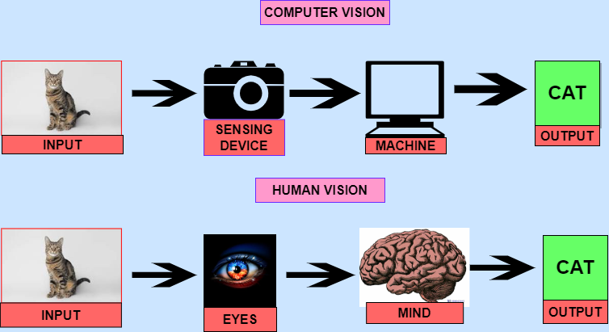
In light of this, the computer vision community has turned its attention to creating reliable and effective algorithms for object detection and localization. Researchers are pushing the envelope of what is possible by utilizing deep learning and neural network designs, which is propelling the adoption of computer vision technology across a wide range of industries and applications. It's becoming more and more clear that object recognition and localization using deep learning techniques has the potential to have a revolutionary effect on both society and technology.

Figure 1:Computer Vision

- Fundamentals of Deep Learning

A kind of machine learning called "deep learning" has become a potent paradigm for drawing connections and patterns out of complex data. Neural networks—computational models inspired by the architecture and operation of the human brain—are the basic idea behind deep learning. These networks are made up of linked nodes, or neurons, arranged in layers, each of which processes the input data in a different way.
Through the process of forward and backward propagation, in which information travels through the network and model parameters are adjusted based on the disparity between expected and actual outputs, neural networks are particularly good at learning hierarchical representations of data. This feature makes neural networks extremely accurate and efficient at solving a variety of tasks, such as generation, regression, and classification.
Convolutional Neural Network (CNN) designs are among the most prominent in deep learning [3]. CNNs are very useful for computer vision and image analysis jobs because of their capacity to automatically deduce the spatial hierarchies of features from unprocessed pixel input. CNNs can efficiently recognize local patterns and spatial correlations in pictures by utilizing convolutional layers, pooling layers, and non-linear activation functions. This allows CNNs to perform tasks like object detection, image classification, and semantic segmentation.
Practitioners in the subject need to be knowledgeable with deep learning frameworks in addition to neural network structures. The infrastructure and abstractions required for effectively developing, training, and implementing neural network models are provided by deep learning frameworks.
Two of the most popular frameworks are TensorFlow and PyTorch, which provide rich libraries of pre-defined layers, optimization techniques, and tools for easy testing and implementation [4]. The speed of innovation in the area is accelerated by these frameworks, which enable researchers and developers to take full advantage of deep learning's capabilities without becoming bogged down in minute implementation details.
To summarize, mastery of deep learning frameworks such as TensorFlow and PyTorch, together with a firm understanding of neural networks, especially CNNs, are prerequisites for successfully utilizing deep learning methods for object detection and localization in computer vision systems.
With these concepts and methods at their disposal, practitioners can push the limits of computer vision technology and take on challenging real-world problems.

Type of Deep Learning:- There are some type of Deep Learning. Which are given below-

- Feedforward Neural Networks (FNN):
- Alternatively referred to as multilayer perceptrons (MLPs), these are the most basic type of deep learning models [5].
- consists of an output layer, an input layer, and one or more hidden layers.
- There are no cycles or loops in the network since every neuron in one layer is connected to every other layer's neuron.
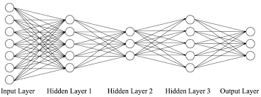

Figure 2: Feedforward Neural Networks (FNN):

- Convolutional Neural Networks (CNN):
- Mostly utilized for jobs involving picture identification and categorization.
- consists of fully connected, pooling, and convolutional layers.
- Convolutional layers utilize filters to extract characteristics from input data [6].
- Pooling layers preserve significant information while reducing the dimensionality of the data.
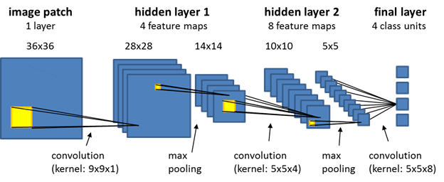
- Fully connected layers categorize the characteristics that were extracted by earlier levels.
Figure 3: Convolutional Neural Networks (CNN)

- Recurrent Neural Networks (RNN):
- Designed to manage sequential data, including audio, text, and time series data.
- Possess directed cycle-forming connections, which enable them to display temporal dynamic activity [7].
- Their ability to store knowledge about past inputs through hidden states makes them appropriate for applications such as sentiment analysis, machine translation, and language modeling.
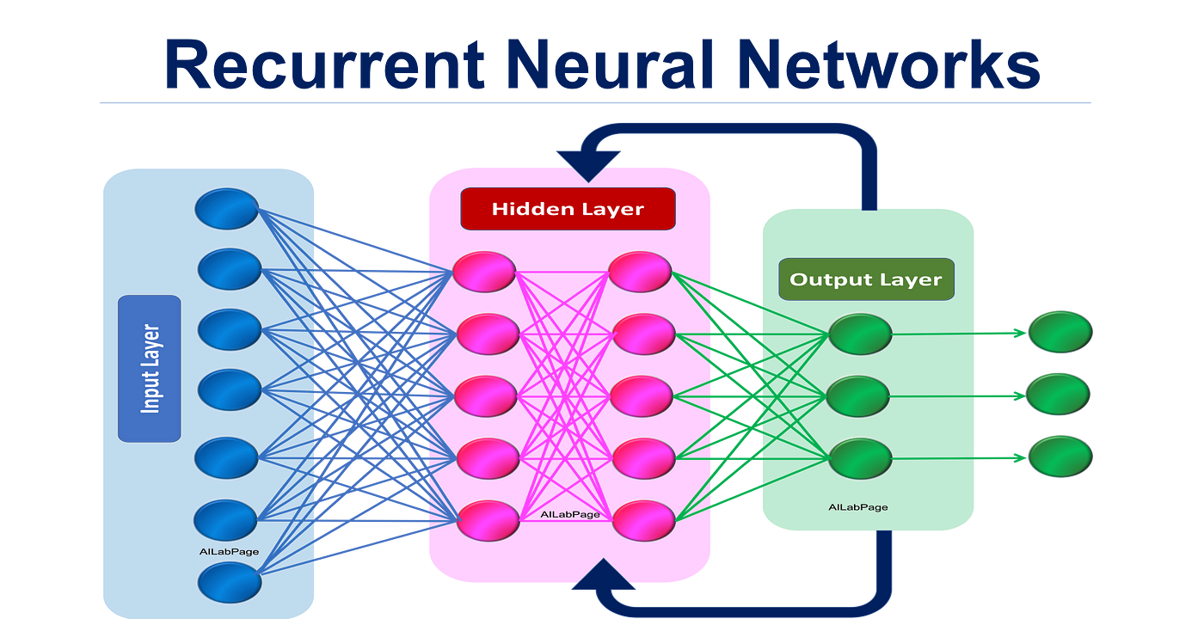

Figure 4: Recurrent Neural Networks (RNN):

- Object Detection Techniques

One of the most important tasks in computer vision is object detection, which allows machines to recognize and locate several things inside an image or video frame. Many strategies, from more modern deep learning approaches to more conventional ways, have been developed over time to address this issue.
In order to identify things within photos, traditional object identification techniques frequently rely on manually created features and meticulously designed algorithms. These methods usually include several phases of feature extraction, categorization, and preprocessing. Although useful in some situations, traditional approaches' reliance on hand-crafted features makes them unreliable in complicated settings, changing illumination, and occlusions.
On the other hand, deep learning techniques have completely changed object detection by using neural networks' ability to autonomously create hierarchical representations of visual data. There is a significant difference between single-stage and two-stage detectors in deep learning-based object detection methods.
Two-step detectors work in this manner: Region-Based Convolutional Neural Networks (R-CNN), Fast R-CNN, and Faster R-CNN. Using region proposal techniques (such as selective search or region proposal networks), they first identify prospective regions that are likely to contain items. They then categorize and improve these suggestions to produce final detections. Because these approaches include multiple steps, they are frequently slower even though they have a higher accuracy rate.
However, object bounding boxes and class probabilities are directly predicted by single-stage detectors, as demonstrated by models like as You Only Look Once (YOLO) and Single Shot MultiBox Detector (SSD), in a single network run. These models are well-suited for real-time applications because of their efficiency and well-known simplicity. But when compared to two-stage detectors, they might give up some accuracy, particularly when handling overlapping cases or identifying small objects.
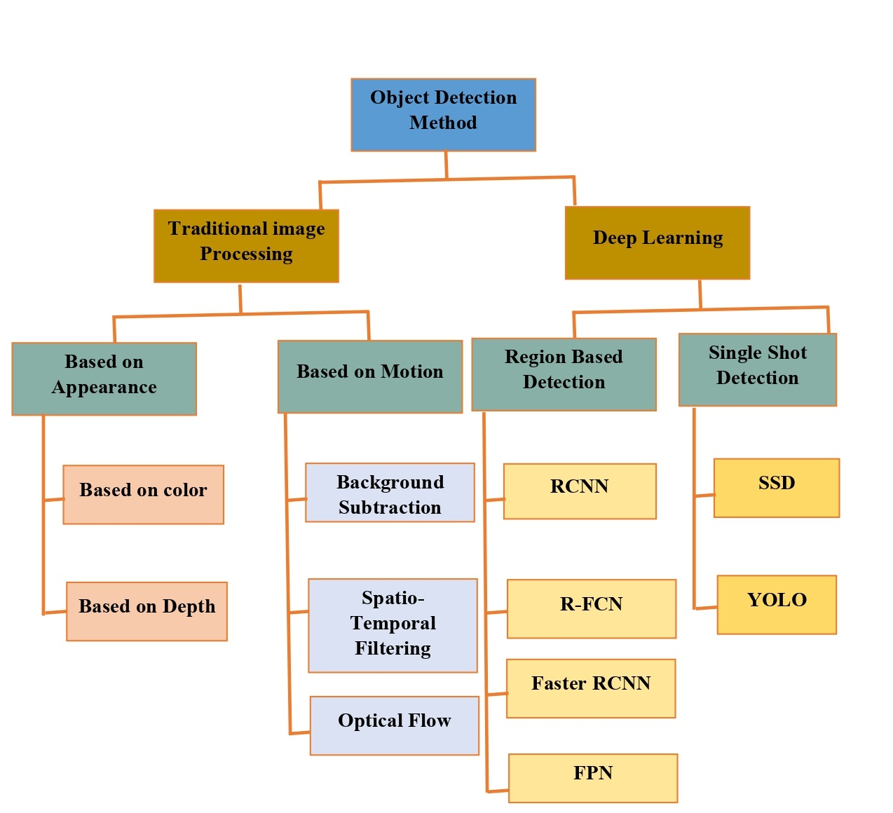
The decision between region-based and single-shot detectors is based on the particular needs of the application, including factors like speed, accuracy, and processing capacity. Each type of detector has advantages and disadvantages. Whether a use case requires autonomous navigation, real-time object tracking, or surveillance, practitioners can choose the best method by knowing the capabilities and trade-offs of various object detection approaches.

Figure 5: Object Detection Techniques

- Localization Techniques

Although they have different functions, object localization and object detection are closely connected computer vision tasks. Identifying and classifying things in an image or video is known as object detection [8]. This is usually accomplished by projecting bounding boxes around objects and matching class labels. In contrast, object localization does not require classifying items into established categories; instead, it focuses only on figuring out the exact geographical extent or position of objects.
Especially when it comes to object detection, bounding box regression is an essential feature of object localization. Bounding box regression aims to estimate the coordinates of a bounding box that encloses an object of interest closely given an input image. Typically, this procedure entails developing a regression model that can precisely predict the bounding box's center, width, and height from the neural network-extracted image data, then parameterizing the bounding box using coordinates relative to a reference point.
Two popular strategies for object localization are anchor-based and anchor-free techniques. Anchor-based techniques, like the ones used in SSD and Faster R-CNN, use pre-made anchor boxes with various aspect ratios and scales to locate objects in an image. During training, the network learns to modify these anchor boxes, which act as reference templates, to better fit the sizes and forms of the objects. Anchor-free approaches, on the other hand, as demonstrated by models such as CenterNet and CornerNet, do not utilize anchor boxes at all and instead forecast object key points or centers coupled with the corresponding bounding box offsets. Anchor-free approaches make localization easier by doing away with the requirement for anchor boxes, and they may be able to handle objects with different scales and aspect ratios more skillfully.
The decision between the two approaches—anchor-based and anchor-free—depends on a number of variables, including the complexity of the objects that need to be localized, the available computer power, and the required balance between efficiency and accuracy. Researchers and practitioners can create more efficient object identification and localization systems that are suited to their particular application requirements by comprehending the fundamental concepts of these localization approaches.

- Deep Learning Architectures for Object Detection and Localization

Achieving accurate and economical results in deep learning architectures for object detection and localization requires careful consideration of several critical components.
First of all, an architecture overview offers a high-level comprehension of the various components' interactions to complete the goal. These systems typically comprise two primary modules: object detection heads and a feature extraction network [9].
The foundation of the architecture is made up of feature extraction networks, including VGG, ResNet, or EfficientNet, which are in charge of removing hierarchical features from the input image. Utilizing convolutional layers, these networks acquire progressively more abstract depictions of the visual material, facilitating the model's ability to identify significant patterns and structures associated with object identification and positioning. The performance of the entire architecture can be greatly impacted by the feature extraction network selection, with deeper and more complex networks frequently producing better feature representations at the cost of higher computational complexity.
Using the features that the backbone network has retrieved, object detection heads are in charge of producing object predictions. Usually, these heads are made up of multiple parts, such as regression heads, classification heads, and region proposal networks (RPNs). Region proposal networks, which are used in designs such as Faster R-CNN, predict bounding box offsets and objectness scores for anchor boxes that are dispersed around the image to produce candidate bounding box suggestions. Subsequently, classification heads allocate class probabilities to every suggested bounding box, signifying the probability of it comprising a specific object category. Regression heads ensure closer alignment with the actual item locations by fine-tuning the bounding box coordinates that the RPNs predicted.
Deep learning architectures are able to locate and identify things in images with amazing efficiency and accuracy by combining feature extraction networks with specific object detection heads. The interaction of these elements, together with meticulous optimization and fine-tuning, allows for the creation of cutting-edge object identification systems that can handle a variety of real-world computer vision difficulties.
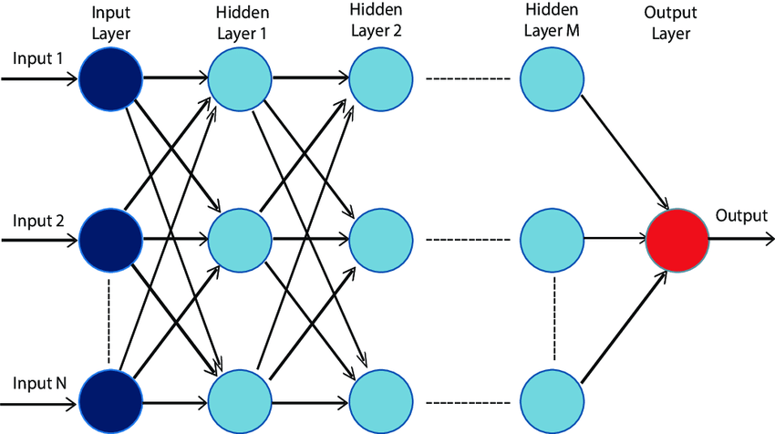
Figure 6: Deep Learning Architectures for Object Detection and Localization

- Datasets and Annotations

Good datasets are essential for training and testing object detection and localization models because they offer a variety of annotated examples that aid in model learning. The Common Objects in Context (COCO) dataset and the Pascal VOC dataset are two of the most often used datasets for this job and are considered industry standards.
The COCO dataset is a sizable collection of photos with rich object-centric annotations applied, such as segmentation masks, bounding boxes, and object classifications. COCO provides a thorough testbed for assessing the robustness and generalization abilities of object identification and localization algorithms, with over 80 item categories and a wide variety of scenes and object instances [10].
In a similar vein, the Pascal VOC dataset comprises annotated photos of many object categories, including commonplace items like vehicles, people, and animals. Pascal VOC offers a carefully selected benchmark for assessing object detection algorithms, with standardized assessment metrics and annotation formats, while being smaller in scope than COCO.
Bounding boxes and segmentation masks are the most common forms of annotation seen in object identification and localization datasets. Bounding boxes use the coordinates of their top-left and bottom-right corners to define the spatial extent of objects within images. Because of its efficiency and simplicity, this format is frequently used and can be applied to a variety of situations. Segmentation masks, on the other hand, offer annotations down to the pixel level, precisely defining the shapes of objects in pictures. Segmentation masks provide finer-grained item localization and can help with tasks like instance segmentation and pixel-wise object recognition, despite being more computationally demanding to generate and work with.
Through the utilization of standardized annotation formats like bounding boxes and segmentation masks, in conjunction with datasets like Pascal VOC and COCO, researchers and practitioners can effectively train and evaluate models for object detection and localization, leading to advancements in the field and promoting innovation in computer vision applications.

- Training Object Detection Models

Preparing the data, choosing the best training methods, and defining the right loss functions are all crucial aspects in the training of object detection models [11]. These actions maximize the performance of the models.
When it comes to getting training data ready for object identification models, data preprocessing is essential. This frequently entails actions like leveling pixel values, scaling photographs to a consistent size, and adding data to boost robustness and diversity. Preprocessing approaches can also solve other typical issues with object detection datasets, such as mitigating occlusions and handling uneven class distributions.
Effective training of object identification models requires training procedures, especially considering the intricacy and resource-demanding nature of deep learning architectures. For example, transfer learning uses pre-trained models on massive datasets such as ImageNet to initialize the feature extraction backbone weights. Transfer learning can speed up convergence and enhance object detection model performance by applying knowledge from generic visual features, particularly in situations where training data is few. Another popular approach is data augmentation, which involves creating artificial training samples by rotating, resizing, and flipping data. By exposing the model to a wider variety of input data variances, augmentation improves generalization and lowers overfitting.
Loss functions are essential for directing the training procedure since they measure the difference between the ground truth and anticipated annotations. Classification loss and localization loss are two often used loss functions in the context of object detection. Classification loss encourages the model to classify objects within bounding boxes accurately by measuring the difference between ground truth class labels and predicted class probabilities. In contrast, localization loss incentivizes the model to accurately localize items inside images by penalizing variations between predicted bounding box coordinates and ground truth annotations. The particulars of the task and the intended balance between localization precision and classification accuracy determine which of these loss functions to use and how much weight to give each.
Through meticulous planning and execution of data preparation pipelines, training approaches, and loss functions, professionals may efficiently train object identification models to get cutting-edge results on various datasets and practical applications [12]. These methods are essential for expanding the potential of computer vision systems and propelling advancements in the fields of localization and object detection.

- Evaluation Metrics

The accuracy and efficacy of object detection and localization models must be measured using the proper metrics in order to assess their performance. Mean Average Precision (mAP) and Intersection over Union (IoU) are two frequently used evaluation measures.
A commonly used metric for evaluating the overall effectiveness of object detection models is mAP [13]. In order to provide a thorough assessment of the model's capacity to identify objects of various sizes and complexity, it computes the average precision over several object categories and detection thresholds. mAP is a reliable metric for assessing detection performance across various datasets and tasks because it considers both the precision (the ratio of true positive detections to all positive detections) and recall (the ratio of true positive detections to all ground truth instances) of the model.
Conversely, IoU quantifies the extent to which ground truth annotations and anticipated bounding boxes overlap spatially [14]. It does this by dividing the union area of the two bounding boxes by the intersection area of the predicted and ground truth bounding boxes. Higher IoU values correspond to more accurate item detections, and are used as a basic metric to evaluate the spatial precision of object localization.
Even with these measures available, there are still a number of obstacles to overcome when assessing object identification and localization models. Determining ground truth annotations is a frequent problem, especially in situations with intricate object forms, occlusions, or unclear occurrences. Evaluation processes may become biased and variable as a result of the meticulous manual labor and subject knowledge needed to generate correct and consistent annotations for training and assessment datasets.
The choice of suitable evaluation procedures and thresholds for determining true positive detections is another difficulty. Model performance across studies and benchmarks can be difficult to compare since different datasets and applications may call for different evaluation criteria. Furthermore, the reproducibility and field extension of study findings may be hampered by the absence of established evaluation methods and datasets.
In order to overcome these obstacles, more work needs to be put into standardizing evaluation procedures, enhancing annotation quality, and creating reliable evaluation metrics that take into consideration the complexity of actual object detection tasks. Through tackling these obstacles, scholars and professionals can guarantee more dependable and significant assessments of object detection and localization models, ultimately propelling advancements and creativity in the domain of computer vision [15].

- Applications of Object Detection and Localization

Technologies for object identification and localization have been widely used in a variety of fields, demonstrating their adaptability and importance in a range of real-world situations [16].
When it comes to autonomous vehicles, object detection and localization are essential for allowing the vehicles to see and comprehend their environment. Autonomous vehicles are capable of making knowledgeable decisions, safe navigation, and collision avoidance through the accurate detection and localization of items such as humans, automobiles, cyclists, and traffic signals. Autonomous vehicles can now analyze complicated traffic situations, foresee possible dangers, and obey traffic laws thanks to object detection technologies, opening the door to safer and more effective transportation networks.
Surveillance systems monitor and analyze activity in public areas, commercial buildings, and vital infrastructure by utilizing object detection and localization capabilities. Surveillance systems improve security, help law enforcement, and enable proactive threat identification by recognizing and tracking people, cars, and items of interest in real-time. By detecting suspicious behaviors, unlawful intrusions, and security incidents quickly, object detection technologies help surveillance systems protect public safety and discourage criminal activity.
For robots to be able to see and interact with their surroundings on their own, object detection and localization are crucial in robotics. Robots can efficiently plan and carry out activities in dynamic and unstructured environments by identifying and localizing objects such as obstacles, tools, and workpieces. Robots using object detection technologies may work with humans in a variety of contexts, from industrial automation to service robotics and healthcare support, by navigating securely and precisely manipulating items.
Object recognition and localization are vital for illness diagnosis, surgical intervention guidance, and patient health monitoring in medical imaging. Object detection technologies help medical professionals diagnose patients accurately, plan treatments, and evaluate treatment outcomes by recognizing and localizing anatomical structures, abnormalities, and pathological findings in medical images like X-rays, CT scans, and MRI scans. Medical imaging systems can identify lesions and tumors locally, perform minimally invasive operations, and detect early warning signs of disease thanks to object detection technology. These advancements improve patient outcomes and boost the effectiveness of healthcare delivery.
To sum up, object detection and localization technologies have a significant influence on a wide range of applications, such as robots, autonomous cars, medical imaging, and surveillance systems. Through the ability of robots to sense, comprehend, and engage with their surroundings, these advancements stimulate creativity, bolster security, and elevate standard of living in many fields.

Object detection and localization have a wide range of applications across various fields. Here are some prominent ones:
- Autonomous Vehicles: Object detection and localization are crucial for autonomous vehicles to perceive and understand their environment. This includes detecting pedestrians, vehicles, traffic signs, and other obstacles on the road to ensure safe navigation.
- Surveillance and Security: Object detection is used in surveillance systems for monitoring public spaces, airports, borders, and other sensitive areas. It helps in identifying and tracking objects or individuals of interest [17].
- Retail: Retailers use object detection for inventory management, tracking product movements, and analyzing customer behavior. It enables them to optimize store layouts, manage stock levels, and enhance the shopping experience.
- Medical Imaging: In medical imaging, object detection assists in identifying and localizing anomalies such as tumors, lesions, or other abnormalities in X-rays, MRIs, CT scans, and other medical images. This aids in diagnosis and treatment planning.
- Augmented Reality: Object detection is fundamental in augmented reality applications for recognizing and tracking objects or surfaces in the real world. It allows virtual objects to interact realistically with the physical environment.
- Industrial Automation: Object detection is used in manufacturing and industrial automation for quality control, defect detection, robotic pick-and-place tasks, and monitoring production processes.
- Environmental Monitoring: Object detection can be employed in environmental monitoring systems to track wildlife, monitor habitats, detect deforestation or illegal activities, and assess changes in landscapes.
- Agriculture: In precision agriculture, object detection is utilized for crop monitoring, pest detection, yield estimation, and automated harvesting. It helps farmers optimize resource usage and improve crop yields [18].
- Human-Computer Interaction: Object detection enables natural and intuitive human-computer interaction in applications such as gesture recognition, facial recognition, and pose estimation.
- Sports Analytics: Object detection is used in sports analytics to track players' movements, analyze tactics, and provide insights for coaches, broadcasters, and fans.

- Challenges and Future Directions

Though object detection and localization have advanced significantly in recent years, there are still a number of obstacles to overcome, as well as new trends and moral issues that will affect how these technologies develop in the future.
Object recognition and localization are currently hindered by problems including complicated backdrop clutter, lighting fluctuations, and robustness to occlusions [19]. Even with tremendous advancements, current algorithms may not be able to generalize well enough across a wide range of datasets and real-world settings, which could result in performance loss under difficult circumstances. Furthermore, scaling issues arise due to the computational and memory demands of modern object detection models, especially for real-time applications and devices with limited resources.
New developments in object detection and localization are centered on overcoming these constraints and expanding the realm of the possible. The use of multi-modal sensor data—such as lidar, radar, and depth sensors—to improve the accuracy and resilience of object recognition systems is one prominent trend, particularly when it comes to bad weather and low visibility situations. Exploring novel architectures and learning paradigms, like self-supervised learning, graph neural networks, and attention processes, is another movement that aims to increase model efficiency and generalization while lowering the dependency on extensive annotated datasets.
The ethical implications of object detection and localization technology have also gained attention, posing significant queries of accountability, bias, and privacy. Concerns regarding human privacy and civil liberties are sparked by the increasing usage of surveillance systems with object detection capabilities. As a result, requests have been made for open and accountable governance frameworks to guarantee the responsible use of these technologies. Furthermore, biases in training data and algorithmic decision-making processes can produce unfair results and worsen already-existing societal disparities. To reduce these risks and encourage the inclusive and equitable deployment of object detection systems, ethical guidelines and algorithmic fairness principles are necessary [20].
In conclusion, object detection and localization technologies present serious obstacles and ethical issues that need to be resolved even if they have the enormous potential to transform a wide range of applications. Researchers, legislators, and industry stakeholders can harness the transformative power of these technologies while ensuring their responsible and equitable deployment in society, mitigating potential risks, and embracing emerging trends, all while upholding ethical principles.

- Conclusion

In conclusion, object detection and localization are foundational tasks in computer vision, playing a pivotal role in enabling machines to perceive and understand visual information from their surroundings. Throughout this exploration, we've highlighted several key points.
Firstly, object detection and localization are essential components of many computer vision applications, including autonomous vehicles, surveillance systems, robotics, and medical imaging. By accurately identifying and localizing objects within images and videos, these technologies enable machines to make informed decisions, navigate complex environments, and interact intelligently with the world around them.
Second, the development of extremely accurate and efficient models that can handle a wide range of item categories and environmental situations has been made possible by breakthroughs in deep learning, which have revolutionized object recognition and localization. Convolutional neural networks (CNNs), one type of deep learning architecture, have greatly increased object detection systems' performance, advancing the science and opening up new avenues for practical applications.
Thirdly, despite the impressive progress made in object detection and localization, a number of issues still need to be resolved, such as robustness to occlusions, fluctuations in lighting conditions, and moral concerns about justice and privacy [21]. In order to overcome these obstacles, more research, creativity, and cooperation between the government, business, and academic sectors are needed.
To sum up, object detection and localization are essential parts of computer vision systems that enable robots to see, understand, and respond to visual data in a variety of changing settings. It is impossible to overestimate the significance of object detection and localization in developing technology and society as we continue to push the envelope in this area. Future chances for innovation and beneficial societal effect can be unlocked by wisely and ethically utilizing the promise of these technologies.

REFERENCES:

- Murphy, K., Torralba, A., Eaton, D., & Freeman, W. (2006). Object detection and localization using local and global features. Toward category-level object recognition, 382-400.
- Learned-Miller, E. G. (2011). Introduction to computer vision. University of Massachusetts, Amherst.
- Weimer, D., Scholz-Reiter, B., & Shpitalni, M. (2016). Design of deep convolutional neural network architectures for automated feature extraction in industrial inspection. CIRP annals, 65(1), 417-420.
- Zaccone, G., & Karim, M. R. (2018). Deep Learning with TensorFlow: Explore neural networks and build intelligent systems with Python. Packt Publishing Ltd.
- Chiu, H. J., Li, T. H. S., & Kuo, P. H. (2020). Breast cancer–detection system using PCA, multilayer perceptron, transfer learning, and support vector machine. IEEE Access, 8, 204309-204324.
- Jogin, M., Madhulika, M. S., Divya, G. D., Meghana, R. K., & Apoorva, S. (2018, May). Feature extraction using convolution neural networks (CNN) and deep learning. In 2018 3rd IEEE international conference on recent trends in electronics, information & communication technology (RTEICT) (pp. 2319-2323). IEEE.
- Wilson, M. A. T. T. H. E. W., & Bower, J. M. (1992). Cortical oscillations and temporal interactions in a computer simulation of piriform cortex. Journal of Neurophysiology, 67(4), 981-995.
- Zhao, Z. Q., Zheng, P., Xu, S. T., & Wu, X. (2019). Object detection with deep learning: A review. IEEE transactions on neural networks and learning systems, 30(11), 3212-3232.
- Ma, W., Wu, Y., Cen, F., & Wang, G. (2020). Mdfn: Multi-scale deep feature learning network for object detection. Pattern Recognition, 100, 107149.
- Wu, X., Sahoo, D., & Hoi, S. C. (2020). Recent advances in deep learning for object detection. Neurocomputing, 396, 39-64.
- Girshick, R., Donahue, J., Darrell, T., & Malik, J. (2015). Region-based convolutional networks for accurate object detection and segmentation. IEEE transactions on pattern analysis and machine intelligence, 38(1), 142-158.
- Amiri, Z., Heidari, A., Navimipour, N. J., Unal, M., & Mousavi, A. (2023). Adventures in data analysis: A systematic review of Deep Learning techniques for pattern recognition in cyber-physical-social systems. Multimedia Tools and Applications, 1-65.
- Girshick, R., Donahue, J., Darrell, T., & Malik, J. (2015). Region-based convolutional networks for accurate object detection and segmentation. IEEE transactions on pattern analysis and machine intelligence, 38(1), 142-158.
- Ali, S., Zhou, F., Braden, B., Bailey, A., Yang, S., Cheng, G., ... & Rittscher, J. (2020). An objective comparison of detection and segmentation algorithms for artefacts in clinical endoscopy. Scientific reports, 10(1), 2748.
- Sarkar, K., Shiuly, A., & Dhal, K. G. (2024). Revolutionizing concrete analysis: An in-depth survey of AI-powered insights with image-centric approaches on comprehensive quality control, advanced crack detection and concrete property exploration. Construction and Building Materials, 411, 134212.
- Khelifi, F., Bradai, A., Benslimane, A., Rawat, P., & Atri, M. (2019). A survey of localization systems in internet of things. Mobile Networks and Applications, 24, 761-785.
- Iqbal, M. J., Iqbal, M. M., Ahmad, I., Alassafi, M. O., Alfakeeh, A. S., & Alhomoud, A. (2021). Real-time surveillance using deep learning. Security and Communication Networks, 2021, 1-17.
- Darwin, B., Dharmaraj, P., Prince, S., Popescu, D. E., & Hemanth, D. J. (2021). Recognition of bloom/yield in crop images using deep learning models for smart agriculture: A review. Agronomy, 11(4), 646.
- Shaikh, R. A., Memon, I., Hussain, R., Maitlo, A., & Shaikh, H. (2018). A contemporary approach for object recognition based on spatial layout and low level features’ integration. Multimedia Tools and Applications, 1-24.
- Tsamados, A., Aggarwal, N., Cowls, J., Morley, J., Roberts, H., Taddeo, M., & Floridi, L. (2021). The ethics of algorithms: key problems and solutions. Ethics, Governance, and Policies in Artificial Intelligence, 97-123.
- Chen, J., Dowman, I., Li, S., Li, Z., Madden, M., Mills, J., ... & Heipke, C. (2016). Information from imagery: ISPRS scientific vision and research agenda. ISPRS Journal of Photogrammetry and Remote Sensing, 115, 3-21.

