Linguistic perspective on technology evolution
Zamzam Rehman
UG student, Department of Biotechnology, GD Rungta College of Science and Technology, Bhilai, Chhattisgarh, India
Corresponding Author - zamzamrehman65759@gmail.com
INTRODUCTION
Language is something which cannot be ignored at all. Even when you talk about language you still need a “language” to talk in. For a short introduction “language is a system of conventional spoken, manual (signed) or written symbols by means of which human beings as members of social group and participants in a culture, express themselves.” Likewise, technology is also a thing which runs along with you side by side. The more you grow, the more you will find it complexly enhancing.
Now the question is how does they both corelate? Language grows and adapts continuously, evolving as we come up with better words that reflects our culture and society. It mirrors the unexpected interwining of our lives with technology.
Further elaborating on the linguistic perspective on technology evolution, this approach considers how language serves as a lens through which we interpret and interact with technological developments. By analyzing the language used to describe and discuss technology, we can uncover underlying societal attitudes, values, and priorities. Additionally, studying linguistic changes and innovations in response to technological advancements provides insights into how language evolves alongside technology, reflecting shifts in human behavior and cognition. This perspective offers a nuanced understanding of the dynamic relationship between language and technology, illuminating the intricate ways in which they shape and are shaped by each other within the broader context of societal evolution.
In a nutshell, examining the linguistic perspective on technology evolution explores how language reflects and shapes our interactions with technology over time. It helps us understand how societal values and cultural norms influence technological advancements and adoption.
HISTORY
Talking about history of language, some scholars think its relationship with human evolution, and its consequences have been subjects of study for centuries. Scholars wish to study language origination must draw some inferences from fossil records, archaeological evidences, studies of language acquisition, and to compare human language and communication system of other animals.
When communication is developing to this extend why would the technology be slow then? The history of technology is history of invention of tools and techniques. The term technology actually comes from the Greek word “techne” meaning art and craft and the word “logos” means word or speech but this word technology used to describe the advancements or changes that affects the environment around us.
THEORIES THAT RELATE THEM
A controversy related to language and technology has something to do with the appropriate theoretical grounding for the field.
- Chapelle, in her groundbreaking article in 1997 which is titled as “Call in the year 2000: Still in Search of Research Paradigms?” argues that fields like computational linguistics, psychology will lack the specificity needed to design the pedagogy of CALL.
- Writing 8 years later Chapelle cites a substantial body of CALL Research in the interactionalist tradition.
There are several theories that explore the relationship between linguistic perspective and technology evolution. One prominent theory is the Sapir-Whorf hypothesis, which suggests that language shapes our perception of the world and influences our thought processes. In the context of technology evolution, this theory implies that changes in language and communication technologies can impact how we think about and interact with technology. For example, the introduction of new terms and concepts related to technology can shape our understanding of it and drive further innovation. Additionally, theories of technological determinism propose that technological development follows a predetermined path influenced by societal values and cultural norms, which in turn can be reflected in language use and evolution. This perspective suggests that changes in technology can lead to shifts in language and communication patterns as people adapt to new technological capabilities and ways of interacting. Overall, these theories highlight the dynamic interplay between language, technology, and societal change.

HOW TECHNOLOGY DRIVES EVOLUTION OF LANGUAGE?
- WHEN WORDS GET NEW MEANINGS
Words do not get into our language in their final state but it evolves with time, which hereby changes our understanding and perception of term.
For example, the label ‘nerd’ was earlier used to insult the people who were secluded, socially awkward or any outsider. In contrary to this now it is being used as a title of honour.
‘NERDISM’ today means ‘reliable expertise’, which acknowledge the shift in a=the age of evolution.
This change is due to the economic success of Silicon Valley pioneers such as Steve jobs and Bill Gates whose company earns billions today.
- WORDS APPROACH IN DICTIONARY
While the generation prior to us may have seen the dictionaries as custodians and defenders of “correct” language- that is no longer the case.

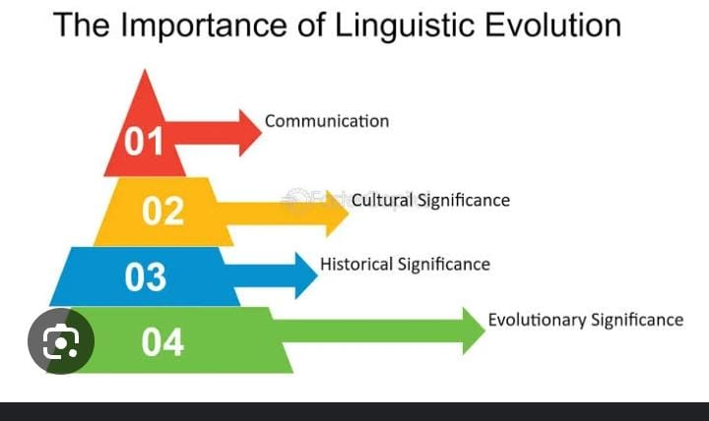

Figure:

Back in 2007, the Oxford English Dictionary removed the words like acorn, dandelion, pasture etc. which described the nature but now they replaced those words with ‘blog’, ‘chatroom’.

- INTERNET LITERACY
The language spoken by young generation and technology can sometimes be difficult to decipher, but it’s also the key to understand the evolution of language around us.

GRAPH THAT SHOWS THE IMPACT FACTOR OF TEXT ,SPEECH AND LANGUAGE TECHNOLOGY

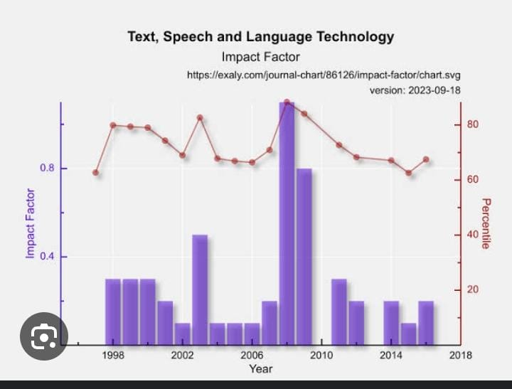
Figure:

COMPUTER LANGUAGES

While relating technology and language, how could we forget talking about computer languages. Yes, you heard it right “language of computers.”
“A computer language is a formal language used to communicate with a computer.”
It is based on binary system.
All humans and animals have their ways of communicating with each other. Humans have different languages such as Hindi, English, Telugu, etc whereas animals communicate through their sounds and signals. We have been working on computers for decades now but have you ever wondered how do we communicate with them? Isn’t it kind of inquisitive?

Well, computers certainly cannot understand human languages so we cannot directly communicate with them. Hence, with time, we developed several languages which help us to convey our messages to computers and make them do our work. In this article, we have discussed all these computer languages and their types.

What are Computer Languages
In essence, a computer language is a set of rules and symbols used to write instructions that a computer can understand and execute. These instructions tell the computer what to do, how to do it, and when to do it. Computer languages enable programmers to create software, develop algorithms, and solve various computational problems by writing code in a structured and systematic manner. Each language has its own syntax and semantics, which determine how the code is written and interpreted by the computer. Ultimately, computer languages serve as the bridge between human intentions and machine actions in the realm of computing.
Types of computer languages
1. Machine Language: This language is the most basic form of communication between computers and humans. It's like speaking in binary code, where every instruction and piece of data is represented by a sequence of 0s and 1s. It's the language that the computer's hardware understands directly, but it's incredibly difficult for humans to work with because it's tedious and error-prone.

2. Assembly Language: Think of assembly language as a step up from machine language. It's like using short abbreviations or codes to represent the binary instructions. Instead of dealing with raw 0s and 1s, programmers write instructions using mnemonic codes like ADD for addition or MOV for moving data. While still quite low-level, assembly language is easier for humans to understand and work with compared to machine language.

3. High-Level Language: Now imagine speaking in a language that's much closer to how we naturally communicate. High-level languages are designed to be intuitive and expressive, allowing programmers to write code using words and syntax that closely resemble human language. Languages like Python, Java, and C++ fall into this category. They abstract away many of the complexities of the underlying hardware, making it easier to write and understand programs. However, these languages need to be translated into machine code before they can be executed by the computer, usually through a process called compilation or interpretation.

So, in summary, machine language is like speaking in 0s and 1s, assembly language is like using shorthand for those 0s and 1s, and high-level languages are like having a conversation in a language that's much closer to our own. Each type of language has its own level of abstraction and complexity, catering to different needs and preferences of programmers.
- 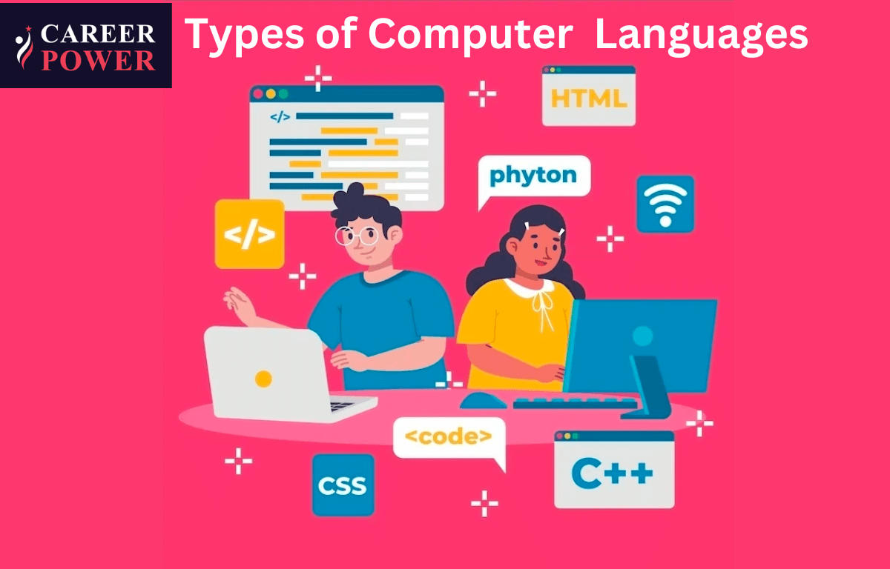

Opportunities in their blending

The following is the list given below that offers an overview of the affordances of technology for language education:
- It reduces anxiety of language learning and increase motivation through game-based activities, creative ideas like mashups and digital storytelling etc.
- It enables multiple modes of language activities in which reading, learning, writing, speaking, and listening skills are all integrated which thereby enhances the strength and interest of different learners.
- Learners find a new platform to make a new social identity.
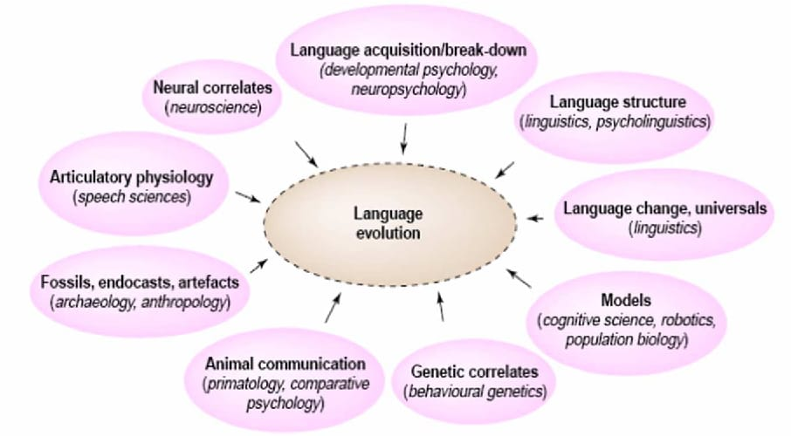
- It facilitates individual learning experiences.

Figure:

CONCLUSION
To sum up, technological evolution significantly shapes language, leading to linguistic changes and adjustments. From the introduction of new terms to changes in communication styles, technology constantly alters how we express ourselves and interact with others. As we embrace a more digital era, our language will keep evolving, mirroring the continuous impact of technological advancements on human communication.
To put it another way, technology's evolution shapes our language and perception, influencing how we interact and understand each other. It can make illusions of connection but also distance us from genuine human interaction, which language helps us navigate and understand.

REFERENCES
- Gong, T., Shuai, L., & Comrie, B. (2014). Evolutionary linguistics: theory of language in an interdisciplinary space. Language Sciences, 41, 243-253.
- Dediu, D., & Christiansen, M. H. (2016). Language evolution: constraints and opportunities from modern genetics. Topics in Cognitive Science, 8(2), 361-370.
- Kinsella, A. R. (2009). Language evolution and syntactic theory (Vol. 1). Cambridge University Press.
- Számadó, S., & Szathmáry, E. (2006). Selective scenarios for the emergence of natural language. Trends in Ecology & Evolution, 21(10), 555-561.
- Bernabeu, P., & Vogt, P. (2015). Language evolution: Current status and future directions. In 10th Language at the University of Essex Postgraduate Conference (LangUE) (pp. 1-27).
- Dor, D., & Jablonka, E. (2001). How language changed the genes: toward an explicit account of the evolution of language. New essays on the origin of language, 133, 151-175.
- Pleyer, M., Hartmann, S., Winters, J., & Zlatev, J. (2017). Interaction and iconicity in the evolution of language: Introduction to the
- Fujita, H., & Fujita, K. (2022). Human language evolution: a view from theoretical linguistics on how syntax and the lexicon first came into being. Primates, 63(5), 403-415.
- Christiansen, M. H., & Kirby, S. (2003). Language evolution: Consensus and controversies. Trends in cognitive sciences, 7(7), 300-307.
- Wacewicz, S., Zywiczynski, P., Hartmann, S., Pleyer, M., & Benítez-Burraco, A. (2020). Language in Language Evolution Research. Biolinguistics, 14, 59-101.
- Gontier, N. (2012). Selectionist approaches in evolutionary linguistics: an epistemological analysis. International Studies in the Philosophy of Science, 26(1), 67-95.
- Botha, R., & Everaert, M. (Eds.). (2013). The evolutionary emergence of language: Evidence and inference (Vol. 17). Oxford Studies in the Evolutio.
- Steels, L. (2017). Do languages evolve or merely change?. Journal of Neurolinguistics, 43, 199-203.
- Kirby, S. (1999). Function, selection, and innateness: The emergence of language universals. OUP Oxford.
- McMahon, A., & McMahon, R. (2012). Evolutionary linguistics (Vol. 223). Cambridge University Press.

